

Description of
Partner Interface Process® for 6C4

Validated 11.00.01

Specification Information
Name | Notify Of Case Confirmation
Cluster | Service and Support
Segment | Technical Support and Service Management
Publication Date | 03 August 2009
Version Identifier | V11.00

Table of Contents
1 Document Management 4
1.1 Legal Disclaimer 4
1.2 Copyright 4
1.3 Trademarks 4
1.4 Acknowledgments 4
1.5 Related Documents 5
1.6 Document Version History 5
1.7 Document Structure 5
2 Business Process 6
2.1 Business Process Definition 6
2.1.1 Executive Summary 6
2.1.2 Business Process Description 6
2.2 PIP Scope Description 6
2.2.1 Business Process Scope Diagram 8
2.3 PIP Business Document 9
2.4 PIP Business Process Flow Diagram 9
2.5 PIP Start State 10
2.6 PIP End States 10
2.7 Partner Role Descriptions 11
2.8 Business Process Activity Controls 11
3 Network and Implementation Specification 12
3.1 Business Action and Business Signal Specifications 12
3.2 Business Transaction Dialog Specification 12
3.2.1 Message Exchange Controls 13
3.2.2 Communications Specification 13

List of Figures:
Figure 1: Business Process Scope Diagram 8
Figure 2: Activity Diagram of Notify Of Case Confirmation 9
Figure 3: Sequence Diagram of Notify Of Case Confirmation 12

List of Tables:
Table 1: PIP Business Document 9
Table 2: PIP Start State 10
Table 3: PIP End State 10
Table 4: PIP Failure State 10
Table 5: Partner Role Description 11
Table 6: Business Activity Description 11
Table 7: Business Activity Performance Control 11
Table 8: Network Component Specification 12
Table 9: Business Action – Business Document Mapping 12
Table 10: Message Exchange Control 13
Table 11: Dialog: Service-Service 13

Document Management

Legal Disclaimer
RosettaNet™, its members, officers, directors, employees, or agents shall not be liable for any injury, loss, damages, financial or otherwise, arising from, related to, or caused by the use of this document or the specifications herein, as well as associated guidelines and schemas. The use of said specifications shall constitute your express consent to the foregoing exculpation.

Copyright
©2009 RosettaNet. All rights reserved. No part of this publication may be reproduced, stored in a retrieval system, or transmitted, in any form or by any means, electronic, mechanical, photocopying, recording, or otherwise, without the prior written permission of the publisher. Printed in the United States of America.

Trademarks
RosettaNet, Partner Interface Process, PIP and the RosettaNet logo are trademarks or registered trademarks of "RosettaNet," a non-profit organization. All other product names and company logos mentioned herein are the trademarks of their respective owners. In the best effort, all terms mentioned in this document that are known to be trademarks or registered trademarks have been appropriately recognized in the first occurrence of the term.

Acknowledgments
This document has been prepared by RosettaNet (http://www.rosettanet.org/) from requirements gathered during the Milestone Program and in conformance with the methodology. Listed below are the legal entities that contributed to the design and development of this PIP.
BT | Cisco Systems
Ericsson | HP
IBM | Motorola
Nokia | TeliaSonera

Related Documents
- Associated PIP Message Schemas (included within the PIP Specification package only)
- Description of 6C4 Message
- Messages Structure
- XML instance of ebXML BPSS for PIP 6C4

Document Version History
Version | Date | Description
Validated 11.00.00 | 20 April 2009 | Validated Version : Q12009 Maintenance Process
Validated 11.00.01 | 03 August 2009 | Validated Version : Q32009 Maintenance Process

Document Structure
A Partner Interface Process (PIP) Specification is comprised of the following two parts:
- Business Process. Captures the semantics of the business process and the flow of the message exchange between roles as they perform business activities.
- Network and Implementation Specification. Specifies the network protocol message formats and communications requirements between peer-protocols supported by network components in the RosettaNet Implementation Framework.

Business Process

Business Process Definition
The Automated Ticketing process will provide B2B automation for the creation, updating and closing of technical support cases between a Case Sender and a Case Receiver.

Executive Summary
The main proposal for this PIP is to replace manual processes (Portal, Fax, email..) through seamless ticket routing from system to system, saving cost and increasing quality. The system existing now supports descriptive attachments to ticket cases. The system to system that supports automated tracking will enable trace management and tracking of performance for each case history.
The reduced cycle time increases customer satisfaction in problem handling along the value chain.
With the introduction of standard processes within the service and support chain, it enables scalable implementations and eliminates proprietary point to point solutions. Hence, improving accuracy and quality of data.

Business Process Description
The service and support chain roles that influence this process are:
- Customer – The entity experiencing the problem, such as the failure in a network module.
Example is a commercial customer for Hewlett Packard (HP), using Cisco networking devices as sold to them by HP.
- Case Sender – The entity ultimately responsible for resolution of the problem to the Customer. If only two parties in the relationship, then the Case Owner is also the Case Resolver.
Example is HP, having provided Cisco networking equipment and support to their commercial customer.
- Case Receiver –The entity responsible for resolution of the problem to the Case Owner should the Case Owner escalate the problem to the Case Resolver.
Example is Cisco, providing support to HP on a commercial customer case escalated to Cisco as part of some contractual agreement between the two parties

PIP Scope Description
There are 5 use cases that this PIP supports:
Use Case | Scenarios
1. Case Open Request | Case Sender opens case with Case Receiver and Case Receiver accepts case
1. Case Open Request | Case Sender opens case with Case Receiver and Case Receiver rejects case
2. Case Update | Case Sender updates case with Case Receiver and Case Receiver accepts update
2. Case Update | Case Sender updates case with Case Receiver and Case Receiver rejects update
2. Case Update | Case Receiver updates case with Case Sender and Case Sender accepts update
2. Case Update | Case Receiver updates case with Case Sender and Case Sender rejects update
3. Case Close/cancellation | Case Sender requests Case Receiver to close/cancel case and Case Receiver accepts case close/cancel request
3. Case Close/cancellation | Case Sender requests Case Receiver to close/cancel case and Case Receiver rejects case close/cancel request
3. Case Close/cancellation | Case Receiver requests Case Sender to close/cancel case and Case Sender accepts case close/cancel request
3. Case Close/cancellation | Case Receiver requests Case Sender to close/cancel case and Case Sender rejects case close/cancel request
4. Case Re-Open | Case Sender requests Case Receiver to re-open the case and Case Receiver accepts
4. Case Re-Open | Case Sender requests Case Receiver to re-open the case and Case Receiver rejects
5. Case synchronization | Case Sender and Case Receiver can send an ‘inventory’ of cases for a set period (opened and closed cases)

Business Process Scope Diagram
Customer detects issue & raises ticket to supplier/provider/
case owner
eTicket Routing
Case Sender validates case, assesses problem & forwards ticket to Case Receiver(if required)

Case Receiver identifies issue & provides fix back to Case Sender
Case owner
Case problem message
Case problem message
Update and fix problem
Update and fix problem
Figure 1: Business Process Scope Diagram

PIP Business Document
Business Document are generated and exchanged by roles performing activities in this PIP. Business Document is listed and defined in Table 1.
Table 1: PIP Business Document
Business Document | Description
Case Confirmation Notification | The Automated Ticketing process will provide B2B automation for the creation, updating and closing of technical support cases between a Case Sender and a Case Receiver.

PIP Business Process Flow Diagram
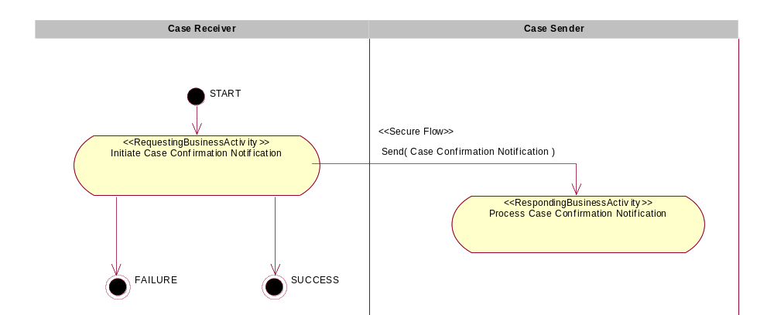
Figure 2: Activity Diagram of Notify Of Case Confirmation

PIP Start State
The start state is comprised of the following conditions:
Table 2: PIP Start State
 | Approved | Exist |  | Valid | Non-Repudiated | Retry Count | Authorized
 | Approved | Party | In Backend System
TPA |  |  | 
Sending Partner |  |  |  | 
Receiving Partner |  | 
Business Document |  |  |  |  |  |  | 

PIP End States
The end state is comprised of the following conditions:
Table 3: PIP End State
 | Approved | Exist |  | Valid | Non-Repudiated | Retry Count | Authorized
 | Approved | Party | In Backend system
Acknowledgment of Receipt |  |  |  |  | 
Receiving Partner |  |  |  |  |  |  | 

The PIP failure state is comprised of one or more of the following conditions:
Table 4: PIP Failure State
 | NO | Exceeded
Success | 
Retry Count |  | 

Partner Role Descriptions
Table 5 describes the partner roles in this PIP.
Table 5: Partner Role Description
Role Name | Role Description
Case Receiver | The entity responsible for resolution of the problem to the Case Owner should the Case Owner escalates the problem to the Case Resolver.
Case Sender | The entity ultimately responsible for resolution of the problem to the Customer. If only two parties in the relationship, then the Case Owner is also the Case Resolver.

Business Process Activity Controls
Table 6 describes the interaction between roles performing business activity in this PIP.
Table 6: Business Activity Description
Role  Name | Activity Name | Activity Description
Case Receiver | Initiate Case Confirmation Notification | Case Receiver identifies the issue and provides the fix to the Case Sender. The Case Sender initiates the case problem and the Case Receiver update fixes to the case.

Table 7 details the security, audit and process controls relating to activity performed in the PIP.
Table 7: Business Activity Performance Control
Role  Name | Activity  Name | Acknowledgment  of Receipt |  | Time to Perform | Retry Count | Is Authorization Required? | Non-Repudiation of Origin and Content?
Role  Name | Activity  Name | Non-Repudiation Required? | Time to Acknowledge
Case Receiver | Initiate Case Confirmation Notification | Y | 2hrs | N/A | 3 | Y | Y

Network and Implementation Specification
Each network component maps into a role of the PIP model. Table 8 specifies the mapping between roles and network components.
Table 8: Network Component Specification
Network Component | Classification | Maps to Role in Business Process
Case Receiver Service | Business Service | Case Receiver
Case Sender Service | Business Service | Case Sender

Business Action and Business Signal Specifications
Each business action maps to a Business Document of the PIP model. Table 9 specifies the mapping between Business Documents and business actions.
Table 9: Business Action – Business Document Mapping
Business Action | Business Document | Document Function
Case Confirmation Notification Action | Case Confirmation Notification | Request

Business Transaction Dialog Specification
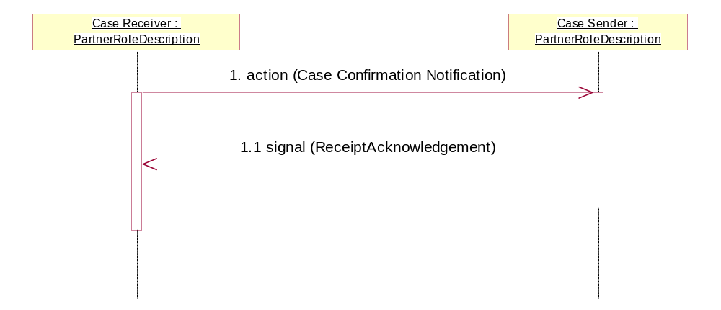
Figure 3: Sequence Diagram of Notify Of Case Confirmation

Message Exchange Controls
Table 10: Message Exchange Control
# | Name |  | Time to Acknowledge Receipt Signal |  | Time to Respond to Action |  | Included in Time to Perform |  | Is Authorization Required? |  | Is Non-Repudiation Required? |  | Is Secure Transport Required?
1. |  | Case Confirmation Notification Action |  | 2hrs |  | N/A |  | N/A |  | Y |  | Y |  | Y
1.1. |  | Receipt Acknowledgment |  | N/A |  | N/A |  | N/A |  | Y |  | Y |  | Y

Communications Specification
Table 11: Dialog: Service-Service
# | Business Message | Digital Signature Required? | SSL Required?
1. | Case Confirmation Notification | Y | Y
1.1. | Receipt Acknowledgment | Y | Y

