

Description of 6C5 Message

PIP® 6C5
Validated 11.00.00

Specification Information
Name | Description of 6C5 Message
PIP | Distribute Service Entitlement Query
Cluster | Service and Support
Segment | Technical Support and Service Management
Publication Date | 8 March 2010
Version Identifier | V11.00

Table of Content

1. Document Management 5
1.1 Legal Disclaimer 5
1.2 Copyright 5
1.3 Trademarks 5
1.4 Acknowledgments 5
1.5 Related Documents 5
1.6 Document Version History 5
1.7 Document Purpose 5
2. Interchange Model 6
2.1 ServiceEntitlementQueryNotification 6
2.1.1 Interchange Diagram 6
2.1.2 Dependency Diagram 6
2.1.3 EventInformation 7
2.1.4 PartInformation 8
2.1.5 ServiceEntitlement 9
2.1.6 ServiceEntitlementQuery 10
2.1.7 UnitInformation 11
3. Domain Model 12
3.1 Service 12
3.1.1 Dependency Diagram 12
3.1.2 PurchaseDate 12
3.1.3 CodeList 13
3.1.3.1 ServiceDeliveryMethod 13
3.1.3.2 WarrantyProgram 13
4. Universal Structure 14
4.1 ContactInformation 14
4.1.1 ContactInformation 14
4.2 DataType 15
4.2.1 Contact 15
4.2.2 DUNS 15
4.2.3 DUNSPlus4 16
4.2.4 GLN 16
4.2.5 GTIN 17
4.3 Locations 17
4.3.1 AlternativeIdentifier 17
4.3.2 Location 18
4.3.3 LocationChoice 19
4.3.4 PhysicalAddress 20
4.4 PartnerIdentification 22
4.4.1 FullPartner 22
4.4.2 IntermittentPartner 23
4.4.3 KnownPartner 23
4.4.4 KnownPartnerContact 24
4.4.5 NewPartner 24
4.4.6 PartnerDescription 25
4.4.7 PartnerDescriptionChoice 26
4.4.8 PartnerIdentification 27
4.4.9 PartnerIdentificationChoice 28
4.4.10 SpecifiedFullPartner 29
4.4.11 SpecifiedIntermittentPartner 30
4.4.12 SpecifiedKnownPartner 30
4.4.13 SpecifiedNewPartner 31
4.5 ProductIdentification 32
4.5.1 ProductIdentification 32
4.5.2 ProductIdentificationChoice 32
4.6 CodeList 33
4.6.1 Country 33
4.6.2 CountrySubdivision 33
4.6.3 Language 33
4.6.4 MimeTypeQualifier 34
4.6.5 ProcessRoleIdentifier 45
5. System Structure 48
5.1 BusinessProcessIdentifier 48
5.2 BusinessServiceInformation 49
5.3 ContractInformation 50
5.4 CorrelationInformation 50
5.5 DocumentHeader 51
5.6 DocumentIdentification 52
5.7 DocumentIdentificationChoice 53
5.8 DocumentInformation 53
5.9 DocumentManifest 54
5.10 DocumentSecurity 55
5.11 ManifestItem 56
5.12 PipIdentifier 57
5.13 PipVersion 57
5.14 Receiver 58
5.15 RequestingDocumentInformation 59
5.16 Sender 60
5.17 StandardDocumentIdentification 61
5.18 TpirPipIdentification 62
5.19 VersionIdentifier 63
5.20 CodeList 63
5.20.1 TPIRFileType 63
6. XML Data Type 64
6.1 anyURI 64
6.2 boolean 64
6.3 dateTime 64
6.4 positiveInteger 64
6.5 string 64

Table of Figures

Figure ‎2-1 Interchange 6
Figure ‎2-2 Dependency 6
Figure ‎2-3 EventInformation 7
Figure ‎2-4 PartInformation 8
Figure ‎2-5 ServiceEntitlement 9
Figure ‎2-6 ServiceEntitlementQuery 10
Figure ‎2-7 UnitInformation 11
Figure ‎3-2 Dependency 12
Figure ‎3-3 PurchaseDate 12
Figure ‎4-1 ContactInformation 14
Figure ‎4-2 Contact 15
Figure ‎4-3 DUNS 15
Figure ‎4-4 DUNSPlus4 16
Figure ‎4-5 GLN 16
Figure ‎4-6 GTIN 17
Figure ‎4-7 AlternativeIdentifier 17
Figure ‎4-8 Location 18
Figure ‎4-9 PhysicalAddress 20
Figure ‎4-10 FullPartner 22
Figure ‎4-11 IntermittentPartner 23
Figure ‎4-12 KnownPartner 23
Figure ‎4-13 KnownPartnerContact 24
Figure ‎4-14 NewPartner 24
Figure ‎4-15 PartnerDescription 25
Figure ‎4-16 PartnerIdentification 27
Figure ‎4-17 SpecifiedFullPartner 29
Figure ‎4-18 SpecifiedIntermittentPartner 30
Figure ‎4-19 SpecifiedKnownPartner 30
Figure ‎4-20 SpecifiedNewPartner 31
Figure ‎4-21 ProductIdentification 32
Figure ‎5-1 BusinessProcessIdentifier 48
Figure ‎5-2 BusinessServiceInformation 49
Figure ‎5-3 ContractInformation 50
Figure ‎5-4 CorrelationInformation 50
Figure ‎5-5 DocumentHeader 51
Figure ‎5-6 DocumentIdentification 52
Figure ‎5-7 DocumentInformation 53
Figure ‎5-8 DocumentManifest 54
Figure ‎5-9 DocumentSecurity 55
Figure ‎5-10 ManifestItem 56
Figure ‎5-11 PipIdentifier 57
Figure ‎5-12 PipVersion 57
Figure ‎5-13 Receiver 58
Figure ‎5-14 RequestingDocumentInformation 59
Figure ‎5-15 Sender 60
Figure ‎5-16 StandardDocumentIdentification 61
Figure ‎5-17 TpirPipIdentification 62
Figure ‎5-18 VersionIdentifier 63

Document Management

Legal Disclaimer
RosettaNet, its members, officers, directors, employees, or agents shall not be liable for any injury, loss, damages, financial or otherwise, arising from, related to, or caused by the use of this document or the specifications herein, as well as associated guidelines and schemas. The use of said specifications shall constitute your express consent to the foregoing exculpation.

Copyright
©2010 RosettaNet. All rights reserved. No part of this publication may be reproduced, stored in a retrieval system, or transmitted, in any form or by any means, electronic, mechanical, photocopying, recording, or otherwise, without the inclusion of this copyright notice. Any derivative works must cite the copyright notice. Any public redistribution or sale of this publication or derivative works requires prior written permission of the publisher.

Trademarks
RosettaNet, Partner Interface Process, PIP and the RosettaNet logo are trademarks or registered trademarks of "RosettaNet," a non-profit organization. All other product names and company logos mentioned herein are the trademarks of their respective owners. In the best effort, all terms mentioned in this document that are known to be trademarks or registered trademarks have been appropriately recognized in the first occurrence of the term.

Acknowledgments
This document has been prepared by RosettaNet (http://www.rosettanet.org/) from requirements gathered during the Milestone Program and in conformance with the methodology.

Related Documents
- Associated PIP Message Schemas (included with PIP Specification only)
- Description of Partner Interface Process for 6C5
- Message Structure

Document Version History
Version | Date | Description
Validated 11.00.00 | 8 March 2010 | Validated Version : MCC Program

Document Purpose
The purpose of the document is to explain the structure, the association between objects, the content of objects and the definition for single elements to a non-technical audience.

Interchange Model

ServiceEntitlementQueryNotification

Interchange Diagram
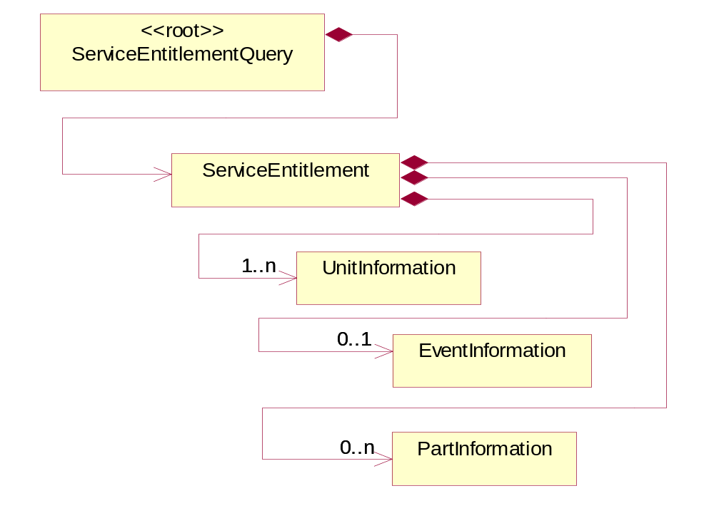
Figure ‎2-1 Interchange

Dependency Diagram
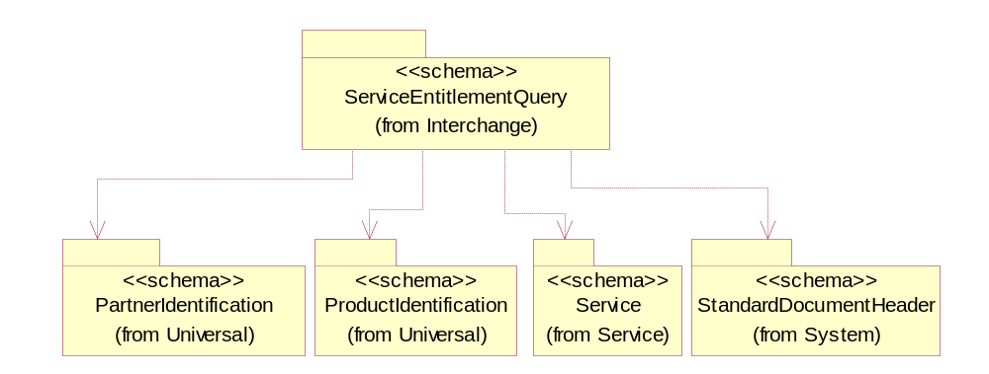
Figure ‎2-2 Dependency

EventInformation
The collection of business properties that describe the data elements and entities associated with performing repair or maintenance service on a part or unit of product.
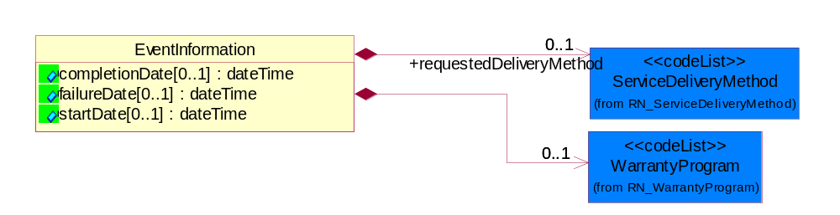
Figure ‎2-3 EventInformation

Attribute | Type | Documentation
completionDate[0..1] | dateTime | Date Warranty Service was completed on a unit.
failureDate[0..1] | dateTime | Captures the date of failure of a product.
startDate[0..1] | dateTime | Date Warranty Service was begun on a unit.

Composition | Cardinality | Type | Documentation
WarrantyProgram | 0..1 | WarrantyProgram | The program used when verifying service entitlement.
requestedDeliveryMethod | 0..1 | ServiceDeliveryMethod | The service delivery method suggested by the ASP to deliver the warranty entitilement on a unit.

PartInformation
The collection of part data entities that comprise a request for warranty entitlement on the part to a Warranty Provider.
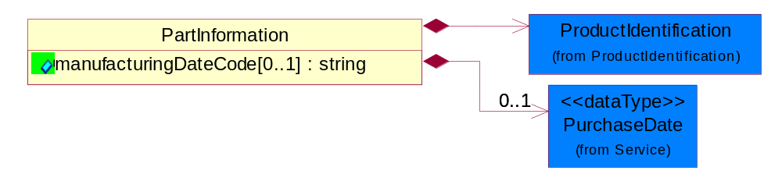
Figure ‎2-4 PartInformation

Attribute | Type | Documentation
manufacturingDateCode[0..1] | string | The unique identifier assigned to a product by a manufacturer to distinguish individual manufacturing periods.

Composition | Cardinality | Type | Documentation
ProductIdentification | 1 | ProductIdentification | The object provides the identifier(s) of a product.
PurchaseDate | 0..1 | PurchaseDate | Date of purchase of a unit.

ServiceEntitlement
The collection of data entities that comprise a request for entitlement status to a Warranty Provider.
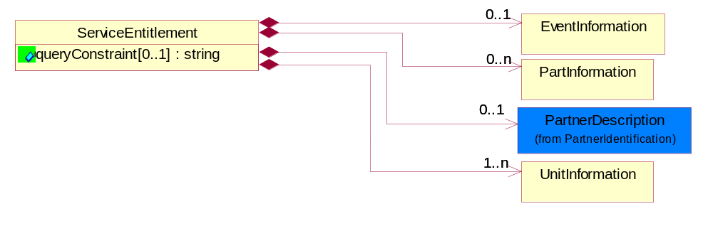
Figure ‎2-5 ServiceEntitlement

Attribute | Type | Documentation
queryConstraint[0..1] | string | An OCL compliant expression that constrains one or more parameters in a query.

Composition | Cardinality | Type | Documentation
PartInformation | 0..n | PartInformation | The collection of part data entities that comprise a request for warranty entitlement on the part to a Warranty Provider.
EventInformation | 0..1 | EventInformation | The collection of business properties that describe the data elements and entities associated with performing repair or maintenance service on a part or unit of product.
PartnerDescription | 0..1 | PartnerDescription | The collection of business properties that describe a business partners' identity, their contact information, where they are physically located and their function in a supply chain.
UnitInformation | 1..n | UnitInformation | The colllection of data entities that comprise a query as to warranty entitlement on a unit of product.

ServiceEntitlementQuery
Message wrapper for PIP6C1 Query.
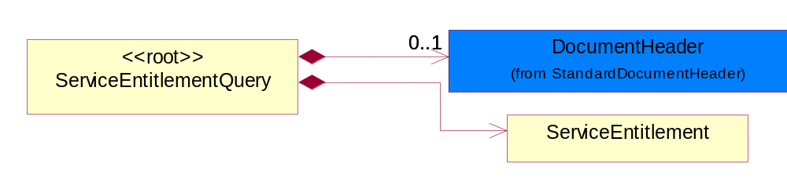
Figure ‎2-6 ServiceEntitlementQuery

Composition | Cardinality | Type | Documentation
DocumentHeader | 0..1 | DocumentHeader | The object allows for the identification of the sender and receiver of the business document.
ServiceEntitlement | 1 | ServiceEntitlement | The collection of data entities that comprise a request for entitlement status to a Warranty Provider.

UnitInformation
The colllection of data entities that comprise a query as to warranty entitlement on a unit of product.
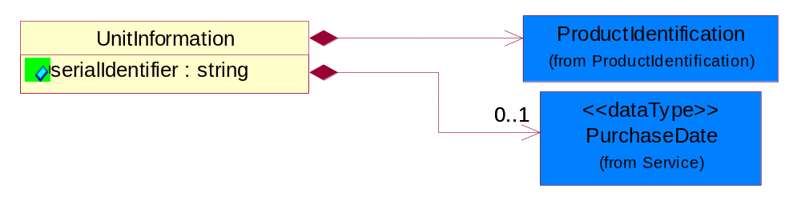
Figure ‎2-7 UnitInformation

Attribute | Type | Documentation
serialIdentifier | string | An internal identifier used to identify a product.

Composition | Cardinality | Type | Documentation
ProductIdentification | 1 | ProductIdentification | The object provides the identifier(s) of a product.
PurchaseDate | 0..1 | PurchaseDate | Date of purchase of a unit.

Domain Model

Service

Dependency Diagram
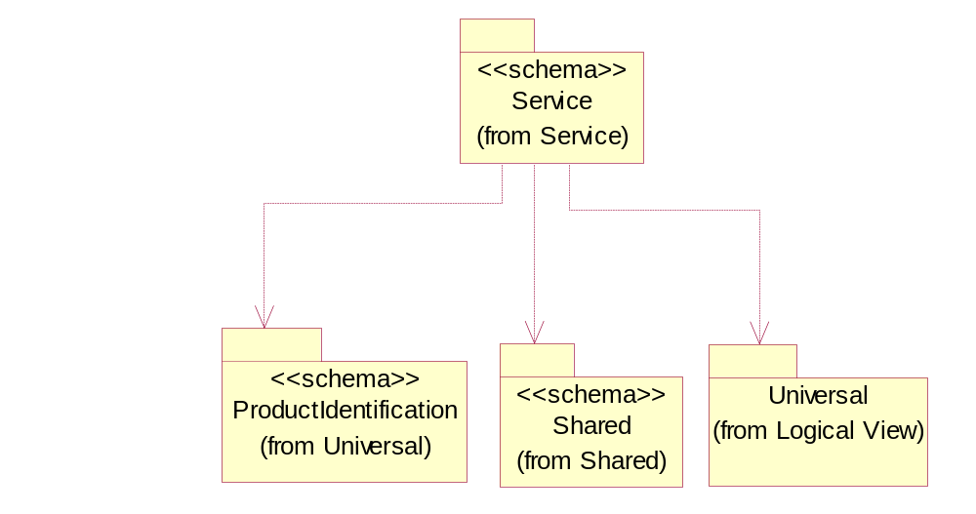
Figure ‎3-8 Dependency

PurchaseDate
Date of purchase of a unit.
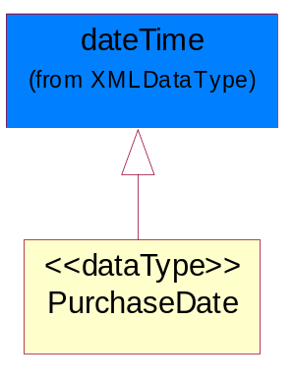
Figure ‎3-9 PurchaseDate

CodeList

ServiceDeliveryMethod
The service delivery method recommended by the OEM to deliver the warranty entitlement on a unit.

Name | Documentation
AON | Adjustment Only - The service event requires an adjustment to the unit or part, no parts are being replaced.
CAR | Carry-In - The service will be performed at an authorized service location.
FAC | Facilitation - Authorized Service Provider sends the unit back to the Original Equipment Manufacturer for repair and receives a facilitation fee.
FUP | Firmware Upgrade - The service event requires a firmware upgrade, no parts are being replaced.
ONS | Onsite - The service will be performed at the customer's location.
PFI | Phone Fix - The service will be performed over the telephone.
TCO | Technical Courier - A technicial courier will perform the service.
URP | URP1-NR - User Replaceable Part, Non-Returnable (disposable.)
URQ | URP1-R-C - User Replaceable Part - Repairable-Centralized.
URR | URP1-R-DC - User Replaceable Part - Repairable-Decentralized.
URS | URP2-NR-C - User Replaceable Part - Astute User - Non-Returnable - Centralized.
URT | URP2-NR-DC - User Replaceable Part - Astute User - Non-Returnable - Decentralized.
URU | URP2-R-C - User Replaceable Part - Astute User - Returnable - Centralized.
URV | URP2-R-DC - User Replaceable Part - Astute User - Returnable - Decentralized.

WarrantyProgram
The program used when verifying service entitlement.

Name | Documentation
DMA | DOA Machine.
SPW | Spare Part Warranty.
SWA | Standard Warranty.

Universal Structure

ContactInformation

ContactInformation
The business document must allow for the identification of the name of the department, service or individual to be contacted regarding the context of the business document.
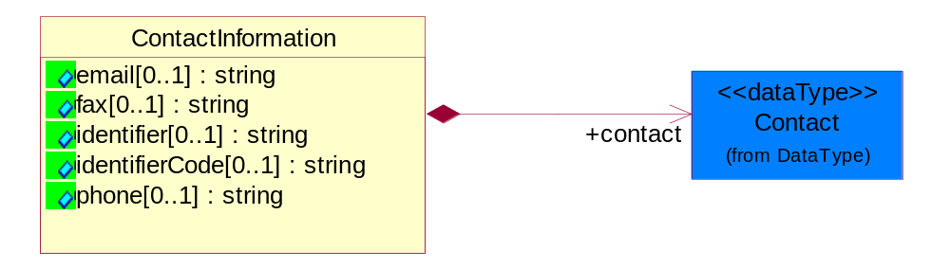
Figure ‎4-10 ContactInformation

Attribute | Type | Documentation
email[0..1] | string | The electronic mail for the specified contact.
fax[0..1] | string | The fax number for the specified contact.
identifier[0..1] | string | Identifies the role of the contact (i.e. Service Technician, Account Manager) in the Business Process.
identifierCode[0..1] | string | IdentifierCode is a unique security authorization code to identify the contact- ie. badge ID.
phone[0..1] | string | The telephone number for the specified contact.

Composition | Cardinality | Type | Documentation
contact | 1 | Contact | The name of the department, service or individual to be contacted within the organization.

DataType

Contact
The name of the department, service or individual to be contacted within the organization.
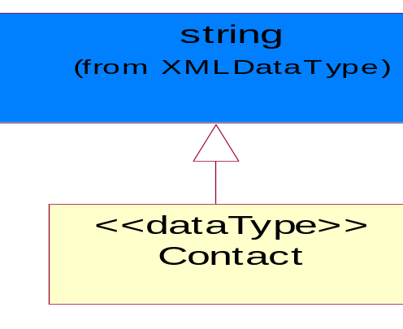
Figure ‎4-11 Contact

DUNS
A number assigned by Dun and Bradstreet to identify a business location.
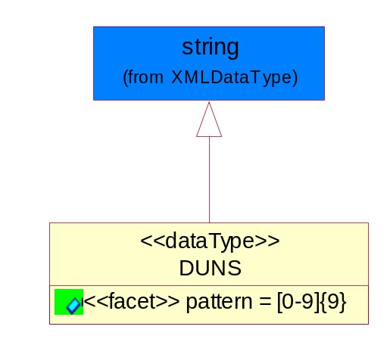
Figure ‎4-12 DUNS

Attribute | Type | Documentation
pattern |  | [0-9]{9}

DUNSPlus4
A identifier to specify a specific location within a business location.
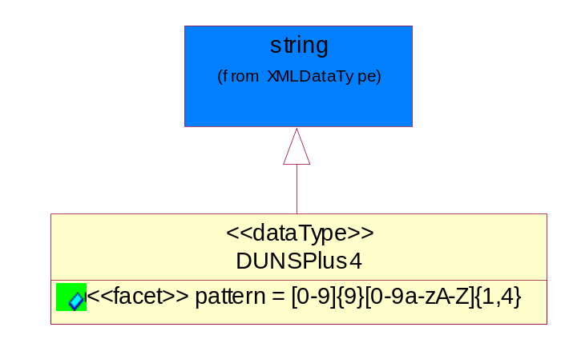
Figure ‎4-13 DUNSPlus4

Attribute | Type | Documentation
pattern |  | Data Universal Numbering System +4 (DUNS+4) number means the DUNS number assigned by Dun and Bradstreet, Inc. (D&B) plus an alphanumeric of length 4 suffix that may be assigned by a business concern.

GLN
Global Location Number (GLN) - A identifier to identify legal entities, trading parties and location.
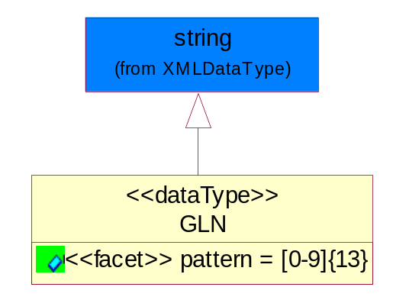
Figure ‎4-14 GLN

Attribute | Type | Documentation
pattern |  | [0-9]{13}

GTIN
Global Trade Identification Number (GTIN).
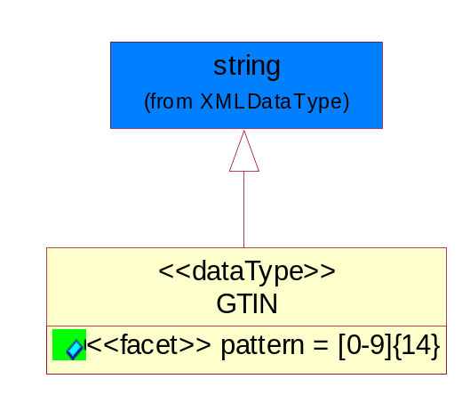
Figure ‎4-15 GTIN

Attribute | Type | Documentation
pattern |  | [0-9]{14}

Locations

AlternativeIdentifier
Identifies the specified code and the name of the organization that a code is utilized from.
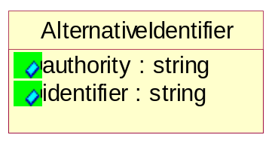
Figure ‎4-16 AlternativeIdentifier

Attribute | Type | Documentation
authority | string | The name of the organization that a code is utilized from.
identifier | string | The specified code to represent an entity (e.g. product, location, partner, etc.).

Location
The business document must specify a location.
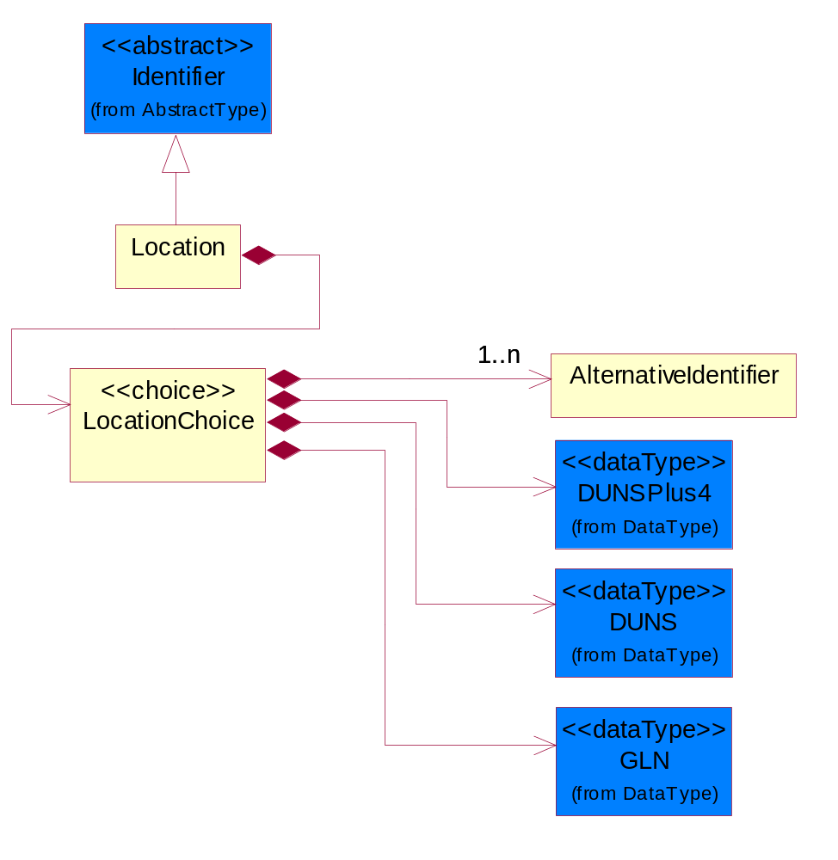
Figure ‎4-17 Location

Composition | Cardinality | Type | Documentation
LocationChoice | 1 | LocationChoice

LocationChoice

Composition | Cardinality | Type | Documentation
DUNSPlus4 | 1 | DUNSPlus4 | A identifier to specify a specific location within a business location.
DUNS | 1 | DUNS | A number assigned by Dun and Bradstreet to identify a business location.
AlternativeIdentifier | 1..n | AlternativeIdentifier | Identifies the specified code and the name of the organization that a code is utilized from.
GLN | 1 | GLN | Global Location Number (GLN) - A identifier to identify legal entities, trading parties and location.

PhysicalAddress
The business document must provide a physical address for a party to the business transaction.
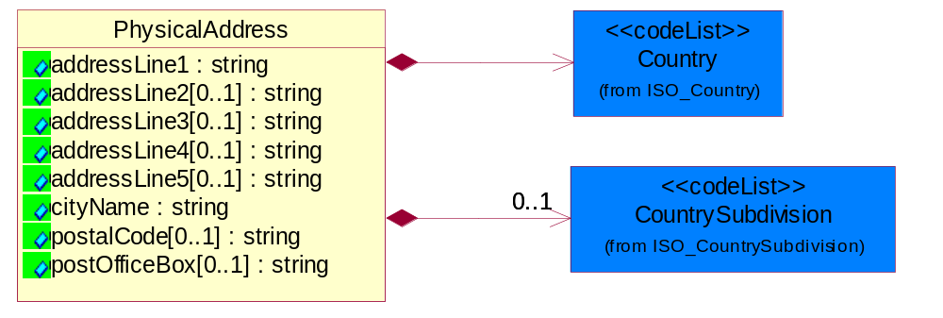
Figure ‎4-18 PhysicalAddress

Attribute | Type | Documentation
addressLine1 | string | The first line of a physical address.
addressLine2[0..1] | string | The second line of a physical address.
addressLine3[0..1] | string | The third line of a physical address.
addressLine4[0..1] | string | The fourth line of a physical address.
addressLine5[0..1] | string | The fifth line of a physical address.
cityName | string | The name of a city.
postalCode[0..1] | string | Identifying geographic location as specified by a national postal code.
postOfficeBox[0..1] | string | The Post Office Box identifier used to identify a party's post office box.

Composition | Cardinality | Type | Documentation
Country | 1 | Country | For representation of Country name RosettaNet has adopted ISO 3166-3; 1999. Refer to the following web page to get the latest version of the standard:  http://www.iso.ch/iso/en/prods-services/iso3166ma/02iso-3166-code-lists/index.html  If you need more information about the ISO standard please contact ISO for more details.
CountrySubdivision | 0..1 | CountrySubdivision | For representation of a Countries subdivisions RosettaNet has adopted ISO 3166-3; 1999. Refer to the following web page to get the latest version of the standard:  http://www.iso.ch/iso/en/prods-services/iso3166ma/02iso-3166-code-lists/index.html  If you need more information about the ISO standard please contact ISO for more details.

PartnerIdentification

FullPartner
The business document must describe the trading partners in the business transaction. This data structure provide the flexibility to describe a partner in all possible methods as for new, existing or known partner.
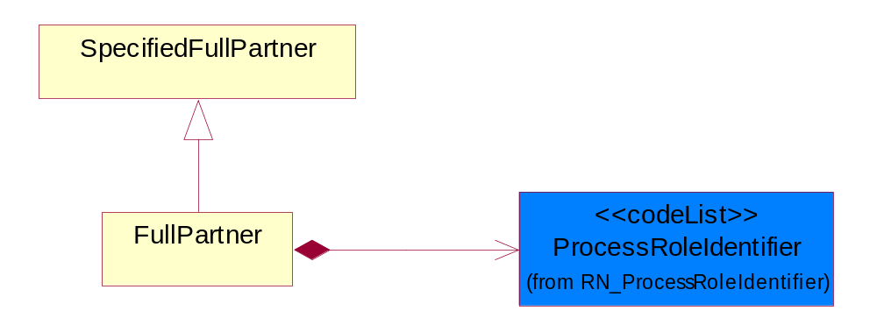
Figure ‎4-19 FullPartner

Composition | Cardinality | Type | Documentation
ProcessRoleIdentifier | 1 | ProcessRoleIdentifier | Describes the role of the partner in the business process. A partner will fulfill at least one or more roles during the business process.

IntermittentPartner
The business document must describe a physical address for a delivery.
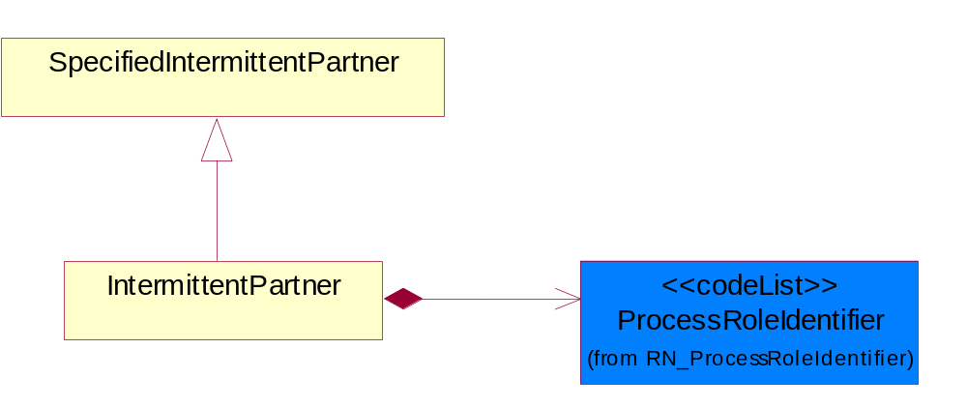
Figure ‎4-20 IntermittentPartner

Composition | Cardinality | Type | Documentation
ProcessRoleIdentifier | 1 | ProcessRoleIdentifier | Describes the role of the partner in the business process. A partner will fulfill at least one or more roles during the business process.

KnownPartner
The business document must describe the trading partners in the business transaction.
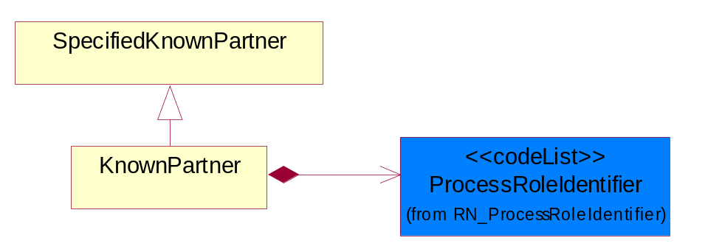
Figure ‎4-21 KnownPartner

Composition | Cardinality | Type | Documentation
ProcessRoleIdentifier | 1 | ProcessRoleIdentifier | Describes the role of the partner in the business process. A partner will fulfill at least one or more roles during the business process.

KnownPartnerContact
The business document must describe the trading partners in the business transaction.
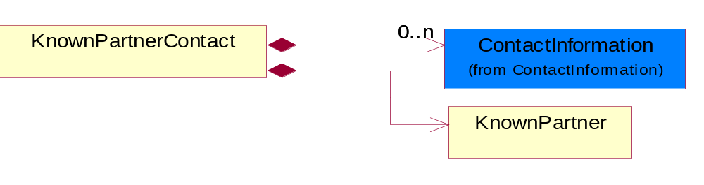
Figure ‎4-22 KnownPartnerContact

Composition | Cardinality | Type | Documentation
KnownPartner | 1 | KnownPartner | The business document must describe the trading partners in the business transaction.
ContactInformation | 0..n | ContactInformation | The business document must allow for the identification of the name of the department, service or individual to be contacted regarding the context of the business document.

NewPartner
The business document must describe a new, existing (but known to only one of the parties to the transaction) or an unknown party to the business transaction.
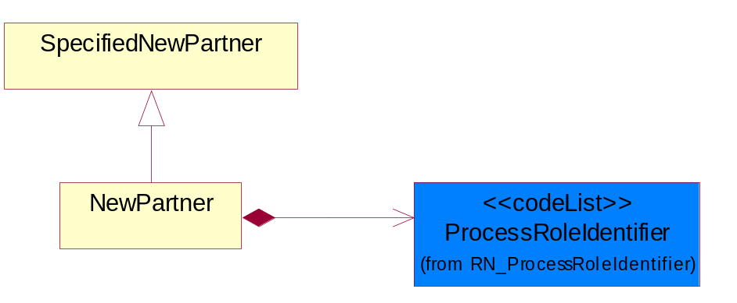
Figure ‎4-23 NewPartner

Composition | Cardinality | Type | Documentation
ProcessRoleIdentifier | 1 | ProcessRoleIdentifier | Describes the role of the partner in the business process. A partner will fulfill at least one or more roles during the business process.

PartnerDescription
The collection of business properties that describe a business partners' identity, their contact information, where they are physically located and their function in a supply chain.
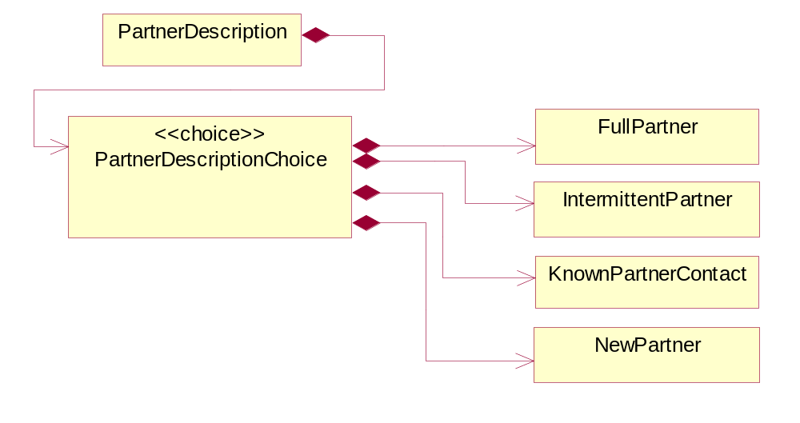
Figure ‎4-24 PartnerDescription

Composition | Cardinality | Type | Documentation
PartnerDescriptionChoice | 1 | PartnerDescriptionChoice

PartnerDescriptionChoice

Composition | Cardinality | Type | Documentation
KnownPartnerContact | 1 | KnownPartnerContact | The business document must describe the trading partners in the business transaction.
IntermittentPartner | 1 | IntermittentPartner | The business document must describe a physical address for a delivery.
NewPartner | 1 | NewPartner | The business document must describe a new, existing (but known to only one of the parties to the transaction) or an unknown party to the business transaction.
FullPartner | 1 | FullPartner | The business document must describe the trading partners in the business transaction. This data structure provide the flexibility to describe a partner in all possible methods as for new, existing or known partner.

PartnerIdentification
The business document must allow for the identity of one or more parties to the transaction.
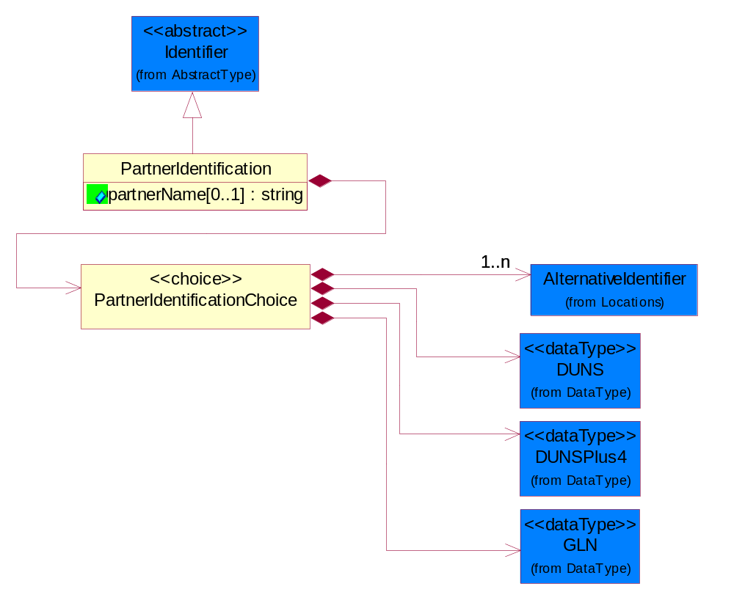
Figure ‎4-25 PartnerIdentification

Attribute | Type | Documentation
partnerName[0..1] | string | The name of the partner’s company/business.

Composition | Cardinality | Type | Documentation
PartnerIdentificationChoice | 1 | PartnerIdentificationChoice

PartnerIdentificationChoice

Composition | Cardinality | Type | Documentation
DUNS | 1 | DUNS | A number assigned by Dun and Bradstreet to identify a business location.
DUNSPlus4 | 1 | DUNSPlus4 | A identifier to specify a specific location within a business location.
AlternativeIdentifier | 1..n | AlternativeIdentifier | Identifies the specified code and the name of the organization that a code is utilized from.
GLN | 1 | GLN | Global Location Number (GLN) - A identifier to identify legal entities, trading parties and location.

SpecifiedFullPartner
The business document must describe the trading partners in the business transaction. This data structure provide the flexibility to describe a partner in all possible methods as for new, existing or known partner. This is specifically for partner who role has been specified.
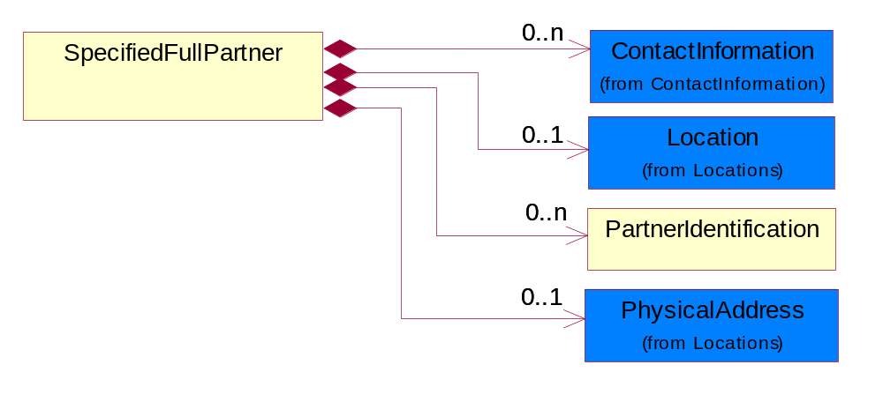
Figure ‎4-26 SpecifiedFullPartner

Composition | Cardinality | Type | Documentation
ContactInformation | 0..n | ContactInformation | The business document must allow for the identification of the name of the department, service or individual to be contacted regarding the context of the business document.
Location | 0..1 | Location | The business document must specify a location.
PartnerIdentification | 0..n | PartnerIdentification | The business document must allow for the identity of one or more parties to the transaction.
PhysicalAddress | 0..1 | PhysicalAddress | The business document must provide a physical address for a party to the business transaction.

SpecifiedIntermittentPartner
The business document must describe a physical address for a delivery.
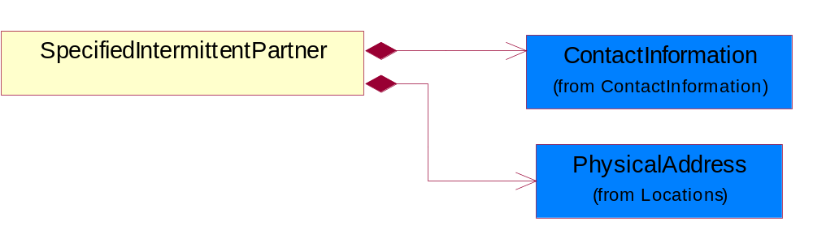
Figure ‎4-27 SpecifiedIntermittentPartner

Composition | Cardinality | Type | Documentation
ContactInformation | 1 | ContactInformation | The business document must allow for the identification of the name of the department, service or individual to be contacted regarding the context of the business document.
PhysicalAddress | 1 | PhysicalAddress | The business document must provide a physical address for a party to the business transaction.

SpecifiedKnownPartner
The business document must describe the trading partners in the business transaction.
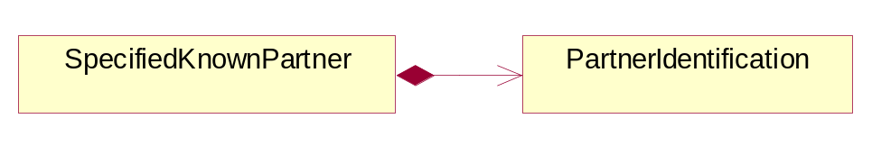
Figure ‎4-28 SpecifiedKnownPartner

Composition | Cardinality | Type | Documentation
PartnerIdentification | 1 | PartnerIdentification | The business document must allow for the identity of one or more parties to the transaction.

SpecifiedNewPartner
The business document must describe a new, existing (but known to only one of the parties to the transaction) or an unknown party to the business transaction.
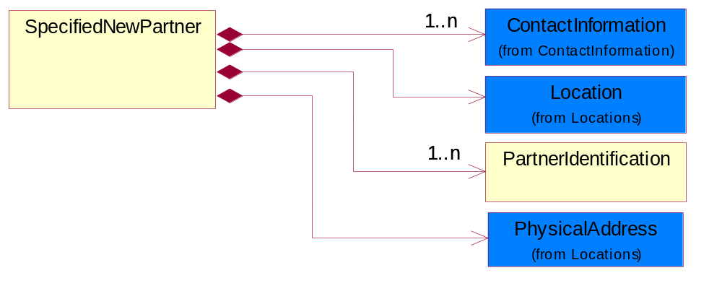
Figure ‎4-29 SpecifiedNewPartner

Composition | Cardinality | Type | Documentation
ContactInformation | 1..n | ContactInformation | The business document must allow for the identification of the name of the department, service or individual to be contacted regarding the context of the business document.
Location | 1 | Location | The business document must specify a location.
PhysicalAddress | 1 | PhysicalAddress | The business document must provide a physical address for a party to the business transaction.
PartnerIdentification | 1..n | PartnerIdentification | The business document must allow for the identity of one or more parties to the transaction.

ProductIdentification

ProductIdentification
The object provides the identifier(s) of a product.
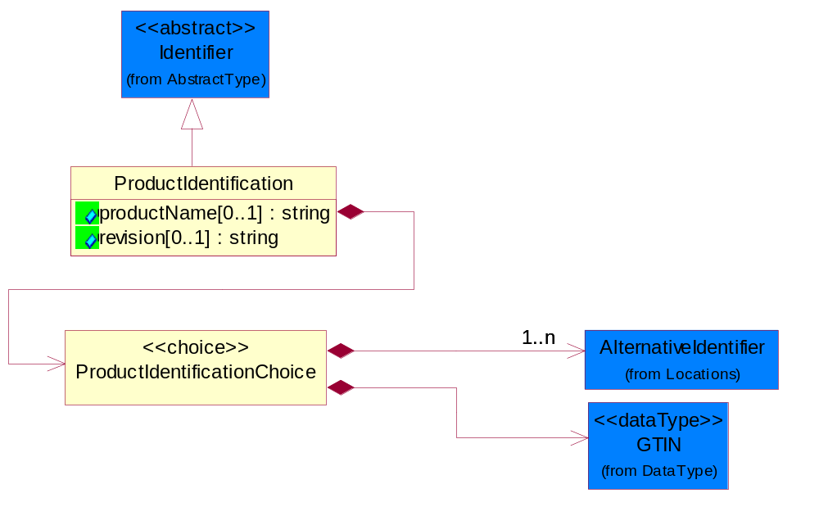
Figure ‎4-30 ProductIdentification

Attribute | Type | Documentation
productName[0..1] | string | The name of the product.
revision[0..1] | string | Referenced the specified product revision.

Composition | Cardinality | Type | Documentation
ProductIdentificationChoice | 1 | ProductIdentificationChoice

ProductIdentificationChoice

Composition | Cardinality | Type | Documentation
AlternativeIdentifier | 1..n | AlternativeIdentifier | Identifies the specified code and the name of the organization that a code is utilized from.
GTIN | 1 | GTIN | Global Trade Identification Number (GTIN).

CodeList

Country
For representation of Country name RosettaNet has adopted ISO 3166-3; 1999. Refer to the following web page to get the latest version of the standard:
http://www.iso.ch/iso/en/prods-services/iso3166ma/02iso-3166-code-lists/index.html

If you need more information about the ISO standard please contact ISO for more details.

CountrySubdivision
For representation of a Countries subdivisions RosettaNet has adopted ISO 3166-3; 1999. Refer to the following web page to get the latest version of the standard:
http://www.iso.ch/iso/en/prods-services/iso3166ma/02iso-3166-code-lists/index.html

If you need more information about the ISO standard please contact ISO for more details.

Language
For representation of Language name RosettaNet has adopted ISO 639-2; 1998. Refer to the following web page to get the latest version of the standard:

http://www.loc.gov/standards/iso639-2/iso639jac.html

If you need more information about the ISO standard please contact ISO for more details.

MimeTypeQualifier
The MIME type as defined by IANA.

Please refer to http://www.iana.org/assignments/media-types/ for a list of types.

Instance | Documentation
application/activemessage | [Shapiro]
application/andrew-inset | [Borenstein]
application/applefile | [Faltstrom]
application/atomicmail | [Borenstein]
application/batch-SMTP | [RFC2442]
application/beep+xml | [RFC3080]
application/cals-1840 | [RFC1895]
application/cnrp+xml | [RFCCNRP]
application/commonground | [Glazer]
application/cpl+xml
application/cybercash | [Eastlake]
application/dca-rft | [Campbell]
application/dec-dx | [Campbell]
application/dicom | [RFC3240]
application/dvcs | [RFC3029]
application/EDI-Consent | [RFC1767]
application/EDIFACT | [RFC1767]
application/EDI-X12 | [RFC1767]
application/eshop | [Katz]
application/font-tdpfr | [RFC3073]
application/http | [RFC2616]
application/hyperstudio | [Domino]
application/iges | [Parks]
application/index | [RFC2652]
application/index.cmd | [RFC2652]
application/index.obj | [RFC2652]
application/index.response | [RFC2652]
application/index.vnd | [RFC2652]
application/iotp | [RFC2935]
application/ipp | [RFC2910]
application/isup | [RFC3204]
application/mac-binhex40 | [Faltstrom]
application/macwriteii | [Lindner]
application/marc | [RFC2220]
application/mathematica | [Van Nostern]
application/msword | [Lindner]
application/news-message-id | [RFC1036,Spencer]
application/news-transmission | [RFC1036, Spencer]
application/ocsp-request | [RFC2560]
application/ocsp-response | [RFC2560]
application/octet-stream | [RFC2045,RFC2046]
application/oda | [RFC2045,RFC2046]
application/ogg | [RFC-walleij-ogg-mediatype-08.txt]
application/parityfec | [RFC3009]
application/pdf | [Lindner]
application/pgp-encrypted | [RFC3156]
application/pgp-keys | [RFC3156]
application/pgp-signature | [RFC3156]
application/pkcs10 | [RFC2311]
application/pkcs7-mime | [RFC2311]
application/pkcs7-signature | [RFC2311]
application/pkix-cert | [RFC2585]
application/pkixcmp | [RFC2510]
application/pkix-crl | [RFC2585]
application/postscript | [RFC2045,RFC2046]
application/prs.alvestrand.titrax-sheet | [Alvestrand]
application/prs.cww | [Rungchavalnont]
application/prs.nprend | [Doggett]
application/prs.plucker | [Janssen]
application/qsig | [RFC3204]
application/reginfo+xml | [RFC-ietf-sipping-reg-event-00.txt]
application/remote-printing | [RFC1486,Rose]
application/riscos | [Smith]
application/rtf | [Lindner]
application/sdp | [RFC2327]
application/set-payment | [Korver]
application/set-payment-initiation | [Korver]
application/set-registration | [Korver]
application/set-registration-initiation | [Korver]
application/sgml | [RFC1874]
application/sgml-open-catalog | [Grosso]
application/sieve | [RFC3028]
application/slate | [Crowley]
application/timestamp-query | [RFC3161]
application/timestamp-reply | [RFC3161]
application/tve-trigger | [Welsh]
application/vemmi | [RFC2122]
application/vnd.3gpp.pic-bw-large | [Meredith]
application/vnd.3gpp.pic-bw-small | [Meredith]
application/vnd.3gpp.pic-bw-var | [Meredith]
application/vnd.3gpp.sms | [Meredith]
application/vnd.3M.Post-it-Notes | [O'Brien]
application/vnd.accpac.simply.aso | [Leow]
application/vnd.accpac.simply.imp | [Leow]
application/vnd.acucobol | [Lubin]
application/vnd.acucorp | [Lubin]
application/vnd.adobe.xfdf | [Perelman]
application/vnd.aether.imp | [Moskowitz]
application/vnd.amiga.ami | [Blumberg]
application/vnd.anser-web-certificate-issue-initiation | [Mori]
application/vnd.anser-web-funds-transfer-initiation | [Mori]
application/vnd.audiograph | [Slusanschi]
application/vnd.blueice.multipass | [Holmstrom]
application/vnd.bmi | [Gotoh]
application/vnd.businessobjects | [Imoucha]
application/vnd.canon-cpdl | [Muto]
application/vnd.canon-lips | [Muto]
application/vnd.cinderella | [Kortenkamp]
application/vnd.claymore | [Simpson]
application/vnd.commerce-battelle | [Applebaum]
application/vnd.commonspace | [Chandhok]
application/vnd.contact.cmsg | [Patz]
application/vnd.cosmocaller | [Dellutri]
application/vnd.ctc-posml | [Kohlhepp]
application/vnd.cups-postscript | [Sweet]
application/vnd.cups-raster | [Sweet]
application/vnd.cups-raw | [Sweet]
application/vnd.curl | [Byrnes]
application/vnd.cybank | [Helmee]
application/vnd.data-vision.rdz | [Fields]
application/vnd.dna | [Searcy]
application/vnd.dpgraph | [Parker]
application/vnd.dreamfactory | [Appleton]
application/vnd.dxr | [Duffy]
application/vnd.ecdis-update | [Buettgenbach]
application/vnd.ecowin.chart | [Olsson]
application/vnd.ecowin.filerequest | [Olsson]
application/vnd.ecowin.fileupdate | [Olsson]
application/vnd.ecowin.series | [Olsson]
application/vnd.ecowin.seriesrequest | [Olsson]
application/vnd.ecowin.seriesupdate | [Olsson]
application/vnd.enliven | [Santinelli]
application/vnd.epson.esf | [Hoshina]
application/vnd.epson.msf | [Hoshina]
application/vnd.epson.quickanime | [Gu]
application/vnd.epson.salt | [Nagatomo]
application/vnd.epson.ssf | [Hoshina]
application/vnd.ericsson.quickcall | [Tidwell]
application/vnd.eudora.data | [Resnick]
application/vnd.fdf | [Zilles]
application/vnd.ffsns | [Holstage]
application/vnd.FloGraphIt | [Floersch]
application/vnd.framemaker | [Wexler]
application/vnd.fsc.weblaunch | [D.Smith]
application/vnd.fujitsu.oasys | [Togashi]
application/vnd.fujitsu.oasys2 | [Togashi]
application/vnd.fujitsu.oasys3 | [Okudaira]
application/vnd.fujitsu.oasysgp | [Sugimoto]
application/vnd.fujitsu.oasysprs | [Ogita]
application/vnd.fujixerox.ddd | [Onda]
application/vnd.fujixerox.docuworks | [Taguchi]
application/vnd.fujixerox.docuworks.binder | [Matsumoto]
application/vnd.fut-misnet | [Pruulmann]
application/vnd.grafeq | [Tupper]
application/vnd.groove-account | [Joseph]
application/vnd.groove-help | [Joseph]
application/vnd.groove-identity-message | [Joseph]
application/vnd.groove-injector | [Joseph]
application/vnd.groove-tool-message | [Joseph]
application/vnd.groove-tool-template | [Joseph]
application/vnd.groove-vcard | [Joseph]
application/vnd.hbci | [Hammann]
application/vnd.hhe.lesson-player | [Jones]
application/vnd.hp-HPGL | [Pentecost]
application/vnd.hp-hpid | [Gupta]
application/vnd.hp-hps | [Aubrey]
application/vnd.hp-PCL | [Pentecost]
application/vnd.hp-PCLXL | [Pentecost]
application/vnd.httphone | [Lefevre]
application/vnd.hzn-3d-crossword | [Minnis]
application/vnd.ibm.afplinedata | [Buis]
application/vnd.ibm.electronic-media | [Tantlinger]
application/vnd.ibm.MiniPay | [Herzberg]
application/vnd.ibm.modcap | [Hohensee]
application/vnd.ibm.secure-container | [Tantlinger]
application/vnd.informix-visionary | [Gales]
application/vnd.intercon.formnet | [Gurak]
application/vnd.intertrust.digibox | [Tomasello]
application/vnd.intertrust.nncp | [Tomasello]
application/vnd.intu.qbo | [Scratchley]
application/vnd.intu.qfx | [Scratchley]
application/vnd.irepository.package+xml | [Knowles]
application/vnd.is-xpr | [Natarajan]
application/vnd.japannet-directory-service | [Fujii]
application/vnd.japannet-jpnstore-wakeup | [Yoshitake]
application/vnd.japannet-payment-wakeup | [Fujii]
application/vnd.japannet-registration | [Yoshitake]
application/vnd.japannet-registration-wakeup | [Fujii]
application/vnd.japannet-setstore-wakeup | [Yoshitake]
application/vnd.japannet-verification | [Yoshitake]
application/vnd.japannet-verification-wakeup | [Fujii]
application/vnd.jisp | [Deckers]
application/vnd.kde.karbon | [Faure]
application/vnd.kde.kchart | [Faure]
application/vnd.kde.kformula | [Faure]
application/vnd.kde.kivio | [Faure]
application/vnd.kde.kontour | [Faure]
application/vnd.kde.kpresenter | [Faure]
application/vnd.kde.kspread | [Faure]
application/vnd.kde.kword | [Faure]
application/vnd.kenameaapp | [DiGiorgio-Haag]
application/vnd.koan | [Cole]
application/vnd.liberty-request+xml | [McDowell]
application/vnd.llamagraphics.life-balance.desktop | [White]
application/vnd.lotus-1-2-3 | [Wattenberger]
application/vnd.lotus-approach | [Wattenberger]
application/vnd.lotus-freelance | [Wattenberger]
application/vnd.lotus-notes | [Laramie]
application/vnd.lotus-organizer | [Wattenberger]
application/vnd.lotus-screencam | [Wattenberger]
application/vnd.lotus-wordpro | [Wattenberger]
application/vnd.mcd | [Gotoh]
application/vnd.mediastation.cdkey | [Flurry]
application/vnd.meridian-slingshot | [Wedel]
application/vnd.micrografx.flo | [Prevo]
application/vnd.micrografx.igx | [Prevo]
application/vnd.mif | [Wexler]
application/vnd.minisoft-hp3000-save | [Bartram]
application/vnd.mitsubishi.misty-guard.trustweb | [Tanaka]
application/vnd.Mobius.DAF | [Kabayama]
application/vnd.Mobius.DIS | [Kabayama]
application/vnd.Mobius.MBK | [Devasia]
application/vnd.Mobius.MQY | [Devasia]
application/vnd.Mobius.MSL | [Kabayama]
application/vnd.Mobius.PLC | [Kabayama]
application/vnd.Mobius.TXF | [Kabayama]
application/vnd.mophun.application | [Wennerstrom]
application/vnd.mophun.certificate | [Wennerstrom]
application/vnd.motorola.flexsuite | [Patton]
application/vnd.motorola.flexsuite.adsi | [Patton]
application/vnd.motorola.flexsuite.fis | [Patton]
application/vnd.motorola.flexsuite.gotap | [Patton]
application/vnd.motorola.flexsuite.kmr | [Patton]
application/vnd.motorola.flexsuite.ttc | [Patton]
application/vnd.motorola.flexsuite.wem | [Patton]
application/vnd.mozilla.xul+xml | [McDaniel]
application/vnd.ms-artgalry | [Slawson]
application/vnd.ms-asf | [Fleischman]
application/vnd.mseq | [Le Bodic]
application/vnd.ms-excel | [Gill]
application/vnd.msign | [Borcherding]
application/vnd.ms-lrm | [Ledoux]
application/vnd.ms-powerpoint | [Gill]
application/vnd.ms-project | [Gill]
application/vnd.ms-tnef | [Gill]
application/vnd.ms-works | [Gill]
application/vnd.ms-wpl | [Plastina]
application/vnd.musician | [Adams]
application/vnd.music-niff | [Butler]
application/vnd.netfpx | [Mutz]
application/vnd.noblenet-directory | [Solomon]
application/vnd.noblenet-sealer | [Solomon]
application/vnd.noblenet-web | [Solomon]
application/vnd.novadigm.EDM | [Swenson]
application/vnd.novadigm.EDX | [Swenson]
application/vnd.novadigm.EXT | [Swenson]
application/vnd.obn | [Hessling]
application/vnd.osa.netdeploy | [Klos]
application/vnd.palm | [Peacock]
application/vnd.pg.format | [Gandert]
application/vnd.pg.osasli | [Gandert]
application/vnd.powerbuilder6 | [Guy]
application/vnd.powerbuilder6-s | [Guy]
application/vnd.powerbuilder7 | [Shilts]
application/vnd.powerbuilder75 | [Shilts]
application/vnd.powerbuilder75-s | [Shilts]
application/vnd.powerbuilder7-s | [Shilts]
application/vnd.previewsystems.box | [Smolgovsky]
application/vnd.publishare-delta-tree | [Ben-Kiki]
application/vnd.pvi.ptid1 | [Lamb]
application/vnd.pwg-multiplexed | [RFC3391]
application/vnd.pwg-xhtml-print+xml | [Wright]
application/vnd.Quark.QuarkXPress | [Scheidler]
application/vnd.rapid | [Szekely]
application/vnd.s3sms | [Tarkkala]
application/vnd.sealed.net | [Lambert]
application/vnd.seemail | [Webb]
application/vnd.shana.informed.formdata | [Selzler]
application/vnd.shana.informed.formtemplate | [Selzler]
application/vnd.shana.informed.interchange | [Selzler]
application/vnd.shana.informed.package | [Selzler]
application/vnd.smaf | [Takahashi]
application/vnd.sss-cod | [Dani]
application/vnd.sss-dtf | [Bruno]
application/vnd.sss-ntf | [Bruno]
application/vnd.street-stream | [Levitt]
application/vnd.svd | [Becker]
application/vnd.swiftview-ics | [Widener]
application/vnd.triscape.mxs | [Simonoff]
application/vnd.trueapp | [Hepler]
application/vnd.truedoc | [Chase]
application/vnd.ufdl | [Manning]
application/vnd.uplanet.alert | [Martin]
application/vnd.uplanet.alert-wbxml | [Martin]
application/vnd.uplanet.bearer-choice | [Martin]
application/vnd.uplanet.bearer-choice-wbxml | [Martin]
application/vnd.uplanet.cacheop | [Martin]
application/vnd.uplanet.cacheop-wbxml | [Martin]
application/vnd.uplanet.channel | [Martin]
application/vnd.uplanet.channel-wbxml | [Martin]
application/vnd.uplanet.list | [Martin]
application/vnd.uplanet.listcmd | [Martin]
application/vnd.uplanet.listcmd-wbxml | [Martin]
application/vnd.uplanet.list-wbxml | [Martin]
application/vnd.uplanet.signal | [Martin]
application/vnd.vcx | [T.Sugimoto]
application/vnd.vectorworks | [Pharr]
application/vnd.vidsoft.vidconference | [Hess]
application/vnd.visio | [Sandal]
application/vnd.visionary | [Aravindakumar]
application/vnd.vividence.scriptfile | [Risher]
application/vnd.vsf | [Rowe]
application/vnd.wap.sic | [WAP-Forum]
application/vnd.wap.slc | [WAP-Forum]
application/vnd.wap.wbxml | [Stark]
application/vnd.wap.wmlc | [Stark]
application/vnd.wap.wmlscriptc | [Stark]
application/vnd.webturbo | [Rehem]
application/vnd.wrq-hp3000-labelled | [Bartram]
application/vnd.wt.stf | [Wohler]
application/vnd.wv.csp+wbxml | [Salmi]
application/vnd.xara | [Matthewman]
application/vnd.xfdl | [Manning]
application/vnd.yellowriver-custom-menu | [Yellow]
application/whoispp-query | [RFC2957]
application/whoispp-response | [RFC2958]
application/wita | [Campbell]
application/wordperfect5.1 | [Lindner]
application/x400-bp | [RFC1494]
application/xhtml+xml | [RFC3236]
application/xml | [RFC3023]
application/xml-dtd | [RFC3023]
application/xml-external-parsed-entity | [RFC3023]
application/zip | [Lindner]
audio/32kadpcm | [RFC2421,RFC2422]
audio/AMR | [RFC3267]
audio/AMR-WB | [RFC3267]
audio/basic | [RFC2045,RFC2046]
audio/CN | [RFC3389]
audio/DAT12 | [RFC3190]
audio/DVI4
audio/EVRC | [RFC-ietf-avt-evrc-smv-03.txt]
audio/EVRC0 | [RFC-ietf-avt-evrc-smv-03.txt]
audio/G.722.1 | [RFC3047]
audio/G722
audio/G723
audio/G726-16
audio/G726-24
audio/G726-32
audio/G726-40
audio/G728
audio/G729
audio/G729D
audio/G729E
audio/GSM
audio/GSM-EFR
audio/L16 | [RFC2586]
audio/L20 | [RFC3190]
audio/L24 | [RFC3190]
audio/L8
audio/LPC
audio/MP4A-LATM | [RFC3016]
audio/MPA
audio/mpa-robust | [RFC3119]
audio/mpeg | [RFC3003]
audio/parityfec | [RFC3009]
audio/PCMA
audio/PCMU
audio/prs.sid | [Walleij]
audio/QCELP
audio/RED
audio/SMV | [RFC-ietf-avt-evrc-smv-03.txt]
audio/SMV0 | [RFC-ietf-avt-evrc-smv-03.txt]
audio/telephone-event | [RFC2833]
audio/tone | [RFC2833]
audio/VDVI
audio/vnd.3gpp.iufp | [Belling]
audio/vnd.cisco.nse | [Kumar]
audio/vnd.cns.anp1 | [McLaughlin]
audio/vnd.cns.inf1 | [McLaughlin]
audio/vnd.digital-winds | [Strazds]
audio/vnd.everad.plj | [Cicelsky]
audio/vnd.lucent.voice | [Vaudreuil]
audio/vnd.nortel.vbk | [Parsons]
audio/vnd.nuera.ecelp4800 | [Fox]
audio/vnd.nuera.ecelp7470 | [Fox]
audio/vnd.nuera.ecelp9600 | [Fox]
audio/vnd.octel.sbc | [Vaudreuil]
audio/vnd.qcelp | [Lundblade]
audio/vnd.rhetorex.32kadpcm | [Vaudreuil]
audio/vnd.vmx.cvsd | [Vaudreuil]
image/cgm | Computer Graphics Metafile
image/g3fax | [RFC1494]
image/gif | [RFC2045,RFC2046]
image/ief | [RFC1314] Image Exchange Format
image/jpeg | [RFC2045,RFC2046]
image/naplps | [Ferber]
image/png | [Randers-Pehrson]
image/prs.btif | [Simon]
image/prs.pti | [Laun]
image/t38 | [RFC3362]
image/tiff | [RFC3302] Tag Image File Format
image/tiff-fx | [RFC3250] Tag Image File Format Fax eXtended
image/vnd.cns.inf2 | [McLaughlin]
image/vnd.djvu | [Bottou]
image/vnd.dwg | [Moline]
image/vnd.dxf | [Moline]
image/vnd.fastbidsheet | [Becker]
image/vnd.fpx | [Spencer]
image/vnd.fst | [Fuldseth]
image/vnd.fujixerox.edmics-mmr | [Onda]
image/vnd.fujixerox.edmics-rlc | [Onda]
image/vnd.globalgraphics.pgb | [Bailey]
image/vnd.mix | [Reddy]
image/vnd.ms-modi | [Vaughan]
image/vnd.net-fpx | [Spencer]
image/vnd.svf | [Moline]
image/vnd.wap.wbmp | [Stark]
image/vnd.xiff | [S.Martin]
message/delivery-status | [RFC1894]
message/disposition-notification | [RFC2298]
message/external-body | [RFC2045,RFC2046]
message/http | [RFC2616]
message/news | [RFC 1036, H.Spencer]
message/partial | [RFC2045,RFC2046]
message/rfc822 | [RFC2045,RFC2046]
message/s-http | [RFC2660]
message/sip | [RFC3261]
message/sipfrag | [RFC3420]
model/iges | [Parks]
model/mesh | [RFC2077]
model/vnd.dwf | [Pratt]
model/vnd.flatland.3dml | [Powers]
model/vnd.gdl | [Babits]
model/vnd.gs-gdl | [Babits]
model/vnd.gtw | [Ozaki]
model/vnd.mts | [Rabinovitch]
model/vnd.parasolid.transmit.binary | [Parasolid]
model/vnd.parasolid.transmit.text | [Parasolid]
model/vnd.vtu | [Rabinovitch]
model/vrml | [RFC2077]
multipart/alternative | [RFC2045,RFC2046]
multipart/appledouble | [Faltstrom]
multipart/byteranges | [RFC2068]
multipart/digest | [RFC2045,RFC2046]
multipart/encrypted | [RFC1847]
multipart/form-data | [RFC2388]
multipart/header-set | [Crocker]
multipart/mixed | [RFC2045,RFC2046]
multipart/parallel | [RFC2045,RFC2046]
multipart/related | [RFC2387]
multipart/report | [RFC1892]
multipart/signed | [RFC1847]
multipart/voice-message | [RFC2421,RFC2423]
text/calendar | [RFC2445]
text/css | [RFC2318]
text/directory | [RFC2425]
text/enriched | [RFC1896]
text/html | [RFC2854]
text/parityfec | [RFC3009]
text/plain | [RFC2646,RFC2046]
text/prs.lines.tag | [Lines]
text/rfc822-headers | [RFC1892]
text/richtext | [RFC2045,RFC2046]
text/rtf | [Lindner]
text/sgml | [RFC1874]
text/t140 | [RFC2793]
text/tab-separated-values | [Lindner]
text/uri-list | [RFC2483]
text/vnd.abc | [Allen]
text/vnd.curl | [Byrnes]
text/vnd.DMClientScript | [Bradley]
text/vnd.fly | [Gurney]
text/vnd.fmi.flexstor | [Hurtta]
text/vnd.in3d.3dml | [Powers]
text/vnd.in3d.spot | [Powers]
text/vnd.IPTC.NewsML | [IPTC]
text/vnd.IPTC.NITF | [IPTC]
text/vnd.latex-z | [Lubos]
text/vnd.motorola.reflex | [Patton]
text/vnd.ms-mediapackage | [Nelson]
text/vnd.net2phone.commcenter.command | [Xie]
text/vnd.sun.j2me.app-descriptor | [G.Adams]
text/vnd.wap.si | [WAP-Forum]
text/vnd.wap.sl | [WAP-Forum]
text/vnd.wap.wml | [Stark]
text/vnd.wap.wmlscript | [Stark]
text/xml | [RFC3023]
text/xml-external-parsed-entity | [RFC3023]
video/BMPEG
video/BT656
video/CelB
video/DV | [RFC3189]
video/H261
video/H263
video/H263-1998
video/H263-2000
video/JPEG
video/MP1S
video/MP2P
video/MP2T
video/MP4V-ES | [RFC3016]
video/mpeg | [RFC2045,RFC2046]
video/MPV
video/nv
video/parityfec | [RFC3009]
video/pointer | [RFC2862]
video/quicktime | [Lindner]
video/SMPTE292M | [RFC-avt-smpte292-video-08.txt]
video/vnd.fvt | [Fuldseth]
video/vnd.motorola.video | [McGinty]
video/vnd.motorola.videop | [McGinty]
video/vnd.mpegurl | [Recktenwald]
video/vnd.nokia.interleaved-multimedia | [Kangaslampi]
video/vnd.objectvideo | [Clark]
video/vnd.vivo | [Wolfe]

ProcessRoleIdentifier
Describes the role of the partner in the business process. A partner will fulfill at least one or more roles during the business process.

Instance | Documentation
ADM | Administered by - The party who is the administrative authority of an account.
ALT | Alternate approval by - The party who has approved a request in the event the approver is not able to respond.
APP | Approval by - The party who has approved a request.
AUT | Authorized By - The party who has authorized a request.
BIF | Bill from - The party that will issue the invoice.
BIT | Bill to - The party that will pay the invoice.
CBK | Customs Broker - CustomsBroker  This object represents the party that declare the shipment on behalf of declarant.
CLF | Collect From - To enable the buyer to specify the location of where products not supplied directly by the seller/installer may be collected.
CLM | Claimed By - This object represents the claimant.
CNC | Cancellation party - The party who is cancelling the shipping order.
COR | Change originated by - The party who originates a proposed change.
COW | Change owned by - The party who owns or who is assigned responsibility for a proposed change.
CRA | Credit applicant - The party who is applying for credit.
CRE | Created by - The party responsible for creating a process or task.
CSP | Contract Service Provider.
CWN | contractOwner - The party who is the owner of the contract. For example, in the direct business, the buyer is the contract owner. In the distribution business, the buyer is the distributor and the contract owner is the reseller.
DCE | DesignCustomerApplicationEngineer. The demand customer's Field Application Engineer.
DCT | Declared To - This object represents the party that the declaration goes to.
DCU | DesignCustomer. The owner of the product for which the design has been created.
DIS | Distributed by - The party who supplies products to retailers.
DLR | Declared By - This object represents the party that declare the shipment.
DST | Distributed To - This object represents the party to send information to.
FCP | Forecast Partner - The collection of business properties that describes the partner types for a forecast.
FIA | From Install At - The collection of sender business properties that describes a business partners' identity, their contact information, where they are physically located and their function in a supply chain.
FIN | Financed by - The party who is the financier.
FNB | Founded by - The party who performs the act, process, or art of casting metals.
FOR | Forwarded to - The party to whom a business document has been forwarded.
IMB | Imported By - The party responsible for importing the product.
INL | Inventory location - The party where the inventory product entry is located.
INO | Inventory owner - The party that owns the inventory product entry.
ITF | In transit from - The party sending the product quantity in a product location transfer.
ITL | installAt - The partner and/or location to which the product must be set up for use or service.
ITT | In transit to - The party receiving the product quantity in a product location transfer.
LGP | Logistics Provided By - The party who handles the details of an operation.
MFG | Manufactured by - The party who creates, processes or produces goods especially in large quantities and by means of industrial machines.
OWN | Owned by - The party who owns a process.
PAE | ProductProviderFieldApplicationEngineer. The product provider Field Application Engineer.
PCW | Primary Contract With - The primary party with whom a contract is formed.
PNB | Planning By - The party who establishes goals, policies or procedures.
PSR | ProductProviderSalesRepresentative. The product provider sales representative.
PUR | Purchased by - The party who is a purchaser of a product.
REA | Requested approval by - The party who has been selected to approve a request.
REC | Received by - The party who has received a product shipment.
REQ | Requested by - The party who has initiated a request.
RES | Respond to - The party to whom a responding business document must be sent when it is not equal to the partner specified in the document header.
RET | Return by - The party responsible for either carrying or forwarding the returned product.
REV | Reviewed by - The party responsible for reviewing a business document.
RFR | receivedFrom - The partner and/or location from where the product was shipped.
RLS | Released By - This object represents the party that releases the goods.
RMT | remitTo - The partner to which payment for a business document is sent.
RPB | Repaired By - The collection of business properties used to identify the business partner responsible for the repair or  rework of a product.
RQT | Refer Quote To - The partner to whom a quote request is being referred.
RSF | Requested Ship From - The party where the product is requested to be shipped from.
RTT | ReturnTo - The partner and/or location to which the returned product must be delivered.
SBF | Self-billing from - The party who initiates the billing in self-billing scenario.
SBT | Self-billing to - The party whom the invoice is addressed to.
SCB | Subcontracted By - The party who is contracted to perform part or all of another party's contract.
SCP | Shipping charges paid by - The party responsible for administering payment of the shipping charges.
SCW | Secondary Contract With - The subsequent party(ies) with whom a contract is formed.
SHF | Ship From - The collection of business properties used to identify the business partner initiating a shipment or transaction.
SHT | Ship To - The partner and/or location to which the product must be delivered.
SLD | Sold to - The party to whom a product has been sold.
SOB | Sold By - The seller involved in a business transaction.
SPL | Supplied by - The party who supplies an item, part or assembly.
SPS | Service Provider Site - Identification for the location of the ASP site that is ordering the replacement parts and/or performing the repair.
SRT | Submit returns to - The party to whom product returns are to be submitted.
STR | Stored By - This object represents the party that stores the goods.
SVA | ShipVia - The partner and/or location through which the product must be shipped, such as the "cross dock" at a shipping hub.  It must not be specified for the last leg, since this would be the same as the final destination specified in the ShipmentInformation/shipTo.
TFR | Transfer From - The party responsible for making the payment (Payer).
TIA | To lnstall At - The collection of receiver business properties that describes business partners' identity, their contact information, where they are physically located and their function in a supply chain.
TMT | Transfer Manufacturing To - The movement of the manufacturing process to another site.
TRA | Transported by - The party responsible for either carrying or forwarding the product.
TSB | Tested By - The collection of business properties used to identify the specific location and resources used to conduct a defined cycle or steps or measurements required to confirm a result or event.
TTR | Transfer To - The party who is receiving the payment (payee).
ULR | Ultimate recipient - The party who ultimately receives the shipment, when an intermediate party takes responsibility for payment and final delivery.
USE | Used by - The party who is the end user of the product.
UST | Unstuffed By - This object represents the party that unstuffs the goods.
WHB | Warehoused By - The party who stocks or stores products.

System Structure

BusinessProcessIdentifier
A Business Process Identifier to uniquely define the TPIR-PIP 'role' within a Business Scenario at a company or MNC level. The identifier MUST be composed of alphanumeric characters only and its length MUST be between one and twelve characters.
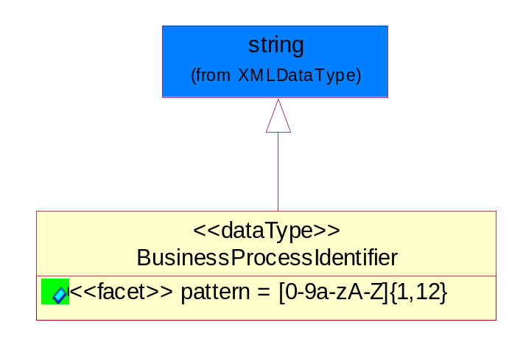
Figure ‎5-31 BusinessProcessIdentifier

Attribute | Type | Documentation
pattern |  | [0-9a-zA-Z]{1,12}

BusinessServiceInformation
The object allows the specification of the business service utilized within the partner company. This may or may not be the same as the information sent by the RNIF.
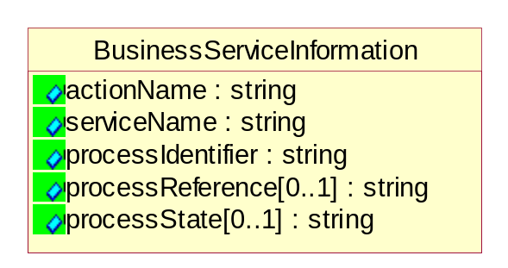
Figure ‎5-32 BusinessServiceInformation

Attribute | Type | Documentation
actionName | string | The name of Action. For RosettaNet usually any of Request/Confirm/Notify/Query/Response.
serviceName | string | The name of the Business Activity with the "Request/Confirm" part removed. E.g., for the Activity "Request Purchase Order"==> "Purchase Order".
processIdentifier | string | The name of the PIP e.g. Notify of Forecast Reply.
processReference[0..1] | string | The URN for the PIP that includes Cluster/Segment/Process pattern used to identify the interface process (such as PIP3A4)
processState[0..1] | string | The business process (or service) state of the sender of a document. When a service receives this document, the receiver may use the state as a precondition.

ContractInformation
A block of information used to correlate a contract in an executing choreography.

Figure ‎5-33 ContractInformation

Attribute | Type | Documentation
contractIdentifier[0..1] | string | Unique identification of a contract between the Sender and the Receiver
contractType[0..1] | string | The type of the contract: an attribute describing the type of the ContractIndentification. Valid values are URI, URN,ebXMLCPA, or other values defined by partners.

CorrelationInformation
A block of information used to correlate a requesting document to a responding document and to the contract in an executing choreography.
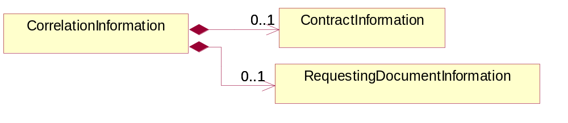
Figure ‎5-34 CorrelationInformation

Composition | Cardinality | Type | Documentation
ContractInformation | 0..1 | ContractInformation | A block of information used to correlate a contract in an executing choreography.
RequestingDocumentInformation | 0..1 | RequestingDocumentInformation | A block of information used to correlate a requesting document to a responding document in an executing choreography.

DocumentHeader
The object allows for the identification of the sender and receiver of the business document.
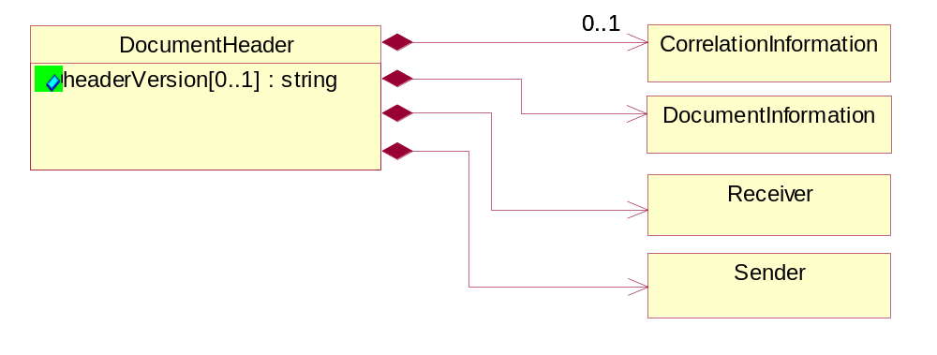
Figure ‎5-35 DocumentHeader

Attribute | Type | Documentation
headerVersion[0..1] | string | The UN/CEFACT version of the document header.

Composition | Cardinality | Type | Documentation
Sender | 1 | Sender | The object allows the identification of the initiating party of the business message.
CorrelationInformation | 0..1 | CorrelationInformation | A block of information used to correlate a requesting document to a responding document and to the contract in an executing choreography.
DocumentInformation | 1 | DocumentInformation | The object specifies information to identify the business document, a summary of attachments, and information about the business document security.
Receiver | 1 | Receiver | The object allows the identification of the receiving party of the business message.

DocumentIdentification
The object specifies all information necessary to identify the business document.
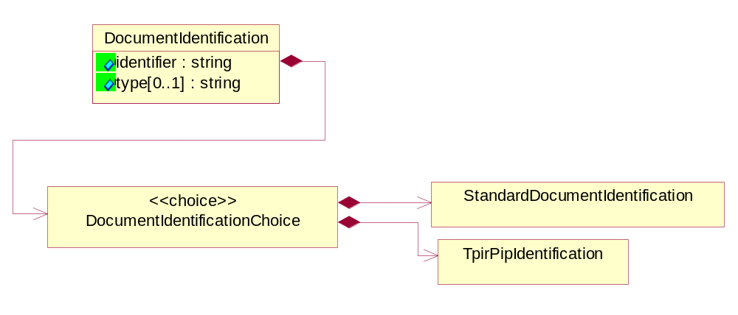
Figure ‎5-36 DocumentIdentification

Attribute | Type | Documentation
identifier | string | The unique identifier for the document being sent.
type[0..1] | string | Name of the Action Message

Composition | Cardinality | Type | Documentation
DocumentIdentificationChoice | 1 | DocumentIdentificationChoice

DocumentIdentificationChoice

Composition | Cardinality | Type | Documentation
StandardDocumentIdentification | 1 | StandardDocumentIdentification | The object specifies additional information necessary to identify the standard business document.
TpirPipIdentification | 1 | TpirPipIdentification | The object specifies all information necessary to uniquely identify a TPIR-PIP within a Registry or trading partner repository.

DocumentInformation
The object specifies information to identify the business document, a summary of attachments, and information about the business document security.
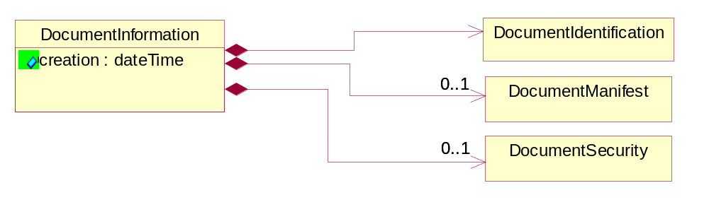
Figure ‎5-37 DocumentInformation

Attribute | Type | Documentation
creation | dateTime | The creation date and time of the specified Business Document (i.e. the Purchase Order date).

Composition | Cardinality | Type | Documentation
DocumentIdentification | 1 | DocumentIdentification | The object specifies all information necessary to identify the business document.
DocumentSecurity | 0..1 | DocumentSecurity | The object provides additional granularity in specifying business document security (this is in addition to the specified PIP security).
DocumentManifest | 0..1 | DocumentManifest | The block provides a brief summary of attachments and Service Content.

DocumentManifest
The block provides a brief summary of attachments and Service Content.
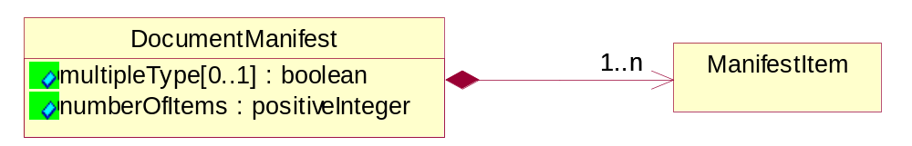
Figure ‎5-38 DocumentManifest

Attribute | Type | Documentation
multipleType[0..1] | boolean | Indicates whether the manifest contains documents of multiple types. True if yes, and False if no.
numberOfItems | positiveInteger | Total number of documents in the message. The physical count of the attachments in the payload plus the RosettaNet Business Message (for Service Content). The value of this field will be at least 1.

Composition | Cardinality | Type | Documentation
ManifestItem | 1..n | ManifestItem | The object provides details about the specific attachment(s).

DocumentSecurity
The object provides additional granularity in specifying business document security (this is in addition to the specified PIP security).

Figure ‎5-39 DocumentSecurity

Attribute | Type | Documentation
nonRepudiableReceipt | boolean | The value "true" will indicate that a signed acknowledgement for the business document is necessary.
persistentEncryption | boolean | The value "true" will indicate that the Business Document (including the header) needs to be encrypted when stored or transported.
persistentSignature | boolean | The value "true" will indicate that a signature is required to be stored with the document while stored or transported.

ManifestItem
The object provides details about the specific attachment(s).

Figure ‎5-40 ManifestItem

Attribute | Type | Documentation
description[0..1] | string | A description of the attachment.
length[0..1] | positiveInteger | The size of the attachment in bytes (i.e. 1 000 000 bytes)
universalResourceIdentifier | string | The generic set of all names/addresses that are short strings that refer to resources.

Composition | Cardinality | Type | Documentation
mimeTypeQualifier | 1 | MimeTypeQualifier | The MIME type as defined by IANA.  Please refer to http://www.iana.org/assignments/media-types/ for a list of types.
language | 0..1 | Language | For representation of Language name RosettaNet has adopted ISO 639-2; 1998. Refer to the following web page to get the latest version of the standard:  http://www.loc.gov/standards/iso639-2/iso639jac.html  If you need more information about the ISO standard please contact ISO for more details.

PipIdentifier
PIP Identification.[ i.e. PIP3A4]
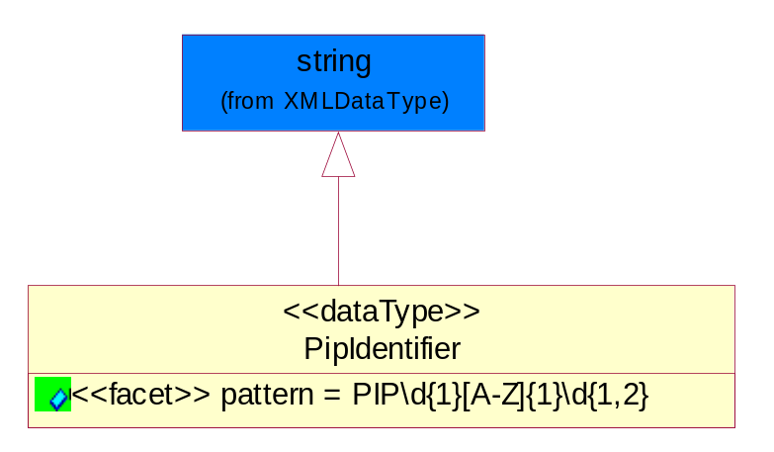
Figure ‎5-41 PipIdentifier

Attribute | Type | Documentation
pattern |  | PIP\d{1}[A-Z]{1}\d{1,2}

PipVersion
PIP version number (i.e. 02.02.00).
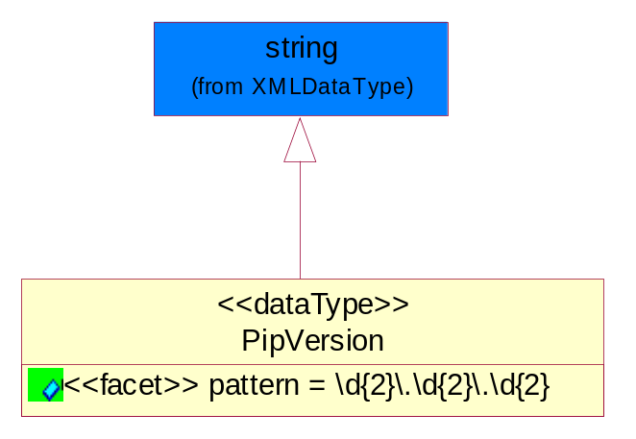
Figure ‎5-42 PipVersion

Attribute | Type | Documentation
pattern |  | \d{2}\.\d{2}\.\d{2}

Receiver
The object allows the identification of the receiving party of the business message.
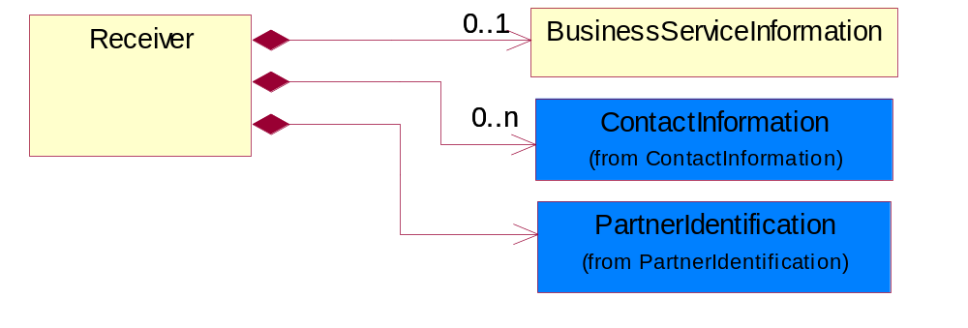
Figure ‎5-43 Receiver

Composition | Cardinality | Type | Documentation
BusinessServiceInformation | 0..1 | BusinessServiceInformation | The object allows the specification of the business service utilized within the partner company. This may or may not be the same as the information sent by the RNIF.
PartnerIdentification | 1 | PartnerIdentification | The business document must allow for the identity of one or more parties to the transaction.
ContactInformation | 0..n | ContactInformation | The business document must allow for the identification of the name of the department, service or individual to be contacted regarding the context of the business document.

RequestingDocumentInformation
A block of information used to correlate a requesting document to a responding document in an executing choreography.

Figure ‎5-44 RequestingDocumentInformation

Attribute | Type | Documentation
businessProcessInstanceIdentifier[0..1] | string | The identifier for the public business process instance being sent that both the sender and receiver can identify.
responseDateTime[0..1] | dateTime | The expected time to receive the response. This can not be greater than the PIP TimeToPerform.
requestingDocumentCreationDateTime[0..1] | dateTime | The date-time of the requesting business document.
requestingDocumentInstanceIdentifier | string | The Business Document identification number that identifies the requesting Business Document.

Sender
The object allows the identification of the initiating party of the business message.
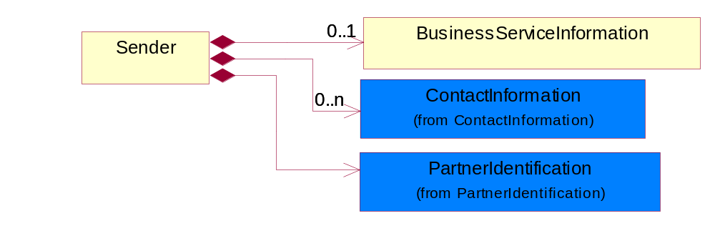
Figure ‎5-45 Sender

Composition | Cardinality | Type | Documentation
PartnerIdentification | 1 | PartnerIdentification | The business document must allow for the identity of one or more parties to the transaction.
BusinessServiceInformation | 0..1 | BusinessServiceInformation | The object allows the specification of the business service utilized within the partner company. This may or may not be the same as the information sent by the RNIF.
ContactInformation | 0..n | ContactInformation | The business document must allow for the identification of the name of the department, service or individual to be contacted regarding the context of the business document.

StandardDocumentIdentification
The object specifies additional information necessary to identify the standard business document.
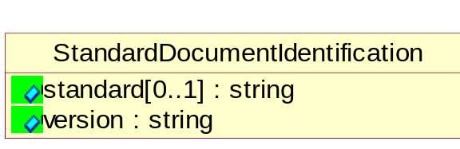
Figure ‎5-46 StandardDocumentIdentification

Attribute | Type | Documentation
standard[0..1] | string | Identifies the standard used to submit the business document. (e.g. RosettaNet).
version | string | PIP3A4v01.00

TpirPipIdentification
The object specifies all information necessary to uniquely identify a TPIR-PIP within a Registry or trading partner repository.

Figure ‎5-47 TpirPipIdentification

Attribute | Type | Documentation
partnerId | DUNSPlus4 | The Trading Partner Identification of MNC that is creating this TPIR PIP.
pipIdentifier | PipIdentifier | A TPIR PIP Identification [i.e., 3A4 ).
pipVersion | PipVersion | A TPIR PIP version number (i.e., 02.02.00)
tpirPipVersion | VersionIdentifier | A TPIR-PIP Version Number (i.e., major and minor version number as XX.XX).
tpirBusinessProcessIdentifier[0..1] | BusinessProcessIdentifier | A Business Process Identifier to uniquely define the TPIR-PIP 'role' within a Business Scenario at a company or MNC level. The identifier MUST be composed of alphanumeric characters only and its length MUST be between one and twelve characters.
uri[0..1] | anyURI | Describes the destination uri for the TPIR form.

Composition | Cardinality | Type | Documentation
fileType | 0..1 | TPIRFileType | Describes the file type of the TPIR form (PDF, XDP or XML).

VersionIdentifier
Version Number (i.e., major and minor version number as XX.XX).
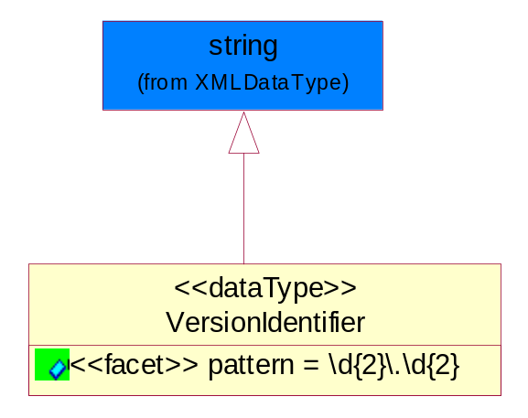
Figure ‎5-48 VersionIdentifier

Attribute | Type | Documentation
pattern |  | \d{2}\.\d{2}

CodeList

TPIRFileType
A code identifying the file type of TPIR form.

Name | Documentation
PDF | Portable Document Format.
XDP | XML Data Package.
XML | eXtensible Markup Language.

XML Data Type

anyURI
Represents a URI as defined by RFC 2396. An anyURI value can be absolute or relative, and may have an optional fragment identifier.

boolean
Represents Boolean values, which are either "true" or "false".

dateTime
Represents a specific instance of time.
The pattern for dateTime is CCYY-MM-DDThh:mm:ss where CC represents the century, YY the year, MM the month, and DD the day, preceded by an optional leading negative (-) character to indicate a negative number. If the negative character is omitted, positive (+) is assumed. The T is the date/time separator and hh, mm, and ss represent hour, minute, and second respectively. Additional digits can be used to increase the precision of fractional seconds if desired. For example, the format ss.ss... with any number of digits after the decimal point is supported. The fractional seconds part is optional.

This representation may be immediately followed by a "Z" to indicate Coordinated Universal Time (UTC) or to indicate the time zone. For example, the difference between the local time and Coordinated Universal Time, immediately followed by a sign, + or -, followed by the difference from UTC represented as hh:mm (minutes is required). If the time zone is included, both hours and minutes must be present.

positiveInteger
Represents an integer that is greater than zero. This data type is derived from nonNegativeInteger.

string
Represents character string.

