

Description of 6C6 Message

PIP® 6C6
Validated 11.00.00

Specification Information
Name | Description of 6C6 Message
PIP | Distribute Service Entitlement Status Response
Cluster | Service and Support
Segment | Technical Support and Service Management
Publication Date | 8 March 2010
Version Identifier | V11.00

Table of Content

1. Document Management 6
1.1 Legal Disclaimer 6
1.2 Copyright 6
1.3 Trademarks 6
1.4 Acknowledgments 6
1.5 Related Documents 6
1.6 Document Version History 6
1.7 Document Purpose 6
2. Interchange Model 7
2.1 ServiceEntitlementStatusResponseNotification 7
2.1.1 Interchange Diagram 7
2.1.2 Dependency Diagram 8
2.1.3 ContractInformation 8
2.1.4 EventInformation 9
2.1.5 PartInformation 10
2.1.6 ServiceEntitlementStatusResponse 11
2.1.7 StatusInformation 11
2.1.8 UnitInformation 12
3. Domain Model 14
3.1 Shared 14
3.1.1 Dependency Diagram 14
3.1.2 PaymentInformation 14
3.1.3 CodeList 15
3.1.3.1 PaymentType 15
3.1.3.2 ShippingServiceLevel 15
3.1.3.3 WarrantyType 17
3.2 Service 18
3.2.1 Dependency Diagram 18
3.2.2 ExpiryDate 18
3.2.3 PurchaseDate 19
3.2.4 ReimbursementInformation 19
3.2.5 WarrantyInformation 20
3.2.6 CodeList 21
3.2.6.1 NotificationCode 21
3.2.6.2 ServiceDeliveryMethod 21
3.2.6.3 WarrantyMethod 22
3.2.6.4 WarrantyProgram 22
4. Universal Structure 23
4.1 ContactInformation 23
4.1.1 ContactInformation 23
4.2 DataType 24
4.2.1 Contact 24
4.2.2 DUNS 24
4.2.3 DUNSPlus4 25
4.2.4 GLN 25
4.2.5 GTIN 26
4.3 Locations 27
4.3.1 AlternativeIdentifier 27
4.3.2 Location 28
4.3.3 LocationChoice 29
4.3.4 PhysicalAddress 29
4.4 MonetaryExpression 31
4.4.1 FinancialAmount 31
4.5 PartnerIdentification 32
4.5.1 FullPartner 32
4.5.2 IntermittentPartner 33
4.5.3 KnownPartner 33
4.5.4 KnownPartnerContact 34
4.5.5 NewPartner 34
4.5.6 PartnerDescription 35
4.5.7 PartnerDescriptionChoice 36
4.5.8 PartnerIdentification 37
4.5.9 PartnerIdentificationChoice 38
4.5.10 SpecifiedFullPartner 39
4.5.11 SpecifiedIntermittentPartner 40
4.5.12 SpecifiedKnownPartner 40
4.5.13 SpecifiedNewPartner 41
4.6 ProductIdentification 42
4.6.1 ProductIdentification 42
4.6.2 ProductIdentificationChoice 42
4.7 CodeList 43
4.7.1 Country 43
4.7.2 CountrySubdivision 43
4.7.3 Currency 43
4.7.4 Language 43
4.7.5 MimeTypeQualifier 44
4.7.6 ProcessRoleIdentifier 54
5. System Structure 58
5.1 BusinessProcessIdentifier 58
5.2 BusinessServiceInformation 59
5.3 ContractInformation 60
5.4 CorrelationInformation 60
5.5 DocumentHeader 61
5.6 DocumentIdentification 62
5.7 DocumentIdentificationChoice 62
5.8 DocumentInformation 63
5.9 DocumentManifest 64
5.10 DocumentSecurity 65
5.11 ManifestItem 66
5.12 PipIdentifier 67
5.13 PipVersion 67
5.14 Receiver 68
5.15 RequestingDocumentInformation 69
5.16 Sender 70
5.17 StandardDocumentIdentification 71
5.18 TpirPipIdentification 72
5.19 VersionIdentifier 73
5.20 CodeList 73
5.20.1 TPIRFileType 73
6. XML Data Type 74
6.1 anyURI 74
6.2 boolean 74
6.3 date 74
6.4 dateTime 74
6.5 float 74
6.6 positiveInteger 74
6.7 string 74

Table of Figures

Figure ‎2-1 Interchange 7
Figure ‎2-2 Dependency 8
Figure ‎2-3 ContractInformation 8
Figure ‎2-4 EventInformation 9
Figure ‎2-5 PartInformation 10
Figure ‎2-6 ServiceEntitlementStatusResponse 11
Figure ‎2-7 StatusInformation 11
Figure ‎2-8 UnitInformation 12
Figure ‎3-1 Dependency 14
Figure ‎3-2 PaymentInformation 14
Figure ‎3-3 Dependency 18
Figure ‎3-4 ExpiryDate 18
Figure ‎3-5 PurchaseDate 19
Figure ‎3-6 ReimbursementInformation 19
Figure ‎3-7 WarrantyInformation 20
Figure ‎4-1 ContactInformation 23
Figure ‎4-2 Contact 24
Figure ‎4-3 DUNS 24
Figure ‎4-4 DUNSPlus4 25
Figure ‎4-5 GLN 25
Figure ‎4-6 GTIN 26
Figure ‎4-7 AlternativeIdentifier 27
Figure ‎4-8 Location 28
Figure ‎4-9 PhysicalAddress 29
Figure ‎4-10 FinancialAmount 31
Figure ‎4-11 FullPartner 32
Figure ‎4-12 IntermittentPartner 33
Figure ‎4-13 KnownPartner 33
Figure ‎4-14 KnownPartnerContact 34
Figure ‎4-15 NewPartner 34
Figure ‎4-16 PartnerDescription 35
Figure ‎4-17 PartnerIdentification 37
Figure ‎4-18 SpecifiedFullPartner 39
Figure ‎4-19 SpecifiedIntermittentPartner 40
Figure ‎4-20 SpecifiedKnownPartner 40
Figure ‎4-21 SpecifiedNewPartner 41
Figure ‎4-22 ProductIdentification 42
Figure ‎5-1 BusinessProcessIdentifier 58
Figure ‎5-2 BusinessServiceInformation 59
Figure ‎5-3 ContractInformation 60
Figure ‎5-4 CorrelationInformation 60
Figure ‎5-5 DocumentHeader 61
Figure ‎5-6 DocumentIdentification 62
Figure ‎5-7 DocumentInformation 63
Figure ‎5-8 DocumentManifest 64
Figure ‎5-9 DocumentSecurity 65
Figure ‎5-10 ManifestItem 66
Figure ‎5-11 PipIdentifier 67
Figure ‎5-12 PipVersion 67
Figure ‎5-13 Receiver 68
Figure ‎5-14 RequestingDocumentInformation 69
Figure ‎5-15 Sender 70
Figure ‎5-16 StandardDocumentIdentification 71
Figure ‎5-17 TpirPipIdentification 72
Figure ‎5-18 VersionIdentifier 73

Document Management

Legal Disclaimer
RosettaNet, its members, officers, directors, employees, or agents shall not be liable for any injury, loss, damages, financial or otherwise, arising from, related to, or caused by the use of this document or the specifications herein, as well as associated guidelines and schemas. The use of said specifications shall constitute your express consent to the foregoing exculpation.

Copyright
©2010 RosettaNet. All rights reserved. No part of this publication may be reproduced, stored in a retrieval system, or transmitted, in any form or by any means, electronic, mechanical, photocopying, recording, or otherwise, without the inclusion of this copyright notice. Any derivative works must cite the copyright notice. Any public redistribution or sale of this publication or derivative works requires prior written permission of the publisher.

Trademarks
RosettaNet, Partner Interface Process, PIP and the RosettaNet logo are trademarks or registered trademarks of "RosettaNet," a non-profit organization. All other product names and company logos mentioned herein are the trademarks of their respective owners. In the best effort, all terms mentioned in this document that are known to be trademarks or registered trademarks have been appropriately recognized in the first occurrence of the term.

Acknowledgments
This document has been prepared by RosettaNet (http://www.rosettanet.org/) from requirements gathered during the Milestone Program and in conformance with the methodology.

Related Documents
- Associated PIP Message Schemas (included with PIP Specification only)
- Description of Partner Interface Process for 6C6
- Message Structure

Document Version History
Version | Date | Description
Validated 11.00.00 | 8 March 2010 | Validated Version : MCC Program

Document Purpose
The purpose of the document is to explain the structure, the association between objects, the content of objects and the definition for single elements to a non-technical audience.

Interchange Model

ServiceEntitlementStatusResponseNotification

Interchange Diagram
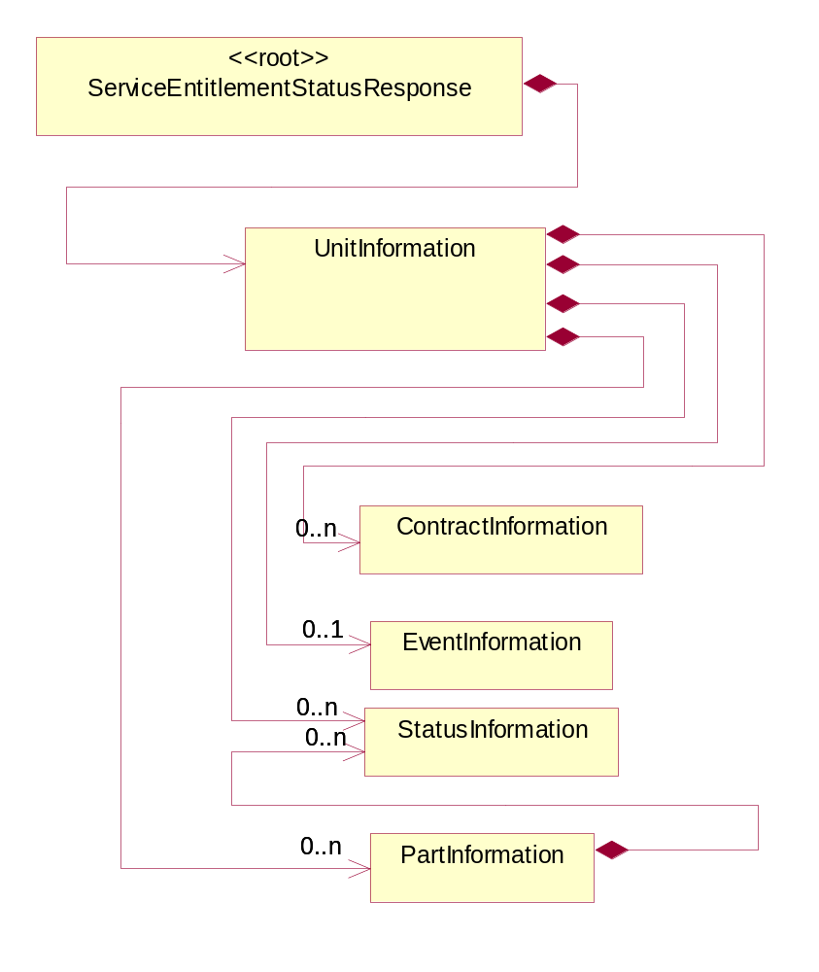
Figure ‎2-1 Interchange

Dependency Diagram
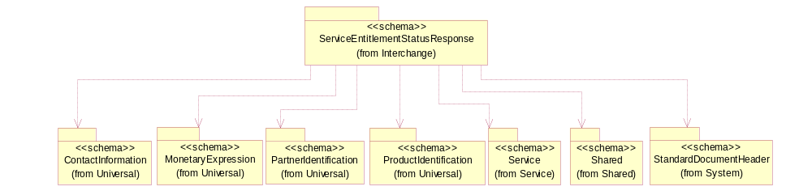
Figure ‎2-2 Dependency

ContractInformation
The collection of business properties that represent a business arrangement for the supply of goods or services at an agreed price.
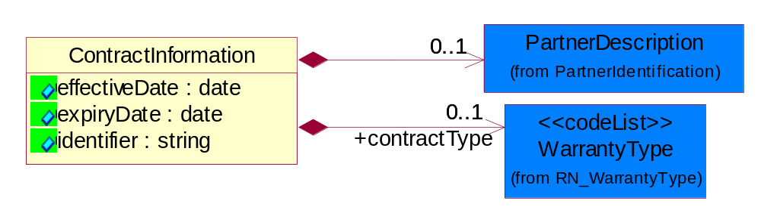
Figure ‎2-3 ContractInformation

Attribute | Type | Documentation
effectiveDate | date | The date information or an activity becomes effective.
expiryDate | date | The date that a contractual agreement expires.
identifier | string | A unique identifier for referencing specific contracts.

Composition | Cardinality | Type | Documentation
PartnerDescription | 0..1 | PartnerDescription | The collection of business properties that describe a business partners' identity, their contact information, where they are physically located and their function in a supply chain.
contractType | 0..1 | WarrantyType | Used to specify the type of contractual arrangement.

EventInformation
The collection of business properties that describe the data elements and entities associated with performing repair or maintenance ser cie on a part or unit of product.
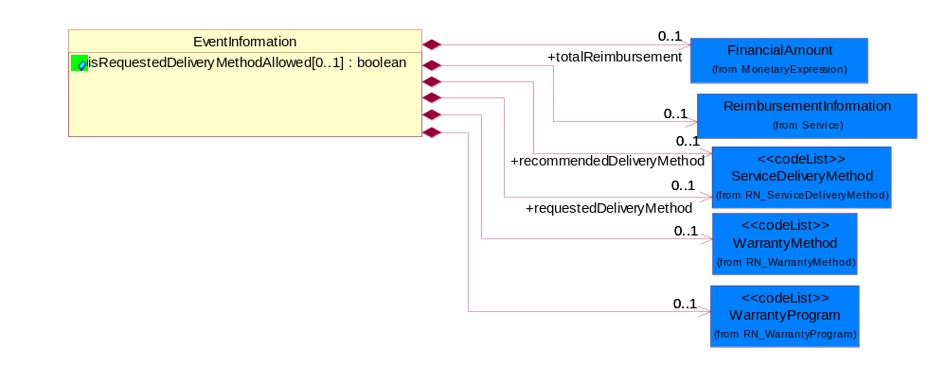
Figure ‎2-4 EventInformation

Attribute | Type | Documentation
isRequestedDeliveryMethodAllowed[0..1] | boolean | Used to indicate if the requested service delivery method is allowed.

Composition | Cardinality | Type | Documentation
totalReimbursement | 0..1 | FinancialAmount | The total amount the ASP will be reimbursed for performing a service event.
ReimbursementInformation | 0..1 | ReimbursementInformation | A collection of business properties containing the approximate reimbursement rate calculated by the OEM, including any additional bonuses based upon the Authorized Service Provider's rating.
requestedDeliveryMethod | 0..1 | ServiceDeliveryMethod | The service delivery method suggested by the ASP to deliver the warranty entitilement on a unit.
recommendedDeliveryMethod | 0..1 | ServiceDeliveryMethod | OEM's recommended Service Delivery Method for warranty entitlement of a unit.
WarrantyProgram | 0..1 | WarrantyProgram | The program used when verifying service entitlement.
WarrantyMethod | 0..1 | WarrantyMethod | Defines the method used to validate warranty.

PartInformation
The collection of part data entities that comprise the response for warranty entitlement on a part from a Warranty Provider.
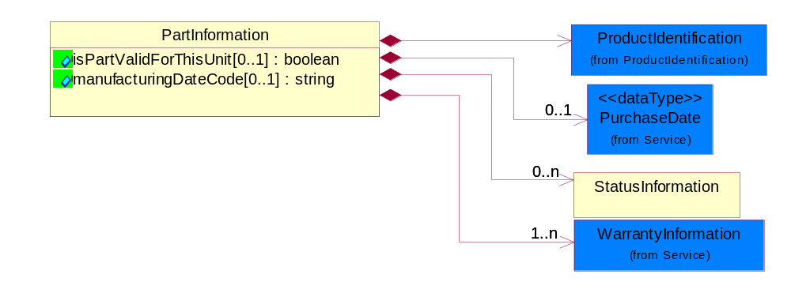
Figure ‎2-5 PartInformation

Attribute | Type | Documentation
isPartValidForThisUnit[0..1] | boolean | Indicates whether or not the requested part is a valid part for the unit being serviced.
manufacturingDateCode[0..1] | string | The unique identifier assigned to a product by a manufacturer to distinguish individual manufacturing periods.

Composition | Cardinality | Type | Documentation
ProductIdentification | 1 | ProductIdentification | The object provides the identifier(s) of a product.
StatusInformation | 0..n | StatusInformation | Data entities that provide additional information on a warranty item.
WarrantyInformation | 1..n | WarrantyInformation | The colllection of data entities that comprise information relative to a specific warranty.
PurchaseDate | 0..1 | PurchaseDate | Date of purchase of a unit.

ServiceEntitlementStatusResponse
Message wrapper for PIP6C1 Response.
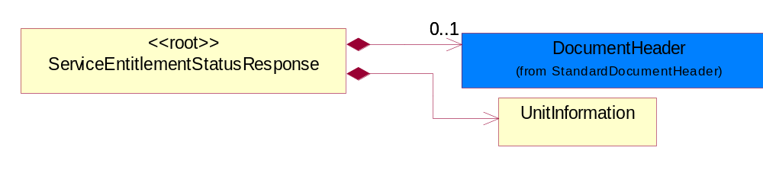
Figure ‎2-6 ServiceEntitlementStatusResponse

Composition | Cardinality | Type | Documentation
DocumentHeader | 0..1 | DocumentHeader | The object allows for the identification of the sender and receiver of the business document.
UnitInformation | 1 | UnitInformation | The collection of data entities that comprise the response from a Warranty Provider for the status of the warranty entitlement on a unit of product.

StatusInformation
Data entities that provide additional information on a warranty item.
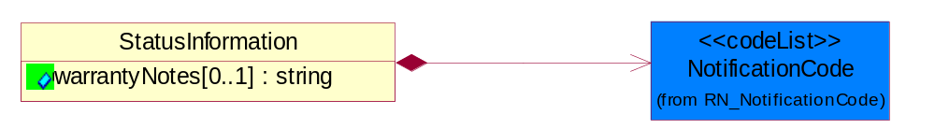
Figure ‎2-7 StatusInformation

Attribute | Type | Documentation
warrantyNotes[0..1] | string | Text that contains information on the status of a unit under warranty.

Composition | Cardinality | Type | Documentation
NotificationCode | 1 | NotificationCode | Code identifying the purpose of a notification document.

UnitInformation
The collection of data entities that comprise the response from a Warranty Provider for the status of the warranty entitlement on a unit of product.
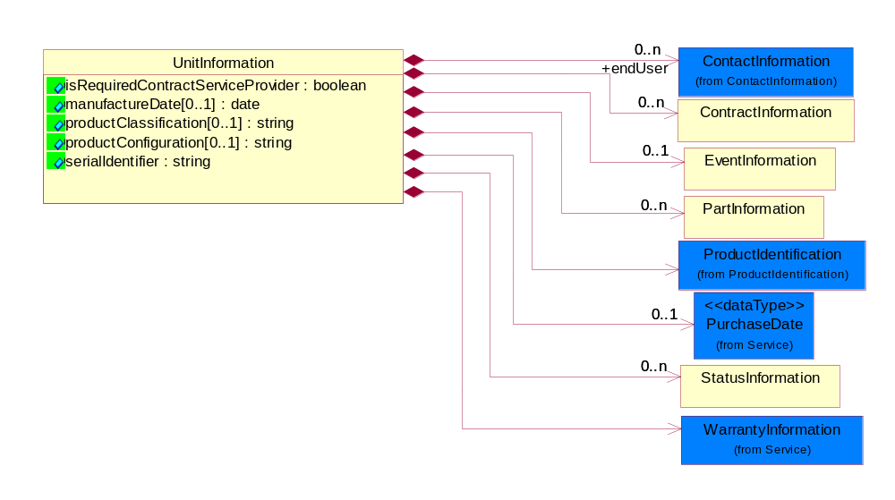
Figure ‎2-8 UnitInformation

Attribute | Type | Documentation
isRequiredContractServiceProvider | boolean | Used to indicate whether or not complete contract information may be displayed or included in the response to a service entitlement query.
manufactureDate[0..1] | date | The date the product was manufactured.
productClassification[0..1] | string | Proprietary code that classifies a product based on a proprietary classification criterion.
productConfiguration[0..1] | string | The configuration code of the unit used to classify the product group.
serialIdentifier | string | Unique serial identifier assigned to the product.

Composition | Cardinality | Type | Documentation
endUser | 0..n | ContactInformation | Used to reference the contct information for an end user of a serviced unit.
PartInformation | 0..n | PartInformation | The collection of part data entities that comprise the response for warranty entitlement on a part from a Warranty Provider.
ProductIdentification | 1 | ProductIdentification | The object provides the identifier(s) of a product.
EventInformation | 0..1 | EventInformation | The collection of business properties that describe the data elements and entities associated with performing repair or maintenance ser cie on a part or unit of product.
StatusInformation | 0..n | StatusInformation | Data entities that provide additional information on a warranty item.
WarrantyInformation | 1 | WarrantyInformation | The colllection of data entities that comprise information relative to a specific warranty.
PurchaseDate | 0..1 | PurchaseDate | Date of purchase of a unit.
ContractInformation | 0..n | ContractInformation | The collection of business properties that represent a business arrangement for the supply of goods or services at an agreed price.

Domain Model

Shared

Dependency Diagram
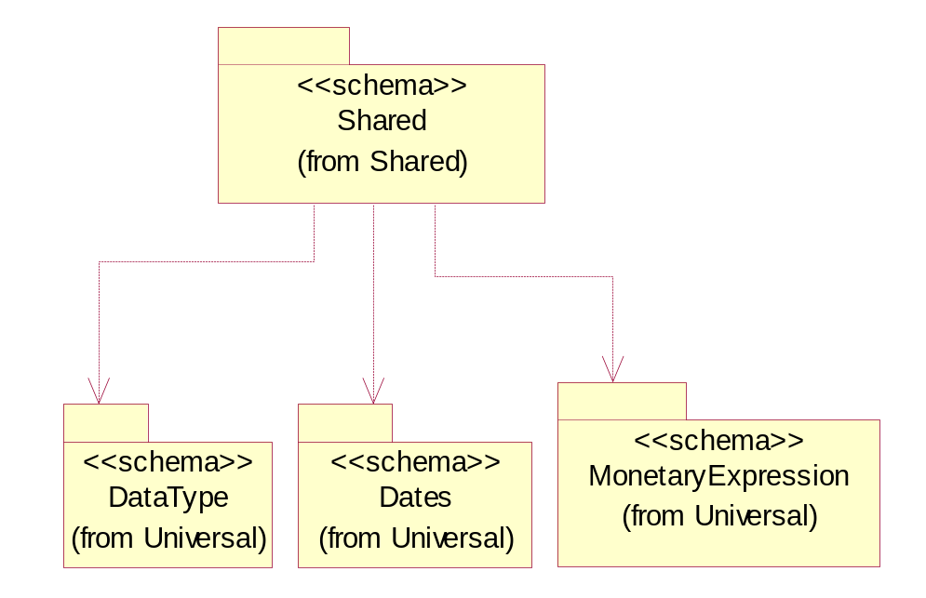
Figure ‎3-9 Dependency

PaymentInformation
The colllection of data entities that comprise information relative to a specific payment.

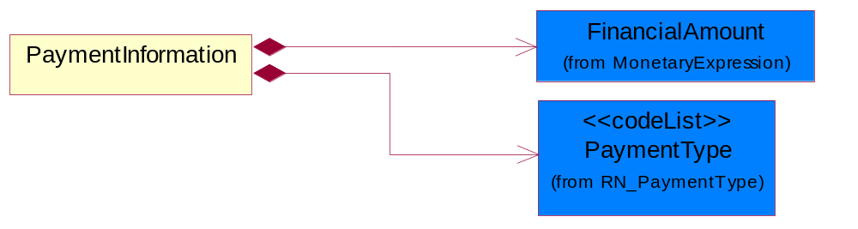
Figure ‎3-10 PaymentInformation

Composition | Cardinality | Type | Documentation
FinancialAmount | 1 | FinancialAmount | The business document must express financial amounts.
PaymentType | 1 | PaymentType | Code identifying what the payment represents.

CodeList

PaymentType
Code identifying what the payment represents.

Name | Documentation
CUR | Curtailment.
DBD | DBD - The bonus paid when the unit failure is diagnosed before a technicial is dispatched.
EVE | Event - The labor warranty coverage per incident.
FIX | Fix-in-Time - The warranty coverage for repairing a unit within a specified time frame.
MPR | Matured Principal.
NFF | No-Fault-Found - Bonus paid when no fault was found when repairing a unit.
ONS | Onsite - Additonal credit for repairing a unit at the customer's location.
PCR | Part Credit - The credit received for returning defective parts during a service event.
PDU | Past Due.
PFP | PFP - Pay for performance payment.
PPE | PPE - The bonus paid for each part replaced per service event (Parts per Event)
SCH | Scheduled.
TIN | Training Incentive - Bonus for technician cerftification.

ShippingServiceLevel
Code identifying the shipping service level, e.g., overnight, same day.

Name | Documentation
1BD | 1BD, Same Business Day - 4 hour Response Time.
5BD | 5 Business Days.
9AM | 9 A.M.
ACH | Air Charter.
AEC | Air Economy.
AIC | Air Cargo.
AM | A.M.
ARS | Authorized Return Service.
ATA | Airport to Airport.
ATD | Airport to Door.
BCT | Bulk Commodity Train.
BUC | Business Class.
CBS | Consignee Billing Service.
COE | Courier Express.
DCR | Delivery Confirmation Return.
DEC | Delivery Confirmation.
DES | Deferred Service.
DNO | Delivery Notification Only.
DOS | Door Service.
DSN | Delivery scheduled next day by cartage agent.
DSS | Delivery scheduled second day by cartage agent.
DST | Delivery scheduled third day by cartage agent.
DTA | Door to Airport.
DTD | Door to Door.
DTP | Door to Port (Ocean).
ESP | Express Service Plus.
ESV | Expedited Service.
ESW | Expedited Service Worldwide.
EXS | Express Service.
EXW | Express Service - Worldwide.
FIC | First Class.
GEN | General.
GRO | Ground.
ISS | Other intermodal and stack service.
MAF | Manifest freight.
MET | Metro.
MUW | Multiweight.
NBD | Next Business Day.
NDA | Next Day Air.
NEM | Next Morning.
NFO | Next Flight Out.
NHW | Next day Hundred Weight.
NOR | NORMAL - Normal delivery.
NOS | Not served.
OIS | Other Intermodal and Stack service
OTH | Other.
OVN | Overnight.
PAS | Passenger service.
PIU | Pickup.
PM | PM.
PMI | Priority Mail Insured.
POB | P.O. Box/Zip code.
POD | Proof of Delivery (POD) with Signature.
PRM | Priority Mail.
PRS | Premium Surface.
PS1 | Primary Service Area - Next Day by 10:30 A.M.
PS2 | Primary Service Area - Next Day by 5:00 P.M.
PS3 | Primary Service Area - Next Day By 9:30 A.M.
PS4 | Primary Service Area - Next Day by Noon.
PS5 | Primary Service Area - Second Day by Noon.
PTD | Port to Door (Ocean).
PTP | Port to Port (Ocean).
REG | Regular.
SAD | Same day.
SAP | Saturday Pickup.
SAT | Saturday.
SBD | SBD, Second Business Day.
SCH | Scheduled.
SDA | Second Day Air.
SDW | Second Day Hundred Weight.
SED | Second Day.
SEM | Second Morning.
SGW | Standard Ground Hundred Weight.
STC | Standard Class.
STG | Standard Ground.
STO | Standard Ocean.
STS | Standard Service.
SUH | Sunday and Holidays.
TDS | Three Day Service.
TIC | Time Critical.
TRG | Tracking - Ground.

WarrantyType
The classification of each warranty coverage type that can be claimed.

Name | Documentation
CRI | Carry In - The warranty coverage for a unit that is carried in for repair.
DEP | Depot.
EVN | Event - The labor warranty coverage per incident.
FCL | Facilitation.
FLL | Full - A warranty which covers all aspects of the product.
LTD | Limited - A warranty which only certain aspects of the product which is described more fully in the warranty description.
OEM | OEM Service Pack.
ONS | Onsite - The warranty coverage for repairing a unit at the customer's location.
PCI | Portable Carry In - The warranty coverage for a portable unit that is carried in for repair.
PCK | Support Pack.
PLA | Parts and Labor - A warranty which covers both the parts cost as well as any labor charges required to replace those parts.
PRO | Parts Only - A warranty which covers only the parts cost of the product.
PRT | Part - The spare parts warranty coverage.
STD | Standard - Indicates standard warranty coverage.

Service

Dependency Diagram
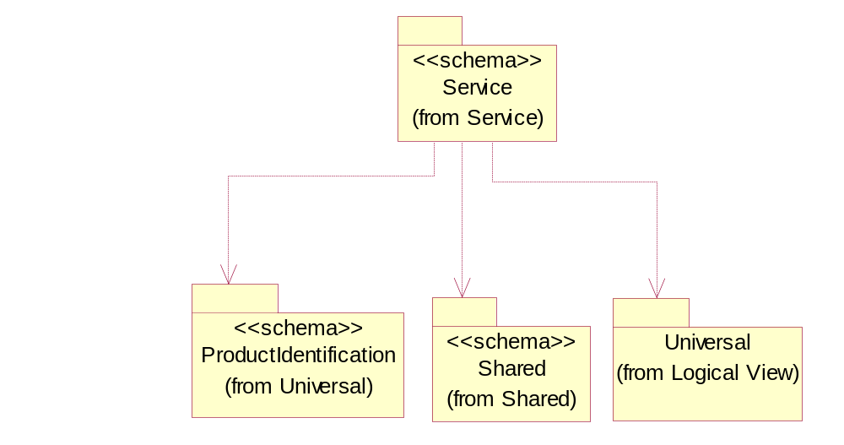
Figure ‎3-11 Dependency

ExpiryDate
The date that a contractual agreement expires.
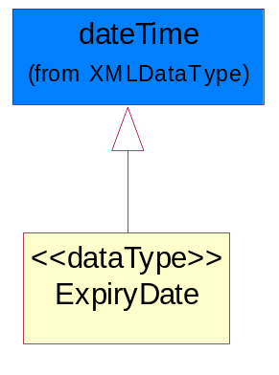
Figure ‎3-12 ExpiryDate

PurchaseDate
Date of purchase of a unit.
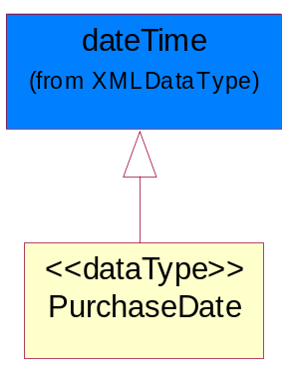
Figure ‎3-13 PurchaseDate

ReimbursementInformation
A collection of business properties containing the approximate reimbursement rate calculated by the OEM, including any additional bonuses based upon the Authorized Service Provider's rating.

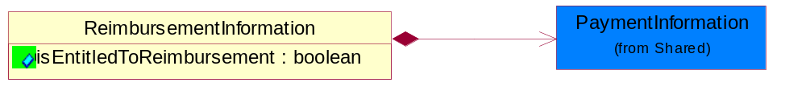
Figure ‎3-14 ReimbursementInformation

Attribute | Type | Documentation
isEntitledToReimbursement | boolean | A flag indicating whether or not a credit will be given to the ASP for providing warranty work.

Composition | Cardinality | Type | Documentation
PaymentInformation | 1 | PaymentInformation | The colllection of data entities that comprise information relative to a specific payment.

WarrantyInformation
The colllection of data entities that comprise information relative to a specific warranty.

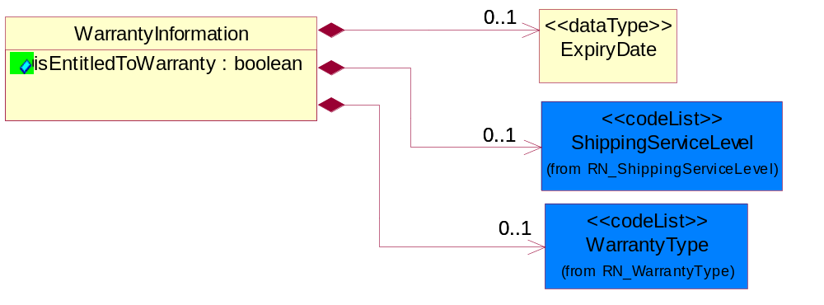
Figure ‎3-15 WarrantyInformation

Attribute | Type | Documentation
isEntitledToWarranty | boolean | Indicates whether or not the particulary warranty type is covered.

Composition | Cardinality | Type | Documentation
ExpiryDate | 0..1 | ExpiryDate | The date that a contractual agreement expires.
ShippingServiceLevel | 0..1 | ShippingServiceLevel | Code identifying the shipping service level, e.g., overnight, same day.
WarrantyType | 0..1 | WarrantyType | The classification of each warranty coverage type that can be claimed.

CodeList

NotificationCode
Code identifying the purpose of a notification document.

Name | Documentation
AME | Amendment.
CAN | Cancellation.
ERR | Error.
FIN | Final.
INF | Informational.
INI | Initial.
UPD | Update.
WAR | Warning.

ServiceDeliveryMethod
The service delivery method recommended by the OEM to deliver the warranty entitlement on a unit.

Name | Documentation
AON | Adjustment Only - The service event requires an adjustment to the unit or part, no parts are being replaced.
CAR | Carry-In - The service will be performed at an authorized service location.
FAC | Facilitation - Authorized Service Provider sends the unit back to the Original Equipment Manufacturer for repair and receives a facilitation fee.
FUP | Firmware Upgrade - The service event requires a firmware upgrade, no parts are being replaced.
ONS | Onsite - The service will be performed at the customer's location.
PFI | Phone Fix - The service will be performed over the telephone.
TCO | Technical Courier - A technicial courier will perform the service.
URP | URP1-NR - User Replaceable Part, Non-Returnable (disposable.)
URQ | URP1-R-C - User Replaceable Part - Repairable-Centralized.
URR | URP1-R-DC - User Replaceable Part - Repairable-Decentralized.
URS | URP2-NR-C - User Replaceable Part - Astute User - Non-Returnable - Centralized.
URT | URP2-NR-DC - User Replaceable Part - Astute User - Non-Returnable - Decentralized.
URU | URP2-R-C - User Replaceable Part - Astute User - Returnable - Centralized.
URV | URP2-R-DC - User Replaceable Part - Astute User - Returnable - Decentralized.

WarrantyMethod
Defines the method used to validate warranty.

Name | Documentation
MDA | Manufacturing Date - Manufacturing date code decode.
SND | Serial Number Decode - The configuration code from the serial number used for baseline warranty calculation.
SPE | SpecialPartWarranty.
UNK | Unknown.

WarrantyProgram
The program used when verifying service entitlement.

Name | Documentation
DMA | DOA Machine.
SPW | Spare Part Warranty.
SWA | Standard Warranty.

Universal Structure

ContactInformation

ContactInformation
The business document must allow for the identification of the name of the department, service or individual to be contacted regarding the context of the business document.
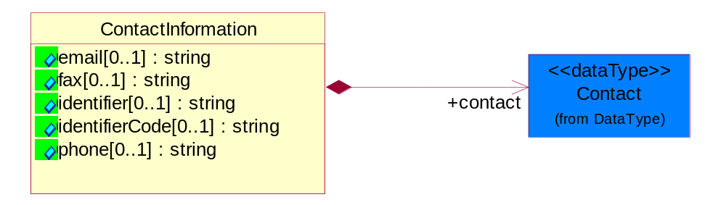
Figure ‎4-16 ContactInformation

Attribute | Type | Documentation
email[0..1] | string | The electronic mail for the specified contact.
fax[0..1] | string | The fax number for the specified contact.
identifier[0..1] | string | Identifies the role of the contact (i.e. Service Technician, Account Manager) in the Business Process.
identifierCode[0..1] | string | IdentifierCode is a unique security authorization code to identify the contact- ie. badge ID.
phone[0..1] | string | The telephone number for the specified contact.

Composition | Cardinality | Type | Documentation
contact | 1 | Contact | The name of the department, service or individual to be contacted within the organization.

DataType

Contact
The name of the department, service or individual to be contacted within the organization.
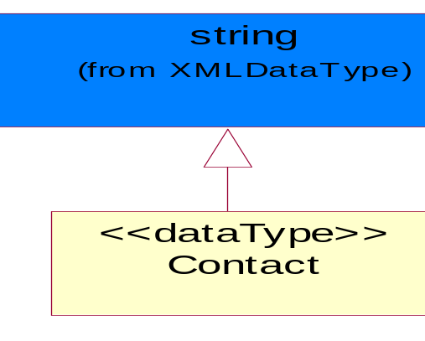
Figure ‎4-17 Contact

DUNS
A number assigned by Dun and Bradstreet to identify a business location.
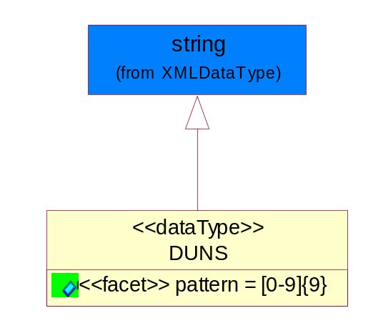
Figure ‎4-18 DUNS

Attribute | Type | Documentation
pattern |  | [0-9]{9}

DUNSPlus4
A identifier to specify a specific location within a business location.
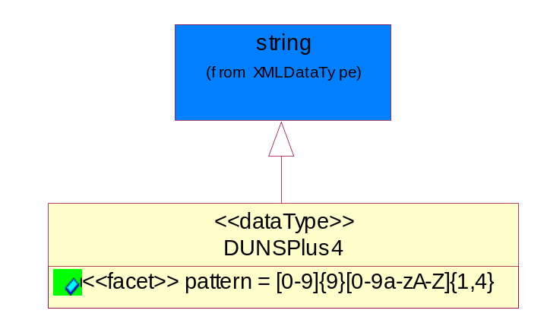
Figure ‎4-19 DUNSPlus4

Attribute | Type | Documentation
pattern |  | Data Universal Numbering System +4 (DUNS+4) number means the DUNS number assigned by Dun and Bradstreet, Inc. (D&B) plus an alphanumeric of length 4 suffix that may be assigned by a business concern.

GLN
Global Location Number (GLN) - A identifier to identify legal entities, trading parties and location.
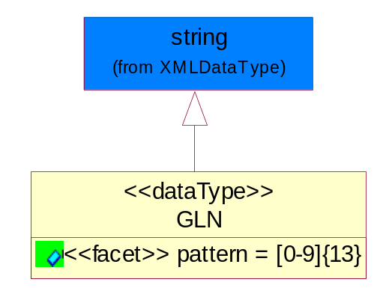
Figure ‎4-20 GLN

Attribute | Type | Documentation
pattern |  | [0-9]{13}

GTIN
Global Trade Identification Number (GTIN).
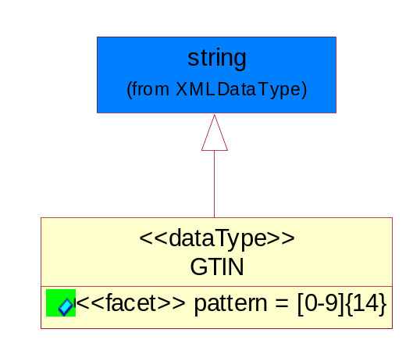
Figure ‎4-21 GTIN

Attribute | Type | Documentation
pattern |  | [0-9]{14}

Locations

AlternativeIdentifier
Identifies the specified code and the name of the organization that a code is utilized from.
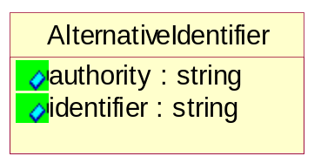
Figure ‎4-22 AlternativeIdentifier

Attribute | Type | Documentation
authority | string | The name of the organization that a code is utilized from.
identifier | string | The specified code to represent an entity (e.g. product, location, partner, etc.).

Location
The business document must specify a location.
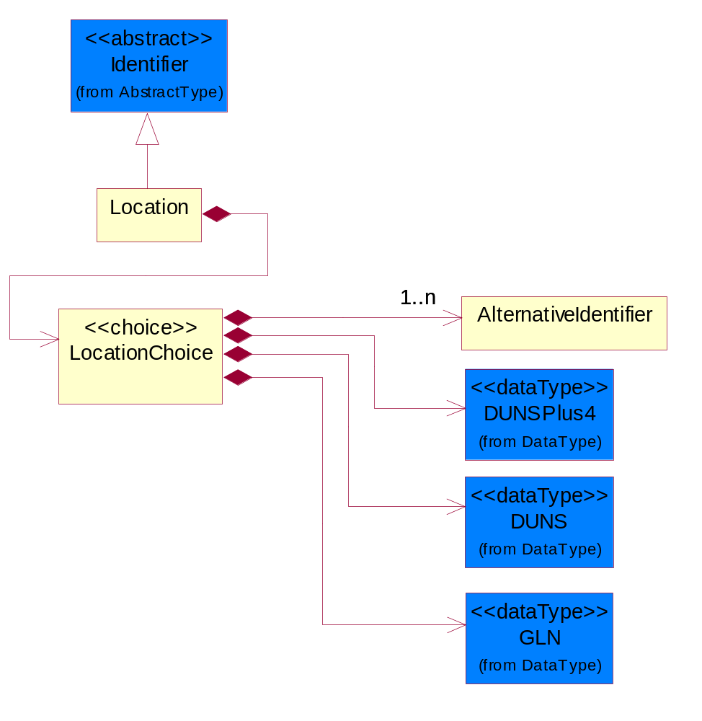
Figure ‎4-23 Location

Composition | Cardinality | Type | Documentation
LocationChoice | 1 | LocationChoice

LocationChoice

Composition | Cardinality | Type | Documentation
DUNSPlus4 | 1 | DUNSPlus4 | A identifier to specify a specific location within a business location.
DUNS | 1 | DUNS | A number assigned by Dun and Bradstreet to identify a business location.
AlternativeIdentifier | 1..n | AlternativeIdentifier | Identifies the specified code and the name of the organization that a code is utilized from.
GLN | 1 | GLN | Global Location Number (GLN) - A identifier to identify legal entities, trading parties and location.

PhysicalAddress
The business document must provide a physical address for a party to the business transaction.
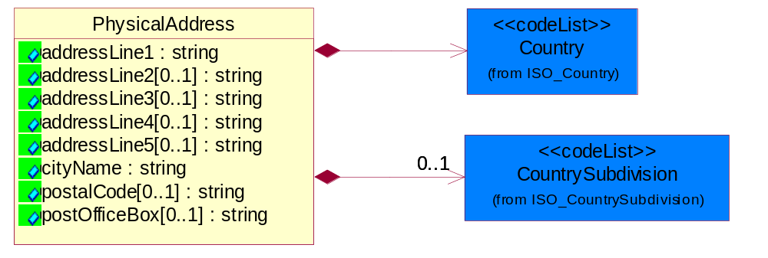
Figure ‎4-24 PhysicalAddress

Attribute | Type | Documentation
addressLine1 | string | The first line of a physical address.
addressLine2[0..1] | string | The second line of a physical address.
addressLine3[0..1] | string | The third line of a physical address.
addressLine4[0..1] | string | The fourth line of a physical address.
addressLine5[0..1] | string | The fifth line of a physical address.
cityName | string | The name of a city.
postalCode[0..1] | string | Identifying geographic location as specified by a national postal code.
postOfficeBox[0..1] | string | The Post Office Box identifier used to identify a party's post office box.

Composition | Cardinality | Type | Documentation
Country | 1 | Country | For representation of Country name RosettaNet has adopted ISO 3166-3; 1999. Refer to the following web page to get the latest version of the standard:  http://www.iso.ch/iso/en/prods-services/iso3166ma/02iso-3166-code-lists/index.html  If you need more information about the ISO standard please contact ISO for more details.
CountrySubdivision | 0..1 | CountrySubdivision | For representation of a Countries subdivisions RosettaNet has adopted ISO 3166-3; 1999. Refer to the following web page to get the latest version of the standard:  http://www.iso.ch/iso/en/prods-services/iso3166ma/02iso-3166-code-lists/index.html  If you need more information about the ISO standard please contact ISO for more details.

MonetaryExpression

FinancialAmount
The business document must express financial amounts.
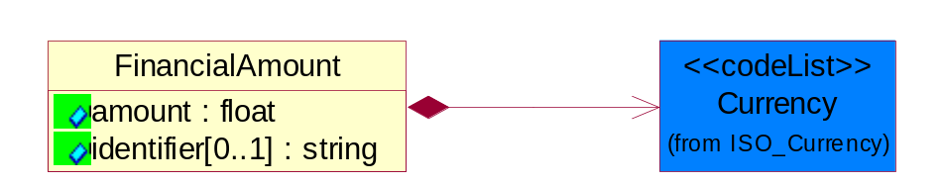
Figure ‎4-25 FinancialAmount

Attribute | Type | Documentation
amount | float | Specifies the monetary amount.
identifier[0..1] | string | Identifier is a unique identifier to which the specific price is tied - ie. promotion name/ program.

Composition | Cardinality | Type | Documentation
Currency | 1 | Currency | For representation of Currency codes RosettaNet has adopted ISO 4217; 1995. The British Standards Institution (BSI) is the ISO 4217 Maintenance Agency. Refer to the following web page to get the latest version of the standard:  http://www.bsi-global.com/Technical+Information/Publications/_Publications/tig90.xalter  If you need more information about the ISO standard please contact ISO for more details.

PartnerIdentification

FullPartner
The business document must describe the trading partners in the business transaction. This data structure provide the flexibility to describe a partner in all possible methods as for new, existing or known partner.
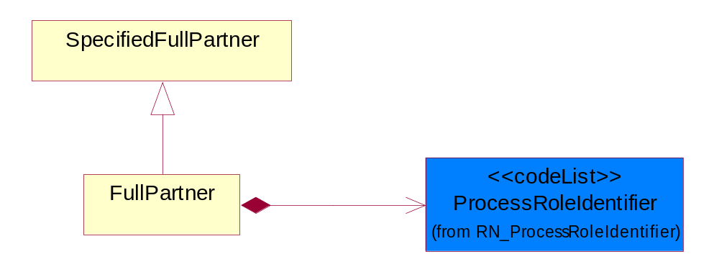
Figure ‎4-26 FullPartner

Composition | Cardinality | Type | Documentation
ProcessRoleIdentifier | 1 | ProcessRoleIdentifier | Describes the role of the partner in the business process. A partner will fulfill at least one or more roles during the business process.

IntermittentPartner
The business document must describe a physical address for a delivery.
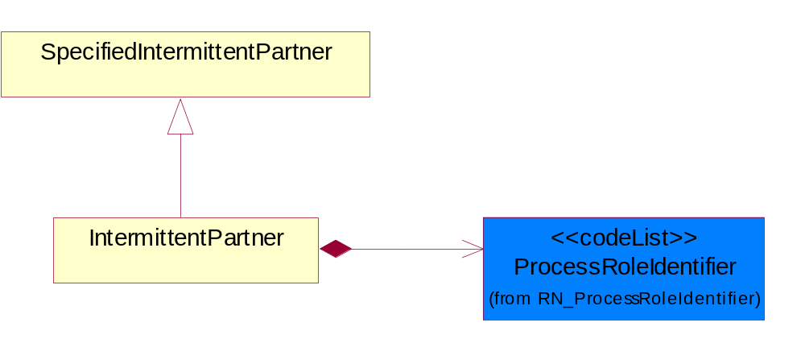
Figure ‎4-27 IntermittentPartner

Composition | Cardinality | Type | Documentation
ProcessRoleIdentifier | 1 | ProcessRoleIdentifier | Describes the role of the partner in the business process. A partner will fulfill at least one or more roles during the business process.

KnownPartner
The business document must describe the trading partners in the business transaction.
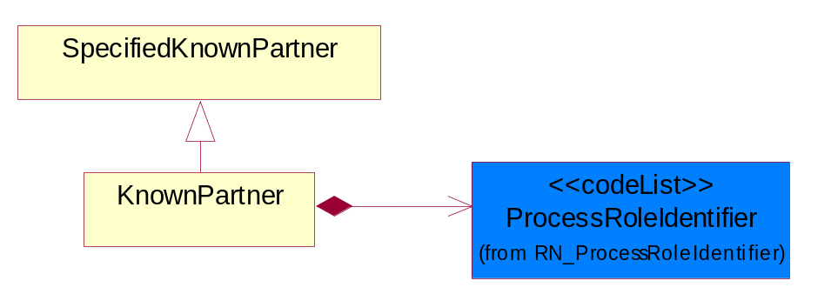
Figure ‎4-28 KnownPartner

Composition | Cardinality | Type | Documentation
ProcessRoleIdentifier | 1 | ProcessRoleIdentifier | Describes the role of the partner in the business process. A partner will fulfill at least one or more roles during the business process.

KnownPartnerContact
The business document must describe the trading partners in the business transaction.
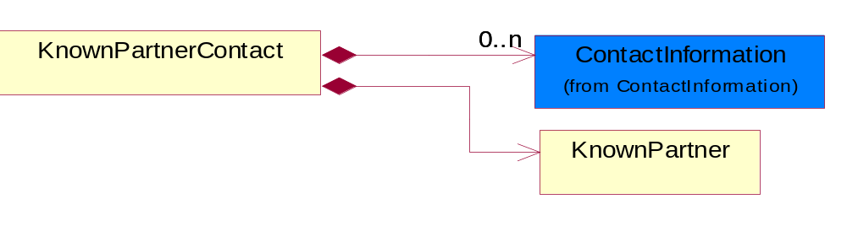
Figure ‎4-29 KnownPartnerContact

Composition | Cardinality | Type | Documentation
KnownPartner | 1 | KnownPartner | The business document must describe the trading partners in the business transaction.
ContactInformation | 0..n | ContactInformation | The business document must allow for the identification of the name of the department, service or individual to be contacted regarding the context of the business document.

NewPartner
The business document must describe a new, existing (but known to only one of the parties to the transaction) or an unknown party to the business transaction.
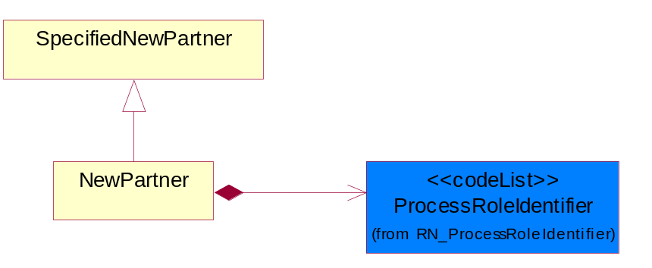
Figure ‎4-30 NewPartner

Composition | Cardinality | Type | Documentation
ProcessRoleIdentifier | 1 | ProcessRoleIdentifier | Describes the role of the partner in the business process. A partner will fulfill at least one or more roles during the business process.

PartnerDescription
The collection of business properties that describe a business partners' identity, their contact information, where they are physically located and their function in a supply chain.
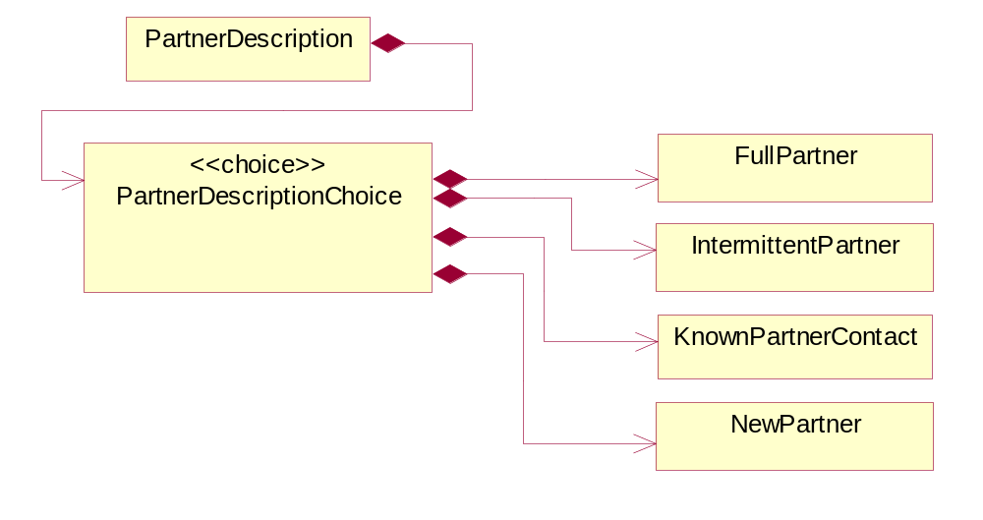
Figure ‎4-31 PartnerDescription

Composition | Cardinality | Type | Documentation
PartnerDescriptionChoice | 1 | PartnerDescriptionChoice

PartnerDescriptionChoice

Composition | Cardinality | Type | Documentation
KnownPartnerContact | 1 | KnownPartnerContact | The business document must describe the trading partners in the business transaction.
IntermittentPartner | 1 | IntermittentPartner | The business document must describe a physical address for a delivery.
NewPartner | 1 | NewPartner | The business document must describe a new, existing (but known to only one of the parties to the transaction) or an unknown party to the business transaction.
FullPartner | 1 | FullPartner | The business document must describe the trading partners in the business transaction. This data structure provide the flexibility to describe a partner in all possible methods as for new, existing or known partner.

PartnerIdentification
The business document must allow for the identity of one or more parties to the transaction.
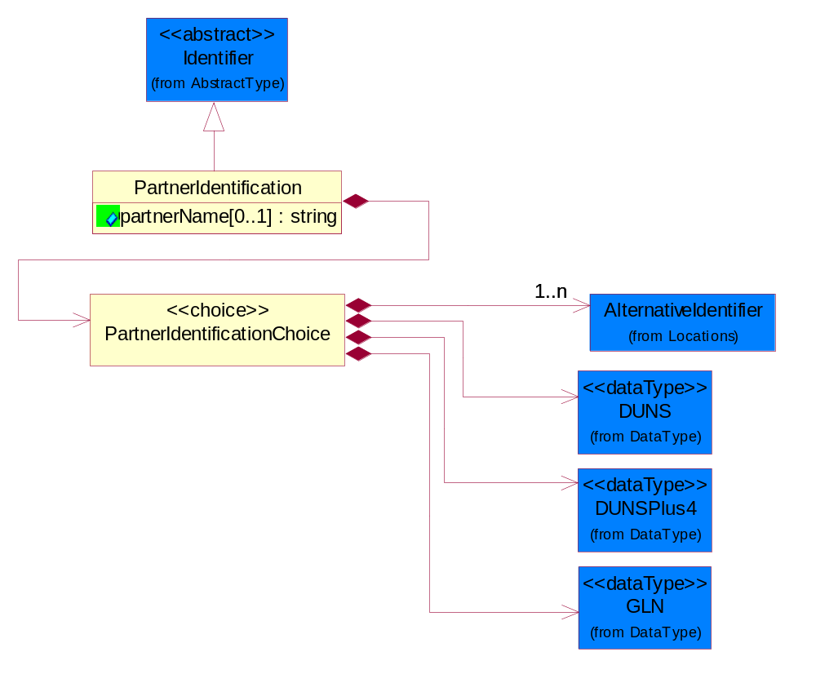
Figure ‎4-32 PartnerIdentification

Attribute | Type | Documentation
partnerName[0..1] | string | The name of the partner’s company/business.

Composition | Cardinality | Type | Documentation
PartnerIdentificationChoice | 1 | PartnerIdentificationChoice

PartnerIdentificationChoice

Composition | Cardinality | Type | Documentation
DUNS | 1 | DUNS | A number assigned by Dun and Bradstreet to identify a business location.
DUNSPlus4 | 1 | DUNSPlus4 | A identifier to specify a specific location within a business location.
AlternativeIdentifier | 1..n | AlternativeIdentifier | Identifies the specified code and the name of the organization that a code is utilized from.
GLN | 1 | GLN | Global Location Number (GLN) - A identifier to identify legal entities, trading parties and location.

SpecifiedFullPartner
The business document must describe the trading partners in the business transaction. This data structure provide the flexibility to describe a partner in all possible methods as for new, existing or known partner. This is specifically for partner who role has been specified.
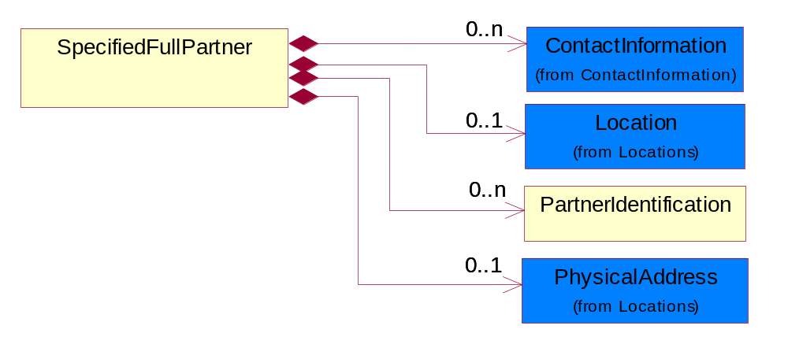
Figure ‎4-33 SpecifiedFullPartner

Composition | Cardinality | Type | Documentation
ContactInformation | 0..n | ContactInformation | The business document must allow for the identification of the name of the department, service or individual to be contacted regarding the context of the business document.
Location | 0..1 | Location | The business document must specify a location.
PartnerIdentification | 0..n | PartnerIdentification | The business document must allow for the identity of one or more parties to the transaction.
PhysicalAddress | 0..1 | PhysicalAddress | The business document must provide a physical address for a party to the business transaction.

SpecifiedIntermittentPartner
The business document must describe a physical address for a delivery.
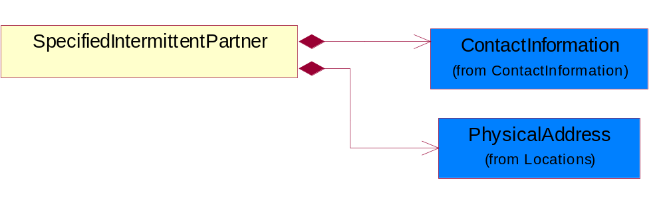
Figure ‎4-34 SpecifiedIntermittentPartner

Composition | Cardinality | Type | Documentation
ContactInformation | 1 | ContactInformation | The business document must allow for the identification of the name of the department, service or individual to be contacted regarding the context of the business document.
PhysicalAddress | 1 | PhysicalAddress | The business document must provide a physical address for a party to the business transaction.

SpecifiedKnownPartner
The business document must describe the trading partners in the business transaction.
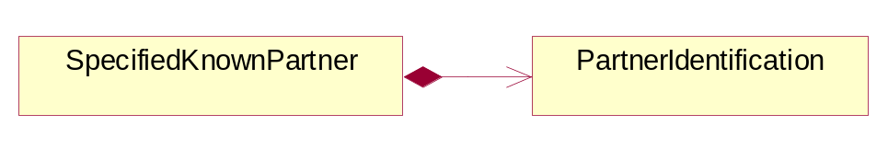
Figure ‎4-35 SpecifiedKnownPartner

Composition | Cardinality | Type | Documentation
PartnerIdentification | 1 | PartnerIdentification | The business document must allow for the identity of one or more parties to the transaction.

SpecifiedNewPartner
The business document must describe a new, existing (but known to only one of the parties to the transaction) or an unknown party to the business transaction.
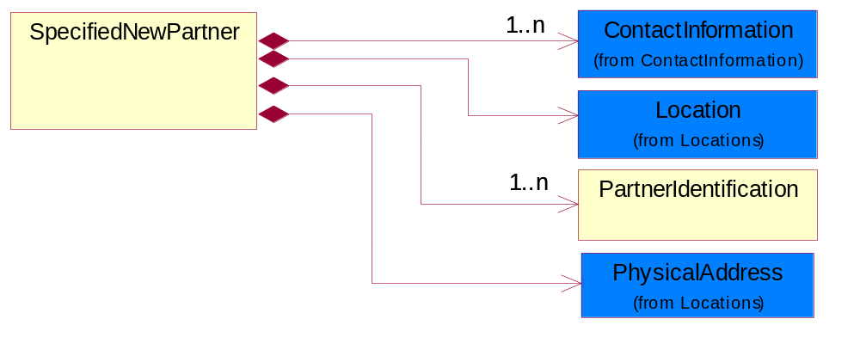
Figure ‎4-36 SpecifiedNewPartner

Composition | Cardinality | Type | Documentation
ContactInformation | 1..n | ContactInformation | The business document must allow for the identification of the name of the department, service or individual to be contacted regarding the context of the business document.
Location | 1 | Location | The business document must specify a location.
PhysicalAddress | 1 | PhysicalAddress | The business document must provide a physical address for a party to the business transaction.
PartnerIdentification | 1..n | PartnerIdentification | The business document must allow for the identity of one or more parties to the transaction.

ProductIdentification

ProductIdentification
The object provides the identifier(s) of a product.
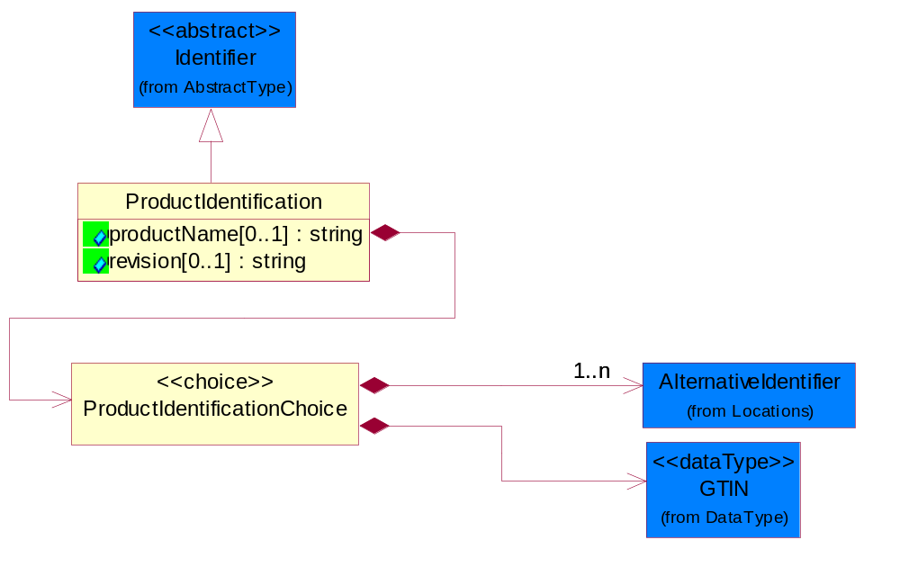
Figure ‎4-37 ProductIdentification

Attribute | Type | Documentation
productName[0..1] | string | The name of the product.
revision[0..1] | string | Referenced the specified product revision.

Composition | Cardinality | Type | Documentation
ProductIdentificationChoice | 1 | ProductIdentificationChoice

ProductIdentificationChoice

Composition | Cardinality | Type | Documentation
AlternativeIdentifier | 1..n | AlternativeIdentifier | Identifies the specified code and the name of the organization that a code is utilized from.
GTIN | 1 | GTIN | Global Trade Identification Number (GTIN).

CodeList

Country
For representation of Country name RosettaNet has adopted ISO 3166-3; 1999. Refer to the following web page to get the latest version of the standard:
http://www.iso.ch/iso/en/prods-services/iso3166ma/02iso-3166-code-lists/index.html

If you need more information about the ISO standard please contact ISO for more details.

CountrySubdivision
For representation of a Countries subdivisions RosettaNet has adopted ISO 3166-3; 1999. Refer to the following web page to get the latest version of the standard:
http://www.iso.ch/iso/en/prods-services/iso3166ma/02iso-3166-code-lists/index.html

If you need more information about the ISO standard please contact ISO for more details.

Currency
For representation of Currency codes RosettaNet has adopted ISO 4217; 1995. The British Standards Institution (BSI) is the ISO 4217 Maintenance Agency. Refer to the following web page to get the latest version of the standard:
http://www.bsi-global.com/Technical+Information/Publications/_Publications/tig90.xalter

If you need more information about the ISO standard please contact ISO for more details.

Language
For representation of Language name RosettaNet has adopted ISO 639-2; 1998. Refer to the following web page to get the latest version of the standard:

http://www.loc.gov/standards/iso639-2/iso639jac.html

If you need more information about the ISO standard please contact ISO for more details.

MimeTypeQualifier
The MIME type as defined by IANA.

Please refer to http://www.iana.org/assignments/media-types/ for a list of types.

Instance | Documentation
application/activemessage | [Shapiro]
application/andrew-inset | [Borenstein]
application/applefile | [Faltstrom]
application/atomicmail | [Borenstein]
application/batch-SMTP | [RFC2442]
application/beep+xml | [RFC3080]
application/cals-1840 | [RFC1895]
application/cnrp+xml | [RFCCNRP]
application/commonground | [Glazer]
application/cpl+xml
application/cybercash | [Eastlake]
application/dca-rft | [Campbell]
application/dec-dx | [Campbell]
application/dicom | [RFC3240]
application/dvcs | [RFC3029]
application/EDI-Consent | [RFC1767]
application/EDIFACT | [RFC1767]
application/EDI-X12 | [RFC1767]
application/eshop | [Katz]
application/font-tdpfr | [RFC3073]
application/http | [RFC2616]
application/hyperstudio | [Domino]
application/iges | [Parks]
application/index | [RFC2652]
application/index.cmd | [RFC2652]
application/index.obj | [RFC2652]
application/index.response | [RFC2652]
application/index.vnd | [RFC2652]
application/iotp | [RFC2935]
application/ipp | [RFC2910]
application/isup | [RFC3204]
application/mac-binhex40 | [Faltstrom]
application/macwriteii | [Lindner]
application/marc | [RFC2220]
application/mathematica | [Van Nostern]
application/msword | [Lindner]
application/news-message-id | [RFC1036,Spencer]
application/news-transmission | [RFC1036, Spencer]
application/ocsp-request | [RFC2560]
application/ocsp-response | [RFC2560]
application/octet-stream | [RFC2045,RFC2046]
application/oda | [RFC2045,RFC2046]
application/ogg | [RFC-walleij-ogg-mediatype-08.txt]
application/parityfec | [RFC3009]
application/pdf | [Lindner]
application/pgp-encrypted | [RFC3156]
application/pgp-keys | [RFC3156]
application/pgp-signature | [RFC3156]
application/pkcs10 | [RFC2311]
application/pkcs7-mime | [RFC2311]
application/pkcs7-signature | [RFC2311]
application/pkix-cert | [RFC2585]
application/pkixcmp | [RFC2510]
application/pkix-crl | [RFC2585]
application/postscript | [RFC2045,RFC2046]
application/prs.alvestrand.titrax-sheet | [Alvestrand]
application/prs.cww | [Rungchavalnont]
application/prs.nprend | [Doggett]
application/prs.plucker | [Janssen]
application/qsig | [RFC3204]
application/reginfo+xml | [RFC-ietf-sipping-reg-event-00.txt]
application/remote-printing | [RFC1486,Rose]
application/riscos | [Smith]
application/rtf | [Lindner]
application/sdp | [RFC2327]
application/set-payment | [Korver]
application/set-payment-initiation | [Korver]
application/set-registration | [Korver]
application/set-registration-initiation | [Korver]
application/sgml | [RFC1874]
application/sgml-open-catalog | [Grosso]
application/sieve | [RFC3028]
application/slate | [Crowley]
application/timestamp-query | [RFC3161]
application/timestamp-reply | [RFC3161]
application/tve-trigger | [Welsh]
application/vemmi | [RFC2122]
application/vnd.3gpp.pic-bw-large | [Meredith]
application/vnd.3gpp.pic-bw-small | [Meredith]
application/vnd.3gpp.pic-bw-var | [Meredith]
application/vnd.3gpp.sms | [Meredith]
application/vnd.3M.Post-it-Notes | [O'Brien]
application/vnd.accpac.simply.aso | [Leow]
application/vnd.accpac.simply.imp | [Leow]
application/vnd.acucobol | [Lubin]
application/vnd.acucorp | [Lubin]
application/vnd.adobe.xfdf | [Perelman]
application/vnd.aether.imp | [Moskowitz]
application/vnd.amiga.ami | [Blumberg]
application/vnd.anser-web-certificate-issue-initiation | [Mori]
application/vnd.anser-web-funds-transfer-initiation | [Mori]
application/vnd.audiograph | [Slusanschi]
application/vnd.blueice.multipass | [Holmstrom]
application/vnd.bmi | [Gotoh]
application/vnd.businessobjects | [Imoucha]
application/vnd.canon-cpdl | [Muto]
application/vnd.canon-lips | [Muto]
application/vnd.cinderella | [Kortenkamp]
application/vnd.claymore | [Simpson]
application/vnd.commerce-battelle | [Applebaum]
application/vnd.commonspace | [Chandhok]
application/vnd.contact.cmsg | [Patz]
application/vnd.cosmocaller | [Dellutri]
application/vnd.ctc-posml | [Kohlhepp]
application/vnd.cups-postscript | [Sweet]
application/vnd.cups-raster | [Sweet]
application/vnd.cups-raw | [Sweet]
application/vnd.curl | [Byrnes]
application/vnd.cybank | [Helmee]
application/vnd.data-vision.rdz | [Fields]
application/vnd.dna | [Searcy]
application/vnd.dpgraph | [Parker]
application/vnd.dreamfactory | [Appleton]
application/vnd.dxr | [Duffy]
application/vnd.ecdis-update | [Buettgenbach]
application/vnd.ecowin.chart | [Olsson]
application/vnd.ecowin.filerequest | [Olsson]
application/vnd.ecowin.fileupdate | [Olsson]
application/vnd.ecowin.series | [Olsson]
application/vnd.ecowin.seriesrequest | [Olsson]
application/vnd.ecowin.seriesupdate | [Olsson]
application/vnd.enliven | [Santinelli]
application/vnd.epson.esf | [Hoshina]
application/vnd.epson.msf | [Hoshina]
application/vnd.epson.quickanime | [Gu]
application/vnd.epson.salt | [Nagatomo]
application/vnd.epson.ssf | [Hoshina]
application/vnd.ericsson.quickcall | [Tidwell]
application/vnd.eudora.data | [Resnick]
application/vnd.fdf | [Zilles]
application/vnd.ffsns | [Holstage]
application/vnd.FloGraphIt | [Floersch]
application/vnd.framemaker | [Wexler]
application/vnd.fsc.weblaunch | [D.Smith]
application/vnd.fujitsu.oasys | [Togashi]
application/vnd.fujitsu.oasys2 | [Togashi]
application/vnd.fujitsu.oasys3 | [Okudaira]
application/vnd.fujitsu.oasysgp | [Sugimoto]
application/vnd.fujitsu.oasysprs | [Ogita]
application/vnd.fujixerox.ddd | [Onda]
application/vnd.fujixerox.docuworks | [Taguchi]
application/vnd.fujixerox.docuworks.binder | [Matsumoto]
application/vnd.fut-misnet | [Pruulmann]
application/vnd.grafeq | [Tupper]
application/vnd.groove-account | [Joseph]
application/vnd.groove-help | [Joseph]
application/vnd.groove-identity-message | [Joseph]
application/vnd.groove-injector | [Joseph]
application/vnd.groove-tool-message | [Joseph]
application/vnd.groove-tool-template | [Joseph]
application/vnd.groove-vcard | [Joseph]
application/vnd.hbci | [Hammann]
application/vnd.hhe.lesson-player | [Jones]
application/vnd.hp-HPGL | [Pentecost]
application/vnd.hp-hpid | [Gupta]
application/vnd.hp-hps | [Aubrey]
application/vnd.hp-PCL | [Pentecost]
application/vnd.hp-PCLXL | [Pentecost]
application/vnd.httphone | [Lefevre]
application/vnd.hzn-3d-crossword | [Minnis]
application/vnd.ibm.afplinedata | [Buis]
application/vnd.ibm.electronic-media | [Tantlinger]
application/vnd.ibm.MiniPay | [Herzberg]
application/vnd.ibm.modcap | [Hohensee]
application/vnd.ibm.secure-container | [Tantlinger]
application/vnd.informix-visionary | [Gales]
application/vnd.intercon.formnet | [Gurak]
application/vnd.intertrust.digibox | [Tomasello]
application/vnd.intertrust.nncp | [Tomasello]
application/vnd.intu.qbo | [Scratchley]
application/vnd.intu.qfx | [Scratchley]
application/vnd.irepository.package+xml | [Knowles]
application/vnd.is-xpr | [Natarajan]
application/vnd.japannet-directory-service | [Fujii]
application/vnd.japannet-jpnstore-wakeup | [Yoshitake]
application/vnd.japannet-payment-wakeup | [Fujii]
application/vnd.japannet-registration | [Yoshitake]
application/vnd.japannet-registration-wakeup | [Fujii]
application/vnd.japannet-setstore-wakeup | [Yoshitake]
application/vnd.japannet-verification | [Yoshitake]
application/vnd.japannet-verification-wakeup | [Fujii]
application/vnd.jisp | [Deckers]
application/vnd.kde.karbon | [Faure]
application/vnd.kde.kchart | [Faure]
application/vnd.kde.kformula | [Faure]
application/vnd.kde.kivio | [Faure]
application/vnd.kde.kontour | [Faure]
application/vnd.kde.kpresenter | [Faure]
application/vnd.kde.kspread | [Faure]
application/vnd.kde.kword | [Faure]
application/vnd.kenameaapp | [DiGiorgio-Haag]
application/vnd.koan | [Cole]
application/vnd.liberty-request+xml | [McDowell]
application/vnd.llamagraphics.life-balance.desktop | [White]
application/vnd.lotus-1-2-3 | [Wattenberger]
application/vnd.lotus-approach | [Wattenberger]
application/vnd.lotus-freelance | [Wattenberger]
application/vnd.lotus-notes | [Laramie]
application/vnd.lotus-organizer | [Wattenberger]
application/vnd.lotus-screencam | [Wattenberger]
application/vnd.lotus-wordpro | [Wattenberger]
application/vnd.mcd | [Gotoh]
application/vnd.mediastation.cdkey | [Flurry]
application/vnd.meridian-slingshot | [Wedel]
application/vnd.micrografx.flo | [Prevo]
application/vnd.micrografx.igx | [Prevo]
application/vnd.mif | [Wexler]
application/vnd.minisoft-hp3000-save | [Bartram]
application/vnd.mitsubishi.misty-guard.trustweb | [Tanaka]
application/vnd.Mobius.DAF | [Kabayama]
application/vnd.Mobius.DIS | [Kabayama]
application/vnd.Mobius.MBK | [Devasia]
application/vnd.Mobius.MQY | [Devasia]
application/vnd.Mobius.MSL | [Kabayama]
application/vnd.Mobius.PLC | [Kabayama]
application/vnd.Mobius.TXF | [Kabayama]
application/vnd.mophun.application | [Wennerstrom]
application/vnd.mophun.certificate | [Wennerstrom]
application/vnd.motorola.flexsuite | [Patton]
application/vnd.motorola.flexsuite.adsi | [Patton]
application/vnd.motorola.flexsuite.fis | [Patton]
application/vnd.motorola.flexsuite.gotap | [Patton]
application/vnd.motorola.flexsuite.kmr | [Patton]
application/vnd.motorola.flexsuite.ttc | [Patton]
application/vnd.motorola.flexsuite.wem | [Patton]
application/vnd.mozilla.xul+xml | [McDaniel]
application/vnd.ms-artgalry | [Slawson]
application/vnd.ms-asf | [Fleischman]
application/vnd.mseq | [Le Bodic]
application/vnd.ms-excel | [Gill]
application/vnd.msign | [Borcherding]
application/vnd.ms-lrm | [Ledoux]
application/vnd.ms-powerpoint | [Gill]
application/vnd.ms-project | [Gill]
application/vnd.ms-tnef | [Gill]
application/vnd.ms-works | [Gill]
application/vnd.ms-wpl | [Plastina]
application/vnd.musician | [Adams]
application/vnd.music-niff | [Butler]
application/vnd.netfpx | [Mutz]
application/vnd.noblenet-directory | [Solomon]
application/vnd.noblenet-sealer | [Solomon]
application/vnd.noblenet-web | [Solomon]
application/vnd.novadigm.EDM | [Swenson]
application/vnd.novadigm.EDX | [Swenson]
application/vnd.novadigm.EXT | [Swenson]
application/vnd.obn | [Hessling]
application/vnd.osa.netdeploy | [Klos]
application/vnd.palm | [Peacock]
application/vnd.pg.format | [Gandert]
application/vnd.pg.osasli | [Gandert]
application/vnd.powerbuilder6 | [Guy]
application/vnd.powerbuilder6-s | [Guy]
application/vnd.powerbuilder7 | [Shilts]
application/vnd.powerbuilder75 | [Shilts]
application/vnd.powerbuilder75-s | [Shilts]
application/vnd.powerbuilder7-s | [Shilts]
application/vnd.previewsystems.box | [Smolgovsky]
application/vnd.publishare-delta-tree | [Ben-Kiki]
application/vnd.pvi.ptid1 | [Lamb]
application/vnd.pwg-multiplexed | [RFC3391]
application/vnd.pwg-xhtml-print+xml | [Wright]
application/vnd.Quark.QuarkXPress | [Scheidler]
application/vnd.rapid | [Szekely]
application/vnd.s3sms | [Tarkkala]
application/vnd.sealed.net | [Lambert]
application/vnd.seemail | [Webb]
application/vnd.shana.informed.formdata | [Selzler]
application/vnd.shana.informed.formtemplate | [Selzler]
application/vnd.shana.informed.interchange | [Selzler]
application/vnd.shana.informed.package | [Selzler]
application/vnd.smaf | [Takahashi]
application/vnd.sss-cod | [Dani]
application/vnd.sss-dtf | [Bruno]
application/vnd.sss-ntf | [Bruno]
application/vnd.street-stream | [Levitt]
application/vnd.svd | [Becker]
application/vnd.swiftview-ics | [Widener]
application/vnd.triscape.mxs | [Simonoff]
application/vnd.trueapp | [Hepler]
application/vnd.truedoc | [Chase]
application/vnd.ufdl | [Manning]
application/vnd.uplanet.alert | [Martin]
application/vnd.uplanet.alert-wbxml | [Martin]
application/vnd.uplanet.bearer-choice | [Martin]
application/vnd.uplanet.bearer-choice-wbxml | [Martin]
application/vnd.uplanet.cacheop | [Martin]
application/vnd.uplanet.cacheop-wbxml | [Martin]
application/vnd.uplanet.channel | [Martin]
application/vnd.uplanet.channel-wbxml | [Martin]
application/vnd.uplanet.list | [Martin]
application/vnd.uplanet.listcmd | [Martin]
application/vnd.uplanet.listcmd-wbxml | [Martin]
application/vnd.uplanet.list-wbxml | [Martin]
application/vnd.uplanet.signal | [Martin]
application/vnd.vcx | [T.Sugimoto]
application/vnd.vectorworks | [Pharr]
application/vnd.vidsoft.vidconference | [Hess]
application/vnd.visio | [Sandal]
application/vnd.visionary | [Aravindakumar]
application/vnd.vividence.scriptfile | [Risher]
application/vnd.vsf | [Rowe]
application/vnd.wap.sic | [WAP-Forum]
application/vnd.wap.slc | [WAP-Forum]
application/vnd.wap.wbxml | [Stark]
application/vnd.wap.wmlc | [Stark]
application/vnd.wap.wmlscriptc | [Stark]
application/vnd.webturbo | [Rehem]
application/vnd.wrq-hp3000-labelled | [Bartram]
application/vnd.wt.stf | [Wohler]
application/vnd.wv.csp+wbxml | [Salmi]
application/vnd.xara | [Matthewman]
application/vnd.xfdl | [Manning]
application/vnd.yellowriver-custom-menu | [Yellow]
application/whoispp-query | [RFC2957]
application/whoispp-response | [RFC2958]
application/wita | [Campbell]
application/wordperfect5.1 | [Lindner]
application/x400-bp | [RFC1494]
application/xhtml+xml | [RFC3236]
application/xml | [RFC3023]
application/xml-dtd | [RFC3023]
application/xml-external-parsed-entity | [RFC3023]
application/zip | [Lindner]
audio/32kadpcm | [RFC2421,RFC2422]
audio/AMR | [RFC3267]
audio/AMR-WB | [RFC3267]
audio/basic | [RFC2045,RFC2046]
audio/CN | [RFC3389]
audio/DAT12 | [RFC3190]
audio/DVI4
audio/EVRC | [RFC-ietf-avt-evrc-smv-03.txt]
audio/EVRC0 | [RFC-ietf-avt-evrc-smv-03.txt]
audio/G.722.1 | [RFC3047]
audio/G722
audio/G723
audio/G726-16
audio/G726-24
audio/G726-32
audio/G726-40
audio/G728
audio/G729
audio/G729D
audio/G729E
audio/GSM
audio/GSM-EFR
audio/L16 | [RFC2586]
audio/L20 | [RFC3190]
audio/L24 | [RFC3190]
audio/L8
audio/LPC
audio/MP4A-LATM | [RFC3016]
audio/MPA
audio/mpa-robust | [RFC3119]
audio/mpeg | [RFC3003]
audio/parityfec | [RFC3009]
audio/PCMA
audio/PCMU
audio/prs.sid | [Walleij]
audio/QCELP
audio/RED
audio/SMV | [RFC-ietf-avt-evrc-smv-03.txt]
audio/SMV0 | [RFC-ietf-avt-evrc-smv-03.txt]
audio/telephone-event | [RFC2833]
audio/tone | [RFC2833]
audio/VDVI
audio/vnd.3gpp.iufp | [Belling]
audio/vnd.cisco.nse | [Kumar]
audio/vnd.cns.anp1 | [McLaughlin]
audio/vnd.cns.inf1 | [McLaughlin]
audio/vnd.digital-winds | [Strazds]
audio/vnd.everad.plj | [Cicelsky]
audio/vnd.lucent.voice | [Vaudreuil]
audio/vnd.nortel.vbk | [Parsons]
audio/vnd.nuera.ecelp4800 | [Fox]
audio/vnd.nuera.ecelp7470 | [Fox]
audio/vnd.nuera.ecelp9600 | [Fox]
audio/vnd.octel.sbc | [Vaudreuil]
audio/vnd.qcelp | [Lundblade]
audio/vnd.rhetorex.32kadpcm | [Vaudreuil]
audio/vnd.vmx.cvsd | [Vaudreuil]
image/cgm | Computer Graphics Metafile
image/g3fax | [RFC1494]
image/gif | [RFC2045,RFC2046]
image/ief | [RFC1314] Image Exchange Format
image/jpeg | [RFC2045,RFC2046]
image/naplps | [Ferber]
image/png | [Randers-Pehrson]
image/prs.btif | [Simon]
image/prs.pti | [Laun]
image/t38 | [RFC3362]
image/tiff | [RFC3302] Tag Image File Format
image/tiff-fx | [RFC3250] Tag Image File Format Fax eXtended
image/vnd.cns.inf2 | [McLaughlin]
image/vnd.djvu | [Bottou]
image/vnd.dwg | [Moline]
image/vnd.dxf | [Moline]
image/vnd.fastbidsheet | [Becker]
image/vnd.fpx | [Spencer]
image/vnd.fst | [Fuldseth]
image/vnd.fujixerox.edmics-mmr | [Onda]
image/vnd.fujixerox.edmics-rlc | [Onda]
image/vnd.globalgraphics.pgb | [Bailey]
image/vnd.mix | [Reddy]
image/vnd.ms-modi | [Vaughan]
image/vnd.net-fpx | [Spencer]
image/vnd.svf | [Moline]
image/vnd.wap.wbmp | [Stark]
image/vnd.xiff | [S.Martin]
message/delivery-status | [RFC1894]
message/disposition-notification | [RFC2298]
message/external-body | [RFC2045,RFC2046]
message/http | [RFC2616]
message/news | [RFC 1036, H.Spencer]
message/partial | [RFC2045,RFC2046]
message/rfc822 | [RFC2045,RFC2046]
message/s-http | [RFC2660]
message/sip | [RFC3261]
message/sipfrag | [RFC3420]
model/iges | [Parks]
model/mesh | [RFC2077]
model/vnd.dwf | [Pratt]
model/vnd.flatland.3dml | [Powers]
model/vnd.gdl | [Babits]
model/vnd.gs-gdl | [Babits]
model/vnd.gtw | [Ozaki]
model/vnd.mts | [Rabinovitch]
model/vnd.parasolid.transmit.binary | [Parasolid]
model/vnd.parasolid.transmit.text | [Parasolid]
model/vnd.vtu | [Rabinovitch]
model/vrml | [RFC2077]
multipart/alternative | [RFC2045,RFC2046]
multipart/appledouble | [Faltstrom]
multipart/byteranges | [RFC2068]
multipart/digest | [RFC2045,RFC2046]
multipart/encrypted | [RFC1847]
multipart/form-data | [RFC2388]
multipart/header-set | [Crocker]
multipart/mixed | [RFC2045,RFC2046]
multipart/parallel | [RFC2045,RFC2046]
multipart/related | [RFC2387]
multipart/report | [RFC1892]
multipart/signed | [RFC1847]
multipart/voice-message | [RFC2421,RFC2423]
text/calendar | [RFC2445]
text/css | [RFC2318]
text/directory | [RFC2425]
text/enriched | [RFC1896]
text/html | [RFC2854]
text/parityfec | [RFC3009]
text/plain | [RFC2646,RFC2046]
text/prs.lines.tag | [Lines]
text/rfc822-headers | [RFC1892]
text/richtext | [RFC2045,RFC2046]
text/rtf | [Lindner]
text/sgml | [RFC1874]
text/t140 | [RFC2793]
text/tab-separated-values | [Lindner]
text/uri-list | [RFC2483]
text/vnd.abc | [Allen]
text/vnd.curl | [Byrnes]
text/vnd.DMClientScript | [Bradley]
text/vnd.fly | [Gurney]
text/vnd.fmi.flexstor | [Hurtta]
text/vnd.in3d.3dml | [Powers]
text/vnd.in3d.spot | [Powers]
text/vnd.IPTC.NewsML | [IPTC]
text/vnd.IPTC.NITF | [IPTC]
text/vnd.latex-z | [Lubos]
text/vnd.motorola.reflex | [Patton]
text/vnd.ms-mediapackage | [Nelson]
text/vnd.net2phone.commcenter.command | [Xie]
text/vnd.sun.j2me.app-descriptor | [G.Adams]
text/vnd.wap.si | [WAP-Forum]
text/vnd.wap.sl | [WAP-Forum]
text/vnd.wap.wml | [Stark]
text/vnd.wap.wmlscript | [Stark]
text/xml | [RFC3023]
text/xml-external-parsed-entity | [RFC3023]
video/BMPEG
video/BT656
video/CelB
video/DV | [RFC3189]
video/H261
video/H263
video/H263-1998
video/H263-2000
video/JPEG
video/MP1S
video/MP2P
video/MP2T
video/MP4V-ES | [RFC3016]
video/mpeg | [RFC2045,RFC2046]
video/MPV
video/nv
video/parityfec | [RFC3009]
video/pointer | [RFC2862]
video/quicktime | [Lindner]
video/SMPTE292M | [RFC-avt-smpte292-video-08.txt]
video/vnd.fvt | [Fuldseth]
video/vnd.motorola.video | [McGinty]
video/vnd.motorola.videop | [McGinty]
video/vnd.mpegurl | [Recktenwald]
video/vnd.nokia.interleaved-multimedia | [Kangaslampi]
video/vnd.objectvideo | [Clark]
video/vnd.vivo | [Wolfe]

ProcessRoleIdentifier
Describes the role of the partner in the business process. A partner will fulfill at least one or more roles during the business process.

Instance | Documentation
ADM | Administered by - The party who is the administrative authority of an account.
ALT | Alternate approval by - The party who has approved a request in the event the approver is not able to respond.
APP | Approval by - The party who has approved a request.
AUT | Authorized By - The party who has authorized a request.
BIF | Bill from - The party that will issue the invoice.
BIT | Bill to - The party that will pay the invoice.
CBK | Customs Broker - CustomsBroker  This object represents the party that declare the shipment on behalf of declarant.
CLF | Collect From - To enable the buyer to specify the location of where products not supplied directly by the seller/installer may be collected.
CLM | Claimed By - This object represents the claimant.
CNC | Cancellation party - The party who is cancelling the shipping order.
COR | Change originated by - The party who originates a proposed change.
COW | Change owned by - The party who owns or who is assigned responsibility for a proposed change.
CRA | Credit applicant - The party who is applying for credit.
CRE | Created by - The party responsible for creating a process or task.
CSP | Contract Service Provider.
CWN | contractOwner - The party who is the owner of the contract. For example, in the direct business, the buyer is the contract owner. In the distribution business, the buyer is the distributor and the contract owner is the reseller.
DCE | DesignCustomerApplicationEngineer. The demand customer's Field Application Engineer.
DCT | Declared To - This object represents the party that the declaration goes to.
DCU | DesignCustomer. The owner of the product for which the design has been created.
DIS | Distributed by - The party who supplies products to retailers.
DLR | Declared By - This object represents the party that declare the shipment.
DST | Distributed To - This object represents the party to send information to.
FCP | Forecast Partner - The collection of business properties that describes the partner types for a forecast.
FIA | From Install At - The collection of sender business properties that describes a business partners' identity, their contact information, where they are physically located and their function in a supply chain.
FIN | Financed by - The party who is the financier.
FNB | Founded by - The party who performs the act, process, or art of casting metals.
FOR | Forwarded to - The party to whom a business document has been forwarded.
IMB | Imported By - The party responsible for importing the product.
INL | Inventory location - The party where the inventory product entry is located.
INO | Inventory owner - The party that owns the inventory product entry.
ITF | In transit from - The party sending the product quantity in a product location transfer.
ITL | installAt - The partner and/or location to which the product must be set up for use or service.
ITT | In transit to - The party receiving the product quantity in a product location transfer.
LGP | Logistics Provided By - The party who handles the details of an operation.
MFG | Manufactured by - The party who creates, processes or produces goods especially in large quantities and by means of industrial machines.
OWN | Owned by - The party who owns a process.
PAE | ProductProviderFieldApplicationEngineer. The product provider Field Application Engineer.
PCW | Primary Contract With - The primary party with whom a contract is formed.
PNB | Planning By - The party who establishes goals, policies or procedures.
PSR | ProductProviderSalesRepresentative. The product provider sales representative.
PUR | Purchased by - The party who is a purchaser of a product.
REA | Requested approval by - The party who has been selected to approve a request.
REC | Received by - The party who has received a product shipment.
REQ | Requested by - The party who has initiated a request.
RES | Respond to - The party to whom a responding business document must be sent when it is not equal to the partner specified in the document header.
RET | Return by - The party responsible for either carrying or forwarding the returned product.
REV | Reviewed by - The party responsible for reviewing a business document.
RFR | receivedFrom - The partner and/or location from where the product was shipped.
RLS | Released By - This object represents the party that releases the goods.
RMT | remitTo - The partner to which payment for a business document is sent.
RPB | Repaired By - The collection of business properties used to identify the business partner responsible for the repair or  rework of a product.
RQT | Refer Quote To - The partner to whom a quote request is being referred.
RSF | Requested Ship From - The party where the product is requested to be shipped from.
RTT | ReturnTo - The partner and/or location to which the returned product must be delivered.
SBF | Self-billing from - The party who initiates the billing in self-billing scenario.
SBT | Self-billing to - The party whom the invoice is addressed to.
SCB | Subcontracted By - The party who is contracted to perform part or all of another party's contract.
SCP | Shipping charges paid by - The party responsible for administering payment of the shipping charges.
SCW | Secondary Contract With - The subsequent party(ies) with whom a contract is formed.
SHF | Ship From - The collection of business properties used to identify the business partner initiating a shipment or transaction.
SHT | Ship To - The partner and/or location to which the product must be delivered.
SLD | Sold to - The party to whom a product has been sold.
SOB | Sold By - The seller involved in a business transaction.
SPL | Supplied by - The party who supplies an item, part or assembly.
SPS | Service Provider Site - Identification for the location of the ASP site that is ordering the replacement parts and/or performing the repair.
SRT | Submit returns to - The party to whom product returns are to be submitted.
STR | Stored By - This object represents the party that stores the goods.
SVA | ShipVia - The partner and/or location through which the product must be shipped, such as the "cross dock" at a shipping hub.  It must not be specified for the last leg, since this would be the same as the final destination specified in the ShipmentInformation/shipTo.
TFR | Transfer From - The party responsible for making the payment (Payer).
TIA | To lnstall At - The collection of receiver business properties that describes business partners' identity, their contact information, where they are physically located and their function in a supply chain.
TMT | Transfer Manufacturing To - The movement of the manufacturing process to another site.
TRA | Transported by - The party responsible for either carrying or forwarding the product.
TSB | Tested By - The collection of business properties used to identify the specific location and resources used to conduct a defined cycle or steps or measurements required to confirm a result or event.
TTR | Transfer To - The party who is receiving the payment (payee).
ULR | Ultimate recipient - The party who ultimately receives the shipment, when an intermediate party takes responsibility for payment and final delivery.
USE | Used by - The party who is the end user of the product.
UST | Unstuffed By - This object represents the party that unstuffs the goods.
WHB | Warehoused By - The party who stocks or stores products.

System Structure

BusinessProcessIdentifier
A Business Process Identifier to uniquely define the TPIR-PIP 'role' within a Business Scenario at a company or MNC level. The identifier MUST be composed of alphanumeric characters only and its length MUST be between one and twelve characters.
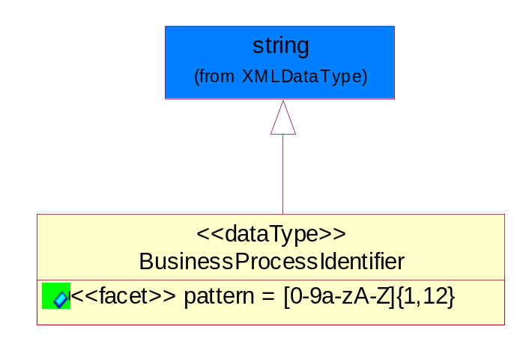
Figure ‎5-38 BusinessProcessIdentifier

Attribute | Type | Documentation
pattern |  | [0-9a-zA-Z]{1,12}

BusinessServiceInformation
The object allows the specification of the business service utilized within the partner company. This may or may not be the same as the information sent by the RNIF.
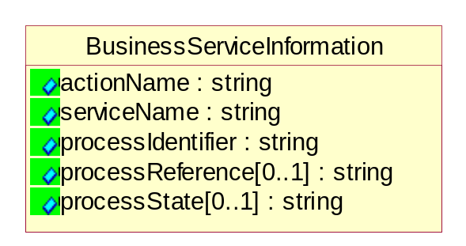
Figure ‎5-39 BusinessServiceInformation

Attribute | Type | Documentation
actionName | string | The name of Action. For RosettaNet usually any of Request/Confirm/Notify/Query/Response.
serviceName | string | The name of the Business Activity with the "Request/Confirm" part removed. E.g., for the Activity "Request Purchase Order"==> "Purchase Order".
processIdentifier | string | The name of the PIP e.g. Notify of Forecast Reply.
processReference[0..1] | string | The URN for the PIP that includes Cluster/Segment/Process pattern used to identify the interface process (such as PIP3A4)
processState[0..1] | string | The business process (or service) state of the sender of a document. When a service receives this document, the receiver may use the state as a precondition.

ContractInformation
A block of information used to correlate a contract in an executing choreography.

Figure ‎5-40 ContractInformation

Attribute | Type | Documentation
contractIdentifier[0..1] | string | Unique identification of a contract between the Sender and the Receiver
contractType[0..1] | string | The type of the contract: an attribute describing the type of the ContractIndentification. Valid values are URI, URN,ebXMLCPA, or other values defined by partners.

CorrelationInformation
A block of information used to correlate a requesting document to a responding document and to the contract in an executing choreography.
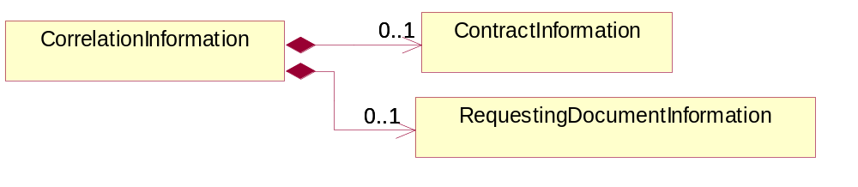
Figure ‎5-41 CorrelationInformation

Composition | Cardinality | Type | Documentation
ContractInformation | 0..1 | ContractInformation | A block of information used to correlate a contract in an executing choreography.
RequestingDocumentInformation | 0..1 | RequestingDocumentInformation | A block of information used to correlate a requesting document to a responding document in an executing choreography.

DocumentHeader
The object allows for the identification of the sender and receiver of the business document.
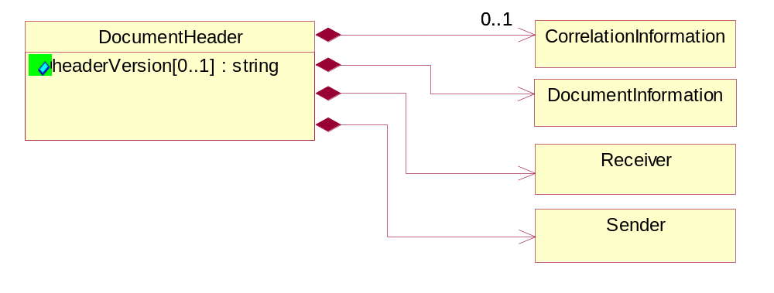
Figure ‎5-42 DocumentHeader

Attribute | Type | Documentation
headerVersion[0..1] | string | The UN/CEFACT version of the document header.

Composition | Cardinality | Type | Documentation
Sender | 1 | Sender | The object allows the identification of the initiating party of the business message.
CorrelationInformation | 0..1 | CorrelationInformation | A block of information used to correlate a requesting document to a responding document and to the contract in an executing choreography.
DocumentInformation | 1 | DocumentInformation | The object specifies information to identify the business document, a summary of attachments, and information about the business document security.
Receiver | 1 | Receiver | The object allows the identification of the receiving party of the business message.

DocumentIdentification
The object specifies all information necessary to identify the business document.
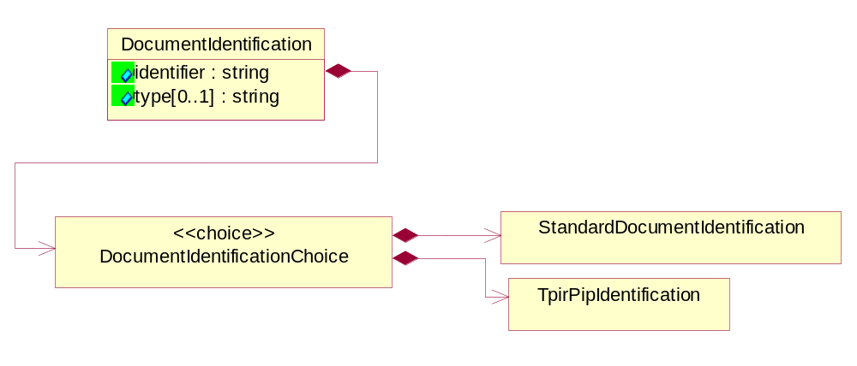
Figure ‎5-43 DocumentIdentification

Attribute | Type | Documentation
identifier | string | The unique identifier for the document being sent.
type[0..1] | string | Name of the Action Message

Composition | Cardinality | Type | Documentation
DocumentIdentificationChoice | 1 | DocumentIdentificationChoice

DocumentIdentificationChoice

Composition | Cardinality | Type | Documentation
StandardDocumentIdentification | 1 | StandardDocumentIdentification | The object specifies additional information necessary to identify the standard business document.
TpirPipIdentification | 1 | TpirPipIdentification | The object specifies all information necessary to uniquely identify a TPIR-PIP within a Registry or trading partner repository.

DocumentInformation
The object specifies information to identify the business document, a summary of attachments, and information about the business document security.
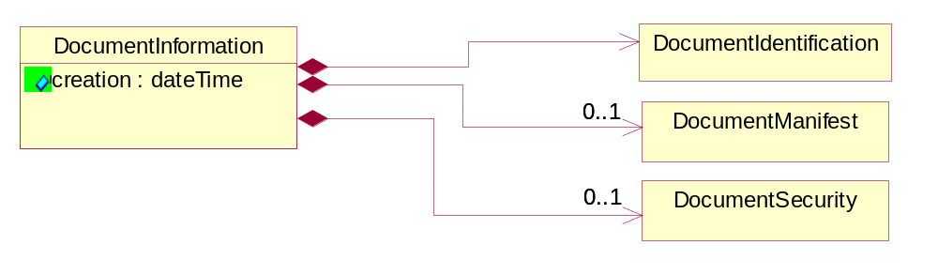
Figure ‎5-44 DocumentInformation

Attribute | Type | Documentation
creation | dateTime | The creation date and time of the specified Business Document (i.e. the Purchase Order date).

Composition | Cardinality | Type | Documentation
DocumentIdentification | 1 | DocumentIdentification | The object specifies all information necessary to identify the business document.
DocumentSecurity | 0..1 | DocumentSecurity | The object provides additional granularity in specifying business document security (this is in addition to the specified PIP security).
DocumentManifest | 0..1 | DocumentManifest | The block provides a brief summary of attachments and Service Content.

DocumentManifest
The block provides a brief summary of attachments and Service Content.
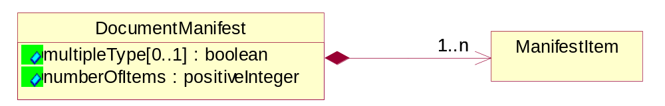
Figure ‎5-45 DocumentManifest

Attribute | Type | Documentation
multipleType[0..1] | boolean | Indicates whether the manifest contains documents of multiple types. True if yes, and False if no.
numberOfItems | positiveInteger | Total number of documents in the message. The physical count of the attachments in the payload plus the RosettaNet Business Message (for Service Content). The value of this field will be at least 1.

Composition | Cardinality | Type | Documentation
ManifestItem | 1..n | ManifestItem | The object provides details about the specific attachment(s).

DocumentSecurity
The object provides additional granularity in specifying business document security (this is in addition to the specified PIP security).

Figure ‎5-46 DocumentSecurity

Attribute | Type | Documentation
nonRepudiableReceipt | boolean | The value "true" will indicate that a signed acknowledgement for the business document is necessary.
persistentEncryption | boolean | The value "true" will indicate that the Business Document (including the header) needs to be encrypted when stored or transported.
persistentSignature | boolean | The value "true" will indicate that a signature is required to be stored with the document while stored or transported.

ManifestItem
The object provides details about the specific attachment(s).

Figure ‎5-47 ManifestItem

Attribute | Type | Documentation
description[0..1] | string | A description of the attachment.
length[0..1] | positiveInteger | The size of the attachment in bytes (i.e. 1 000 000 bytes)
universalResourceIdentifier | string | The generic set of all names/addresses that are short strings that refer to resources.

Composition | Cardinality | Type | Documentation
mimeTypeQualifier | 1 | MimeTypeQualifier | The MIME type as defined by IANA.  Please refer to http://www.iana.org/assignments/media-types/ for a list of types.
language | 0..1 | Language | For representation of Language name RosettaNet has adopted ISO 639-2; 1998. Refer to the following web page to get the latest version of the standard:  http://www.loc.gov/standards/iso639-2/iso639jac.html  If you need more information about the ISO standard please contact ISO for more details.

PipIdentifier
PIP Identification.[ i.e. PIP3A4]
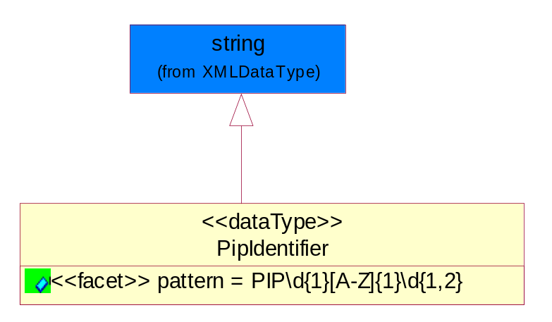
Figure ‎5-48 PipIdentifier

Attribute | Type | Documentation
pattern |  | PIP\d{1}[A-Z]{1}\d{1,2}

PipVersion
PIP version number (i.e. 02.02.00).
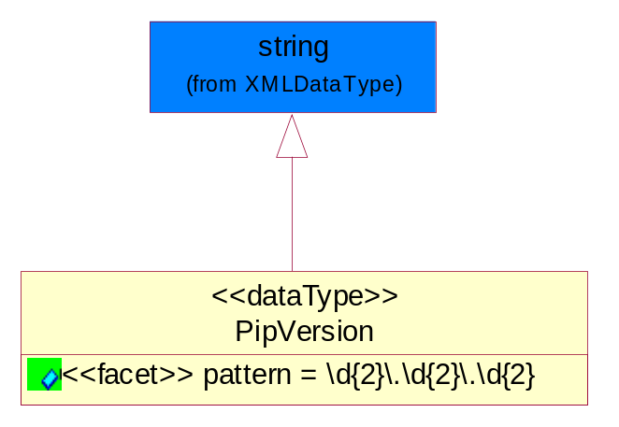
Figure ‎5-49 PipVersion

Attribute | Type | Documentation
pattern |  | \d{2}\.\d{2}\.\d{2}

Receiver
The object allows the identification of the receiving party of the business message.
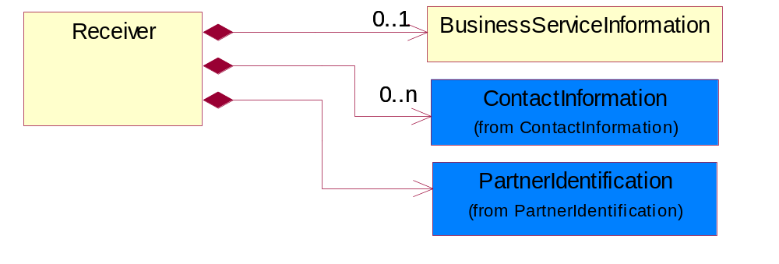
Figure ‎5-50 Receiver

Composition | Cardinality | Type | Documentation
BusinessServiceInformation | 0..1 | BusinessServiceInformation | The object allows the specification of the business service utilized within the partner company. This may or may not be the same as the information sent by the RNIF.
PartnerIdentification | 1 | PartnerIdentification | The business document must allow for the identity of one or more parties to the transaction.
ContactInformation | 0..n | ContactInformation | The business document must allow for the identification of the name of the department, service or individual to be contacted regarding the context of the business document.

RequestingDocumentInformation
A block of information used to correlate a requesting document to a responding document in an executing choreography.

Figure ‎5-51 RequestingDocumentInformation

Attribute | Type | Documentation
businessProcessInstanceIdentifier[0..1] | string | The identifier for the public business process instance being sent that both the sender and receiver can identify.
responseDateTime[0..1] | dateTime | The expected time to receive the response. This can not be greater than the PIP TimeToPerform.
requestingDocumentCreationDateTime[0..1] | dateTime | The date-time of the requesting business document.
requestingDocumentInstanceIdentifier | string | The Business Document identification number that identifies the requesting Business Document.

Sender
The object allows the identification of the initiating party of the business message.
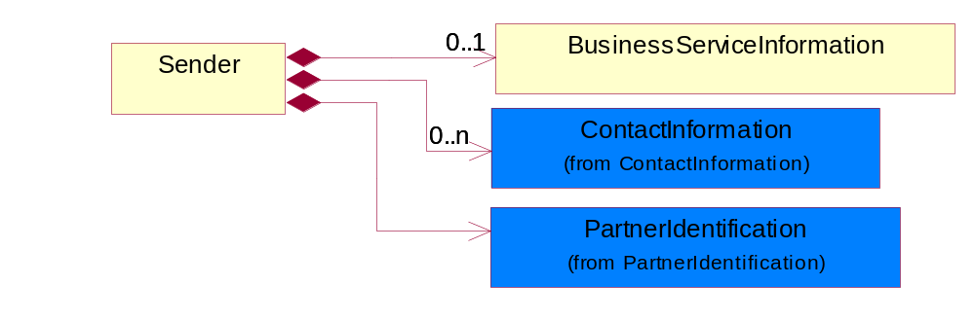
Figure ‎5-52 Sender

Composition | Cardinality | Type | Documentation
PartnerIdentification | 1 | PartnerIdentification | The business document must allow for the identity of one or more parties to the transaction.
BusinessServiceInformation | 0..1 | BusinessServiceInformation | The object allows the specification of the business service utilized within the partner company. This may or may not be the same as the information sent by the RNIF.
ContactInformation | 0..n | ContactInformation | The business document must allow for the identification of the name of the department, service or individual to be contacted regarding the context of the business document.

StandardDocumentIdentification
The object specifies additional information necessary to identify the standard business document.
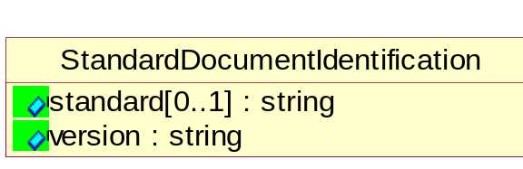
Figure ‎5-53 StandardDocumentIdentification

Attribute | Type | Documentation
standard[0..1] | string | Identifies the standard used to submit the business document. (e.g. RosettaNet).
version | string | PIP3A4v01.00

TpirPipIdentification
The object specifies all information necessary to uniquely identify a TPIR-PIP within a Registry or trading partner repository.

Figure ‎5-54 TpirPipIdentification

Attribute | Type | Documentation
partnerId | DUNSPlus4 | The Trading Partner Identification of MNC that is creating this TPIR PIP.
pipIdentifier | PipIdentifier | A TPIR PIP Identification [i.e., 3A4 ).
pipVersion | PipVersion | A TPIR PIP version number (i.e., 02.02.00)
tpirPipVersion | VersionIdentifier | A TPIR-PIP Version Number (i.e., major and minor version number as XX.XX).
tpirBusinessProcessIdentifier[0..1] | BusinessProcessIdentifier | A Business Process Identifier to uniquely define the TPIR-PIP 'role' within a Business Scenario at a company or MNC level. The identifier MUST be composed of alphanumeric characters only and its length MUST be between one and twelve characters.
uri[0..1] | anyURI | Describes the destination uri for the TPIR form.

Composition | Cardinality | Type | Documentation
fileType | 0..1 | TPIRFileType | Describes the file type of the TPIR form (PDF, XDP or XML).

VersionIdentifier
Version Number (i.e., major and minor version number as XX.XX).
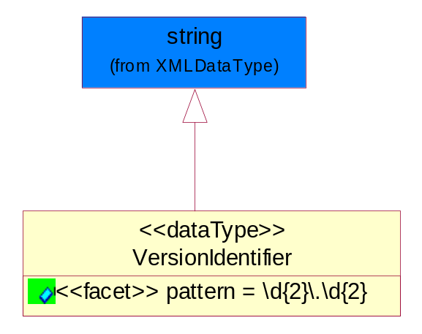
Figure ‎5-55 VersionIdentifier

Attribute | Type | Documentation
pattern |  | \d{2}\.\d{2}

CodeList

TPIRFileType
A code identifying the file type of TPIR form.

Name | Documentation
PDF | Portable Document Format.
XDP | XML Data Package.
XML | eXtensible Markup Language.

XML Data Type

anyURI
Represents a URI as defined by RFC 2396. An anyURI value can be absolute or relative, and may have an optional fragment identifier.

boolean
Represents Boolean values, which are either "true" or "false".

date
For the represents a calendar date.
The pattern for a date is CCYY-MM-DD where CC represents the century, YY the year, MM the month, and DD the day, with an optional time zone indicator as allowed for dateTime.

dateTime
Represents a specific instance of time.
The pattern for dateTime is CCYY-MM-DDThh:mm:ss where CC represents the century, YY the year, MM the month, and DD the day, preceded by an optional leading negative (-) character to indicate a negative number. If the negative character is omitted, positive (+) is assumed. The T is the date/time separator and hh, mm, and ss represent hour, minute, and second respectively. Additional digits can be used to increase the precision of fractional seconds if desired. For example, the format ss.ss... with any number of digits after the decimal point is supported. The fractional seconds part is optional.

This representation may be immediately followed by a "Z" to indicate Coordinated Universal Time (UTC) or to indicate the time zone. For example, the difference between the local time and Coordinated Universal Time, immediately followed by a sign, + or -, followed by the difference from UTC represented as hh:mm (minutes is required). If the time zone is included, both hours and minutes must be present.

float
Represents single-precision 32-bit floating-point numbers.

positiveInteger
Represents an integer that is greater than zero. This data type is derived from nonNegativeInteger.

string
Represents character string.

