

Description of
Partner Interface Process® for 6C8

Validated 11.00.00

Specification Information
Name | Notify of Warranty Claim Confirmation
Cluster | Service and Support
Segment | Technical Support & Service Management
Publication Date | 10 March 2010
Version Identifier | V11.00

Table of Contents
1 Document Management 4
1.1 Legal Disclaimer 4
1.2 Copyright 4
1.3 Trademarks 4
1.4 Acknowledgments 4
1.5 Related Documents 4
1.6 Document Version History 4
1.7 Document Structure 5
2 Business Process 6
2.1 Business Process Definition 6
2.1.1 PIP Process Definition 7
2.2 PIP Scope Description 7
2.3 PIP Business Document 8
2.4 PIP Business Process Flow Diagram 8
2.5 PIP Start State 9
2.6 PIP End States 9
2.7 Partner Role Description 10
2.8 Business Process Activity Controls 10
3 Network and Implementation Specification 11
3.1 Business Action and Business Signal Specifications 11
3.2 Business Transaction Dialog Specification 11
3.2.1 Message Exchange Controls 12
3.2.2 Communications Specification 12

List of Figures:
Figure 1: Reverse Supply Chain Management 6
Figure 2: Activity Diagram 8
Figure 3: Sequence Diagram 11

List of Tables:
Table 1: PIP Business Document 8
Table 2: PIP Start State 9
Table 3: PIP End State 9
Table 4: PIP Failure State 9
Table 5: Partner Role Description 10
Table 6: Business Activity Description 10
Table 7: Business Activity Performance Control 10
Table 8: Network Component Specification 11
Table 9: Business Action – Business Document Mapping 11
Table 10: Message Exchange Control 12
Table 11: Dialog: Service-Service 12

Document Management

Legal Disclaimer
RosettaNet™, its members, officers, directors, employees, or agents shall not be liable for any injury, loss, damages, financial or otherwise, arising from, related to, or caused by the use of this document or the specifications herein, as well as associated guidelines and schemas. The use of said specifications shall constitute your express consent to the foregoing exculpation.

Copyright
©2010 RosettaNet. All rights reserved. No part of this publication may be reproduced, stored in a retrieval system, or transmitted, in any form or by any means, electronic, mechanical, photocopying, recording, or otherwise, without the prior written permission of the publisher. Printed in the United States of America.

Trademarks
RosettaNet, Partner Interface Process, PIP and the RosettaNet logo are trademarks or registered trademarks of "RosettaNet," a non-profit organization. All other product names and company logos mentioned herein are the trademarks of their respective owners. In the best effort, all terms mentioned in this document that are known to be trademarks or registered trademarks have been appropriately recognized in the first occurrence of the term.

Acknowledgments
This document has been prepared by RosettaNet (http://www.rosettanet.org/) from requirements gathered during the Milestone Program and in conformance with the methodology.

Related Documents
- Associated PIP Message Schemas (included within the PIP Specification package only)
- Description of 6C8 Message
- Messages Structure
- XML instance of ebXML BPSS for PIP 6C8

Document Version History
Version | Date | Description
Validated 11.00.00 | 10 March 2010 | Validated Version : MCC Program

Document Structure
A Partner Interface Process (PIP) Specification is comprised of the following two parts:
- Business Process. Captures the semantics of the business process and the flow of the message exchange between roles as they perform business activities.
- Network and Implementation Specification. Specifies the network protocol message formats and communications requirements between peer-protocols supported by network components in the RosettaNet Implementation Framework.

Business Process

Business Process Definition

Reverse Supply Chain Management (RSCM)
Reverse Supply Chain Management is the automation of business processes and information exchange to manage the complete path of a product from the customer to its final disposition. These RSCM processes include returns, advanced exchanges, fulfillment, real-time inventory management, warranty tracking, repairs, reverse logistics, parts ordering, de-manufacturing, and re-disposition.
The reverse supply chain is considerably different from the forward supply chain. Customer Relationship Management (CRM), Enterprise Resource Planning (ERP), and traditional supply chain management systems were not built to handle the complex processes of the reverse supply chain.
Streamlining reverse processes and capturing accurate information about inventory and operations is essential to increasing bottom line profitability and reducing costs. To manage their business better, manufacturers require real-time data visibility across the entire reverse supply chain, thereby allowing monitoring of actual inventory, cycle times, returns costs, and supplier operations. Integrating RSCM solutions with CRM, ERP and forward supply chain applications gives OEMs complete visibility and management of the entire product life cycle.
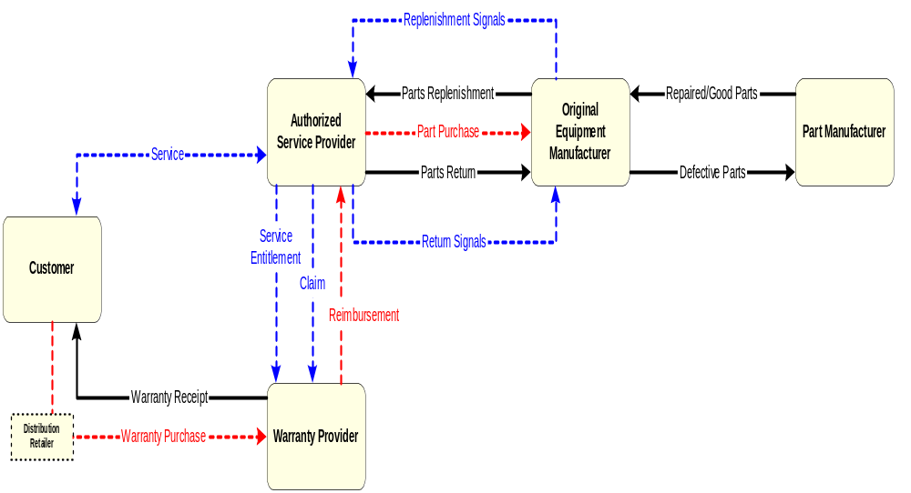
Figure 1: Reverse Supply Chain Management

The service event business process models the workflow initiated by a customer request for service on a purchased unit. The interactions between the customer and the Authorized Service Provider (ASP) and the ASP to the Warranty Provider (WP) can be complex, taking various courses based on characteristics and decisions made during the course of the service event. A service event begins with the determination of service entitlement, a repair process, and completes with a warranty reimbursement claim submitted to the warranty provider.

PIP Process Definition
The “Notify of Warranty Claim Confirmation” Partner Interface Process (PIP®) enables the Warranty Provider to respond to the request. The submitted claim can be either a Part and Labor Claim or a Labor Only claim.
In the event of a Parts and Labor claim the ordering of parts, their return and the verification of the shipping status are handled by separate PIPs:
- Request Purchase Order (3A4) for the ordering portion
- Query Shipment Status (3B4) for shipment status
- Return Product (3C1) for parts return

Reference to the business documents exchanged during the execution of the ordering, returning and shipping PIPs allows consolidating the information, presenting the claim and processing it.
In both cases the data sent from the Authorized Service Provider to the Warranty Provider includes information about the repaired unit, the analysis of the failure, the service event, the technician that serviced the unit and the end user.
The confirmation business document allows the Warranty Provider to respond to the ASP request and to send the ASP information concerning the warranty, the serviced unit, the claim and the service delivery and location.

PIP Scope Description
This PIP enables the Warranty Provider to acknowledge the receipt of warranty claim data for work completed on a service event.

PIP Business Document
Business Document are generated and exchanged by roles performing activities in this PIP. Business Document is listed and defined in Table 1.
Table 1: PIP Business Document
Business Document | Description
Warranty Claim Confirmation Notification | Response concerning the status of a Warranty Claim.

PIP Business Process Flow Diagram
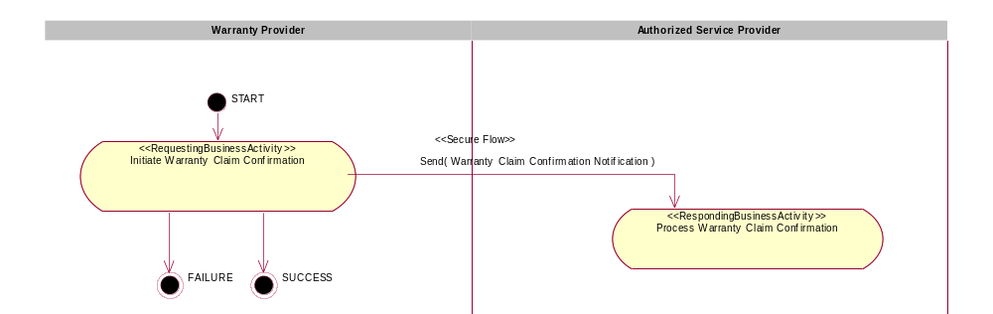
Figure 2: Activity Diagram

PIP Start State
The start state is comprised of the following conditions:
Table 2: PIP Start State
 | Approved | Exist |  | Valid | Non-Repudiated | Retry Count | Authorized
 | Approved | Party | In Backend System
TPA |  |  | 
Sending Partner |  |  |  |  |  |  | 
Receiving Partner |  | 
Business Document |  |  |  |  |  |  | 

PIP End States
The end state is comprised of the following conditions:
Table 3: PIP End State
 | Approved | Exist |  | Valid | Non-Repudiated | Retry Count | Authorized
 | Approved | Party | In Backend system
Acknowledgment of Receipt |  |  |  |  | 
Receiving Partner |  |  |  |  |  |  | 

The PIP failure state is comprised of one or more of the following conditions
Table 4: PIP Failure State
 | NO | Exceeded
Success | 
Retry Count |  | 

Partner Role Description
Table 5 describes the partner roles in this PIP:
Table 5: Partner Role Description
Role Name | Role Description
Warranty Provider | The provider who honors the warranty terms and reimburses the Authorized Service Provider for a service event performed within the warranty obligation terms.
Authorized Service Provider | The provider authorized by the Original Equipment Manufacturer (OEM) to perform service on a unit.

Business Process Activity Controls
Table 6 describes the interaction between roles performing business activity in this PIP.
Table 6: Business Activity Description
Role Name |  | Activity Name |  | Activity Description
Warranty Provider | Notify of Warranty Claim Confirmation |  | This activity issues a confirmation for a submitted claim to an Authorized Service Provider.

Table 7 details the security, audit and process controls relating to activity performed in the PIP.
Table 7: Business Activity Performance Control
Role  Name | Activity  Name | Acknowledgment  of Receipt |  | Time to Perform | Retry Count | Is Authorization Required? | Non-Repudiation of Origin and Content?
Role  Name | Activity  Name | Non-Repudiation Required? | Time to Acknowledge
Warranty Provider | Notify of Warranty Claim Confirmation | Y | 2 hrs | 2 hrs | 3 | Y | Y

Network and Implementation Specification
Each network component maps into a role of the PIP model. Table 8 specifies the mapping between roles and network components.
Table 8: Network Component Specification
Network Component | Classification | Maps to Role in Business Process
Warranty Provider Service | Business Service | Warranty Provider
Authorized Service Provider Service | Business Service | Authorized Service Provider

Business Action and Business Signal Specifications
Each business action maps to a Business Document of the PIP model. Table 9 specifies the mapping between Business Documents and business actions.
Table 9: Business Action – Business Document Mapping
Business Action | Business Document | Document Function
Warranty Claim Confirmation Notification Action | Warranty Claim Confirmation Notification | Response

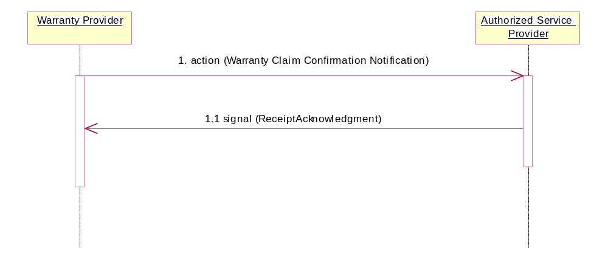
Figure 3: Sequence Diagram

Message Exchange Controls
Table 10: Message Exchange Control
# | Name |  | Time to Acknowledge Receipt Signal |  | Time to Respond to Action |  | Included in Time to Perform | Is Authorization Required? | Is Non-Repudiation Required? | Is Secure Transport Required?
1. |  | Warranty Claim Confirmation Action |  | 2 hrs |  | 2 hrs | Y | Y | Y | Y
1.1. |  | Receipt Acknowledgment |  | N/A |  | N/A | N | Y | Y | Y

Communications Specification
Table 11: Dialog: Service-Service
# | Business Message | Digital Signature Required? | SSL Required?
1. | Warranty Claim Confirmation | Y | Y
1.1. | Receipt Acknowledgment | Y | Y

