

Description of 7B1 Message

PIP® 7B1
Validated 11.00.00

Specification Information
Name | Description of 7B1 Message
PIP | Distribute Work In Process
Cluster | Manufacturing
Segment | Manage Manufacturing WO & WIP
Publication Date | 07 July 2008
Version Identifier | V11.00

Table of Content

1. Document Management 6
1.1 Legal Disclaimer 6
1.2 Copyright 6
1.3 Trademarks 6
1.4 Acknowledgments 6
1.5 Related Documents 7
1.6 Document Version History 7
1.7 Document Purpose 7
2. Interchange Model 8
2.1 WorkInProcessDistribution 8
2.1.1 Interchange Diagram 8
2.1.2 Dependency Diagram 9
2.1.3 Lot 9
2.1.4 LotShipment 11
2.1.5 ManufacturingLot 12
2.1.6 PartInformation 13
2.1.7 PreviousLot 13
2.1.8 QuantityChangeDescription 14
2.1.9 StatusChangeDescription 14
2.1.10 SubLot 14
2.1.11 WaferIdentification 15
2.1.12 WaferInformation 15
2.1.13 WorkInProcess 16
2.1.14 WorkInProcessDistribution 17
3. Domain Model 18
3.1 Procurement 18
3.1.1 Procurement 18
3.1.1.1 Dependency Diagram 18
3.1.1.2 LotIdentification 18
3.2 Manufacturing 19
3.2.1 Manufacturing 19
3.2.1.1 Dependency Diagram 19
3.2.1.2 ChangeDescription 19
3.2.1.3 LotQuantity 20
3.2.1.4 OrderReference 20
3.2.1.5 ProcessRouting 21
3.2.1.6 WorkInProcessStage 21
3.2.1.7 WorkInProcessStep 22
3.2.2 CodeList 22
3.2.2.1 LotType 22
3.2.2.2 EquipmentType 23
3.2.2.3 WorkInProcessType 24
3.2.2.4 ChangeReason 24
3.2.2.5 QuantityChange 26
3.2.2.6 QualityStatus 26
3.2.2.7 LotQuantityClassification 26
3.2.2.8 Priority 27
3.2.2.9 LotStatus 27
3.2.2.10 WorkInProcessLocation 27
3.2.2.11 WorkInProcessPartType 28
3.2.2.12 StatusChange 28
4. Universal Structure 29
4.1 ContactInformation 29
4.1.1 ContactInformation 29
4.2 DataType 29
4.2.1 Contact 29
4.2.2 DUNS 30
4.2.3 DUNSPlus4 30
4.2.4 GLN 31
4.2.5 GTIN 31
4.2.6 PercentAmount 31
4.3 Dates 32
4.3.1 DateTimePeriod 32
4.4 Document 32
4.4.1 BusinessDocumentReference 32
4.5 Locations 33
4.5.1 AlternativeIdentifier 33
4.5.2 Location 33
4.5.3 LocationChoice 34
4.5.4 PhysicalAddress 34
4.6 PartnerIdentification 36
4.6.1 PartnerIdentification 36
4.6.2 PartnerIdentificationChoice 37
4.6.3 SpecifiedFullPartner 37
4.6.4 SpecifiedIntermittentPartner 38
4.6.5 SpecifiedKnownPartner 38
4.6.6 SpecifiedKnownPartnerContact 39
4.6.7 SpecifiedNewPartner 39
4.6.8 SpecifiedPartnerDescription 40
4.6.9 SpecifiedPartnerDescriptionChoice 40
4.7 ProductIdentification 41
4.7.1 ProductIdentification 41
4.7.2 ProductIdentificationChoice 42
4.8 CodeList 42
4.8.1 Country 42
4.8.2 CountrySubdivision 42
4.8.3 Language 42
4.8.4 DocumentType 42
4.8.5 MimeTypeQualifier 44
4.8.6 UnitOfMeasure 55
5. System Structure 63
5.1 BusinessProcessIdentifier 63
5.2 BusinessServiceInformation 63
5.3 ContractInformation 64
5.4 CorrelationInformation 64
5.5 DocumentHeader 65
5.6 DocumentIdentification 66
5.7 DocumentIdentificationChoice 66
5.8 DocumentInformation 67
5.9 DocumentManifest 67
5.10 DocumentSecurity 68
5.11 ManifestItem 68
5.12 PipIdentifier 69
5.13 PipVersion 70
5.14 Receiver 70
5.15 RequestingDocumentInformation 71
5.16 Sender 71
5.17 StandardDocumentIdentification 72
5.18 TpirPipIdentification 72
5.19 VersionIdentifier 73
5.20 CodeList 73
5.20.1 TPIRFileType 73
6. XML Data Type 74
6.1 anyURI 74
6.2 boolean 74
6.3 dateTime 74
6.4 decimal 74
6.5 float 74
6.6 positiveInteger 74
6.7 string 74

Table of Figures

Figure 2-1 Interchange 8
Figure 2-2 Dependency 9
Figure 2-3 Lot 9
Figure 2-4 LotShipment 11
Figure 2-5 ManufacturingLot 12
Figure 2-6 PartInformation 13
Figure 2-7 PreviousLot 13
Figure 2-8 QuantityChangeDescription 14
Figure 2-9 StatusChangeDescription 14
Figure 2-10 SubLot 14
Figure 2-11 WaferIdentification 15
Figure 2-12 WaferInformation 15
Figure 2-13 WorkInProcess 16
Figure 2-14 WorkInProcessDistribution 17
Figure 3-1 Dependency 18
Figure 3-2 LotIdentification 18
Figure 3-3 Dependency 19
Figure 3-4 ChangeDescription 19
Figure 3-5 LotQuantity 20
Figure 3-6 OrderReference 20
Figure 3-7 ProcessRouting 21
Figure 3-8 WorkInProcessStage 21
Figure 3-9 WorkInProcessStep 22
Figure 4-1 ContactInformation 29
Figure 4-2 Contact 29
Figure 4-3 DUNS 30
Figure 4-4 DUNSPlus4 30
Figure 4-5 GLN 31
Figure 4-6 GTIN 31
Figure 4-7 PercentAmount 31
Figure 4-8 DateTimePeriod 32
Figure 4-9 BusinessDocumentReference 32
Figure 4-10 AlternativeIdentifier 33
Figure 4-11 Location 33
Figure 4-12 PhysicalAddress 34
Figure 4-13 PartnerIdentification 36
Figure 4-14 SpecifiedFullPartner 37
Figure 4-15 SpecifiedIntermittentPartner 38
Figure 4-16 SpecifiedKnownPartner 38
Figure 4-17 SpecifiedKnownPartnerContact 39
Figure 4-18 SpecifiedNewPartner 39
Figure 4-19 SpecifiedPartnerDescription 40
Figure 4-20 ProductIdentification 41
Figure 5-1 BusinessProcessIdentifier 63
Figure 5-2 BusinessServiceInformation 63
Figure 5-3 ContractInformation 64
Figure 5-4 CorrelationInformation 64
Figure 5-5 DocumentHeader 65
Figure 5-6 DocumentIdentification 66
Figure 5-7 DocumentInformation 67
Figure 5-8 DocumentManifest 67
Figure 5-9 DocumentSecurity 68
Figure 5-10 ManifestItem 68
Figure 5-11 PipIdentifier 69
Figure 5-12 PipVersion 70
Figure 5-13 Receiver 70
Figure 5-14 RequestingDocumentInformation 71
Figure 5-15 Sender 71
Figure 5-16 StandardDocumentIdentification 72
Figure 5-17 TpirPipIdentification 72
Figure 5-18 VersionIdentifier 73

Document Management

Legal Disclaimer
RosettaNet, its members, officers, directors, employees, or agents shall not be liable for any injury, loss, damages, financial or otherwise, arising from, related to, or caused by the use of this document or the specifications herein, as well as associated guidelines and schemas. The use of said specifications shall constitute your express consent to the foregoing exculpation.

Copyright
©2008 RosettaNet. All rights reserved. No part of this publication may be reproduced, stored in a retrieval system, or transmitted, in any form or by any means, electronic, mechanical, photocopying, recording, or otherwise, without the inclusion of this copyright notice. Any derivative works must cite the copyright notice. Any public redistribution or sale of this publication or derivative works requires prior written permission of the publisher.

Trademarks
RosettaNet, Partner Interface Process, PIP and the RosettaNet logo are trademarks or registered trademarks of "RosettaNet," a non-profit organization. All other product names and company logos mentioned herein are the trademarks of their respective owners. In the best effort, all terms mentioned in this document that are known to be trademarks or registered trademarks have been appropriately recognized in the first occurrence of the term.

Acknowledgments
This document has been prepared by RosettaNet (http://www.rosettanet.org/) from requirements gathered during the Milestone Program and in conformance with the methodology. Listed below are the legal entities that contributed to the design and development of this PIP.
Advanced Semiconductor Engineering, Inc. | Amkor Technology, Inc.
Motorola Semiconductor Product Sector, Motorola SPS | National Semiconductor
Intel Corporation | MIMOS Berhad
STMicroelectronics | Taiwan Semiconductor Manufacturing Co., Ltd. (TSMC)
UMC (United Microelectronics Corp.)

Related Documents
- Associated PIP Message Schemas (included with PIP Specification only)
- Description of Partner Interface Process for 7B1
- Message Structure

Document Version History
Version | Date | Description
Validated 11.00.00 | 07 July 2008 | Validated Version : RosettaNet Schema to Market to Validation 2008

Document Purpose
The purpose of the document is to explain the structure, the association between objects, the content of objects and the definition for single elements to a non-technical audience.

Interchange Model

WorkInProcessDistribution

Interchange Diagram
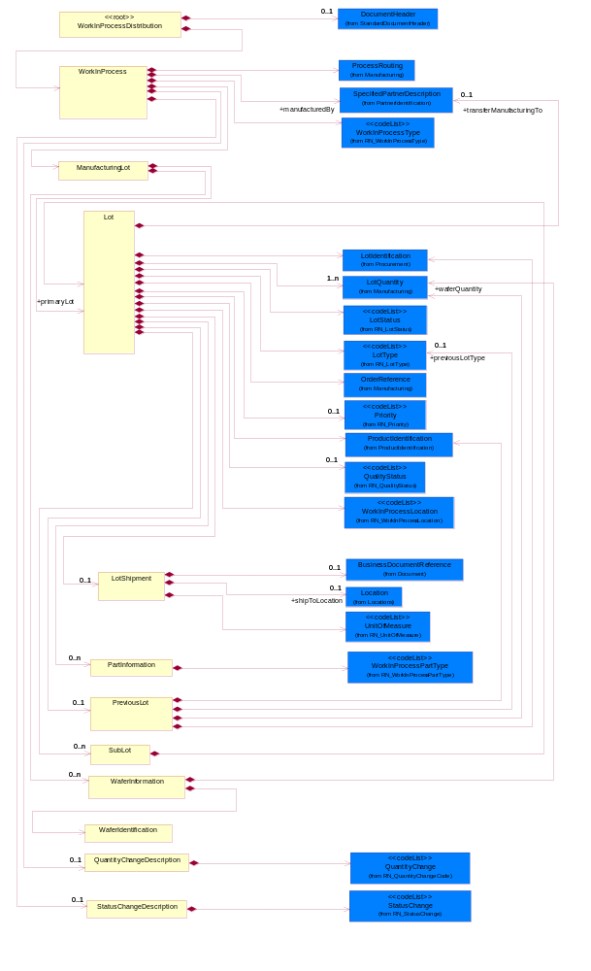
Figure 2-1 Interchange

Dependency Diagram
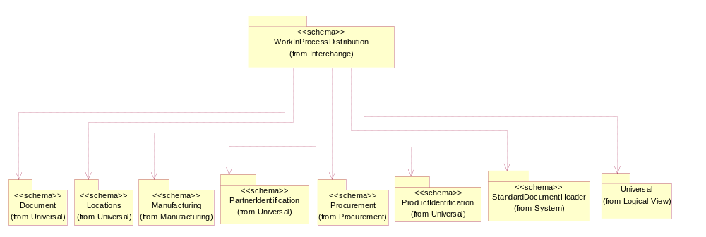
Figure 2-2 Dependency

Lot
The collection of business properties that describe the quantity produced at one operation.
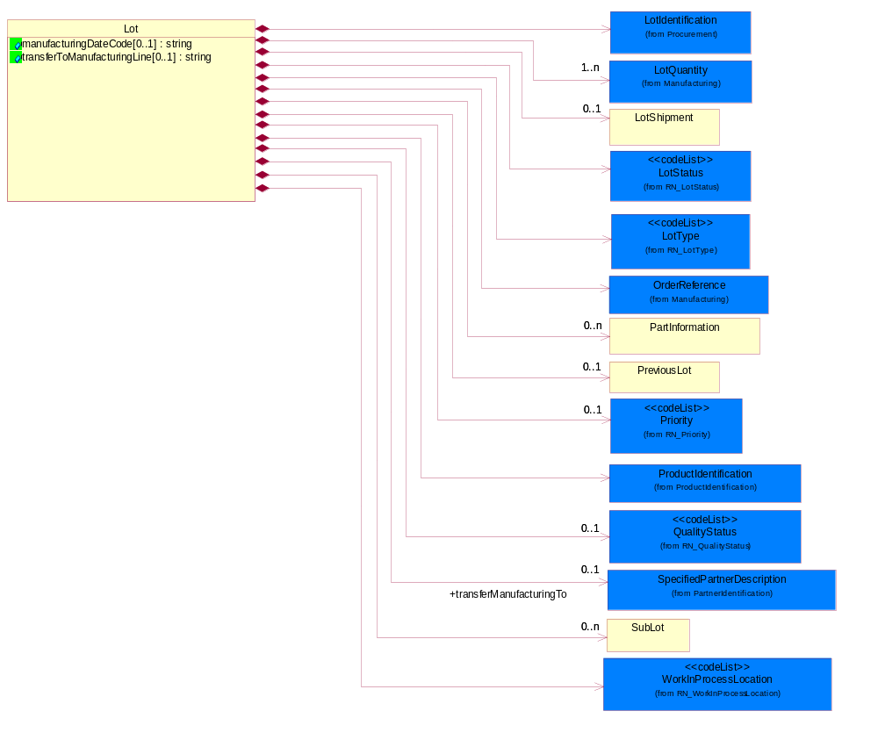
Figure 2-3 Lot

Attribute | Type | Documentation
manufacturingDateCode[0..1] | string | The unique identifier assigned to a product by a manufacturer to distinguish individual manufacturing periods.
transferToManufacturingLine[0..1] | string | The movement of the manufacturing process to a specific line within a site.

Composition | Cardinality | Type | Documentation
LotIdentification | 1 | LotIdentification | This object identifies a lot which associates the product with a specific group of products with some similar attributes.
LotQuantity | 1..n | LotQuantity | The collection of business properties that describe the quantity of items in a lot.
LotShipment | 0..1 | LotShipment | The collection of business properties that describe shipping information for a given manufacturing lot.
LotStatus | 1 | LotStatus | Code identifying the status of a lot.
LotType | 1 | LotType | Describes the mode in which product was tested.
OrderReference | 1 | OrderReference | The collection of business properties that describe information about proprietary documents.
PartInformation | 0..n | PartInformation | The collection of business properties that describe a proprietary part number.
PreviousLot | 0..1 | PreviousLot | The collection of business properties that describe manufacturing lot information for the lot process prior to the current manufacturing lot.
Priority | 0..1 | Priority | Code identifying the priority order of an activity, product or service.
ProductIdentification | 1 | ProductIdentification | The object provides the identifier(s) of a product.
QualityStatus | 0..1 | QualityStatus | This code indicates a non confirmity, defined as the departure or the absence of one or more quality characteristics from specified requirements, the non belonging to a normal statistical distribution, and the non fulfillment of intended usage requirements.
transferManufacturingTo | 0..1 | SpecifiedPartnerDescription | The movement of the manufacturing process to another site.
SubLot | 0..n | SubLot | The collection of business properties that describe a discrete quantity within a lot.
WorkInProcessLocation | 1 | WorkInProcessLocation | Code identifying the location of manufacturing, fabrication and assembly of components.

LotShipment
The collection of business properties that describe shipping information for a given manufacturing lot.
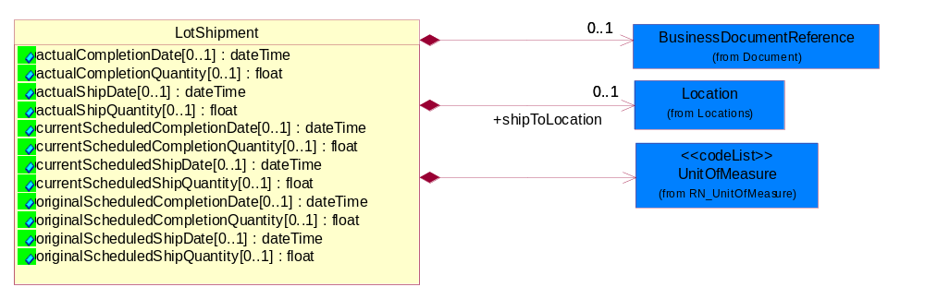
Figure 2-4 LotShipment
Attribute | Type | Documentation
actualCompletionDate[0..1] | dateTime | The actual date this lot was completed.
actualCompletionQuantity[0..1] | float | The actual quantity completed for this lot.
actualShipDate[0..1] | dateTime | The actual date a shipment was sent.
actualShipQuantity[0..1] | float | The actual quantity shipped for this lot.
currentScheduledCompletionDate[0..1] | dateTime | Current projected completion date for this lot.
currentScheduledCompletionQuantity[0..1] | float | Current projected completion quantity for this lot.
currentScheduledShipDate[0..1] | dateTime | Current projected ship date for this lot.
currentScheduledShipQuantity[0..1] | float | Current projected ship quantity for this lot.
originalScheduledCompletionDate[0..1] | dateTime | The original completion date promised to the customer at time of order placement/acknowledgement. The original completion date never changes.
originalScheduledCompletionQuantity[0..1] | float | The original completion quantity promised to the customer at time of order placement/acknowledgement. The original completion quantity never changes.
originalScheduledShipDate[0..1] | dateTime | The initial date of shipment.
originalScheduledShipQuantity[0..1] | float | Quantity of product shipped originally scheduled for shipment.

Composition | Cardinality | Type | Documentation
BusinessDocumentReference | 0..1 | BusinessDocumentReference | The business document reference object allows for the indirect referencing of a relationship to other business related documents.
shipToLocation | 0..1 | Location | The location to which the product must be delivered.
UnitOfMeasure | 1 | UnitOfMeasure | Code identifying a product unit of measure.

ManufacturingLot
The collection of business properties that describe manufacturing lot information for a manufacturing process.
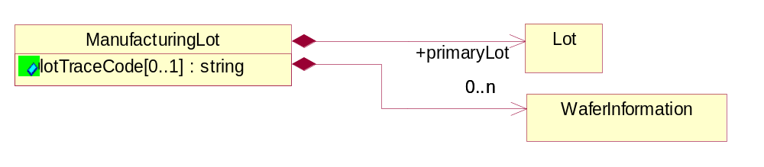
Figure 2-5 ManufacturingLot
Attribute | Type | Documentation
lotTraceCode[0..1] | string | A summary of the lot's main traceability information assigned by the manufacturer, enabling to reconstruct the full genealogy of a lot from wafer fab until finished good.

Composition | Cardinality | Type | Documentation
primaryLot | 1 | Lot | The initial lot scheduled for manufacturing.
WaferInformation | 0..n | WaferInformation | Information on the individual wafers which compose a semiconductor manufacturing lot.

PartInformation
The collection of business properties that describe a proprietary part number.
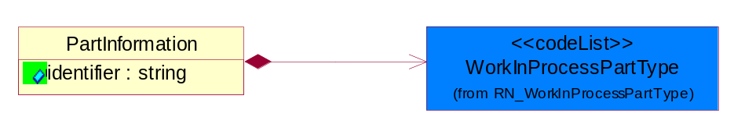
Figure 2-6 PartInformation
Attribute | Type | Documentation
identifier | string | The unique identifier for a part.

Composition | Cardinality | Type | Documentation
WorkInProcessPartType | 1 | WorkInProcessPartType | Code identifying the type of proprietary part number sent in a work in process activity.

PreviousLot
The collection of business properties that describe manufacturing lot information for the lot process prior to the current manufacturing lot.
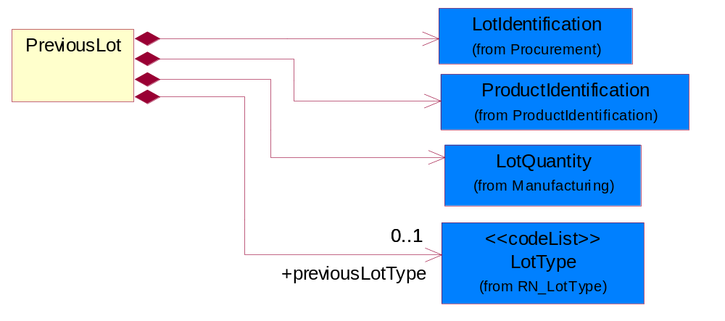
Figure 2-7 PreviousLot
Composition | Cardinality | Type | Documentation
LotIdentification | 1 | LotIdentification | This object identifies a lot which associates the product with a specific group of products with some similar attributes.
ProductIdentification | 1 | ProductIdentification | The object provides the identifier(s) of a product.
LotQuantity | 1 | LotQuantity | The collection of business properties that describe the quantity of items in a lot.
previousLotType | 0..1 | LotType | The type of the previous lot.

QuantityChangeDescription
The collection of business properties that describe a work in process quantity change.
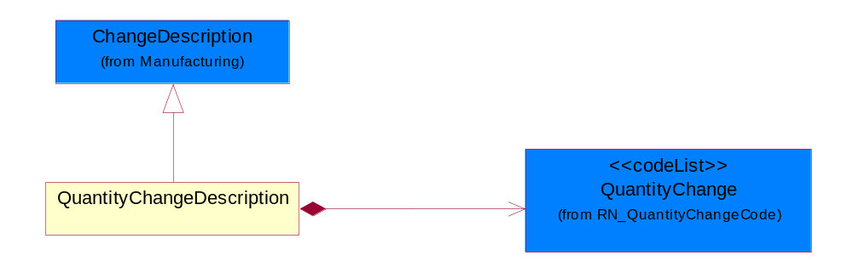
Figure 2-8 QuantityChangeDescription
Composition | Cardinality | Type | Documentation
QuantityChange | 1 | QuantityChange | A descriptor that classifies a work in process quantity change.

StatusChangeDescription
The collection of business properties that describe a work in process status change.
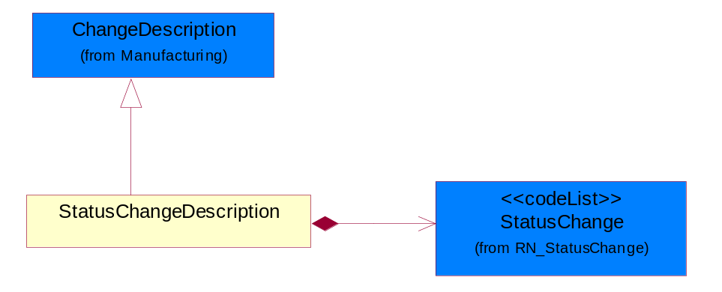
Figure 2-9 StatusChangeDescription
Composition | Cardinality | Type | Documentation
StatusChange | 1 | StatusChange | A descriptor that classifies a status change.

SubLot
The collection of business properties that describe a discrete quantity within a lot.
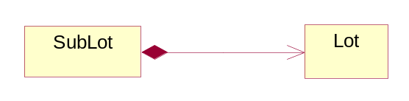
Figure 2-10 SubLot
Composition | Cardinality | Type | Documentation
Lot | 1 | Lot | The collection of business properties that describe the quantity produced at one operation.

WaferIdentification
Specific wafer identification for each wafer within a semiconductor manufacturing lot.
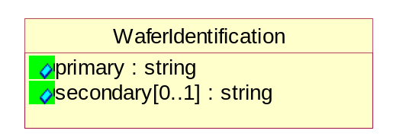
Figure 2-11 WaferIdentification
Attribute | Type | Documentation
primary | string | Primary wafer identification number.
secondary[0..1] | string | Secondary wafer identification number.

WaferInformation
Information on the individual wafers which compose a semiconductor manufacturing lot.
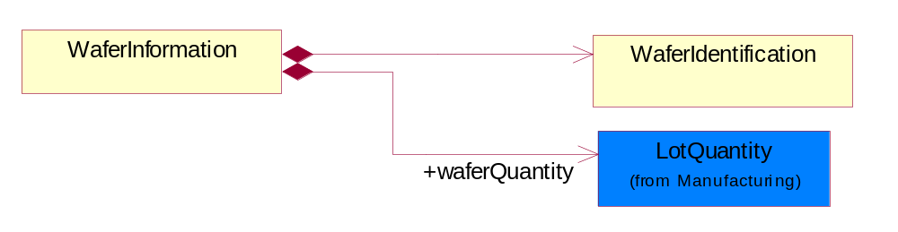
Figure 2-12 WaferInformation
Composition | Cardinality | Type | Documentation
WaferIdentification | 1 | WaferIdentification | Specific wafer identification for each wafer within a semiconductor manufacturing lot.
waferQuantity | 1 | LotQuantity | Quantity of wafers contained within a semiconductor manufacturing lot.

WorkInProcess
The collection of business properties that describe the manufacturing steps which must be performed.
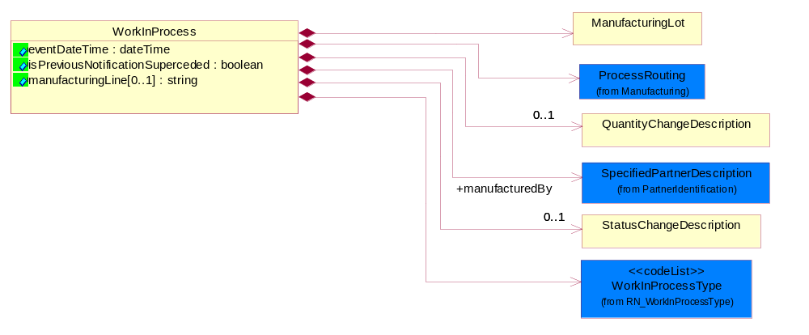
Figure 2-13 WorkInProcess
Attribute | Type | Documentation
eventDateTime | dateTime | The date and time the manufacturing event occurred.
isPreviousNotificationSuperceded | boolean | Indicates whether the previous work in process notification is replaced.
manufacturingLine[0..1] | string | A specific manufacturing line within a site.

Composition | Cardinality | Type | Documentation
ManufacturingLot | 1 | ManufacturingLot | The collection of business properties that describe manufacturing lot information for a manufacturing process.
ProcessRouting | 1 | ProcessRouting | The collection of business properties that describe the manufacturing routing for fabrication and assembly.
QuantityChangeDescription | 0..1 | QuantityChangeDescription | The collection of business properties that describe a work in process quantity change.
manufacturedBy | 1 | SpecifiedPartnerDescription | The party who creates, processes or produces goods especially in large quantities and by means of industrial machines.
StatusChangeDescription | 0..1 | StatusChangeDescription | The collection of business properties that describe a work in process status change.
WorkInProcessType | 1 | WorkInProcessType | Code identifying the manufacturing, fabrication and assembly status of components.

WorkInProcessDistribution
A message wrapper or root for PIP7B1.
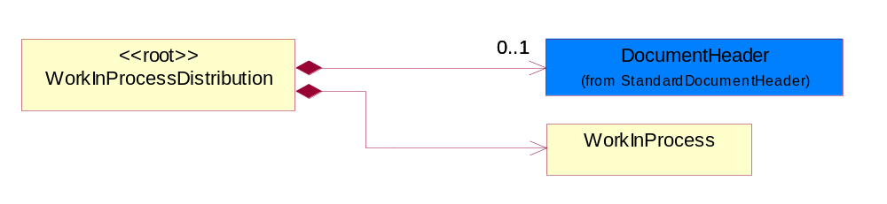
Figure 2-14 WorkInProcessDistribution
Composition | Cardinality | Type | Documentation
DocumentHeader | 0..1 | DocumentHeader | The object allows for the identification of the sender and receiver of the business document.
WorkInProcess | 1 | WorkInProcess | The collection of business properties that describe the manufacturing steps which must be performed.

Domain Model

Procurement

Procurement

Dependency Diagram
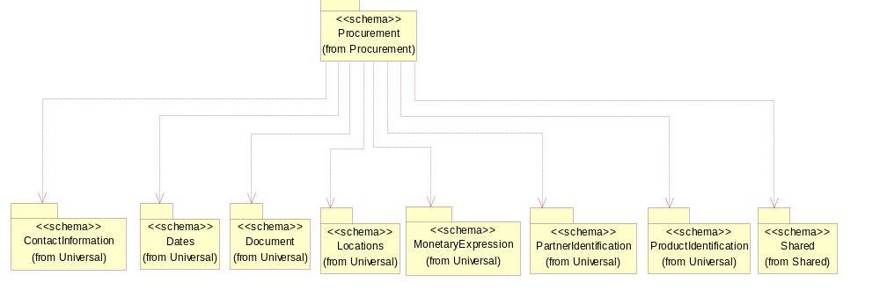
Figure 3-15 Dependency

LotIdentification
This object identifies a lot which associates the product with a specific group of products with some similar attributes.
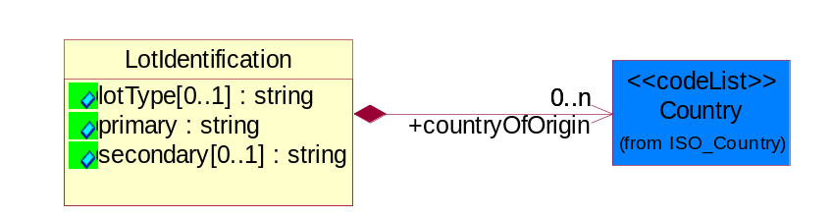
Figure 3-16 LotIdentification
Attribute | Type | Documentation
lotType[0..1] | string | Identify the type of the lot whether it's for Production or Engineering.
primary | string | The primary lot identifier.
secondary[0..1] | string | The secondary lot identifier.

Composition | Cardinality | Type | Documentation
countryOfOrigin | 0..n | Country | This object represents the country where the product originates.

Manufacturing

Manufacturing

Dependency Diagram
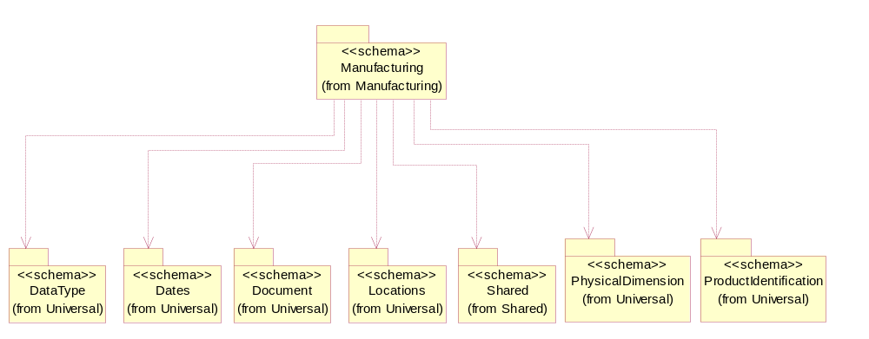
Figure 3-17 Dependency

ChangeDescription
The collection of business properties that describe a change.
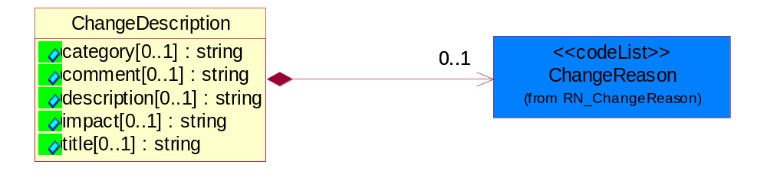
Figure 3-18 ChangeDescription
Attribute | Type | Documentation
category[0..1] | string | This object represents the type of categories for a change.
comment[0..1] | string | The detailed description of why the change is being made.
description[0..1] | string | Business properties describing the description of the reason.
impact[0..1] | string | The anticipated positive or negative impact on form, fit, function, quality or reliability of the affected product.
title[0..1] | string | This object represents a textual summary of the change title.

Composition | Cardinality | Type | Documentation
ChangeReason | 0..1 | ChangeReason | Reason Code for change of a business document or a line item or subline item in a business document.

LotQuantity
The collection of business properties that describe the quantity of items in a lot.
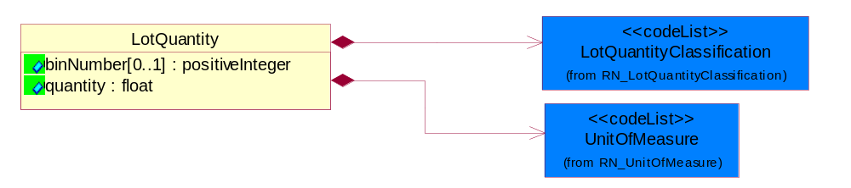
Figure 3-19 LotQuantity
Attribute | Type | Documentation
binNumber[0..1] | positiveInteger | Code number used to segregate lot quantities by performance after final testing.
quantity | float | A quantity specifying the number of product units.

Composition | Cardinality | Type | Documentation
LotQuantityClassification | 1 | LotQuantityClassification | Code identifying the classification of a manufacturing lot quantity.
UnitOfMeasure | 1 | UnitOfMeasure | Code identifying a product unit of measure.

OrderReference
The collection of business properties that describe information about proprietary documents.
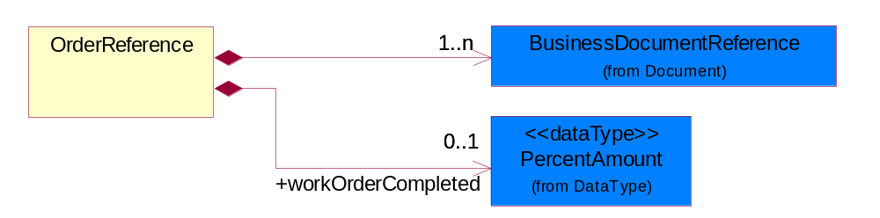
Figure 3-20 OrderReference
Composition | Cardinality | Type | Documentation
BusinessDocumentReference | 1..n | BusinessDocumentReference | The business document reference object allows for the indirect referencing of a relationship to other business related documents.
workOrderCompleted | 0..1 | PercentAmount | The amount a work order has been completed.

ProcessRouting
The collection of business properties that describe the manufacturing routing for fabrication and assembly.
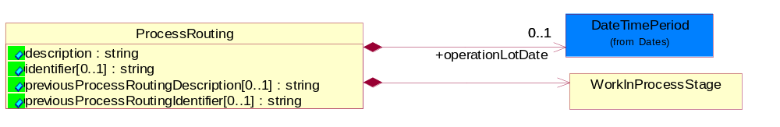
Figure 3-21 ProcessRouting
Attribute | Type | Documentation
description | string | Text identifying the manufacturing process flow.
identifier[0..1] | string | A proprietary code identifying the manufacturing process flow.
previousProcessRoutingDescription[0..1] | string | Text identifying the previous process routing.
previousProcessRoutingIdentifier[0..1] | string | A proprietary code identifying the previous process routing.

Composition | Cardinality | Type | Documentation
operationLotDate | 0..1 | DateTimePeriod | The period over which the lot was manufactured.
WorkInProcessStage | 1 | WorkInProcessStage | The collection of business properties that describe a group of work in process steps.

WorkInProcessStage
The collection of business properties that describe a group of work in process steps.
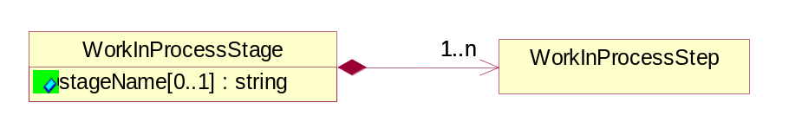
Figure 3-22 WorkInProcessStage
Attribute | Type | Documentation
stageName[0..1] | string | The name of a work in process stage.

Composition | Cardinality | Type | Documentation
WorkInProcessStep | 1..n | WorkInProcessStep | The collection of business properties that describe the lowest level manufacturing which must be performed.

WorkInProcessStep
The collection of business properties that describe the lowest level manufacturing which must be performed.
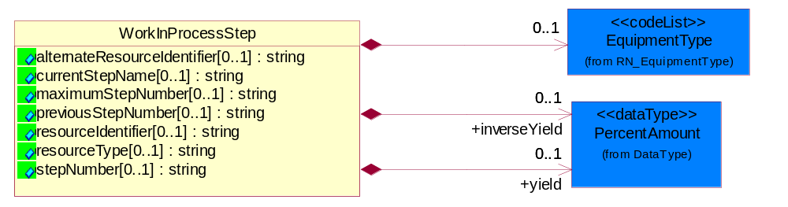
Figure 3-23 WorkInProcessStep
Attribute | Type | Documentation
alternateResourceIdentifier[0..1] | string | The identifier used to reference the alternate manufacturing used for the process step.
currentStepName[0..1] | string | The name of a work in process step.
maximumStepNumber[0..1] | string | The total number of steps in the process.
previousStepNumber[0..1] | string | The number of a previous step.
resourceIdentifier[0..1] | string | The identifier of the specific manufacturing equipment used to perform this process step.
resourceType[0..1] | string | The specific model of manufacturing equipment used to perform this process step.
stepNumber[0..1] | string | The number of a work in process step.

Composition | Cardinality | Type | Documentation
EquipmentType | 0..1 | EquipmentType | Code identifying the type of manufacturing equipment in use for a particular process step.
inverseYield | 0..1 | PercentAmount | The inverse of the yield per step.
yield | 0..1 | PercentAmount | An amount yielded or produced.

CodeList

LotType
Describes the mode in which product was tested.

Name | Documentation
DEV | Development.
ENG | Engineering - State where product is made using test processes on non-production tools or equipment.
EUH | EUH type.
MFG | Manufacturing.
NCL | NonConformingLot - Lots affected by a nonconformity to preset quality characteristics.
PLT | Pilot - The first lot of the product (never produced at the dedicated subcontractor).
PPD | Pre-Production.
PQC | Process Qualification Check - Process to qualify manufacturing processes in preparation for volume manufacturing.
PRD | Production - State where product is made using all production tools, processes, equipment, environment, facility, and cycle time.
RND | Research and Development - Process for developing prototype products.
RWK | Rework - Parts sent back from further down the manufacturing line.
SVC | Service.
TST | Test - The manufacturing stage in which the packaged die is tested.

EquipmentType
Code identifying the type of manufacturing equipment in use for a particular process step.

Name | Documentation
BAC | Backgrind. Equipment used for thinning the wafers just before dicing them up in the packaging process.
CLE | Clean. Equipment used to clean wafers during the manufacturing process.
DAT | Die attach. Equipment used to physically attach the die to the raw stock assembly.
DIF | DIFF. Equipment used during the diffusion step of a manufacturing process.
ETC | Etch. Equipment used during the etch step of a manufacturing process.
ETE | ETEST. Electrical parametric testing equipment used to test completed wafers for specification compliance.
FSO | Final sort. A test process after assembly process.
IMP | Implant. Equipment used during the implant step of a manufacturing process.
MAP | Mark and Pack. Equipment used for packaging and labeling products before shipment to the customer.
MOL | Molding. Equipment used for molding assemblies or sub-assemblies.
OQA | OQA. Out-going quality assurance equipment used to check for physical defects on the wafer.
PHO | Photo. Equipment used during the photo-lithography step of a manufacturing process.
TAF | Trim and form. Equipment used for preparing die/components before the packaging process.
WBO | Wire bond. Equipment used to connect a point on an integrated circuit die with a lead or ball, which is used to connect the packaged die to a circuit board.
WSA | Wafer saw. Equipment used for sawing the wafers into individual die parts.
WSO | Wafer sort. The process after wafer fabrication during which the electrical parameters of integrated circuits are tested for functionality.

WorkInProcessType
Code identifying the manufacturing, fabrication and assembly status of components.

Name | Documentation
BON | Bonus.
CIT | Change item.
CLN | Change lot number.
COM | Complete. Event where a manufacturing lot has completed a process step or stage.
CON | Consume.
CQU | Change quantity.
FAB | FABout. Fabrication complete.
HOL | Hold. Event where a manufacturing lot is stopped or held.
LOT | Lotlink.
MER | Merge. Event where a manufacturing lot is merged or combined with another manufacturing lot.
MOV | Move. Event where a manufacturing lot is moved to a physical location.
REC | Receipt. Event where a manufacturing lot is received into a facility or area.
REJ | Reject.
REL | Release. Event where a manufacturing lot is received into a facility or area.
SCH | Scheduled. Event where a manufacturing lot is scheduled into a facility or area.
SCR | Scrap. Dispose of product in accordance with local rules and regulations covering the specific type of product.
SHI | Ship. Event where a manufacturing lot is shipped out of a facility or area.
SPL | Split. Event where a manufacturing lot is split into two or more manufacturing lots.
STA | Start. Event where a manufacturing lot is started at a facility or area.
STB | Status.
TER | Terminate.
TRA | Transfer. Event where a manufacturing lot is transferred to another facility or area.
UNC | Uncomplete.
UNL | Unlotlink.
UNS | Unstart.

ChangeReason
Reason Code for change of a business document or a line item or subline item in a business document.

Name | Documentation
AID | Assembly Instruction Discrepancy.
BDD | Bonding Diagram Discrepancy.
BWA | Broken Wafer.
CCH | Capacity Change.
CCO | Capacity Constraint (No Capacity).
CHR | Customer Hold Request.
CIC | Charge Information Change.
DMN | Die Mask Number Discrepancy.
DPW | Document Paper Work Error along with the PIP.
DQP | Bad Quality Problem of Dimension.
ESC | Engineering Spec Change.
ETO | Equipment Trouble Occurred.
ICW | Instruction Change in WIP.
IPI | Incomplete Product Information.
LTV | Lead Time Violation.
LYI | Low Yield.
MDI | Marking Discrepancy.
MSD | Machine Shut-Down.
NAI | No Assembly Instruction.
NBD | No Bonding Diagram.
NBS | No Building Sheet for assembly (No Assembly Instruction).
NCL | Wafers are Not Completely Loaded (due to wafer lot size).
NGW | No Good Wafers.
NMA | No Marking on the device.
NMS | No Marking Spec.
NRE | A New Requirement is added to the request.
PIC | Processing Instruction Change.
PQB | Packing material Quality problem by the Buyer.
PQS | Packing material Quality problem by the Supplier.
PRC | Process Routing Change.
PSB | Packing material Shortage by the Buyer.
PSD | Plant Shut-Down.
PSS | Packing material Shortage by the Supplier.
QCH | Quantity Change.
QIC | The Index of Quality Change.
RMC | Raw Materials Constraint.
RQB | Raw material Quality problem by the Buyer.
RQS | Raw material Quality problem by the Supplier.
RSB | Raw material Shortage by the Buyer.
RSS | Raw material Shortage by the Supplier.
SDC | Shipping Date Change.
SDP | Start Date of Processing change.
SDU | Source Die Unavailable (No Dice).
SLC | Ship-to-Location Change.
TTO | Tool Trouble Occurred.
VQD | Bad Visual Quality of the Device.
WDD | Wafer/Die quantity Discrepancy.
WDP | Wafer/Die quality Problem.
WDT | Bad Thickness of Wafer/Die.
WOC | Work Order has been manually Cancelled.
WOP | Wrong Operation.
WOS | Work Order too Small (quantity too small).

QuantityChange
A descriptor that classifies a work in process quantity change.

Name | Documentation
BON | Bonus. A positive variance in the lot quantity.
CQU | Change Quantity. The change quantity event and quantity is intended to be used when the quantity of a lot changes for a reason other than those we have defined events for (scrap, reject, and bonus).
REJ | Reject.
SCR | Scrap. Dispose of product in accordance with local rules and regulations covering the specific type of product.

QualityStatus
This code indicates a non conformity, defined as the departure or the absence of one or more quality characteristics from specified requirements, the non belonging to a normal statistical distribution, and the non fulfillment of intended usage requirements.

Name | Documentation
NMA | NonConforming Major. All anomalous quality characteristics that could have an impact on reliability of the product. All anomalous quality characteristics that do not directly affect Front-End yields, but that could induce reliability problems at Back-End level.
NMI | NonConforming Minor. All anomalous quality characteristics that have a possible impact on probing yield when it has been proven to have no impact on the reliability of the product. All anomalous quality characteristics that do not directly affect Front-End yields, but that could induce manufacturability or yield problems at Back-Ends level or at external Customer level.

LotQuantityClassification
Code identifying the classification of a manufacturing lot quantity.

Name | Documentation
ACC | Acceptable. The lot quantity meets the minimum requirements.
BON | Bonus. A positive variance in the lot quantity.
BTE | Bin Test. Bin Test Quantity.
CQU | Change Quantity. The change quantity event and quantity is intended to be used when the quantity of a lot changes for a reason other then those we have defined events for (scrap, reject, and bonus).
CUR | Current. Current Quantity.
GRO | Gross. The initial quantity of the lot.
LPR | Lot probe.
MER | Merge. Merge Quantity.
NET | Net. The final quantity of the lot.
PFI | Projected final. The estimated final quantity of the lot.
PLO | Previous lot. The quantity of the preceding lot.
REC | Receipt. Receipt Quantity.
REJ | Reject. Reject/Loss Quantity.
SCH | Schedule. A lot is still physically in the Die Bank (before being started) but has been allocated to start and as a result, is not available for being considered for planning purposes as it is already committed to.
SCR | Scrap. The quantity of products which is disposed of.
SHI | Ship. Actual Ship Quantity.
SPL | Split. Split Quantity.
STA | Start. Start Quantity.

Priority
Code identifying the priority order of an activity, product or service.

Name | Documentation
HIG | High.
HIH | Highest.
LOW | Low.
LOX | Lowest.
MED | Medium.

LotStatus
Code identifying the status of a lot.

Name | Documentation
BAN | Bank - A lot is waiting in the die bank to be scheduled.
HOL | Hold - The lot is on hold.
INQ | In-queue - The lot is about to begin production.
RUN | Run - The lot is currently in production.
SCH | Schedule - A lot is scheduled to start.
SCR | Scrap - Dispose of product in accordance with local rules and regulations covering the specific type of product.
SHI | Ship - The lot has been shipped.
TRA | Transfer - A lot is being transferred to another site.
WIP | WIP - A lot is in WIP (assembly or test).

WorkInProcessLocation
Code identifying the location of manufacturing, fabrication and assembly of components.

Name | Documentation
ASS | Assembly - The manufacturing stage in which components or materials are assembled for packaging.
BUM | Bump - Step used in semi-conductor fabrication - contact points on a wafer heightened above wafer surface for conductivity.
FAB | Fab - The main manufacturing facility for processing semiconductor wafers.
MAP | Mark and Pack - A process where the final steps (often including packaging and labeling) are performed before shipment to the customer.
MAS | Mask - Step used in semi-conductor fabrication - sectioning off substrate.
PRO | Probe - Step used in semi-conductor fabrication - probing substrate.
SOR | Sort - The process of physically separating a material or products.
STA | Staged - Components that have been pulled from stock and readied for movement to a production area.
TES | Test - The manufacturing stage in which the packaged die is tested.

WorkInProcessPartType
Code identifying the type of proprietary part number sent in a work in process activity.

Name | Documentation
CNU | Component number. Part number for a component.
DPN | Die part number. Part number for a die.
EIT | Enterprise item. Proprietary part number.
PEI | Previous enterprise item. Proprietary part number.
PNU | Package number. Part number for a package.
WPN | Wafer part number. Part number for a wafer.

StatusChange
A descriptor that classifies a status change.

Name | Documentation
CAN | Cancellation - The cancellation of the process.
HOL | Hold - The process is putting on hold.
REC | Reschedule - The reschedule of the process.
RES | Restart - The restart of the process.

Universal Structure

ContactInformation

ContactInformation
The business document must allow for the identification of the name of the department, service or individual to be contacted regarding the context of the business document.
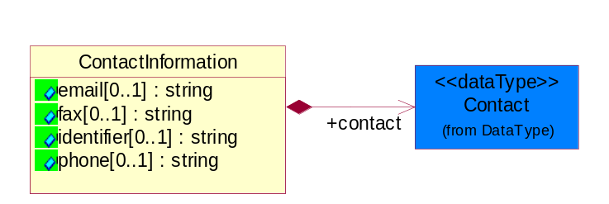
Figure 4-24 ContactInformation
Attribute | Type | Documentation
email[0..1] | string | The electronic mail for the specified contact.
fax[0..1] | string | The fax number for the specified contact.
identifier[0..1] | string | Identifies the role of the contact (i.e. Service Technician, Account Manager) in the Business Process.
phone[0..1] | string | The telephone number for the specified contact.

Composition | Cardinality | Type | Documentation
contact | 1 | Contact | The name of the department, service or individual to be contacted within the organization.

DataType

Contact
The name of the department, service or individual to be contacted within the organization.
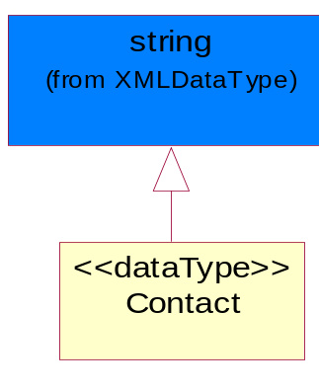
Figure 4-25 Contact

DUNS
A number assigned by Dun and Bradstreet to identify a business location.
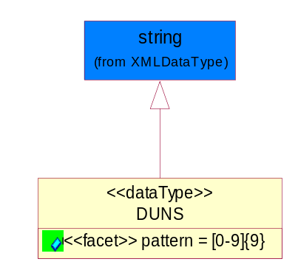
Figure 4-26 DUNS
Attribute | Type | Documentation
pattern |  | [0-9]{9}

DUNSPlus4
A identifier to specify a specific location within a business location.
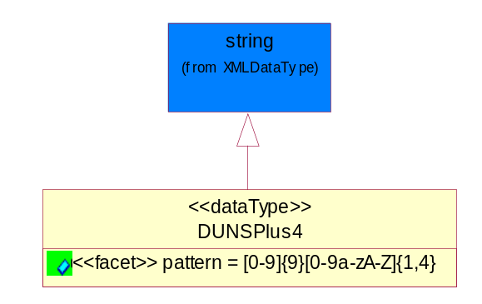
Figure 4-27 DUNSPlus4
Attribute | Type | Documentation
pattern |  | Data Universal Numbering System +4 (DUNS+4) number means the DUNS number assigned by Dun and Bradstreet, Inc. (D&B) plus an alphanumeric of length 4 suffix that may be assigned by a business concern.

GLN
Global Location Number (GLN) - A identifier to identify legal entities, trading parties and location.
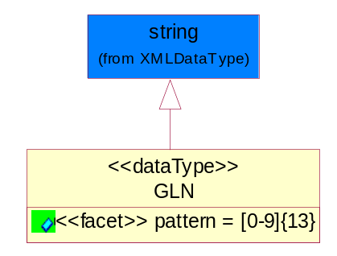
Figure 4-28 GLN
Attribute | Type | Documentation
pattern |  | [0-9]{13}

GTIN
Global Trade Identification Number (GTIN).
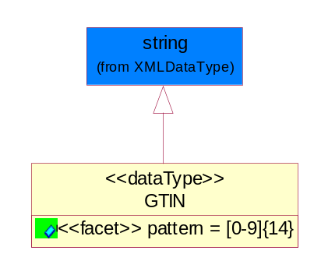
Figure 4-29 GTIN
Attribute | Type | Documentation
pattern |  | [0-9]{14}

PercentAmount
A number representing a percentage value, e.g. 75.125 represents 75 1/8 percent.
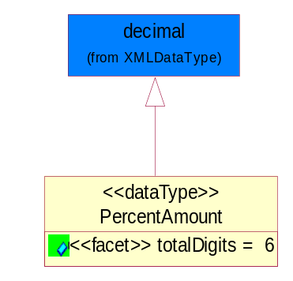
Figure 4-30 PercentAmount
Attribute | Type | Documentation
totalDigits |  | 6

Dates

DateTimePeriod
The business document must allow for the computation or statement of a period of time based upon date and time.
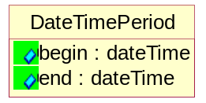
Figure 4-31 DateTimePeriod
Attribute | Type | Documentation
begin | dateTime | The date and time indicating the beginning of the date time period.
end | dateTime | The date and time indicating the ending of the date time period.

Document

BusinessDocumentReference
The business document reference object allows for the indirect referencing of a relationship to other business related documents.
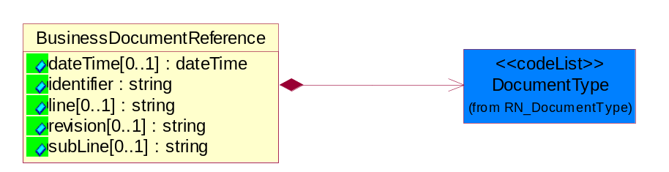
Figure 4-32 BusinessDocumentReference
Attribute | Type | Documentation
dateTime[0..1] | dateTime | The date-time stamp indicating on the referenced business document.
identifier | string | Unique identification of the referenced business document.
line[0..1] | string | References the specific line number of the specified business document.
revision[0..1] | string | Referenced the revision of the specified business document.
subLine[0..1] | string | References the specific subline number of the specified business document.

Composition | Cardinality | Type | Documentation
DocumentType | 1 | DocumentType | A code identifying the business context of a document.

Locations

AlternativeIdentifier
Identifies the specified code and the name of the organization that a code is utilized from.
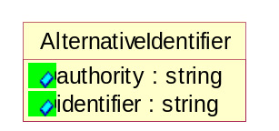
Figure 4-33 AlternativeIdentifier
Attribute | Type | Documentation
authority | string | The name of the organization that a code is utilized from.
identifier | string | The specified code to represent an entity (e.g. product, location, partner, etc.).

Location
The business document must specify a location.
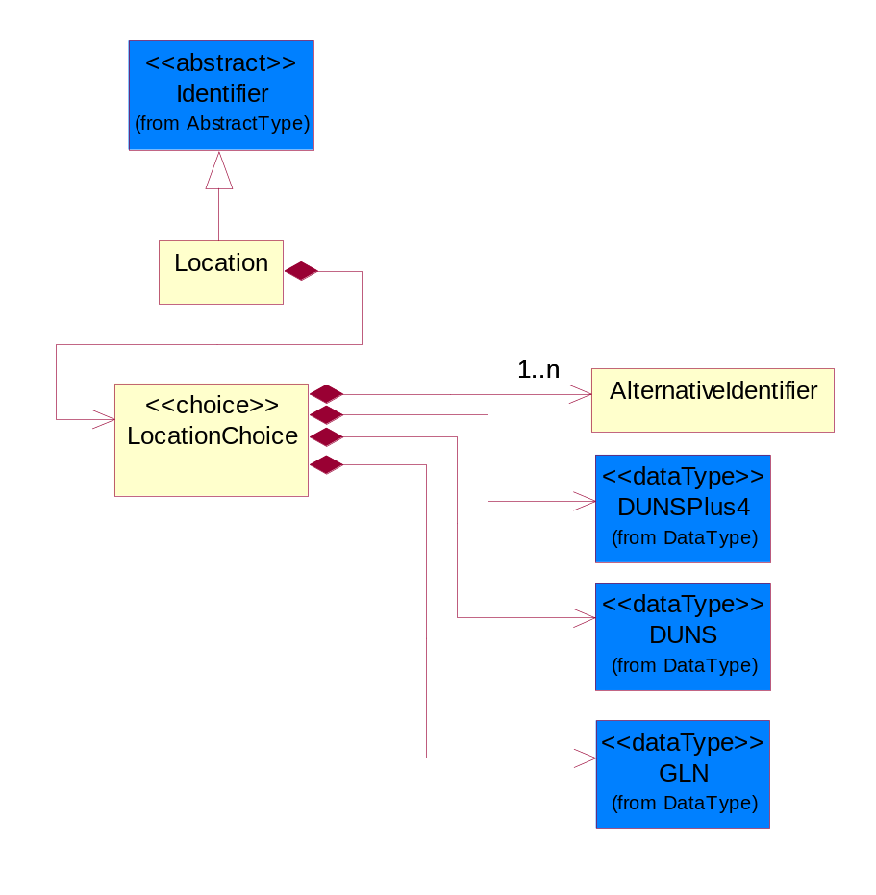
Figure 4-34 Location
Composition | Cardinality | Type | Documentation
LocationChoice | 1 | LocationChoice

LocationChoice

Composition | Cardinality | Type | Documentation
AlternativeIdentifier | 1..n | AlternativeIdentifier | Identifies the specified code and the name of the organization that a code is utilized from.
DUNSPlus4 | 1 | DUNSPlus4 | A identifier to specify a specific location within a business location.
DUNS | 1 | DUNS | A number assigned by Dun and Bradstreet to identify a business location.
GLN | 1 | GLN | Global Location Number (GLN) - A identifier to identify legal entities, trading parties and location.

PhysicalAddress
The business document must provide a physical address for a party to the business transaction.
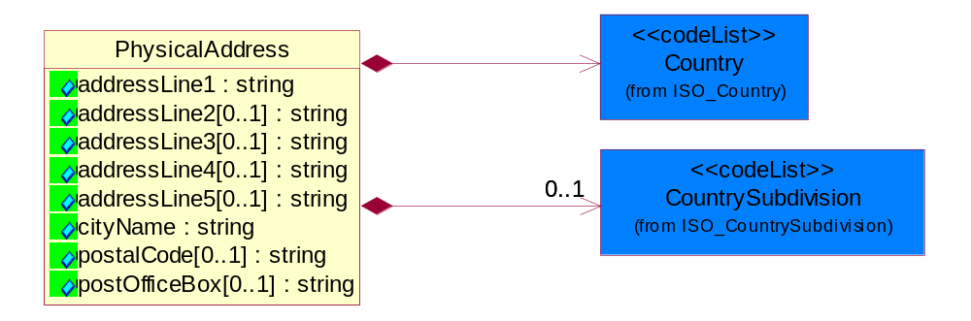
Figure 4-35 PhysicalAddress
Attribute | Type | Documentation
addressLine1 | string | The first line of a physical address.
addressLine2[0..1] | string | The second line of a physical address.
addressLine3[0..1] | string | The third line of a physical address.
addressLine4[0..1] | string | The fourth line of a physical address.
addressLine5[0..1] | string | The fifth line of a physical address.
cityName | string | The name of a city.
postalCode[0..1] | string | Identifying geographic location as specified by a national postal code.
postOfficeBox[0..1] | string | The Post Office Box identifier used to identify a party's post office box.

Composition | Cardinality | Type | Documentation
Country | 1 | Country | For representation of Country name RosettaNet has adopted ISO 3166-3; 1999. Refer to the following web page to get the latest version of the standard:  http://www.iso.ch/iso/en/prods-services/iso3166ma/02iso-3166-code-lists/index.html  If you need more information about the ISO standard please contact ISO for more details.
CountrySubdivision | 0..1 | CountrySubdivision | For representation of a Countries subdivisions RosettaNet has adopted ISO 3166-3; 1999. Refer to the following web page to get the latest version of the standard:  http://www.iso.ch/iso/en/prods-services/iso3166ma/02iso-3166-code-lists/index.html  If you need more information about the ISO standard please contact ISO for more details.

PartnerIdentification

PartnerIdentification
The business document must allow for the identity of one or more parties to the transaction.
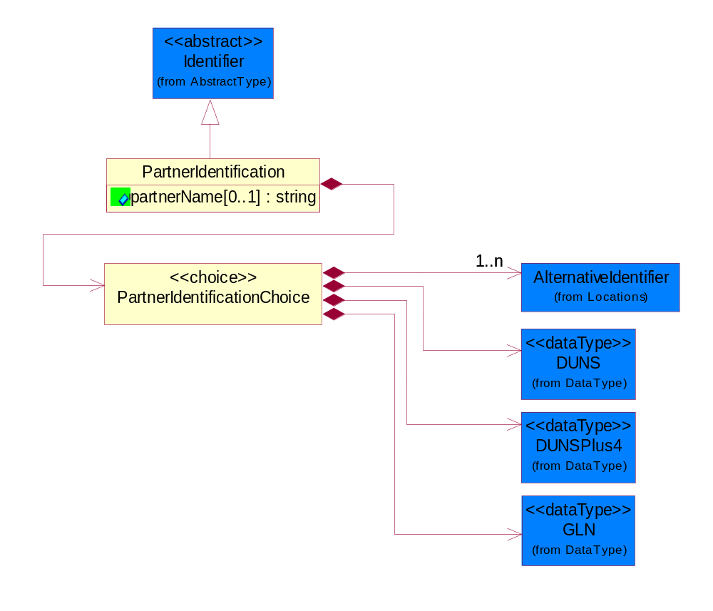
Figure 4-36 PartnerIdentification
Attribute | Type | Documentation
partnerName[0..1] | string | The name of the partner’s company/business.

Composition | Cardinality | Type | Documentation
PartnerIdentificationChoice | 1 | PartnerIdentificationChoice

PartnerIdentificationChoice

Composition | Cardinality | Type | Documentation
AlternativeIdentifier | 1..n | AlternativeIdentifier | Identifies the specified code and the name of the organization that a code is utilized from.
DUNS | 1 | DUNS | A number assigned by Dun and Bradstreet to identify a business location.
DUNSPlus4 | 1 | DUNSPlus4 | A identifier to specify a specific location within a business location.
GLN | 1 | GLN | Global Location Number (GLN) - A identifier to identify legal entities, trading parties and location.

SpecifiedFullPartner
The business document must describe the trading partners in the business transaction. This data structure provide the flexibility to describe a partner in all possible methods as for new, existing or known partner. This is specifically for partner who role has been specified.
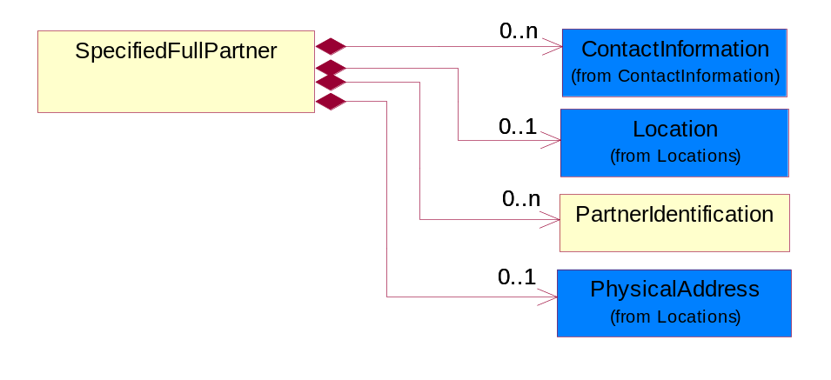
Figure 4-37 SpecifiedFullPartner
Composition | Cardinality | Type | Documentation
ContactInformation | 0..n | ContactInformation | The business document must allow for the identification of the name of the department, service or individual to be contacted regarding the context of the business document.
Location | 0..1 | Location | The business document must specify a location.
PhysicalAddress | 0..1 | PhysicalAddress | The business document must provide a physical address for a party to the business transaction.
PartnerIdentification | 0..n | PartnerIdentification | The business document must allow for the identity of one or more parties to the transaction.

SpecifiedIntermittentPartner
The business document must describe a physical address for a delivery.
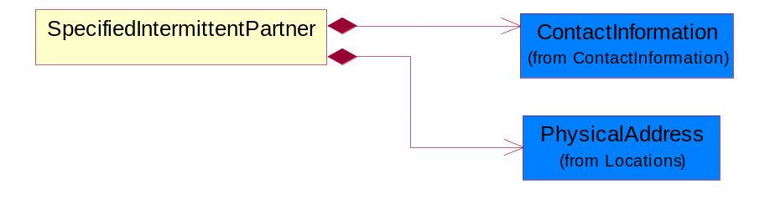
Figure 4-38 SpecifiedIntermittentPartner
Composition | Cardinality | Type | Documentation
ContactInformation | 1 | ContactInformation | The business document must allow for the identification of the name of the department, service or individual to be contacted regarding the context of the business document.
PhysicalAddress | 1 | PhysicalAddress | The business document must provide a physical address for a party to the business transaction.

SpecifiedKnownPartner
The business document must describe the trading partners in the business transaction.
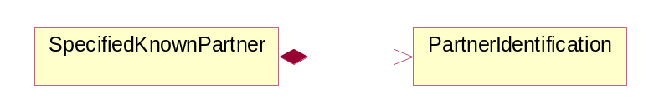
Figure 4-39 SpecifiedKnownPartner
Composition | Cardinality | Type | Documentation
PartnerIdentification | 1 | PartnerIdentification | The business document must allow for the identity of one or more parties to the transaction.

SpecifiedKnownPartnerContact
The business document must describe the trading partners in the business transaction and allow for a identification of an individual of the trading partner.
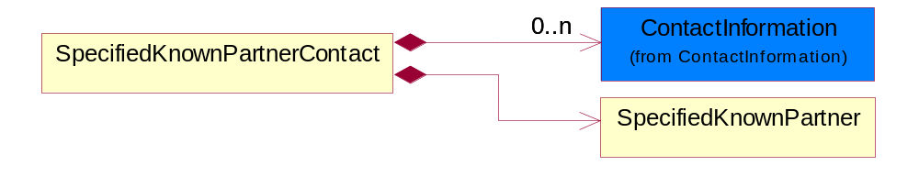
Figure 4-40 SpecifiedKnownPartnerContact
Composition | Cardinality | Type | Documentation
ContactInformation | 0..n | ContactInformation | The business document must allow for the identification of the name of the department, service or individual to be contacted regarding the context of the business document.
SpecifiedKnownPartner | 1 | SpecifiedKnownPartner | The business document must describe the trading partners in the business transaction.

SpecifiedNewPartner
The business document must describe a new, existing (but known to only one of the parties to the transaction) or an unknown party to the business transaction.
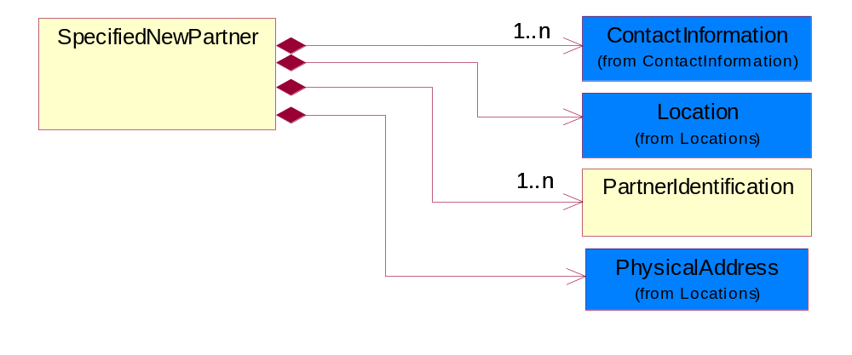
Figure 4-41 SpecifiedNewPartner
Composition | Cardinality | Type | Documentation
ContactInformation | 1..n | ContactInformation | The business document must allow for the identification of the name of the department, service or individual to be contacted regarding the context of the business document.
Location | 1 | Location | The business document must specify a location.
PartnerIdentification | 1..n | PartnerIdentification | The business document must allow for the identity of one or more parties to the transaction.
PhysicalAddress | 1 | PhysicalAddress | The business document must provide a physical address for a party to the business transaction.

SpecifiedPartnerDescription
The collection of business properties that describe a business partners' identity, their contact information, where they are physically located and their function in a supply chain.
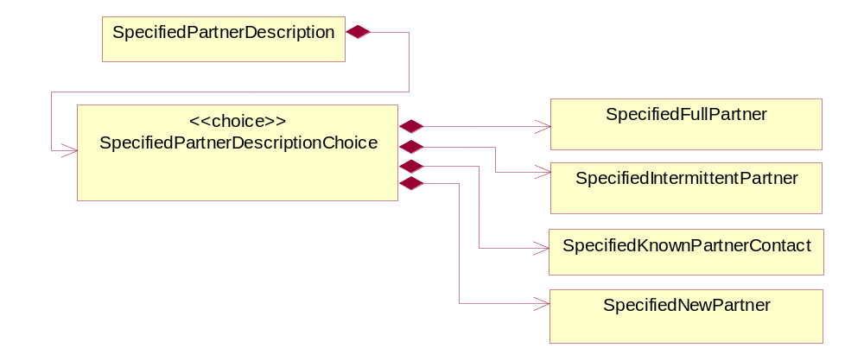
Figure 4-42 SpecifiedPartnerDescription
Composition | Cardinality | Type | Documentation
SpecifiedPartnerDescriptionChoice | 1 | SpecifiedPartnerDescriptionChoice

SpecifiedPartnerDescriptionChoice

Composition | Cardinality | Type | Documentation
SpecifiedFullPartner | 1 | SpecifiedFullPartner | The business document must describe the trading partners in the business transaction. This data structure provide the flexibility to describe a partner in all possible methods as for new, existing or known partner. This is specifically for partner who role has been specified.
SpecifiedIntermittentPartner | 1 | SpecifiedIntermittentPartner | The business document must describe a physical address for a delivery.
SpecifiedKnownPartnerContact | 1 | SpecifiedKnownPartnerContact | The business document must describe the trading partners in the business transaction and allow for a identification of an individual of the trading partner.
SpecifiedNewPartner | 1 | SpecifiedNewPartner | The business document must describe a new, existing (but known to only one of the parties to the transaction) or an unknown party to the business transaction.

ProductIdentification

ProductIdentification
The object provides the identifier(s) of a product.
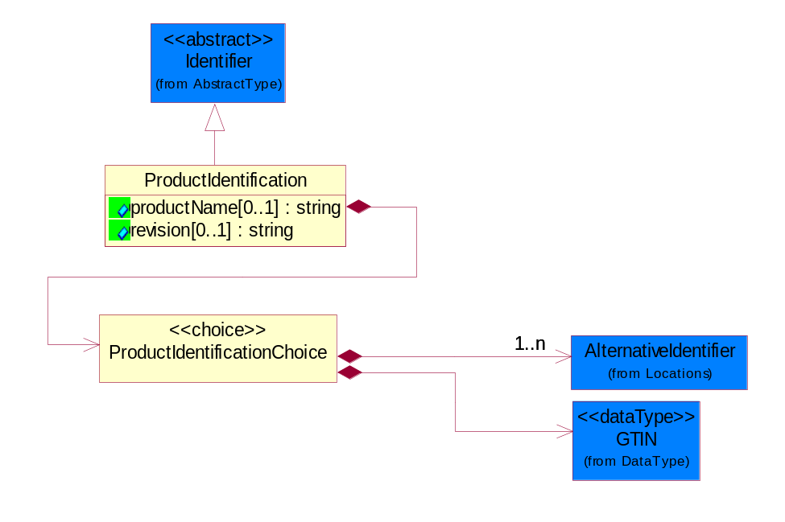
Figure 4-43 ProductIdentification
Attribute | Type | Documentation
productName[0..1] | string | The name of the product.
revision[0..1] | string | Referenced the specified product revision.

Composition | Cardinality | Type | Documentation
ProductIdentificationChoice | 1 | ProductIdentificationChoice

ProductIdentificationChoice

Composition | Cardinality | Type | Documentation
AlternativeIdentifier | 1..n | AlternativeIdentifier | Identifies the specified code and the name of the organization that a code is utilized from.
GTIN | 1 | GTIN | Global Trade Identification Number (GTIN).

CodeList

Country
For representation of Country name RosettaNet has adopted ISO 3166-3; 1999. Refer to the following web page to get the latest version of the standard:
http://www.iso.ch/iso/en/prods-services/iso3166ma/02iso-3166-code-lists/index.html

If you need more information about the ISO standard please contact ISO for more details.

CountrySubdivision
For representation of a Countries subdivisions RosettaNet has adopted ISO 3166-3; 1999. Refer to the following web page to get the latest version of the standard:
http://www.iso.ch/iso/en/prods-services/iso3166ma/02iso-3166-code-lists/index.html

If you need more information about the ISO standard please contact ISO for more details.

Language
For representation of Language name RosettaNet has adopted ISO 639-2; 1998. Refer to the following web page to get the latest version of the standard:

http://www.loc.gov/standards/iso639-2/iso639jac.html

If you need more information about the ISO standard please contact ISO for more details.

DocumentType
A code identifying the business context of a document.

Instance | Documentation
ARA | Authorization Request Approval.
CBN | Product batch number of customer.
CCN | Customs clearance number.
CFA | Failure Analysis - Request document that will accompany the product providing characteristics of the component failure.
CIN | Commercial Invoice.
CNM | Traditional credit note or memo.
CON | In a virtual sourcing relationship, a third party trading partner is supplying a part to a customer on behalf of another company that has taken the order for the customer. In this case a Customer Order Number is associated to the request for material that is sent to the virtual trading partners.
COS | Consumption Notice.
COT | Contract.
CRN | Unique consumption reference number identifying the product consumption issue i.e. one-to-one relationship with physical flow.
DEM | Traditional debit note or memo.
DEN | Delivery Note.
DIN | Discontinuation Notice.
DOR | Delivery Order.
DRN | Drawing Number.
DRR | Design Registration Request.
ECO | Engineering Change Order - The proprietary unique identification number that represents an engineering change order.
EIR | Engineering Information Request.
EOL | End of Life.
FUO | Sales order or transfer order fulfilling demand out of a facility (outbound shipment).
INV | Invoice.
LID | Location Identifier. Data for on-site work that have to be done on the machine (associated with preventive maintenance order).
MEN | Master Event Number.
MID | Machine Identifier. Data for on-site work that have to be done on the machine (associated with preventive maintenance order).
MON | Model Number.
OCL | The unique identifier assigned by the OEM for a warranty claim.
OGA | Other governmental agency issued document.
OPO | The unique identifier assigned by the OEM for a part order.
OPR | The unique identifier assigned by the OEM for a part return.
PCN | Product/Process Change.
PFA | Failure Analysis - Request document that will accompany the product providing characteristics of the product failure.
PII | Refers to previously issued invoice.
PLS | Unique number that identifies packing form prior to shipment.
POI | Purchase Order IN.
PON | Production order number for material release.
POO | Purchase Order OUT.
PRC | Product Catalog.
PSI | Refers to previously issued self-billing invoice.
PUO | Purchase Order.
QUO | Quote.
REC | Document identifying the receipt of materials or products into a facility against a purchase order or transfer order (inbound shipment).
REO | Purchase order or transfer order replenishing inventory into a facility (inbound shipment).
REQ | Requisition.
RMA | Returned Material Authorization.
RPO | Purchase order for materials or product returned to and reworked by a supplier.
RTA | Remittance Advice - Remittance details.
SAO | Sales Order.
SBC | Credit Memo used in self-billing scenario.
SBD | Debit Memo used in self-billing scenario.
SBI | Invoice in self billing scenario.
SBN | Product batch number of supplier.
SCA | Similar to contracts - Contains the quantity of an article that is to be ordered from a vendor and the price for article or service that is to be procured.
SEN | Serial Number.
SEO | A document that gives a repair provider the necessary authorization to repair or upgrade a product either at the customer site or at the repair provider’s site.
SHD | Shipping Document.
SNC | Shipset Number on Code List.
SPC | The unique identifier assigned by the ASP for a warranty claim.
SPN | Spec Number.
SPO | The unique identifier assigned by the ASP for a part order.
SPR | The unique identifier assigned by the ASP for a part return.
SPW | The unique identifier assigned by the ASP to reference a work order.
SRI | A document that contains the shipping reference number which allows the product to be tracked within the outsourced logistic providers network.
TRO | Order which results in materials or products being moved from one facility to another (outbound shipment and inbound shipment).
WAB | Waybill.
WAC | Denotes a warranty claim.
WOO | Work Order.

MimeTypeQualifier
The MIME type as defined by IANA.

Please refer to http://www.iana.org/assignments/media-types/ for a list of types.

Instance | Documentation
application/activemessage | [Shapiro]
application/andrew-inset | [Borenstein]
application/applefile | [Faltstrom]
application/atomicmail | [Borenstein]
application/batch-SMTP | [RFC2442]
application/beep+xml | [RFC3080]
application/cals-1840 | [RFC1895]
application/cnrp+xml | [RFCCNRP]
application/commonground | [Glazer]
application/cpl+xml
application/cybercash | [Eastlake]
application/dca-rft | [Campbell]
application/dec-dx | [Campbell]
application/dicom | [RFC3240]
application/dvcs | [RFC3029]
application/EDI-Consent | [RFC1767]
application/EDIFACT | [RFC1767]
application/EDI-X12 | [RFC1767]
application/eshop | [Katz]
application/font-tdpfr | [RFC3073]
application/http | [RFC2616]
application/hyperstudio | [Domino]
application/iges | [Parks]
application/index | [RFC2652]
application/index.cmd | [RFC2652]
application/index.obj | [RFC2652]
application/index.response | [RFC2652]
application/index.vnd | [RFC2652]
application/iotp | [RFC2935]
application/ipp | [RFC2910]
application/isup | [RFC3204]
application/mac-binhex40 | [Faltstrom]
application/macwriteii | [Lindner]
application/marc | [RFC2220]
application/mathematica | [Van Nostern]
application/msword | [Lindner]
application/news-message-id | [RFC1036,Spencer]
application/news-transmission | [RFC1036, Spencer]
application/ocsp-request | [RFC2560]
application/ocsp-response | [RFC2560]
application/octet-stream | [RFC2045,RFC2046]
application/oda | [RFC2045,RFC2046]
application/ogg | [RFC-walleij-ogg-mediatype-08.txt]
application/parityfec | [RFC3009]
application/pdf | [Lindner]
application/pgp-encrypted | [RFC3156]
application/pgp-keys | [RFC3156]
application/pgp-signature | [RFC3156]
application/pkcs10 | [RFC2311]
application/pkcs7-mime | [RFC2311]
application/pkcs7-signature | [RFC2311]
application/pkix-cert | [RFC2585]
application/pkixcmp | [RFC2510]
application/pkix-crl | [RFC2585]
application/postscript | [RFC2045,RFC2046]
application/prs.alvestrand.titrax-sheet | [Alvestrand]
application/prs.cww | [Rungchavalnont]
application/prs.nprend | [Doggett]
application/prs.plucker | [Janssen]
application/qsig | [RFC3204]
application/reginfo+xml | [RFC-ietf-sipping-reg-event-00.txt]
application/remote-printing | [RFC1486,Rose]
application/riscos | [Smith]
application/rtf | [Lindner]
application/sdp | [RFC2327]
application/set-payment | [Korver]
application/set-payment-initiation | [Korver]
application/set-registration | [Korver]
application/set-registration-initiation | [Korver]
application/sgml | [RFC1874]
application/sgml-open-catalog | [Grosso]
application/sieve | [RFC3028]
application/slate | [Crowley]
application/timestamp-query | [RFC3161]
application/timestamp-reply | [RFC3161]
application/tve-trigger | [Welsh]
application/vemmi | [RFC2122]
application/vnd.3gpp.pic-bw-large | [Meredith]
application/vnd.3gpp.pic-bw-small | [Meredith]
application/vnd.3gpp.pic-bw-var | [Meredith]
application/vnd.3gpp.sms | [Meredith]
application/vnd.3M.Post-it-Notes | [O'Brien]
application/vnd.accpac.simply.aso | [Leow]
application/vnd.accpac.simply.imp | [Leow]
application/vnd.acucobol | [Lubin]
application/vnd.acucorp | [Lubin]
application/vnd.adobe.xfdf | [Perelman]
application/vnd.aether.imp | [Moskowitz]
application/vnd.amiga.ami | [Blumberg]
application/vnd.anser-web-certificate-issue-initiation | [Mori]
application/vnd.anser-web-funds-transfer-initiation | [Mori]
application/vnd.audiograph | [Slusanschi]
application/vnd.blueice.multipass | [Holmstrom]
application/vnd.bmi | [Gotoh]
application/vnd.businessobjects | [Imoucha]
application/vnd.canon-cpdl | [Muto]
application/vnd.canon-lips | [Muto]
application/vnd.cinderella | [Kortenkamp]
application/vnd.claymore | [Simpson]
application/vnd.commerce-battelle | [Applebaum]
application/vnd.commonspace | [Chandhok]
application/vnd.contact.cmsg | [Patz]
application/vnd.cosmocaller | [Dellutri]
application/vnd.ctc-posml | [Kohlhepp]
application/vnd.cups-postscript | [Sweet]
application/vnd.cups-raster | [Sweet]
application/vnd.cups-raw | [Sweet]
application/vnd.curl | [Byrnes]
application/vnd.cybank | [Helmee]
application/vnd.data-vision.rdz | [Fields]
application/vnd.dna | [Searcy]
application/vnd.dpgraph | [Parker]
application/vnd.dreamfactory | [Appleton]
application/vnd.dxr | [Duffy]
application/vnd.ecdis-update | [Buettgenbach]
application/vnd.ecowin.chart | [Olsson]
application/vnd.ecowin.filerequest | [Olsson]
application/vnd.ecowin.fileupdate | [Olsson]
application/vnd.ecowin.series | [Olsson]
application/vnd.ecowin.seriesrequest | [Olsson]
application/vnd.ecowin.seriesupdate | [Olsson]
application/vnd.enliven | [Santinelli]
application/vnd.epson.esf | [Hoshina]
application/vnd.epson.msf | [Hoshina]
application/vnd.epson.quickanime | [Gu]
application/vnd.epson.salt | [Nagatomo]
application/vnd.epson.ssf | [Hoshina]
application/vnd.ericsson.quickcall | [Tidwell]
application/vnd.eudora.data | [Resnick]
application/vnd.fdf | [Zilles]
application/vnd.ffsns | [Holstage]
application/vnd.FloGraphIt | [Floersch]
application/vnd.framemaker | [Wexler]
application/vnd.fsc.weblaunch | [D.Smith]
application/vnd.fujitsu.oasys | [Togashi]
application/vnd.fujitsu.oasys2 | [Togashi]
application/vnd.fujitsu.oasys3 | [Okudaira]
application/vnd.fujitsu.oasysgp | [Sugimoto]
application/vnd.fujitsu.oasysprs | [Ogita]
application/vnd.fujixerox.ddd | [Onda]
application/vnd.fujixerox.docuworks | [Taguchi]
application/vnd.fujixerox.docuworks.binder | [Matsumoto]
application/vnd.fut-misnet | [Pruulmann]
application/vnd.grafeq | [Tupper]
application/vnd.groove-account | [Joseph]
application/vnd.groove-help | [Joseph]
application/vnd.groove-identity-message | [Joseph]
application/vnd.groove-injector | [Joseph]
application/vnd.groove-tool-message | [Joseph]
application/vnd.groove-tool-template | [Joseph]
application/vnd.groove-vcard | [Joseph]
application/vnd.hbci | [Hammann]
application/vnd.hhe.lesson-player | [Jones]
application/vnd.hp-HPGL | [Pentecost]
application/vnd.hp-hpid | [Gupta]
application/vnd.hp-hps | [Aubrey]
application/vnd.hp-PCL | [Pentecost]
application/vnd.hp-PCLXL | [Pentecost]
application/vnd.httphone | [Lefevre]
application/vnd.hzn-3d-crossword | [Minnis]
application/vnd.ibm.afplinedata | [Buis]
application/vnd.ibm.electronic-media | [Tantlinger]
application/vnd.ibm.MiniPay | [Herzberg]
application/vnd.ibm.modcap | [Hohensee]
application/vnd.ibm.secure-container | [Tantlinger]
application/vnd.informix-visionary | [Gales]
application/vnd.intercon.formnet | [Gurak]
application/vnd.intertrust.digibox | [Tomasello]
application/vnd.intertrust.nncp | [Tomasello]
application/vnd.intu.qbo | [Scratchley]
application/vnd.intu.qfx | [Scratchley]
application/vnd.irepository.package+xml | [Knowles]
application/vnd.is-xpr | [Natarajan]
application/vnd.japannet-directory-service | [Fujii]
application/vnd.japannet-jpnstore-wakeup | [Yoshitake]
application/vnd.japannet-payment-wakeup | [Fujii]
application/vnd.japannet-registration | [Yoshitake]
application/vnd.japannet-registration-wakeup | [Fujii]
application/vnd.japannet-setstore-wakeup | [Yoshitake]
application/vnd.japannet-verification | [Yoshitake]
application/vnd.japannet-verification-wakeup | [Fujii]
application/vnd.jisp | [Deckers]
application/vnd.kde.karbon | [Faure]
application/vnd.kde.kchart | [Faure]
application/vnd.kde.kformula | [Faure]
application/vnd.kde.kivio | [Faure]
application/vnd.kde.kontour | [Faure]
application/vnd.kde.kpresenter | [Faure]
application/vnd.kde.kspread | [Faure]
application/vnd.kde.kword | [Faure]
application/vnd.kenameaapp | [DiGiorgio-Haag]
application/vnd.koan | [Cole]
application/vnd.liberty-request+xml | [McDowell]
application/vnd.llamagraphics.life-balance.desktop | [White]
application/vnd.lotus-1-2-3 | [Wattenberger]
application/vnd.lotus-approach | [Wattenberger]
application/vnd.lotus-freelance | [Wattenberger]
application/vnd.lotus-notes | [Laramie]
application/vnd.lotus-organizer | [Wattenberger]
application/vnd.lotus-screencam | [Wattenberger]
application/vnd.lotus-wordpro | [Wattenberger]
application/vnd.mcd | [Gotoh]
application/vnd.mediastation.cdkey | [Flurry]
application/vnd.meridian-slingshot | [Wedel]
application/vnd.micrografx.flo | [Prevo]
application/vnd.micrografx.igx | [Prevo]
application/vnd.mif | [Wexler]
application/vnd.minisoft-hp3000-save | [Bartram]
application/vnd.mitsubishi.misty-guard.trustweb | [Tanaka]
application/vnd.Mobius.DAF | [Kabayama]
application/vnd.Mobius.DIS | [Kabayama]
application/vnd.Mobius.MBK | [Devasia]
application/vnd.Mobius.MQY | [Devasia]
application/vnd.Mobius.MSL | [Kabayama]
application/vnd.Mobius.PLC | [Kabayama]
application/vnd.Mobius.TXF | [Kabayama]
application/vnd.mophun.application | [Wennerstrom]
application/vnd.mophun.certificate | [Wennerstrom]
application/vnd.motorola.flexsuite | [Patton]
application/vnd.motorola.flexsuite.adsi | [Patton]
application/vnd.motorola.flexsuite.fis | [Patton]
application/vnd.motorola.flexsuite.gotap | [Patton]
application/vnd.motorola.flexsuite.kmr | [Patton]
application/vnd.motorola.flexsuite.ttc | [Patton]
application/vnd.motorola.flexsuite.wem | [Patton]
application/vnd.mozilla.xul+xml | [McDaniel]
application/vnd.ms-artgalry | [Slawson]
application/vnd.ms-asf | [Fleischman]
application/vnd.mseq | [Le Bodic]
application/vnd.ms-excel | [Gill]
application/vnd.msign | [Borcherding]
application/vnd.ms-lrm | [Ledoux]
application/vnd.ms-powerpoint | [Gill]
application/vnd.ms-project | [Gill]
application/vnd.ms-tnef | [Gill]
application/vnd.ms-works | [Gill]
application/vnd.ms-wpl | [Plastina]
application/vnd.musician | [Adams]
application/vnd.music-niff | [Butler]
application/vnd.netfpx | [Mutz]
application/vnd.noblenet-directory | [Solomon]
application/vnd.noblenet-sealer | [Solomon]
application/vnd.noblenet-web | [Solomon]
application/vnd.novadigm.EDM | [Swenson]
application/vnd.novadigm.EDX | [Swenson]
application/vnd.novadigm.EXT | [Swenson]
application/vnd.obn | [Hessling]
application/vnd.osa.netdeploy | [Klos]
application/vnd.palm | [Peacock]
application/vnd.pg.format | [Gandert]
application/vnd.pg.osasli | [Gandert]
application/vnd.powerbuilder6 | [Guy]
application/vnd.powerbuilder6-s | [Guy]
application/vnd.powerbuilder7 | [Shilts]
application/vnd.powerbuilder75 | [Shilts]
application/vnd.powerbuilder75-s | [Shilts]
application/vnd.powerbuilder7-s | [Shilts]
application/vnd.previewsystems.box | [Smolgovsky]
application/vnd.publishare-delta-tree | [Ben-Kiki]
application/vnd.pvi.ptid1 | [Lamb]
application/vnd.pwg-multiplexed | [RFC3391]
application/vnd.pwg-xhtml-print+xml | [Wright]
application/vnd.Quark.QuarkXPress | [Scheidler]
application/vnd.rapid | [Szekely]
application/vnd.s3sms | [Tarkkala]
application/vnd.sealed.net | [Lambert]
application/vnd.seemail | [Webb]
application/vnd.shana.informed.formdata | [Selzler]
application/vnd.shana.informed.formtemplate | [Selzler]
application/vnd.shana.informed.interchange | [Selzler]
application/vnd.shana.informed.package | [Selzler]
application/vnd.smaf | [Takahashi]
application/vnd.sss-cod | [Dani]
application/vnd.sss-dtf | [Bruno]
application/vnd.sss-ntf | [Bruno]
application/vnd.street-stream | [Levitt]
application/vnd.svd | [Becker]
application/vnd.swiftview-ics | [Widener]
application/vnd.triscape.mxs | [Simonoff]
application/vnd.trueapp | [Hepler]
application/vnd.truedoc | [Chase]
application/vnd.ufdl | [Manning]
application/vnd.uplanet.alert | [Martin]
application/vnd.uplanet.alert-wbxml | [Martin]
application/vnd.uplanet.bearer-choice | [Martin]
application/vnd.uplanet.bearer-choice-wbxml | [Martin]
application/vnd.uplanet.cacheop | [Martin]
application/vnd.uplanet.cacheop-wbxml | [Martin]
application/vnd.uplanet.channel | [Martin]
application/vnd.uplanet.channel-wbxml | [Martin]
application/vnd.uplanet.list | [Martin]
application/vnd.uplanet.listcmd | [Martin]
application/vnd.uplanet.listcmd-wbxml | [Martin]
application/vnd.uplanet.list-wbxml | [Martin]
application/vnd.uplanet.signal | [Martin]
application/vnd.vcx | [T.Sugimoto]
application/vnd.vectorworks | [Pharr]
application/vnd.vidsoft.vidconference | [Hess]
application/vnd.visio | [Sandal]
application/vnd.visionary | [Aravindakumar]
application/vnd.vividence.scriptfile | [Risher]
application/vnd.vsf | [Rowe]
application/vnd.wap.sic | [WAP-Forum]
application/vnd.wap.slc | [WAP-Forum]
application/vnd.wap.wbxml | [Stark]
application/vnd.wap.wmlc | [Stark]
application/vnd.wap.wmlscriptc | [Stark]
application/vnd.webturbo | [Rehem]
application/vnd.wrq-hp3000-labelled | [Bartram]
application/vnd.wt.stf | [Wohler]
application/vnd.wv.csp+wbxml | [Salmi]
application/vnd.xara | [Matthewman]
application/vnd.xfdl | [Manning]
application/vnd.yellowriver-custom-menu | [Yellow]
application/whoispp-query | [RFC2957]
application/whoispp-response | [RFC2958]
application/wita | [Campbell]
application/wordperfect5.1 | [Lindner]
application/x400-bp | [RFC1494]
application/xhtml+xml | [RFC3236]
application/xml | [RFC3023]
application/xml-dtd | [RFC3023]
application/xml-external-parsed-entity | [RFC3023]
application/zip | [Lindner]
audio/32kadpcm | [RFC2421,RFC2422]
audio/AMR | [RFC3267]
audio/AMR-WB | [RFC3267]
audio/basic | [RFC2045,RFC2046]
audio/CN | [RFC3389]
audio/DAT12 | [RFC3190]
audio/DVI4
audio/EVRC | [RFC-ietf-avt-evrc-smv-03.txt]
audio/EVRC0 | [RFC-ietf-avt-evrc-smv-03.txt]
audio/G.722.1 | [RFC3047]
audio/G722
audio/G723
audio/G726-16
audio/G726-24
audio/G726-32
audio/G726-40
audio/G728
audio/G729
audio/G729D
audio/G729E
audio/GSM
audio/GSM-EFR
audio/L16 | [RFC2586]
audio/L20 | [RFC3190]
audio/L24 | [RFC3190]
audio/L8
audio/LPC
audio/MP4A-LATM | [RFC3016]
audio/MPA
audio/mpa-robust | [RFC3119]
audio/mpeg | [RFC3003]
audio/parityfec | [RFC3009]
audio/PCMA
audio/PCMU
audio/prs.sid | [Walleij]
audio/QCELP
audio/RED
audio/SMV | [RFC-ietf-avt-evrc-smv-03.txt]
audio/SMV0 | [RFC-ietf-avt-evrc-smv-03.txt]
audio/telephone-event | [RFC2833]
audio/tone | [RFC2833]
audio/VDVI
audio/vnd.3gpp.iufp | [Belling]
audio/vnd.cisco.nse | [Kumar]
audio/vnd.cns.anp1 | [McLaughlin]
audio/vnd.cns.inf1 | [McLaughlin]
audio/vnd.digital-winds | [Strazds]
audio/vnd.everad.plj | [Cicelsky]
audio/vnd.lucent.voice | [Vaudreuil]
audio/vnd.nortel.vbk | [Parsons]
audio/vnd.nuera.ecelp4800 | [Fox]
audio/vnd.nuera.ecelp7470 | [Fox]
audio/vnd.nuera.ecelp9600 | [Fox]
audio/vnd.octel.sbc | [Vaudreuil]
audio/vnd.qcelp | [Lundblade]
audio/vnd.rhetorex.32kadpcm | [Vaudreuil]
audio/vnd.vmx.cvsd | [Vaudreuil]
image/cgm | Computer Graphics Metafile
image/g3fax | [RFC1494]
image/gif | [RFC2045,RFC2046]
image/ief | [RFC1314] Image Exchange Format
image/jpeg | [RFC2045,RFC2046]
image/naplps | [Ferber]
image/png | [Randers-Pehrson]
image/prs.btif | [Simon]
image/prs.pti | [Laun]
image/t38 | [RFC3362]
image/tiff | [RFC3302] Tag Image File Format
image/tiff-fx | [RFC3250] Tag Image File Format Fax eXtended
image/vnd.cns.inf2 | [McLaughlin]
image/vnd.djvu | [Bottou]
image/vnd.dwg | [Moline]
image/vnd.dxf | [Moline]
image/vnd.fastbidsheet | [Becker]
image/vnd.fpx | [Spencer]
image/vnd.fst | [Fuldseth]
image/vnd.fujixerox.edmics-mmr | [Onda]
image/vnd.fujixerox.edmics-rlc | [Onda]
image/vnd.globalgraphics.pgb | [Bailey]
image/vnd.mix | [Reddy]
image/vnd.ms-modi | [Vaughan]
image/vnd.net-fpx | [Spencer]
image/vnd.svf | [Moline]
image/vnd.wap.wbmp | [Stark]
image/vnd.xiff | [S.Martin]
message/delivery-status | [RFC1894]
message/disposition-notification | [RFC2298]
message/external-body | [RFC2045,RFC2046]
message/http | [RFC2616]
message/news | [RFC 1036, H.Spencer]
message/partial | [RFC2045,RFC2046]
message/rfc822 | [RFC2045,RFC2046]
message/s-http | [RFC2660]
message/sip | [RFC3261]
message/sipfrag | [RFC3420]
model/iges | [Parks]
model/mesh | [RFC2077]
model/vnd.dwf | [Pratt]
model/vnd.flatland.3dml | [Powers]
model/vnd.gdl | [Babits]
model/vnd.gs-gdl | [Babits]
model/vnd.gtw | [Ozaki]
model/vnd.mts | [Rabinovitch]
model/vnd.parasolid.transmit.binary | [Parasolid]
model/vnd.parasolid.transmit.text | [Parasolid]
model/vnd.vtu | [Rabinovitch]
model/vrml | [RFC2077]
multipart/alternative | [RFC2045,RFC2046]
multipart/appledouble | [Faltstrom]
multipart/byteranges | [RFC2068]
multipart/digest | [RFC2045,RFC2046]
multipart/encrypted | [RFC1847]
multipart/form-data | [RFC2388]
multipart/header-set | [Crocker]
multipart/mixed | [RFC2045,RFC2046]
multipart/parallel | [RFC2045,RFC2046]
multipart/related | [RFC2387]
multipart/report | [RFC1892]
multipart/signed | [RFC1847]
multipart/voice-message | [RFC2421,RFC2423]
text/calendar | [RFC2445]
text/css | [RFC2318]
text/directory | [RFC2425]
text/enriched | [RFC1896]
text/html | [RFC2854]
text/parityfec | [RFC3009]
text/plain | [RFC2646,RFC2046]
text/prs.lines.tag | [Lines]
text/rfc822-headers | [RFC1892]
text/richtext | [RFC2045,RFC2046]
text/rtf | [Lindner]
text/sgml | [RFC1874]
text/t140 | [RFC2793]
text/tab-separated-values | [Lindner]
text/uri-list | [RFC2483]
text/vnd.abc | [Allen]
text/vnd.curl | [Byrnes]
text/vnd.DMClientScript | [Bradley]
text/vnd.fly | [Gurney]
text/vnd.fmi.flexstor | [Hurtta]
text/vnd.in3d.3dml | [Powers]
text/vnd.in3d.spot | [Powers]
text/vnd.IPTC.NewsML | [IPTC]
text/vnd.IPTC.NITF | [IPTC]
text/vnd.latex-z | [Lubos]
text/vnd.motorola.reflex | [Patton]
text/vnd.ms-mediapackage | [Nelson]
text/vnd.net2phone.commcenter.command | [Xie]
text/vnd.sun.j2me.app-descriptor | [G.Adams]
text/vnd.wap.si | [WAP-Forum]
text/vnd.wap.sl | [WAP-Forum]
text/vnd.wap.wml | [Stark]
text/vnd.wap.wmlscript | [Stark]
text/xml | [RFC3023]
text/xml-external-parsed-entity | [RFC3023]
video/BMPEG
video/BT656
video/CelB
video/DV | [RFC3189]
video/H261
video/H263
video/H263-1998
video/H263-2000
video/JPEG
video/MP1S
video/MP2P
video/MP2T
video/MP4V-ES | [RFC3016]
video/mpeg | [RFC2045,RFC2046]
video/MPV
video/nv
video/parityfec | [RFC3009]
video/pointer | [RFC2862]
video/quicktime | [Lindner]
video/SMPTE292M | [RFC-avt-smpte292-video-08.txt]
video/vnd.fvt | [Fuldseth]
video/vnd.motorola.video | [McGinty]
video/vnd.motorola.videop | [McGinty]
video/vnd.mpegurl | [Recktenwald]
video/vnd.nokia.interleaved-multimedia | [Kangaslampi]
video/vnd.objectvideo | [Clark]
video/vnd.vivo | [Wolfe]

UnitOfMeasure
Code identifying a product unit of measure.

Instance | Documentation
10P | 10-pack.
1BF | 100 Board Feet.
1FC | 20 Foot Container.
1GR | Gram/Cubic Centimeter.
1GT | 10,000 Gallon Tankcar.
1KB | 25 Kilogram Bulk Bag.
1KD | 10 Kilogram Drum.
1KP | 1000-pack.
1PA | 20-Pack.
1PB | 50 Pound Bag.
1PD | 100 Pound Drum.
2FC | 40 Foot Container.
2GR | Gram/square meter.
2GT | 20,000 Gallon Tankcar.
2KB | 300 Kilogram Bulk Bag.
2KD | 15 Kilogram Drum.
2PA | 100-Pack.
3GR | Grams Per 100 Centimeters.
3KB | 500 Kilogram Bulk Bag.
3KD | 55 Gallon Drum.
4GR | Grams Per 100 Grams.
4KD | 115 Kilogram Drum.
50P | 50-pack.
5GR | Grams Per Cubic Centimeter.
6GR | Grams Per Square Centimeter.
7GR | Grams Per Square Meter.
ACR | Acre.
ACT | Actual Pounds.
ALU | Aluminum Pounds Only.
AMP | Ampere.
ASM | Angstrom.
BAB | Base Box.
BAC | Batch.
BAE | Bale.
BAG | Bag.
BAL | Ball.
BAN | Band.
BAP | Batting Pound.
BAR | Bar.
BAS | Basket.
BAT | Batt.
BAW | Base Weight.
BEA | Beam.
BEC | Becquerel/kilogram.
BEL | Belt.
BIL | Billet.
BIN | Bin.
BIT | Bit.
BKC | Bulk Car Load.
BLO | Block.
BOA | Board.
BOF | Board Feet.
BOL | Bolt.
BOT | Bottle.
BOX | Box.
BRD | Barrels Per Day.
BRE | Barrel.
BRI | Barrel (Imperial).
BRM | Barrels Per Minute.
BTF | British Thermal Units (BTUs) Per Cubic Foot.
BTP | British Thermal Units (BTUs) Per Pound.
BTU | British Thermal Unit (BTU).
BUC | Bucket.
BUD | Bushel, Dry Imperial.
BUK | Bunks.
BUL | Bulk.
BUN | Bundle.
BUP | Bulk Pack.
BUS | Bushel.
BYT | Bytes.
CAA | Carat.
CAB | Carboy.
CAC | Card.
CAD | Candela.
CAG | Cartridge.
CAK | Cask.
CAL | Calorie.
CAN | Can.
CAO | Carload.
CAR | Car.
CAS | Case.
CAT | Canister.
CAW | Catchweight.
CEL | Cell.
CEM | Centimeter.
CEP | Centipoise (CPS).
CET | Centiliter.
CGM | Centigram.
CHA | Chains (Land Survey).
CHE | Chest.
CNN | Connector.
COG | Coil Group.
COI | Coil.
COL | Coulomb.
COM | Composite Product Pounds (Total Weight).
CON | Cone.
COT | Container.
COV | Cover.
CRA | Crate.
CRT | Carton.
CSE | Cassette.
CUB | Cubic centimeter.
CUC | Cubic centimeter/second.
CUF | Cubic Foot.
CUI | Cubic inch.
CUM | Cubicmeter.
CUP | Cup.
CUY | Cubic yard.
CYC | Cycles.
CYL | Cylinder.
DAY | Day.
DCB | Decibels.
DCG | Decagram.
DCL | Deciliter.
DEA | Deal.
DEC | Decimeter.
DEF | Degree Fahrenheit.
DEG | Degree Celsius.
DEP | Dep. Factor.
DGM | Decigram.
DIE | Die.
DIL | Display.
DIP | Dispenser.
DOZ | Dozen.
DRA | Dram.
DRU | Drum.
DRY | Dry Pounds.
EAC | Each.
ELE | Electrical Capacitance.
FAR | Farads.
FFA | Femtofarad.
FLO | Fluid Ounce.
FOI | Fluid Ounce (Imperial).
FOO | Foot.
FOU | Fluid Ounce US.
FUU | Fuel Usage (Gallons).
GAL | Gallon.
GAS | Gage Systems.
GIH | Gigahertz.
GIJ | Gigajoules.
GIL | Gill (Imperial).
GOB | Gross Barrels.
GOG | Gross Gallons.
GOK | Gross Kilogram.
GOT | Gross Ton.
GOY | Gross Yard.
GRA | Gram.
GRG | Great Gross (Dozen Gross).
GRK | Grams Per Kilogram.
GRL | Grams Per Liter.
GRM | Grams Per Milliliter.
GRN | Grain.
GRO | Gross.
GRP | Group.
HAG | Half Gallon.
HAH | Half Hour.
HAL | Half Liter.
HAN | Hank.
HEA | Heat lots.
HEC | Hectare.
HEL | Hectoliter.
HEP | Hectopascal.
HER | Hertz.
HNY | Henry.
HOS | Hours.
HOU | Hour.
HUA | Hundredth of a Carat.
HUB | Hundred Boxes.
HUC | Hundred Count.
HUS | Hundred Sheets.
IMG | Imperial Gallons.
INC | Inch.
JAR | Jar.
JOI | Joint.
JOU | Joule.
KBY | Kilobyte.
KEG | Keg.
KEL | Kelvin.
KHO | Kilometer/hour.
KIC | Kilogram per cubic meter.
KIE | Kilometer.
KIG | Kilogram.
KIH | Kilohertz.
KIK | Kilobecquerel/Kilogram.
KIL | Kiloampere.
KIM | Kilogram/square meter.
KIO | Kiloohm.
KIS | Kilogramm pro Sekunde.
KIT | Kit.
KIV | Kilovolt.
KIW | Kilowatt.
KJL | Kilojoule.
KKG | Kilogram/Kilogram.
KUD | Kubikdezimeter.
KUM | Kubikmeter pro Sekunde.
KWH | Kilowatt-hour.
LIF | Lifts.
LIM | Link.
LIQ | Liquid Pounds.
LIT | Liter.
LOA | Load.
LOT | Lot.
LUG | Lug.
MAM | Milliamps/mm.
MAT | Mat.
MBY | Megabyte.
MCG | Microgram.
MCM | Milligrams Per Cubic Meter.
MCR | Micron.
MEG | Megagram.
MEH | Megahertz.
MEP | Megapascal.
MET | Meter.
MEW | Megawatt.
MGM | Milligram.
MIB | Million BTU's.
MIC | Mikrogram/cubic meter.
MIG | Micrograms Per Cubic Meter.
MIL | Mile.
MIM | Micrometer.
MIN | Minute.
MIP | Millipascal seconds.
MIS | Microsecond.
MIT | Miter.
MIV | Millivolt.
MIW | Milliwatt.
MJO | Millijoule.
MLA | Milliampere.
MLB | Millibar.
MLC | Milligram/cubic meter.
MLI | Milliliter.
MLK | Milligram/kilogram.
MLL | Milligram/Liter.
MLS | Miles.
MME | Millimeter.
MMH | Millimeter H20.
MMK | Millimol/kilogram.
MMO | Millimol.
MOK | Mol/kilogram.
MOL | Mol.
MON | Month.
MPH | Megagrams Per Hour.
MSC | Millisecond.
MSM | Milligrams Per Square Meter.
MTA | Millitesla.
MTQ | Meter pro Quadratsekunde.
MTS | Meters per second.
MUL | Multichip - When 2 or more dies (chips) are merged into one package.
MVS | Millivolts.
MVT | Millivolt.
NAA | Nanoamps.
NAM | Nanometer.
NAS | Nanosecond.
NEB | Net Barrels.
NEG | Net Gallons.
NEI | Net Imperial Gallons.
NEL | Net Liters.
NEW | Newton.
OCT | Ohm/ct.
OHM | Ohm.
OMM | Ohm/mm.
ONE | One.
OSQ | Ohm/sq.
OTP | One Thousand Pieces.
OUN | Ounce.
OVI | Ohm/via.
PAC | Parcel.
PAD | Pad.
PAG | Package.
PAI | Pail.
PAK | Pack (PAK).
PAL | Pallet.
PAN | Panel.
PAR | Pair.
PAS | Pascal.
PAT | Packet.
PEC | Percent.
PEG | Percentage.
PEH | Percent Per 1000 Hours.
PEN | Pennyweight.
PER | Per Hundred Pieces.
PEW | Percent Weight.
PFR | Picofarad.
PID | Pint U.S. Dry.
PIE | Piece.
PIL | Pint - US liquid.
PLA | Plate.
PLL | Pallet (Lift).
PLT | Pallete.
PLU | Pallet/Unit Load.
POF | Pounds Per Foot.
POG | Pounds Per Gallon.
PON | Pound.
POP | Pounds Per Piece of Product.
POS | Pounds Per 1000 Square Feet.
POT | Pounds Per Thousand.
PPB | Parts per billion (US).
PPM | Parts per million.
PPP | Pounds Per Pound of Product.
PSC | Picosecond.
PSS | Pascal second.
QUA | Quart - US liquid.
RAC | Rack.
REA | Ream of 500 Sheets.
REE | Reel.
RIN | Ring.
ROD | Rod.
ROL | Roll.
SAC | Sack.
SBB | Super Bulk Bag.
SEC | Second.
SET | Set.
SHE | Sheet.
SHI | Shipment.
SHM | Sheet - Metric measure.
SHO | Shot.
SID | Disk (Disc).
SKE | Skein.
SKI | Skid.
SLE | Sleeve.
SLI | Slip Sheet.
SMI | Square mile.
SMM | Square millimeter.
SPO | Spool.
SQF | Square foot.
SQI | Square inch.
SQK | Square kilometer.
SQM | Square meter.
SQS | Square meter/second.
SQU | Square.
SQY | Square Yard.
STI | Stick.
STM | Statute Mile.
STR | Strip.
TAB | Tablet.
TAN | Tank.
TAT | Tank Truck.
TES | Tesla.
THO | Thousand.
TNN | Tonne.
TON | Ton.
TOR | Torr.
TOT | Tote.
TRA | Train.
TRF | Track Foot.
TRL | Trailer.
TRO | Troy.
TRU | Truckload.
TRY | Tray.
TRZ | Troy OZ.
TUB | Tube.
ULU | Unitless Unit of Measure.
UNT | Unit.
USG | US gallon.
USP | US pound.
UST | US ton.
VIA | Vial.
VOL | Volt.
VTA | Volts (Alternating Current).
VTD | Volts (Direct Current).
VTM | Volts Per Meter.
WAF | Wafer.
WAR | Watt.
WEE | Week.
WRA | Wrap.
YAR | Yard.
YEA | Year.

System Structure

BusinessProcessIdentifier
A Business Process Identifier to uniquely define the TPIR-PIP 'role' within a Business Scenario at a company or MNC level. The identifier MUST be composed of alphanumeric characters only and its length MUST be between one and twelve characters.
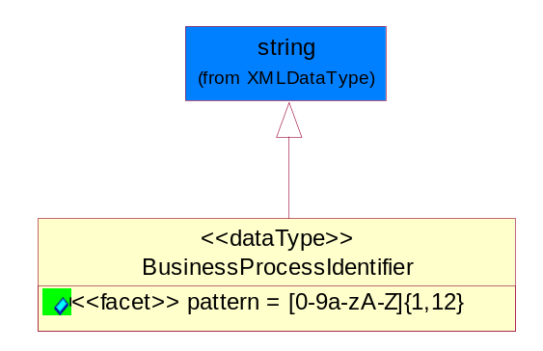
Figure 5-44 BusinessProcessIdentifier
Attribute | Type | Documentation
pattern |  | [0-9a-zA-Z]{1,12}

BusinessServiceInformation
The object allows the specification of the business service utilized within the partner company. This may or may not be the same as the information sent by the RNIF.
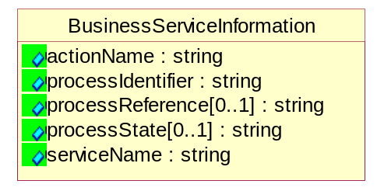
Figure 5-45 BusinessServiceInformation
Attribute | Type | Documentation
actionName | string | The name of Action. For RosettaNet usually any of Request/Confirm/Notify/Query/Response.
processIdentifier | string | The name of the PIP e.g. Notify of Forecast Reply.
processReference[0..1] | string | The URN for the PIP that includes Cluster/Segment/Process pattern used to identify the interface process (such as PIP3A4)
processState[0..1] | string | The business process (or service) state of the sender of a document. When a service receives this document, the receiver may use the state as a precondition.
serviceName | string | The name of the Business Activity with the "Request/Confirm" part removed. E.g., for the Activity "Request Purchase Order"==> "Purchase Order".

ContractInformation
A block of information used to correlate a contract in an executing choreography.
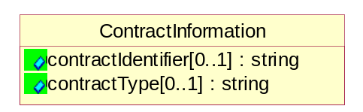
Figure 5-46 ContractInformation
Attribute | Type | Documentation
contractIdentifier[0..1] | string | Unique identification of a contract between the Sender and the Receiver
contractType[0..1] | string | The type of the contract: an attribute describing the type of the ContractIndentification. Valid values are URI, URN,ebXMLCPA, or other values defined by partners.

CorrelationInformation
A block of information used to correlate a requesting document to a responding document and to the contract in an executing choreography.
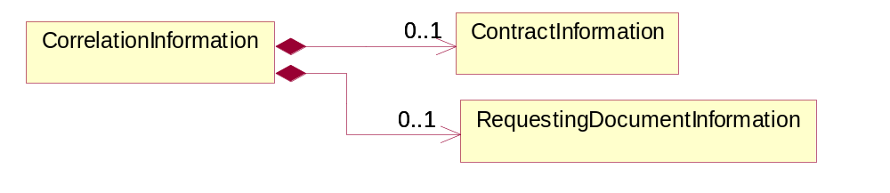
Figure 5-47 CorrelationInformation
Composition | Cardinality | Type | Documentation
ContractInformation | 0..1 | ContractInformation | A block of information used to correlate a contract in an executing choreography.
RequestingDocumentInformation | 0..1 | RequestingDocumentInformation | A block of information used to correlate a requesting document to a responding document in an executing choreography.

DocumentHeader
The object allows for the identification of the sender and receiver of the business document.
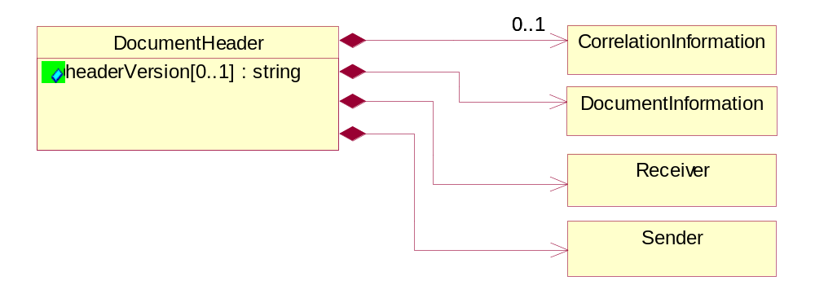
Figure 5-48 DocumentHeader
Attribute | Type | Documentation
headerVersion[0..1] | string | The UN/CEFACT version of the document header.

Composition | Cardinality | Type | Documentation
CorrelationInformation | 0..1 | CorrelationInformation | A block of information used to correlate a requesting document to a responding document and to the contract in an executing choreography.
DocumentInformation | 1 | DocumentInformation | The object specifies information to identify the business document, a summary of attachments, and information about the business document security.
Receiver | 1 | Receiver | The object allows the identification of the receiving party of the business message.
Sender | 1 | Sender | The object allows the identification of the initiating party of the business message.

DocumentIdentification
The object specifies all information necessary to identify the business document.
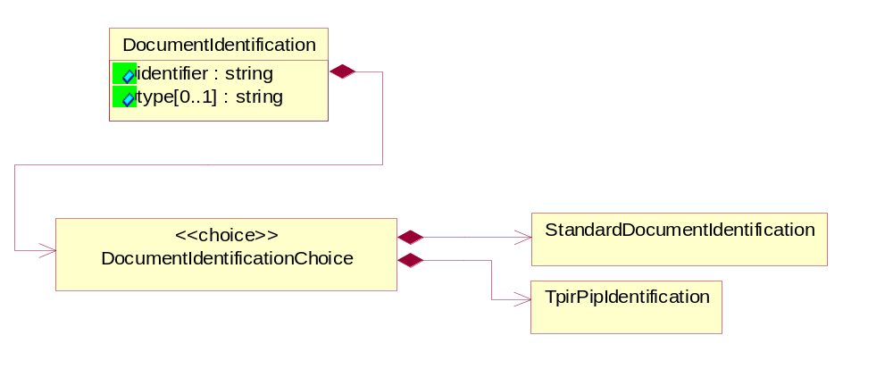
Figure 5-49 DocumentIdentification
Attribute | Type | Documentation
identifier | string | The unique identifier for the document being sent.
type[0..1] | string | Name of the Action Message

Composition | Cardinality | Type | Documentation
DocumentIdentificationChoice | 1 | DocumentIdentificationChoice

DocumentIdentificationChoice

Composition | Cardinality | Type | Documentation
StandardDocumentIdentification | 1 | StandardDocumentIdentification | The object specifies additional information necessary to identify the standard business document.
TpirPipIdentification | 1 | TpirPipIdentification | The object specifies all information necessary to uniquely identify a TPIR-PIP within a Registry or trading partner repository.

DocumentInformation
The object specifies information to identify the business document, a summary of attachments, and information about the business document security.
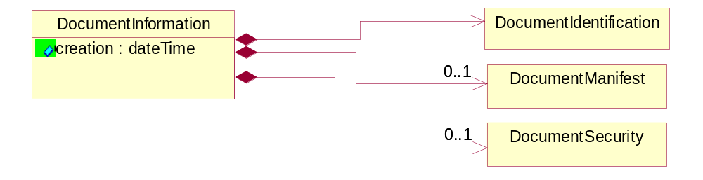
Figure 5-50 DocumentInformation
Attribute | Type | Documentation
creation | dateTime | The creation date and time of the specified Business Document (i.e. the Purchase Order date).

Composition | Cardinality | Type | Documentation
DocumentIdentification | 1 | DocumentIdentification | The object specifies all information necessary to identify the business document.
DocumentManifest | 0..1 | DocumentManifest | The block provides a brief summary of attachments and Service Content.
DocumentSecurity | 0..1 | DocumentSecurity | The object provides additional granularity in specifying business document security (this is in addition to the specified PIP security).

DocumentManifest
The block provides a brief summary of attachments and Service Content.
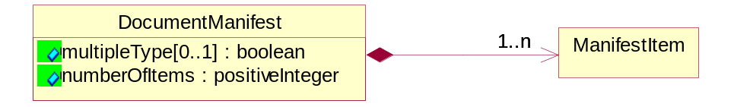
Figure 5-51 DocumentManifest
Attribute |  | Type |  | Documentation
multipleType[0..1] |  | boolean |  | Indicates whether the manifest contains documents of multiple types. True if yes, and False if no.
numberOfItems |  | positiveInteger |  | Total number of documents in the message. The physical count of the attachments in the payload plus the RosettaNet Business Message (for Service Content). The value of this field will be at least 1.
Composition | Cardinality |  | Type |  | Documentation
ManifestItem | 1..n |  | ManifestItem |  | The object provides details about the specific attachment(s).

DocumentSecurity
The object provides additional granularity in specifying business document security (this is in addition to the specified PIP security).
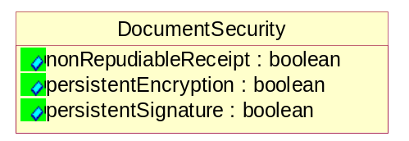
Figure 5-52 DocumentSecurity
Attribute | Type | Documentation
nonRepudiableReceipt | boolean | The value "true" will indicate that a signed acknowledgement for the business document is necessary.
persistentEncryption | boolean | The value "true" will indicate that the Business Document (including the header) needs to be encrypted when stored or transported.
persistentSignature | boolean | The value "true" will indicate that a signature is required to be stored with the document while stored or transported.

ManifestItem
The object provides details about the specific attachment(s).
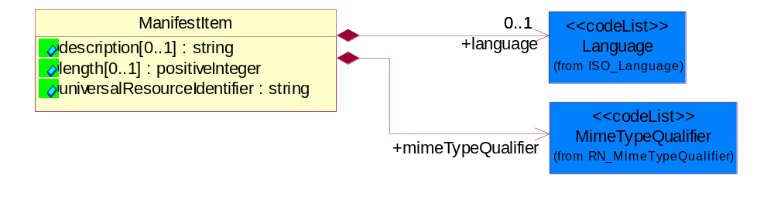
Figure 5-53 ManifestItem
Attribute | Type | Documentation
description[0..1] | string | A description of the attachment.
length[0..1] | positiveInteger | The size of the attachment in bytes (i.e. 1 000 000 bytes)
universalResourceIdentifier | string | The generic set of all names/addresses that are short strings that refer to resources.

Composition | Cardinality | Type | Documentation
language | 0..1 | Language | For representation of Language name RosettaNet has adopted ISO 639-2; 1998. Refer to the following web page to get the latest version of the standard:  http://www.loc.gov/standards/iso639-2/iso639jac.html  If you need more information about the ISO standard please contact ISO for more details.
mimeTypeQualifier | 1 | MimeTypeQualifier | The MIME type as defined by IANA.  Please refer to http://www.iana.org/assignments/media-types/ for a list of types.

PipIdentifier
PIP Identification.[ i.e. PIP3A4]
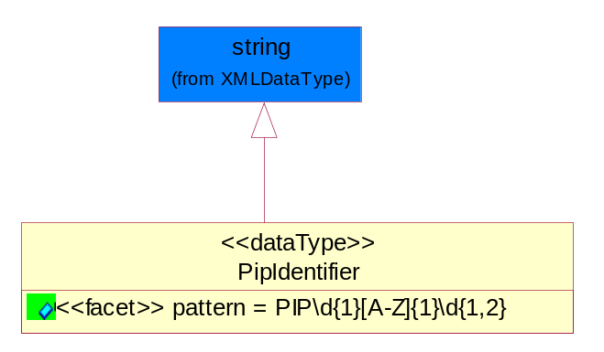
Figure 5-54 PipIdentifier
Attribute | Type | Documentation
pattern |  | PIP\d{1}[A-Z]{1}\d{1,2}

PipVersion
PIP version number (i.e. 02.02.00).
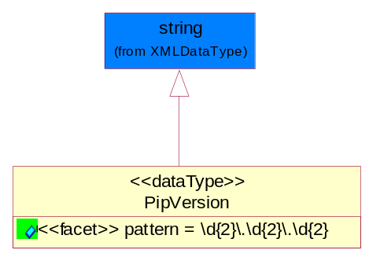
Figure 5-55 PipVersion
Attribute | Type | Documentation
pattern |  | \d{2}\.\d{2}\.\d{2}

Receiver
The object allows the identification of the receiving party of the business message.
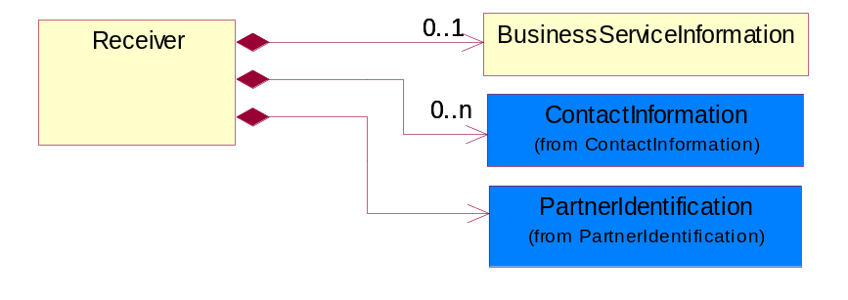
Figure 5-56 Receiver
Composition | Cardinality | Type | Documentation
BusinessServiceInformation | 0..1 | BusinessServiceInformation | The object allows the specification of the business service utilized within the partner company. This may or may not be the same as the information sent by the RNIF.
ContactInformation | 0..n | ContactInformation | The business document must allow for the identification of the name of the department, service or individual to be contacted regarding the context of the business document.
PartnerIdentification | 1 | PartnerIdentification | The business document must allow for the identity of one or more parties to the transaction.

RequestingDocumentInformation
A block of information used to correlate a requesting document to a responding document in an executing choreography.
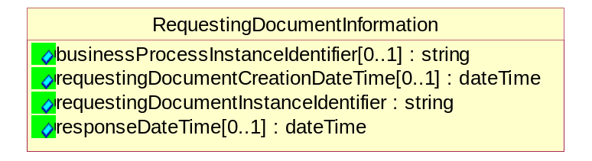
Figure 5-57 RequestingDocumentInformation
Attribute | Type | Documentation
businessProcessInstanceIdentifier[0..1] | string | The identifier for the public business process instance being sent that both the sender and receiver can identify.
requestingDocumentCreationDateTime[0..1] | dateTime | The date-time of the requesting business document.
requestingDocumentInstanceIdentifier | string | The Business Document identification number that identifies the requesting Business Document.
responseDateTime[0..1] | dateTime | The expected time to receive the response. This can not be greater than the PIP TimeToPerform.

Sender
The object allows the identification of the initiating party of the business message.
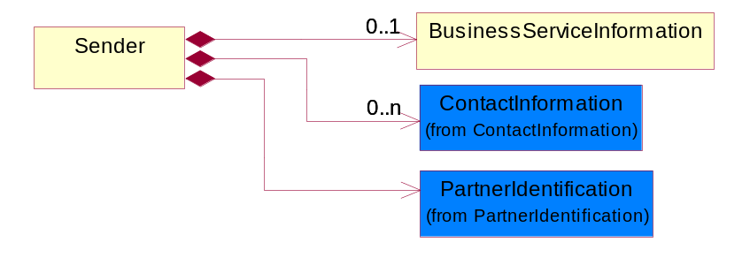
Figure 5-58 Sender
Composition | Cardinality | Type | Documentation
BusinessServiceInformation | 0..1 | BusinessServiceInformation | The object allows the specification of the business service utilized within the partner company. This may or may not be the same as the information sent by the RNIF.
ContactInformation | 0..n | ContactInformation | The business document must allow for the identification of the name of the department, service or individual to be contacted regarding the context of the business document.
PartnerIdentification | 1 | PartnerIdentification | The business document must allow for the identity of one or more parties to the transaction.

StandardDocumentIdentification
The object specifies additional information necessary to identify the standard business document.
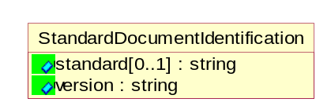
Figure 5-59 StandardDocumentIdentification

Attribute | Type | Documentation
standard[0..1] | string | Identifies the standard used to submit the business document. (e.g. RosettaNet).
version | string | PIP3A4v01.00

TpirPipIdentification
The object specifies all information necessary to uniquely identify a TPIR-PIP within a Registry or trading partner repository.
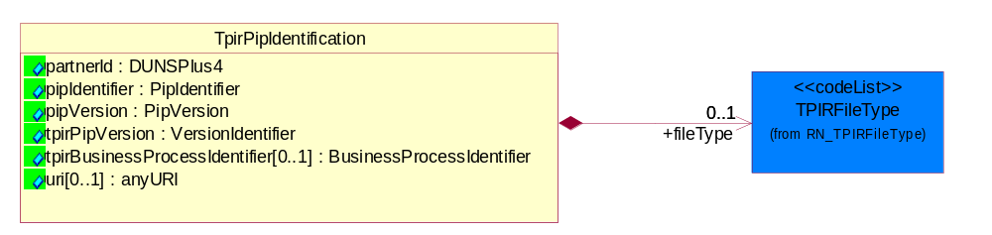
Figure 5-60 TpirPipIdentification
Attribute | Type | Documentation
partnerId | DUNSPlus4 | The Trading Partner Identification of MNC that is creating this TPIR PIP.
pipIdentifier | PipIdentifier | A TPIR PIP Identification [i.e., 3A4 ).
pipVersion | PipVersion | A TPIR PIP version number (i.e., 02.02.00)
tpirPipVersion | VersionIdentifier | A TPIR-PIP Version Number (i.e., major and minor version number as XX.XX).
tpirBusinessProcessIdentifier[0..1] | BusinessProcessIdentifier | A Business Process Identifier to uniquely define the TPIR-PIP 'role' within a Business Scenario at a company or MNC level. The identifier MUST be composed of alphanumeric characters only and its length MUST be between one and twelve characters.
uri[0..1] | anyURI | Describes the destination uri for the TPIR form.

Composition | Cardinality | Type | Documentation
fileType | 0..1 | TPIRFileType | Describes the file type of the TPIR form (PDF, XDP or XML).

VersionIdentifier
Version Number (i.e., major and minor version number as XX.XX).
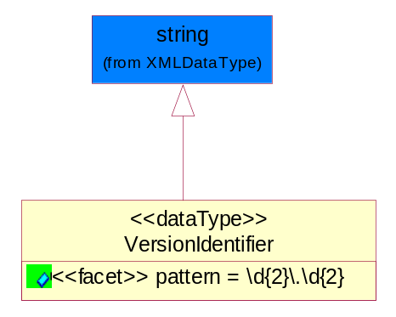
Figure 5-61 VersionIdentifier
Attribute | Type | Documentation
pattern |  | \d{2}\.\d{2}

CodeList

TPIRFileType
A code identifying the file type of TPIR form.

Name | Documentation
PDF | Portable Document Format.
XDP | XML Data Package.
XML | eXtensible Markup Language.

XML Data Type

anyURI
Represents a URI as defined by RFC 2396. An anyURI value can be absolute or relative, and may have an optional fragment identifier.

boolean
Represents Boolean values, which are either "true" or "false".

dateTime
Represents a specific instance of time.
The pattern for dateTime is CCYY-MM-DDThh:mm:ss where CC represents the century, YY the year, MM the month, and DD the day, preceded by an optional leading negative (-) character to indicate a negative number. If the negative character is omitted, positive (+) is assumed. The T is the date/time separator and hh, mm, and ss represent hour, minute, and second respectively. Additional digits can be used to increase the precision of fractional seconds if desired. For example, the format ss.ss... with any number of digits after the decimal point is supported. The fractional seconds part is optional.
This representation may be immediately followed by a "Z" to indicate Coordinated Universal Time (UTC) or to indicate the time zone. For example, the difference between the local time and Coordinated Universal Time, immediately followed by a sign, + or -, followed by the difference from UTC represented as hh:mm (minutes is required). If the time zone is included, both hours and minutes must be present.

decimal
A data type that contains decimal numbers scaled by a power of 10.

float
Represents single-precision 32-bit floating-point numbers.

positiveInteger
Represents an integer that is greater than zero. This data type is derived from nonNegativeInteger.

string
Represents character string.

