

Description of
Partner Interface Process® for 7B1

Validated 11.00.00

Specification Information
Name | Distribute Work In Process
Cluster | Manufacturing
Segment | Manage Manufacturing WO & WIP
Publication Date | 07 July 2008
Version Identifier | V11.00

Table of Contents
1 Document Management 4
1.1 Legal Disclaimer 4
1.2 Copyright 4
1.3 Trademarks 4
1.4 Acknowledgments 4
1.5 Related Documents 5
1.6 Document Version History 5
1.7 Document Structure 5
2 Business Process 6
2.1 Business Process Definition 6
2.2 PIP Scope Description 6
2.3 PIP Business Document 6
2.4 PIP Business Process Flow Diagram 7
2.5 PIP Start State 7
2.6 PIP End States 8
2.7 Partner Role Descriptions 8
2.8 Business Process Activity Controls 8
3 Network and Implementation Specification 10
3.1 Business Action and Business Signal Specifications 10
3.2 Business Transaction Dialog Specification 10
3.2.1 Message Exchange Controls 11
3.2.2 Communications Specification 11

List of Figures:

Figure 1: Activity Diagram of Distribute Work in Process 7
Figure 2: Sequence Diagram of Distribute Work In Process 10

List of Tables:
Table 1: PIP Business Document 6
Table 2: PIP Start State 7
Table 3: PIP End State 8
Table 4: PIP Failure State 8
Table 5: Partner Role Description 8
Table 6: Business Activity Description 8
Table 7: Business Activity Performance Control 9
Table 8: Network Component Specification 10
Table 9: Business Action – Business Document Mapping 10
Table 10: Message Exchange Control 11
Table 11: Dialog: Service-Service 11

Document Management

Legal Disclaimer
RosettaNet™, its members, officers, directors, employees, or agents shall not be liable for any injury, loss, damages, financial or otherwise, arising from, related to, or caused by the use of this document or the specifications herein, as well as associated guidelines and schemas. The use of said specifications shall constitute your express consent to the foregoing exculpation.

Copyright
©2008 RosettaNet. All rights reserved. No part of this publication may be reproduced, stored in a retrieval system, or transmitted, in any form or by any means, electronic, mechanical, photocopying, recording, or otherwise, without the prior written permission of the publisher. Printed in the United States of America.

Trademarks
RosettaNet, Partner Interface Process, PIP and the RosettaNet logo are trademarks or registered trademarks of "RosettaNet," a non-profit organization. All other product names and company logos mentioned herein are the trademarks of their respective owners. In the best effort, all terms mentioned in this document that are known to be trademarks or registered trademarks have been appropriately recognized in the first occurrence of the term.

Acknowledgments
This document has been prepared by RosettaNet (http://www.rosettanet.org/) from requirements gathered during the Milestone Program and in conformance with the methodology. Listed below are the legal entities that contributed to the design and development of this PIP.
Advanced Semiconductor Engineering, Inc. | Amkor Technology, Inc.
Motorola Semiconductor Product Sector, Motorola SPS | National Semiconductor
Intel Corporation | MIMOS Berhad
STMicroelectronics | Taiwan Semiconductor Manufacturing Co., Ltd. (TSMC)
UMC (United Microelectronics Corp.)

Related Documents
- Associated PIP Message Schemas (included within the PIP Specification package only)
- Description of 7B1 Message
- Messages Structure
- XML instance of ebXML BPSS for PIP 7B1

Document Version History
Version | Date | Description
Validated 11.00.00 | 07 July 2008 | Validated Version : RosettaNet Schema to Market to Validation 2008

Document Structure
A Partner Interface Process (PIP) Specification is comprised of the following two parts:
- Business Process. Captures the semantics of the business process and the flow of the message exchange between roles as they perform business activities.
- Network and Implementation Specification. Specifies the network protocol message formats and communications requirements between peer-protocols supported by network components in the RosettaNet Implementation Framework.

Business Process

Business Process Definition
The "Description of Partner Interface Process for 7B1" Partner Interface Process™ (PIP) supports the process used by a product manufacturer or assembler to inform a party of product configuration status. The recipient of the product status information could either be an end customer or another party acting on behalf of the end customer.
For example, a manufacturing subcontractor could use this PIP to inform a product supplier of product status.
This PIP is usually executed when product configuration status is one of the following:
- Assembly
- Fabricate
- Test
Should this transaction not complete successfully, the requesting partner executes PIP0A1, "Notification of Failure”.

PIP Scope Description
This PIP distributes status information about the manufacture or assembly of a product configuration to parties needing such information.

PIP Business Document
Business Document are generated and exchanged by roles performing activities in this PIP. Business Document is listed and defined in Table 1.
Table 1: PIP Business Document
Business Document | Description
Work In Process Distribution | Contains status information about the manufacture or assembly of a product configuration.

PIP Business Process Flow Diagram
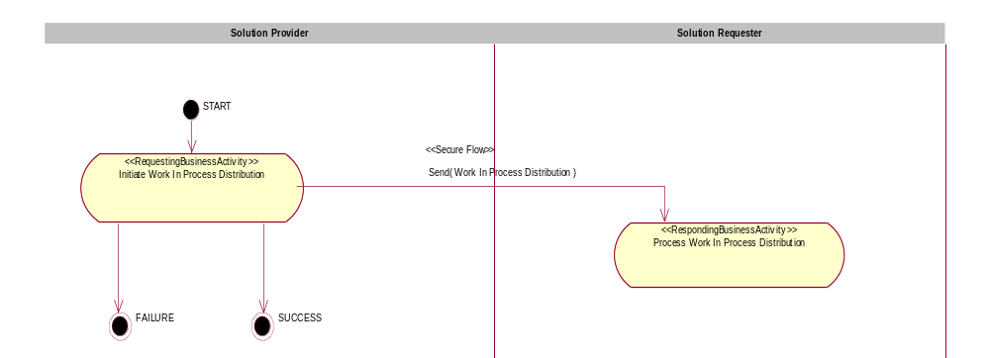
Figure 1: Activity Diagram of Distribute Work in Process

PIP Start State
The start state is comprised of the following conditions:
Table 2: PIP Start State
 | Approved | Exist |  | Valid | Non-Repudiated | Retry Count | Authorized
 | Approved | Party | In Backend System
TPA |  |  | 
Sending Partner |  |  |  | 
Receiving Partner |  | 
Business Document |  |  |  | 

PIP End States
The end state is comprised of the following conditions:
Table 3: PIP End State
 | Approved | Exist |  | Valid | Non-Repudiated | Retry Count | Authorized
 | Approved | Party | In Backend system
Acknowledgment of Receipt |  |  |  | 
Receiving Partner |  |  |  |  |  |  | 
The PIP failure state is comprised of one or more of the following conditions:
Table 4: PIP Failure State
 | NO | Exceeded
Success | 
Retry Count |  | 

Partner Role Descriptions
Table 5 describes the partner roles in this PIP.
Table 5: Partner Role Description
Role Name | Role Description
Solution Provider | The party that may architect, configure, engineer, sell and determine the fulfillment of the configured solution to partners in the supply chain.
Solution Requester | The party that creates a demand for a product or service, or has contracted with a Solution Provider for the manufacture or fulfillment of a product(s).

Business Process Activity Controls
Table 6 describes the interaction between roles performing business activity in this PIP.
Table 6: Business Activity Description
Role  Name | Activity Name | Activity Description
Solution Provider | Initiate Work In Process Distribution | The Distribute Work in Process activity sends the Work in Process Notification to a Solution Requester. Using internal system data about the status of product that is in assembly, fabrication or test, the information needed is extracted and provided.
Table 7 details the security, audit and process controls relating to activity performed in the PIP.
Table 7: Business Activity Performance Control
Role  Name | Activity  Name | Acknowledgment  of Receipt |  | Time to Perform | Retry Count | Is Authorization Required? | Non-Repudiation of Origin and Content?
Role  Name | Activity  Name | Non-Repudiation Required? | Time to Acknowledge
Solution Provider | Initiate Work In Process Distribution | N | 2 hrs | N/A | 3 | N | N

Network and Implementation Specification
Each network component maps into a role of the PIP model. Table 8 specifies the mapping between roles and network components.
Table 8: Network Component Specification
Network Component | Classification | Maps to Role in Business Process
Solution Provider Service | Business Service | Solution Provider
Solution Requester Service | Business Service | Solution Requester

Business Action and Business Signal Specifications
Each business action maps to a Business Document of the PIP model. Table 9 specifies the mapping between Business Documents and business actions.
Table 9: Business Action – Business Document Mapping
Business Action | Business Document | Document Function
Work In Process Distribution Action | Distribute Work In Process | Request

Business Transaction Dialog Specification
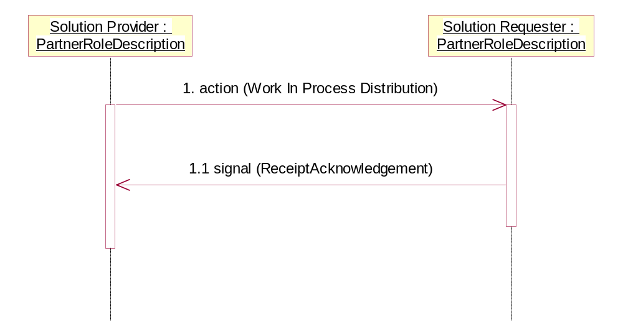
Figure 2: Sequence Diagram of Distribute Work In Process

Message Exchange Controls
Table 10: Message Exchange Control
# | Name |  | Time to Acknowledge Receipt Signal |  | Time to Respond to Action |  | Included in Time to Perform |  | Is Authorization Required? |  | Is Non-Repudiation Required? |  | Is Secure Transport Required?
1. |  | Work In Process Distribution Action |  | 2 hrs |  | N/A |  | N/A |  | N |  | N |  | Y
1.1. |  | Receipt Acknowledgment |  | N/A |  | N/A |  | N/A |  | N |  | N |  | Y

Communications Specification
Table 11: Dialog: Service-Service
# | Business Message | Digital Signature Required? | SSL Required?
1. | Work In Process Distribution | N | Y
1.1. | Receipt Acknowledgment | N | Y

