

Description of
Partner Interface Process® for 7B5

Validated 11.00.00

Specification Information
Name | Notify Of Manufacturing Work Order
Cluster | Manufacturing
Segment | Manage Manufacturing WO and WIP
Publication Date | 08 July 2008
Version Identifier | V11.00

Table of Contents
1 Document Management 4
1.1 Legal Disclaimer 4
1.2 Copyright 4
1.3 Trademarks 4
1.4 Acknowledgments 4
1.5 Related Documents 5
1.6 Document Version History 5
1.7 Document Structure 5
2 Business Process 6
2.1 Business Process Definition 6
2.1.1 Business Process Context Diagram 7
2.2 PIP Scope Description 7
2.3 PIP Business Document 8
2.4 PIP Business Process Flow Diagram 8
2.5 PIP Start State 9
2.6 PIP End States 9
2.7 Partner Role Description 10
2.8 Business Process Activity Controls 10
3 Network and Implementation Specification 11
3.1 Business Action and Business Signal Specifications 11
3.2 Business Transaction Dialog Specification 11
3.2.1 Message Exchange Controls 12
3.2.2 Communications Specification 12

List of Figures:
Figure 1: High-level Context Diagram 7
Figure 2: Activity Diagram of Notify of Manufacturing Work Order 8
Figure 3: Sequence Diagram of Notify of Manufacturing Work Order 11

List of Tables:
Table 1: PIP Business Document 8
Table 2: PIP Start State 9
Table 3: PIP End State 9
Table 4: PIP Failure State 9
Table 5: Partner Role Description 10
Table 6: Business Activity Description 10
Table 7: Business Activity Performance Control 10
Table 8: Network Component Specification 11
Table 9: Business Action – Business Document Mapping 11
Table 10: Message Exchange Control 12
Table 11: Dialog: Service-Service 12

Document Management

Legal Disclaimer
RosettaNet™, its members, officers, directors, employees, or agents shall not be liable for any injury, loss, damages, financial or otherwise, arising from, related to, or caused by the use of this document or the specifications herein, as well as associated guidelines and schemas. The use of said specifications shall constitute your express consent to the foregoing exculpation.

Copyright
© 2008 RosettaNet. All rights reserved. No part of this publication may be reproduced, stored in a retrieval system, or transmitted, in any form or by any means, electronic, mechanical, photocopying, recording, or otherwise, without the prior written permission of the publisher. Printed in the United States of America.

Trademarks
RosettaNet, Partner Interface Process, PIP and the RosettaNet logo are trademarks or registered trademarks of "RosettaNet," a non-profit organization. All other product names and company logos mentioned herein are the trademarks of their respective owners. In the best effort, all terms mentioned in this document that are known to be trademarks or registered trademarks have been appropriately recognized in the first occurrence of the term.

Acknowledgments
This document has been prepared by RosettaNet (http://www.rosettanet.org/) from requirements gathered during the Milestone Program and in conformance with the methodology. Listed below are the legal entities that contributed to the design and development of this PIP.
Amkor Technology, Inc. | Peregrine Connectivity, Inc.
Advanced Semiconductor Engineering, Inc. | Siliconware Precision Industries Co., Ltd.
ASE | Sterling Commerce
Cisco System, Inc. | STMicroelectronics
IBM | Taiwan Semiconductor Manufacturing Co., Ltd. (TSMC)
III | Toshiba Semiconductor
Inovis Company | UMC
Institute for Information Industry | United Microelectronics Corp.
International Business Machines | Unitopia Taiwan Corp.
Motorola Semiconductor Product Sector | Winbond Electronics
National Semiconductor

Related Documents
- Associated PIP Message Schemas (included within the PIP Specification package only)
- Description of 7B5 Message
- Messages Structure
- XML instance of ebXML BPSS for PIP 7B5

Document Version History
Version | Date | Description
Validated 11.00.00 | 08 July 2008 | Validated Version : RosettaNet Schema to Market to Validation 2008

Document Structure
A Partner Interface Process (PIP) Specification is comprised of the following two parts:
- Business Process. Captures the semantics of the business process and the flow of the message exchange between roles as they perform business activities.
- Network and Implementation Specification. Specifies the network protocol message formats and communications requirements between peer-protocols supported by network components in the RosettaNet Implementation Framework.

Business Process

Business Process Definition
The Work Order Management Program focuses on the use of work order instructions to trigger a variety of manufacturing processes by contract manufacturers. Work orders are dependent on having a Purchase Order or by other contractual agreement, such as a Trading Partner Agreement, in place between trading partners before creating and transmitting a work order. The contractual agreements are referenced only, they are not included as part of the PIP.

This program scope includes Semiconductor Manufacturing (SM), Original Equipment Manufacturers (OEM) and Electronic Components (EC) work orders. The process deals with issuing work instructions for shop floor manufacturing of semiconductors; build requests for IT products where the products to be built have been contractually agreed to; and the dispatch of work orders for hardware final assembly and test between Integrated Device Manufacturers (IDMs); Fabless Semiconductor Design; and Foundry Fab/Sort/Assembly/Test Contract Manufacturers (CM). These instructions are used as authorization to process work for the requesting company.

Specifically, semiconductor companies have adopted outsourcing as the manufacturing strategy for many of the same reasons that other industries have evolved to. For example, in a Fabless Semiconductor Company the outsourcing of silicon wafers allows semiconductor companies to focus on design and marketing of its product without the burden of building, operating and upgrading manufacturing facilities. As the cost of building a wafer fabrication plant and maintenance of leading-edge process technology escalates, the fabless model is an attractive long-term option for many semiconductor companies.

Business Process Context Diagram
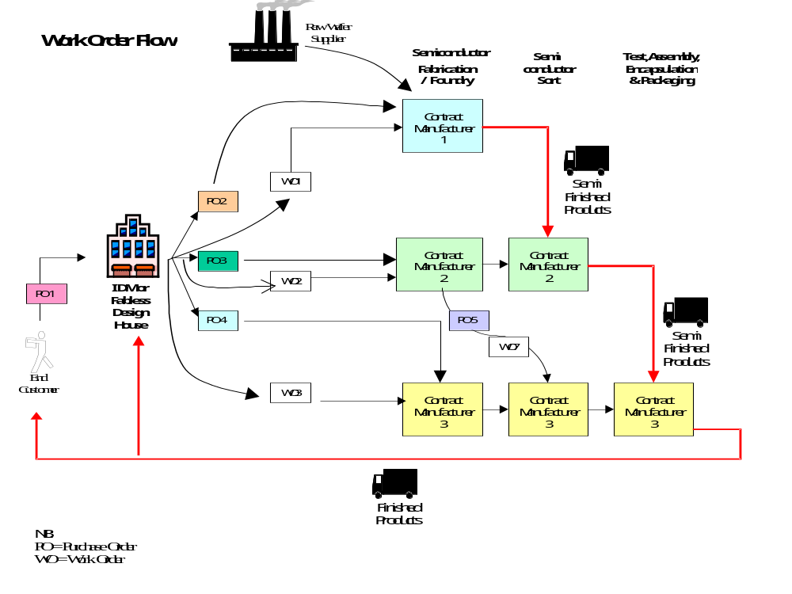
Figure 1: High-level Context Diagram
An IDM or OEM will typically choose to outsource selected products or processes to a CM with the intent of augmenting capacity for the same reasons.

PIP Scope Description
The purpose of this PIP is to notify the seller of a work order to trigger production after a PO is issued or a contract agreement exists between trading partners.

PIP Business Document
Business Document are generated and exchanged by roles performing activities in this PIP. Business Document is listed and defined in Table 1.
Table 1: PIP Business Document
Business Document | Description
Manufacturing Work Order Notification | Contains the Buyer's manufacturing work order request including line item information. The business document reference section may contain the PO or TPA information.

PIP Business Process Flow Diagram
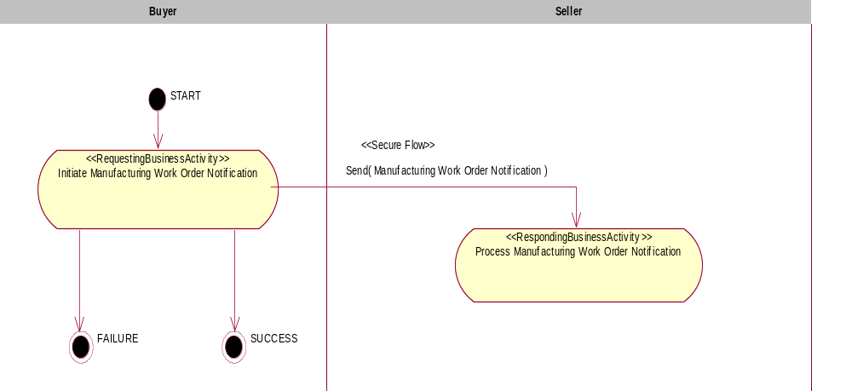

Figure 4: Activity Diagram of Notify Of Manufacturing Work Order

PIP Start State
The start state is comprised of the following conditions:
Table 2: PIP Start State
 | Approved | Exist |  | Valid | Non-Repudiated | Retry Count | Authorized
 | Approved | Party | In Backend System
TPA |  |  | 
Sending Partner |  |  |  | 
Receiving Partner |  | 
Business Document |  |  |  |  |  |  | 

PIP End States
The end state is comprised of the following conditions:
Table 3: PIP End State
 | Approved | Exist |  | Valid | Non-Repudiated | Retry Count | Authorized
 | Approved | Party | In Backend system
Acknowledgment of Receipt |  |  |  |  | 
Receiving Partner |  |  |  |  |  |  | 

The PIP failure state is comprised of one or more of the following conditions
Table 4: PIP Failure State
 | NO | Exceeded
Success | 
Retry Count |  | 

Partner Role Description
Table 5 describes the partner roles in this PIP:
Table 5: Partner Role Description
Role Name | Role Description
Buyer | The party that creates a manufacturing work order request.
Seller | The party that manufacturers, sorts, tests and/or assembles the dies.

Business Process Activity Controls
Table 6 describes the interaction between roles performing business activity in this PIP.
Table 6: Business Activity Description
Role Name |  | Activity Name |  | Activity Description
Buyer | Initiate Manufacturing Work Order Notification |  | The Buyer has prepared the Manufacturing Work Order and sends it to the CM.

Table 7 details the security, audit and process controls relating to activity performed in the PIP.
Table 7: Business Activity Performance Control
Role  Name | Activity  Name | Acknowledgment of Receipt Non-Repudiation Required? | Acknowledgment of Receipt Time to Acknowledge | Time to Perform | Retry Count | Is Authorization Required? | Non-Repudiation of Origin and Content?
Buyer | Initiate Manufacturing Work Order Notification | Y | 2hrs | N/A | 3 | Y | Y

Network and Implementation Specification
Each network component maps into a role of the PIP model. Table 8 specifies the mapping between roles and network components.
Table 8: Network Component Specification
Network Component | Classification | Maps to Role in Business Process
Buyer Service | Business Service | Buyer
Seller Service | Business Service | Seller

Business Action and Business Signal Specifications
Each business action maps to a Business Document of the PIP model. Table 9 specifies the mapping between Business Documents and business actions.
Table 9: Business Action – Business Document Mapping
Business Action | Business Document | Document Function
Manufacturing Work Order Notification Action | Manufacturing Work Order Notification | Request

Business Transaction Dialog Specification
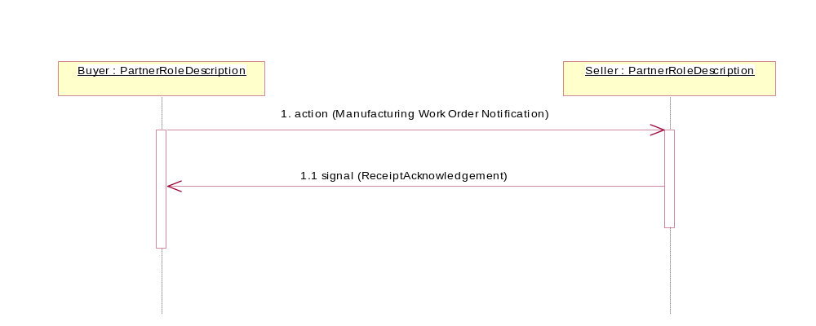
Figure 2: Sequence Diagram of Notify Of Manufacturing Work Order

Message Exchange Controls
Table 10: Message Exchange Control
# | Name |  | Time to Acknowledge Receipt Signal |  | Time to Respond to Action |  | Included in Time to Perform | Is Authorization Required? | Is Non-Repudiation Required? | Is Secure Transport Required?
1. |  | Manufacturing Work Order Notification Action |  | 2hrs |  | N/A | N/A | Y | Y | Y
1.1. |  | Receipt Acknowledgement |  | N/A |  | N/A | N/A | Y | Y | Y

Communications Specification
Table 11: Dialog: Service-Service
# | Business Message | Digital Signature Required? | SSL Required?
1. | Manufacturing Work Order Notification Action | Y | Y
1.1. | Receipt Acknowledgment | Y | Y

