

Description of 7B5 Message

PIP® 7B5
Validated 11.01.00

Specification Information
Name | Description Of 7B5 Message
PIP | Notify Of Manufacturing Work Order
Cluster | Manufacturing
Segment | Manage Manufacturing WO and WIP
Publication Date | 06 August 2009
Version Identifier | V11.01

Table of Content

1. Document Management 6
1.1 Legal Disclaimer 6
1.2 Copyright 6
1.3 Trademarks 6
1.4 Acknowledgments 6
1.5 Related Documents 7
1.6 Document Version History 7
1.7 Document Purpose 7
2. Interchange Model 8
2.1 ManufacturingWorkOrderNotification 8
2.1.1 Interchange Diagram 8
2.1.2 Dependency Diagram 9
2.1.3 CustomerProfile 9
2.1.4 ManufacturingWorkOrderNotification 10
2.1.5 SublineItems 10
2.1.6 TargetDevice 10
2.1.7 WorkOrder 12
2.1.8 WorkOrderLineItems 13
3. Domain Model 16
3.1 Procurement 16
3.1.1 Procurement 16
3.1.1.1 Dependency Diagram 16
3.1.2 CodeList 16
3.1.2.1 LineItemStatus 16
3.1.2.2 BusinessAction 17
3.2 Manufacturing 20
3.2.1 Manufacturing 20
3.2.1.1 Dependency Diagram 20
3.2.1.2 Attachment 20
3.2.1.3 EngineeringInformation 21
3.2.1.4 MarkInformation 22
3.2.1.5 MarkingContents 22
3.2.1.6 ProcessInformation 23
3.2.1.7 SourceDevice 24
3.2.1.8 SourceLot 25
3.2.1.9 SpecialProcessingInformation 26
3.2.1.10 WaferBacksideInformation 26
3.2.1.11 WaferInformation 27
3.2.1.12 WaferLotQuantity 27
3.2.2 CodeList 28
3.2.2.1 LotType 28
3.2.2.2 ChangeReason 28
3.2.2.3 Priority 30
3.2.2.4 WorkInProcessLocation 30
3.2.2.5 AttachmentDescription 30
3.2.2.6 DevicePackageType 31
3.2.2.7 MarkSide 32
3.2.2.8 MarkType 32
3.2.2.9 ProcessType 32
3.2.2.10 WaferBackSideFinish 32
3.2.2.11 WaferPassivation 33
3.2.2.12 WaferQualityRating 33
3.2.2.13 RawWaferType 33
3.2.2.14 SpecialInstructionCategory 33
3.2.2.15 DeviceType 33
3.3 Shared 34
3.3.1 Shared 34
3.3.1.1 Dependency Diagram 34
3.3.2 CodeList 34
3.3.2.1 PackageType 34
4. Universal Structure 35
4.1 ContactInformation 35
4.1.1 ContactInformation 35
4.2 DataType 36
4.2.1 Contact 36
4.2.2 DUNS 36
4.2.3 DUNSPlus4 37
4.2.4 GLN 37
4.2.5 GTIN 38
4.3 Dates 38
4.3.1 DatePeriod 38
4.4 Document 39
4.4.1 BusinessDocumentReference 39
4.5 Locations 39
4.5.1 AlternativeIdentifier 39
4.5.2 Location 40
4.5.3 LocationChoice 40
4.5.4 PhysicalAddress 41
4.6 MonetaryExpression 42
4.7 PartnerIdentification 42
4.7.1 FullPartner 42
4.7.2 IntermittentPartner 43
4.7.3 KnownPartner 43
4.7.4 KnownPartnerContact 44
4.7.5 NewPartner 44
4.7.6 PartnerDescription 45
4.7.7 PartnerDescriptionChoice 45
4.7.8 PartnerIdentification 46
4.7.9 PartnerIdentificationChoice 46
4.7.10 SpecifiedFullPartner 47
4.7.11 SpecifiedIntermittentPartner 48
4.7.12 SpecifiedKnownPartner 48
4.7.13 SpecifiedNewPartner 49
4.8 PhysicalDimension 50
4.8.1 Linear 50
4.8.2 Measure 50
4.9 ProductIdentification 51
4.9.1 ProductIdentification 51
4.9.2 ProductIdentificationChoice 51
4.10 CodeList 52
4.10.1 Country 52
4.10.2 CountrySubdivision 52
4.10.3 Language 52
4.10.4 DocumentType 52
4.10.5 MimeTypeQualifier 54
4.10.6 UnitOfMeasure 65
4.10.7 ProcessRoleIdentifier 77
5. System Structure 81
5.1 BusinessProcessIdentifier 81
5.2 BusinessServiceInformation 81
5.3 ContractInformation 82
5.4 CorrelationInformation 82
5.5 DocumentHeader 83
5.6 DocumentIdentification 84
5.7 DocumentIdentificationChoice 84
5.8 DocumentInformation 85
5.9 DocumentManifest 85
5.10 DocumentSecurity 86
5.11 ManifestItem 86
5.12 PipIdentifier 87
5.13 PipVersion 88
5.14 Receiver 88
5.15 RequestingDocumentInformation 88
5.16 Sender 88
5.17 StandardDocumentIdentification 90
5.18 TpirPipIdentification 90
5.19 VersionIdentifier 91
5.20 CodeList 91
5.20.1 TPIRFileType 91
6. XML Data Type 92
6.1 anyURI 92
6.2 boolean 92
6.3 date 92
6.4 dateTime 92
6.5 float 92
6.6 positiveInteger 92
6.7 string 92

Table of Figures

Figure ‎2-1 Interchange 8
Figure ‎2-2 Dependency 9
Figure ‎2-3 CustomerProfile 9
Figure ‎2-4 ManufacturingWorkOrderNotification 10
Figure ‎2-5 SublineItems 10
Figure ‎2-6 TargetDevice 11
Figure ‎2-7 WorkOrder 12
Figure ‎2-8 WorkOrderLineItems 13
Figure ‎3-1 Dependency 16
Figure ‎3-2 Dependency 20
Figure ‎3-3 Attachment 20
Figure ‎3-4 EngineeringInformation 21
Figure ‎3-5 MarkInformation 22
Figure ‎3-6 MarkingContents 22
Figure ‎3-7 ProcessInformation 23
Figure ‎3-8 SourceDevice 24
Figure ‎3-9 SourceLot 25
Figure ‎3-10 SpecialProcessingInformation 26
Figure ‎3-11 WaferBacksideInformation 26
Figure ‎3-12 WaferInformation 27
Figure ‎3-13 WaferLotQuantity 27
Figure ‎3-14 Dependency 34
Figure ‎4-1 ContactInformation 35
Figure ‎4-2 Contact 36
Figure ‎4-3 DUNS 36
Figure ‎4-4 DUNSPlus4 37
Figure ‎4-5 GLN 37
Figure ‎4-6 GTIN 38
Figure ‎4-7 DatePeriod 38
Figure ‎4-8 BusinessDocumentReference 39
Figure ‎4-9 AlternativeIdentifier 39
Figure ‎4-10 Location 40
Figure ‎4-11 PhysicalAddress 41
Figure ‎4-12 FullPartner 42
Figure ‎4-13 IntermittentPartner 43
Figure ‎4-14 KnownPartner 43
Figure ‎4-15 KnownPartnerContact 44
Figure ‎4-16 NewPartner 44
Figure ‎4-17 PartnerDescription 45
Figure ‎4-18 PartnerIdentification 46
Figure ‎4-19 SpecifiedFullPartner 47
Figure ‎4-20 SpecifiedIntermittentPartner 48
Figure ‎4-21 SpecifiedKnownPartner 48
Figure ‎4-22 SpecifiedNewPartner 49
Figure ‎4-23 Linear 50
Figure ‎4-24 Measure 50
Figure ‎4-25 ProductIdentification 51
Figure ‎5-1 BusinessProcessIdentifier 81
Figure ‎5-2 BusinessServiceInformation 81
Figure ‎5-3 ContractInformation 82
Figure ‎5-4 CorrelationInformation 82
Figure ‎5-5 DocumentHeader 83
Figure ‎5-6 DocumentIdentification 84
Figure ‎5-7 DocumentInformation 85
Figure ‎5-8 DocumentManifest 85
Figure ‎5-9 DocumentSecurity 86
Figure ‎5-10 ManifestItem 86
Figure ‎5-11 PipIdentifier 87
Figure ‎5-12 PipVersion 88
Figure ‎5-13 Receiver 88
Figure ‎5-14 RequestingDocumentInformation 89
Figure ‎5-15 Sender 89
Figure ‎5-16 StandardDocumentIdentification 90
Figure ‎5-17 TpirPipIdentification 90
Figure ‎5-18 VersionIdentifier 91

Document Management

Legal Disclaimer
RosettaNet, its members, officers, directors, employees, or agents shall not be liable for any injury, loss, damages, financial or otherwise, arising from, related to, or caused by the use of this document or the specifications herein, as well as associated guidelines and schemas. The use of said specifications shall constitute your express consent to the foregoing exculpation.

Copyright
©2009 RosettaNet. All rights reserved. No part of this publication may be reproduced, stored in a retrieval system, or transmitted, in any form or by any means, electronic, mechanical, photocopying, recording, or otherwise, without the inclusion of this copyright notice. Any derivative works must cite the copyright notice. Any public redistribution or sale of this publication or derivative works requires prior written permission of the publisher.

Trademarks
RosettaNet, Partner Interface Process, PIP and the RosettaNet logo are trademarks or registered trademarks of "RosettaNet," a non-profit organization. All other product names and company logos mentioned herein are the trademarks of their respective owners. In the best effort, all terms mentioned in this document that are known to be trademarks or registered trademarks have been appropriately recognized in the first occurrence of the term.

Acknowledgments
This document has been prepared by RosettaNet (http://www.rosettanet.org/) from requirements gathered during the Milestone Program and in conformance with the methodology. Listed below are the legal entities that contributed to the design and development of this PIP.
Amkor Technology, Inc. | Peregrine Connectivity, Inc.
Advanced Semiconductor Engineering, Inc. | Siliconware Precision Industries Co., Ltd.
ASE | Sterling Commerce
Cisco System, Inc. | STMicroelectronics
IBM | Taiwan Semiconductor Manufacturing Co., Ltd. (TSMC)
III | Toshiba Semiconductor
Inovis Company | UMC
Institute for Information Industry | United Microelectronics Corp.
International Business Machines | Unitopia Taiwan Corp.
Motorola Semiconductor Product Sector | Winbond Electronics
National Semiconductor

Related Documents
- Associated PIP Message Schemas (included with PIP Specification only)
- Description of Partner Interface Process for 7B5
- Message Structure

Document Version History
Version | Date | Description
Validated 11.00.00 | 08 July 2008 | Validated Version : RosettaNet Schema to Market to Validation 2008
Validated 11.01.00 | 06 August 2009 | Validated Version : Q32009 Maintenance Process

Document Purpose
The purpose of the document is to explain the structure, the association between objects, the content of objects and the definition for single elements to a non-technical audience.

Interchange Model

ManufacturingWorkOrderNotification

Interchange Diagram
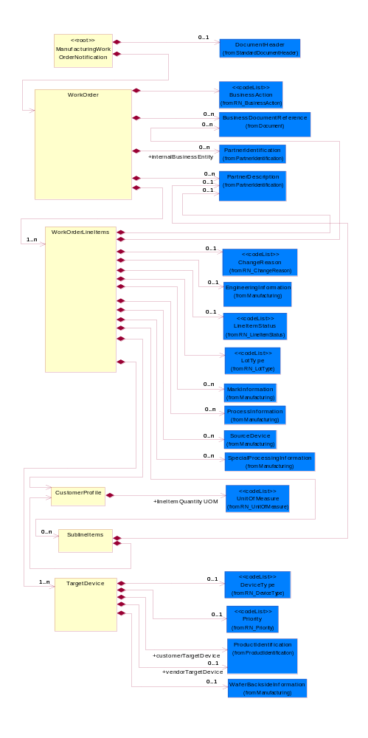
Figure ‎2-1 Interchange

Dependency Diagram
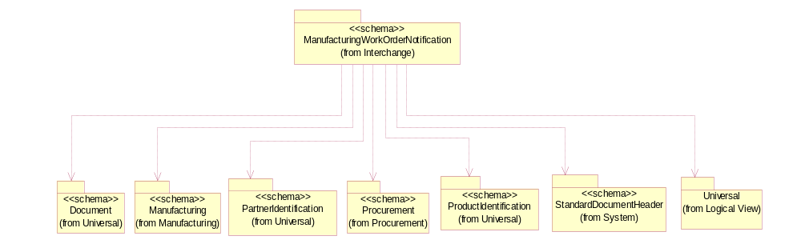
Figure ‎2-2 Dependency

CustomerProfile
The collection of business properties that describe a customer's requirements or needs.
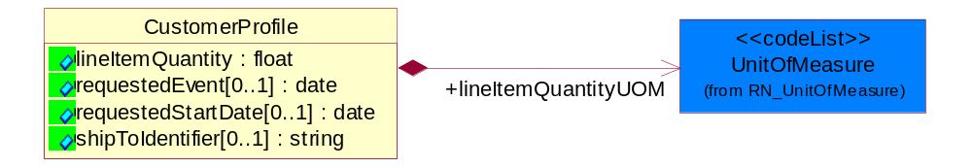
Figure ‎2-3 CustomerProfile

Attribute | Type | Documentation
lineItemQuantity | float | Requested quantity of target device in line item.
requestedEvent[0..1] | date | The date a transportation event is requested to occur.
requestedStartDate[0..1] | date | Requested start date for processing.
shipToIdentifier[0..1] | string | A unique identifier created by a partner that references a complete block of shipping information.

Composition | Cardinality | Type | Documentation
lineItemQuantityUOM | 1 | UnitOfMeasure | UOM of requested quantity of target device in line item.

ManufacturingWorkOrderNotification
A message wrapper for the PIP7B5.
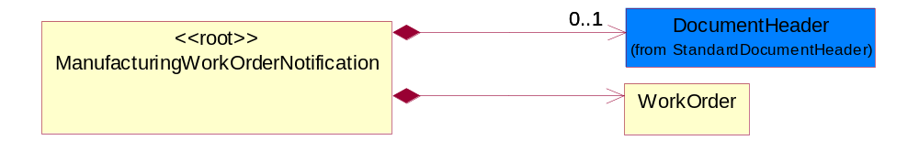
Figure ‎2-4 ManufacturingWorkOrderNotification

Composition | Cardinality | Type | Documentation
DocumentHeader | 0..1 | DocumentHeader | The object allows for the identification of the sender and receiver of the business document.
WorkOrder | 1 | WorkOrder | The compilation of elements necessary to trigger production or a process step.  Recommended ProcessRoleIdentifier for PartnerDescription is BIT - Bill To & SHT - Ship To.

SublineItems
Subline Items under Line item.

Recommended ProcessRoleIdentifier used in PartnerDescription is SHT- ShipTo.
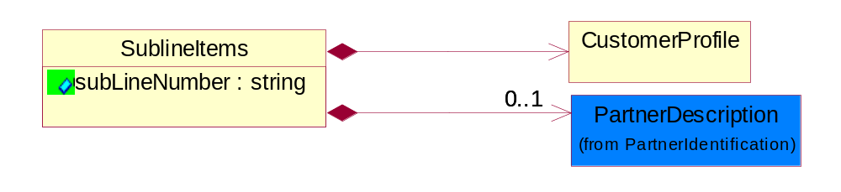
Figure ‎2-5 SublineItems

Attribute | Type | Documentation
subLineNumber | string | Number of the subline in the document, associated with a given line number.

Composition | Cardinality | Type | Documentation
CustomerProfile | 1 | CustomerProfile | The collection of business properties that describe a customer's requirements or needs.
PartnerDescription | 0..1 | PartnerDescription | The collection of business properties that describe a business partners' identity, their contact information, where they are physically located and their function in a supply chain.

TargetDevice
The collection of data elements that provides information about the product for which chips are to be a part of.
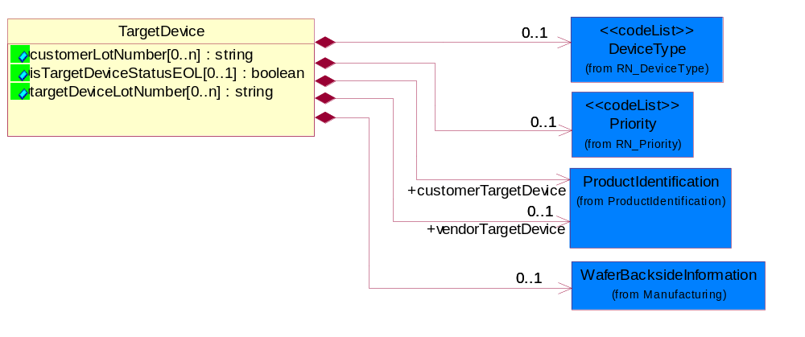
Figure ‎2-6 TargetDevice

Attribute | Type | Documentation
customerLotNumber[0..n] | string | Customer lot number of target device.
isTargetDeviceStatusEOL[0..1] | boolean | Indication of whether the target device is going to out of phase.
targetDeviceLotNumber[0..n] | string | The lot number of the target device of the vendor.

Composition | Cardinality | Type | Documentation
customerTargetDevice | 1 | ProductIdentification | The product information of the customer for the target device.
Priority | 0..1 | Priority | Code identifying the priority order of an activity, product or service.
vendorTargetDevice | 0..1 | ProductIdentification | Vendor Identification of target device.
DeviceType | 0..1 | DeviceType | The product or process for which the output of a WO is destined for.
WaferBacksideInformation | 0..1 | WaferBacksideInformation | The information about wafer backside.

WorkOrder
The compilation of elements necessary to trigger production or a process step.

Recommended ProcessRoleIdentifier for PartnerDescription is BIT - Bill To & SHT - Ship To.
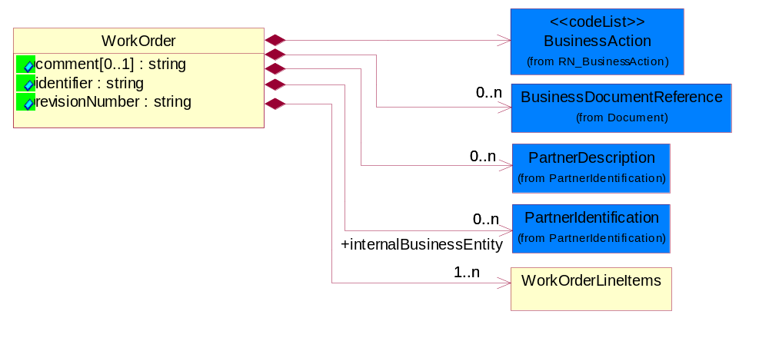
Figure ‎2-7 WorkOrder

Attribute | Type | Documentation
comment[0..1] | string | Free form textual comment attached to a business document.
identifier | string | Unique identifier for a work order.
revisionNumber | string | An incremental number used to identify changes.

Composition | Cardinality | Type | Documentation
BusinessAction | 1 | BusinessAction | Code identifying a business action.
BusinessDocumentReference | 0..n | BusinessDocumentReference | The business document reference object allows for the indirect referencing of a relationship to other business related documents.
internalBusinessEntity | 0..n | PartnerIdentification | Identifies proprietary divisions, planning units, organizations, warehouses, or any other grouping that would cause different contacts or different planning and procurement information. Used to distinguish between multiple divisions.
PartnerDescription | 0..n | PartnerDescription | The collection of business properties that describe a business partners' identity, their contact information, where they are physically located and their function in a supply chain.
WorkOrderLineItems | 1..n | WorkOrderLineItems | Line items in work order notification.  Recommended ProcessRoleIdentifier for PartnerDescription is SHT - Ship To.

WorkOrderLineItems
Line items in work order notification.

Recommended ProcessRoleIdentifier for PartnerDescription is SHT - Ship To.
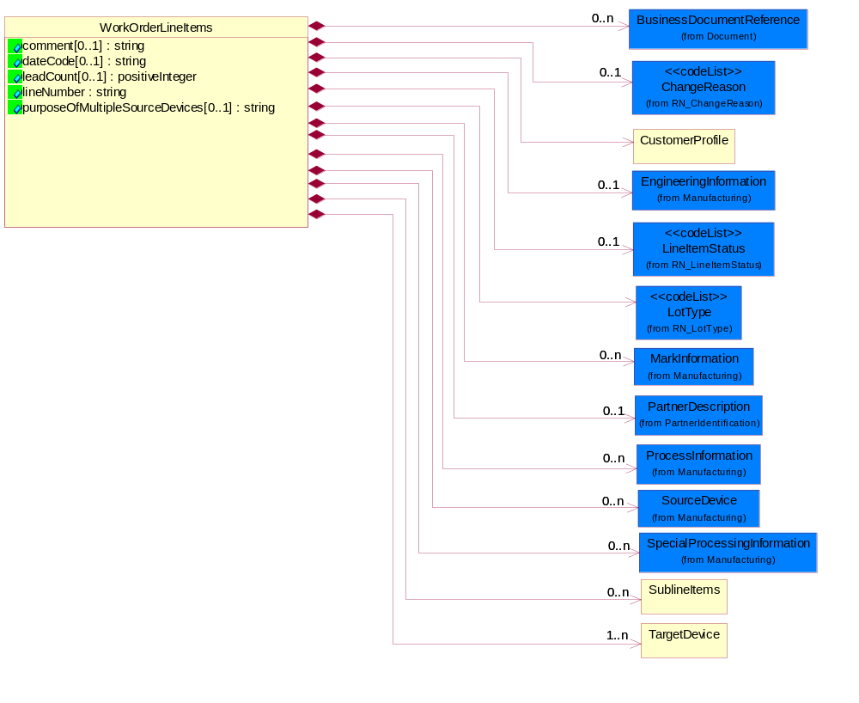
Figure ‎2-8 WorkOrderLineItems

Attribute | Type | Documentation
comment[0..1] | string | Free form textual comment attached to a business document.
dateCode[0..1] | string | Date reference.
leadCount[0..1] | positiveInteger | The number of leads on a chip.
lineNumber | string | Number of the line in the document.
purposeOfMultipleSourceDevices[0..1] | string | The purpose of multiple source devices against target device. The value should be "Stack Die", multiple source devices (dies) can be stacked together as a module to become the target device.

Composition | Cardinality | Type | Documentation
BusinessDocumentReference | 0..n | BusinessDocumentReference | The business document reference object allows for the indirect referencing of a relationship to other business related documents.
ChangeReason | 0..1 | ChangeReason | Reason Code for change of a business document or a line item or subline item in a business document.
CustomerProfile | 1 | CustomerProfile | The collection of business properties that describe a customer's requirements or needs.
EngineeringInformation | 0..1 | EngineeringInformation | The information for engineering purpose, i.e, technical data necessary for process of the device.
LineItemStatus | 0..1 | LineItemStatus | Code identifying the order status of the line item.
LotType | 1 | LotType | Describes the mode in which product was tested.
MarkInformation | 0..n | MarkInformation | The Information to be printed or marked on the devices.
PartnerDescription | 0..1 | PartnerDescription | The collection of business properties that describe a business partners' identity, their contact information, where they are physically located and their function in a supply chain.
ProcessInformation | 0..n | ProcessInformation | The collection of elements that comprise the processing sequence steps.
SourceDevice | 0..n | SourceDevice | The device before processing.
SpecialProcessingInformation | 0..n | SpecialProcessingInformation | The collectiion of data elements pertaining to special processing sequence steps and type.
SublineItems | 0..n | SublineItems | Subline Items under Line item.  Recommended ProcessRoleIdentifier used in PartnerDescription is SHT- ShipTo.
TargetDevice | 1..n | TargetDevice | The collection of data elements that provides information about the product for which chips are to be a part of.

Domain Model

Procurement

Procurement

Dependency Diagram
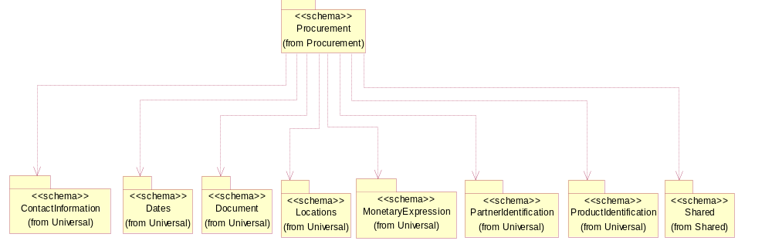
Figure ‎3-9 Dependency

CodeList

LineItemStatus
Code identifying the order status of the line item.

Name | Documentation
ACC | Accepted - The specified or referenced line item has been accepted for processing.
ACT | Active - The business process for the specified or referenced line item has not been acted upon or completed.
CAN | Cancelled - The business process intended for the specified or referenced line item has been cancelled.
CLO | Closed - The business process for the specified or referenced line item has been completed.
FCL | Finally Closed - Order cannot be opened any further updates.
NEW | New - Initial state of an order and hasn't been amended yet.
PEN | Pending - The specified or referenced line item has been accepted but not yet processed.
REJ | Rejected - The specified or referenced line item has been rejected for processing.
UPD | Update - The specified or referenced line item information has changed from its last status.

BusinessAction
Code identifying a business action.

Name | Documentation
ACP | Account Change Response.
ACR | Account Change Request.
ARQ | Account Request.
ASA | Account Setup Acknowledgment.
ASN | Advance Shipment Notification.
BPA | Change basic product information acceptance.
BPC | Basic product information change.
BSN | Billing Statement Notification.
BSS | Blanket Ship from Stock and debit authorization notification.
CPL | Change Product Lifecycle information confirmation.
CPM | Change Product Marketing information confirmation.
CPS | Change Product Sales promotion and rebate information confirmation.
CPT | Change Product Technical information confirmation.
CRA | Create Remittance Advice.
CRQ | Credit Reference Query.
CRR | Credit Reference Response.
DAP | Delivery Appointment Response.
DAR | Delivery Appointment Request.
DEN | Delivery Exception Notification.
DRC | Design Registration Confirmation.
DRR | Design Registration Request.
EAP | Engineering change approval response.
EAR | Engineering change approval request.
ECI | Engineering Change Implementation plan notification.
ECN | Engineering change response notification.
ECO | Engineering change order notification.
ECP | Engineering change response.
ECR | Engineering Change Request.
FAN | Failure notification.
FIP | Financing response.
FIR | Financing request.
IRN | Inspection Result Notification.
IVN | Invoice notification.
IVR | Invoice reject notification.
LIR | Lifecycle Information Response.
MIQ | Marketing Information Query.
MIR | Marketing Information Response.
OPQ | Optional Product information Query.
OPR | Optional Product information Response.
OSN | Open ship from stock and debit authorization status notification.
PAQ | Price and Availability Query.
PAR | Price and Availability Response.
PDQ | Product Discontinuation information Query.
PDR | Product Discontinuation Information Response.
PIN | Product Information Notification.
PIQ | Product Information Query.
PIR | Product Information Response.
PLI | Product Lifecycle Information change.
PLN | Product List Notification.
PLQ | Product Lifecycle Query.
PMI | Product Marketing Information change.
POA | Purchase Order Acceptance.
POC | Purchase Order Cancellation.
POH | Purchase order change.
PON | Purchase Order acceptance Notification.
POP | Purchase Order Status Response.
POQ | Purchase Order status Query.
POR | Purchase Order Request.
POS | Purchase Order Status notification.
PRN | Pending Return Notification.
PRU | Product Resource Update.
PSP | Product sales promotion and rebate information change.
PTI | Product Technical Information change.
QRP | Quote response.
QRQ | Quote request.
RAN | Remittance Advice Notification.
RPP | Return Product Response.
RPR | Return Product Request.
RRS | Return result.
RSN | Registration Status Notification.
RSP | Registration Status Response.
RSQ | Registration Status Query.
SCC | Shipment Change Confirmation.
SCF | Subscription confirmation.
SCG | Subscription change.
SCP | Ship from stock And debit claim response.
SCQ | Shipment change request.
SCR | Ship from stock and debit claim request.
SCS | Ship from stock and debit claim status notification.
SCT | Shopping Cart Transfer.
SKU | Stock Keeping Unit creation notification.
SMN | Shipper's Manifest Notification.
SOC | SOC - Sales Order Change.
SON | Sales order cancel.
SOR | Sales Order Request.
SPC | Subscription cancellation.
SPP | Sales promotion and rebate information response.
SPR | Sales promotion and rebate information query.
SQR | Shipment status query.
SRN | Shipment Receipt Notification.
SRP | Shipment status response.
SRQ | Subscription request.
SSN | Shipment Status Notification.
SSP | Ship from stock and debit authorization response.
SSQ | Ship from stock and debit authorization status query.
SSR | Ship from stock and debit authorization request.
SSS | Ship from stock and debit authorization status response.
STA | Shopping cart transfer acceptance.
TCP | Transportation claim response.
TCR | Transportation Claim Request.
TIQ | Technical Information Query.
TIR | Technical Information Response.
TPN | Transportation Projection Notification.
UAS | Updated authorization status notification.
WCP | Win claim response.
WCR | Win Claim Request.
WOC | Work Order Change.
WON | Work order cancel.
WOR | Work Order Request.
WOS | Work order response.

Manufacturing

Manufacturing

Dependency Diagram
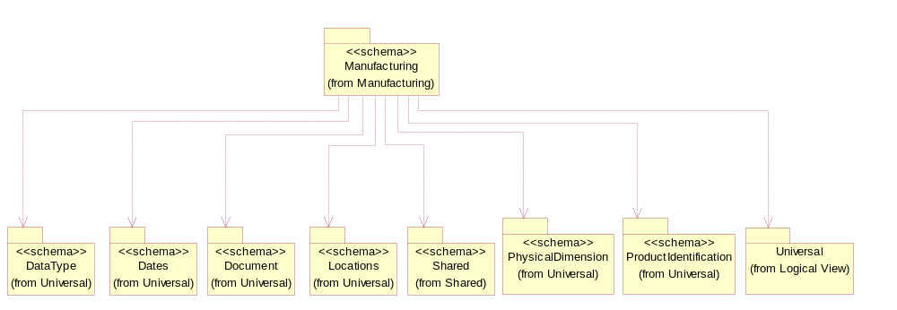
Figure ‎3-10 Dependency

Attachment
A business property that describes additional information regarding a product or process.
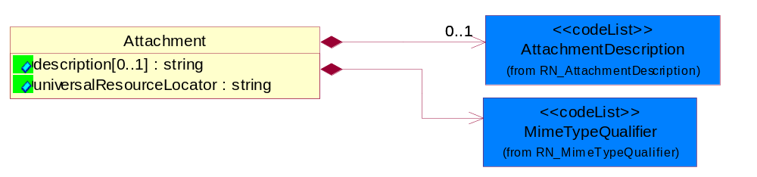
Figure ‎3-11 Attachment

Attribute | Type | Documentation
description[0..1] | string | A description of a process, thing, action, etc.
universalResourceLocator | string | URL for the attachment document.

Composition | Cardinality | Type | Documentation
AttachmentDescription | 0..1 | AttachmentDescription | Code identifying the type of product attachment.
MimeTypeQualifier | 1 | MimeTypeQualifier | The MIME type as defined by IANA.  Please refer to http://www.iana.org/assignments/media-types/ for a list of types.

EngineeringInformation
The information for engineering purpose, i.e, technical data necessary for process of the device.
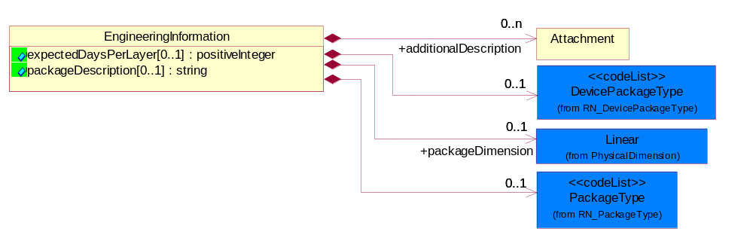
Figure ‎3-12 EngineeringInformation

Attribute | Type | Documentation
expectedDaysPerLayer[0..1] | positiveInteger | The number of days it is expected to process a layer on a chip.
packageDescription[0..1] | string | Description of the package about how the device is packaged.

Composition | Cardinality | Type | Documentation
additionalDescription | 0..n | Attachment | An additional description of a process, thing, action, etc. used to clarify or enhance and existing description.
DevicePackageType | 0..1 | DevicePackageType | Codes used to explain how a die (computer chip) is assembled into an IC (Integrated Circuit).
packageDimension | 0..1 | Linear | Physical dimensions of a package.
PackageType | 0..1 | PackageType | Code specifying the type of packaging for a product.

MarkInformation
The Information to be printed or marked on the devices.
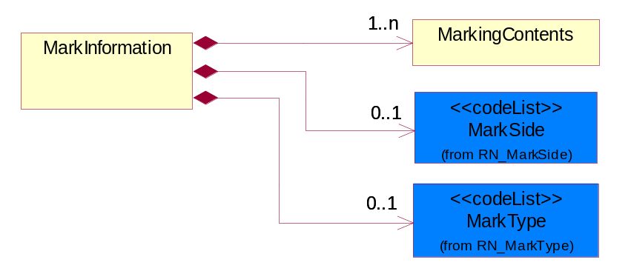
Figure ‎3-13 MarkInformation

Composition | Cardinality | Type | Documentation
MarkingContents | 1..n | MarkingContents | The contents to be printed or marked on the devices.
MarkSide | 0..1 | MarkSide | The side of the device to be printed or marked.
MarkType | 0..1 | MarkType | The method of marking.

MarkingContents
The contents to be printed or marked on the devices.
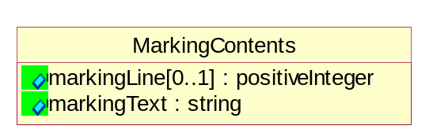
Figure ‎3-14 MarkingContents

Attribute | Type | Documentation
markingLine[0..1] | positiveInteger | The line number of a block of text that is to be printed on a chip.
markingText | string | The text to be printed or marked on the devices.

ProcessInformation
The collection of elements that comprise the processing sequence steps.
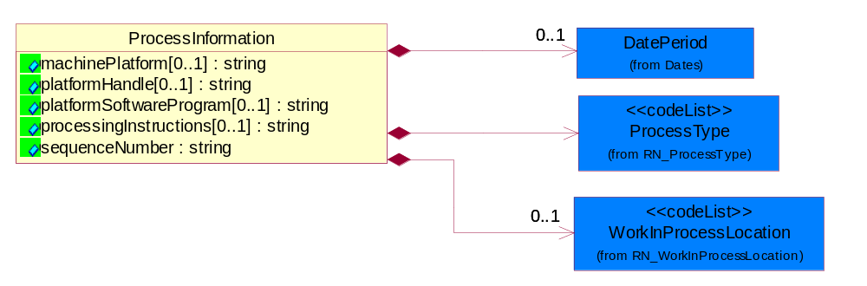
Figure ‎3-15 ProcessInformation

Attribute | Type | Documentation
machinePlatform[0..1] | string | The platform machine for processing.
platformHandle[0..1] | string | Tool or intrument for the platform machine to hold or fix the device during processing.
platformSoftwareProgram[0..1] | string | Software program running on the platform machine for processing or testing.
processingInstructions[0..1] | string | The instruction of the process, additional instructions about some specific routing steps.
sequenceNumber | string | An integer which identifies the order of a designated element within a specified set.

Composition | Cardinality | Type | Documentation
DatePeriod | 0..1 | DatePeriod | The business document must allow for the computation or statement of a duration based upon a beginning and an ending date.
ProcessType | 1 | ProcessType | Process performed on a device.
WorkInProcessLocation | 0..1 | WorkInProcessLocation | Code identifying the location of manufacturing, fabrication and assembly of components.

SourceDevice
The device before processing.
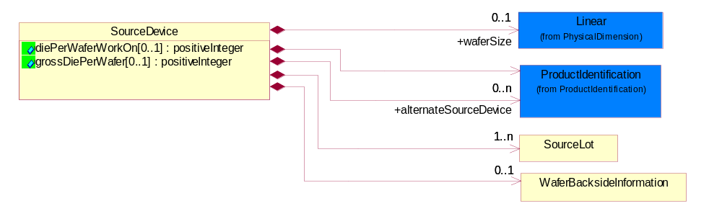
Figure ‎3-16 SourceDevice

Attribute | Type | Documentation
diePerWaferWorkOn[0..1] | positiveInteger | The number of dies the process will work on per wafer.
grossDiePerWafer[0..1] | positiveInteger | The total number of dies on a wafer.

Composition | Cardinality | Type | Documentation
SourceLot | 1..n | SourceLot | The collection of data elements that provides information about a particular lot of source devices.
WaferBacksideInformation | 0..1 | WaferBacksideInformation | The information about wafer backside.
ProductIdentification | 1 | ProductIdentification | The object provides the identifier(s) of a product.
alternateSourceDevice | 0..n | ProductIdentification | The name of the alternate source device.
waferSize | 0..1 | Linear | Physical dimension of the wafer.

SourceLot
The collection of data elements that provides information about a particular lot of source devices.
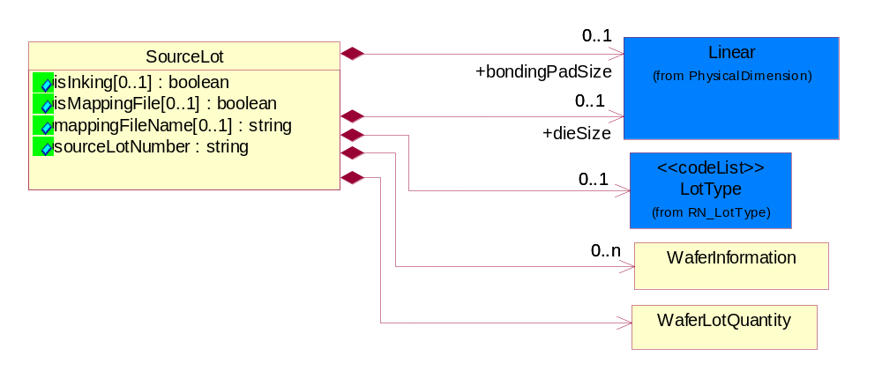
Figure ‎3-17 SourceLot

Attribute | Type | Documentation
isInking[0..1] | boolean | Wheter the good or bad dice are marked by inking on wafer.
isMappingFile[0..1] | boolean | Affirmative or negative response to indicate if a Mapping File is needed for the process.
mappingFileName[0..1] | string | The file name of layout of good/bad dice in wafer.
sourceLotNumber | string | Lot number of source device.

Composition | Cardinality | Type | Documentation
LotType | 0..1 | LotType | Describes the mode in which product was tested.
WaferLotQuantity | 1 | WaferLotQuantity | The collection of business properties that describe the quantity of items in a lot.
WaferInformation | 0..n | WaferInformation | Information on the individual wafers which compose a semiconductor manufacturing lot.
bondingPadSize | 0..1 | Linear | Physical dimensions of a bonding pad.
dieSize | 0..1 | Linear | Physical dimensions of the die.

SpecialProcessingInformation
The collectiion of data elements pertaining to special processing sequence steps and type.
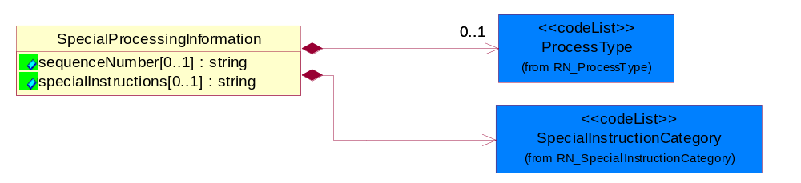
Figure ‎3-18 SpecialProcessingInformation

Attribute | Type | Documentation
sequenceNumber[0..1] | string | A positive integer which identifies the order of a designated element within a specified set.
specialInstructions[0..1] | string | Free form textual description that need to be describe more fully.

Composition | Cardinality | Type | Documentation
SpecialInstructionCategory | 1 | SpecialInstructionCategory | The category of special instruction.
ProcessType | 0..1 | ProcessType | Process performed on a device.

WaferBacksideInformation
The information about wafer backside.
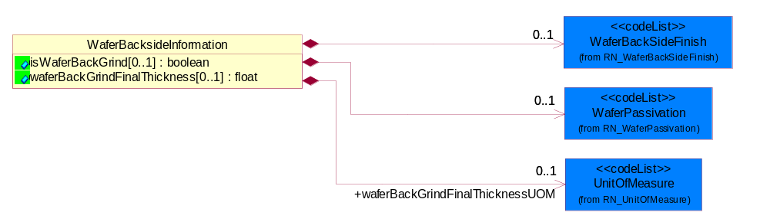
Figure ‎3-19 WaferBacksideInformation

Attribute | Type | Documentation
isWaferBackGrind[0..1] | boolean | Affirmation Indicator Intended to notify the subcontractor whether or not the Back Grind process step has been preformed.
waferBackGrindFinalThickness[0..1] | float | The final backgrind thickness.

Composition | Cardinality | Type | Documentation
WaferBackSideFinish | 0..1 | WaferBackSideFinish | The finish condition of wafer back side.
WaferPassivation | 0..1 | WaferPassivation | Name of the chemical material spread over a wafer to protect it from scratching or 'dirty-mixing'.
waferBackGrindFinalThicknessUOM | 0..1 | UnitOfMeasure | UOM of final backgrind thickness.

WaferInformation
Information on the individual wafers which compose a semiconductor manufacturing lot.
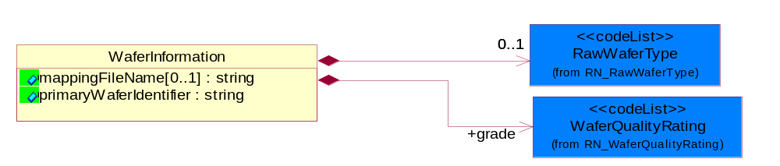
Figure ‎3-20 WaferInformation

Attribute | Type | Documentation
mappingFileName[0..1] | string | The file name of layout of good/bad dice in wafer.
primaryWaferIdentifier | string | The primary identifier of the wafer.

Composition | Cardinality | Type | Documentation
grade | 1 | WaferQualityRating | The quality rating expressed as a code.
RawWaferType | 0..1 | RawWaferType | Type of raw wafer.

WaferLotQuantity
The collection of business properties that describe the quantity of items in a lot.
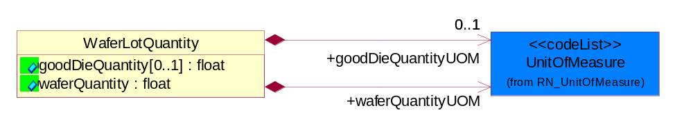
Figure ‎3-21 WaferLotQuantity

Attribute | Type | Documentation
goodDieQuantity[0..1] | float | The number of good dies obtained from wafers in a lot.
waferQuantity | float | The number or amount of wafers (or subsets) which comprise a given die.

Composition | Cardinality | Type | Documentation
waferQuantityUOM | 1 | UnitOfMeasure | UOM of the number of wafers in the lot.
goodDieQuantityUOM | 0..1 | UnitOfMeasure | UOM of good die quantity.

CodeList

LotType
Describes the mode in which product was tested.

Name | Documentation
DEV | Development.
ENG | Engineering - State where product is made using test processes on non-production tools or equipment.
EUH | EUH type.
MFG | Manufacturing.
NCL | NonConformingLot - Lots affected by a nonconformity to preset quality characteristics.
PLT | Pilot - The first lot of the product (never produced at the dedicated subcontractor).
PPD | Pre-Production.
PQC | Process Qualification Check - Process to qualify manufacturing processes in preparation for volume manufacturing.
PRD | Production - State where product is made using all production tools, processes, equipment, environment, facility, and cycle time.
RND | Research and Development - Process for developing prototype products.
RWK | Rework - Parts sent back from further down the manufacturing line.
SVC | Service.
TST | Test - The manufacturing stage in which the packaged die is tested.

ChangeReason
Reason Code for change of a business document or a line item or subline item in a business document.

Name | Documentation
AID | Assembly Instruction Discrepancy.
BDD | Bonding Diagram Discrepancy.
BWA | Broken Wafer.
CCH | Capacity Change.
CCO | Capacity Constraint (No Capacity).
CHR | Customer Hold Request.
CIC | Charge Information Change.
DMN | Die Mask Number Discrepancy.
DPW | Document Paper Work Error along with the PIP.
DQP | Bad Quality Problem of Dimension.
ESC | Engineering Spec Change.
ETO | Equipment Trouble Ocurred.
ICW | Instruction Change in WIP.
IPI | Incomplete Product Information.
LTV | Lead Time Violation.
LYI | Low Yield.
MDI | Marking Discrepancy.
MSD | Machine Shut-Down.
NAI | No Assembly Instruction.
NBD | No Bonding Diagram.
NBS | No Building Sheet for assembly (No Assembly Instruction).
NCL | Wafers are Not Completely Loaded (due to wafer lot size).
NGW | No Good Wafers.
NMA | No Marking on the device.
NMS | No Marking Spec.
NRE | A New Requirement is added to the request.
PIC | Processing Instruction Change.
PQB | Packing material Quality problem by the Buyer.
PQS | Packing material Quality problem by the Supplier.
PRC | Process Routing Change.
PSB | Packing material Shortage by the Buyer.
PSD | Plant Shut-Down.
PSS | Packing material Shortage by the Supplier.
QCH | Quantity Change.
QIC | The Index of Quality Change.
RMC | Raw Materials Constraint.
RQB | Raw material Quality problem by the Buyer.
RQS | Raw material Quality problem by the Supplier.
RSB | Raw material Shortage by the Buyer.
RSS | Raw material Shortage by the Supplier.
SDC | Shipping Date Change.
SDP | Start Date of Processing change.
SDU | Source Die Unavailable (No Dice).
SLC | Ship-to-Location Change.
TTO | Tool Trouble Occurred.
VQD | Bad Visual Quality of the Device.
WDD | Wafer/Die quantity Discrepancy.
WDP | Wafer/Die quality Problem.
WDT | Bad Thickness of Wafer/Die.
WOC | Work Order has been manually Cancelled.
WOP | Wrong Operation.
WOS | Work Order too Small (quantity too small).

Priority
Code identifying the priority order of an activity, product or service.

Name | Documentation
HIG | High.
HIH | Highest.
LOW | Low.
LOX | Lowest.
MED | Medium.

WorkInProcessLocation
Code identifying the location of manufacturing, fabrication and assembly of components.

Name | Documentation
ASS | Assembly - The manufacturing stage in which components or materials are assembled for packaging.
BUM | Bump - Step used in semi-conductor fabrication - contact points on a wafer heightened above wafer surface for conductivity.
FAB | Fab - The main manufacturing facility for processing semiconductor wafers.
MAP | Mark and Pack - A process where the final steps (often including packaging and labeling) are performed before shipment to the customer.
MAS | Mask - Step used in semi-conductor fabrication - sectioning off substrate.
PRO | Probe - Step used in semi-conductor fabrication - probing substrate.
SOR | Sort - The process of physically separating a material or products.
STA | Staged - Components that have been pulled from stock and readied for movement to a production area.
TES | Test - The manufacturing stage in which the packaged die is tested.

AttachmentDescription
Code identifying the type of product attachment.

Name | Documentation
AFI | Assembly/fabrication instructions.
ASD | Assembly drawings.
BLD | Block diagrams.
BLP | Blueprints.
BOM | Bill of Material.
CAD | Computer Aided Design Information.
LGT | Logistics. eg. packaging, carrier requirements, etc.
QAD | Quality data. Yield data.
SAP | Sample plan. Quantity of sample in a sample plan.
SCM | Schematics.
TES | Test instructions.

DevicePackageType
Codes used to explain how a die (computer chip) is assembled into an IC (Integrated Circuit).

Name | Documentation
BCC | Bump Chip Carrier uses plating metal pads to connect with the PCB.
BGA | Ball Grid Arrays are IC packages which place output pins in the form of solder ball matrix.
CSB | Ceramic Substrate BGA(ball-grid arrays).
CSP | Chip Scale Package.
FCB | Flip Chip BGA(ball-grid arrays).
FCC | Flip Chip CSP(chip ccale package).
FIL | Using polyimide-based films, Film BGA provides better line/space wiring capabilities as narrow as 1/1 mil.
HPF | High Performance FC-BGA, the thermally enhanced FC-BGA, is the composite package of FC-BGA and a copper heat sink.
HQF | The Heat spreader QFP (HQFP) uses a composite lead frame to increase heat dissipation.
HSB | Heat Slug BGA (HSBGA) is an upgraded type of PBGA.
LBG | Low BGA in which the total thickness between 1.2 mm and 1.7mm.
LFB | Low & Fine pitch BGA in which the total thickness between 1.2 mm and 1.7mm.
LGA | Land Grid Array (LGA) uses laminate substrate to form the landing pad and the exposed pad for performance enhancement.
LQF | LQFPs are ideal package for lightweight and portable electronic products requiring broad performance characteristics.
MCM | Multi-Chip Module Ball Grid Array.
MPB | Multi Package BGA.
PDI | Plastic Dual-in-line packaging.
PLC | Plastic Leaded Chip Carrier (PLCC) considered as legacy package is widely used in micro-controllers and consumer electronics.
QFN | Quad Flat No-lead.
QFP | Quad Flat Package (QFP) is popular among quad packages.
SOJ | Small Outline J-leaded (SOJ) is similar to PDIP, but the leads' end is formed in "J"-shape to be folded under the body.
SOP | The features of Small Outline Package (SOP) are similar to SOJ, but the lead's end is formed in the shape of gull-wing.
SPB | Stack Package BGA.
SSO | SSOP is the shrunk version of SOP, which lead pitch is narrowed 1.27mm (50mil) to 0.635mm (25mil).
TAB | Tape Automated Bonding package (same as TPC).
TBG | Thin BGA in which the total thickness between 1.0 mm and 1.2mm.
TFB | Thin & Fine pitch BGA in which the total thickness between 1.0 mm and 1.2mm.
TPC | Tape Carrier package.
TQF | TQFP provides better thermal performance which gives IC designers the needed margin for high performance products.
TSO | Thin profile SOP with overall thickness as thin as 1.1mm.
UBG | Micro BGA package is a true chip-scale package. (definition of chip scale: package is less than 20% larger than the die itself).
UFP | Ultra Fine Pitch BGA.
VBG | Very thin BGA in which the total thickness can be lower than 1.0 mm.
VFB | This package is a Very Fine pitch BGA (VFBGA) in which the total thickness can be lower than 1.0 mm due to significant improvement in substrate technology.
VIP | ViperBGA - Brand name for a trademarked ball grid array IC package.

MarkSide
The side of the device to be printed or marked.

Name | Documentation
BOT | Bottom of the device.
COM | Component of the device.
HEA | HeatSink of the device.
TOP | Top of the device.

MarkType
The method of marking.

Name | Documentation
INK | Ink. The text is marked on the device in ink.
LAS | Laser. The text is marked on the device by laser.

ProcessType
Process performed on a device.

Name | Documentation
ASS | Assembly - To package the devices.
BUR | Burn-In - To burn the circuit into the wafer.
CPR | Configurable Product.
FTE | Final Test - Final testing before the devices to become final products.
OCL | Option Class.
OPO | Configurable Product with Options.
PRO | Probe to test the device.
SOR | Sort - Differentiate and sort good or bad dice.
SPR | Standalone Product.

WaferBackSideFinish
The finish condition of wafer back side.

Name | Documentation
COA | Coarse.
FIN | Fine.

WaferPassivation
Name of the chemical material spread over a wafer to protect it from scratching or 'dirty-mixing'.

Name | Documentation
SIN | Si3N4. Silicon Nitride.

WaferQualityRating
Codes that specify a quality level.

Name | Documentation
AVG | Average. Middle rating (3).
BES | Best. Best rating (1).
LOW | Lowest. Lowest rating (5).
SBT | Secon best rating (2).
SLW | Second lowest rating (4).
TIA | Tier 1 Wafer Quality.
TIB | Tier 2 Wafer Quality.
WDI | Wafer quality has been downgraded by inhouse test.
WDO | Wafer quality has been downgraded by out source test.
WQD | Wafer quality has been down graded.

RawWaferType
Type of raw wafer.

Name | Documentation
EPI | EPI. Epitaxial Wafer.
NEP | NEPI. Non-Epitaxial Wafer.

SpecialInstructionCategory
The category of special instruction.

Name | Documentation
PRO | Process. Instruction concerned with processing.
STA | Stagine. Instruction concerned with staging.

DeviceType
The product or process for which the output of a WO is destined for.

Name | Documentation
DIE | Die.
FGO | Finished Goods.
RST | Raw Stock.
WAF | Wafer.

Shared

Shared

Dependency Diagram
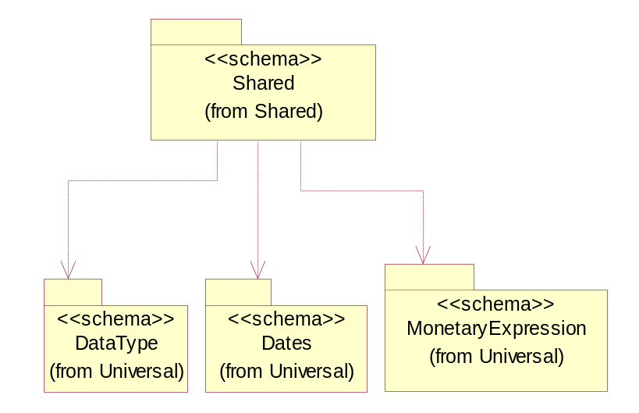
Figure ‎3-22 Dependency

CodeList

PackageType
Code specifying the type of packaging for a product.

Name | Documentation
BOX | Box.
BRL | Barrel.
CRT | Carton.
LPK | Loose Package.
MHC | Material/Method of holding a string of computer chips.
MIX | Mixed Package.
OTH | Others.
PAC | Parcel.
PBG | Plastic Ball Grind Array.
PBX | Paper Box.
PCC | Plastic Chip Carrier.
PLT | Pallet.
REE | Reel.
TQF | Thin Quad Flat Package.
TRA | Tray.
TUB | Plastic tube to hold computer chips.
WDC | Wooden Crate.

Universal Structure

ContactInformation

ContactInformation
The business document must allow for the identification of the name of the department, service or individual to be contacted regarding the context of the business document.
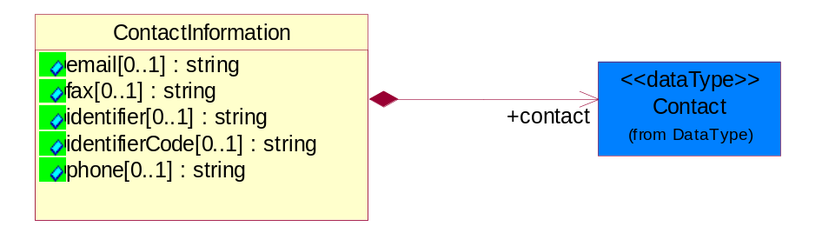
Figure ‎4-23 ContactInformation

Attribute | Type | Documentation
email[0..1] | string | The electronic mail for the specified contact.
fax[0..1] | string | The fax number for the specified contact.
identifier[0..1] | string | Identifies the role of the contact (i.e. Service Technician, Account Manager) in the Business Process.
identifierCode[0..1] | string | IdentifierCode is a unique security authorization code to identify the contact- ie. badge ID.
phone[0..1] | string | The telephone number for the specified contact.

Composition | Cardinality | Type | Documentation
contact | 1 | Contact | The name of the department, service or individual to be contacted within the organization.

DataType

Contact
The name of the department, service or individual to be contacted within the organization.
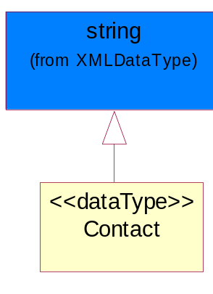
Figure ‎4-24 Contact

DUNS
A number assigned by Dun and Bradstreet to identify a business location.
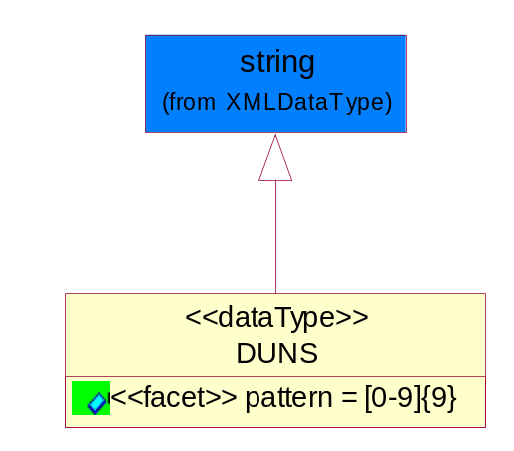
Figure ‎4-25 DUNS

Attribute | Type | Documentation
pattern |  | [0-9]{9}

DUNSPlus4
A identifier to specify a specific location within a business location.
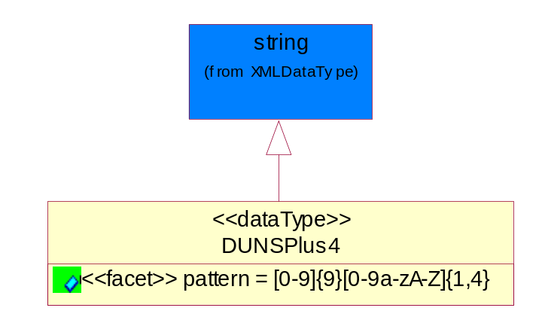
Figure ‎4-26 DUNSPlus4

Attribute | Type | Documentation
pattern |  | Data Universal Numbering System +4 (DUNS+4) number means the DUNS number assigned by Dun and Bradstreet, Inc. (D&B) plus an alphanumeric of length 4 suffix that may be assigned by a business concern.

GLN
Global Location Number (GLN) - A identifier to identify legal entities, trading parties and location.
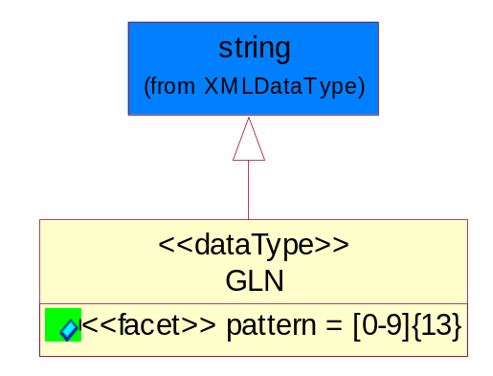
Figure ‎4-27 GLN

Attribute | Type | Documentation
pattern |  | [0-9]{13}

GTIN
Global Trade Identification Number (GTIN).
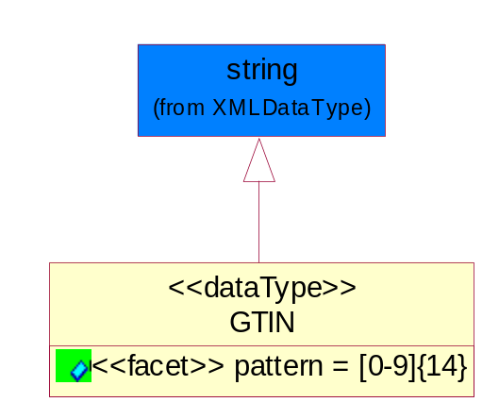
Figure ‎4-28 GTIN

Attribute | Type | Documentation
pattern |  | [0-9]{14}

Dates

DatePeriod
The business document must allow for the computation or statement of a duration based upon a beginning and an ending date.
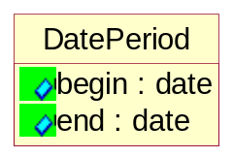
Figure ‎4-29 DatePeriod

Attribute | Type | Documentation
begin | date | The date indicating the beginning of the date period.
end | date | The date indicating the ending of the date period.

Document

BusinessDocumentReference
The business document reference object allows for the indirect referencing of a relationship to other business related documents.
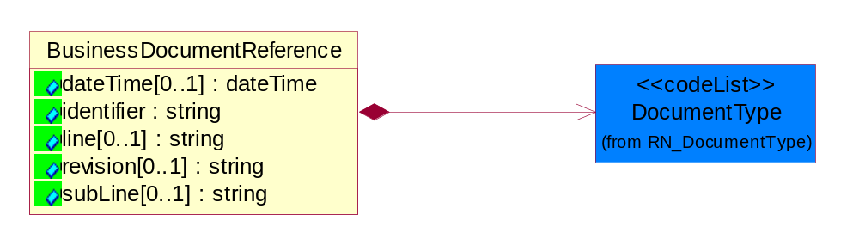
Figure ‎4-30 BusinessDocumentReference

Attribute | Type | Documentation
dateTime[0..1] | dateTime | The date-time stamp indicating on the referenced business document.
identifier | string | Unique identification of the referenced business document.
line[0..1] | string | References the specific line number of the specified business document.
revision[0..1] | string | Referenced the revision of the specified business document.
subLine[0..1] | string | References the specific subline number of the specified business document.

Composition | Cardinality | Type | Documentation
DocumentType | 1 | DocumentType | A code identifying the business context of a document.

Locations

AlternativeIdentifier
Identifies the specified code and the name of the organization that a code is utilized from.
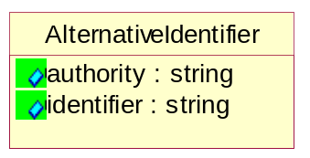
Figure ‎4-31 AlternativeIdentifier

Attribute | Type | Documentation
authority | string | The name of the organization that a code is utilized from.
identifier | string | The specified code to represent an entity (e.g. product, location, partner, etc.).

Location
The business document must specify a location.
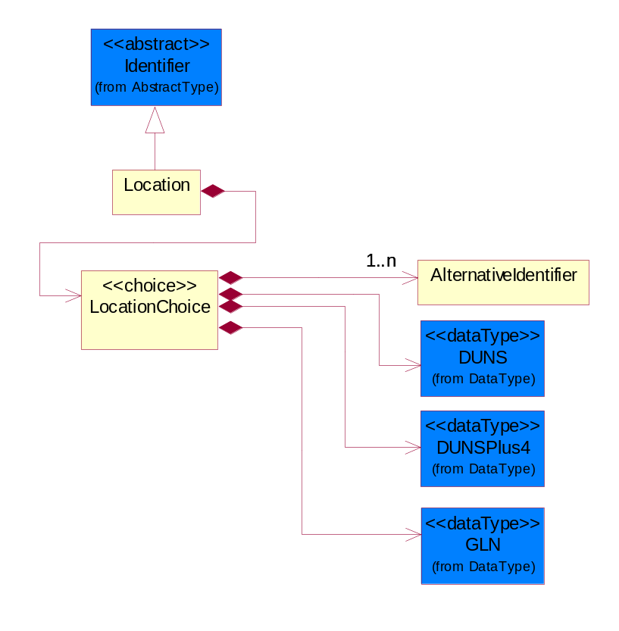
Figure ‎4-32 Location

Composition | Cardinality | Type | Documentation
LocationChoice | 1 | LocationChoice

LocationChoice

Composition | Cardinality | Type | Documentation
AlternativeIdentifier | 1..n | AlternativeIdentifier | Identifies the specified code and the name of the organization that a code is utilized from.
DUNS | 1 | DUNS | A number assigned by Dun and Bradstreet to identify a business location.
DUNSPlus4 | 1 | DUNSPlus4 | A identifier to specify a specific location within a business location.
GLN | 1 | GLN | Global Location Number (GLN) - A identifier to identify legal entities, trading parties and location.

PhysicalAddress
The business document must provide a physical address for a party to the business transaction.
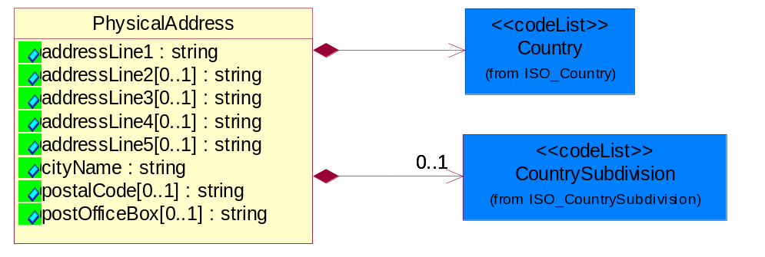
Figure ‎4-33 PhysicalAddress

Attribute | Type | Documentation
addressLine1 | string | The first line of a physical address.
addressLine2[0..1] | string | The second line of a physical address.
addressLine3[0..1] | string | The third line of a physical address.
addressLine4[0..1] | string | The fourth line of a physical address.
addressLine5[0..1] | string | The fifth line of a physical address.
cityName | string | The name of a city.
postalCode[0..1] | string | Identifying geographic location as specified by a national postal code.
postOfficeBox[0..1] | string | The Post Office Box identifier used to identify a party's post office box.

Composition | Cardinality | Type | Documentation
Country | 1 | Country | For representation of Country name RosettaNet has adopted ISO 3166-3; 1999. Refer to the following web page to get the latest version of the standard:  http://www.iso.ch/iso/en/prods-services/iso3166ma/02iso-3166-code-lists/index.html  If you need more information about the ISO standard please contact ISO for more details.
CountrySubdivision | 0..1 | CountrySubdivision | For representation of a Countries subdivisions RosettaNet has adopted ISO 3166-3; 1999. Refer to the following web page to get the latest version of the standard:  http://www.iso.ch/iso/en/prods-services/iso3166ma/02iso-3166-code-lists/index.html  If you need more information about the ISO standard please contact ISO for more details.

MonetaryExpression

PartnerIdentification

FullPartner
The business document must describe the trading partners in the business transaction. This data structure provide the flexibility to describe a partner in all possible methods as for new, existing or known partner.
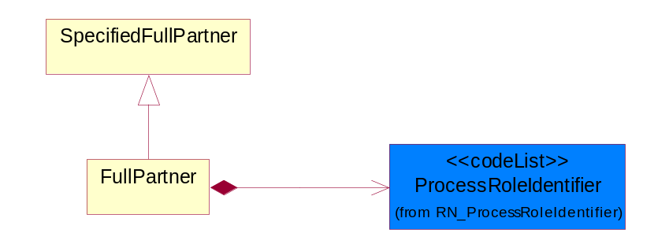
Figure ‎4-34 FullPartner

Composition | Cardinality | Type | Documentation
ProcessRoleIdentifier | 1 | ProcessRoleIdentifier | Describes the role of the partner in the business process. A partner will fulfill at least one or more roles during the business process.

IntermittentPartner
The business document must describe a physical address for a delivery.
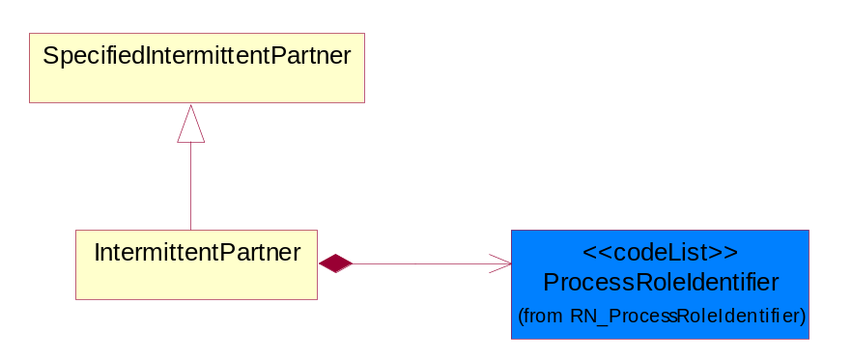
Figure ‎4-35 IntermittentPartner

Composition | Cardinality | Type | Documentation
ProcessRoleIdentifier | 1 | ProcessRoleIdentifier | Describes the role of the partner in the business process. A partner will fulfill at least one or more roles during the business process.

KnownPartner
The business document must describe the trading partners in the business transaction.
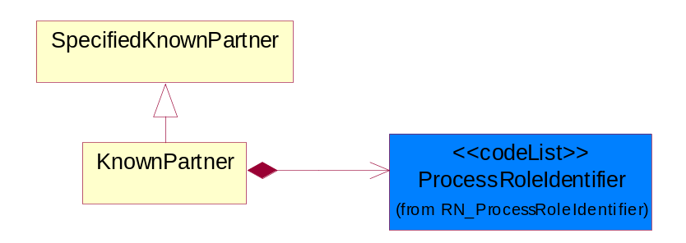
Figure ‎4-36 KnownPartner

Composition | Cardinality | Type | Documentation
ProcessRoleIdentifier | 1 | ProcessRoleIdentifier | Describes the role of the partner in the business process. A partner will fulfill at least one or more roles during the business process.

KnownPartnerContact
The business document must describe the trading partners in the business transaction.
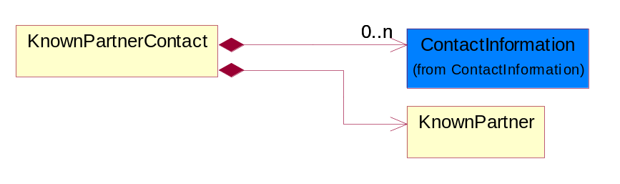
Figure ‎4-37 KnownPartnerContact

Composition | Cardinality | Type | Documentation
KnownPartner | 1 | KnownPartner | The business document must describe the trading partners in the business transaction.
ContactInformation | 0..n | ContactInformation | The business document must allow for the identification of the name of the department, service or individual to be contacted regarding the context of the business document.

NewPartner
The business document must describe a new, existing (but known to only one of the parties to the transaction) or an unknown party to the business transaction.
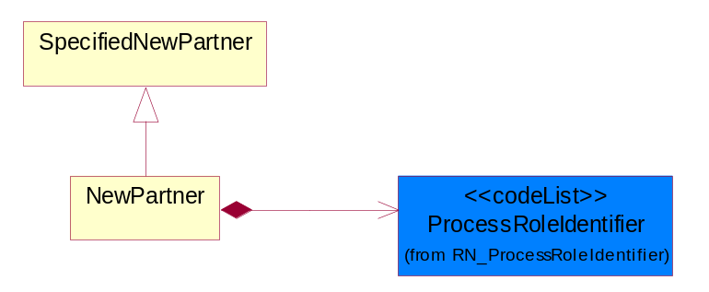
Figure ‎4-38 NewPartner

Composition | Cardinality | Type | Documentation
ProcessRoleIdentifier | 1 | ProcessRoleIdentifier | Describes the role of the partner in the business process. A partner will fulfill at least one or more roles during the business process.

PartnerDescription
The collection of business properties that describe a business partners' identity, their contact information, where they are physically located and their function in a supply chain.
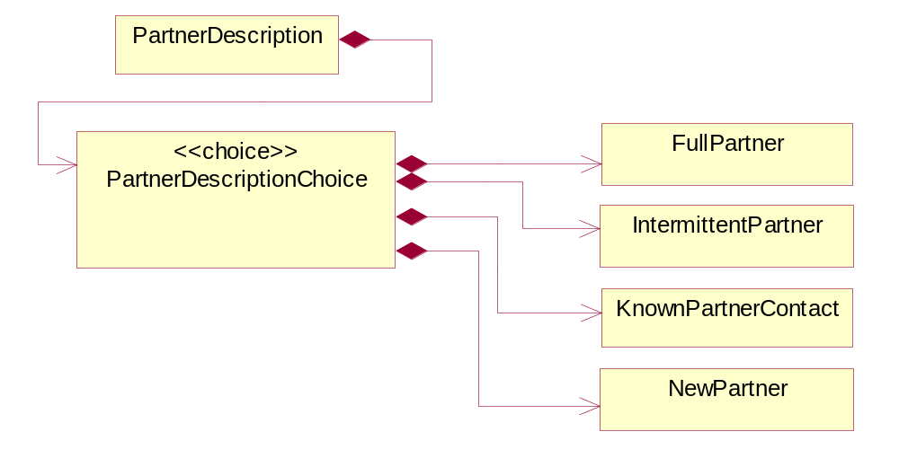
Figure ‎4-39 PartnerDescription

Composition | Cardinality | Type | Documentation
PartnerDescriptionChoice | 1 | PartnerDescriptionChoice

PartnerDescriptionChoice

Composition | Cardinality | Type | Documentation
FullPartner | 1 | FullPartner | The business document must describe the trading partners in the business transaction. This data structure provide the flexibility to describe a partner in all possible methods as for new, existing or known partner.
IntermittentPartner | 1 | IntermittentPartner | The business document must describe a physical address for a delivery.
KnownPartnerContact | 1 | KnownPartnerContact | The business document must describe the trading partners in the business transaction.
NewPartner | 1 | NewPartner | The business document must describe a new, existing (but known to only one of the parties to the transaction) or an unknown party to the business transaction.

PartnerIdentification
The business document must allow for the identity of one or more parties to the transaction.
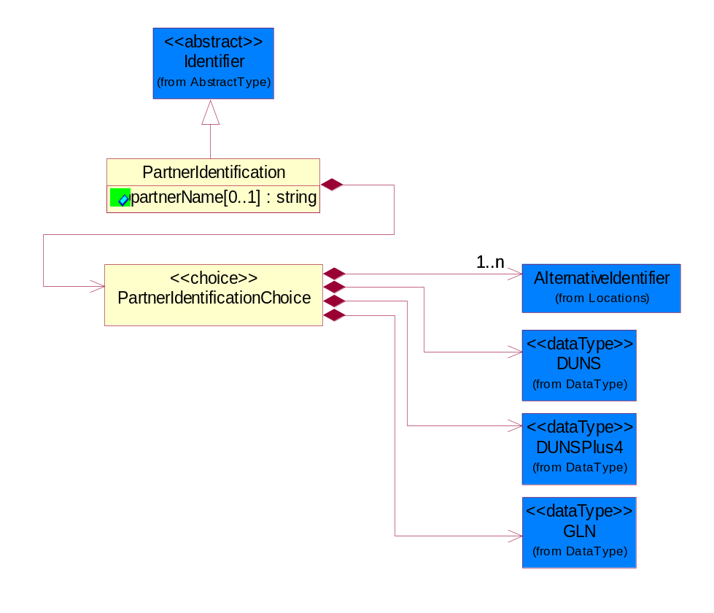
Figure ‎4-40 PartnerIdentification

Attribute | Type | Documentation
partnerName[0..1] | string | The name of the partner’s company/business.

Composition | Cardinality | Type | Documentation
PartnerIdentificationChoice | 1 | PartnerIdentificationChoice

PartnerIdentificationChoice

Composition | Cardinality | Type | Documentation
AlternativeIdentifier | 1..n | AlternativeIdentifier | Identifies the specified code and the name of the organization that a code is utilized from.
DUNS | 1 | DUNS | A number assigned by Dun and Bradstreet to identify a business location.
DUNSPlus4 | 1 | DUNSPlus4 | A identifier to specify a specific location within a business location.
GLN | 1 | GLN | Global Location Number (GLN) - A identifier to identify legal entities, trading parties and location.

SpecifiedFullPartner
The business document must describe the trading partners in the business transaction. This data structure provide the flexibility to describe a partner in all possible methods as for new, existing or known partner. This is specifically for partner who role has been specified.
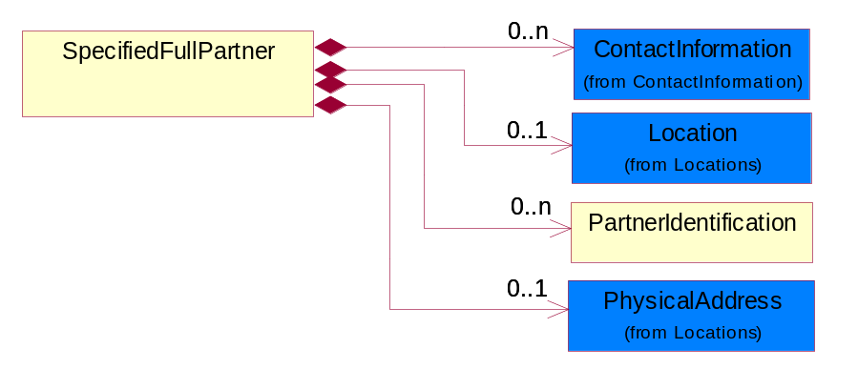
Figure ‎4-41 SpecifiedFullPartner

Composition | Cardinality | Type | Documentation
ContactInformation | 0..n | ContactInformation | The business document must allow for the identification of the name of the department, service or individual to be contacted regarding the context of the business document.
Location | 0..1 | Location | The business document must specify a location.
PartnerIdentification | 0..n | PartnerIdentification | The business document must allow for the identity of one or more parties to the transaction.
PhysicalAddress | 0..1 | PhysicalAddress | The business document must provide a physical address for a party to the business transaction.

SpecifiedIntermittentPartner
The business document must describe a physical address for a delivery.
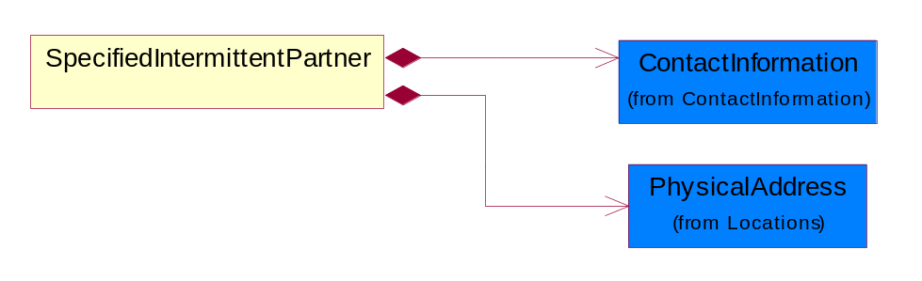
Figure ‎4-42 SpecifiedIntermittentPartner

Composition | Cardinality | Type | Documentation
ContactInformation | 1 | ContactInformation | The business document must allow for the identification of the name of the department, service or individual to be contacted regarding the context of the business document.
PhysicalAddress | 1 | PhysicalAddress | The business document must provide a physical address for a party to the business transaction.

SpecifiedKnownPartner
The business document must describe the trading partners in the business transaction.
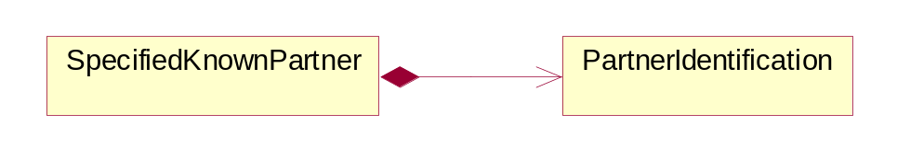
Figure ‎4-43 SpecifiedKnownPartner

Composition | Cardinality | Type | Documentation
PartnerIdentification | 1 | PartnerIdentification | The business document must allow for the identity of one or more parties to the transaction.

SpecifiedNewPartner
The business document must describe a new, existing (but known to only one of the parties to the transaction) or an unknown party to the business transaction.
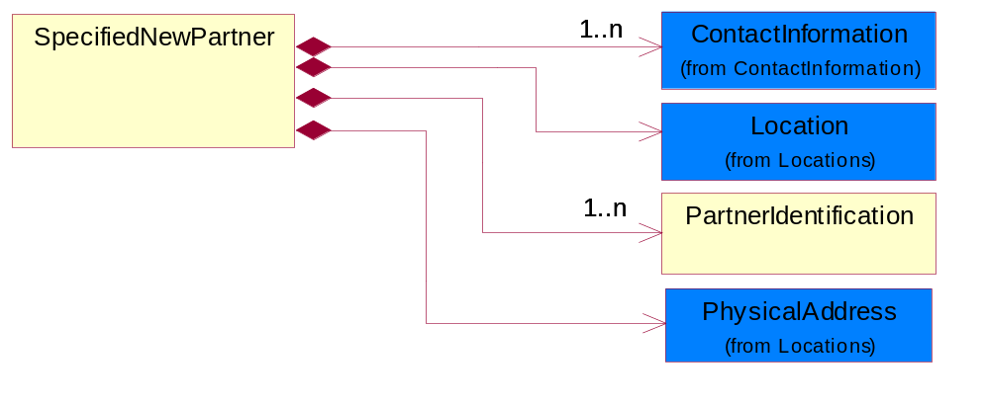
Figure ‎4-44 SpecifiedNewPartner

Composition | Cardinality | Type | Documentation
ContactInformation | 1..n | ContactInformation | The business document must allow for the identification of the name of the department, service or individual to be contacted regarding the context of the business document.
Location | 1 | Location | The business document must specify a location.
PartnerIdentification | 1..n | PartnerIdentification | The business document must allow for the identity of one or more parties to the transaction.
PhysicalAddress | 1 | PhysicalAddress | The business document must provide a physical address for a party to the business transaction.

PhysicalDimension

Linear
The business document must be able to express the linear dimensions of an object.
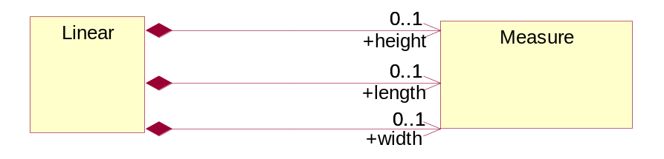
Figure ‎4-45 Linear

Composition | Cardinality | Type | Documentation
height | 0..1 | Measure | To express the height of an object.
length | 0..1 | Measure | To express the length of an object.
width | 0..1 | Measure | To express the weight of an object.

Measure
The business document must describe measurement information.
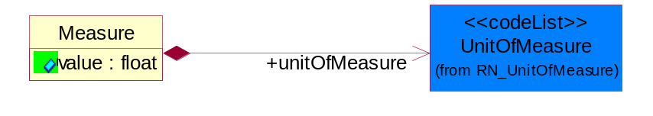
Figure ‎4-46 Measure

Attribute | Type | Documentation
value | float | The worth of an object in the specified unit of measure.

Composition | Cardinality | Type | Documentation
unitOfMeasure | 1 | UnitOfMeasure | To express the unit type of measurement.

ProductIdentification

ProductIdentification
The object provides the identifier(s) of a product.
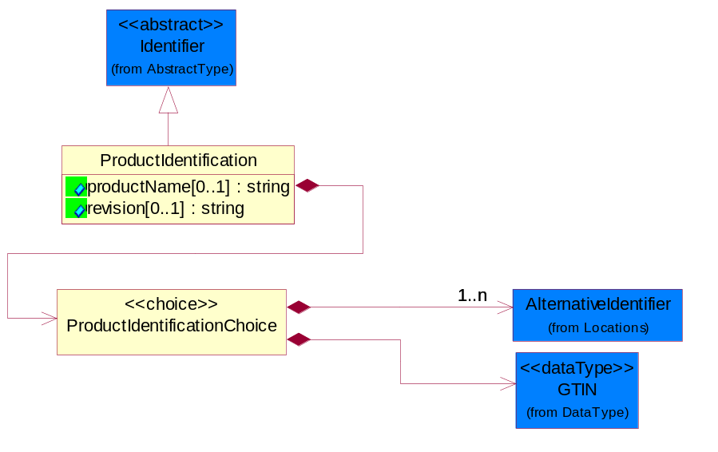
Figure ‎4-47 ProductIdentification

Attribute | Type | Documentation
productName[0..1] | string | The name of the product.
revision[0..1] | string | Referenced the specified product revision.

Composition | Cardinality | Type | Documentation
ProductIdentificationChoice | 1 | ProductIdentificationChoice

ProductIdentificationChoice

Composition | Cardinality | Type | Documentation
AlternativeIdentifier | 1..n | AlternativeIdentifier | Identifies the specified code and the name of the organization that a code is utilized from.
GTIN | 1 | GTIN | Global Trade Identification Number (GTIN).

CodeList

Country
For representation of Country name RosettaNet has adopted ISO 3166-3; 1999. Refer to the following web page to get the latest version of the standard:
http://www.iso.ch/iso/en/prods-services/iso3166ma/02iso-3166-code-lists/index.html

If you need more information about the ISO standard please contact ISO for more details.

CountrySubdivision
For representation of a Countries subdivisions RosettaNet has adopted ISO 3166-3; 1999. Refer to the following web page to get the latest version of the standard:
http://www.iso.ch/iso/en/prods-services/iso3166ma/02iso-3166-code-lists/index.html

If you need more information about the ISO standard please contact ISO for more details.

Language
For representation of Language name RosettaNet has adopted ISO 639-2; 1998. Refer to the following web page to get the latest version of the standard:

http://www.loc.gov/standards/iso639-2/iso639jac.html

If you need more information about the ISO standard please contact ISO for more details.

DocumentType
A code identifying the business context of a document.

Instance | Documentation
APM | Applied Promotions.
ARA | Authorization Request Approval.
CAR | Certificate of Analysis Response.
CBN | Product batch number of customer.
CCN | Customs clearance number.
CFA | Failure Analysis - Request document that will accompany the product providing characteristics of the component failure.
CIN | Commercial Invoice.
CNM | Traditional credit note or memo.
COA | Certificate of Analysis.
CON | In a virtual sourcing relationship, a third party trading partner is supplying a part to a customer on behalf of another company that has taken the order for the customer. In this case a Customer Order Number is associated to the request for material that is sent to the virtual trading partners.
COS | Consumption Notice.
COT | Contract.
CRN | Unique consumption reference number identifying the product consumption issue i.e. one-to-one relationship with physical flow.
DEM | Traditional debit note or memo.
DEN | Delivery Note.
DIN | Discontinuation Notice.
DOR | Delivery Order.
DRN | Drawing Number.
DRR | Design Registration Request.
ECO | Engineering Change Order - The proprietary unique identification number that represents an engineering change order.
EDD | Export Declaration Document.
EIR | Engineering Information Request.
EOL | End of Life.
FUO | Sales order or transfer order fulfilling demand out of a facility (outbound shipment).
IDD | Import Declaration Document.
INV | Invoice.
LID | Location Identifier. Data for on-site work that have to be done on the machine (associated with preventive maintenance order).
MEN | Master Event Number.
MID | Machine Identifier. Data for on-site work that have to be done on the machine (associated with preventive maintenance order).
MON | Model Number.
NTS | Notes.
OCL | The unique identifier assigned by the OEM for a warranty claim.
OGA | Other governmental agency issued document.
OPO | The unique identifier assigned by the OEM for a part order.
OPR | The unique identifier assigned by the OEM for a part return.
PCN | Product/Process Change.
PFA | Failure Analysis - Request document that will accompany the product providing characteristics of the product failure.
PII | Refers to previously issued invoice.
PLS | Unique number that identifies packing form prior to shipment.
POI | Purchase Order IN.
PON | Production order number for material release.
POO | Purchase Order OUT.
PRC | Product Catalog.
PSI | Refers to previously issued self-billing invoice.
PUO | Purchase Order.
QUO | Quote.
REC | Document identifying the receipt of materials or products into a facility against a purchase order or transfer order (inbound shipment).
REN | Release Number.
REO | Purchase order or transfer order replenishing inventory into a facility (inbound shipment).
REQ | Requisition.
RMA | Returned Material Authorization.
RPO | Purchase order for materials or product returned to and reworked by a supplier.
RTA | Remittance Advice - Remittance details.
SAO | Sales Order.
SBC | Credit Memo used in self-billing scenario.
SBD | Debit Memo used in self-billing scenario.
SBI | Invoice in self billing scenario.
SBN | Product batch number of supplier.
SCA | Similar to contracts - Contains the quantity of an article that is to be ordered from a vendor and the price for article or service that is to be procured.
SEN | Serial Number.
SEO | A document that gives a repair provider the necessary authorization to repair or upgrade a product either at the customer site or at the repair provider’s site.
SHD | Shipping Document.
SNC | Shipset Number on Code List.
SPC | The unique identifier assigned by the ASP for a warranty claim.
SPN | Spec Number.
SPO | The unique identifier assigned by the ASP for a part order.
SPR | The unique identifier assigned by the ASP for a part return.
SPW | The unique identifier assigned by the ASP to reference a work order.
SRI | A document that contains the shipping reference number which allows the product to be tracked within the outsourced logistic providers network.
SWT | Switch Authorization.
TCS | Terms and Conditions.
TRO | Order which results in materials or products being moved from one facility to another (outbound shipment and inbound shipment).
WAB | Waybill.
WAC | Denotes a warranty claim.
WOO | Work Order.

MimeTypeQualifier
The MIME type as defined by IANA.

Please refer to http://www.iana.org/assignments/media-types/ for a list of types.

Instance | Documentation
application/activemessage | [Shapiro]
application/andrew-inset | [Borenstein]
application/applefile | [Faltstrom]
application/atomicmail | [Borenstein]
application/batch-SMTP | [RFC2442]
application/beep+xml | [RFC3080]
application/cals-1840 | [RFC1895]
application/cnrp+xml | [RFCCNRP]
application/commonground | [Glazer]
application/cpl+xml
application/cybercash | [Eastlake]
application/dca-rft | [Campbell]
application/dec-dx | [Campbell]
application/dicom | [RFC3240]
application/dvcs | [RFC3029]
application/EDI-Consent | [RFC1767]
application/EDIFACT | [RFC1767]
application/EDI-X12 | [RFC1767]
application/eshop | [Katz]
application/font-tdpfr | [RFC3073]
application/http | [RFC2616]
application/hyperstudio | [Domino]
application/iges | [Parks]
application/index | [RFC2652]
application/index.cmd | [RFC2652]
application/index.obj | [RFC2652]
application/index.response | [RFC2652]
application/index.vnd | [RFC2652]
application/iotp | [RFC2935]
application/ipp | [RFC2910]
application/isup | [RFC3204]
application/mac-binhex40 | [Faltstrom]
application/macwriteii | [Lindner]
application/marc | [RFC2220]
application/mathematica | [Van Nostern]
application/msword | [Lindner]
application/news-message-id | [RFC1036,Spencer]
application/news-transmission | [RFC1036, Spencer]
application/ocsp-request | [RFC2560]
application/ocsp-response | [RFC2560]
application/octet-stream | [RFC2045,RFC2046]
application/oda | [RFC2045,RFC2046]
application/ogg | [RFC-walleij-ogg-mediatype-08.txt]
application/parityfec | [RFC3009]
application/pdf | [Lindner]
application/pgp-encrypted | [RFC3156]
application/pgp-keys | [RFC3156]
application/pgp-signature | [RFC3156]
application/pkcs10 | [RFC2311]
application/pkcs7-mime | [RFC2311]
application/pkcs7-signature | [RFC2311]
application/pkix-cert | [RFC2585]
application/pkixcmp | [RFC2510]
application/pkix-crl | [RFC2585]
application/postscript | [RFC2045,RFC2046]
application/prs.alvestrand.titrax-sheet | [Alvestrand]
application/prs.cww | [Rungchavalnont]
application/prs.nprend | [Doggett]
application/prs.plucker | [Janssen]
application/qsig | [RFC3204]
application/reginfo+xml | [RFC-ietf-sipping-reg-event-00.txt]
application/remote-printing | [RFC1486,Rose]
application/riscos | [Smith]
application/rtf | [Lindner]
application/sdp | [RFC2327]
application/set-payment | [Korver]
application/set-payment-initiation | [Korver]
application/set-registration | [Korver]
application/set-registration-initiation | [Korver]
application/sgml | [RFC1874]
application/sgml-open-catalog | [Grosso]
application/sieve | [RFC3028]
application/slate | [Crowley]
application/timestamp-query | [RFC3161]
application/timestamp-reply | [RFC3161]
application/tve-trigger | [Welsh]
application/vemmi | [RFC2122]
application/vnd.3gpp.pic-bw-large | [Meredith]
application/vnd.3gpp.pic-bw-small | [Meredith]
application/vnd.3gpp.pic-bw-var | [Meredith]
application/vnd.3gpp.sms | [Meredith]
application/vnd.3M.Post-it-Notes | [O'Brien]
application/vnd.accpac.simply.aso | [Leow]
application/vnd.accpac.simply.imp | [Leow]
application/vnd.acucobol | [Lubin]
application/vnd.acucorp | [Lubin]
application/vnd.adobe.xfdf | [Perelman]
application/vnd.aether.imp | [Moskowitz]
application/vnd.amiga.ami | [Blumberg]
application/vnd.anser-web-certificate-issue-initiation | [Mori]
application/vnd.anser-web-funds-transfer-initiation | [Mori]
application/vnd.audiograph | [Slusanschi]
application/vnd.blueice.multipass | [Holmstrom]
application/vnd.bmi | [Gotoh]
application/vnd.businessobjects | [Imoucha]
application/vnd.canon-cpdl | [Muto]
application/vnd.canon-lips | [Muto]
application/vnd.cinderella | [Kortenkamp]
application/vnd.claymore | [Simpson]
application/vnd.commerce-battelle | [Applebaum]
application/vnd.commonspace | [Chandhok]
application/vnd.contact.cmsg | [Patz]
application/vnd.cosmocaller | [Dellutri]
application/vnd.ctc-posml | [Kohlhepp]
application/vnd.cups-postscript | [Sweet]
application/vnd.cups-raster | [Sweet]
application/vnd.cups-raw | [Sweet]
application/vnd.curl | [Byrnes]
application/vnd.cybank | [Helmee]
application/vnd.data-vision.rdz | [Fields]
application/vnd.dna | [Searcy]
application/vnd.dpgraph | [Parker]
application/vnd.dreamfactory | [Appleton]
application/vnd.dxr | [Duffy]
application/vnd.ecdis-update | [Buettgenbach]
application/vnd.ecowin.chart | [Olsson]
application/vnd.ecowin.filerequest | [Olsson]
application/vnd.ecowin.fileupdate | [Olsson]
application/vnd.ecowin.series | [Olsson]
application/vnd.ecowin.seriesrequest | [Olsson]
application/vnd.ecowin.seriesupdate | [Olsson]
application/vnd.enliven | [Santinelli]
application/vnd.epson.esf | [Hoshina]
application/vnd.epson.msf | [Hoshina]
application/vnd.epson.quickanime | [Gu]
application/vnd.epson.salt | [Nagatomo]
application/vnd.epson.ssf | [Hoshina]
application/vnd.ericsson.quickcall | [Tidwell]
application/vnd.eudora.data | [Resnick]
application/vnd.fdf | [Zilles]
application/vnd.ffsns | [Holstage]
application/vnd.FloGraphIt | [Floersch]
application/vnd.framemaker | [Wexler]
application/vnd.fsc.weblaunch | [D.Smith]
application/vnd.fujitsu.oasys | [Togashi]
application/vnd.fujitsu.oasys2 | [Togashi]
application/vnd.fujitsu.oasys3 | [Okudaira]
application/vnd.fujitsu.oasysgp | [Sugimoto]
application/vnd.fujitsu.oasysprs | [Ogita]
application/vnd.fujixerox.ddd | [Onda]
application/vnd.fujixerox.docuworks | [Taguchi]
application/vnd.fujixerox.docuworks.binder | [Matsumoto]
application/vnd.fut-misnet | [Pruulmann]
application/vnd.grafeq | [Tupper]
application/vnd.groove-account | [Joseph]
application/vnd.groove-help | [Joseph]
application/vnd.groove-identity-message | [Joseph]
application/vnd.groove-injector | [Joseph]
application/vnd.groove-tool-message | [Joseph]
application/vnd.groove-tool-template | [Joseph]
application/vnd.groove-vcard | [Joseph]
application/vnd.hbci | [Hammann]
application/vnd.hhe.lesson-player | [Jones]
application/vnd.hp-HPGL | [Pentecost]
application/vnd.hp-hpid | [Gupta]
application/vnd.hp-hps | [Aubrey]
application/vnd.hp-PCL | [Pentecost]
application/vnd.hp-PCLXL | [Pentecost]
application/vnd.httphone | [Lefevre]
application/vnd.hzn-3d-crossword | [Minnis]
application/vnd.ibm.afplinedata | [Buis]
application/vnd.ibm.electronic-media | [Tantlinger]
application/vnd.ibm.MiniPay | [Herzberg]
application/vnd.ibm.modcap | [Hohensee]
application/vnd.ibm.secure-container | [Tantlinger]
application/vnd.informix-visionary | [Gales]
application/vnd.intercon.formnet | [Gurak]
application/vnd.intertrust.digibox | [Tomasello]
application/vnd.intertrust.nncp | [Tomasello]
application/vnd.intu.qbo | [Scratchley]
application/vnd.intu.qfx | [Scratchley]
application/vnd.irepository.package+xml | [Knowles]
application/vnd.is-xpr | [Natarajan]
application/vnd.japannet-directory-service | [Fujii]
application/vnd.japannet-jpnstore-wakeup | [Yoshitake]
application/vnd.japannet-payment-wakeup | [Fujii]
application/vnd.japannet-registration | [Yoshitake]
application/vnd.japannet-registration-wakeup | [Fujii]
application/vnd.japannet-setstore-wakeup | [Yoshitake]
application/vnd.japannet-verification | [Yoshitake]
application/vnd.japannet-verification-wakeup | [Fujii]
application/vnd.jisp | [Deckers]
application/vnd.kde.karbon | [Faure]
application/vnd.kde.kchart | [Faure]
application/vnd.kde.kformula | [Faure]
application/vnd.kde.kivio | [Faure]
application/vnd.kde.kontour | [Faure]
application/vnd.kde.kpresenter | [Faure]
application/vnd.kde.kspread | [Faure]
application/vnd.kde.kword | [Faure]
application/vnd.kenameaapp | [DiGiorgio-Haag]
application/vnd.koan | [Cole]
application/vnd.liberty-request+xml | [McDowell]
application/vnd.llamagraphics.life-balance.desktop | [White]
application/vnd.lotus-1-2-3 | [Wattenberger]
application/vnd.lotus-approach | [Wattenberger]
application/vnd.lotus-freelance | [Wattenberger]
application/vnd.lotus-notes | [Laramie]
application/vnd.lotus-organizer | [Wattenberger]
application/vnd.lotus-screencam | [Wattenberger]
application/vnd.lotus-wordpro | [Wattenberger]
application/vnd.mcd | [Gotoh]
application/vnd.mediastation.cdkey | [Flurry]
application/vnd.meridian-slingshot | [Wedel]
application/vnd.micrografx.flo | [Prevo]
application/vnd.micrografx.igx | [Prevo]
application/vnd.mif | [Wexler]
application/vnd.minisoft-hp3000-save | [Bartram]
application/vnd.mitsubishi.misty-guard.trustweb | [Tanaka]
application/vnd.Mobius.DAF | [Kabayama]
application/vnd.Mobius.DIS | [Kabayama]
application/vnd.Mobius.MBK | [Devasia]
application/vnd.Mobius.MQY | [Devasia]
application/vnd.Mobius.MSL | [Kabayama]
application/vnd.Mobius.PLC | [Kabayama]
application/vnd.Mobius.TXF | [Kabayama]
application/vnd.mophun.application | [Wennerstrom]
application/vnd.mophun.certificate | [Wennerstrom]
application/vnd.motorola.flexsuite | [Patton]
application/vnd.motorola.flexsuite.adsi | [Patton]
application/vnd.motorola.flexsuite.fis | [Patton]
application/vnd.motorola.flexsuite.gotap | [Patton]
application/vnd.motorola.flexsuite.kmr | [Patton]
application/vnd.motorola.flexsuite.ttc | [Patton]
application/vnd.motorola.flexsuite.wem | [Patton]
application/vnd.mozilla.xul+xml | [McDaniel]
application/vnd.ms-artgalry | [Slawson]
application/vnd.ms-asf | [Fleischman]
application/vnd.mseq | [Le Bodic]
application/vnd.ms-excel | [Gill]
application/vnd.msign | [Borcherding]
application/vnd.ms-lrm | [Ledoux]
application/vnd.ms-powerpoint | [Gill]
application/vnd.ms-project | [Gill]
application/vnd.ms-tnef | [Gill]
application/vnd.ms-works | [Gill]
application/vnd.ms-wpl | [Plastina]
application/vnd.musician | [Adams]
application/vnd.music-niff | [Butler]
application/vnd.netfpx | [Mutz]
application/vnd.noblenet-directory | [Solomon]
application/vnd.noblenet-sealer | [Solomon]
application/vnd.noblenet-web | [Solomon]
application/vnd.novadigm.EDM | [Swenson]
application/vnd.novadigm.EDX | [Swenson]
application/vnd.novadigm.EXT | [Swenson]
application/vnd.obn | [Hessling]
application/vnd.osa.netdeploy | [Klos]
application/vnd.palm | [Peacock]
application/vnd.pg.format | [Gandert]
application/vnd.pg.osasli | [Gandert]
application/vnd.powerbuilder6 | [Guy]
application/vnd.powerbuilder6-s | [Guy]
application/vnd.powerbuilder7 | [Shilts]
application/vnd.powerbuilder75 | [Shilts]
application/vnd.powerbuilder75-s | [Shilts]
application/vnd.powerbuilder7-s | [Shilts]
application/vnd.previewsystems.box | [Smolgovsky]
application/vnd.publishare-delta-tree | [Ben-Kiki]
application/vnd.pvi.ptid1 | [Lamb]
application/vnd.pwg-multiplexed | [RFC3391]
application/vnd.pwg-xhtml-print+xml | [Wright]
application/vnd.Quark.QuarkXPress | [Scheidler]
application/vnd.rapid | [Szekely]
application/vnd.s3sms | [Tarkkala]
application/vnd.sealed.net | [Lambert]
application/vnd.seemail | [Webb]
application/vnd.shana.informed.formdata | [Selzler]
application/vnd.shana.informed.formtemplate | [Selzler]
application/vnd.shana.informed.interchange | [Selzler]
application/vnd.shana.informed.package | [Selzler]
application/vnd.smaf | [Takahashi]
application/vnd.sss-cod | [Dani]
application/vnd.sss-dtf | [Bruno]
application/vnd.sss-ntf | [Bruno]
application/vnd.street-stream | [Levitt]
application/vnd.svd | [Becker]
application/vnd.swiftview-ics | [Widener]
application/vnd.triscape.mxs | [Simonoff]
application/vnd.trueapp | [Hepler]
application/vnd.truedoc | [Chase]
application/vnd.ufdl | [Manning]
application/vnd.uplanet.alert | [Martin]
application/vnd.uplanet.alert-wbxml | [Martin]
application/vnd.uplanet.bearer-choice | [Martin]
application/vnd.uplanet.bearer-choice-wbxml | [Martin]
application/vnd.uplanet.cacheop | [Martin]
application/vnd.uplanet.cacheop-wbxml | [Martin]
application/vnd.uplanet.channel | [Martin]
application/vnd.uplanet.channel-wbxml | [Martin]
application/vnd.uplanet.list | [Martin]
application/vnd.uplanet.listcmd | [Martin]
application/vnd.uplanet.listcmd-wbxml | [Martin]
application/vnd.uplanet.list-wbxml | [Martin]
application/vnd.uplanet.signal | [Martin]
application/vnd.vcx | [T.Sugimoto]
application/vnd.vectorworks | [Pharr]
application/vnd.vidsoft.vidconference | [Hess]
application/vnd.visio | [Sandal]
application/vnd.visionary | [Aravindakumar]
application/vnd.vividence.scriptfile | [Risher]
application/vnd.vsf | [Rowe]
application/vnd.wap.sic | [WAP-Forum]
application/vnd.wap.slc | [WAP-Forum]
application/vnd.wap.wbxml | [Stark]
application/vnd.wap.wmlc | [Stark]
application/vnd.wap.wmlscriptc | [Stark]
application/vnd.webturbo | [Rehem]
application/vnd.wrq-hp3000-labelled | [Bartram]
application/vnd.wt.stf | [Wohler]
application/vnd.wv.csp+wbxml | [Salmi]
application/vnd.xara | [Matthewman]
application/vnd.xfdl | [Manning]
application/vnd.yellowriver-custom-menu | [Yellow]
application/whoispp-query | [RFC2957]
application/whoispp-response | [RFC2958]
application/wita | [Campbell]
application/wordperfect5.1 | [Lindner]
application/x400-bp | [RFC1494]
application/xhtml+xml | [RFC3236]
application/xml | [RFC3023]
application/xml-dtd | [RFC3023]
application/xml-external-parsed-entity | [RFC3023]
application/zip | [Lindner]
audio/32kadpcm | [RFC2421,RFC2422]
audio/AMR | [RFC3267]
audio/AMR-WB | [RFC3267]
audio/basic | [RFC2045,RFC2046]
audio/CN | [RFC3389]
audio/DAT12 | [RFC3190]
audio/DVI4
audio/EVRC | [RFC-ietf-avt-evrc-smv-03.txt]
audio/EVRC0 | [RFC-ietf-avt-evrc-smv-03.txt]
audio/G.722.1 | [RFC3047]
audio/G722
audio/G723
audio/G726-16
audio/G726-24
audio/G726-32
audio/G726-40
audio/G728
audio/G729
audio/G729D
audio/G729E
audio/GSM
audio/GSM-EFR
audio/L16 | [RFC2586]
audio/L20 | [RFC3190]
audio/L24 | [RFC3190]
audio/L8
audio/LPC
audio/MP4A-LATM | [RFC3016]
audio/MPA
audio/mpa-robust | [RFC3119]
audio/mpeg | [RFC3003]
audio/parityfec | [RFC3009]
audio/PCMA
audio/PCMU
audio/prs.sid | [Walleij]
audio/QCELP
audio/RED
audio/SMV | [RFC-ietf-avt-evrc-smv-03.txt]
audio/SMV0 | [RFC-ietf-avt-evrc-smv-03.txt]
audio/telephone-event | [RFC2833]
audio/tone | [RFC2833]
audio/VDVI
audio/vnd.3gpp.iufp | [Belling]
audio/vnd.cisco.nse | [Kumar]
audio/vnd.cns.anp1 | [McLaughlin]
audio/vnd.cns.inf1 | [McLaughlin]
audio/vnd.digital-winds | [Strazds]
audio/vnd.everad.plj | [Cicelsky]
audio/vnd.lucent.voice | [Vaudreuil]
audio/vnd.nortel.vbk | [Parsons]
audio/vnd.nuera.ecelp4800 | [Fox]
audio/vnd.nuera.ecelp7470 | [Fox]
audio/vnd.nuera.ecelp9600 | [Fox]
audio/vnd.octel.sbc | [Vaudreuil]
audio/vnd.qcelp | [Lundblade]
audio/vnd.rhetorex.32kadpcm | [Vaudreuil]
audio/vnd.vmx.cvsd | [Vaudreuil]
image/cgm | Computer Graphics Metafile
image/g3fax | [RFC1494]
image/gif | [RFC2045,RFC2046]
image/ief | [RFC1314] Image Exchange Format
image/jpeg | [RFC2045,RFC2046]
image/naplps | [Ferber]
image/png | [Randers-Pehrson]
image/prs.btif | [Simon]
image/prs.pti | [Laun]
image/t38 | [RFC3362]
image/tiff | [RFC3302] Tag Image File Format
image/tiff-fx | [RFC3250] Tag Image File Format Fax eXtended
image/vnd.cns.inf2 | [McLaughlin]
image/vnd.djvu | [Bottou]
image/vnd.dwg | [Moline]
image/vnd.dxf | [Moline]
image/vnd.fastbidsheet | [Becker]
image/vnd.fpx | [Spencer]
image/vnd.fst | [Fuldseth]
image/vnd.fujixerox.edmics-mmr | [Onda]
image/vnd.fujixerox.edmics-rlc | [Onda]
image/vnd.globalgraphics.pgb | [Bailey]
image/vnd.mix | [Reddy]
image/vnd.ms-modi | [Vaughan]
image/vnd.net-fpx | [Spencer]
image/vnd.svf | [Moline]
image/vnd.wap.wbmp | [Stark]
image/vnd.xiff | [S.Martin]
message/delivery-status | [RFC1894]
message/disposition-notification | [RFC2298]
message/external-body | [RFC2045,RFC2046]
message/http | [RFC2616]
message/news | [RFC 1036, H.Spencer]
message/partial | [RFC2045,RFC2046]
message/rfc822 | [RFC2045,RFC2046]
message/s-http | [RFC2660]
message/sip | [RFC3261]
message/sipfrag | [RFC3420]
model/iges | [Parks]
model/mesh | [RFC2077]
model/vnd.dwf | [Pratt]
model/vnd.flatland.3dml | [Powers]
model/vnd.gdl | [Babits]
model/vnd.gs-gdl | [Babits]
model/vnd.gtw | [Ozaki]
model/vnd.mts | [Rabinovitch]
model/vnd.parasolid.transmit.binary | [Parasolid]
model/vnd.parasolid.transmit.text | [Parasolid]
model/vnd.vtu | [Rabinovitch]
model/vrml | [RFC2077]
multipart/alternative | [RFC2045,RFC2046]
multipart/appledouble | [Faltstrom]
multipart/byteranges | [RFC2068]
multipart/digest | [RFC2045,RFC2046]
multipart/encrypted | [RFC1847]
multipart/form-data | [RFC2388]
multipart/header-set | [Crocker]
multipart/mixed | [RFC2045,RFC2046]
multipart/parallel | [RFC2045,RFC2046]
multipart/related | [RFC2387]
multipart/report | [RFC1892]
multipart/signed | [RFC1847]
multipart/voice-message | [RFC2421,RFC2423]
text/calendar | [RFC2445]
text/css | [RFC2318]
text/directory | [RFC2425]
text/enriched | [RFC1896]
text/html | [RFC2854]
text/parityfec | [RFC3009]
text/plain | [RFC2646,RFC2046]
text/prs.lines.tag | [Lines]
text/rfc822-headers | [RFC1892]
text/richtext | [RFC2045,RFC2046]
text/rtf | [Lindner]
text/sgml | [RFC1874]
text/t140 | [RFC2793]
text/tab-separated-values | [Lindner]
text/uri-list | [RFC2483]
text/vnd.abc | [Allen]
text/vnd.curl | [Byrnes]
text/vnd.DMClientScript | [Bradley]
text/vnd.fly | [Gurney]
text/vnd.fmi.flexstor | [Hurtta]
text/vnd.in3d.3dml | [Powers]
text/vnd.in3d.spot | [Powers]
text/vnd.IPTC.NewsML | [IPTC]
text/vnd.IPTC.NITF | [IPTC]
text/vnd.latex-z | [Lubos]
text/vnd.motorola.reflex | [Patton]
text/vnd.ms-mediapackage | [Nelson]
text/vnd.net2phone.commcenter.command | [Xie]
text/vnd.sun.j2me.app-descriptor | [G.Adams]
text/vnd.wap.si | [WAP-Forum]
text/vnd.wap.sl | [WAP-Forum]
text/vnd.wap.wml | [Stark]
text/vnd.wap.wmlscript | [Stark]
text/xml | [RFC3023]
text/xml-external-parsed-entity | [RFC3023]
video/BMPEG
video/BT656
video/CelB
video/DV | [RFC3189]
video/H261
video/H263
video/H263-1998
video/H263-2000
video/JPEG
video/MP1S
video/MP2P
video/MP2T
video/MP4V-ES | [RFC3016]
video/mpeg | [RFC2045,RFC2046]
video/MPV
video/nv
video/parityfec | [RFC3009]
video/pointer | [RFC2862]
video/quicktime | [Lindner]
video/SMPTE292M | [RFC-avt-smpte292-video-08.txt]
video/vnd.fvt | [Fuldseth]
video/vnd.motorola.video | [McGinty]
video/vnd.motorola.videop | [McGinty]
video/vnd.mpegurl | [Recktenwald]
video/vnd.nokia.interleaved-multimedia | [Kangaslampi]
video/vnd.objectvideo | [Clark]
video/vnd.vivo | [Wolfe]

UnitOfMeasure
Code identifying a product unit of measure.

Instance | Documentation
10P | 10-pack.
1BF | 100 Board Feet.
1FC | 20 Foot Container.
1GR | Gram/Cubic Centimeter.
1GT | 10,000 Gallon Tankcar.
1KB | 25 Kilogram Bulk Bag.
1KD | 10 Kilogram Drum.
1KP | 1000-pack.
1M2 | 1/Square Meter (1/M2).
1PA | 20-Pack.
1PB | 50 Pound Bag.
1PD | 100 Pound Drum.
1PM | 1/minute (1/min).
22S | Square Millimeter/Second (mm2/s).
2FC | 40 Foot Container.
2GR | Gram/square meter.
2GT | 20,000 Gallon Tankcar.
2KB | 300 Kilogram Bulk Bag.
2KD | 15 Kilogram Drum.
2PA | 100-Pack.
3GR | Grams Per 100 Centimeters.
3KB | 500 Kilogram Bulk Bag.
3KD | 55 Gallon Drum.
3MH | Cubic Millimeters/Hour (mm3/hour).
4GR | Grams Per 100 Grams.
4KD | 115 Kilogram Drum.
50P | 50-pack.
5GR | Grams Per Cubic Centimeter.
6GR | Grams Per Square Centimeter.
7GR | Grams Per Square Meter.
ABC | Absorbance per centimeter (Absorbance per cm).
ABU | Absorbance per Unit (absorbance per unit).
ACC | Atoms per Cubic Centimeters (atoms per cu cm).
ACR | Acre.
ACS | Acidic strength/concentration.
ACT | Actual Pounds.
ACU | Activity unit (Activ.unit).
ALU | Aluminum Pounds Only.
AM1 | Ampoule.
AMN | Ångstroms/Minute (Ångst/min).
AMP | Ampere.
ANG | Angstrom (A).
APB | Atomic Parts per Billion (atomic ppb).
APG | API Specific Gravity (API Grav).
APM | Atomic Parts per Million (atomic ppm).
APT | Atomic Parts per Trillion (atomic ppt).
APU | APHA Units (apha).
ASC | Atoms per Square Centimeters (atoms per sq cm).
ASM | Angstrom.
ASY | Assembly (ASY).
ATG | Atmospheric gauge.
ATM | Atmosphere absolute.
ATP | Atomic %.
ATY | Activity.
BAB | Base Box.
BAC | Batch.
BAE | Bale.
BAG | Bag.
BAL | Ball.
BAN | Band.
BAP | Batting Pound.
BAR | Bar.
BAS | Basket.
BAT | Batt.
BAW | Base Weight.
BEA | Beam.
BEC | Becquerel/kilogram.
BEL | Belt.
BHP | Brake HP.
BIL | Billet.
BIN | Bin.
BIT | Bit.
BKC | Bulk Car Load.
BLN | Balance.
BLO | Block.
BOA | Board.
BOF | Board Feet.
BOL | Bolt.
BOT | Bottle.
BOX | Box.
BRB | Bar absolute.
BRD | Barrels Per Day.
BRE | Barrel.
BRI | Barrel (Imperial).
BRM | Barrels Per Minute.
BTF | British Thermal Units (BTUs) Per Cubic Foot.
BTP | British Thermal Units (BTUs) Per Pound.
BTU | British Thermal Unit (BTU).
BUB | Bubbler.
BUC | Bucket.
BUD | Bushel, Dry Imperial.
BUK | Bunks.
BUL | Bulk.
BUN | Bundle.
BUP | Bulk Pack.
BUS | Bushel.
BYT | Bytes.
C0W | Counts per Wafer (Counts/wf).
C3M | Cubic centimeter per minute (cm3/minute).
CAA | Carat.
CAB | Carboy.
CAC | Card.
CAD | Candela.
CAG | Cartridge.
CAK | Cask.
CAL | Calorie.
CAN | Can.
CAO | Carload.
CAR | Car.
CAS | Case.
CAT | Canister.
CAW | Catchweight.
CC2 | Centipoises per hour per square centimeters (cps per hr per sq cm).
CCC | Counts per Square Centimeters (Counts/cm2).
CD3 | Cubic decimeter (Cubic dec).
CEL | Cell.
CEM | Centimeter.
CEP | Centipoises (CPS).
CET | Centiliter.
CGM | Centigram.
CHA | Chains (Land Survey).
CHE | Chest.
CM2 | Square centimeter (cm2).
CMH | Centimeter/hour (cm/h).
CML | Colony/Milliliter (col/ml).
CMS | Centimeter/Second (cm/s).
CNN | Connector.
COG | Coil Group.
COI | Coil.
COL | Coulomb.
COM | Composite Product Pounds (Total Weight).
CON | Cone.
COT | Container.
COV | Cover.
CRA | Crate.
CRT | Carton.
CSE | Cassette.
CST | Centistokes.
CUB | Cubic centimeter.
CUC | Cubic centimeter/second.
CUF | Cubic Foot.
CUI | Cubic inch.
CUM | Cubic meter.
CUP | Cup.
CUY | Cubic yard.
CYC | Cycles.
CYL | Cylinder.
DAL | Dalton units (dalton).
DAY | Day.
DCB | Decibels.
DCG | Decagram.
DCL | Deciliter.
DCM | Defects per Square Centimeters (Defects/cm2).
DE1 | Defects.
DE2 | Degrees in Angles.
DE3 | Degree.
DEA | Deal.
DEC | Decimeter.
DEF | Degree Fahrenheit.
DEG | Degree Celsius.
DEP | Dep. Factor.
DFW | Defects per Wafer (Defects/Wafer).
DGM | Decigram.
DIE | Die.
DIL | Display.
DIP | Dispenser.
DNC | Dynes per centimeter (Dynes per cm).
DOZ | Dozen.
DPM | Parts per Million per Day (ppm per day).
DRA | Dram.
DRU | Drum.
DRY | Dry Pounds.
EAC | Each.
ELE | Electrical Capacitance.
EML | Enzyme Units/Milliliter (Enzyme/ml).
ENU | Enzyme Units (Enzy.Units).
EQ2 | Milliequivalent per 30 Kg (mequ/30Kg).
EQG | Milliequivalent per gram (milliequivalent per g).
EQK | Milliequivalent per Kilogram (mequ/Kg).
EQM | Milliequivalent per Millimeter (milliequivalent per mm).
FAR | Farads.
FFA | Femtofarad.
FIN | 1/32 inch.
FLO | Fluid Ounce.
FOI | Fluid Ounce (Imperial).
FOO | Foot.
FOU | Fluid Ounce US.
FPS | Feet per second (Feet/s).
FRH | Sales FT3 at 60°F per hour (FTR/hour).
FRM | Sales FT3 at 60°F per minute (FTR/min).
FTR | Sales FT3 at 60°F, 14.7 psia (SFT3_60F_S).
FTS | Sales FT3 at 70°F, 14.7 psia (SFT3_70F_S).
FTT | 1000 FT3 at 60°F, 14.7 psia (KFT3_60F_S).
FTU | 1000 FT3 at 70°F, 14.7 psia (KFT3_70F_S).
FUU | Fuel Usage (Gallons).
G2S | Gram square per second (g²/s).
GAI | Gram act. ingrd. (g act.ing).
GAL | Gallon.
GAS | Gage Systems.
GAU | Gram Gold.
GCL | Gardner Color.
GEG | Keim/Gramm (keim/g).
GEQ | Gram per Equivalent (g/Eq).
GGM | Gram per gram mole (g/gmole).
GHG | Gram per Hectogram (g/hg).
GIH | Gigahertz.
GIJ | Gigajoules.
GIL | Gill (Imperial).
GM4 | Gram per 100 Milliliters (g/100ml).
GME | Gram per Mole Equivalent (g/mole Eq).
GMO | Gram per Mol (g/mol).
GNL | Gram act.Ingrd per Liter (gai/liter).
GOB | Gross Barrels.
GOG | Gross Gallons.
GOH | Gigaohm (GOhm).
GOK | Gross Kilogram.
GOT | Gross Ton.
GOY | Gross Yard.
GPN | US Gallon per minute (gpm US).
GRA | Gram.
GRG | Great Gross (Dozen Gross).
GRK | Grams Per Kilogram.
GRL | Grams Per Liter.
GRM | Grams Per Milliliter.
GRN | Grain.
GRO | Gross.
GRP | Group.
HAG | Half Gallon.
HAH | Half Hour.
HAL | Half Liter.
HAN | Hank.
HEA | Heat lots.
HEC | Hectare.
HEL | Hectoliter.
HEP | Hectopascal.
HER | Hertz.
HGM | Hegman.
HNY | Henry.
HOS | Hours.
HOU | Hour.
HUA | Hundredth of a Carat.
HUB | Hundred Boxes.
HUC | Hundred Count.
HUS | Hundred Sheets.
HZM | Hertz per Minute (Hertz per min).
IH2 | Inches of Water Gauge (inH2O-g).
IHG | Inches of Mercury Gauge (inHg-g).
ILB | Inch pounds (in.lb).
IMG | Imperial Gallons.
INC | Inch.
IPS | Inch per second (inch / sec).
JAR | Jar.
JKG | Joule/Kilogram (J/kg).
JMO | Joule/Mol (J/mol).
JOI | Joint.
JOU | Joule.
KAI | Kilogram act. Ingrd. (kg ac.ing.).
KAK | kg act.ingrd. / kg (kai/kg).
KBY | Kilobyte.
KCM | Kilogram per cm2 gauge (kg/cm2-g).
KD3 | Kilogram per Cubic Decimeter (kg/dm3).
KEG | Keg.
KEL | Kelvin.
KGE | Container Fill Weight in Kg/Ea.
KGH | Kilogram per Hour (kg/h).
KGL | Kilograms per Liter (kg/L).
KGM | Kilogram/Mol (kg/mol).
KGS | Kilogram per Second (kg/s).
KHO | Kilometer/hour.
KIC | Kilogram per cubic meter.
KIE | Kilometer.
KIG | Kilogram.
KIH | Kilohertz.
KIK | Kilobecquerel/Kilogram.
KIL | Kiloampere.
KIM | Kilogram/square meter.
KIO | Kiloohm.
KIS | Kilogramm pro Sekunde.
KIT | Kit.
KIV | Kilovolt.
KIW | Kilowatt.
KJK | Kilojoule per kilogram (KJ/kg).
KJL | Kilojoule.
KJM | Kilojoule/Mol (KJ/mol).
KKG | Kilogram/Kilogram.
KMK | Cubic meter/Cubic meter (m3/m3).
KMN | Kelvin per Minute (K/min).
KMS | Kelvin per Second (K/s).
KNM | Kilonewton per square meter (kN/m2).
KNT | Kilonewton (ND).
KPA | Kilopascal (kPa).
KRU | Kreb Unit.
KTN | Kilotonne (kt).
KUD | Kubikdezimeter.
KUM | Kubikmeter pro Sekunde.
KVA | Kilovoltampere (kVA).
KWH | Kilowatt-hour.
KWR | Kilovolt ampere reactive hours (KVAH reac.).
LBH | US Pound per Hour (lb/hour).
LBM | US Pound per minute (lb/min).
LG2 | Liter per Gram per Centimeter (l/g/cm).
LGC | Liters per Gram-Centimeters (l/g-cm).
LHK | Liter per 100 km (l/100 km).
LIF | Lifts.
LIM | Link.
LIQ | Liquid Pounds.
LIT | Liter.
LMI | Liter per Minute (l/min).
LMS | Liter per Molsecond (l/mol.s).
LOA | Load.
LOT | Lot.
LPD | Light Point Defects per Wafer (LPD/Wafer).
LPH | Liter per hour (l/hr).
LUG | Lug.
M15 | Micron per 15 Square Millimeters (mu per 15 sq mm).
M20 | Micron per 20 Square Millimeters (mu per 20 sq mm).
M25 | Micron per 25 Square Millimeters (mu per 25 sq mm).
M26 | Micron per 26 by 8 Millimeters (mu per 26 by 8 mm).
M2G | Meters square per gram (m sq per gram).
M3A | Sales m3 at 15 °C, 1 atmos (Sm3_15C_S).
M3B | Sales m3 at 21 °C, 1 atmos (Sm3_21C_S).
M3C | Sales m3 at 10 °C, 1 atmos (Sm3_10C_S).
M3D | Sales m3 at 43 °C, 1 bar (Sm3_43C_D).
M3E | Sales m3 at 9 °C, 1 bar (Sm3_9C_D).
M3F | Sales m3 at 15 °C, 1 bar (Sm3_15C_D).
M3G | Sales m3 at 27 °C, 1 atmos (Sm3_27C_S).
M3H | Cubic Meter per Hour (m3/h).
M3J | Sales m3 at 35 °C, 1 atmos (Sm3_35C_S).
M3K | Cubic Meter/Kilogram (m3/Kg).
M3M | Milliliter per Cubic Meter (ml/m3).
M3N | Mol per Cubic Meter (Mol/m3).
MAM | Milliamps/mm.
MAT | Mat.
MBY | Megabyte.
MBZ | Meterbar per Second (m.bar/s).
MC2 | Millisecond per Centimeter (mS/cm).
MCA | Microampere (µA).
MCG | Microgram.
MCH | Micromhos (µmhos).
MCK | Microcuries per Kilogram (µci/kg).
MCL | Microcuries per Gaseous Liter (µc/l).
MCM | Milligrams Per Cubic Meter.
MCN | Metal Can.
MCP | Manifolded Cylinder Pack.
MCR | Micron.
MEG | Megagram.
MEH | Megahertz.
MEJ | Megajoule (MJ).
MEP | Megapascal.
MET | Meter.
MEW | Megawatt.
MFD | Microfarad (µF).
MGA | Milligram per Amp (mg per amp).
MGF | Milligram per Square Centimeter (mg/cm2).
MGG | Milligram per Gram (mg/g).
MGL | Microgram per Liter (µg/l).
MGM | Milligram.
MGO | Megohm (MOhm).
MGR | Micrograms per Gram (µg/g).
MGS | Milligram per Second (mg per sec).
MH1 | Millimeter per Hour (mm/h).
MHC | Micromhos per Centimeter (µmhos/cm).
MHR | Meter per Hour (m/h).
MHV | Megavolt.
MIB | Million BTU's.
MIC | Mikrogram/cubic meter.
MIG | Micrograms Per Cubic Meter.
MIL | Mile.
MIM | Micrometer.
MIN | Minute.
MIP | Millipascal seconds.
MIS | Microsecond.
MIT | Miter.
MIV | Millivolt.
MIW | Milliwatt.
MJM | Wobbe Number (MJ/m3).
MJO | Millijoule.
MKG | Milligrams of KOH per Gram (mg KOH per g).
MKL | Millimol per Gram (mmol/g).
ML1 | Milliliter per Liter (ml/l).
ML2 | Milliliter per Liter (ml/l).
ML3 | Mol per Liter (Mol/Liter).
ML4 | Millimol per Liter (Millimol/l).
MLA | Milliampere.
MLB | Millibar.
MLC | Milligram/cubic meter.
MLG | Milliliter per Gallon (ml per gal).
MLI | Milliliter.
MLK | Milligram/kilogram.
MLL | Milligram/Liter.
MLM | Mole per Mole (mole/mole).
MLP | Mole Percent (% mole).
MLR | Microliter (µl).
MLS | Miles.
MLW | Milliliter act. Ingr. (ml act.in.).
MM3 | Cubic Millimeter (mm3).
MMA | Millimeter per Year (mm/a).
MME | Millimeter.
MMG | Millimol/gram (mmol/g).
MMH | Millimeter H20.
MMK | Millimol/kilogram.
MMM | 0.000001 meter (1 millionth of a meter). (Micrometer/Micron).
MMN | Meter per Minute (m/min).
MMO | Millimol.
MMS | Millimeter per Second (mm/s).
MNM | Millinewton per meter (mN/m).
MNT | Meganewton (MN).
MOK | Mol/kilogram.
MOL | Mol.
MON | Month.
MPB | Mass parts per billion (ppb(m)).
MPG | Miles per Gallon (US) (Mi/Gal(US)).
MPH | Megagrams Per Hour.
MPM | Mass Parts per Million (ppm(m)).
MPT | Mass Parts per Trillion (ppt(m)).
MPZ | Meterpascal per Second (m.Pa/s).
MQG | Mircoequivalent per Gram (microeq/g).
MRF | Millifarad (mF).
MS1 | MilliSiemen per Centimeter (mS/cm).
MS2 | Meter per Second Squared (m/s2).
MS3 | Microsiemens per Centimeter (µS/cm).
MSC | Millisecond.
MSM | Milligrams Per Square Meter.
MTA | Millitesla.
MTQ | Meter pro Quadratsekunde.
MTR | Meter (m).
MTS | Meters per second.
MUL | Multichip - When 2 or more dies (chips) are merged into one package.
MVA | Megavoltampere (MVA).
MVS | Millivolts.
MVT | Millivolt.
MWH | Megawatt Hours (mwh).
MWR | Megavolt Ampere Reactive Hours (MVAH reac.).
MWT | Molecular Weight (mW).
MYS | Micro Siemens (mic. Siem.).
N2M | Newton/Square millimeter (N/mm2).
NAA | Nanoamps.
NAM | Nanometer.
NAS | Nanosecond.
NEB | Net Barrels.
NEG | Net Gallons.
NEI | Net Imperial Gallons.
NEL | Net Liters.
NEW | Newton.
NM2 | Newton per Square Meter (N/m²).
NM3 | Normal m3 at 0°C, 1 atmos (Normal m3).
NMH | Newton per Hour (N/h).
NMM | Newton per Millimeter (N/mm).
NMR | Normal m3 per Hour (Nm3/h).
NOL | Normality.
NPK | Nowpac Container (Nowpac).
NRG | Bar Gauge.
NRU | Nanofarad (nF).
NTU | Nephelometric Turbidity Units (NTU).
NTY | Equivalents per Liter (equ/l).
NUM | Numbers.
NWM | Newton per Meter (N/m).
NXM | Newton per 25 mm (N/25mm).
O2P | Percent Oxygen (% Oxygen).
OCT | Ohm/ct.
OHC | Ohm-Centimeter (ohm cm).
OHM | Ohm.
OMM | Ohm/mm.
ONE | One.
OPH | Operating hour (Oper. Hour).
OSQ | Ohm/sq.
OTP | One Thousand Pieces.
OUN | Ounce.
OVI | Ohm/via.
OZG | Ounce per Gallon (oz per gal).
PAC | Parcel.
PAD | Pad.
PAG | Package.
PAI | Pail.
PAK | Pack (PAK).
PAL | Pallet.
PAN | Panel.
PAR | Pair.
PAS | Pascal.
PAT | Packet.
PBA | PPBA Silicon (ppba Si).
PBW | Parts Per Billion by Weight (ppbw).
PC2 | Parts per Square Centimeters (part per sq cm).
PCA | Percent Active (% Active).
PCL | Picocuries per Liter (pCi/l).
PEC | Percent.
PEG | Percentage.
PEH | Percent Per 1000 Hours.
PEN | Pennyweight.
PER | Per Hundred Pieces.
PEW | Percent Weight.
PF3 | Per Cubic Foot (per cu ft).
PF4 | Particles per Cubic Feet (particles per cu ft).
PFA | Percent Failed Area (Failed Area %).
PFR | Picofarad.
PH | PH Factor (pH).
PI2 | Parts per Square Inch (part per sq in).
PID | Pint U.S. Dry.
PIE | Piece.
PIL | Pint - US liquid.
PL1 | Parts per Liter (parts per l).
PL2 | Parts per Milliliter (parts per ml).
PL3 | Part per Millilitre (Part/ml).
PLA | Plate.
PLI | Pounds per Linear Inch (lb/Lin. In).
PLL | Pallet (Lift).
PLR | Per Liter.
PLT | Palette.
PLU | Pallet/Unit Load.
PMA | Percent Mass (%(m)).
PMI | Per Mille (%0).
PML | Particles per Milliliter (particles/mL).
PMO | Per Mille mass (%0(mass)).
PMP | Parts Per Million Platinum (ppm Pt).
PMV | Parts Per Million (weight/Vol) (ppm (w/v)).
PMW | Parts Per Million by Weight (ppmw).
PNJ | Particles per Injection (particles per inj).
PNT | Points.
POF | Pounds Per Foot.
POG | Pounds Per Gallon.
PON | Pound.
POP | Pounds Per Piece of Product.
POR | Pores.
POS | Pounds Per 1000 Square Feet.
POT | Pounds Per Thousand.
PP3 | Parts per Million mole (ppm mole).
PP4 | Parts per Billion Mole (ppb mole).
PPB | Parts per billion (US).
PPF | Parts per Ft3 (Parts/Ft3).
PPH | Parts Per Hundred (pph).
PPM | Parts per million.
PPP | Pounds Per Pound of Product.
PPT | Parts per Trillion (ppt).
PRS | Number of Persons.
PSA | Pounds per Square Inch Absolute.
PSC | Picosecond.
PSG | Pound per Square Inch Gauge (psi gauge).
PSI | PSI Unit (PSI).
PSS | Pascal second.
PSV | Poise.
PTL | Particles per Liter (Part/Liter).
PWF | Particles per Wafer (particles/wf).
QML | Kilomol (kmol).
QUA | Quart - US liquid.
RAC | Rack.
REA | Ream of 500 Sheets.
REE | Reel.
RIN | Ring.
RLU | Relative Light Unit (RLU).
ROD | Rod.
ROL | Roll.
RPM | Revolutions per Minute (Revs/min).
SAC | Sack.
SBB | Super Bulk Bag.
SCL | Scales.
SEC | Second.
SET | Set.
SHE | Sheet.
SHI | Shipment.
SHM | Sheet - Metric measure.
SHO | Shot.
SID | Disk (Disc).
SIE | Siemens per Meter (Siemens/m).
SKE | Skein.
SKI | Skid.
SLE | Sleeve.
SLI | Slip Sheet.
SMI | Square mile.
SMM | Square millimeter.
SPO | Spool.
SQF | Square foot.
SQI | Square inch.
SQK | Square kilometer.
SQM | Square meter.
SQS | Square meter/second.
SQU | Square.
SQY | Square Yard.
STI | Stick.
STM | Statute Mile.
STP | Steps.
STR | Strip.
STU | Stabilizer Units (SU).
SVU | Say Bolt Viscosity Units (SVU).
TAB | Tablet.
TAN | Tank.
TAR | Target pieces (target).
TAT | Tank Truck.
TES | Tesla.
THO | Thousand.
TM3 | 1/Cubic Meter (1/m3).
TNN | Tonne.
TOM | Ton per Cubic Meter (t/m3).
TON | Ton.
TOR | Torr.
TOT | Tote.
TPT | Pass Test (Pass).
TRA | Train.
TRF | Track Foot.
TRL | Trailer.
TRO | Troy.
TRU | Truckload.
TRY | Tray.
TRZ | Troy OZ.
TUB | Tube.
ULU | Unitless Unit of Measure.
UNT | Unit.
USG | US gallon.
USP | US pound.
UST | US ton.
VAL | VO mat. (Value).
VAP | Voltampere (VA).
VHN | Vickers Micro-Hardness (VHN10).
VIA | Vial.
VMP | Molar %.
VOL | Volt.
VPB | Volume Parts per Billion (ppb(V)).
VPC | Percent Volume (%(V)).
VPM | Volume Parts per Million (ppm(V)).
VPR | Per Mille Volume (%O(V)).
VPT | Volume parts per Trillion (ppt(V)).
VTA | Volts (Alternating Current).
VTD | Volts (Direct Current).
VTM | Volts Per Meter.
WAF | Wafer.
WAR | Watt.
WEE | Week.
WPT | Parts Per Trillion by Weight (pptw).
WRA | Wrap.
YAR | Yard.
YEA | Year.

ProcessRoleIdentifier
Describes the role of the partner in the business process. A partner will fulfill at least one or more roles during the business process.

Instance | Documentation
ADM | Administered by - The party who is the administrative authority of an account.
ALT | Alternate approval by - The party who has approved a request in the event the approver is not able to respond.
APP | Approval by - The party who has approved a request.
AUT | Authorized By - The party who has authorized a request.
BIF | Bill from - The party that will issue the invoice.
BIT | Bill to - The party that will pay the invoice.
CBK | Customs Broker - CustomsBroker  This object represents the party that declare the shipment on behalf of declarant.
CLF | Collect From - To enable the buyer to specify the location of where products not supplied directly by the seller/installer may be collected.
CLM | Claimed By - This object represents the claimant.
CNC | Cancellation party - The party who is cancelling the shipping order.
COR | Change originated by - The party who originates a proposed change.
COW | Change owned by - The party who owns or who is assigned responsibility for a proposed change.
CRA | Credit applicant - The party who is applying for credit.
CRE | Created by - The party responsible for creating a process or task.
CSP | Contract Service Provider.
CWN | contractOwner - The party who is the owner of the contract. For example, in the direct business, the buyer is the contract owner. In the distribution business, the buyer is the distributor and the contract owner is the reseller.
DCE | DesignCustomerApplicationEngineer. The demand customer's Field Application Engineer.
DCT | Declared To - This object represents the party that the declaration goes to.
DCU | DesignCustomer. The owner of the product for which the design has been created.
DIS | Distributed by - The party who supplies products to retailers.
DLR | Declared By - This object represents the party that declare the shipment.
DST | Distributed To - This object represents the party to send information to.
FCP | Forecast Partner - The collection of business properties that describes the partner types for a forecast.
FIA | From Install At - The collection of sender business properties that describes a business partners' identity, their contact information, where they are physically located and their function in a supply chain.
FIN | Financed by - The party who is the financier.
FNB | Founded by - The party who performs the act, process, or art of casting metals.
FOR | Forwarded to - The party to whom a business document has been forwarded.
IMB | Imported By - The party responsible for importing the product.
INL | Inventory location - The party where the inventory product entry is located.
INO | Inventory owner - The party that owns the inventory product entry.
ITF | In transit from - The party sending the product quantity in a product location transfer.
ITL | installAt - The partner and/or location to which the product must be set up for use or service.
ITT | In transit to - The party receiving the product quantity in a product location transfer.
LGP | Logistics Provided By - The party who handles the details of an operation.
MFG | Manufactured by - The party who creates, processes or produces goods especially in large quantities and by means of industrial machines.
OWN | Owned by - The party who owns a process.
PAE | ProductProviderFieldApplicationEngineer. The product provider Field Application Engineer.
PCW | Primary Contract With - The primary party with whom a contract is formed.
PNB | Planning By - The party who establishes goals, policies or procedures.
PSR | ProductProviderSalesRepresentative. The product provider sales representative.
PUR | Purchased by - The party who is a purchaser of a product.
REA | Requested approval by - The party who has been selected to approve a request.
REC | Received by - The party who has received a product shipment.
REQ | Requested by - The party who has initiated a request.
RES | Respond to - The party to whom a responding business document must be sent when it is not equal to the partner specified in the document header.
RET | Return by - The party responsible for either carrying or forwarding the returned product.
REV | Reviewed by - The party responsible for reviewing a business document.
RFR | receivedFrom - The partner and/or location from where the product was shipped.
RLS | Released By - This object represents the party that releases the goods.
RMT | remitTo - The partner to which payment for a business document is sent.
RPB | Repaired By - The collection of business properties used to identify the business partner responsible for the repair or  rework of a product.
RQT | Refer Quote To - The partner to whom a quote request is being referred.
RSF | Requested Ship From - The party where the product is requested to be shipped from.
RTT | ReturnTo - The partner and/or location to which the returned product must be delivered.
SBF | Self-billing from - The party who initiates the billing in self-billing scenario.
SBT | Self-billing to - The party whom the invoice is addressed to.
SCB | Subcontracted By - The party who is contracted to perform part or all of another party's contract.
SCP | Shipping charges paid by - The party responsible for administering payment of the shipping charges.
SCW | Secondary Contract With - The subsequent party(ies) with whom a contract is formed.
SHF | Ship From - The collection of business properties used to identify the business partner initiating a shipment or transaction.
SHT | Ship To - The partner and/or location to which the product must be delivered.
SLD | Sold to - The party to whom a product has been sold.
SOB | Sold By - The seller involved in a business transaction.
SPL | Supplied by - The party who supplies an item, part or assembly.
SPS | Service Provider Site - Identification for the location of the ASP site that is ordering the replacement parts and/or performing the repair.
SRT | Submit returns to - The party to whom product returns are to be submitted.
STR | Stored By - This object represents the party that stores the goods.
SVA | ShipVia - The partner and/or location through which the product must be shipped, such as the "cross dock" at a shipping hub.  It must not be specified for the last leg, since this would be the same as the final destination specified in the ShipmentInformation/shipTo.
TFR | Transfer From - The party responsible for making the payment (Payer).
TIA | To lnstall At - The collection of receiver business properties that describes business partners' identity, their contact information, where they are physically located and their function in a supply chain.
TMT | Transfer Manufacturing To - The movement of the manufacturing process to another site.
TRA | Transported by - The party responsible for either carrying or forwarding the product.
TSB | Tested By - The collection of business properties used to identify the specific location and resources used to conduct a defined cycle or steps or measurements required to confirm a result or event.
TTR | Transfer To - The party who is receiving the payment (payee).
ULR | Ultimate recipient - The party who ultimately receives the shipment, when an intermediate party takes responsibility for payment and final delivery.
USE | Used by - The party who is the end user of the product.
UST | Unstuffed By - This object represents the party that unstuffs the goods.
WHB | Warehoused By - The party who stocks or stores products.

System Structure

BusinessProcessIdentifier
A Business Process Identifier to uniquely define the TPIR-PIP 'role' within a Business Scenario at a company or MNC level. The identifier MUST be composed of alphanumeric characters only and its length MUST be between one and twelve characters.
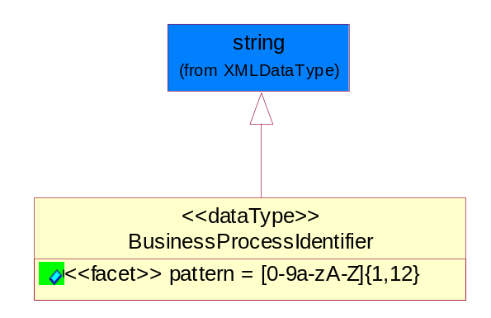
Figure ‎5-48 BusinessProcessIdentifier

Attribute | Type | Documentation
pattern |  | [0-9a-zA-Z]{1,12}

BusinessServiceInformation
The object allows the specification of the business service utilized within the partner company. This may or may not be the same as the information sent by the RNIF.
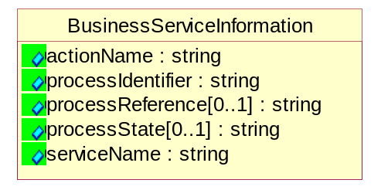
Figure ‎5-49 BusinessServiceInformation

Attribute | Type | Documentation
actionName | string | The name of Action. For RosettaNet usually any of Request/Confirm/Notify/Query/Response.
processIdentifier | string | The name of the PIP e.g. Notify of Forecast Reply.
processReference[0..1] | string | The URN for the PIP that includes Cluster/Segment/Process pattern used to identify the interface process (such as PIP3A4)
processState[0..1] | string | The business process (or service) state of the sender of a document. When a service receives this document, the receiver may use the state as a precondition.
serviceName | string | The name of the Business Activity with the "Request/Confirm" part removed. E.g., for the Activity "Request Purchase Order"==> "Purchase Order".

ContractInformation
A block of information used to correlate a contract in an executing choreography.
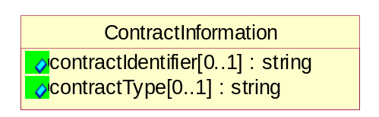
Figure ‎5-50 ContractInformation

Attribute | Type | Documentation
contractIdentifier[0..1] | string | Unique identification of a contract between the Sender and the Receiver
contractType[0..1] | string | The type of the contract: an attribute describing the type of the ContractIndentification. Valid values are URI, URN,ebXMLCPA, or other values defined by partners.

CorrelationInformation
A block of information used to correlate a requesting document to a responding document and to the contract in an executing choreography.
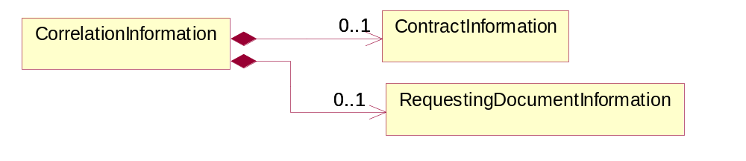
Figure ‎5-51 CorrelationInformation

Composition | Cardinality | Type | Documentation
ContractInformation | 0..1 | ContractInformation | A block of information used to correlate a contract in an executing choreography.
RequestingDocumentInformation | 0..1 | RequestingDocumentInformation | A block of information used to correlate a requesting document to a responding document in an executing choreography.

DocumentHeader
The object allows for the identification of the sender and receiver of the business document.
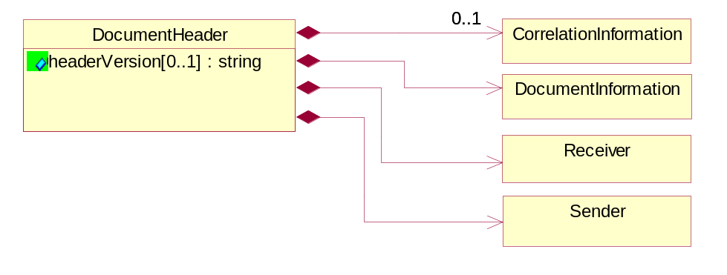
Figure ‎5-52 DocumentHeader

Attribute | Type | Documentation
headerVersion[0..1] | string | The UN/CEFACT version of the document header.

Composition | Cardinality | Type | Documentation
CorrelationInformation | 0..1 | CorrelationInformation | A block of information used to correlate a requesting document to a responding document and to the contract in an executing choreography.
DocumentInformation | 1 | DocumentInformation | The object specifies information to identify the business document, a summary of attachments, and information about the business document security.
Receiver | 1 | Receiver | The object allows the identification of the receiving party of the business message.
Sender | 1 | Sender | The object allows the identification of the initiating party of the business message.

DocumentIdentification
The object specifies all information necessary to identify the business document.
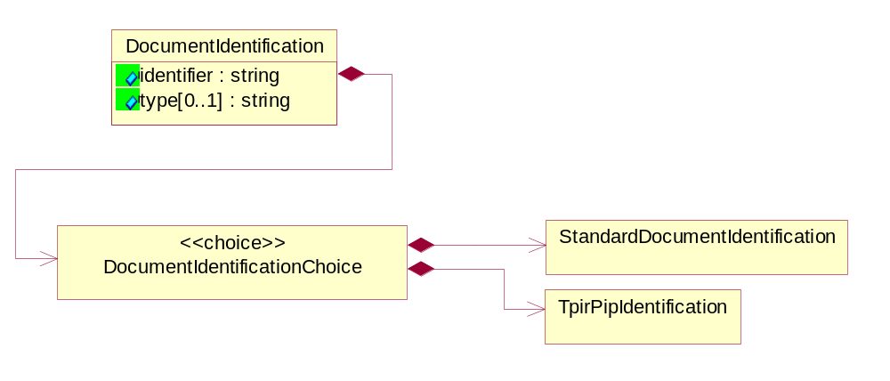
Figure ‎5-53 DocumentIdentification

Attribute | Type | Documentation
identifier | string | The unique identifier for the document being sent.
type[0..1] | string | Name of the Action Message

Composition | Cardinality | Type | Documentation
DocumentIdentificationChoice | 1 | DocumentIdentificationChoice

DocumentIdentificationChoice

Composition | Cardinality | Type | Documentation
StandardDocumentIdentification | 1 | StandardDocumentIdentification | The object specifies additional information necessary to identify the standard business document.
TpirPipIdentification | 1 | TpirPipIdentification | The object specifies all information necessary to uniquely identify a TPIR-PIP within a Registry or trading partner repository.

DocumentInformation
The object specifies information to identify the business document, a summary of attachments, and information about the business document security.
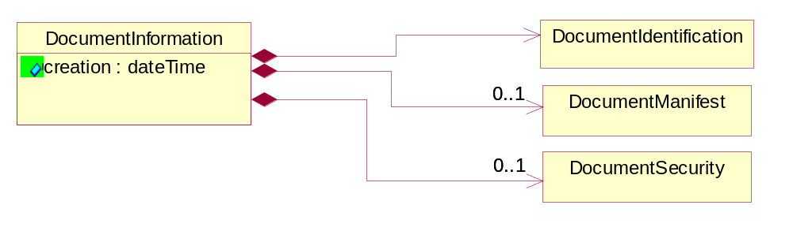
Figure ‎5-54 DocumentInformation

Attribute | Type | Documentation
creation | dateTime | The creation date and time of the specified Business Document (i.e. the Purchase Order date).

Composition | Cardinality | Type | Documentation
DocumentIdentification | 1 | DocumentIdentification | The object specifies all information necessary to identify the business document.
DocumentManifest | 0..1 | DocumentManifest | The block provides a brief summary of attachments and Service Content.
DocumentSecurity | 0..1 | DocumentSecurity | The object provides additional granularity in specifying business document security (this is in addition to the specified PIP security).

DocumentManifest
The block provides a brief summary of attachments and Service Content.
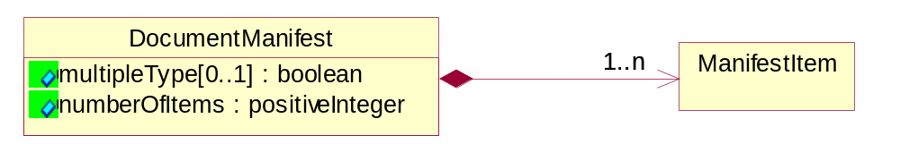
Figure ‎5-55 DocumentManifest

Attribute | Type | Documentation
multipleType[0..1] | boolean | Indicates whether the manifest contains documents of multiple types. True if yes, and False if no.
numberOfItems | positiveInteger | Total number of documents in the message. The physical count of the attachments in the payload plus the RosettaNet Business Message (for Service Content). The value of this field will be at least 1.

Composition | Cardinality | Type | Documentation
ManifestItem | 1..n | ManifestItem | The object provides details about the specific attachment(s).

DocumentSecurity
The object provides additional granularity in specifying business document security (this is in addition to the specified PIP security).
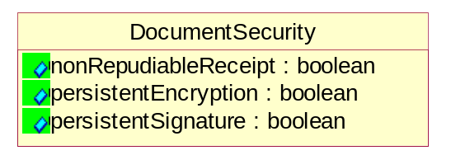
Figure ‎5-56 DocumentSecurity

Attribute | Type | Documentation
nonRepudiableReceipt | boolean | The value "true" will indicate that a signed acknowledgement for the business document is necessary.
persistentEncryption | boolean | The value "true" will indicate that the Business Document (including the header) needs to be encrypted when stored or transported.
persistentSignature | boolean | The value "true" will indicate that a signature is required to be stored with the document while stored or transported.

ManifestItem
The object provides details about the specific attachment(s).

Figure ‎5-57 ManifestItem

Attribute | Type | Documentation
description[0..1] | string | A description of the attachment.
length[0..1] | positiveInteger | The size of the attachment in bytes (i.e. 1 000 000 bytes)
universalResourceIdentifier | string | The generic set of all names/addresses that are short strings that refer to resources.

Composition | Cardinality | Type | Documentation
language | 0..1 | Language | For representation of Language name RosettaNet has adopted ISO 639-2; 1998. Refer to the following web page to get the latest version of the standard:  http://www.loc.gov/standards/iso639-2/iso639jac.html  If you need more information about the ISO standard please contact ISO for more details.
mimeTypeQualifier | 1 | MimeTypeQualifier | The MIME type as defined by IANA.  Please refer to http://www.iana.org/assignments/media-types/ for a list of types.

PipIdentifier
PIP Identification.[ i.e. PIP3A4]
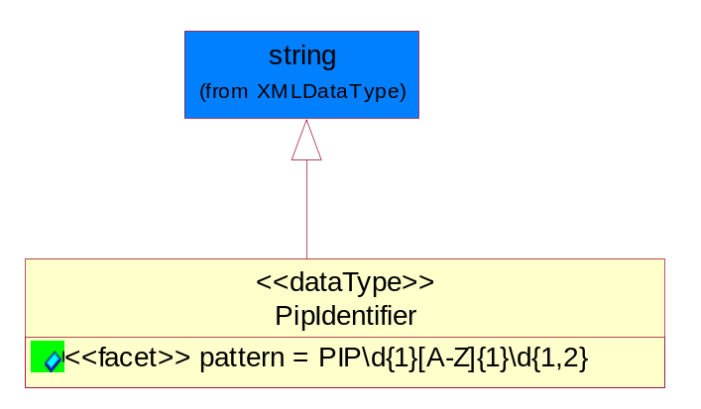
Figure ‎5-58 PipIdentifier

Attribute | Type | Documentation
pattern |  | PIP\d{1}[A-Z]{1}\d{1,2}

PipVersion
PIP version number (i.e. 02.02.00).
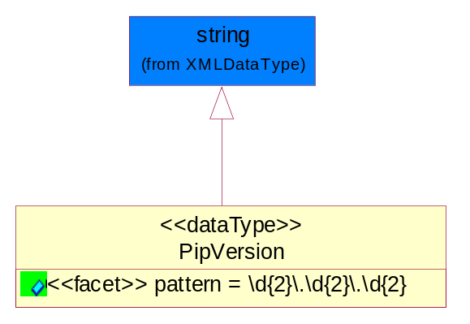
Figure ‎5-59 PipVersion

Attribute | Type | Documentation
pattern |  | \d{2}\.\d{2}\.\d{2}

Receiver
The object allows the identification of the receiving party of the business message.
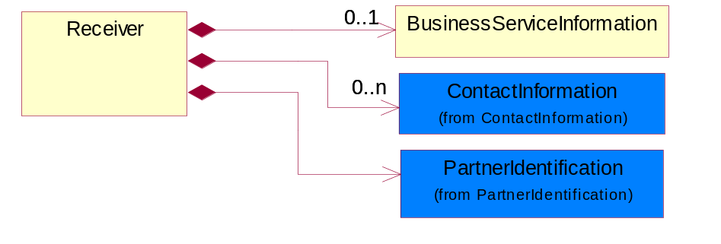
Figure ‎5-60 Receiver

Composition | Cardinality | Type | Documentation
BusinessServiceInformation | 0..1 | BusinessServiceInformation | The object allows the specification of the business service utilized within the partner company. This may or may not be the same as the information sent by the RNIF.
ContactInformation | 0..n | ContactInformation | The business document must allow for the identification of the name of the department, service or individual to be contacted regarding the context of the business document.
PartnerIdentification | 1 | PartnerIdentification | The business document must allow for the identity of one or more parties to the transaction.

RequestingDocumentInformation
A block of information used to correlate a requesting document to a responding document in an executing choreography.
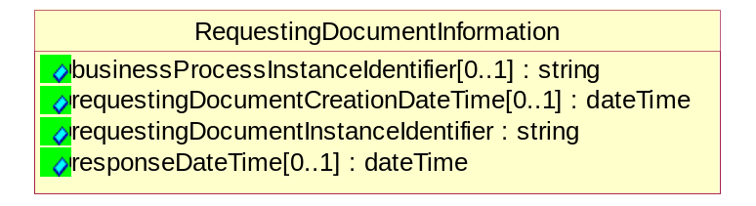
Figure ‎5-61 RequestingDocumentInformation

Attribute | Type | Documentation
businessProcessInstanceIdentifier[0..1] | string | The identifier for the public business process instance being sent that both the sender and receiver can identify.
requestingDocumentCreationDateTime[0..1] | dateTime | The date-time of the requesting business document.
requestingDocumentInstanceIdentifier | string | The Business Document identification number that identifies the requesting Business Document.
responseDateTime[0..1] | dateTime | The expected time to receive the response. This can not be greater than the PIP TimeToPerform.

Sender
The object allows the identification of the initiating party of the business message.
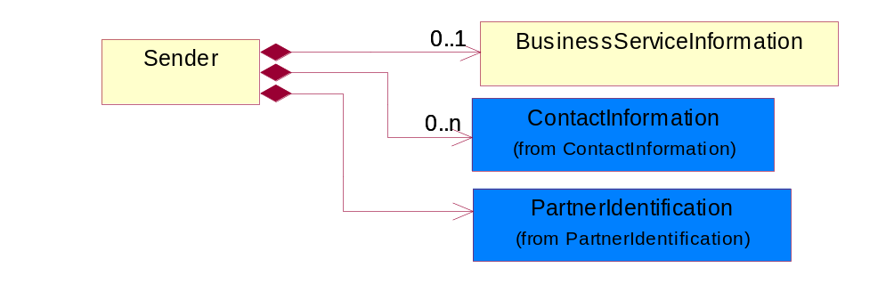
Figure ‎5-62 Sender

Composition | Cardinality | Type | Documentation
BusinessServiceInformation | 0..1 | BusinessServiceInformation | The object allows the specification of the business service utilized within the partner company. This may or may not be the same as the information sent by the RNIF.
ContactInformation | 0..n | ContactInformation | The business document must allow for the identification of the name of the department, service or individual to be contacted regarding the context of the business document.
PartnerIdentification | 1 | PartnerIdentification | The business document must allow for the identity of one or more parties to the transaction.

StandardDocumentIdentification
The object specifies additional information necessary to identify the standard business document.
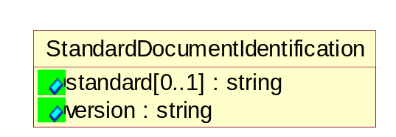
Figure ‎5-63 StandardDocumentIdentification

Attribute | Type | Documentation
standard[0..1] | string | Identifies the standard used to submit the business document. (e.g. RosettaNet).
version | string | PIP3A4v01.00

TpirPipIdentification
The object specifies all information necessary to uniquely identify a TPIR-PIP within a Registry or trading partner repository.
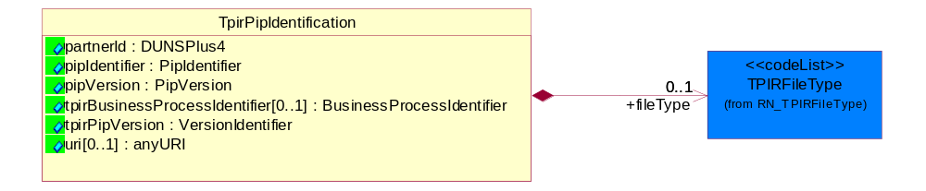
Figure ‎5-64 TpirPipIdentification

Attribute | Type | Documentation
partnerId | DUNSPlus4 | The Trading Partner Identification of MNC that is creating this TPIR PIP.
pipIdentifier | PipIdentifier | A TPIR PIP Identification [i.e., 3A4 ).
pipVersion | PipVersion | A TPIR PIP version number (i.e., 02.02.00)
tpirBusinessProcessIdentifier[0..1] | BusinessProcessIdentifier | A Business Process Identifier to uniquely define the TPIR-PIP 'role' within a Business Scenario at a company or MNC level. The identifier MUST be composed of alphanumeric characters only and its length MUST be between one and twelve characters.
tpirPipVersion | VersionIdentifier | A TPIR-PIP Version Number (i.e., major and minor version number as XX.XX).
uri[0..1] | anyURI | Describes the destination uri for the TPIR form.

Composition | Cardinality | Type | Documentation
fileType | 0..1 | TPIRFileType | Describes the file type of the TPIR form (PDF, XDP or XML).

VersionIdentifier
Version Number (i.e., major and minor version number as XX.XX).
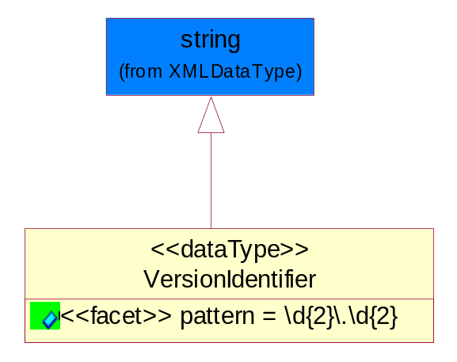
Figure ‎5-65 VersionIdentifier

Attribute | Type | Documentation
pattern |  | \d{2}\.\d{2}

CodeList

TPIRFileType
A code identifying the file type of TPIR form.

Name | Documentation
PDF | Portable Document Format.
XDP | XML Data Package.
XML | eXtensible Markup Language.

XML Data Type

anyURI
Represents a URI as defined by RFC 2396. An anyURI value can be absolute or relative, and may have an optional fragment identifier.

boolean
Represents Boolean values, which are either "true" or "false".

date
For the represents a calendar date.
The pattern for a date is CCYY-MM-DD where CC represents the century, YY the year, MM the month, and DD the day, with an optional time zone indicator as allowed for dateTime.

dateTime
Represents a specific instance of time.
The pattern for dateTime is CCYY-MM-DDThh:mm:ss where CC represents the century, YY the year, MM the month, and DD the day, preceded by an optional leading negative (-) character to indicate a negative number. If the negative character is omitted, positive (+) is assumed. The T is the date/time separator and hh, mm, and ss represent hour, minute, and second respectively. Additional digits can be used to increase the precision of fractional seconds if desired. For example, the format ss.ss... with any number of digits after the decimal point is supported. The fractional seconds part is optional.
This representation may be immediately followed by a "Z" to indicate Coordinated Universal Time (UTC) or to indicate the time zone. For example, the difference between the local time and Coordinated Universal Time, immediately followed by a sign, + or -, followed by the difference from UTC represented as hh:mm (minutes is required). If the time zone is included, both hours and minutes must be present.

float
Represents single-precision 32-bit floating-point numbers.

positiveInteger
Represents an integer that is greater than zero. This data type is derived from nonNegativeInteger.

string
Represents character string.

