

Description of 7B6 Message

PIP® 7B6
Validated 11.01.00

Specification Information
Name | Description of 7B6 Message
PIP | Notify Of Manufacturing Work Order Reply
Cluster | Manufacturing
Segment | Manage Manufacturing WO & WIP
Publication Date | 12 August 2009
Version Identifier | V11.01

Table of Content

1. Document Management 5
1.1 Legal Disclaimer 5
1.2 Copyright 5
1.3 Trademarks 5
1.4 Acknowledgments 5
1.5 Related Documents 5
1.6 Document Version History 5
1.7 Document Purpose 6
2. Interchange Model 7
2.1 ManufacturingWorkOrderReplyNotification 7
2.1.1 Interchange Diagram 7
2.1.2 Dependency Diagram 8
2.1.3 CustomerProfile 8
2.1.4 ManufacturingWorkOrderReplyNotification 9
2.1.5 SublineItems 9
2.1.6 TargetDevice 10
2.1.7 WorkOrderReply 11
2.1.8 WorkOrderReplyLineItem 11
3. Domain Model 13
3.1 Manufacturing 13
3.1.1 Manufacturing 13
3.1.1.1 Dependency Diagram 13
3.1.2 CodeList 13
3.1.2.1 ChangeReason 13
3.1.2.2 DeviceType 14
3.2 Procurement 15
3.2.1 Procurement 15
3.2.1.1 Dependency Diagram 15
3.2.1.2 ItemQuantity 15
3.2.2 CodeList 16
3.2.2.1 LineItemStatus 16
3.3 Shared 17
3.3.1 Shared 17
3.3.1.1 Dependency Diagram 17
3.3.1.2 ProductQuantity 17
4. Universal Structure 18
4.1 ContactInformation 18
4.1.1 ContactInformation 18
4.2 DataType 19
4.2.1 Contact 19
4.2.2 DUNS 19
4.2.3 DUNSPlus4 20
4.2.4 GLN 20
4.2.5 GTIN 21
4.3 Dates 21
4.3.1 DatePeriod 21
4.4 Document 22
4.4.1 BusinessDocumentReference 22
4.5 Locations 22
4.5.1 AlternativeIdentifier 22
4.6 PartnerIdentification 23
4.6.1 PartnerIdentification 23
4.6.2 PartnerIdentificationChoice 24
4.7 ProductIdentification 24
4.7.1 ProductIdentification 24
4.7.2 ProductIdentificationChoice 25
4.8 CodeList 25
4.8.1 Language 25
4.8.2 DocumentType 25
4.8.3 MimeTypeQualifier 27
4.8.4 UnitOfMeasure 38
5. System Structure 51
5.1 BusinessProcessIdentifier 51
5.2 BusinessServiceInformation 51
5.3 ContractInformation 52
5.4 CorrelationInformation 52
5.5 DocumentHeader 53
5.6 DocumentIdentification 54
5.7 DocumentIdentificationChoice 54
5.8 DocumentInformation 55
5.9 DocumentManifest 55
5.10 DocumentSecurity 56
5.11 ManifestItem 56
5.12 PipIdentifier 57
5.13 PipVersion 58
5.14 Receiver 58
5.15 RequestingDocumentInformation 59
5.16 Sender 59
5.17 StandardDocumentIdentification 60
5.18 TpirPipIdentification 60
5.19 VersionIdentifier 61
5.20 CodeList 61
5.20.1 TPIRFileType 61
6. XML Data Type 62
6.1 anyURI 62
6.2 boolean 62
6.3 date 62
6.4 dateTime 62
6.5 float 62
6.6 positiveInteger 62
6.7 string 62

Table of Figures

Figure ‎2-1 Interchange 7
Figure ‎2-2 Dependency 8
Figure ‎2-3 CustomerProfile 8
Figure ‎2-4 ManufacturingWorkOrderReplyNotification 9
Figure ‎2-5 SublineItems 9
Figure ‎2-6 TargetDevice 10
Figure ‎2-7 WorkOrderReply 11
Figure ‎2-8 WorkOrderReplyLineItem 11
Figure ‎3-1 Dependency 13
Figure ‎3-2 Dependency 15
Figure ‎3-3 ItemQuantity 15
Figure ‎3-4 Dependency 17
Figure ‎3-5 ProductQuantity 17
Figure ‎4-1 ContactInformation 18
Figure ‎4-2 Contact 19
Figure ‎4-3 DUNS 19
Figure ‎4-4 DUNSPlus4 20
Figure ‎4-5 GLN 20
Figure ‎4-6 GTIN 21
Figure ‎4-7 DatePeriod 21
Figure ‎4-8 BusinessDocumentReference 22
Figure ‎4-9 AlternativeIdentifier 22
Figure ‎4-10 PartnerIdentification 23
Figure ‎4-11 ProductIdentification 24
Figure ‎5-1 BusinessProcessIdentifier 51
Figure ‎5-2 BusinessServiceInformation 51
Figure ‎5-3 ContractInformation 52
Figure ‎5-4 CorrelationInformation 52
Figure ‎5-5 DocumentHeader 53
Figure ‎5-6 DocumentIdentification 54
Figure ‎5-7 DocumentInformation 55
Figure ‎5-8 DocumentManifest 55
Figure ‎5-9 DocumentSecurity 56
Figure ‎5-10 ManifestItem 56
Figure ‎5-11 PipIdentifier 57
Figure ‎5-12 PipVersion 58
Figure ‎5-13 Receiver 58
Figure ‎5-14 RequestingDocumentInformation 59
Figure ‎5-15 Sender 59
Figure ‎5-16 StandardDocumentIdentification 60
Figure ‎5-17 TpirPipIdentification 60
Figure ‎5-18 VersionIdentifier 61

Document Management

Legal Disclaimer
RosettaNet, its members, officers, directors, employees, or agents shall not be liable for any injury, loss, damages, financial or otherwise, arising from, related to, or caused by the use of this document or the specifications herein, as well as associated guidelines and schemas. The use of said specifications shall constitute your express consent to the foregoing exculpation.

Copyright
©2009 RosettaNet. All rights reserved. No part of this publication may be reproduced, stored in a retrieval system, or transmitted, in any form or by any means, electronic, mechanical, photocopying, recording, or otherwise, without the inclusion of this copyright notice. Any derivative works must cite the copyright notice. Any public redistribution or sale of this publication or derivative works requires prior written permission of the publisher.

Trademarks
RosettaNet, Partner Interface Process, PIP and the RosettaNet logo are trademarks or registered trademarks of "RosettaNet," a non-profit organization. All other product names and company logos mentioned herein are the trademarks of their respective owners. In the best effort, all terms mentioned in this document that are known to be trademarks or registered trademarks have been appropriately recognized in the first occurrence of the term.

Acknowledgments
This document has been prepared by RosettaNet (http://www.rosettanet.org/) from requirements gathered during the Milestone Program and in conformance with the methodology. Listed below are the legal entities that contributed to the design and development of this PIP.

Related Documents
- Associated PIP Message Schemas (included with PIP Specification only)
- Description of Partner Interface Process for 7B6
- Message Structure

Document Version History
Version | Date | Description
Validated 11.00.00 | 07 July 2008 | Validated Version : RosettaNet Schema to Market to Validation 2008
Validated 11.01.00 | 12 August 2009 | Validated Version : Q32009 Maintenance Process

Document Purpose
The purpose of the document is to explain the structure, the association between objects, the content of objects and the definition for single elements to a non-technical audience.

Interchange Model

ManufacturingWorkOrderReplyNotification

Interchange Diagram
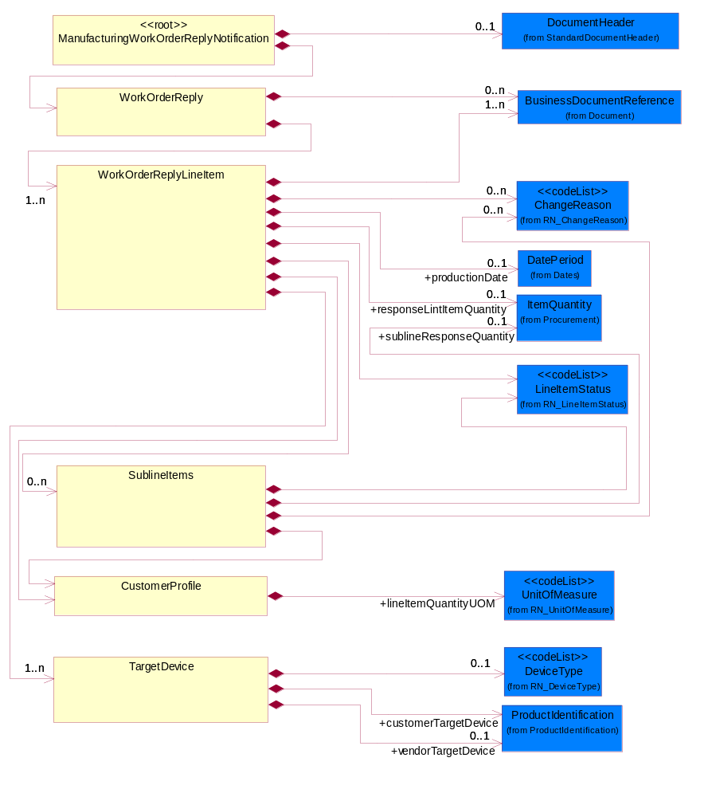
Figure ‎2-1 Interchange

Dependency Diagram
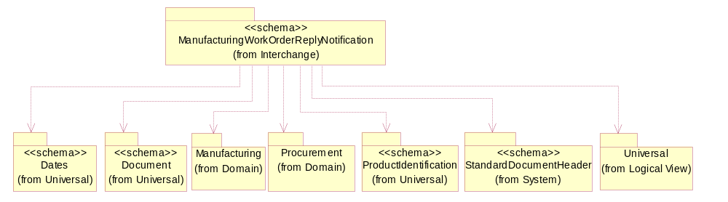
Figure ‎2-2 Dependency

CustomerProfile
The collection of business properties that describe a customer's requirements or needs.
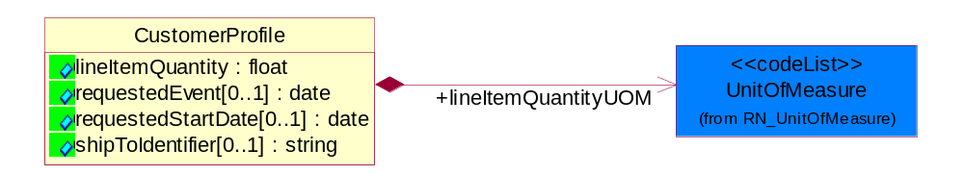
Figure ‎2-3 CustomerProfile

Attribute | Type | Documentation
lineItemQuantity | float | Requested quantity of target device in line item.
requestedEvent[0..1] | date | The date a transportation event is requested to occur.
requestedStartDate[0..1] | date | Requested start date for processing.
shipToIdentifier[0..1] | string | A unique identifier created by a partner that references a complete block of shipping information.

Composition | Cardinality | Type | Documentation
lineItemQuantityUOM | 1 | UnitOfMeasure | UOM of requested quantity of target device in line item.

ManufacturingWorkOrderReplyNotification
Top level object for a Manufacturing Work Order Reply document.
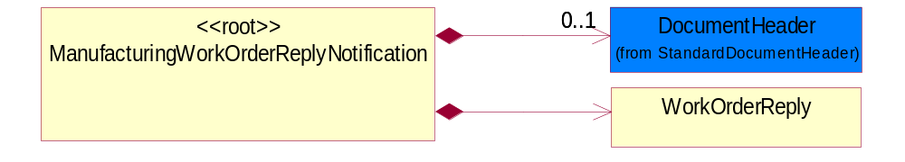
Figure ‎2-4 ManufacturingWorkOrderReplyNotification

Composition | Cardinality | Type | Documentation
DocumentHeader | 0..1 | DocumentHeader | The object allows for the identification of the sender and receiver of the business document.
WorkOrderReply | 1 | WorkOrderReply | Business Document that is used to change, modify or accept a Work Order.

SublineItems
Subline Items under Line item.
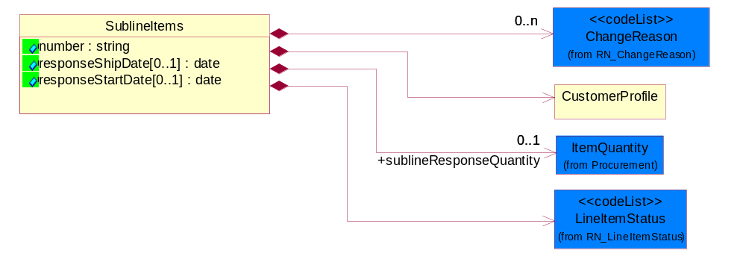
Figure ‎2-5 SublineItems

Attribute |  | Type |  | Documentation
number |  | string |  | Number of the subline in the document, associated with a given line number.
responseShipDate[0..1] |  | date |  | The date the CM or seller proposes as the actual ship date compared to the desired ship date in the Customer Profile for an item as the subline level.
responseStartDate[0..1] |  | date |  | The date the CM or seller proposes as the actual start of production of the work order as compared to the requested start date in the Customer Profile for an item at the subline level.
Composition | Cardinality |  | Type |  | Documentation
LineItemStatus | 1 |  | LineItemStatus |  | Code identifying the order status of the line item.
CustomerProfile | 1 |  | CustomerProfile |  | The collection of business properties that describe a customer's requirements or needs.
ChangeReason | 0..n |  | ChangeReason |  | Reason Code for change of a business document or a line item or subline item in a business document.
sublineResponseQuantity | 0..1 |  | ItemQuantity |  | The collection of data elements that contains the CM or seller's planned or ability to produce quantities and unit of measure when compared to the requested amount in the Customer Profile.

TargetDevice
The collection of data elements that provides information about the product for which chips are to be a part of.
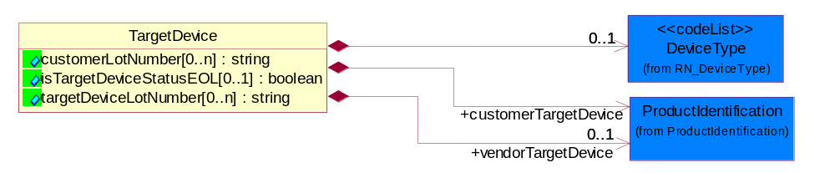
Figure ‎2-6 TargetDevice

Attribute | Type | Documentation
customerLotNumber[0..n] | string | Customer lot number of target device.
isTargetDeviceStatusEOL[0..1] | boolean | Indication of whether the target device is going to out of phase.
targetDeviceLotNumber[0..n] | string | The lot number of the target device of the vendor.

Composition | Cardinality | Type | Documentation
customerTargetDevice | 1 | ProductIdentification | The product information of the customer for the target device.
vendorTargetDevice | 0..1 | ProductIdentification | Vendor Identification of target device.
DeviceType | 0..1 | DeviceType | The product or process for which the output of a WO is destined for.

WorkOrderReply
Business Document that is used to change, modify or accept a Work Order.
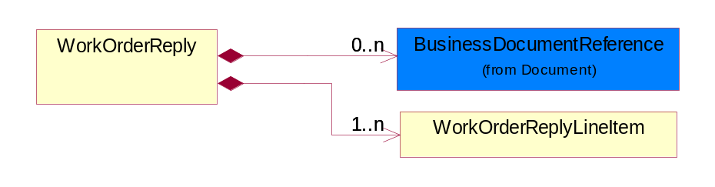
Figure ‎2-7 WorkOrderReply

Composition | Cardinality | Type | Documentation
BusinessDocumentReference | 0..n | BusinessDocumentReference | The business document reference object allows for the indirect referencing of a relationship to other business related documents.
WorkOrderReplyLineItem | 1..n | WorkOrderReplyLineItem | A line item in a Work Order Reply Business Document that is used to change, modify or accept a line item in some way from the original Work Order.

WorkOrderReplyLineItem
A line item in a Work Order Reply Business Document that is used to change, modify or accept a line item in some way from the original Work Order.
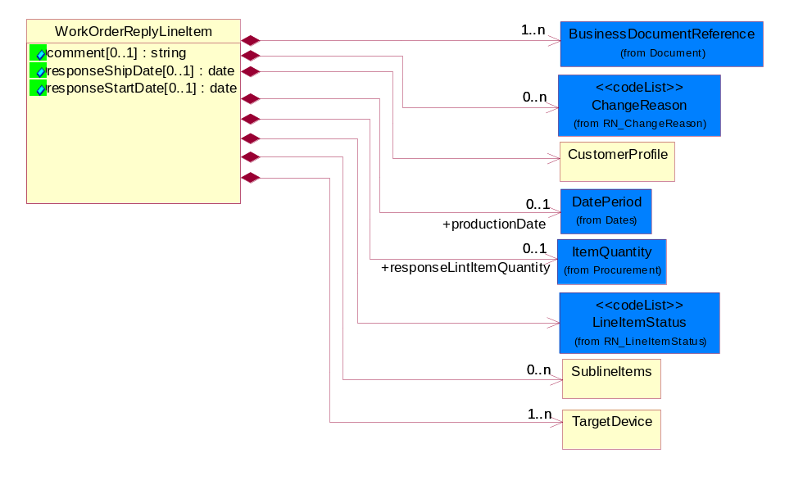
Figure ‎2-8 WorkOrderReplyLineItem

Attribute | Type | Documentation
comment[0..1] | string | Free form textual comment attached to a business document.
responseShipDate[0..1] | date | Response ship-back date for processing.
responseStartDate[0..1] | date | Response start date for processing.

Composition | Cardinality | Type | Documentation
BusinessDocumentReference | 1..n | BusinessDocumentReference | The business document reference object allows for the indirect referencing of a relationship to other business related documents.
ChangeReason | 0..n | ChangeReason | Reason Code for change of a business document or a line item or subline item in a business document.
CustomerProfile | 1 | CustomerProfile | The collection of business properties that describe a customer's requirements or needs.
productionDate | 0..1 | DatePeriod | The range of dates during which a discrete process or portion of a manufacturing process takes place.
LineItemStatus | 1 | LineItemStatus | Code identifying the order status of the line item.
responseLintItemQuantity | 0..1 | ItemQuantity | Response quantity of target device in line item.
SublineItems | 0..n | SublineItems | Subline Items under Line item.
TargetDevice | 1..n | TargetDevice | The collection of data elements that provides information about the product for which chips are to be a part of.

Domain Model

Manufacturing

Manufacturing

Dependency Diagram
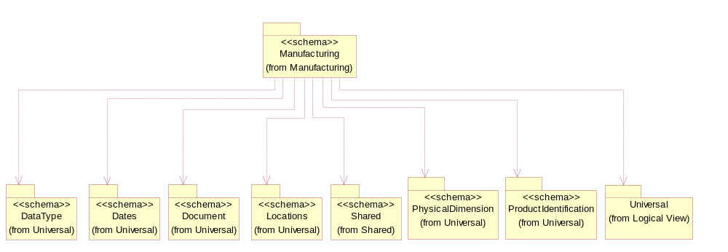
Figure ‎3-9 Dependency

CodeList

ChangeReason
Reason Code for change of a business document or a line item or subline item in a business document.

Name | Documentation
AID | Assembly Instruction Discrepancy.
BDD | Bonding Diagram Discrepancy.
BWA | Broken Wafer.
CCH | Capacity Change.
CCO | Capacity Constraint (No Capacity).
CHR | Customer Hold Request.
CIC | Charge Information Change.
DMN | Die Mask Number Discrepancy.
DPW | Document Paper Work Error along with the PIP.
DQP | Bad Quality Problem of Dimension.
ESC | Engineering Spec Change.
ETO | Equipment Trouble Ocurred.
ICW | Instruction Change in WIP.
IPI | Incomplete Product Information.
LTV | Lead Time Violation.
LYI | Low Yield.
MDI | Marking Discrepancy.
MSD | Machine Shut-Down.
NAI | No Assembly Instruction.
NBD | No Bonding Diagram.
NBS | No Building Sheet for assembly (No Assembly Instruction).
NCL | Wafers are Not Completely Loaded (due to wafer lot size).
NGW | No Good Wafers.
NMA | No Marking on the device.
NMS | No Marking Spec.
NRE | A New Requirement is added to the request.
PIC | Processing Instruction Change.
PQB | Packing material Quality problem by the Buyer.
PQS | Packing material Quality problem by the Supplier.
PRC | Process Routing Change.
PSB | Packing material Shortage by the Buyer.
PSD | Plant Shut-Down.
PSS | Packing material Shortage by the Supplier.
QCH | Quantity Change.
QIC | The Index of Quality Change.
RMC | Raw Materials Constraint.
RQB | Raw material Quality problem by the Buyer.
RQS | Raw material Quality problem by the Supplier.
RSB | Raw material Shortage by the Buyer.
RSS | Raw material Shortage by the Supplier.
SDC | Shipping Date Change.
SDP | Start Date of Processing change.
SDU | Source Die Unavailable (No Dice).
SLC | Ship-to-Location Change.
TTO | Tool Trouble Occurred.
VQD | Bad Visual Quality of the Device.
WDD | Wafer/Die quantity Discrepancy.
WDP | Wafer/Die quality Problem.
WDT | Bad Thickness of Wafer/Die.
WOC | Work Order has been manually Cancelled.
WOP | Wrong Operation.
WOS | Work Order too Small (quantity too small).

DeviceType
The product or process for which the output of a WO is destined for.

Name | Documentation
DIE | Die.
FGO | Finished Goods.
RST | Raw Stock.
WAF | Wafer.

Procurement

Procurement

Dependency Diagram
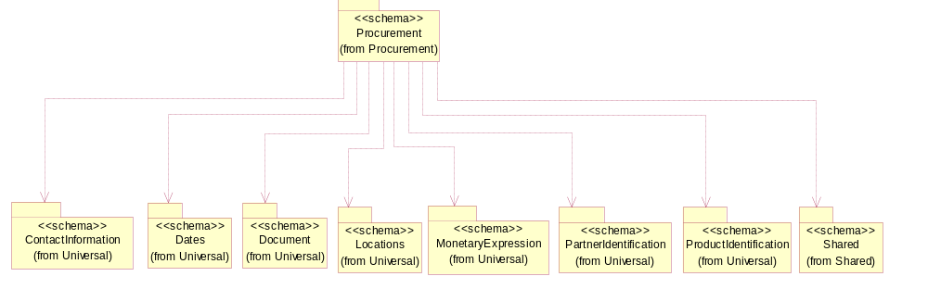
Figure ‎3-10 Dependency

ItemQuantity
Quantity of item involved in the transaction.
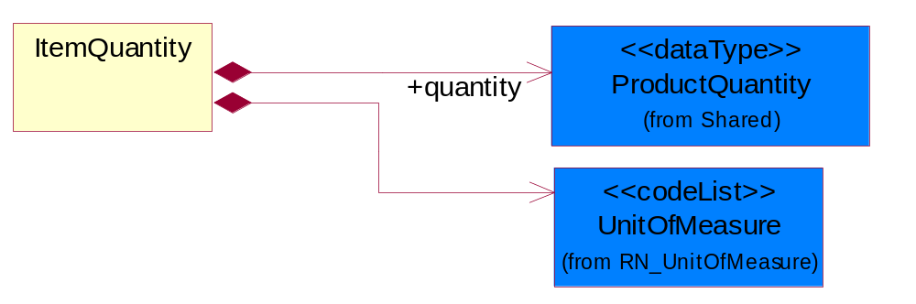
Figure ‎3-11 ItemQuantity

Composition | Cardinality | Type | Documentation
quantity | 1 | ProductQuantity | Value of the quantity.
UnitOfMeasure | 1 | UnitOfMeasure | Code identifying a product unit of measure.

CodeList

LineItemStatus
Code identifying the order status of the line item.

Name | Documentation
ACC | Accepted - The specified or referenced line item has been accepted for processing.
ACT | Active - The business process for the specified or referenced line item has not been acted upon or completed.
CAN | Cancelled - The business process intended for the specified or referenced line item has been cancelled.
CLO | Closed - The business process for the specified or referenced line item has been completed.
FCL | Finally Closed - Order cannot be opened any further updates.
NEW | New - Initial state of an order and hasn't been amended yet.
PEN | Pending - The specified or referenced line item has been accepted but not yet processed.
REJ | Rejected - The specified or referenced line item has been rejected for processing.
UPD | Update - The specified or referenced line item information has changed from its last status.

Shared

Shared

Dependency Diagram
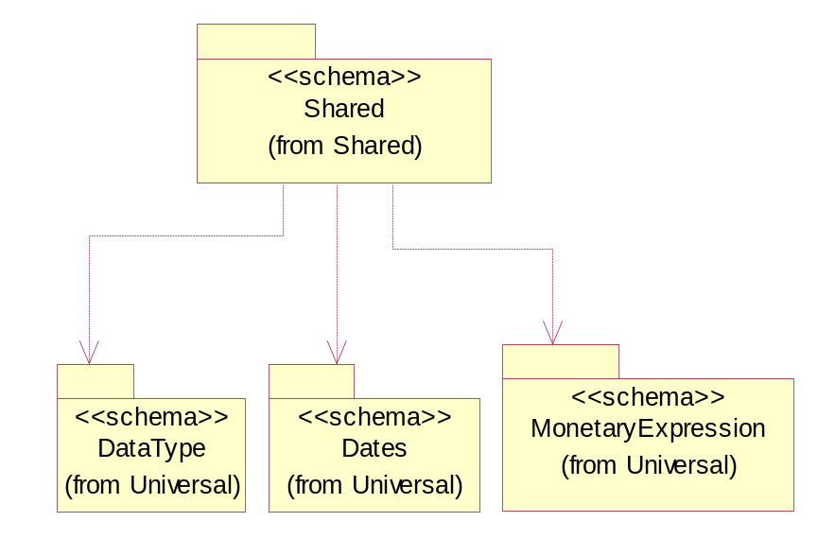
Figure ‎3-12 Dependency

ProductQuantity
A quantity specifying the number of product units.
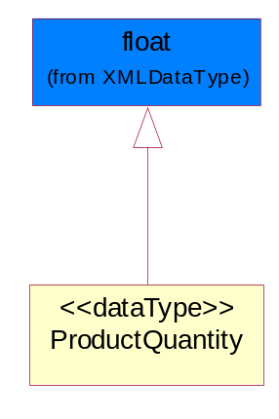
Figure ‎3-13 ProductQuantity

Universal Structure

ContactInformation

ContactInformation
The business document must allow for the identification of the name of the department, service or individual to be contacted regarding the context of the business document.
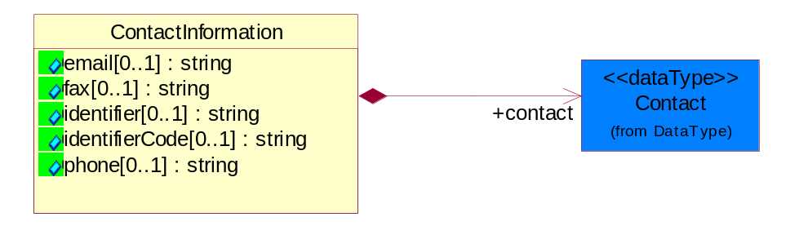
Figure ‎4-14 ContactInformation

Attribute | Type | Documentation
email[0..1] | string | The electronic mail for the specified contact.
fax[0..1] | string | The fax number for the specified contact.
identifier[0..1] | string | Identifies the role of the contact (i.e. Service Technician, Account Manager) in the Business Process.
identifierCode[0..1] | string | IdentifierCode is a unique security authorization code to identify the contact- ie. badge ID.
phone[0..1] | string | The telephone number for the specified contact.

Composition | Cardinality | Type | Documentation
contact | 1 | Contact | The name of the department, service or individual to be contacted within the organization.

DataType

Contact
The name of the department, service or individual to be contacted within the organization.
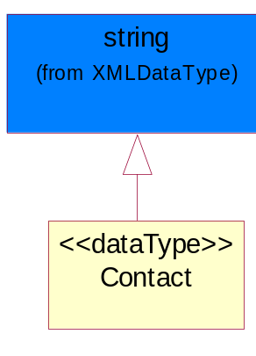
Figure ‎4-15 Contact

DUNS
A number assigned by Dun and Bradstreet to identify a business location.
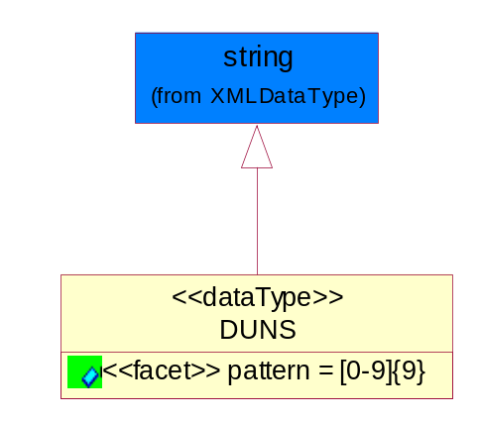
Figure ‎4-16 DUNS

Attribute | Type | Documentation
pattern |  | [0-9]{9}

DUNSPlus4
A identifier to specify a specific location within a business location.
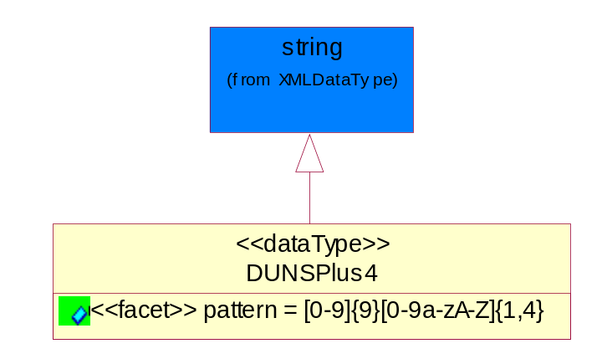
Figure ‎4-17 DUNSPlus4

Attribute | Type | Documentation
pattern |  | Data Universal Numbering System +4 (DUNS+4) number means the DUNS number assigned by Dun and Bradstreet, Inc. (D&B) plus an alphanumeric of length 4 suffix that may be assigned by a business concern.

GLN
Global Location Number (GLN) - A identifier to identify legal entities, trading parties and location.
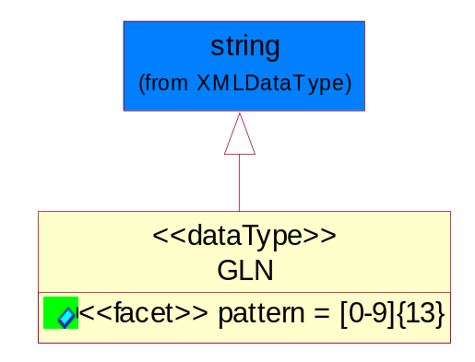
Figure ‎4-18 GLN

Attribute | Type | Documentation
pattern |  | [0-9]{13}

GTIN
Global Trade Identification Number (GTIN).
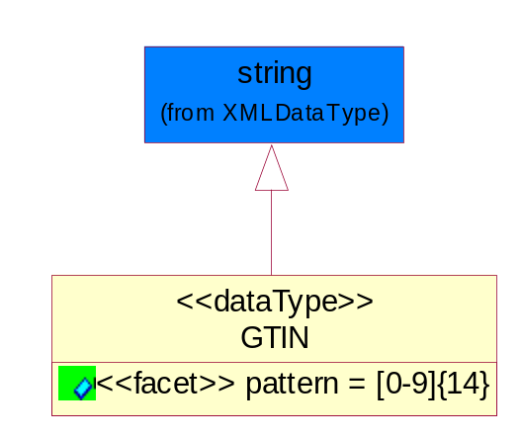
Figure ‎4-19 GTIN

Attribute | Type | Documentation
pattern |  | [0-9]{14}

Dates

DatePeriod
The business document must allow for the computation or statement of a duration based upon a beginning and an ending date.
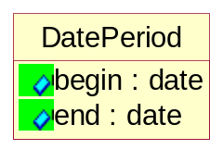
Figure ‎4-20 DatePeriod

Attribute | Type | Documentation
begin | date | The date indicating the beginning of the date period.
end | date | The date indicating the ending of the date period.

Document

BusinessDocumentReference
The business document reference object allows for the indirect referencing of a relationship to other business related documents.
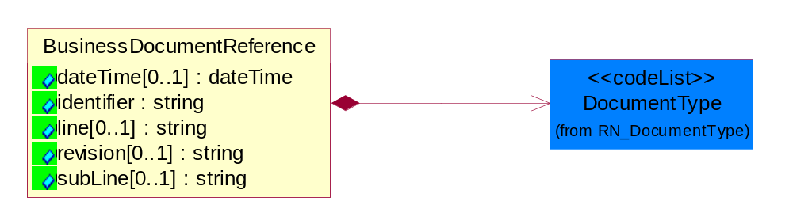
Figure ‎4-21 BusinessDocumentReference

Attribute | Type | Documentation
dateTime[0..1] | dateTime | The date-time stamp indicating on the referenced business document.
identifier | string | Unique identification of the referenced business document.
line[0..1] | string | References the specific line number of the specified business document.
revision[0..1] | string | Referenced the revision of the specified business document.
subLine[0..1] | string | References the specific subline number of the specified business document.

Composition | Cardinality | Type | Documentation
DocumentType | 1 | DocumentType | A code identifying the business context of a document.

Locations

AlternativeIdentifier
Identifies the specified code and the name of the organization that a code is utilized from.
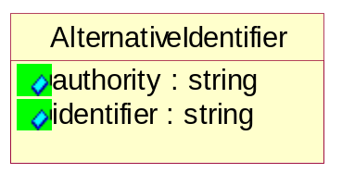
Figure ‎4-22 AlternativeIdentifier

Attribute | Type | Documentation
authority | string | The name of the organization that a code is utilized from.
identifier | string | The specified code to represent an entity (e.g. product, location, partner, etc.).

PartnerIdentification

PartnerIdentification
The business document must allow for the identity of one or more parties to the transaction.
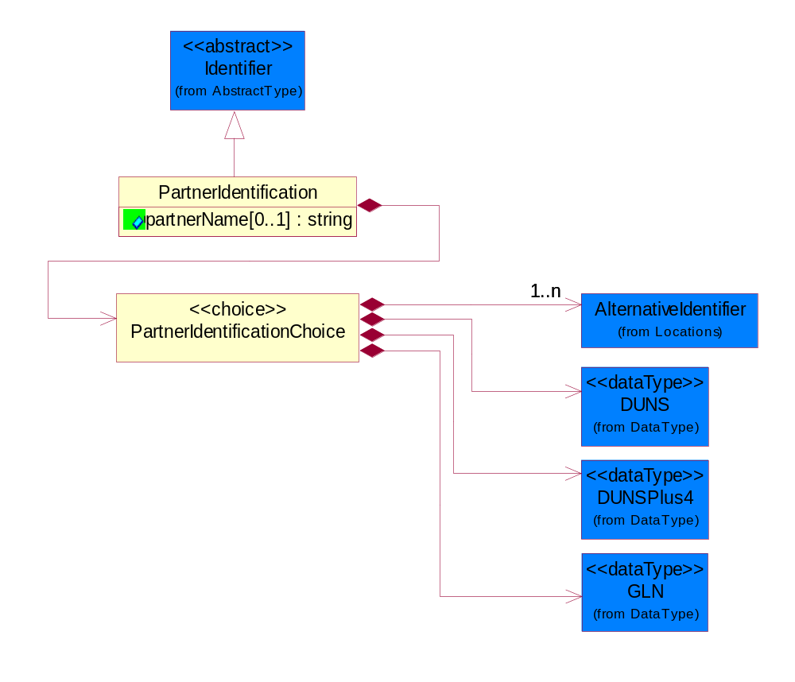
Figure ‎4-23 PartnerIdentification

Attribute | Type | Documentation
partnerName[0..1] | string | The name of the partner’s company/business.

Composition | Cardinality | Type | Documentation
PartnerIdentificationChoice | 1 | PartnerIdentificationChoice

PartnerIdentificationChoice

Composition | Cardinality | Type | Documentation
AlternativeIdentifier | 1..n | AlternativeIdentifier | Identifies the specified code and the name of the organization that a code is utilized from.
DUNS | 1 | DUNS | A number assigned by Dun and Bradstreet to identify a business location.
DUNSPlus4 | 1 | DUNSPlus4 | A identifier to specify a specific location within a business location.
GLN | 1 | GLN | Global Location Number (GLN) - A identifier to identify legal entities, trading parties and location.

ProductIdentification

ProductIdentification
The object provides the identifier(s) of a product.
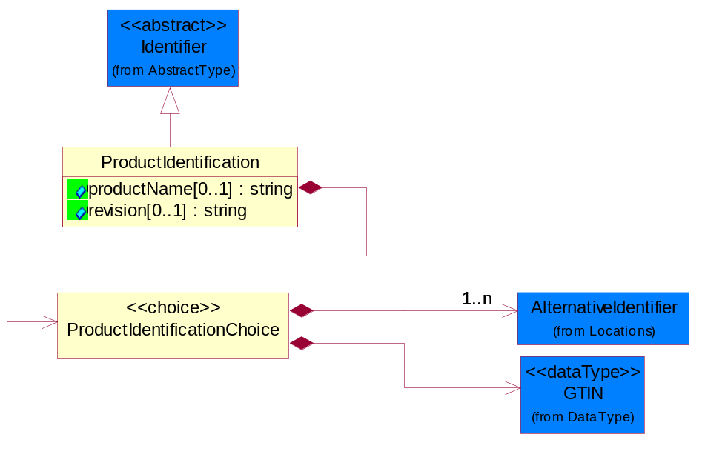
Figure ‎4-24 ProductIdentification

Attribute | Type | Documentation
productName[0..1] | string | The name of the product.
revision[0..1] | string | Referenced the specified product revision.

Composition | Cardinality | Type | Documentation
ProductIdentificationChoice | 1 | ProductIdentificationChoice

ProductIdentificationChoice

Composition | Cardinality | Type | Documentation
AlternativeIdentifier | 1..n | AlternativeIdentifier | Identifies the specified code and the name of the organization that a code is utilized from.
GTIN | 1 | GTIN | Global Trade Identification Number (GTIN).

CodeList

Language
For representation of Language name RosettaNet has adopted ISO 639-2; 1998. Refer to the following web page to get the latest version of the standard:

http://www.loc.gov/standards/iso639-2/iso639jac.html

If you need more information about the ISO standard please contact ISO for more details.

DocumentType
A code identifying the business context of a document.

Instance | Documentation
APM | Applied Promotions.
ARA | Authorization Request Approval.
CAR | Certificate of Analysis Response.
CBN | Product batch number of customer.
CCN | Customs clearance number.
CFA | Failure Analysis - Request document that will accompany the product providing characteristics of the component failure.
CIN | Commercial Invoice.
CNM | Traditional credit note or memo.
COA | Certificate of Analysis.
CON | In a virtual sourcing relationship, a third party trading partner is supplying a part to a customer on behalf of another company that has taken the order for the customer. In this case a Customer Order Number is associated to the request for material that is sent to the virtual trading partners.
COS | Consumption Notice.
COT | Contract.
CRN | Unique consumption reference number identifying the product consumption issue i.e. one-to-one relationship with physical flow.
DEM | Traditional debit note or memo.
DEN | Delivery Note.
DIN | Discontinuation Notice.
DOR | Delivery Order.
DRN | Drawing Number.
DRR | Design Registration Request.
ECO | Engineering Change Order - The proprietary unique identification number that represents an engineering change order.
EDD | Export Declaration Document.
EIR | Engineering Information Request.
EOL | End of Life.
FUO | Sales order or transfer order fulfilling demand out of a facility (outbound shipment).
IDD | Import Declaration Document.
INV | Invoice.
LID | Location Identifier. Data for on-site work that have to be done on the machine (associated with preventive maintenance order).
MEN | Master Event Number.
MID | Machine Identifier. Data for on-site work that have to be done on the machine (associated with preventive maintenance order).
MON | Model Number.
NTS | Notes.
OCL | The unique identifier assigned by the OEM for a warranty claim.
OGA | Other governmental agency issued document.
OPO | The unique identifier assigned by the OEM for a part order.
OPR | The unique identifier assigned by the OEM for a part return.
PCN | Product/Process Change.
PFA | Failure Analysis - Request document that will accompany the product providing characteristics of the product failure.
PII | Refers to previously issued invoice.
PLS | Unique number that identifies packing form prior to shipment.
POI | Purchase Order IN.
PON | Production order number for material release.
POO | Purchase Order OUT.
PRC | Product Catalog.
PSI | Refers to previously issued self-billing invoice.
PUO | Purchase Order.
QUO | Quote.
REC | Document identifying the receipt of materials or products into a facility against a purchase order or transfer order (inbound shipment).
REN | Release Number.
REO | Purchase order or transfer order replenishing inventory into a facility (inbound shipment).
REQ | Requisition.
RMA | Returned Material Authorization.
RPO | Purchase order for materials or product returned to and reworked by a supplier.
RTA | Remittance Advice - Remittance details.
SAO | Sales Order.
SBC | Credit Memo used in self-billing scenario.
SBD | Debit Memo used in self-billing scenario.
SBI | Invoice in self billing scenario.
SBN | Product batch number of supplier.
SCA | Similar to contracts - Contains the quantity of an article that is to be ordered from a vendor and the price for article or service that is to be procured.
SEN | Serial Number.
SEO | A document that gives a repair provider the necessary authorization to repair or upgrade a product either at the customer site or at the repair provider’s site.
SHD | Shipping Document.
SNC | Shipset Number on Code List.
SPC | The unique identifier assigned by the ASP for a warranty claim.
SPN | Spec Number.
SPO | The unique identifier assigned by the ASP for a part order.
SPR | The unique identifier assigned by the ASP for a part return.
SPW | The unique identifier assigned by the ASP to reference a work order.
SRI | A document that contains the shipping reference number which allows the product to be tracked within the outsourced logistic providers network.
SWT | Switch Authorization.
TCS | Terms and Conditions.
TRO | Order which results in materials or products being moved from one facility to another (outbound shipment and inbound shipment).
WAB | Waybill.
WAC | Denotes a warranty claim.
WOO | Work Order.

MimeTypeQualifier
The MIME type as defined by IANA.

Please refer to http://www.iana.org/assignments/media-types/ for a list of types.

Instance | Documentation
application/activemessage | [Shapiro]
application/andrew-inset | [Borenstein]
application/applefile | [Faltstrom]
application/atomicmail | [Borenstein]
application/batch-SMTP | [RFC2442]
application/beep+xml | [RFC3080]
application/cals-1840 | [RFC1895]
application/cnrp+xml | [RFCCNRP]
application/commonground | [Glazer]
application/cpl+xml
application/cybercash | [Eastlake]
application/dca-rft | [Campbell]
application/dec-dx | [Campbell]
application/dicom | [RFC3240]
application/dvcs | [RFC3029]
application/EDI-Consent | [RFC1767]
application/EDIFACT | [RFC1767]
application/EDI-X12 | [RFC1767]
application/eshop | [Katz]
application/font-tdpfr | [RFC3073]
application/http | [RFC2616]
application/hyperstudio | [Domino]
application/iges | [Parks]
application/index | [RFC2652]
application/index.cmd | [RFC2652]
application/index.obj | [RFC2652]
application/index.response | [RFC2652]
application/index.vnd | [RFC2652]
application/iotp | [RFC2935]
application/ipp | [RFC2910]
application/isup | [RFC3204]
application/mac-binhex40 | [Faltstrom]
application/macwriteii | [Lindner]
application/marc | [RFC2220]
application/mathematica | [Van Nostern]
application/msword | [Lindner]
application/news-message-id | [RFC1036,Spencer]
application/news-transmission | [RFC1036, Spencer]
application/ocsp-request | [RFC2560]
application/ocsp-response | [RFC2560]
application/octet-stream | [RFC2045,RFC2046]
application/oda | [RFC2045,RFC2046]
application/ogg | [RFC-walleij-ogg-mediatype-08.txt]
application/parityfec | [RFC3009]
application/pdf | [Lindner]
application/pgp-encrypted | [RFC3156]
application/pgp-keys | [RFC3156]
application/pgp-signature | [RFC3156]
application/pkcs10 | [RFC2311]
application/pkcs7-mime | [RFC2311]
application/pkcs7-signature | [RFC2311]
application/pkix-cert | [RFC2585]
application/pkixcmp | [RFC2510]
application/pkix-crl | [RFC2585]
application/postscript | [RFC2045,RFC2046]
application/prs.alvestrand.titrax-sheet | [Alvestrand]
application/prs.cww | [Rungchavalnont]
application/prs.nprend | [Doggett]
application/prs.plucker | [Janssen]
application/qsig | [RFC3204]
application/reginfo+xml | [RFC-ietf-sipping-reg-event-00.txt]
application/remote-printing | [RFC1486,Rose]
application/riscos | [Smith]
application/rtf | [Lindner]
application/sdp | [RFC2327]
application/set-payment | [Korver]
application/set-payment-initiation | [Korver]
application/set-registration | [Korver]
application/set-registration-initiation | [Korver]
application/sgml | [RFC1874]
application/sgml-open-catalog | [Grosso]
application/sieve | [RFC3028]
application/slate | [Crowley]
application/timestamp-query | [RFC3161]
application/timestamp-reply | [RFC3161]
application/tve-trigger | [Welsh]
application/vemmi | [RFC2122]
application/vnd.3gpp.pic-bw-large | [Meredith]
application/vnd.3gpp.pic-bw-small | [Meredith]
application/vnd.3gpp.pic-bw-var | [Meredith]
application/vnd.3gpp.sms | [Meredith]
application/vnd.3M.Post-it-Notes | [O'Brien]
application/vnd.accpac.simply.aso | [Leow]
application/vnd.accpac.simply.imp | [Leow]
application/vnd.acucobol | [Lubin]
application/vnd.acucorp | [Lubin]
application/vnd.adobe.xfdf | [Perelman]
application/vnd.aether.imp | [Moskowitz]
application/vnd.amiga.ami | [Blumberg]
application/vnd.anser-web-certificate-issue-initiation | [Mori]
application/vnd.anser-web-funds-transfer-initiation | [Mori]
application/vnd.audiograph | [Slusanschi]
application/vnd.blueice.multipass | [Holmstrom]
application/vnd.bmi | [Gotoh]
application/vnd.businessobjects | [Imoucha]
application/vnd.canon-cpdl | [Muto]
application/vnd.canon-lips | [Muto]
application/vnd.cinderella | [Kortenkamp]
application/vnd.claymore | [Simpson]
application/vnd.commerce-battelle | [Applebaum]
application/vnd.commonspace | [Chandhok]
application/vnd.contact.cmsg | [Patz]
application/vnd.cosmocaller | [Dellutri]
application/vnd.ctc-posml | [Kohlhepp]
application/vnd.cups-postscript | [Sweet]
application/vnd.cups-raster | [Sweet]
application/vnd.cups-raw | [Sweet]
application/vnd.curl | [Byrnes]
application/vnd.cybank | [Helmee]
application/vnd.data-vision.rdz | [Fields]
application/vnd.dna | [Searcy]
application/vnd.dpgraph | [Parker]
application/vnd.dreamfactory | [Appleton]
application/vnd.dxr | [Duffy]
application/vnd.ecdis-update | [Buettgenbach]
application/vnd.ecowin.chart | [Olsson]
application/vnd.ecowin.filerequest | [Olsson]
application/vnd.ecowin.fileupdate | [Olsson]
application/vnd.ecowin.series | [Olsson]
application/vnd.ecowin.seriesrequest | [Olsson]
application/vnd.ecowin.seriesupdate | [Olsson]
application/vnd.enliven | [Santinelli]
application/vnd.epson.esf | [Hoshina]
application/vnd.epson.msf | [Hoshina]
application/vnd.epson.quickanime | [Gu]
application/vnd.epson.salt | [Nagatomo]
application/vnd.epson.ssf | [Hoshina]
application/vnd.ericsson.quickcall | [Tidwell]
application/vnd.eudora.data | [Resnick]
application/vnd.fdf | [Zilles]
application/vnd.ffsns | [Holstage]
application/vnd.FloGraphIt | [Floersch]
application/vnd.framemaker | [Wexler]
application/vnd.fsc.weblaunch | [D.Smith]
application/vnd.fujitsu.oasys | [Togashi]
application/vnd.fujitsu.oasys2 | [Togashi]
application/vnd.fujitsu.oasys3 | [Okudaira]
application/vnd.fujitsu.oasysgp | [Sugimoto]
application/vnd.fujitsu.oasysprs | [Ogita]
application/vnd.fujixerox.ddd | [Onda]
application/vnd.fujixerox.docuworks | [Taguchi]
application/vnd.fujixerox.docuworks.binder | [Matsumoto]
application/vnd.fut-misnet | [Pruulmann]
application/vnd.grafeq | [Tupper]
application/vnd.groove-account | [Joseph]
application/vnd.groove-help | [Joseph]
application/vnd.groove-identity-message | [Joseph]
application/vnd.groove-injector | [Joseph]
application/vnd.groove-tool-message | [Joseph]
application/vnd.groove-tool-template | [Joseph]
application/vnd.groove-vcard | [Joseph]
application/vnd.hbci | [Hammann]
application/vnd.hhe.lesson-player | [Jones]
application/vnd.hp-HPGL | [Pentecost]
application/vnd.hp-hpid | [Gupta]
application/vnd.hp-hps | [Aubrey]
application/vnd.hp-PCL | [Pentecost]
application/vnd.hp-PCLXL | [Pentecost]
application/vnd.httphone | [Lefevre]
application/vnd.hzn-3d-crossword | [Minnis]
application/vnd.ibm.afplinedata | [Buis]
application/vnd.ibm.electronic-media | [Tantlinger]
application/vnd.ibm.MiniPay | [Herzberg]
application/vnd.ibm.modcap | [Hohensee]
application/vnd.ibm.secure-container | [Tantlinger]
application/vnd.informix-visionary | [Gales]
application/vnd.intercon.formnet | [Gurak]
application/vnd.intertrust.digibox | [Tomasello]
application/vnd.intertrust.nncp | [Tomasello]
application/vnd.intu.qbo | [Scratchley]
application/vnd.intu.qfx | [Scratchley]
application/vnd.irepository.package+xml | [Knowles]
application/vnd.is-xpr | [Natarajan]
application/vnd.japannet-directory-service | [Fujii]
application/vnd.japannet-jpnstore-wakeup | [Yoshitake]
application/vnd.japannet-payment-wakeup | [Fujii]
application/vnd.japannet-registration | [Yoshitake]
application/vnd.japannet-registration-wakeup | [Fujii]
application/vnd.japannet-setstore-wakeup | [Yoshitake]
application/vnd.japannet-verification | [Yoshitake]
application/vnd.japannet-verification-wakeup | [Fujii]
application/vnd.jisp | [Deckers]
application/vnd.kde.karbon | [Faure]
application/vnd.kde.kchart | [Faure]
application/vnd.kde.kformula | [Faure]
application/vnd.kde.kivio | [Faure]
application/vnd.kde.kontour | [Faure]
application/vnd.kde.kpresenter | [Faure]
application/vnd.kde.kspread | [Faure]
application/vnd.kde.kword | [Faure]
application/vnd.kenameaapp | [DiGiorgio-Haag]
application/vnd.koan | [Cole]
application/vnd.liberty-request+xml | [McDowell]
application/vnd.llamagraphics.life-balance.desktop | [White]
application/vnd.lotus-1-2-3 | [Wattenberger]
application/vnd.lotus-approach | [Wattenberger]
application/vnd.lotus-freelance | [Wattenberger]
application/vnd.lotus-notes | [Laramie]
application/vnd.lotus-organizer | [Wattenberger]
application/vnd.lotus-screencam | [Wattenberger]
application/vnd.lotus-wordpro | [Wattenberger]
application/vnd.mcd | [Gotoh]
application/vnd.mediastation.cdkey | [Flurry]
application/vnd.meridian-slingshot | [Wedel]
application/vnd.micrografx.flo | [Prevo]
application/vnd.micrografx.igx | [Prevo]
application/vnd.mif | [Wexler]
application/vnd.minisoft-hp3000-save | [Bartram]
application/vnd.mitsubishi.misty-guard.trustweb | [Tanaka]
application/vnd.Mobius.DAF | [Kabayama]
application/vnd.Mobius.DIS | [Kabayama]
application/vnd.Mobius.MBK | [Devasia]
application/vnd.Mobius.MQY | [Devasia]
application/vnd.Mobius.MSL | [Kabayama]
application/vnd.Mobius.PLC | [Kabayama]
application/vnd.Mobius.TXF | [Kabayama]
application/vnd.mophun.application | [Wennerstrom]
application/vnd.mophun.certificate | [Wennerstrom]
application/vnd.motorola.flexsuite | [Patton]
application/vnd.motorola.flexsuite.adsi | [Patton]
application/vnd.motorola.flexsuite.fis | [Patton]
application/vnd.motorola.flexsuite.gotap | [Patton]
application/vnd.motorola.flexsuite.kmr | [Patton]
application/vnd.motorola.flexsuite.ttc | [Patton]
application/vnd.motorola.flexsuite.wem | [Patton]
application/vnd.mozilla.xul+xml | [McDaniel]
application/vnd.ms-artgalry | [Slawson]
application/vnd.ms-asf | [Fleischman]
application/vnd.mseq | [Le Bodic]
application/vnd.ms-excel | [Gill]
application/vnd.msign | [Borcherding]
application/vnd.ms-lrm | [Ledoux]
application/vnd.ms-powerpoint | [Gill]
application/vnd.ms-project | [Gill]
application/vnd.ms-tnef | [Gill]
application/vnd.ms-works | [Gill]
application/vnd.ms-wpl | [Plastina]
application/vnd.musician | [Adams]
application/vnd.music-niff | [Butler]
application/vnd.netfpx | [Mutz]
application/vnd.noblenet-directory | [Solomon]
application/vnd.noblenet-sealer | [Solomon]
application/vnd.noblenet-web | [Solomon]
application/vnd.novadigm.EDM | [Swenson]
application/vnd.novadigm.EDX | [Swenson]
application/vnd.novadigm.EXT | [Swenson]
application/vnd.obn | [Hessling]
application/vnd.osa.netdeploy | [Klos]
application/vnd.palm | [Peacock]
application/vnd.pg.format | [Gandert]
application/vnd.pg.osasli | [Gandert]
application/vnd.powerbuilder6 | [Guy]
application/vnd.powerbuilder6-s | [Guy]
application/vnd.powerbuilder7 | [Shilts]
application/vnd.powerbuilder75 | [Shilts]
application/vnd.powerbuilder75-s | [Shilts]
application/vnd.powerbuilder7-s | [Shilts]
application/vnd.previewsystems.box | [Smolgovsky]
application/vnd.publishare-delta-tree | [Ben-Kiki]
application/vnd.pvi.ptid1 | [Lamb]
application/vnd.pwg-multiplexed | [RFC3391]
application/vnd.pwg-xhtml-print+xml | [Wright]
application/vnd.Quark.QuarkXPress | [Scheidler]
application/vnd.rapid | [Szekely]
application/vnd.s3sms | [Tarkkala]
application/vnd.sealed.net | [Lambert]
application/vnd.seemail | [Webb]
application/vnd.shana.informed.formdata | [Selzler]
application/vnd.shana.informed.formtemplate | [Selzler]
application/vnd.shana.informed.interchange | [Selzler]
application/vnd.shana.informed.package | [Selzler]
application/vnd.smaf | [Takahashi]
application/vnd.sss-cod | [Dani]
application/vnd.sss-dtf | [Bruno]
application/vnd.sss-ntf | [Bruno]
application/vnd.street-stream | [Levitt]
application/vnd.svd | [Becker]
application/vnd.swiftview-ics | [Widener]
application/vnd.triscape.mxs | [Simonoff]
application/vnd.trueapp | [Hepler]
application/vnd.truedoc | [Chase]
application/vnd.ufdl | [Manning]
application/vnd.uplanet.alert | [Martin]
application/vnd.uplanet.alert-wbxml | [Martin]
application/vnd.uplanet.bearer-choice | [Martin]
application/vnd.uplanet.bearer-choice-wbxml | [Martin]
application/vnd.uplanet.cacheop | [Martin]
application/vnd.uplanet.cacheop-wbxml | [Martin]
application/vnd.uplanet.channel | [Martin]
application/vnd.uplanet.channel-wbxml | [Martin]
application/vnd.uplanet.list | [Martin]
application/vnd.uplanet.listcmd | [Martin]
application/vnd.uplanet.listcmd-wbxml | [Martin]
application/vnd.uplanet.list-wbxml | [Martin]
application/vnd.uplanet.signal | [Martin]
application/vnd.vcx | [T.Sugimoto]
application/vnd.vectorworks | [Pharr]
application/vnd.vidsoft.vidconference | [Hess]
application/vnd.visio | [Sandal]
application/vnd.visionary | [Aravindakumar]
application/vnd.vividence.scriptfile | [Risher]
application/vnd.vsf | [Rowe]
application/vnd.wap.sic | [WAP-Forum]
application/vnd.wap.slc | [WAP-Forum]
application/vnd.wap.wbxml | [Stark]
application/vnd.wap.wmlc | [Stark]
application/vnd.wap.wmlscriptc | [Stark]
application/vnd.webturbo | [Rehem]
application/vnd.wrq-hp3000-labelled | [Bartram]
application/vnd.wt.stf | [Wohler]
application/vnd.wv.csp+wbxml | [Salmi]
application/vnd.xara | [Matthewman]
application/vnd.xfdl | [Manning]
application/vnd.yellowriver-custom-menu | [Yellow]
application/whoispp-query | [RFC2957]
application/whoispp-response | [RFC2958]
application/wita | [Campbell]
application/wordperfect5.1 | [Lindner]
application/x400-bp | [RFC1494]
application/xhtml+xml | [RFC3236]
application/xml | [RFC3023]
application/xml-dtd | [RFC3023]
application/xml-external-parsed-entity | [RFC3023]
application/zip | [Lindner]
audio/32kadpcm | [RFC2421,RFC2422]
audio/AMR | [RFC3267]
audio/AMR-WB | [RFC3267]
audio/basic | [RFC2045,RFC2046]
audio/CN | [RFC3389]
audio/DAT12 | [RFC3190]
audio/DVI4
audio/EVRC | [RFC-ietf-avt-evrc-smv-03.txt]
audio/EVRC0 | [RFC-ietf-avt-evrc-smv-03.txt]
audio/G.722.1 | [RFC3047]
audio/G722
audio/G723
audio/G726-16
audio/G726-24
audio/G726-32
audio/G726-40
audio/G728
audio/G729
audio/G729D
audio/G729E
audio/GSM
audio/GSM-EFR
audio/L16 | [RFC2586]
audio/L20 | [RFC3190]
audio/L24 | [RFC3190]
audio/L8
audio/LPC
audio/MP4A-LATM | [RFC3016]
audio/MPA
audio/mpa-robust | [RFC3119]
audio/mpeg | [RFC3003]
audio/parityfec | [RFC3009]
audio/PCMA
audio/PCMU
audio/prs.sid | [Walleij]
audio/QCELP
audio/RED
audio/SMV | [RFC-ietf-avt-evrc-smv-03.txt]
audio/SMV0 | [RFC-ietf-avt-evrc-smv-03.txt]
audio/telephone-event | [RFC2833]
audio/tone | [RFC2833]
audio/VDVI
audio/vnd.3gpp.iufp | [Belling]
audio/vnd.cisco.nse | [Kumar]
audio/vnd.cns.anp1 | [McLaughlin]
audio/vnd.cns.inf1 | [McLaughlin]
audio/vnd.digital-winds | [Strazds]
audio/vnd.everad.plj | [Cicelsky]
audio/vnd.lucent.voice | [Vaudreuil]
audio/vnd.nortel.vbk | [Parsons]
audio/vnd.nuera.ecelp4800 | [Fox]
audio/vnd.nuera.ecelp7470 | [Fox]
audio/vnd.nuera.ecelp9600 | [Fox]
audio/vnd.octel.sbc | [Vaudreuil]
audio/vnd.qcelp | [Lundblade]
audio/vnd.rhetorex.32kadpcm | [Vaudreuil]
audio/vnd.vmx.cvsd | [Vaudreuil]
image/cgm | Computer Graphics Metafile
image/g3fax | [RFC1494]
image/gif | [RFC2045,RFC2046]
image/ief | [RFC1314] Image Exchange Format
image/jpeg | [RFC2045,RFC2046]
image/naplps | [Ferber]
image/png | [Randers-Pehrson]
image/prs.btif | [Simon]
image/prs.pti | [Laun]
image/t38 | [RFC3362]
image/tiff | [RFC3302] Tag Image File Format
image/tiff-fx | [RFC3250] Tag Image File Format Fax eXtended
image/vnd.cns.inf2 | [McLaughlin]
image/vnd.djvu | [Bottou]
image/vnd.dwg | [Moline]
image/vnd.dxf | [Moline]
image/vnd.fastbidsheet | [Becker]
image/vnd.fpx | [Spencer]
image/vnd.fst | [Fuldseth]
image/vnd.fujixerox.edmics-mmr | [Onda]
image/vnd.fujixerox.edmics-rlc | [Onda]
image/vnd.globalgraphics.pgb | [Bailey]
image/vnd.mix | [Reddy]
image/vnd.ms-modi | [Vaughan]
image/vnd.net-fpx | [Spencer]
image/vnd.svf | [Moline]
image/vnd.wap.wbmp | [Stark]
image/vnd.xiff | [S.Martin]
message/delivery-status | [RFC1894]
message/disposition-notification | [RFC2298]
message/external-body | [RFC2045,RFC2046]
message/http | [RFC2616]
message/news | [RFC 1036, H.Spencer]
message/partial | [RFC2045,RFC2046]
message/rfc822 | [RFC2045,RFC2046]
message/s-http | [RFC2660]
message/sip | [RFC3261]
message/sipfrag | [RFC3420]
model/iges | [Parks]
model/mesh | [RFC2077]
model/vnd.dwf | [Pratt]
model/vnd.flatland.3dml | [Powers]
model/vnd.gdl | [Babits]
model/vnd.gs-gdl | [Babits]
model/vnd.gtw | [Ozaki]
model/vnd.mts | [Rabinovitch]
model/vnd.parasolid.transmit.binary | [Parasolid]
model/vnd.parasolid.transmit.text | [Parasolid]
model/vnd.vtu | [Rabinovitch]
model/vrml | [RFC2077]
multipart/alternative | [RFC2045,RFC2046]
multipart/appledouble | [Faltstrom]
multipart/byteranges | [RFC2068]
multipart/digest | [RFC2045,RFC2046]
multipart/encrypted | [RFC1847]
multipart/form-data | [RFC2388]
multipart/header-set | [Crocker]
multipart/mixed | [RFC2045,RFC2046]
multipart/parallel | [RFC2045,RFC2046]
multipart/related | [RFC2387]
multipart/report | [RFC1892]
multipart/signed | [RFC1847]
multipart/voice-message | [RFC2421,RFC2423]
text/calendar | [RFC2445]
text/css | [RFC2318]
text/directory | [RFC2425]
text/enriched | [RFC1896]
text/html | [RFC2854]
text/parityfec | [RFC3009]
text/plain | [RFC2646,RFC2046]
text/prs.lines.tag | [Lines]
text/rfc822-headers | [RFC1892]
text/richtext | [RFC2045,RFC2046]
text/rtf | [Lindner]
text/sgml | [RFC1874]
text/t140 | [RFC2793]
text/tab-separated-values | [Lindner]
text/uri-list | [RFC2483]
text/vnd.abc | [Allen]
text/vnd.curl | [Byrnes]
text/vnd.DMClientScript | [Bradley]
text/vnd.fly | [Gurney]
text/vnd.fmi.flexstor | [Hurtta]
text/vnd.in3d.3dml | [Powers]
text/vnd.in3d.spot | [Powers]
text/vnd.IPTC.NewsML | [IPTC]
text/vnd.IPTC.NITF | [IPTC]
text/vnd.latex-z | [Lubos]
text/vnd.motorola.reflex | [Patton]
text/vnd.ms-mediapackage | [Nelson]
text/vnd.net2phone.commcenter.command | [Xie]
text/vnd.sun.j2me.app-descriptor | [G.Adams]
text/vnd.wap.si | [WAP-Forum]
text/vnd.wap.sl | [WAP-Forum]
text/vnd.wap.wml | [Stark]
text/vnd.wap.wmlscript | [Stark]
text/xml | [RFC3023]
text/xml-external-parsed-entity | [RFC3023]
video/BMPEG
video/BT656
video/CelB
video/DV | [RFC3189]
video/H261
video/H263
video/H263-1998
video/H263-2000
video/JPEG
video/MP1S
video/MP2P
video/MP2T
video/MP4V-ES | [RFC3016]
video/mpeg | [RFC2045,RFC2046]
video/MPV
video/nv
video/parityfec | [RFC3009]
video/pointer | [RFC2862]
video/quicktime | [Lindner]
video/SMPTE292M | [RFC-avt-smpte292-video-08.txt]
video/vnd.fvt | [Fuldseth]
video/vnd.motorola.video | [McGinty]
video/vnd.motorola.videop | [McGinty]
video/vnd.mpegurl | [Recktenwald]
video/vnd.nokia.interleaved-multimedia | [Kangaslampi]
video/vnd.objectvideo | [Clark]
video/vnd.vivo | [Wolfe]

UnitOfMeasure
Code identifying a product unit of measure.

Instance | Documentation
10P | 10-pack.
1BF | 100 Board Feet.
1FC | 20 Foot Container.
1GR | Gram/Cubic Centimeter.
1GT | 10,000 Gallon Tankcar.
1KB | 25 Kilogram Bulk Bag.
1KD | 10 Kilogram Drum.
1KP | 1000-pack.
1M2 | 1/Square Meter (1/M2).
1PA | 20-Pack.
1PB | 50 Pound Bag.
1PD | 100 Pound Drum.
1PM | 1/minute (1/min).
22S | Square Millimeter/Second (mm2/s).
2FC | 40 Foot Container.
2GR | Gram/square meter.
2GT | 20,000 Gallon Tankcar.
2KB | 300 Kilogram Bulk Bag.
2KD | 15 Kilogram Drum.
2PA | 100-Pack.
3GR | Grams Per 100 Centimeters.
3KB | 500 Kilogram Bulk Bag.
3KD | 55 Gallon Drum.
3MH | Cubic Millimeters/Hour (mm3/hour).
4GR | Grams Per 100 Grams.
4KD | 115 Kilogram Drum.
50P | 50-pack.
5GR | Grams Per Cubic Centimeter.
6GR | Grams Per Square Centimeter.
7GR | Grams Per Square Meter.
ABC | Absorbance per centimeter (Absorbance per cm).
ABU | Absorbance per Unit (absorbance per unit).
ACC | Atoms per Cubic Centimeters (atoms per cu cm).
ACR | Acre.
ACS | Acidic strength/concentration.
ACT | Actual Pounds.
ACU | Activity unit (Activ.unit).
ALU | Aluminum Pounds Only.
AM1 | Ampoule.
AMN | Ångstroms/Minute (Ångst/min).
AMP | Ampere.
ANG | Angstrom (A).
APB | Atomic Parts per Billion (atomic ppb).
APG | API Specific Gravity (API Grav).
APM | Atomic Parts per Million (atomic ppm).
APT | Atomic Parts per Trillion (atomic ppt).
APU | APHA Units (apha).
ASC | Atoms per Square Centimeters (atoms per sq cm).
ASM | Angstrom.
ASY | Assembly (ASY).
ATG | Atmospheric gauge.
ATM | Atmosphere absolute.
ATP | Atomic %.
ATY | Activity.
BAB | Base Box.
BAC | Batch.
BAE | Bale.
BAG | Bag.
BAL | Ball.
BAN | Band.
BAP | Batting Pound.
BAR | Bar.
BAS | Basket.
BAT | Batt.
BAW | Base Weight.
BEA | Beam.
BEC | Becquerel/kilogram.
BEL | Belt.
BHP | Brake HP.
BIL | Billet.
BIN | Bin.
BIT | Bit.
BKC | Bulk Car Load.
BLN | Balance.
BLO | Block.
BOA | Board.
BOF | Board Feet.
BOL | Bolt.
BOT | Bottle.
BOX | Box.
BRB | Bar absolute.
BRD | Barrels Per Day.
BRE | Barrel.
BRI | Barrel (Imperial).
BRM | Barrels Per Minute.
BTF | British Thermal Units (BTUs) Per Cubic Foot.
BTP | British Thermal Units (BTUs) Per Pound.
BTU | British Thermal Unit (BTU).
BUB | Bubbler.
BUC | Bucket.
BUD | Bushel, Dry Imperial.
BUK | Bunks.
BUL | Bulk.
BUN | Bundle.
BUP | Bulk Pack.
BUS | Bushel.
BYT | Bytes.
C0W | Counts per Wafer (Counts/wf).
C3M | Cubic centimeter per minute (cm3/minute).
CAA | Carat.
CAB | Carboy.
CAC | Card.
CAD | Candela.
CAG | Cartridge.
CAK | Cask.
CAL | Calorie.
CAN | Can.
CAO | Carload.
CAR | Car.
CAS | Case.
CAT | Canister.
CAW | Catchweight.
CC2 | Centipoises per hour per square centimeters (cps per hr per sq cm).
CCC | Counts per Square Centimeters (Counts/cm2).
CD3 | Cubic decimeter (Cubic dec).
CEL | Cell.
CEM | Centimeter.
CEP | Centipoises (CPS).
CET | Centiliter.
CGM | Centigram.
CHA | Chains (Land Survey).
CHE | Chest.
CM2 | Square centimeter (cm2).
CMH | Centimeter/hour (cm/h).
CML | Colony/Milliliter (col/ml).
CMS | Centimeter/Second (cm/s).
CNN | Connector.
COG | Coil Group.
COI | Coil.
COL | Coulomb.
COM | Composite Product Pounds (Total Weight).
CON | Cone.
COT | Container.
COV | Cover.
CRA | Crate.
CRT | Carton.
CSE | Cassette.
CST | Centistokes.
CUB | Cubic centimeter.
CUC | Cubic centimeter/second.
CUF | Cubic Foot.
CUI | Cubic inch.
CUM | Cubic meter.
CUP | Cup.
CUY | Cubic yard.
CYC | Cycles.
CYL | Cylinder.
DAL | Dalton units (dalton).
DAY | Day.
DCB | Decibels.
DCG | Decagram.
DCL | Deciliter.
DCM | Defects per Square Centimeters (Defects/cm2).
DE1 | Defects.
DE2 | Degrees in Angles.
DE3 | Degree.
DEA | Deal.
DEC | Decimeter.
DEF | Degree Fahrenheit.
DEG | Degree Celsius.
DEP | Dep. Factor.
DFW | Defects per Wafer (Defects/Wafer).
DGM | Decigram.
DIE | Die.
DIL | Display.
DIP | Dispenser.
DNC | Dynes per centimeter (Dynes per cm).
DOZ | Dozen.
DPM | Parts per Million per Day (ppm per day).
DRA | Dram.
DRU | Drum.
DRY | Dry Pounds.
EAC | Each.
ELE | Electrical Capacitance.
EML | Enzyme Units/Milliliter (Enzyme/ml).
ENU | Enzyme Units (Enzy.Units).
EQ2 | Milliequivalent per 30 Kg (mequ/30Kg).
EQG | Milliequivalent per gram (milliequivalent per g).
EQK | Milliequivalent per Kilogram (mequ/Kg).
EQM | Milliequivalent per Millimeter (milliequivalent per mm).
FAR | Farads.
FFA | Femtofarad.
FIN | 1/32 inch.
FLO | Fluid Ounce.
FOI | Fluid Ounce (Imperial).
FOO | Foot.
FOU | Fluid Ounce US.
FPS | Feet per second (Feet/s).
FRH | Sales FT3 at 60°F per hour (FTR/hour).
FRM | Sales FT3 at 60°F per minute (FTR/min).
FTR | Sales FT3 at 60°F, 14.7 psia (SFT3_60F_S).
FTS | Sales FT3 at 70°F, 14.7 psia (SFT3_70F_S).
FTT | 1000 FT3 at 60°F, 14.7 psia (KFT3_60F_S).
FTU | 1000 FT3 at 70°F, 14.7 psia (KFT3_70F_S).
FUU | Fuel Usage (Gallons).
G2S | Gram square per second (g²/s).
GAI | Gram act. ingrd. (g act.ing).
GAL | Gallon.
GAS | Gage Systems.
GAU | Gram Gold.
GCL | Gardner Color.
GEG | Keim/Gramm (keim/g).
GEQ | Gram per Equivalent (g/Eq).
GGM | Gram per gram mole (g/gmole).
GHG | Gram per Hectogram (g/hg).
GIH | Gigahertz.
GIJ | Gigajoules.
GIL | Gill (Imperial).
GM4 | Gram per 100 Milliliters (g/100ml).
GME | Gram per Mole Equivalent (g/mole Eq).
GMO | Gram per Mol (g/mol).
GNL | Gram act.Ingrd per Liter (gai/liter).
GOB | Gross Barrels.
GOG | Gross Gallons.
GOH | Gigaohm (GOhm).
GOK | Gross Kilogram.
GOT | Gross Ton.
GOY | Gross Yard.
GPN | US Gallon per minute (gpm US).
GRA | Gram.
GRG | Great Gross (Dozen Gross).
GRK | Grams Per Kilogram.
GRL | Grams Per Liter.
GRM | Grams Per Milliliter.
GRN | Grain.
GRO | Gross.
GRP | Group.
HAG | Half Gallon.
HAH | Half Hour.
HAL | Half Liter.
HAN | Hank.
HEA | Heat lots.
HEC | Hectare.
HEL | Hectoliter.
HEP | Hectopascal.
HER | Hertz.
HGM | Hegman.
HNY | Henry.
HOS | Hours.
HOU | Hour.
HUA | Hundredth of a Carat.
HUB | Hundred Boxes.
HUC | Hundred Count.
HUS | Hundred Sheets.
HZM | Hertz per Minute (Hertz per min).
IH2 | Inches of Water Gauge (inH2O-g).
IHG | Inches of Mercury Gauge (inHg-g).
ILB | Inch pounds (in.lb).
IMG | Imperial Gallons.
INC | Inch.
IPS | Inch per second (inch / sec).
JAR | Jar.
JKG | Joule/Kilogram (J/kg).
JMO | Joule/Mol (J/mol).
JOI | Joint.
JOU | Joule.
KAI | Kilogram act. Ingrd. (kg ac.ing.).
KAK | kg act.ingrd. / kg (kai/kg).
KBY | Kilobyte.
KCM | Kilogram per cm2 gauge (kg/cm2-g).
KD3 | Kilogram per Cubic Decimeter (kg/dm3).
KEG | Keg.
KEL | Kelvin.
KGE | Container Fill Weight in Kg/Ea.
KGH | Kilogram per Hour (kg/h).
KGL | Kilograms per Liter (kg/L).
KGM | Kilogram/Mol (kg/mol).
KGS | Kilogram per Second (kg/s).
KHO | Kilometer/hour.
KIC | Kilogram per cubic meter.
KIE | Kilometer.
KIG | Kilogram.
KIH | Kilohertz.
KIK | Kilobecquerel/Kilogram.
KIL | Kiloampere.
KIM | Kilogram/square meter.
KIO | Kiloohm.
KIS | Kilogramm pro Sekunde.
KIT | Kit.
KIV | Kilovolt.
KIW | Kilowatt.
KJK | Kilojoule per kilogram (KJ/kg).
KJL | Kilojoule.
KJM | Kilojoule/Mol (KJ/mol).
KKG | Kilogram/Kilogram.
KMK | Cubic meter/Cubic meter (m3/m3).
KMN | Kelvin per Minute (K/min).
KMS | Kelvin per Second (K/s).
KNM | Kilonewton per square meter (kN/m2).
KNT | Kilonewton (ND).
KPA | Kilopascal (kPa).
KRU | Kreb Unit.
KTN | Kilotonne (kt).
KUD | Kubikdezimeter.
KUM | Kubikmeter pro Sekunde.
KVA | Kilovoltampere (kVA).
KWH | Kilowatt-hour.
KWR | Kilovolt ampere reactive hours (KVAH reac.).
LBH | US Pound per Hour (lb/hour).
LBM | US Pound per minute (lb/min).
LG2 | Liter per Gram per Centimeter (l/g/cm).
LGC | Liters per Gram-Centimeters (l/g-cm).
LHK | Liter per 100 km (l/100 km).
LIF | Lifts.
LIM | Link.
LIQ | Liquid Pounds.
LIT | Liter.
LMI | Liter per Minute (l/min).
LMS | Liter per Molsecond (l/mol.s).
LOA | Load.
LOT | Lot.
LPD | Light Point Defects per Wafer (LPD/Wafer).
LPH | Liter per hour (l/hr).
LUG | Lug.
M15 | Micron per 15 Square Millimeters (mu per 15 sq mm).
M20 | Micron per 20 Square Millimeters (mu per 20 sq mm).
M25 | Micron per 25 Square Millimeters (mu per 25 sq mm).
M26 | Micron per 26 by 8 Millimeters (mu per 26 by 8 mm).
M2G | Meters square per gram (m sq per gram).
M3A | Sales m3 at 15 °C, 1 atmos (Sm3_15C_S).
M3B | Sales m3 at 21 °C, 1 atmos (Sm3_21C_S).
M3C | Sales m3 at 10 °C, 1 atmos (Sm3_10C_S).
M3D | Sales m3 at 43 °C, 1 bar (Sm3_43C_D).
M3E | Sales m3 at 9 °C, 1 bar (Sm3_9C_D).
M3F | Sales m3 at 15 °C, 1 bar (Sm3_15C_D).
M3G | Sales m3 at 27 °C, 1 atmos (Sm3_27C_S).
M3H | Cubic Meter per Hour (m3/h).
M3J | Sales m3 at 35 °C, 1 atmos (Sm3_35C_S).
M3K | Cubic Meter/Kilogram (m3/Kg).
M3M | Milliliter per Cubic Meter (ml/m3).
M3N | Mol per Cubic Meter (Mol/m3).
MAM | Milliamps/mm.
MAT | Mat.
MBY | Megabyte.
MBZ | Meterbar per Second (m.bar/s).
MC2 | Millisecond per Centimeter (mS/cm).
MCA | Microampere (µA).
MCG | Microgram.
MCH | Micromhos (µmhos).
MCK | Microcuries per Kilogram (µci/kg).
MCL | Microcuries per Gaseous Liter (µc/l).
MCM | Milligrams Per Cubic Meter.
MCN | Metal Can.
MCP | Manifolded Cylinder Pack.
MCR | Micron.
MEG | Megagram.
MEH | Megahertz.
MEJ | Megajoule (MJ).
MEP | Megapascal.
MET | Meter.
MEW | Megawatt.
MFD | Microfarad (µF).
MGA | Milligram per Amp (mg per amp).
MGF | Milligram per Square Centimeter (mg/cm2).
MGG | Milligram per Gram (mg/g).
MGL | Microgram per Liter (µg/l).
MGM | Milligram.
MGO | Megohm (MOhm).
MGR | Micrograms per Gram (µg/g).
MGS | Milligram per Second (mg per sec).
MH1 | Millimeter per Hour (mm/h).
MHC | Micromhos per Centimeter (µmhos/cm).
MHR | Meter per Hour (m/h).
MHV | Megavolt.
MIB | Million BTU's.
MIC | Mikrogram/cubic meter.
MIG | Micrograms Per Cubic Meter.
MIL | Mile.
MIM | Micrometer.
MIN | Minute.
MIP | Millipascal seconds.
MIS | Microsecond.
MIT | Miter.
MIV | Millivolt.
MIW | Milliwatt.
MJM | Wobbe Number (MJ/m3).
MJO | Millijoule.
MKG | Milligrams of KOH per Gram (mg KOH per g).
MKL | Millimol per Gram (mmol/g).
ML1 | Milliliter per Liter (ml/l).
ML2 | Milliliter per Liter (ml/l).
ML3 | Mol per Liter (Mol/Liter).
ML4 | Millimol per Liter (Millimol/l).
MLA | Milliampere.
MLB | Millibar.
MLC | Milligram/cubic meter.
MLG | Milliliter per Gallon (ml per gal).
MLI | Milliliter.
MLK | Milligram/kilogram.
MLL | Milligram/Liter.
MLM | Mole per Mole (mole/mole).
MLP | Mole Percent (% mole).
MLR | Microliter (µl).
MLS | Miles.
MLW | Milliliter act. Ingr. (ml act.in.).
MM3 | Cubic Millimeter (mm3).
MMA | Millimeter per Year (mm/a).
MME | Millimeter.
MMG | Millimol/gram (mmol/g).
MMH | Millimeter H20.
MMK | Millimol/kilogram.
MMM | 0.000001 meter (1 millionth of a meter). (Micrometer/Micron).
MMN | Meter per Minute (m/min).
MMO | Millimol.
MMS | Millimeter per Second (mm/s).
MNM | Millinewton per meter (mN/m).
MNT | Meganewton (MN).
MOK | Mol/kilogram.
MOL | Mol.
MON | Month.
MPB | Mass parts per billion (ppb(m)).
MPG | Miles per Gallon (US) (Mi/Gal(US)).
MPH | Megagrams Per Hour.
MPM | Mass Parts per Million (ppm(m)).
MPT | Mass Parts per Trillion (ppt(m)).
MPZ | Meterpascal per Second (m.Pa/s).
MQG | Mircoequivalent per Gram (microeq/g).
MRF | Millifarad (mF).
MS1 | MilliSiemen per Centimeter (mS/cm).
MS2 | Meter per Second Squared (m/s2).
MS3 | Microsiemens per Centimeter (µS/cm).
MSC | Millisecond.
MSM | Milligrams Per Square Meter.
MTA | Millitesla.
MTQ | Meter pro Quadratsekunde.
MTR | Meter (m).
MTS | Meters per second.
MUL | Multichip - When 2 or more dies (chips) are merged into one package.
MVA | Megavoltampere (MVA).
MVS | Millivolts.
MVT | Millivolt.
MWH | Megawatt Hours (mwh).
MWR | Megavolt Ampere Reactive Hours (MVAH reac.).
MWT | Molecular Weight (mW).
MYS | Micro Siemens (mic. Siem.).
N2M | Newton/Square millimeter (N/mm2).
NAA | Nanoamps.
NAM | Nanometer.
NAS | Nanosecond.
NEB | Net Barrels.
NEG | Net Gallons.
NEI | Net Imperial Gallons.
NEL | Net Liters.
NEW | Newton.
NM2 | Newton per Square Meter (N/m²).
NM3 | Normal m3 at 0°C, 1 atmos (Normal m3).
NMH | Newton per Hour (N/h).
NMM | Newton per Millimeter (N/mm).
NMR | Normal m3 per Hour (Nm3/h).
NOL | Normality.
NPK | Nowpac Container (Nowpac).
NRG | Bar Gauge.
NRU | Nanofarad (nF).
NTU | Nephelometric Turbidity Units (NTU).
NTY | Equivalents per Liter (equ/l).
NUM | Numbers.
NWM | Newton per Meter (N/m).
NXM | Newton per 25 mm (N/25mm).
O2P | Percent Oxygen (% Oxygen).
OCT | Ohm/ct.
OHC | Ohm-Centimeter (ohm cm).
OHM | Ohm.
OMM | Ohm/mm.
ONE | One.
OPH | Operating hour (Oper. Hour).
OSQ | Ohm/sq.
OTP | One Thousand Pieces.
OUN | Ounce.
OVI | Ohm/via.
OZG | Ounce per Gallon (oz per gal).
PAC | Parcel.
PAD | Pad.
PAG | Package.
PAI | Pail.
PAK | Pack (PAK).
PAL | Pallet.
PAN | Panel.
PAR | Pair.
PAS | Pascal.
PAT | Packet.
PBA | PPBA Silicon (ppba Si).
PBW | Parts Per Billion by Weight (ppbw).
PC2 | Parts per Square Centimeters (part per sq cm).
PCA | Percent Active (% Active).
PCL | Picocuries per Liter (pCi/l).
PEC | Percent.
PEG | Percentage.
PEH | Percent Per 1000 Hours.
PEN | Pennyweight.
PER | Per Hundred Pieces.
PEW | Percent Weight.
PF3 | Per Cubic Foot (per cu ft).
PF4 | Particles per Cubic Feet (particles per cu ft).
PFA | Percent Failed Area (Failed Area %).
PFR | Picofarad.
PH | PH Factor (pH).
PI2 | Parts per Square Inch (part per sq in).
PID | Pint U.S. Dry.
PIE | Piece.
PIL | Pint - US liquid.
PL1 | Parts per Liter (parts per l).
PL2 | Parts per Milliliter (parts per ml).
PL3 | Part per Millilitre (Part/ml).
PLA | Plate.
PLI | Pounds per Linear Inch (lb/Lin. In).
PLL | Pallet (Lift).
PLR | Per Liter.
PLT | Palette.
PLU | Pallet/Unit Load.
PMA | Percent Mass (%(m)).
PMI | Per Mille (%0).
PML | Particles per Milliliter (particles/mL).
PMO | Per Mille mass (%0(mass)).
PMP | Parts Per Million Platinum (ppm Pt).
PMV | Parts Per Million (weight/Vol) (ppm (w/v)).
PMW | Parts Per Million by Weight (ppmw).
PNJ | Particles per Injection (particles per inj).
PNT | Points.
POF | Pounds Per Foot.
POG | Pounds Per Gallon.
PON | Pound.
POP | Pounds Per Piece of Product.
POR | Pores.
POS | Pounds Per 1000 Square Feet.
POT | Pounds Per Thousand.
PP3 | Parts per Million mole (ppm mole).
PP4 | Parts per Billion Mole (ppb mole).
PPB | Parts per billion (US).
PPF | Parts per Ft3 (Parts/Ft3).
PPH | Parts Per Hundred (pph).
PPM | Parts per million.
PPP | Pounds Per Pound of Product.
PPT | Parts per Trillion (ppt).
PRS | Number of Persons.
PSA | Pounds per Square Inch Absolute.
PSC | Picosecond.
PSG | Pound per Square Inch Gauge (psi gauge).
PSI | PSI Unit (PSI).
PSS | Pascal second.
PSV | Poise.
PTL | Particles per Liter (Part/Liter).
PWF | Particles per Wafer (particles/wf).
QML | Kilomol (kmol).
QUA | Quart - US liquid.
RAC | Rack.
REA | Ream of 500 Sheets.
REE | Reel.
RIN | Ring.
RLU | Relative Light Unit (RLU).
ROD | Rod.
ROL | Roll.
RPM | Revolutions per Minute (Revs/min).
SAC | Sack.
SBB | Super Bulk Bag.
SCL | Scales.
SEC | Second.
SET | Set.
SHE | Sheet.
SHI | Shipment.
SHM | Sheet - Metric measure.
SHO | Shot.
SID | Disk (Disc).
SIE | Siemens per Meter (Siemens/m).
SKE | Skein.
SKI | Skid.
SLE | Sleeve.
SLI | Slip Sheet.
SMI | Square mile.
SMM | Square millimeter.
SPO | Spool.
SQF | Square foot.
SQI | Square inch.
SQK | Square kilometer.
SQM | Square meter.
SQS | Square meter/second.
SQU | Square.
SQY | Square Yard.
STI | Stick.
STM | Statute Mile.
STP | Steps.
STR | Strip.
STU | Stabilizer Units (SU).
SVU | Say Bolt Viscosity Units (SVU).
TAB | Tablet.
TAN | Tank.
TAR | Target pieces (target).
TAT | Tank Truck.
TES | Tesla.
THO | Thousand.
TM3 | 1/Cubic Meter (1/m3).
TNN | Tonne.
TOM | Ton per Cubic Meter (t/m3).
TON | Ton.
TOR | Torr.
TOT | Tote.
TPT | Pass Test (Pass).
TRA | Train.
TRF | Track Foot.
TRL | Trailer.
TRO | Troy.
TRU | Truckload.
TRY | Tray.
TRZ | Troy OZ.
TUB | Tube.
ULU | Unitless Unit of Measure.
UNT | Unit.
USG | US gallon.
USP | US pound.
UST | US ton.
VAL | VO mat. (Value).
VAP | Voltampere (VA).
VHN | Vickers Micro-Hardness (VHN10).
VIA | Vial.
VMP | Molar %.
VOL | Volt.
VPB | Volume Parts per Billion (ppb(V)).
VPC | Percent Volume (%(V)).
VPM | Volume Parts per Million (ppm(V)).
VPR | Per Mille Volume (%O(V)).
VPT | Volume parts per Trillion (ppt(V)).
VTA | Volts (Alternating Current).
VTD | Volts (Direct Current).
VTM | Volts Per Meter.
WAF | Wafer.
WAR | Watt.
WEE | Week.
WPT | Parts Per Trillion by Weight (pptw).
WRA | Wrap.
YAR | Yard.
YEA | Year.

System Structure

BusinessProcessIdentifier
A Business Process Identifier to uniquely define the TPIR-PIP 'role' within a Business Scenario at a company or MNC level. The identifier MUST be composed of alphanumeric characters only and its length MUST be between one and twelve characters.
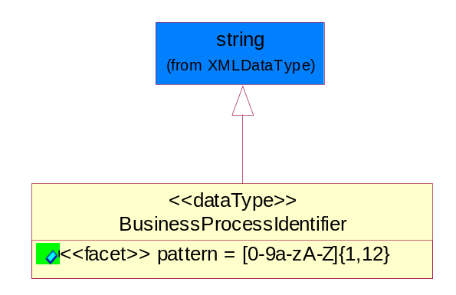
Figure ‎5-25 BusinessProcessIdentifier

Attribute | Type | Documentation
pattern |  | [0-9a-zA-Z]{1,12}

BusinessServiceInformation
The object allows the specification of the business service utilized within the partner company. This may or may not be the same as the information sent by the RNIF.
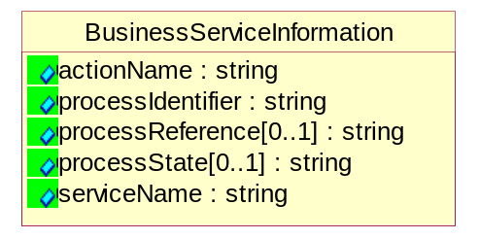
Figure ‎5-26 BusinessServiceInformation

Attribute | Type | Documentation
actionName | string | The name of Action. For RosettaNet usually any of Request/Confirm/Notify/Query/Response.
processIdentifier | string | The name of the PIP e.g. Notify of Forecast Reply.
processReference[0..1] | string | The URN for the PIP that includes Cluster/Segment/Process pattern used to identify the interface process (such as PIP3A4)
processState[0..1] | string | The business process (or service) state of the sender of a document. When a service receives this document, the receiver may use the state as a precondition.
serviceName | string | The name of the Business Activity with the "Request/Confirm" part removed. E.g., for the Activity "Request Purchase Order"==> "Purchase Order".

ContractInformation
A block of information used to correlate a contract in an executing choreography.
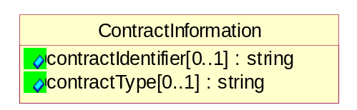
Figure ‎5-27 ContractInformation

Attribute | Type | Documentation
contractIdentifier[0..1] | string | Unique identification of a contract between the Sender and the Receiver
contractType[0..1] | string | The type of the contract: an attribute describing the type of the ContractIndentification. Valid values are URI, URN,ebXMLCPA, or other values defined by partners.

CorrelationInformation
A block of information used to correlate a requesting document to a responding document and to the contract in an executing choreography.
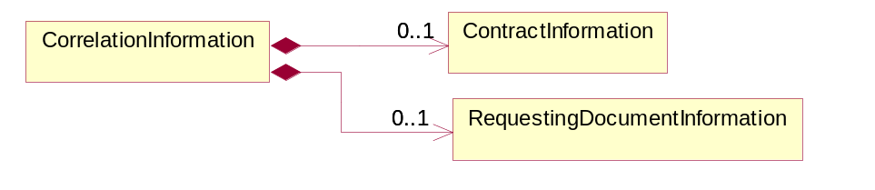
Figure ‎5-28 CorrelationInformation

Composition | Cardinality | Type | Documentation
ContractInformation | 0..1 | ContractInformation | A block of information used to correlate a contract in an executing choreography.
RequestingDocumentInformation | 0..1 | RequestingDocumentInformation | A block of information used to correlate a requesting document to a responding document in an executing choreography.

DocumentHeader
The object allows for the identification of the sender and receiver of the business document.
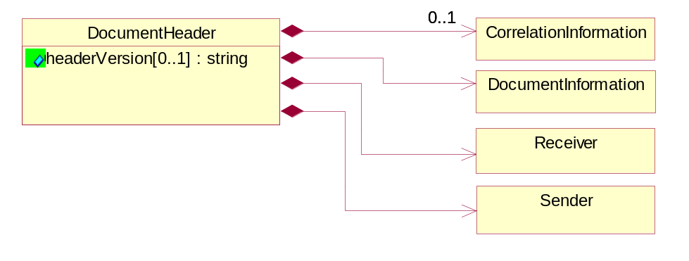
Figure ‎5-29 DocumentHeader

Attribute | Type | Documentation
headerVersion[0..1] | string | The UN/CEFACT version of the document header.

Composition | Cardinality | Type | Documentation
CorrelationInformation | 0..1 | CorrelationInformation | A block of information used to correlate a requesting document to a responding document and to the contract in an executing choreography.
DocumentInformation | 1 | DocumentInformation | The object specifies information to identify the business document, a summary of attachments, and information about the business document security.
Receiver | 1 | Receiver | The object allows the identification of the receiving party of the business message.
Sender | 1 | Sender | The object allows the identification of the initiating party of the business message.

DocumentIdentification
The object specifies all information necessary to identify the business document.
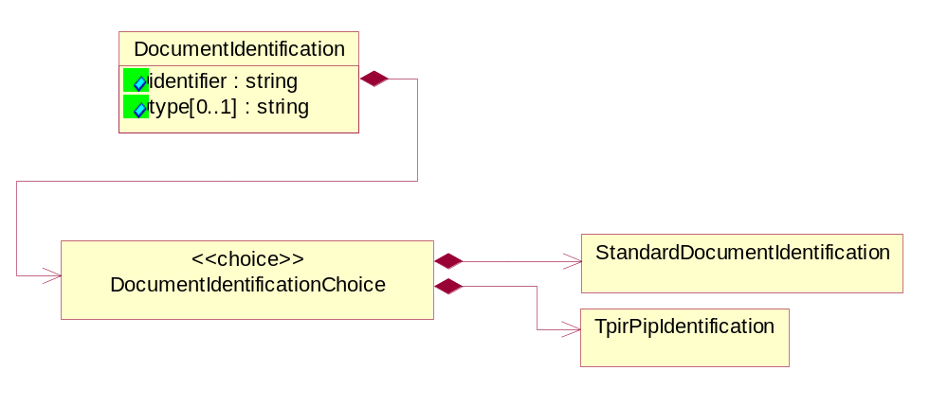
Figure ‎5-30 DocumentIdentification

Attribute | Type | Documentation
identifier | string | The unique identifier for the document being sent.
type[0..1] | string | Name of the Action Message

Composition | Cardinality | Type | Documentation
DocumentIdentificationChoice | 1 | DocumentIdentificationChoice

DocumentIdentificationChoice

Composition | Cardinality | Type | Documentation
StandardDocumentIdentification | 1 | StandardDocumentIdentification | The object specifies additional information necessary to identify the standard business document.
TpirPipIdentification | 1 | TpirPipIdentification | The object specifies all information necessary to uniquely identify a TPIR-PIP within a Registry or trading partner repository.

DocumentInformation
The object specifies information to identify the business document, a summary of attachments, and information about the business document security.
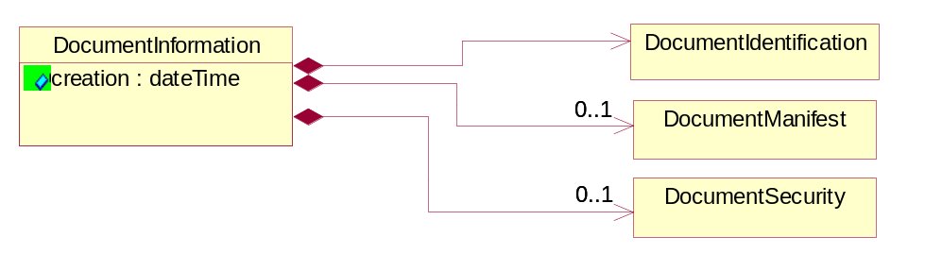
Figure ‎5-31 DocumentInformation

Attribute | Type | Documentation
creation | dateTime | The creation date and time of the specified Business Document (i.e. the Purchase Order date).

Composition | Cardinality | Type | Documentation
DocumentIdentification | 1 | DocumentIdentification | The object specifies all information necessary to identify the business document.
DocumentManifest | 0..1 | DocumentManifest | The block provides a brief summary of attachments and Service Content.
DocumentSecurity | 0..1 | DocumentSecurity | The object provides additional granularity in specifying business document security (this is in addition to the specified PIP security).

DocumentManifest
The block provides a brief summary of attachments and Service Content.
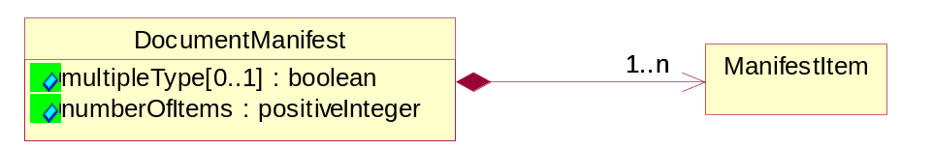
Figure ‎5-32 DocumentManifest

Attribute | Type | Documentation
multipleType[0..1] | boolean | Indicates whether the manifest contains documents of multiple types. True if yes, and False if no.
numberOfItems | positiveInteger | Total number of documents in the message. The physical count of the attachments in the payload plus the RosettaNet Business Message (for Service Content). The value of this field will be at least 1.

Composition | Cardinality | Type | Documentation
ManifestItem | 1..n | ManifestItem | The object provides details about the specific attachment(s).

DocumentSecurity
The object provides additional granularity in specifying business document security (this is in addition to the specified PIP security).
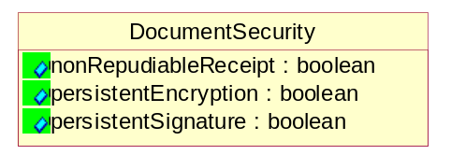
Figure ‎5-33 DocumentSecurity

Attribute | Type | Documentation
nonRepudiableReceipt | boolean | The value "true" will indicate that a signed acknowledgement for the business document is necessary.
persistentEncryption | boolean | The value "true" will indicate that the Business Document (including the header) needs to be encrypted when stored or transported.
persistentSignature | boolean | The value "true" will indicate that a signature is required to be stored with the document while stored or transported.

ManifestItem
The object provides details about the specific attachment(s).

Figure ‎5-34 ManifestItem

Attribute | Type | Documentation
description[0..1] | string | A description of the attachment.
length[0..1] | positiveInteger | The size of the attachment in bytes (i.e. 1 000 000 bytes)
universalResourceIdentifier | string | The generic set of all names/addresses that are short strings that refer to resources.

Composition | Cardinality | Type | Documentation
mimeTypeQualifier | 1 | MimeTypeQualifier | The MIME type as defined by IANA.  Please refer to http://www.iana.org/assignments/media-types/ for a list of types.
language | 0..1 | Language | For representation of Language name RosettaNet has adopted ISO 639-2; 1998. Refer to the following web page to get the latest version of the standard:  http://www.loc.gov/standards/iso639-2/iso639jac.html  If you need more information about the ISO standard please contact ISO for more details.

PipIdentifier
PIP Identification.[ i.e. PIP3A4]
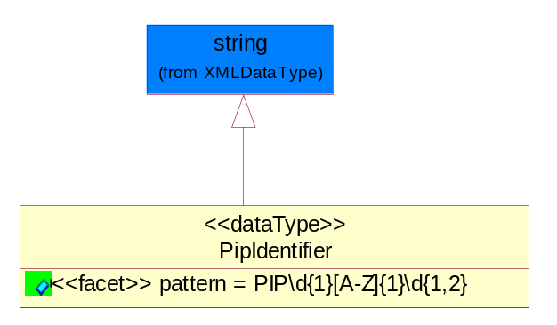
Figure ‎5-35 PipIdentifier

Attribute | Type | Documentation
pattern |  | PIP\d{1}[A-Z]{1}\d{1,2}

PipVersion
PIP version number (i.e. 02.02.00).
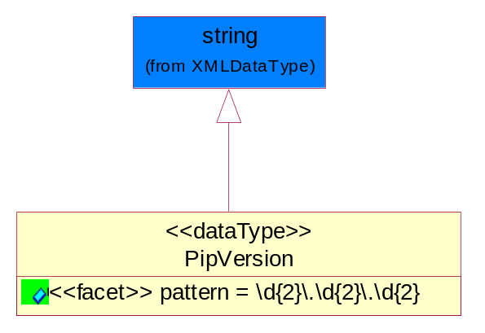
Figure ‎5-36 PipVersion

Attribute | Type | Documentation
pattern |  | \d{2}\.\d{2}\.\d{2}

Receiver
The object allows the identification of the receiving party of the business message.
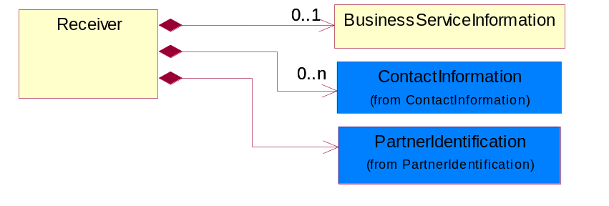
Figure ‎5-37 Receiver

Composition | Cardinality | Type | Documentation
BusinessServiceInformation | 0..1 | BusinessServiceInformation | The object allows the specification of the business service utilized within the partner company. This may or may not be the same as the information sent by the RNIF.
ContactInformation | 0..n | ContactInformation | The business document must allow for the identification of the name of the department, service or individual to be contacted regarding the context of the business document.
PartnerIdentification | 1 | PartnerIdentification | The business document must allow for the identity of one or more parties to the transaction.

RequestingDocumentInformation
A block of information used to correlate a requesting document to a responding document in an executing choreography.
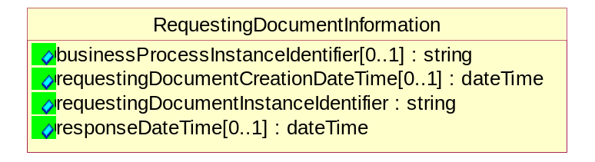
Figure ‎5-38 RequestingDocumentInformation

Attribute | Type | Documentation
businessProcessInstanceIdentifier[0..1] | string | The identifier for the public business process instance being sent that both the sender and receiver can identify.
requestingDocumentCreationDateTime[0..1] | dateTime | The date-time of the requesting business document.
requestingDocumentInstanceIdentifier | string | The Business Document identification number that identifies the requesting Business Document.
responseDateTime[0..1] | dateTime | The expected time to receive the response. This can not be greater than the PIP TimeToPerform.

Sender
The object allows the identification of the initiating party of the business message.
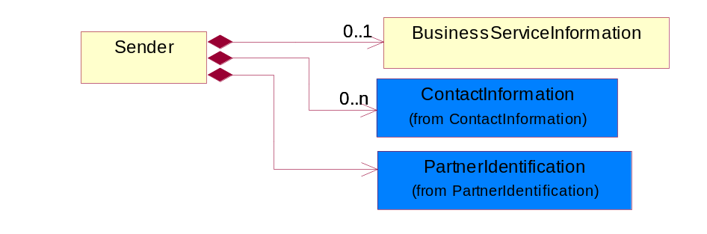
Figure ‎5-39 Sender

Composition | Cardinality | Type | Documentation
BusinessServiceInformation | 0..1 | BusinessServiceInformation | The object allows the specification of the business service utilized within the partner company. This may or may not be the same as the information sent by the RNIF.
ContactInformation | 0..n | ContactInformation | The business document must allow for the identification of the name of the department, service or individual to be contacted regarding the context of the business document.
PartnerIdentification | 1 | PartnerIdentification | The business document must allow for the identity of one or more parties to the transaction.

StandardDocumentIdentification
The object specifies additional information necessary to identify the standard business document.
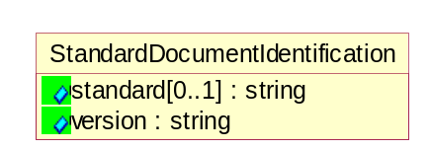
Figure ‎5-40 StandardDocumentIdentification

Attribute | Type | Documentation
standard[0..1] | string | Identifies the standard used to submit the business document. (e.g. RosettaNet).
version | string | PIP3A4v01.00

TpirPipIdentification
The object specifies all information necessary to uniquely identify a TPIR-PIP within a Registry or trading partner repository.
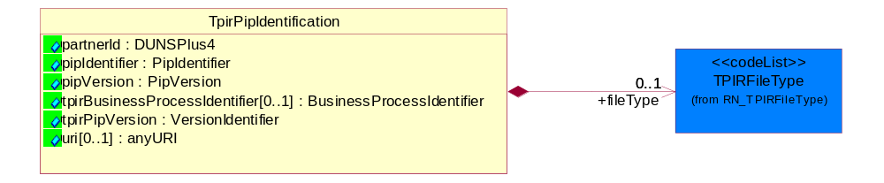
Figure ‎5-41 TpirPipIdentification

Attribute | Type | Documentation
partnerId | DUNSPlus4 | The Trading Partner Identification of MNC that is creating this TPIR PIP.
pipIdentifier | PipIdentifier | A TPIR PIP Identification [i.e., 3A4 ).
pipVersion | PipVersion | A TPIR PIP version number (i.e., 02.02.00)
tpirBusinessProcessIdentifier[0..1] | BusinessProcessIdentifier | A Business Process Identifier to uniquely define the TPIR-PIP 'role' within a Business Scenario at a company or MNC level. The identifier MUST be composed of alphanumeric characters only and its length MUST be between one and twelve characters.
tpirPipVersion | VersionIdentifier | A TPIR-PIP Version Number (i.e., major and minor version number as XX.XX).
uri[0..1] | anyURI | Describes the destination uri for the TPIR form.

Composition | Cardinality | Type | Documentation
fileType | 0..1 | TPIRFileType | Describes the file type of the TPIR form (PDF, XDP or XML).

VersionIdentifier
Version Number (i.e., major and minor version number as XX.XX).
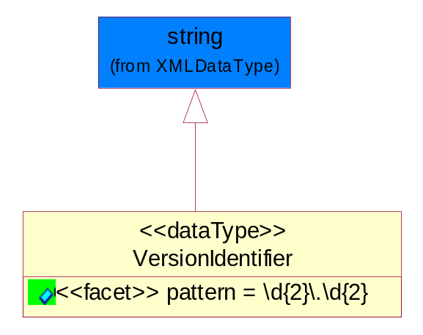
Figure ‎5-42 VersionIdentifier

Attribute | Type | Documentation
pattern |  | \d{2}\.\d{2}

CodeList

TPIRFileType
A code identifying the file type of TPIR form.

Name | Documentation
PDF | Portable Document Format.
XDP | XML Data Package.
XML | eXtensible Markup Language.

XML Data Type

anyURI
Represents a URI as defined by RFC 2396. An anyURI value can be absolute or relative, and may have an optional fragment identifier.

boolean
Represents Boolean values, which are either "true" or "false".

date
For the represents a calendar date.
The pattern for a date is CCYY-MM-DD where CC represents the century, YY the year, MM the month, and DD the day, with an optional time zone indicator as allowed for dateTime.

dateTime
Represents a specific instance of time.
The pattern for dateTime is CCYY-MM-DDThh:mm:ss where CC represents the century, YY the year, MM the month, and DD the day, preceded by an optional leading negative (-) character to indicate a negative number. If the negative character is omitted, positive (+) is assumed. The T is the date/time separator and hh, mm, and ss represent hour, minute, and second respectively. Additional digits can be used to increase the precision of fractional seconds if desired. For example, the format ss.ss... with any number of digits after the decimal point is supported. The fractional seconds part is optional.
This representation may be immediately followed by a "Z" to indicate Coordinated Universal Time (UTC) or to indicate the time zone. For example, the difference between the local time and Coordinated Universal Time, immediately followed by a sign, + or -, followed by the difference from UTC represented as hh:mm (minutes is required). If the time zone is included, both hours and minutes must be present.

float
Represents single-precision 32-bit floating-point numbers.

positiveInteger
Represents an integer that is greater than zero. This data type is derived from nonNegativeInteger.

string
Represents character string.

