

Description of
Partner Interface Process® for 7C6

Validated 11.00.00

Specification Information
Name | Distribute Product Quality Event Data
Cluster | Manufacturing
Segment | Distribute Manufacturing Information
Publication Date | 08 July 2008
Version Identifier | V11.00

Table of Contents
1 Document Management 4
1.1 Legal Disclaimer 4
1.2 Copyright 4
1.3 Trademarks 4
1.4 Acknowledgments 4
1.5 Related Documents 4
1.6 Document Version History 4
1.7 Document Structure 5
2 Business Process 6
2.1 Business Process Definition 6
2.1.1 Business Process Context Diagram 9
2.2 PIP Scope Description 9
2.3 PIP Business Document 10
2.4 PIP Business Process Flow Diagram 10
2.5 PIP Start State 11
2.6 PIP End States 11
2.7 Partner Role Description 12
2.8 Business Process Activity Controls 12
3 Network and Implementation Specification 13
3.1 Business Action and Business Signal Specifications 13
3.2 Business Transaction Dialog Specification 13
3.2.1 Message Exchange Controls 14
3.2.2 Communications Specification 14

List of Figures:
Figure 1: Basic Business Process 6
Figure 2: Extended Business Process 8
Figure 3: High-level Context Diagram 9
Figure 4: Activity Diagram of Distribute Product Quality Event Data 10
Figure 5: Sequence Diagram of Distribute Product Quality Event Data 13

List of Tables:
Table 1: PIP Business Document 10
Table 2: PIP Start State 11
Table 3: PIP End State 11
Table 4: PIP Failure State 11
Table 5: Partner Role Description 12
Table 6: Business Activity Description 12
Table 7: Business Activity Performance Control 12
Table 8: Network Component Specification 13
Table 9: Business Action – Business Document Mapping 13
Table 10: Message Exchange Control 14
Table 11: Dialog: Service-Service 14

Document Management

Legal Disclaimer
RosettaNet™, its members, officers, directors, employees, or agents shall not be liable for any injury, loss, damages, financial or otherwise, arising from, related to, or caused by the use of this document or the specifications herein, as well as associated guidelines and schemas. The use of said specifications shall constitute your express consent to the foregoing exculpation.

Copyright
©2008 RosettaNet. All rights reserved. No part of this publication may be reproduced, stored in a retrieval system, or transmitted, in any form or by any means, electronic, mechanical, photocopying, recording, or otherwise, without the prior written permission of the publisher. Printed in the United States of America.

Trademarks
RosettaNet, Partner Interface Process, PIP and the RosettaNet logo are trademarks or registered trademarks of "RosettaNet," a non-profit organization. All other product names and company logos mentioned herein are the trademarks of their respective owners. In the best effort, all terms mentioned in this document that are known to be trademarks or registered trademarks have been appropriately recognized in the first occurrence of the term.

Acknowledgments
This document has been prepared by RosettaNet (http://www.rosettanet.org/) from requirements gathered during the Milestone Program and in conformance with the methodology. Listed below are the legal entities that contributed to the design and development of this PIP.

Related Documents
- Associated PIP Message Schemas (included within the PIP Specification package only)
- Description of 7C6 Message
- Messages Structure
- XML instance of ebXML BPSS for PIP 7C6

Document Version History
Version | Date | Description
Validated 11.00.00 | 08 July 2008 | Validated Version : RosettaNet Schema to Market to Validation 2008

Document Structure
A Partner Interface Process (PIP) Specification is comprised of the following two parts:
- Business Process. Captures the semantics of the business process and the flow of the message exchange between roles as they perform business activities.
- Network and Implementation Specification. Specifies the network protocol message formats and communications requirements between peer-protocols supported by network components in the RosettaNet Implementation Framework.

Business Process

Business Process Definition
Vertically integrated companies keep track of data dealing with various quality events (e.g., product/component failures and repairs, failure analysis, etc.) on internal systems. Now that many companies outsource their manufacturing and/or repair processes, it is critical for partners to establish ways of making their quality event data available to one another.
The purpose of the "Distribute Product Quality Event Data" Partner Interface Process™ (PIP®) is to enable partners in a manufacturing/repair supply chain to share data related to the quality of services provided.
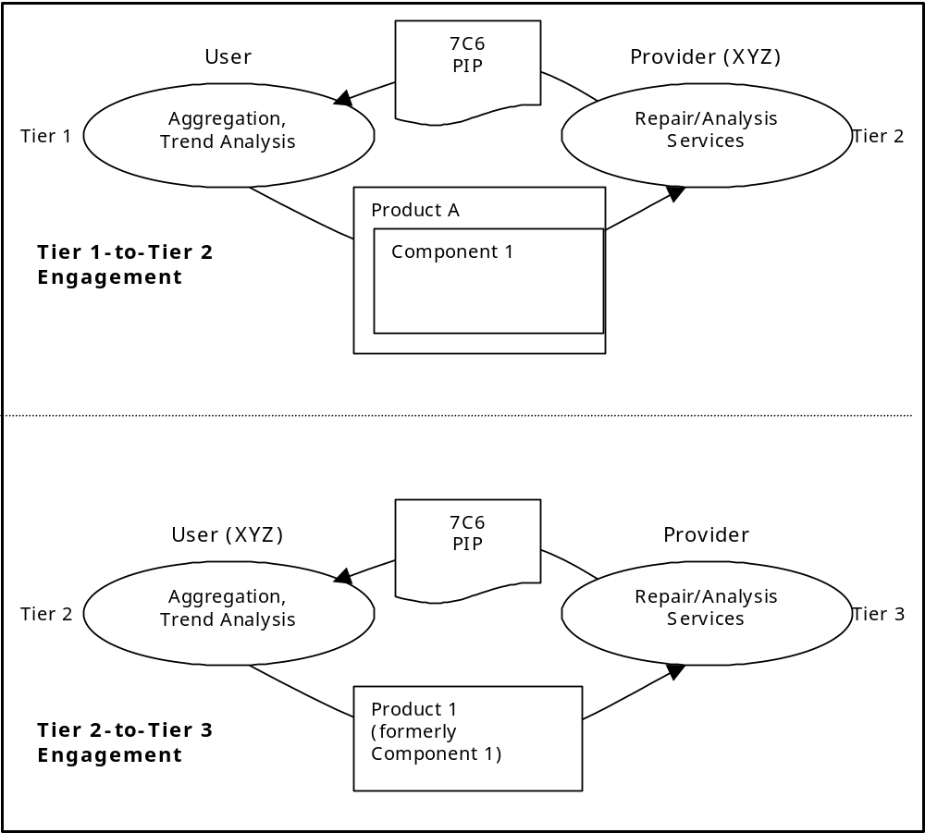There are two roles for this PIP: Quality Data Provider (Provider) and Quality Data User (User). As illustrated in figure 1, the same business entity (XYZ in the
Figure 1: Basic Business Process

diagram) may perform either role at different stages of the manufacturing/repair supply chain – i.e., a Provider of data for a high level product could become a User of data on a component it sends out for repair or analysis. Again, referring to Diagram 3-1, the business process proceeds as follows:
- The Provider sends data to the User dealing with product defect(s) and/or other quality events. Quality events could occur while manufacturing the product or after the product has been sold to the end customer. For purposes of this PIP, a “product” is defined to be the physical object sent to the business partner, in its entirety. A product may have component parts that may also be reported on in the PIP
- The level of detail sent in the PIP will vary depending on the business model of the Provider. For each product:
  - Identification information is provided
  - The type of quality event is specified
    - Product received event
    - Repair event
    - Analysis event
    - Other business-specific events
  - Disposition information (received, repaired, replaced, etc.) is provided
    - Product repaired event
    - Product replaced event
    - Product scrapped event
    - Other business-specific disposition events
  - Failure and/or repair codes are provided
  - Cross-reference information may be provided to associate the product with other business documents (e.g., purchase orders, sales orders, etc.) and/or to associate the product with its component parts (see the next paragraph and its discussion on “Master Event Number”)
  - Test data (e.g., type of tests performed, variables tested for, attribute and parametric test results, etc.) may be provided
  - Components that are repaired, replaced, or updated are identified along with their defect and/or repair codes and, optionally, their test data
- The User aggregates and uses the data according to its business model – e.g., to improve the quality of its manufacturing operations.
As Figure 1 shows, it may be necessary to send a component of a product to a partner for repair/analysis. If this happens, the component takes on the role of “product” in a new instance of the PIP, with the Provider becoming the User and the new business entity becoming the Provider. Products and components are linked together across PIPs by way of a “Master Event Number”, thus allowing the original product vendor to aggregate data regardless of the number of business entities involved. The Master Event Number is one example of cross-reference information (discussed earlier) that may be included in the PIP.
Although Figure 1 only shows PIPs being sent to adjacent partners it is also possible, as shown in Figure 2 on the next page, for a PIP to be sent to any “upstream” partner (assuming, of course, there is an agreement in place between the business entities).
This PIP does not specify turn around times or other details of how the Provider carries out its repair business. These operational aspects are determined by the Provider’s business model and agreements between the Provider and User.
Should this transaction not complete successfully, the initiator of the PIP executes PIP0A1, “Notification of Failure”.
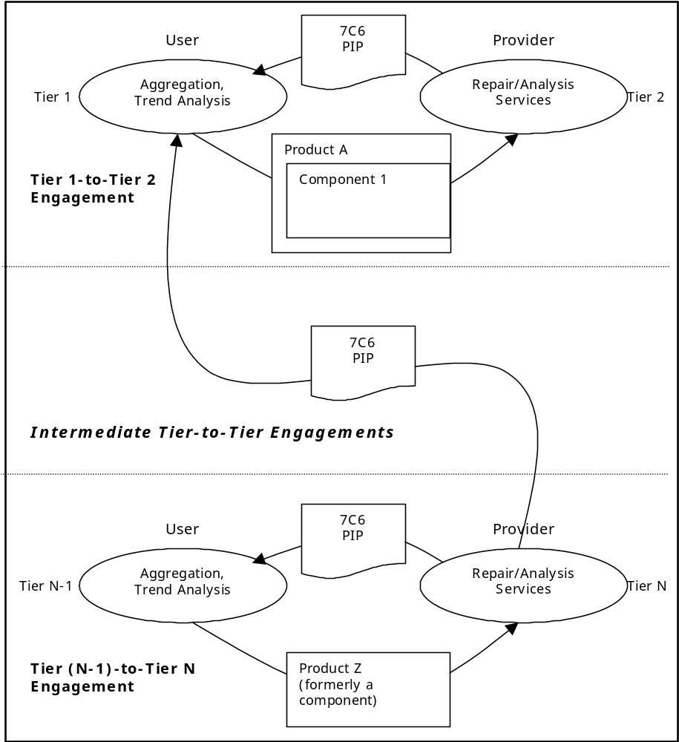Figure 2: Extended Business Process

Business Process Context Diagram
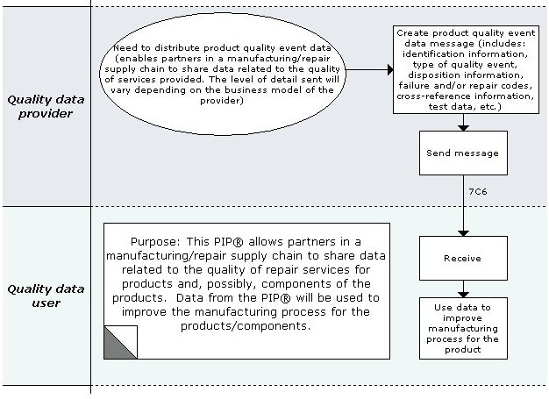
Figure 3: High-level Context Diagram

PIP Scope Description
This PIP allows partners in a manufacturing/repair supply chain to share data related to the quality of repair services for products and, possibly, components of the products. Data from the PIP will be used to improve the manufacturing process for the products/components.

PIP Business Document
Business Document are generated and exchanged by roles performing activities in this PIP. Business Document is listed and defined in Table 1.
Table 1: PIP Business Document
Business Document | Description
Product Quality Event Data Distribution | Contains information dealing with: Defective products and/or product components, Root cause analysis of defective products/components, and Testing procedures used during defect analysis.

PIP Business Process Flow Diagram
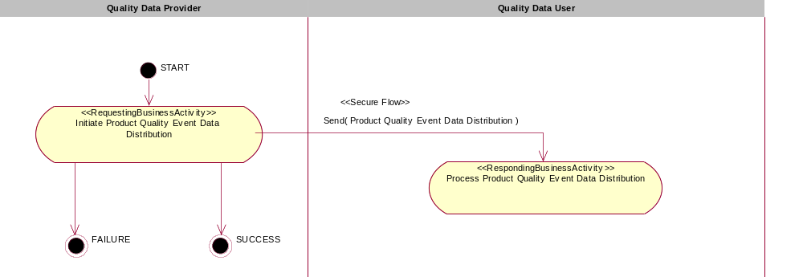

Figure 4: Activity Diagram of Distribute Product Quality Event Data

PIP Start State
The start state is comprised of the following conditions:
Table 2: PIP Start State
 | Approved | Exist |  | Valid | Non-Repudiated | Retry Count | Authorized
 | Approved | Party | In Backend System
TPA |  |  | 
Sending Partner |  |  |  | 
Receiving Partner |  | 
Business Document |  |  |  | 

PIP End States
The end state is comprised of the following conditions:
Table 3: PIP End State
 | Approved | Exist |  | Valid | Non-Repudiated | Retry Count | Authorized
 | Approved | Party | In Backend system
Acknowledgment of Receipt |  |  |  | 
Receiving Partner |  |  |  |  |  |  | 

The PIP failure state is comprised of one or more of the following conditions
Table 4: PIP Failure State
 | NO | Exceeded
Success | 
Retry Count |  | 

Partner Role Description
Table 5 describes the partner roles in this PIP:
Table 5: Partner Role Description
Role Name | Role Description
Quality Data Provider | The party responsible for sending the Product Quality Event Data. The Provider, through various means, learns of product or product component defect(s). Subsequently, the Provider sends repair and/or test data for the defects to its partner (User).
Quality Data User | The party who receives the repair and/or test data. The User analyzes the data and incorporates findings into its business model.

Business Process Activity Controls
Table 6 describes the interaction between roles performing business activity in this PIP.
Table 6: Business Activity Description
Role Name |  | Activity Name |  | Activity Description
Quality Data Provider | Initiate Product Quality Event Data Distribution |  | The Provider sends Product Quality Event Data to the User to inform the User of issues regarding product/component defect(s).

Table 7 details the security, audit and process controls relating to activity performed in the PIP.
Table 7: Business Activity Performance Control
Role  Name | Activity  Name | Acknowledgment  of Receipt |  | Time to Perform | Retry Count | Is Authorization Required? | Non-Repudiation of Origin and Content?
Role  Name | Activity  Name | Non-Repudiation Required? | Time to Acknowledge
Quality Data Provider | Initiate Product Quality Event Data Distribution | N | 2hrs | N/A | 3 | N | N

Network and Implementation Specification
Each network component maps into a role of the PIP model. Table 8 specifies the mapping between roles and network components.
Table 8: Network Component Specification
Network Component | Classification | Maps to Role in Business Process
Quality Data Provider Service | Business Service | Quality Data Provider
Quality Data User Service | Business Service | Quality Data User

Business Action and Business Signal Specifications
Each business action maps to a Business Document of the PIP model. Table 9 specifies the mapping between Business Documents and business actions.
Table 9: Business Action – Business Document Mapping
Business Action | Business Document | Document Function
Product Quality Event Data Distribution Action | Product Quality Event Data Distribution | Request

Business Transaction Dialog Specification
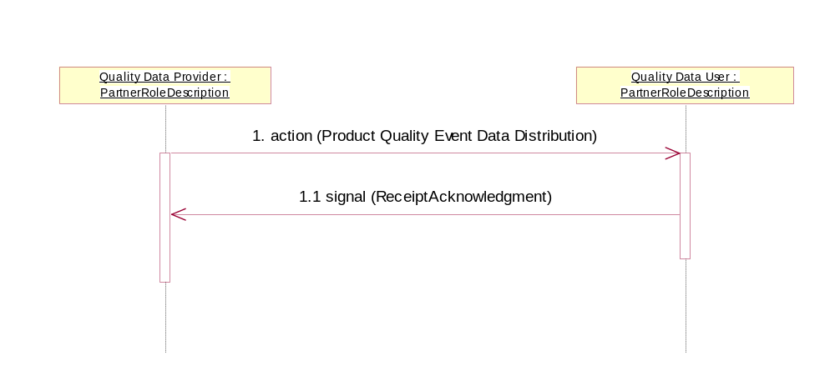

Figure 5: Sequence Diagram of Distribute Product Quality Event Data

Message Exchange Controls
Table 10: Message Exchange Control
# | Name |  | Time to Acknowledge Receipt Signal |  | Time to Respond to Action |  | Included in Time to Perform | Is Authorization Required? | Is Non-Repudiation Required? | Is Secure Transport Required?
1. |  | Product Quality Event Data Distribution Action |  | 2hrs |  | N/A | N | N | N | Y
1.1. |  | Receipt Acknowledgment |  | N/A |  | N/A | N | N | N | Y

Communications Specification
Table 11: Dialog: Service-Service
# | Business Message | Digital Signature Required? | SSL Required?
1. | Product Quality Event Data Distribution | N | Y
1.1. | Receipt Acknowledgment | N | Y

