

Description of
Partner Interface Process® for 7C7

Validated 11.00.00

Specification Information
Name | Notify of Semiconductor Test Data
Cluster | Manufacturing
Segment | Distribute Manufacturing Information
Publication Date | 4 Feb 2005
Version Identifier | V11.00

Table of Contents
1 Document Management 4
1.1 Legal Disclaimer 4
1.2 Copyright 4
1.3 Trademarks 4
1.4 Acknowledgments 4
1.5 Related Documents 5
1.6 Document Version History 5
1.7 Document Structure 5
2 Business Process 6
2.1 Business Process Definition 6
2.1.1 Executive Summary 6
2.1.2 Business Process Description 6
Business Process Context Diagram 7
2.2 PIP Scope Description 7
2.2.1 Business Process Scope Diagram 8
2.3 PIP Business Process Flow Diagram 9
2.4 PIP Start State 10
2.5 PIP End States 10
2.6 Partner Role Descriptions 11
2.7 Business Process Activity Controls 11
3 Network and Implementation Specification 12
3.1 Business Action and Business Signal Specification 12
3.2 Business Transaction Dialog Specification 12
3.2.1 Message Exchange Controls 13
3.2.2 Communications Specification 13

List of Figures
Figure 1: High-level Context Diagram 7
Figure 2: Business Process Context Diagram 8
Figure 3: Activity Diagram of Notify of Semiconductor Test Data 9
Figure 4: Sequence Diagram of Notify of Semiconductor Test Data 12

List of Tables
Table 1: PIP Business Documents 9
Table 2: PIP Start State 10
Table 3: PIP End State 10
Table 4: PIP Failure State 10
Table 5: Partner Role Descriptions 11
Table 6: Business Activity Descriptions 11
Table 7: Business Activity Performance Controls 11
Table 8: Network Component Specification 12
Table 9: Business Action – Business Document Mapping 12
Table 10: Message Exchange Controls 13
Table 11: Notify of Semiconductor Test Data Dialog: Service-Service 13

Document Management

Legal Disclaimer
RosettaNet™, its members, officers, directors, employees, or agents shall not be liable for any injury, loss, damages, financial or otherwise, arising from, related to, or caused by the use of this document or the specifications herein, as well as associated guidelines and schemas. The use of said specifications shall constitute your express consent to the foregoing exculpation.

Copyright
©2004-2005 RosettaNet. All rights reserved. No part of this publication may be reproduced, stored in a retrieval system, or transmitted, in any form or by any means, electronic, mechanical, photocopying, recording, or otherwise, without the prior written permission of the publisher. Printed in the United States of America.

Trademarks
RosettaNet, Partner Interface Process, PIP and the RosettaNet logo are trademarks or registered trademarks of "RosettaNet," a non-profit organization. All other product names and company logos mentioned herein are the trademarks of their respective owners. In the best effort, all terms mentioned in this document that are known to be trademarks or registered trademarks have been appropriately recognized in the first occurrence of the term.

Acknowledgments
This document has been prepared by RosettaNet (http://www.rosettanet.org/) from requirements gathered during the Milestone Program and in conformance with the methodology. Listed below are the legal entities that contributed to the design and development of this PIP.
Agere Systems | AIT
Amkor | ASE
Freescale Semiconductor (Motorola) | Intel
International Business Machines | National Semiconductor
NEC | ST Microelectronics
Taiwan Semiconductor Manufacturing Corp. | Texas Instruments (TI)

Related Documents
- Associated PIP Message Schemas (included within the PIP Specification package only)
- Description of PIP7C7 Message
- Message Structure
- XML instance of ebBPSS for PIP 7C7

Document Version History
Version | Date | Description
Validated 11.00.00 | 4 Feb 2005 | Validated Version

Document Structure
A Partner Interface Process (PIP) Specification is comprised of the following two parts:
- Business Process. Captures the semantics of the business process and the flow of the message exchange between roles as they perform business activities.
- Network and Implementation Specification. Specifies the network protocol message formats and communications requirements between peer-protocols supported by network components in the RosettaNet Implementation Framework.

Business Process

Business Process Definition
The Semiconductor Test Data enables foundry and assembly test partners to deliver semiconductor test data to chip designers for data analysis. The complex fabrication process requires accurate disposition of data, which is required for foundry partners to understand and react to design issues.

Executive Summary
Semiconductor Test Data standardizes test data exchange process by defining a common vocabulary for transmission of test data. The value propositions of this initiative are:
- Standards based test data exchange increases trading partner (Customer/Foundry/Test Services) engineering productivity and collaboration to promote effective yield learning.
- Standards based test data exchange decreases IT support resources and overhead required to assure data integrity.
- Standards based test data exchange enables on demand problem resolution between the trading partners.
- Standards based test data exchange enables rapid new partner setup in B2B environment.
- Standards based test data exchange can be used as a quantifiable metric for customer satisfaction.

Business Process Description
The “Semiconductor Test Data Notification” Partner Interface Process (PIP) supports the process to send test result information to a trading partner for the following semiconductor tests:
a. Process Control Monitor (PCM): The data resulting from the testing of a sample of chips on a semiconductor wafer to determine if chips meet engineering specifications. For a foundry environment, this test data provides the ‘go’ or ‘no go’ decision to determine if the wafer passes or fails the agreed upon wafer acceptance criteria. This test data is limited to data produced from testing individually wired devices / structures built in the “dicing channel”, “kerf” or “scribe line” versus the functional / integrated die on the entire wafer.
b. Wafer Sort: The data resulting from the functional testing for each functional / integrated die on the entire wafer. The test data results may be shared as either reconciled information at the chip summary level or as raw test data. Test results may include parametric measurements and quality sort data.
c. Final Test: The data resulting from the testing of packaged die to ensure functionality of the die encapsulated package. This test also includes parametric and quality sort data.

Business Process Context Diagram
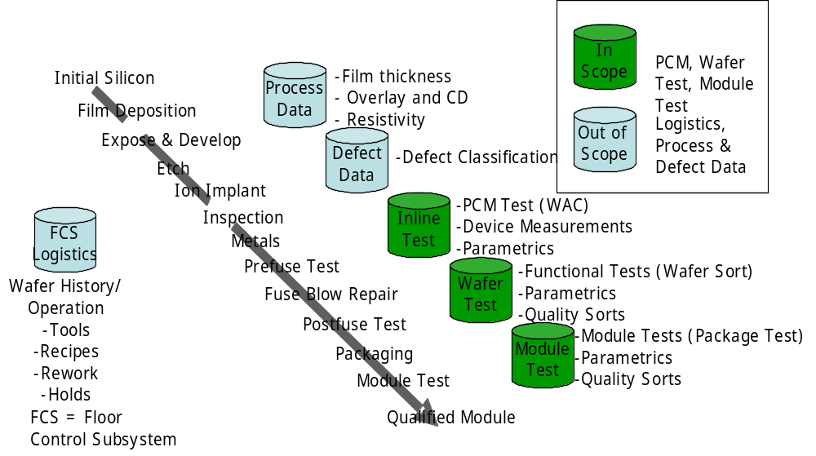
Figure 1: High-level Context Diagram

PIP Scope Description
The purpose of this PIP is to 1) improve the timeliness of the semiconductor test data exchange between trading partners, 2) reduce the IT infrastructure costs from multiple customized data transmission formats to a single standard, 3) promote closer collaboration and on-demand response to data issues between the Customer and their Foundry and Test Services trading partners.

Business Process Scope Diagram
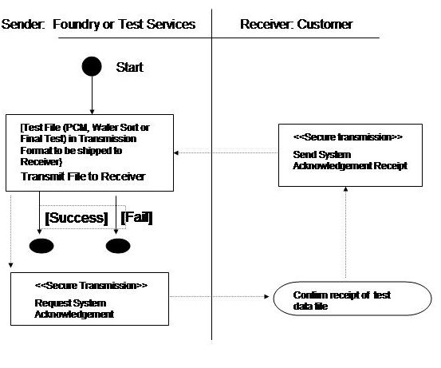
Figure 2: Business Process Context Diagram
PIP Business Documents
Business Documents are generated and exchanged by roles performing activities in this PIP. Business Documents are listed and defined in Table 1.
Table 1: PIP Business Documents
Business Document | Description
Semiconductor Test Data Notification | Contains detailed semiconductor test data information and references required to identify test mode, test specifications and quality requirements. The test data comprises parametric test, functional test and visual inspection.

PIP Business Process Flow Diagram

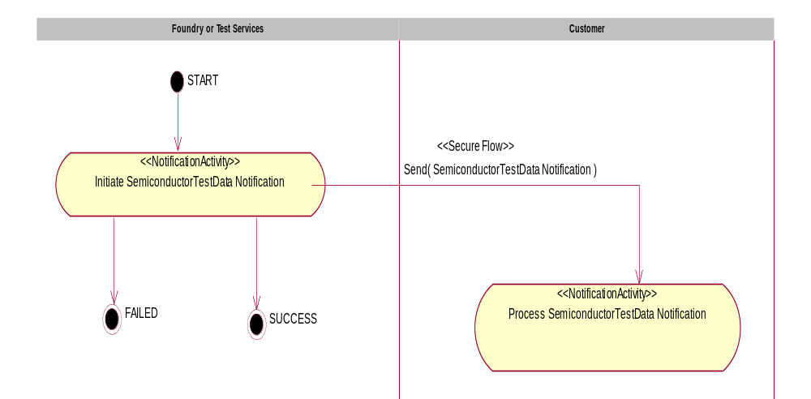

Figure 3: Activity Diagram of Notify of Semiconductor Test Data

PIP Start State
The start state is comprised of the following condition(s):
Table 2: PIP Start State
 | Approved | Exist |  | Valid | Non-Repudiated | Retry Count | Authorized
 | Approved | Party | In Backend system
TPA |  |  | 
Sending Partner |  |  |  | 
Receiving Partner |  | 
Business Document |  |  |  |  |  |  | 

PIP End States
The end state is comprised of the following condition(s):
Table 3: PIP End State
 | Approved | Exist |  | Valid | Non-Repudiated | Retry Count | Authorized
 | Approved | Party | In Backend system
Acknowledgment of Receipt |  |  |  |  | 
Receiving Partner |  |  |  |  |  |  | 

The PIP failure state is comprised of one or more of the following condition(s):

Table 4: PIP Failure State
 | NO | Exceeded
Success | 
Retry Count |  | 

Partner Role Descriptions
Table 6 describes the partner roles in this PIP.
Table 5: Partner Role Descriptions
Role Name | Role Description
Foundry or Test Services | Party, which is requesting Business Activity.
Customer | Party, which is responding to a Business Activity Request.

Business Process Activity Controls
Table 7 describes the interaction between roles performing business activities in this PIP.
Table 6: Business Activity Descriptions
Role  Name | Activity Name | Activity Description
Foundry or Test Services | Notify of Semiconductor Test Data | Foundry or Test Services initiates Semiconductor Test Data Notification to a Recipient. The Notification contains detailed test data information, which could be used by the recipient to understand and react on design issues.

Table 8 details the security, audit and process controls relating to activities performed in the PIP.
Table 7: Business Activity Performance Controls
Role  Name | Activity  Name | Acknowledgment  of Receipt |  | Time to Perform | Retry Count | Is Authorization Required? | Non-Repudiation of Origin and Content?
Role  Name | Activity  Name | Non-Repudiation Required? | Time to Acknowledge
Foundry or Test Services | Notify of Semiconductor Test Data | Y | 2 hrs | N/A | 3 | Y | Y

Network and Implementation Specification
Each network component maps into a role of the PIP model. Table 9 specifies the mapping between roles and network components.
Table 8: Network Component Specification
Network Component | Classification | Maps to Role in Business Process
Foundry or Test Services Service | Business Service | Foundry or Test Services
Customer Service | Business Service | Customer

Business Action and Business Signal Specification
Each business action maps to a Business Document of the PIP model. Table 10 specifies the mapping between Business Documents and business actions.
Table 9: Business Action – Business Document Mapping
Business Action | Business Document | Document Function
Semiconductor Test Data Notification Action | Semiconductor Test Data Notification | Request

Business Transaction Dialog Specification
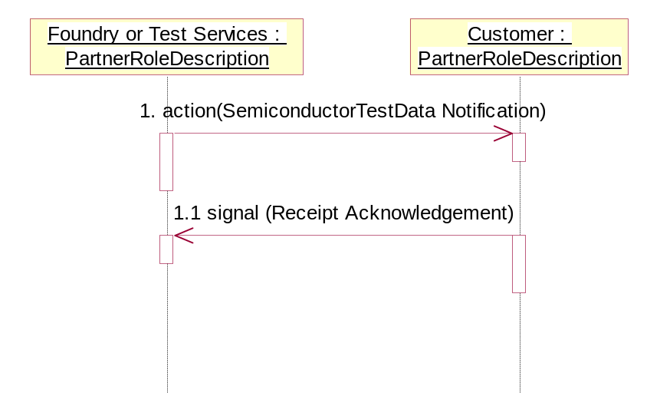
Figure 4: Sequence Diagram of Notify of Semiconductor Test Data

Message Exchange Controls
Table 10: Message Exchange Controls
# | Name |  | Time to Acknowledge |  | Time to Respond to Action |  | Included in Time to Perform |  | Is Authorization Required? |  | Is Non-Repudiation Required? |  | Is Secure Transport Required?
1. |  | Semiconductor Test Data Notification Action |  | 2 hrs |  | N/A |  | N/A |  | Y |  | Y |  | Y
1.1. |  | Receipt Acknowledgment |  | N/A |  | N/A |  | N/A |  | N |  | N |  | Y

Communications Specification
Table 11: Notify of Semiconductor Test Data Dialog: Service-Service
# | Business Message | Digital Signature Required? | SSL Required?
1. | Semiconductor Test Data Notification | Y | Y
1.1. | Receipt Acknowledgment | Y | Y

