

Description of 7C7 Message

PIP® 7C7
Validated 11.10.00

Specification Information
Name | Description of 7C7 Message
PIP | Notify of Semiconductor Test Data
Cluster | Manufacturing
Segment | Distribute Manufacturing Information
Publication Date | 16 October 2006
Version Identifier | V11.10

Table of Content

1. Document Management 7
1.1 Legal Disclaimer 7
1.2 Copyright 7
1.3 Trademarks 7
1.4 Acknowledgments 7
1.5 Related Documents 8
1.6 Document Version History 8
1.7 Document Purpose 8
2. Interchange Model 9
2.1 SemiconductorTestDataNotification 9
2.1.1 Interchange Diagram 9
2.1.2 Dependency Diagram 10
2.1.3 BALocation 10
2.1.4 CalcFailReport 10
2.1.5 Die 11
2.1.6 DieReport 12
2.1.7 FabLocation 13
2.1.8 FinalTest 13
2.1.9 FinalTestLocation 13
2.1.10 FPReport 14
2.1.11 FunctionalPinReport 15
2.1.12 GangTest 15
2.1.13 LotReport 16
2.1.14 OtherLocation 18
2.1.15 PCM 18
2.1.16 PPReport 19
2.1.17 PPResult 19
2.1.18 PRReport 20
2.1.19 SemiconductorTestDataNotification 20
2.1.20 SetupReport 21
2.1.21 Sort 22
2.1.22 TestOperationDescription 23
2.1.23 TestOpIdentification 24
2.1.24 TestOpIdentificationChoice 25
2.1.25 TestReport 25
2.1.26 VectorReport 26
2.1.27 WaferSort 27
2.1.28 WaferSortLocation 27
2.1.29 YieldReport 28
3. Domain Model 29
3.1 Manufacturing 29
3.1.1 Manufacturing 29
3.1.1.1 Dependency Diagram 29
3.1.1.2 ChipPeriodicity 29
3.1.1.3 Dimension 30
3.1.1.4 ECIDReport 30
3.1.1.5 FacilityLocation 31
3.1.1.6 FloatCoordinate 31
3.1.1.7 HardwareSets 32
3.1.1.8 IntCoordinate 32
3.1.1.9 Lot 33
3.1.1.10 LotIdentifier 34
3.1.1.11 MeasurementUnit 34
3.1.1.12 MeasurementUnitChoice 35
3.1.1.13 Pin 35
3.1.1.14 ProprietaryUnits 36
3.1.1.15 StartAndEndDateTime 36
3.1.1.16 Tester 36
3.1.1.17 TesterAttachment 37
3.1.1.18 TesterFEH 37
3.1.1.19 TestMap 38
3.1.1.20 TestParameter 39
3.1.1.21 TestSetup 40
3.1.1.22 TestSpecificationReport 40
3.1.1.23 TestTemperature 41
3.1.1.24 WaferCoordinate 41
3.1.2 CodeList 42
3.1.2.1 Axis 42
3.1.2.2 PCMParmType 42
3.1.2.3 Confidentiality 42
3.1.2.4 Bits 42
3.1.2.5 Status 42
3.1.2.6 LotType 43
3.1.2.7 CoordinateFlag 43
3.1.2.8 SortWeight 43
3.1.2.9 CompletionStatus 43
3.1.2.10 TestResult 44
4. Universal Structure 45
4.1 ContactInformation 45
4.1.1 ContactInformation 45
4.2 DataType 45
4.2.1 Contact 45
4.2.2 DUNS 46
4.2.3 DUNSPlus4 46
4.2.4 GLN 47
4.2.5 GTIN 47
4.2.6 Hexadecimal 48
4.2.7 PercentAmount 48
4.3 Locations 49
4.3.1 AlternativeIdentifier 49
4.3.2 Location 49
4.3.3 LocationChoice 50
4.3.4 PhysicalAddress 50
4.4 PartnerIdentification 52
4.4.1 PartnerIdentification 52
4.4.2 PartnerIdentificationChoice 52
4.5 ProductIdentification 53
4.5.1 ProductIdentification 53
4.5.2 ProductIdentificationChoice 54
4.6 CodeList 54
4.6.1 Country 54
4.6.2 CountrySubdivision 54
4.6.3 Language 54
4.6.4 MimeTypeQualifier 54
4.6.5 UnitOfMeasure 65
5. System Structure 73
5.1 BusinessProcessIdentifier 73
5.2 BusinessServiceInformation 73
5.3 ContractInformation 74
5.4 CorrelationInformation 74
5.5 DocumentHeader 75
5.6 DocumentIdentification 76
5.7 DocumentIdentificationChoice 76
5.8 DocumentInformation 77
5.9 DocumentManifest 77
5.10 DocumentSecurity 78
5.11 ManifestItem 78
5.12 PipIdentifier 79
5.13 PipVersion 80
5.14 Receiver 80
5.15 RequestingDocumentInformation 81
5.16 Sender 81
5.17 StandardDocumentIdentification 82
5.18 TpirPipIdentification 82
5.19 VersionIdentifier 83
5.20 CodeList 84
5.20.1 TPIRFileType 84
6. XML Data Type 85
6.1 anyURI 85
6.2 boolean 85
6.3 dateTime 85
6.4 decimal 85
6.5 float 85
6.6 integer 85
6.7 positiveInteger 85
6.8 string 85

Table of Figures

Figure ‎2-1 Interchange 9
Figure ‎2-2 Dependency 10
Figure ‎2-3 BALocation 10
Figure ‎2-4 CalcFailReport 10
Figure ‎2-5 Die 11
Figure ‎2-6 DieReport 12
Figure ‎2-7 FabLocation 13
Figure ‎2-8 FinalTest 13
Figure ‎2-9 FinalTestLocation 13
Figure ‎2-10 FPReport 14
Figure ‎2-11 FunctionalPinReport 15
Figure ‎2-12 GangTest 15
Figure ‎2-13 LotReport 16
Figure ‎2-14 OtherLocation 18
Figure ‎2-15 PCM 18
Figure ‎2-16 PPReport 19
Figure ‎2-17 PPResult 19
Figure ‎2-18 PRReport 20
Figure ‎2-19 SemiconductorTestDataNotification 20
Figure ‎2-20 SetupReport 21
Figure ‎2-21 Sort 22
Figure ‎2-22 TestOperationDescription 23
Figure ‎2-23 TestOpIdentification 24
Figure ‎2-24 TestReport 25
Figure ‎2-25 VectorReport 26
Figure ‎2-26 WaferSort 27
Figure ‎2-27 WaferSortLocation 27
Figure ‎2-28 YieldReport 28
Figure ‎3-1 Dependency 29
Figure ‎3-2 ChipPeriodicity 29
Figure ‎3-3 Dimension 30
Figure ‎3-4 ECIDReport 30
Figure ‎3-5 FacilityLocation 31
Figure ‎3-6 FloatCoordinate 31
Figure ‎3-7 HardwareSets 32
Figure ‎3-8 IntCoordinate 32
Figure ‎3-9 Lot 33
Figure ‎3-10 LotIdentifier 34
Figure ‎3-11 MeasurementUnit 34
Figure ‎3-12 Pin 35
Figure ‎3-13 ProprietaryUnits 36
Figure ‎3-14 StartAndEndDateTime 36
Figure ‎3-15 Tester 36
Figure ‎3-16 TesterAttachment 37
Figure ‎3-17 TesterFEH 37
Figure ‎3-18 TestMap 38
Figure ‎3-19 TestParameter 39
Figure ‎3-20 TestSetup 40
Figure ‎3-21 TestSpecificationReport 40
Figure ‎3-22 TestTemperature 41
Figure ‎3-23 WaferCoordinate 41
Figure ‎4-1 ContactInformation 45
Figure ‎4-2 Contact 45
Figure ‎4-3 DUNS 46
Figure ‎4-4 DUNSPlus4 46
Figure ‎4-5 GLN 47
Figure ‎4-6 GTIN 47
Figure ‎4-7 Hexadecimal 48
Figure ‎4-8 PercentAmount 48
Figure ‎4-9 AlternativeIdentifier 49
Figure ‎4-10 Location 49
Figure ‎4-11 PhysicalAddress 50
Figure ‎4-12 PartnerIdentification 52
Figure ‎4-13 ProductIdentification 53
Figure ‎5-1 BusinessProcessIdentifier 73
Figure ‎5-2 BusinessServiceInformation 73
Figure ‎5-3 ContractInformation 74
Figure ‎5-4 CorrelationInformation 74
Figure ‎5-5 DocumentHeader 75
Figure ‎5-6 DocumentIdentification 76
Figure ‎5-7 DocumentInformation 77
Figure ‎5-8 DocumentManifest 77
Figure ‎5-9 DocumentSecurity 78
Figure ‎5-10 ManifestItem 78
Figure ‎5-11 PipIdentifier 79
Figure ‎5-12 PipVersion 80
Figure ‎5-13 Receiver 80
Figure ‎5-14 RequestingDocumentInformation 81
Figure ‎5-15 Sender 81
Figure ‎5-16 StandardDocumentIdentification 82
Figure ‎5-17 TpirPipIdentification 82
Figure ‎5-18 VersionIdentifier 83

Document Management

Legal Disclaimer
RosettaNet, its members, officers, directors, employees, or agents shall not be liable for any injury, loss, damages, financial or otherwise, arising from, related to, or caused by the use of this document or the specifications herein, as well as associated guidelines and schemas. The use of said specifications shall constitute your express consent to the foregoing exculpation.

Copyright
©2006 RosettaNet. All rights reserved. No part of this publication may be reproduced, stored in a retrieval system, or transmitted, in any form or by any means, electronic, mechanical, photocopying, recording, or otherwise, without the inclusion of this copyright notice. Any derivative works must cite the copyright notice. Any public redistribution or sale of this publication or derivative works requires prior written permission of the publisher.

Trademarks
RosettaNet, Partner Interface Process, PIP and the RosettaNet logo are trademarks or registered trademarks of "RosettaNet," a non-profit organization. All other product names and company logos mentioned herein are the trademarks of their respective owners. In the best effort, all terms mentioned in this document that are known to be trademarks or registered trademarks have been appropriately recognized in the first occurrence of the term.

Acknowledgments
This document has been prepared by RosettaNet (http://www.rosettanet.org/) from requirements gathered during the Milestone Program and in conformance with the methodology. Listed below are the legal entities that contributed to the design and development of this PIP.
Agere Systems | AIT
Amkor | ASE
Freescale Semiconductor (Motorola) | Intel
International Business Machines | National Semiconductor
NEC | ST Microelectronics
Taiwan Semiconductor Manufacturing Corp. | Texas Instruments (TI)

Related Documents
- Associated PIP Message Schemas (included with PIP Specification only)
- Description of Partner Interface Process for 7C7
- Message Structure

Document Version History
Version | Date | Description
Validated 11.10.00 | 16 Oct 2006 | Validated Version

Document Purpose
The purpose of the document is to explain the structure, the association between objects, the content of objects and the definition for single elements to a non-technical audience.

Interchange Model

SemiconductorTestDataNotification

Interchange Diagram
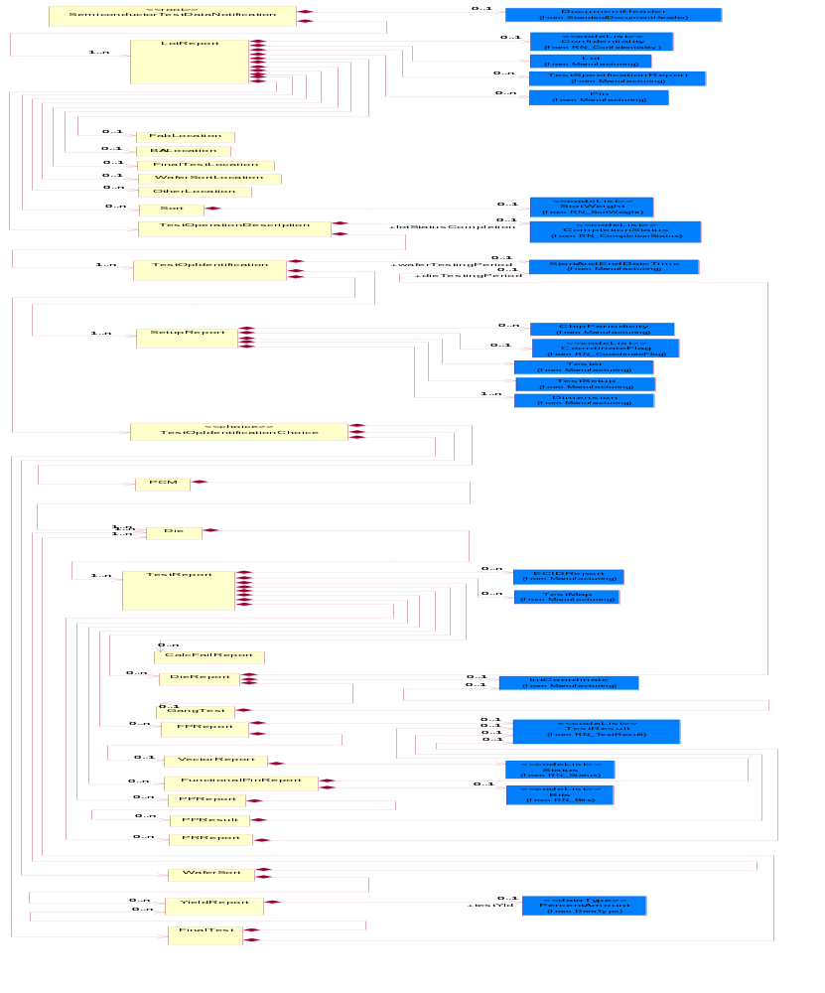
Figure ‎2-1 Interchange

Dependency Diagram
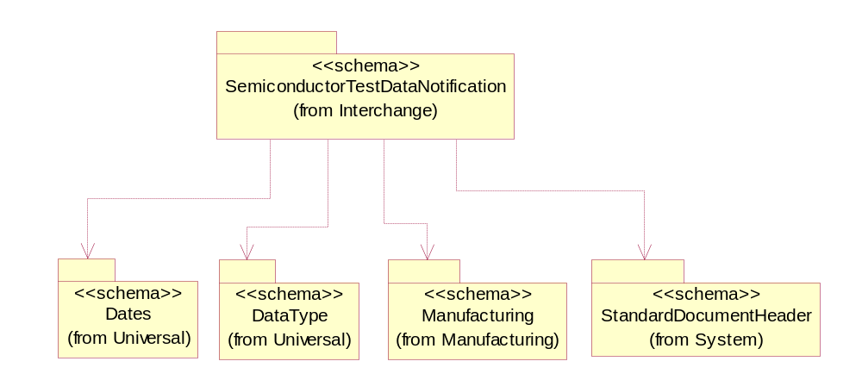
Figure ‎2-2 Dependency

BALocation
Describes where the wafer was sent for bond and assembly.
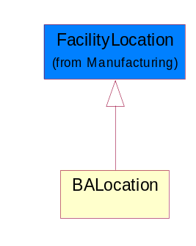
Figure ‎2-3 BALocation

CalcFailReport
A report that catalogs failing calculations that may be performed in determining the result of a test.
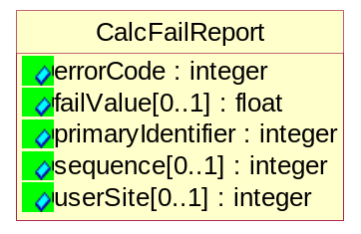
Figure ‎2-4 CalcFailReport

Attribute | Type | Documentation
errorCode | integer | A user defined code for how the calculation failed.
failValue[0..1] | float | The resultant failed value from the calculation test.
primaryIdentifier | integer | A reference back to TestSpecificationReport. This identifier references the electrical attributes only once per lot.
sequence[0..1] | integer | An index indicating at which step of the calculation that it failed.
userSite[0..1] | integer | A user-defined die coordinate represented as an integer which is often associated with the serial number assigned by the tester or prober executive.

Die
Reference optional data attributes to identify die on a wafer.
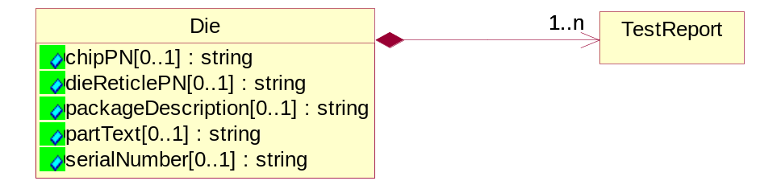
Figure ‎2-5 Die

Attribute | Type | Documentation
chipPN[0..1] | string | A string that describes the part number for the device.
dieReticlePN[0..1] | string | A string which defines the unique part numbers for die associated with a multi-project wafer.
packageDescription[0..1] | string | User definable element for package size (default=mm), package type (string), and pin count (Integer).
partText[0..1] | string | String. A user defined comment field to attach additional die information.
serialNumber[0..1] | string | An alphanumeric string that uniquely defines the numbering of packaged die.

Composition | Cardinality | Type | Documentation
TestReport | 1..n | TestReport | The common report for non-pin data collected at PCM, Wafer Sort and Final Test.

DieReport
References optional information to further identify a die on a wafer.
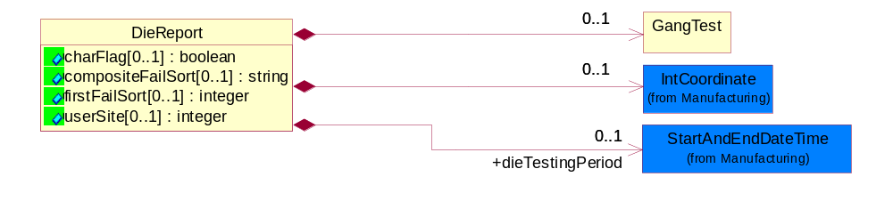
Figure ‎2-6 DieReport

Attribute | Type | Documentation
charFlag[0..1] | boolean | Used as a indicator for the presence of characterization data for a die.
compositeFailSort[0..1] | string | A user initiated failure override of first fail sort to allow for the collection of additional sort fail data. The additional sort fails can be combined in a comma separated list of sort numbers as a composite fail. The compositeFailSort describes the content of the data in the sortID tag.
firstFailSort[0..1] | integer | Described the sort ID for the first fail on the device. See content of data in sortID tag .
userSite[0..1] | integer | A user-defined die coordinate represented as an integer which is often associated with the serial number assigned by the tester or prober executive.

Composition | Cardinality | Type | Documentation
IntCoordinate | 0..1 | IntCoordinate | X, Y and Z Coordinate values.
GangTest | 0..1 | GangTest | Describes the test results for a group of die or packaged units, as in strip testing.
dieTestingPeriod | 0..1 | StartAndEndDateTime | Defines the start and end time for a die being tested.

FabLocation
Describes where the wafer was fabricated.
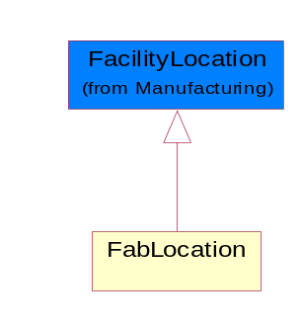
Figure ‎2-7 FabLocation

FinalTest
A test for packaged product that determines that the die functions and performs to the specification. This test also includes parametric and quality sort data.
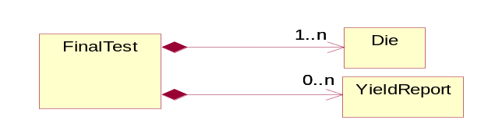
Figure ‎2-8 FinalTest

Composition | Cardinality | Type | Documentation
Die | 1..n | Die | Reference optional data attributes to identify die on a wafer.
YieldReport | 0..n | YieldReport | A report defining the yield from tests at Wafer Sort and Final Test.

FinalTestLocation
Describes where the packaged die was sent for final test.
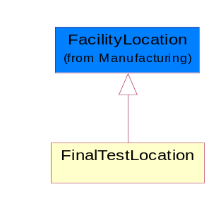
Figure ‎2-9 FinalTestLocation

FPReport
A report that collects functional pin test results. Valid status values are Passed, Failed.
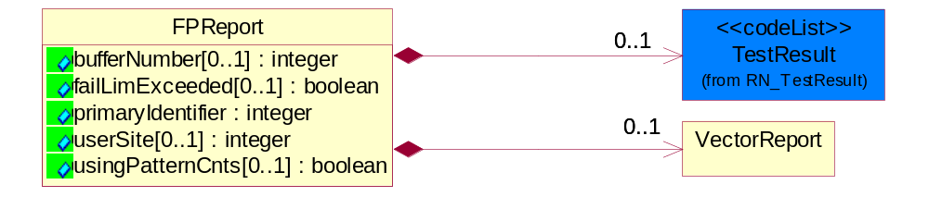
Figure ‎2-10 FPReport

Attribute | Type | Documentation
bufferNumber[0..1] | integer | Pattern buffer number.
failLimExceeded[0..1] | boolean | Flag indicator to whether more fails exists than were datalogged. False = all fails datalogged; True = More fails present.
primaryIdentifier | integer | A reference back to TestSpecificationReport. This identifier references the electrical attributes only once per lot.
userSite[0..1] | integer | A user-defined die coordinate represented as an integer which is often associated with the serial number assigned by the tester or prober executive.
usingPatternCnts[0..1] | boolean | A flag indicator to whether failing addresses or counts were datalogged. True = using pattern counts; False = datalogging vector addresses.

Composition | Cardinality | Type | Documentation
VectorReport | 0..1 | VectorReport | A report for collecting functional results for a single vector or pattern count. Valid status values are: H=actual H, expect unknown L=actual L, expect unknown Z=actual Z, expected unknown A=actual H, expected L B=actual H, expect Z C=actual Z, expect H D=actual Z, expect L E=actual L, expect H F=actual L, expect Z.
TestResult | 0..1 | TestResult | Describes the test result for a parametric test.

FunctionalPinReport
A Pass/Fail per pin report of data logged bit results. Valid status options are: Passed, Failed High Limit, Fail Low Limit, Failed Screened and Failed Censor.
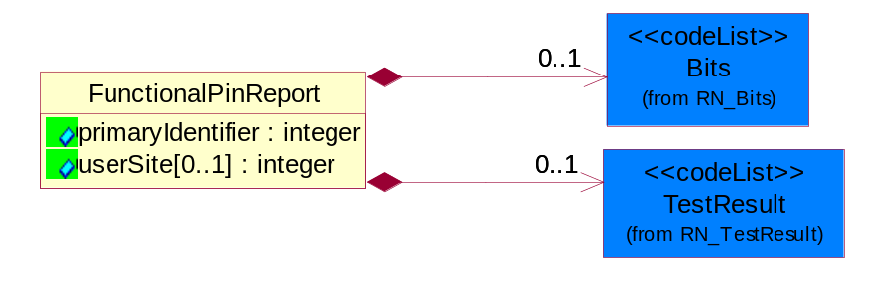
Figure ‎2-11 FunctionalPinReport

Attribute | Type | Documentation
primaryIdentifier | integer | A reference back to TestSpecificationReport. This identifier references the electrical attributes only once per lot.
userSite[0..1] | integer | A user-defined die coordinate represented as an integer which is often associated with the serial number assigned by the tester or prober executive.

Composition | Cardinality | Type | Documentation
Bits | 0..1 | Bits | The value of 0 or 1, which represent On/Off, Pass/Fail or True/False.
TestResult | 0..1 | TestResult | Describes the test result for a parametric test.

GangTest
Describes the test results for a group of die or packaged units, as in strip testing.
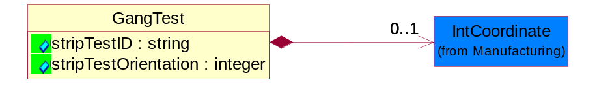
Figure ‎2-12 GangTest

Attribute | Type | Documentation
stripTestID | string | Identify the packaged die numbering on a strip.
stripTestOrientation | integer | Describes the orientation by strip test substrate: Valid values: 0, 90, 180, 270 degrees. Reference SEMI G81, Appendix 2.

Composition | Cardinality | Type | Documentation
IntCoordinate | 0..1 | IntCoordinate | X, Y and Z Coordinate values.

LotReport
A report that is common for reporting data collection for PCM, Wafer Sort and Final Test.
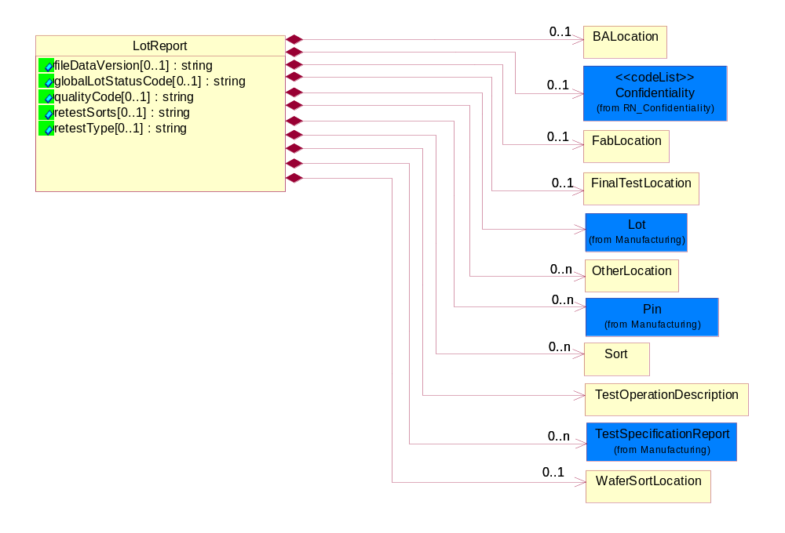
Figure ‎2-13 LotReport

Attribute | Type | Documentation
fileDataVersion[0..1] | string | User defined changes i.e. rules changes to content of data in the data file transfer. Examples: version update to loaders, parsers, or operating system, specification limits etc.
globalLotStatusCode[0..1] | string | Describes lot or sublot status.
qualityCode[0..1] | string | Designate a quality condition of a lot. This can be a proprietary label defined by the Foundry of the Test Services trading partner.
retestSorts[0..1] | string | A list of sort numbers from prior pass that will be retested in this pass.
retestType[0..1] | string | Describes how test data should be combined with prior data for the same LotID, test and level. Valid Options are:  First: Replace all previous data for test and level;  Sorts: Removal of module data from prior pass where sort matches a sort in a prior pass;  Chip: Replaces data on a by chip basis; TestReplace: replaces data on a wafer sort test basis (deletes prior data for wafer or parameter having a non-null retest value.

Composition | Cardinality | Type | Documentation
BALocation | 0..1 | BALocation | Describes where the wafer was sent for bond and assembly.
Confidentiality | 0..1 | Confidentiality | A string which describes the level of security associated with the data, as defined by TPA.
FabLocation | 0..1 | FabLocation | Describes where the wafer was fabricated.
FinalTestLocation | 0..1 | FinalTestLocation | Describes where the packaged die was sent for final test.
Lot | 1 | Lot | Describes the lot information.
OtherLocation | 0..n | OtherLocation | Describes the location where the wafer or packaged die in a lot or sublot was sent for additional fabrication, assembly or testing.  This may be indicated by City, State, Country, Zip Code, DUNS, DUNS+4, or by proprietary label.
Pin | 0..n | Pin | Describes the optional attributes that provide additional pin identification information.
Sort | 0..n | Sort | Contains accumulated count for a sort at Wafer Sort and Final Test.
TestOperationDescription | 1 | TestOperationDescription | Information that describes the manufacturing operation in further detail.
TestSpecificationReport | 0..n | TestSpecificationReport | Report that lists each test and their attributes at PCM, wafer sort and final test. e.g. Test name, electrical conditions, sort number, etc.
WaferSortLocation | 0..1 | WaferSortLocation | Describes where the wafer was sent for wafer sort test.

OtherLocation
Describes the location where the wafer or packaged die in a lot or sublot was sent for additional fabrication, assembly or testing.
This may be indicated by City, State, Country, Zip Code, DUNS, DUNS+4, or by proprietary label.
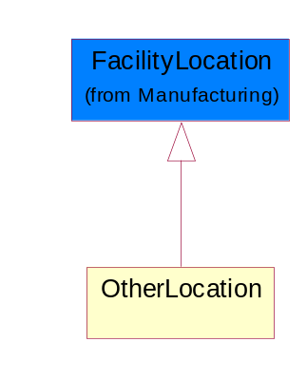
Figure ‎2-14 OtherLocation

PCM
Process Control Monitor: One of the major test modes which collects in-line parametric (electrical) data for the disposition of wafers in the Foundry based on technology criteria.
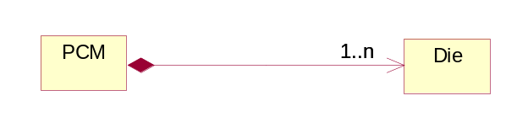
Figure ‎2-15 PCM

Composition | Cardinality | Type | Documentation
Die | 1..n | Die | Reference optional data attributes to identify die on a wafer.

PPReport
A report for datalogged per pin data. Per pin results relate data for tests which measure multiple pins in parallel such as leakage tests.
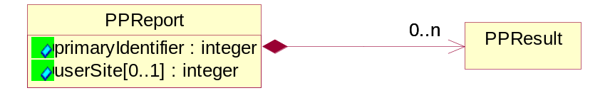
Figure ‎2-16 PPReport

Attribute | Type | Documentation
primaryIdentifier | integer | An integer used as a reference back to TestSpecificationReport. This identifier references the electrical attributes only once per lot.
userSite[0..1] | integer | A user-defined die coordinate represented as an integer which is often associated with the serial number assigned by the tester or prober executive.

Composition | Cardinality | Type | Documentation
PPResult | 0..n | PPResult | A mesurement value for each pin in tests which measure multiple pins in parallel such as leakage tests. Valid status options for this report are: Failed High Limit, Failed Low Limit, Passed, Failed, Screened Value, Failed Censor.

PPResult
A mesurement value for each pin in tests which measure multiple pins in parallel such as leakage tests. Valid status options for this report are: Failed High Limit, Failed Low Limit, Passed, Failed, Screened Value, Failed Censor.
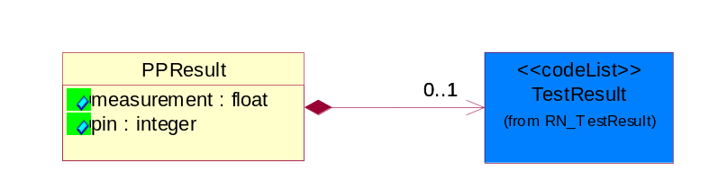
Figure ‎2-17 PPResult

Attribute | Type | Documentation
measurement | float | A data measurement that are collected from each pin measured.
pin | integer | A Pin IDs for each pin measured.

Composition | Cardinality | Type | Documentation
TestResult | 0..1 | TestResult | Describes the test result for a parametric test.

PRReport
A report that data logs parametric test results. The report collects non-per-pin data. Valid status options are: Failed High Limit, Failed Low Limit, Passed, Failed, Screened Value, Failed Censor.
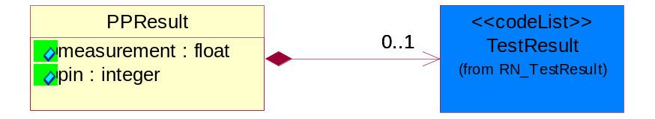
Figure ‎2-18 PRReport

Attribute | Type | Documentation
measurement | float | Measurement in base units.
primaryIdentifier | integer | An integer used as a reference back to TestSpecificationReport. This identifier references the electrical attributes only once per lot.
testerAlarm[0..1] | boolean | An indicator status flag on whether the tester was in alarm during wafer sort or final test.
userSite[0..1] | integer | A user-defined die coordinate represented as an integer which is often associated with the serial number assigned by the tester or prober executive.

Composition | Cardinality | Type | Documentation
TestResult | 0..1 | TestResult | Describes the test result for a parametric test.

SemiconductorTestDataNotification
The message wrapper for SCTDE.
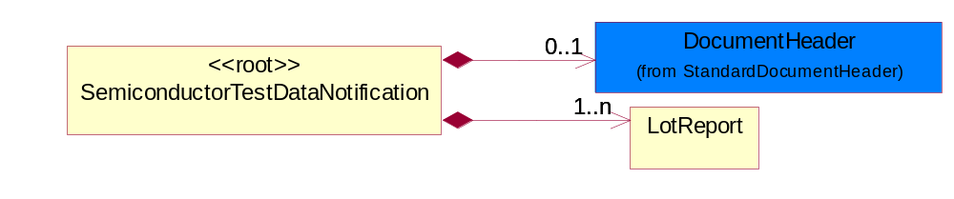
Figure ‎2-19 SemiconductorTestDataNotification

Composition | Cardinality | Type | Documentation
LotReport | 1..n | LotReport | A report that is common for reporting data collection for PCM, Wafer Sort and Final Test.
DocumentHeader | 0..1 | DocumentHeader | The object allows for the identification of the sender and receiver of the business document.

SetupReport
A report that describes setup information for the testing.
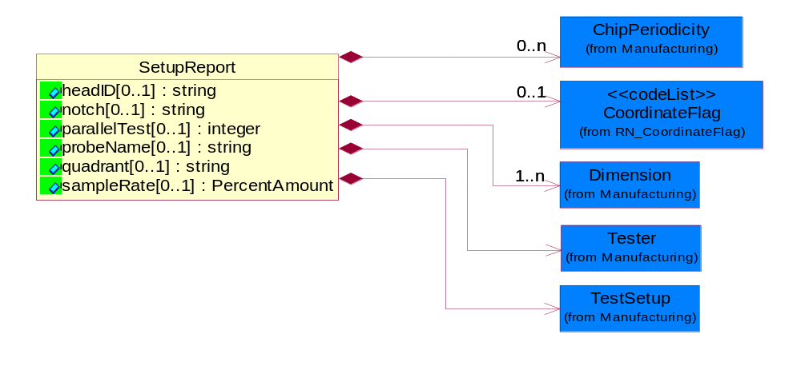

Figure ‎2-20 SetupReport

Attribute | Type | Documentation
headID[0..1] | string | Identifies the test head used for wafer sort and final test.
notch[0..1] | string | Describes the orientation of the wafer notch in a tester: Valid options are: 12 o’clock; 3 o’clock, 6 o’clock, 9 o’clock, notch up, notch down, notch right or notch left, Up=U, Down=D, Left=L, or Right=R, 0, 90, 180 or 270 degrees. Reference SEMI G81, Appendix 1.
parallelTest[0..1] | integer | Tthe number of devices or parallel tests for wafer sort.
probeName[0..1] | string | Describes the probe recipe or pattern file.
quadrant[0..1] | string | A user defined division of the wafer into 4 quadrants. Valid values: I, II, III, IV, Q1,Q2, Q3, Q4, Upper Left, Upper Right, Lower Left, Lower Right and User defined labels. Reference SEMI G81, Appendix 1.
sampleRate[0..1] | PercentAmount | Describes the percentage of die in wafer sort that are being tested under a characterization test plan.

Composition | Cardinality | Type | Documentation
Tester | 1 | Tester | Describe unique tester information for PCM, Wafer Sort and Final Test.
TestSetup | 1 | TestSetup | Describes the identification information for tester set-up.
Dimension | 1..n | Dimension | Describes the dimensional measurement range in X, Y or Z axis.
CoordinateFlag | 0..1 | CoordinateFlag | A status flag to indicate the coordinate measurement is for a single die on a reticle or a multi-chip die on a reticle.
ChipPeriodicity | 0..n | ChipPeriodicity | Dimensional. Describes the distance between devices in micron between established reference points in either the x- and or y-direction on a wafer.

Sort
Contains accumulated count for a sort at Wafer Sort and Final Test.
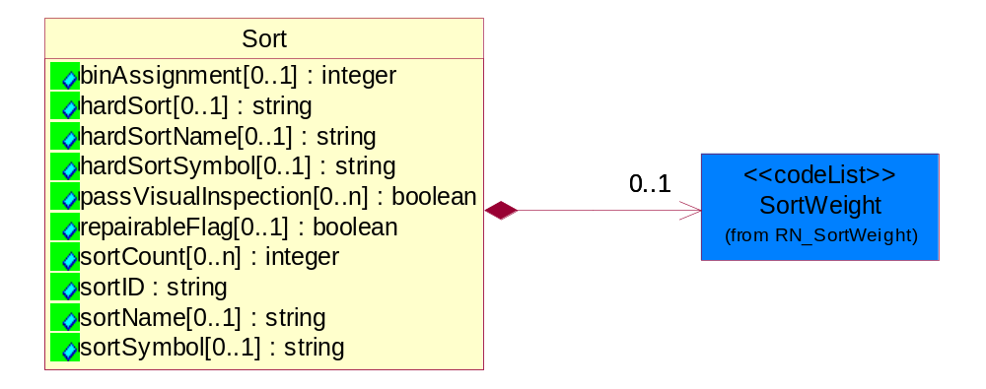
Figure ‎2-21 Sort

Attribute | Type | Documentation
binAssignment[0..1] | integer | A user defined integer designation for hard bins.
hardSort[0..1] | string | Represents the hard sort ID of the Sort test.
hardSortName[0..1] | string | Represents the hard sort name of the Sort Test.
hardSortSymbol[0..1] | string | A user defined grouping of hard sort fails on a wafer map.
passVisualInspection[0..n] | boolean | A user defined pass/fail quality control inspection flag of wafer after wafer sort.
repairableFlag[0..1] | boolean | A flag to indicate if product (die or module) are repairable based on user definition.
sortCount[0..n] | integer | A string that describes the number of counts for each sortID during a test.
sortID | string | The sortid represents the sort name of the Sort Test for which the firstFailSort and compositeFailSort are related to this sort identification.
sortName[0..1] | string | Describes the test in the SortID.
sortSymbol[0..1] | string | A user defined grouping of fails on a wafer map.

Composition | Cardinality | Type | Documentation
SortWeight | 0..1 | SortWeight | A relative representation of yield for a device or module.

TestOperationDescription
Information that describes the manufacturing operation in further detail.
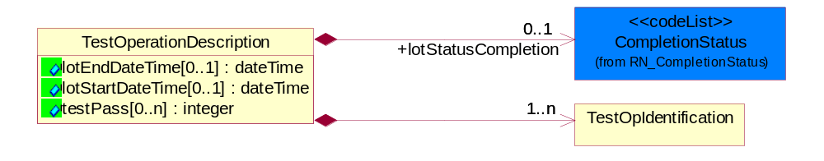
Figure ‎2-22 TestOperationDescription

Attribute | Type | Documentation
lotEndDateTime[0..1] | dateTime | Defines the end time of a lot for a test.
lotStartDateTime[0..1] | dateTime | Defines the start time of the lot for a test.
testPass[0..n] | integer | The number of times a test occurs. The test start and end time needs to be associated with each pass.

Composition | Cardinality | Type | Documentation
TestOpIdentification | 1..n | TestOpIdentification | Describes the manufacturing level of the lot and the test point.
lotStatusCompletion | 0..1 | CompletionStatus | Status completion of lot or sublot at the end of testing.

TestOpIdentification
Describes the manufacturing level of the lot and the test point.
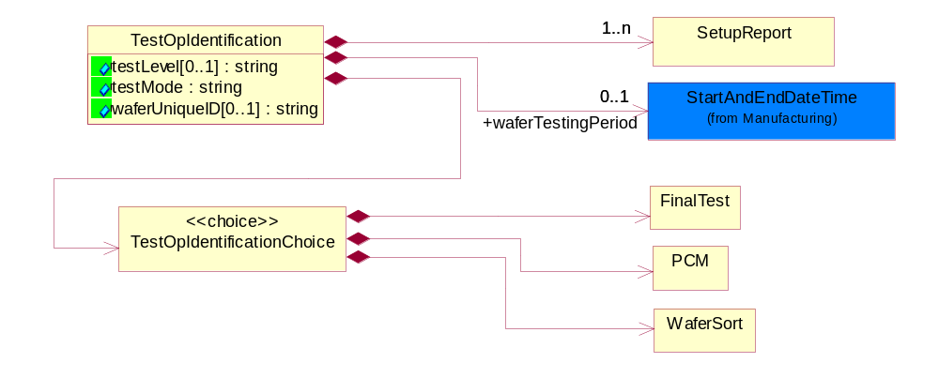
Figure ‎2-23 TestOpIdentification

Attribute | Type | Documentation
testLevel[0..1] | string | A string that describes the test in further detail. Label may change. This is user definable.
testMode | string | A string which is used to identify the type of test: PCM, Wafer Sort or Final Test. Within each major test type their may be multiple tests undertaken for each lot or sublot.
waferUniqueID[0..1] | string | An alphanumeric string which describes the wafer serial number for traceability in a lot or sublot.

Composition | Cardinality | Type | Documentation
TestOpIdentificationChoice | 1 | TestOpIdentificationChoice | A Choice structure for the different type of test mode: PCM, Wafer Sort and Final Test.
SetupReport | 1..n | SetupReport | A report that describes setup information for the testing.
waferTestingPeriod | 0..1 | StartAndEndDateTime | Defines the start and end time for a wafer being tested.

TestOpIdentificationChoice
A Choice structure for the different type of test mode: PCM, Wafer Sort and Final Test.
Composition | Cardinality | Type | Documentation
PCM | 1 | PCM | Process Control Monitor: One of the major test modes which collects in-line parametric (electrical) data for the disposition of wafers in the Foundry based on technology criteria.
FinalTest | 1 | FinalTest | A test for packaged product that determines that the die functions and performs to the specification. This test also includes parametric and quality sort data.
WaferSort | 1 | WaferSort | One of the major test modes which collects data on the electrical performance of the integrated die. The test results may be shared as either reconciled information at the chip summary level or as raw test data. Test results may include parametric measurements and quality sort and/or pass/fail information.

TestReport
The common report for non-pin data collected at PCM, Wafer Sort and Final Test.
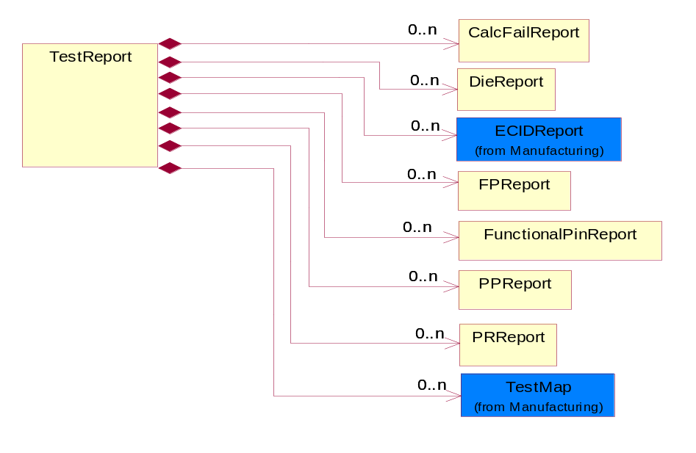
Figure ‎2-24 TestReport

Composition | Cardinality | Type | Documentation
DieReport | 0..n | DieReport | References optional information to further identify a die on a wafer.
PRReport | 0..n | PRReport | A report that data logs parametric test results. The report collects non-per-pin data. Valid status options are: Failed High Limit, Failed Low Limit, Passed, Failed, Screened Value, Failed Censor.
PPReport | 0..n | PPReport | A report for datalogged per pin data. Per pin results relate data for tests which measure multiple pins in parallel such as leakage tests.
FPReport | 0..n | FPReport | A report that collects functional pin test results. Valid status values are Passed, Failed.
FunctionalPinReport | 0..n | FunctionalPinReport | A Pass/Fail per pin report of data logged bit results. Valid status options are: Passed, Failed High Limit, Fail Low Limit, Failed Screened and Failed Censor.
CalcFailReport | 0..n | CalcFailReport | A report that catalogs failing calculations that may be performed in determining the result of a test.
ECIDReport | 0..n | ECIDReport | Report to collect electronic chip ID data.
TestMap | 0..n | TestMap | Describes the wafer orientation and configuration used by manufacturing test (metrology) equipment.

VectorReport
A report for collecting functional results for a single vector or pattern count. Valid status values are: H=actual H, expect unknown L=actual L, expect unknown Z=actual Z, expected unknown A=actual H, expected L B=actual H, expect Z C=actual Z, expect H D=actual Z, expect L E=actual L, expect H F=actual L, expect Z.
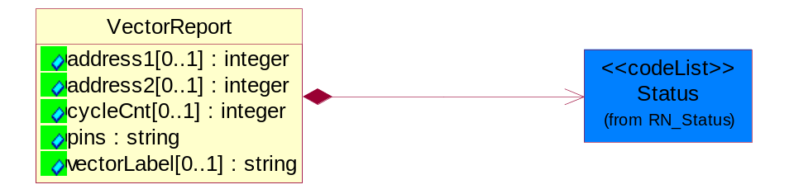
Figure ‎2-25 VectorReport

Attribute | Type | Documentation
address1[0..1] | integer | Failing tester primary address; integer.
address2[0..1] | integer | Failing tester secondary address; integer.
cycleCnt[0..1] | integer | Integer, Cycle count for ABIST/LBIST diagnostic data collection or the T0 count for a pattern.
pins | string | String. Comma separated list of Pin IDs as defined in PinReport.
vectorLabel[0..1] | string | String, Label for failing vector.

Composition | Cardinality | Type | Documentation
Status | 1 | Status | Describes the Status result for a vector test.

WaferSort
One of the major test modes which collects data on the electrical performance of the integrated die. The test results may be shared as either reconciled information at the chip summary level or as raw test data. Test results may include parametric measurements and quality sort and/or pass/fail information.
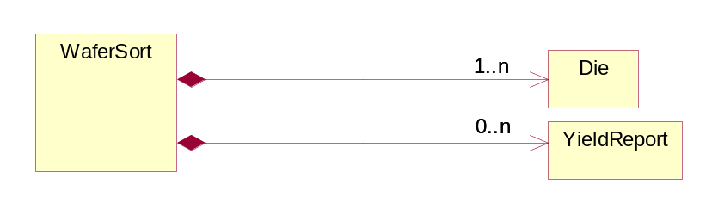
Figure ‎2-26 WaferSort

Composition | Cardinality | Type | Documentation
Die | 1..n | Die | Reference optional data attributes to identify die on a wafer.
YieldReport | 0..n | YieldReport | A report defining the yield from tests at Wafer Sort and Final Test.

WaferSortLocation
Describes where the wafer was sent for wafer sort test.
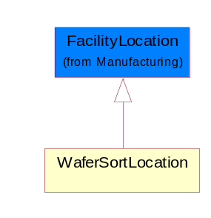
Figure ‎2-27 WaferSortLocation

YieldReport
A report defining the yield from tests at Wafer Sort and Final Test.
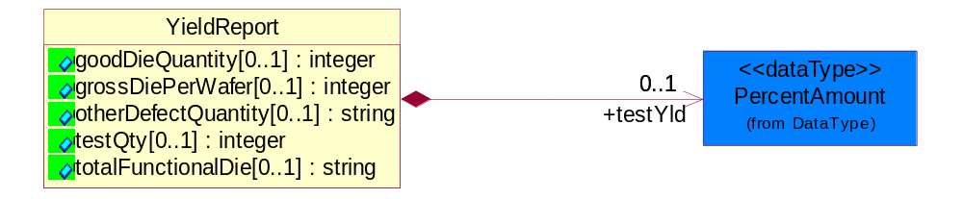
Figure ‎2-28 YieldReport

Attribute | Type | Documentation
goodDieQuantity[0..1] | integer | Integer that describes the number of die or packages that are functional in a lot or sublot.
grossDiePerWafer[0..1] | integer | Integer, Describes the number of complete die on a wafer.
otherDefectQuantity[0..1] | string | String. User defined Quality Control inspection at wafer sort and final test to identify defects. User defined Valid Values.
testQty[0..1] | integer | Used for calculation of yield for die and packaged die for a lot or sublot tested.
totalFunctionalDie[0..1] | string | String. User defined identifier on the level of functionality of die.

Composition | Cardinality | Type | Documentation
testYld | 0..1 | PercentAmount | A TPA defined calculation for yield at wafer sort and final test.

Domain Model

Manufacturing

Manufacturing

Dependency Diagram
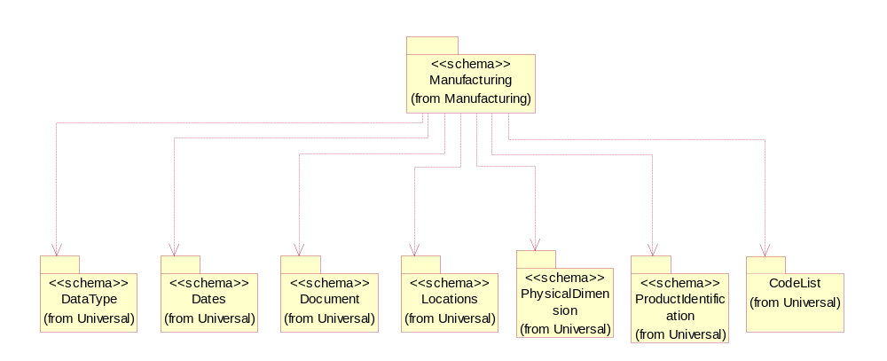
Figure ‎3-29 Dependency

ChipPeriodicity
Dimensional. Describes the distance between devices in micron between established reference points in either the x- and or y-direction on a wafer.
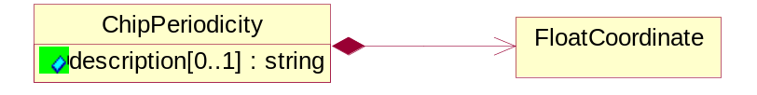
Figure ‎3-30 ChipPeriodicity

Attribute | Type | Documentation
description[0..1] | string | A string that describes the kind of chip periodicity is being defined.

Composition | Cardinality | Type | Documentation
FloatCoordinate | 1 | FloatCoordinate | X, Y and Z Coordinate values.

Dimension
Describes the dimensional measurement range in X, Y or Z axis.
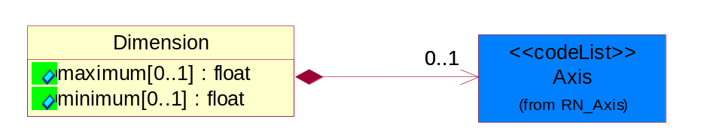
Figure ‎3-31 Dimension

Attribute | Type | Documentation
maximum[0..1] | float | Describes the maximum dimensional measurement for X, Y or Z axis.
minimum[0..1] | float | Describes the minimum dimensional measurement for X, Y or Z axis.

Composition | Cardinality | Type | Documentation
Axis | 0..1 | Axis | Indicate three dimensional direction.

ECIDReport
Report to collect electronic chip ID data.
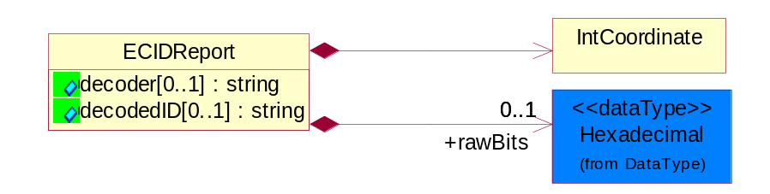
Figure ‎3-32 ECIDReport

Attribute | Type | Documentation
decoder[0..1] | string | Identifies the decoding scheme if ECID is used
decodedID[0..1] | string | Value that could represent waferID or lotID.

Composition | Cardinality | Type | Documentation
rawBits | 0..1 | Hexadecimal | Hexadecimal data type.
IntCoordinate | 1 | IntCoordinate | X, Y and Z Coordinate values.

FacilityLocation
Describes the location where a product is fabricated, manufactured, tested, packaged, etc.
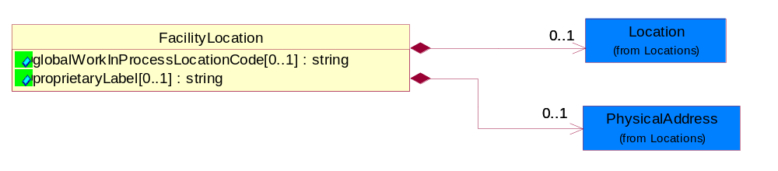
Figure ‎3-33 FacilityLocation

Attribute | Type | Documentation
globalWorkInProcessLocationCode[0..1] | string | References where fabrication, bond, assembly, test and related activities were performed on a lot or sublot.
proprietaryLabel[0..1] | string | User defined label to uniquely identify a facility that is represented in any of the scenarios.

Composition | Cardinality | Type | Documentation
Location | 0..1 | Location | The business document must specify a location.
PhysicalAddress | 0..1 | PhysicalAddress | The business document must provide a physical address for a party to the business transaction.

FloatCoordinate
X, Y and Z Coordinate values.
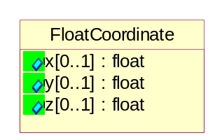
Figure ‎3-34 FloatCoordinate

Attribute | Type | Documentation
x[0..1] | float | Coordinate value for X-axis.
y[0..1] | float | Coordinate value for Y-axis.
z[0..1] | float | Coordinate value for Z-axis.

HardwareSets
Describes the unique attachments, handlers or probers that are associated to the tester.
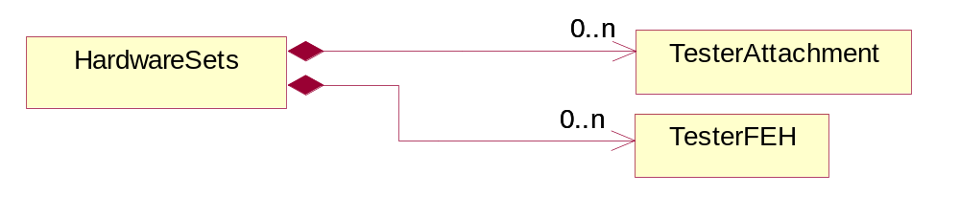
Figure ‎3-35 HardwareSets

Composition | Cardinality | Type | Documentation
TesterAttachment | 0..n | TesterAttachment | Describes the handlers or probers that are attached to the tester.
TesterFEH | 0..n | TesterFEH | Describes the unique Front-End-Hardware (e.g. DUTboards, probes, interposers) that have been used to connect the product to the tester.

IntCoordinate
X, Y and Z Coordinate values.
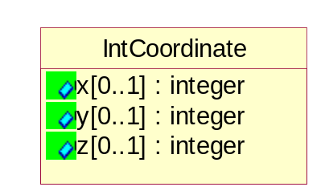
Figure ‎3-36 IntCoordinate

Attribute | Type | Documentation
x[0..1] | integer | Coordinate value for X-axis.
y[0..1] | integer | Coordinate value for Y-axis.
z[0..1] | integer | Coordinate value for Z-axis.

Lot
Describes the lot information.
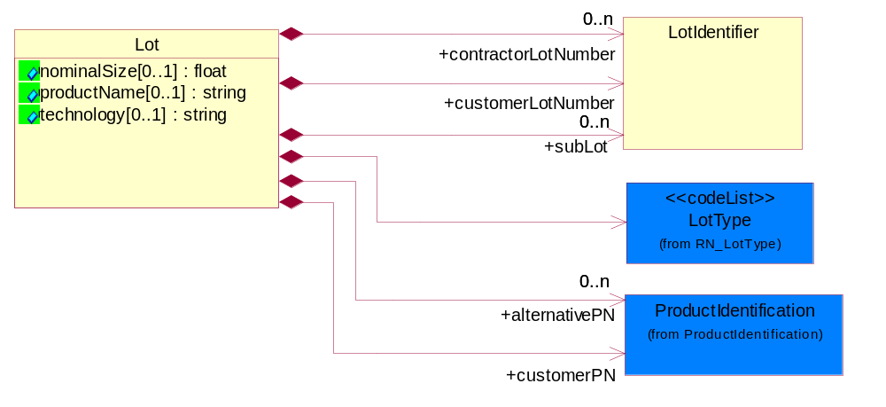
Figure ‎3-37 Lot

Attribute | Type | Documentation
nominalSize[0..1] | float | Describes the diameter of the wafer in mm, or inches.
productName[0..1] | string | A customer defined descriptor or code name for a part being fabricated or tested at a Foundry or Test Service trading partner. Example are Neptune, Big Dog, Antares 6.
technology[0..1] | string | An alphanumeric string that is associated with a fabrication technology. Example. CMOS8SF, MOS-11.

Composition | Cardinality | Type | Documentation
LotType | 1 | LotType | Describes the mode in which product was tested.
customerPN | 1 | ProductIdentification | A string which identifies Foundry defined, the Test Services defined or the customer proprietary defined part number for a wafer or packaged die
alternativePN | 0..n | ProductIdentification | A user defined string to identify a part number for a wafer or packaged die which is associated with customerPN.
customerLotNumber | 1 | LotIdentifier | Customer defined alphanumeric string used to identify the lot
contractorLotNumber | 0..n | LotIdentifier | User defined alphanumeric string which is associated with customer lot number.
subLot | 0..n | LotIdentifier | Alphanumeric string which describes a lot which has been separated from the Lot.

LotIdentifier
Description used to identify a lot
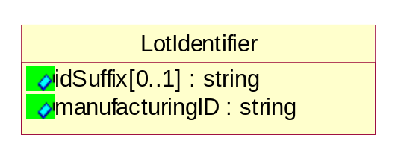
Figure ‎3-38 LotIdentifier

Attribute | Type | Documentation
idSuffix[0..1] | string | An alphanumeric string that could be used to identify a lot at a location. The suffix string is user defined. It can be used to identify a lot split, a bond assembly location, wafer sort or final test location.
manufacturingID | string | Alphanumeric string which describes the lot.

MeasurementUnit
Describes the measurement unit.
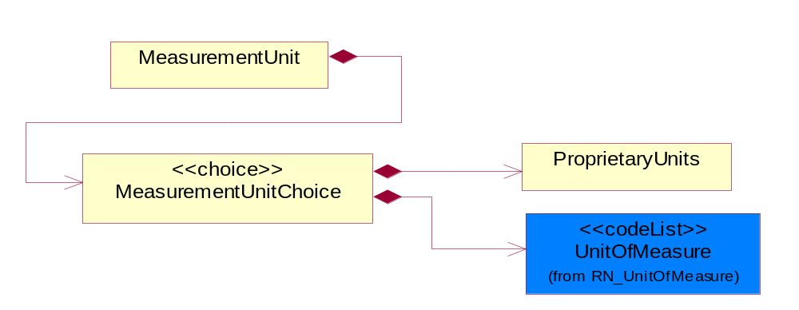
Figure ‎3-39 MeasurementUnit

Composition | Cardinality | Type | Documentation
MeasurementUnitChoice | 1 | MeasurementUnitChoice | Choice structure for describing the unit of measurement.

MeasurementUnitChoice
Choice structure for describing the unit of measurement.

Composition | Cardinality | Type | Documentation
UnitOfMeasure | 1 | UnitOfMeasure | Code identifying a product unit of measure.
ProprietaryUnits | 1 | ProprietaryUnits | Describes a class where the sender defines the units of measure for the test. These units are not listed in code list UnitOfMeasure.

Pin
Describes the optional attributes that provide additional pin identification information.
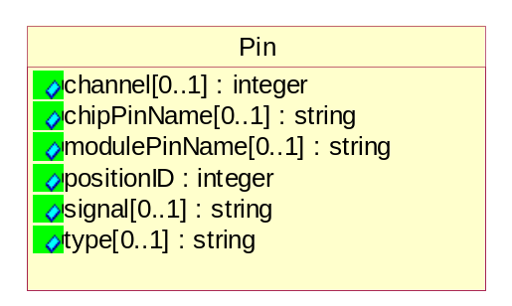
Figure ‎3-40 Pin

Attribute | Type | Documentation
channel[0..1] | integer | Integer, tester channel number.
chipPinName[0..1] | string | Alphanumeric string to describe the name of the pin.
modulePinName[0..1] | string | Alphanumeric string to describe the package pin name.
positionID | integer | Integer to reference ID for pin.
signal[0..1] | string | Alphanumeric string to describes name of signal pin.
type[0..1] | string | Alphanumeric string listing the driver/receiver book types.

ProprietaryUnits
Describes a class where the sender defines the units of measure for the test. These units are not listed in code list UnitOfMeasure.
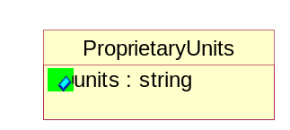
Figure ‎3-41 ProprietaryUnits

Attribute | Type | Documentation
units | string | Special description or code of the units for the measurement value.

StartAndEndDateTime
The start and end date time of a certain period.
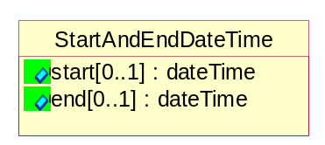
Figure ‎3-42 StartAndEndDateTime

Attribute | Type | Documentation
start[0..1] | dateTime | The start date time of a period.
end[0..1] | dateTime | The end date time of a period.

Tester
Describe unique tester information for PCM, Wafer Sort and Final Test.
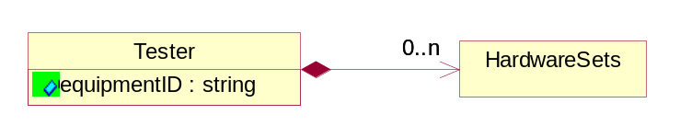
Figure ‎3-43 Tester

Attribute | Type | Documentation
equipmentID | string | An alphanumeric string to identify the tester used at PCM, wafer sort or final test.

Composition | Cardinality | Type | Documentation
HardwareSets | 0..n | HardwareSets | Describes the unique attachments, handlers or probers that are associated to the tester.

TesterAttachment
Describes the handlers or probers that are attached to the tester.
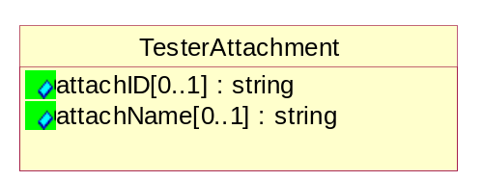
Figure ‎3-44 TesterAttachment

Attribute | Type | Documentation
attachID[0..1] | string | A string that defines the prober handler or any physical device/system that can be attached to the tester used in wafer sort or final test.
attachName[0..1] | string | A string to identify the tools attached to the tester system. e.g. Schlumberger 3100.

TesterFEH
Describes the unique Front-End-Hardware (e.g. DUTboards, probes, interposers) that have been used to connect the product to the tester.
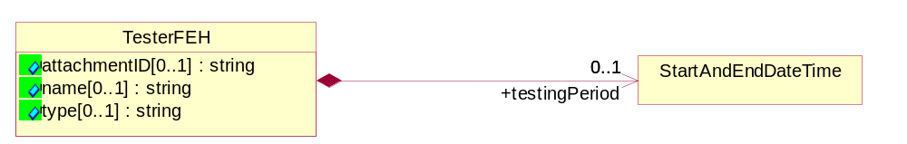
Figure ‎3-45 TesterFEH

Attribute | Type | Documentation
attachmentID[0..1] | string | String. A barcode, electronic ID or alphanumeric identifier for the FEHType used on a tester.
name[0..1] | string | A string that specifically labels the FEH type.
type[0..1] | string | A string that describes the type hardware. It can be an Attachment Sets or FEH (Front End Hardware) that is attached to a tester system. Example: Probe Heads, Sockets, BIB, DIB and user definable attachments.

Composition | Cardinality | Type | Documentation
testingPeriod | 0..1 | StartAndEndDateTime | Defines the start and end time for a wafer being tested.

TestMap
Describes the wafer orientation and configuration used by manufacturing test (metrology) equipment.
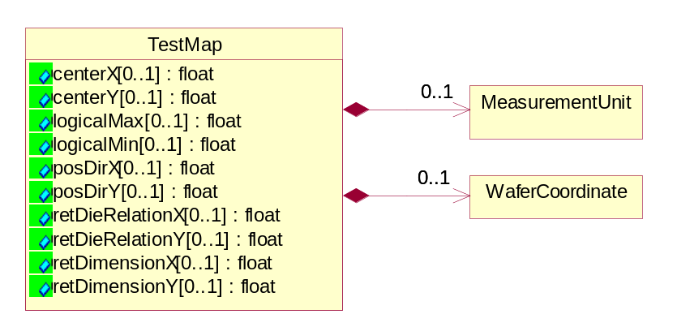
Figure ‎3-46 TestMap

Attribute | Type | Documentation
centerX[0..1] | float | The vector in X direction for index units form the (0,0) coordinate to the index containing the physical center of the wafer. For PCM data the index is reticle steps. For Wafer Sort and Final Test data the index is die steps.
centerY[0..1] | float | The vector in Y direction for index units form the (0,0) coordinate to the index containing the physical center of the wafer. For PCM data the index is reticle steps. For Wafer Sort and Final Test data the index is die steps.
logicalMax[0..1] | float | The logiscal maximum dimensions. For PCM data, units are reticle index steps. For Wafer Sort and Final Test data, units are die index steps.
logicalMin[0..1] | float | The logiscal minimum dimensions. For PCM data, units are reticle index steps. For Wafer Sort and Final Test data, units are die index steps.
posDirX[0..1] | float | The positive direction of the X-axis. Values illustrate Up (U), Down (D), Left (L)and Right (R).
posDirY[0..1] | float | The positive direction of the Y-axis. Values illustrate Up (U), Down (D), Left (L)and Right (R).
retDieRelationX[0..1] | float | The X coordinate of the center die within the center reticle.
retDieRelationY[0..1] | float | The Y coordinate of the center die within the center reticle.
retDimensionX[0..1] | float | The size of the reticle in the X direction , expressed in number of die incements.
retDimensionY[0..1] | float | The size of the reticle in the Y direction , expressed in number of die incements.

Composition | Cardinality | Type | Documentation
MeasurementUnit | 0..1 | MeasurementUnit | Describes the measurement unit.
WaferCoordinate | 0..1 | WaferCoordinate | The collection of business properties that describe the coordinate on a semiconductor wafer.

TestParameter
Describes optional attributes to provide additional information on the parameters of the test.
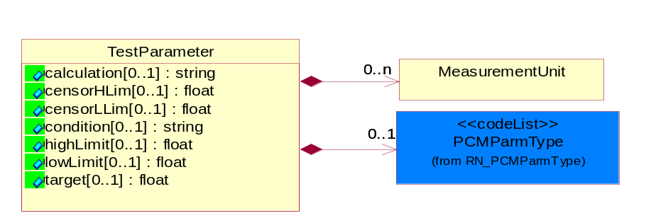
Figure ‎3-47 TestParameter

Attribute | Type | Documentation
calculation[0..1] | string | A string describing the mathematical expression to derive a result.
censorHLim[0..1] | float | FLOAT value for the high boundary for legitimate or valid test data.
censorLLim[0..1] | float | FLOAT value for the low boundary for legitimate or valid test data.
condition[0..1] | string | A string specifying the test parameter. Example: TestTemperature etc.
highLimit[0..1] | float | Describes the high limit value for a test specification.
lowLimit[0..1] | float | Describes the low limit value for a test specification.
target[0..1] | float | Describes the expected value for the test.

Composition | Cardinality | Type | Documentation
MeasurementUnit | 0..n | MeasurementUnit | Describes the measurement unit.
PCMParmType | 0..1 | PCMParmType | Used to identify whether a PCM parameter is part of the wafer acceptance test (WAT) or customer specific parameter (CSP) list. The WAT and CSP list is negotiated between the customer and the foundry for a given technology.

TestSetup
Describes the identification information for tester set-up.
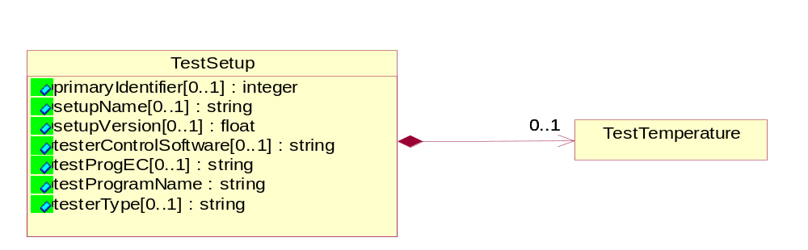
Figure ‎3-48 TestSetup

Attribute | Type | Documentation
primaryIdentifier[0..1] | integer | Reference to link the test report for a lot.
setupName[0..1] | string | A string that describes test conditions.
setupVersion[0..1] | float | Describes the version for the test conditions specified in setupName.
testerControlSoftware[0..1] | string | Describes the software and its version that control the tester.
testProgEC[0..1] | string | A string that indicates the version number for the TestProgName (Req. #43) used for testing a lot or sublot.
testProgramName | string | A string that describes the test program for either a lot or sublot.
testerType[0..1] | string | This object describes the tester model, version and ID number.

Composition | Cardinality | Type | Documentation
TestTemperature | 0..1 | TestTemperature | Temperature value in either Centigrade or Fahrenheit to identify at which a test is performed for lot or sublot.

TestSpecificationReport
Report that lists each test and their attributes at PCM, wafer sort and final test. e.g. Test name, electrical conditions, sort number, etc.
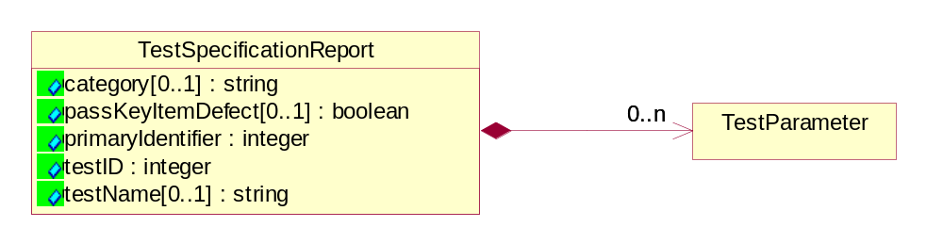
Figure ‎3-49 TestSpecificationReport

Attribute | Type | Documentation
category[0..1] | string | A string that describes a category of tests.
passKeyItemDefect[0..1] | boolean | A flag to identify if a failing parameter is PCM or optional.
primaryIdentifier | integer | Reference to link the test report for a lot.
testID | integer | An integer that uniquely identifies a test.
testName[0..1] | string | A string that describes the test.

Composition | Cardinality | Type | Documentation
TestParameter | 0..n | TestParameter | Describes optional attributes to provide additional information on the parameters of the test.

TestTemperature
Temperature value in either Centigrade or Fahrenheit to identify at which a test is performed for lot or sublot.
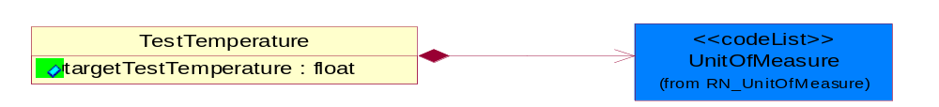
Figure ‎3-50 TestTemperature

Attribute | Type | Documentation
targetTestTemperature | float | The targeted temperature value in either Centigrade or Fahrenheit at which a test is performed for lot or sublot.

Composition | Cardinality | Type | Documentation
UnitOfMeasure | 1 | UnitOfMeasure | Code identifying a product unit of measure.

WaferCoordinate
The collection of business properties that describe the coordinate on a semiconductor wafer.
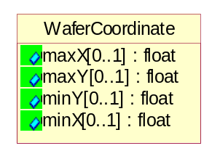
Figure ‎3-51 WaferCoordinate

Attribute | Type | Documentation
maxX[0..1] | float | The maximum X coordinate on a semiconductor wafer.
maxY[0..1] | float | The maximum Y coodinate on a semiconductor wafer.
minY[0..1] | float | The minimum Y coordinate on a semiconductor wafer.
minX[0..1] | float | The minimum X coordinate on a semiconductor wafer.

CodeList

Axis
Indicate three dimensional direction.
Name | Documentation
X | X-axis.
Y | Y-axis.
Z | Z-axis.

PCMParmType
Used to identify whether a PCM parameter is part of the wafer acceptance test (WAT) or customer specific parameter (CSP) list. The WAT and CSP list is negotiated between the customer and the foundry for a given technology.
Name | Documentation
CSP | Customer Specific Parameter.
PSR | Product Specification Limit.
WAT | Wafer Acceptance Test.
WLR | Wafer Level Reliability.

Confidentiality
A string which describes the level of security associated with the data, as defined by TPA.
Name | Documentation
CON | Confidential security level.
NON | No security restriction (None).
RES | Restricted security level.

Bits
The value of 0 or 1, which represent On/Off, Pass/Fail or True/False.
Name | Documentation
0 | Bit value of 0.
1 | Bit value of 1.

Status
Describes the Status result for a vector test.
Name | Documentation
ATH | H=actual H
EHD | expect H D=actual Z
EHF | expect H F=actual L
ELB | expected L B=actual H
ELE | expect L E=actual L
EUA | expected unknown A=actual H
EUL | expect unknown L=actual L
EUZ | expect unknown Z=actual Z
EZC | expect Z C=actual Z
EZZ | expect Z

LotType
Describes the mode in which product was tested.
Name | Documentation
DEV | Development.
ENG | Engineering.
EUH | EUH type.
MFG | Manufacturing.
PLT | Pilot.
PPD | Pre-Production.
PQC | Process Qualification Check.
PRD | Production.
RND | Research and Development.
SVC | Service.
TST | Test.

CoordinateFlag
A status flag to indicate the coordinate measurement is for a single die on a reticle or a multi-chip die on a reticle.
Name | Documentation
MUL | Multi-chip die on a reticle.
SIN | Single Die on a reticle.

SortWeight
A relative representation of yield for a device or module.
Name | Documentation
0 | Bad.
100 | All Good.
25 | 1/4 Good.
50 | 1/2 Good.
75 | 3/4 Good.

CompletionStatus
Describes the status of the lot or sublot at the end of testing.
Name | Documentation
ABO | Aborted: process has been terminated; data is invalid and is purged.
COM | Completed: all process have been completed; data is valid and can be migrated.
SUS | Suspend: process is partially done; data is valid and can be migrated.

TestResult
Describes the test result for a parametric test.
Name | Documentation
FAL | Failed.
FCS | Failed Censor.
FHL | Failed High Limit.
FLL | Failed Low Limit.
PAS | Passed.
SCV | Screened Valued.

Universal Structure

ContactInformation

ContactInformation
The business document must allow for the identification of the name of the department, service or individual to be contacted regarding the context of the business document.
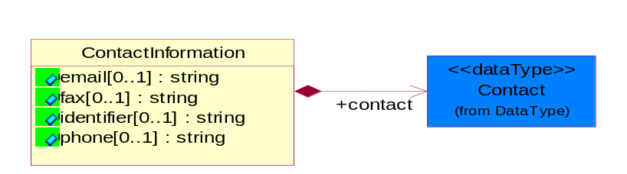
Figure ‎4-52 ContactInformation

Attribute | Type | Documentation
email[0..1] | string | The electronic mail for the specified contact.
fax[0..1] | string | The fax number for the specified contact.
identifier[0..1] | string | Identifies the role of the contact (i.e. Service Technician, Account Manager) in the Business Process.
phone[0..1] | string | The telephone number for the specified contact.

Composition | Cardinality | Type | Documentation
contact | 1 | Contact | The name of the department, service or individual to be contacted within the organization.

DataType

Contact
The name of the department, service or individual to be contacted within the organization.
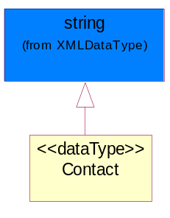
Figure ‎4-53 Contact

DUNS
A number assigned by Dun and Bradstreet to identify a business location.
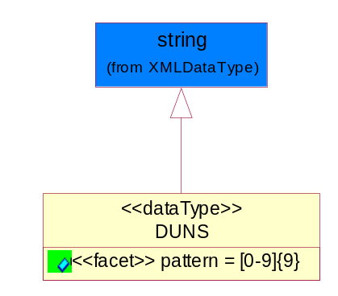
Figure ‎4-54 DUNS

Attribute | Type | Documentation
pattern |  | [0-9]{9}

DUNSPlus4
A identifier to specify a specific location within a business location.
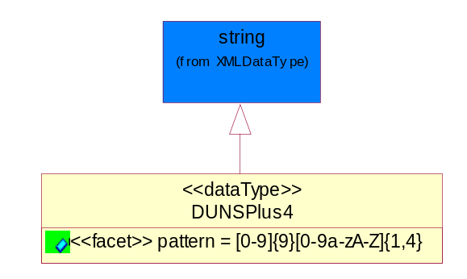
Figure ‎4-55 DUNSPlus4

Attribute | Type | Documentation
pattern |  | Data Universal Numbering System +4 (DUNS+4) number means the DUNS number assigned by Dun and Bradstreet, Inc. (D&B) plus an alphanumeric of length 4 suffix that may be assigned by a business concern.

GLN
Global Location Number (GLN) - A identifier to identify legal entities, trading parties and location.
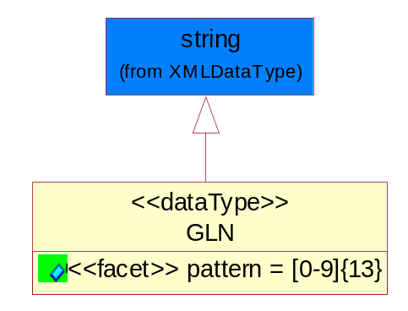
Figure ‎4-56 GLN

Attribute | Type | Documentation
pattern |  | [0-9]{13}

GTIN
Global Trade Identification Number (GTIN).
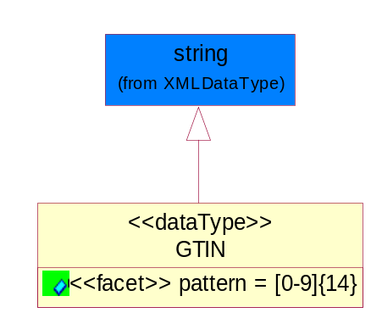
Figure ‎4-57 GTIN

Attribute | Type | Documentation
pattern |  | [0-9]{14}

Hexadecimal
Hexadecimal data type.
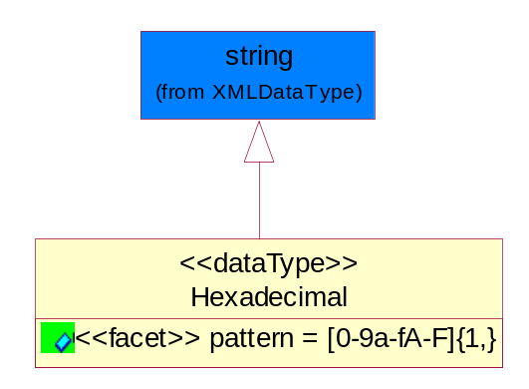
Figure ‎4-58 Hexadecimal

Attribute | Type | Documentation
pattern |  | [0-9a-fA-F]{1,}

PercentAmount
A number representing a percentage value, e.g. 75.125 represents 75 1/8 percent.
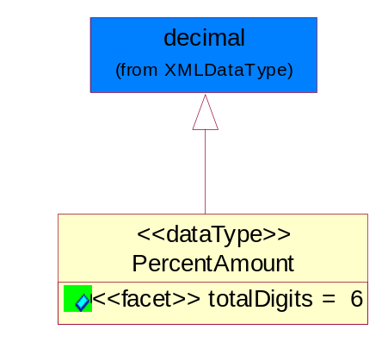
Figure ‎4-59 PercentAmount

Attribute | Type | Documentation
totalDigits |  | 6

Locations

AlternativeIdentifier
Identifies the specified code and the name of the organization that a code is utilized from.
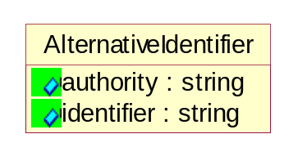
Figure ‎4-60 AlternativeIdentifier

Attribute | Type | Documentation
authority | string | The name of the organization that a code is utilized from.
identifier | string | The specified code to represent an entity (e.g. product, location, partner, etc.).

Location
The business document must specify a location.
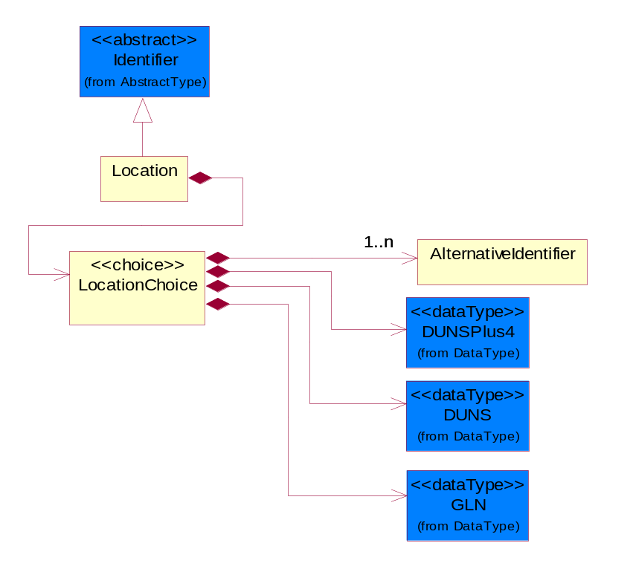
Figure ‎4-61 Location

Composition | Cardinality | Type | Documentation
LocationChoice | 1 | LocationChoice

LocationChoice
Composition | Cardinality | Type | Documentation
DUNSPlus4 | 1 | DUNSPlus4 | A identifier to specify a specific location within a business location.
DUNS | 1 | DUNS | A number assigned by Dun and Bradstreet to identify a business location.
AlternativeIdentifier | 1..n | AlternativeIdentifier | Identifies the specified code and the name of the organization that a code is utilized from.
GLN | 1 | GLN | Global Location Number (GLN) - A identifier to identify legal entities, trading parties and location.

PhysicalAddress
The business document must provide a physical address for a party to the business transaction.
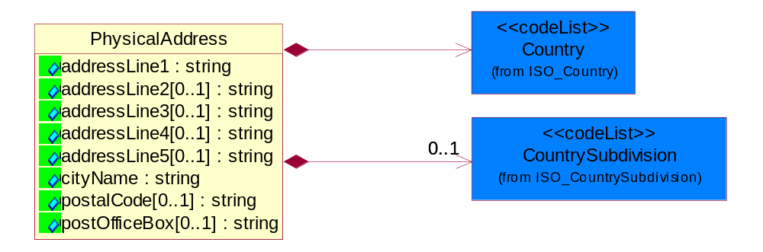
Figure ‎4-62 PhysicalAddress

Attribute | Type | Documentation
addressLine1 | string | The first line of a physical address.
addressLine2[0..1] | string | The second line of a physical address.
addressLine3[0..1] | string | The third line of a physical address.
addressLine4[0..1] | string | The fourth line of a physical address.
addressLine5[0..1] | string | The fifth line of a physical address.
cityName | string | The name of a city.
postalCode[0..1] | string | Identifying geographic location as specified by a national postal code.
postOfficeBox[0..1] | string | The Post Office Box identifier used to identify a party's post office box.

Composition | Cardinality | Type | Documentation
Country | 1 | Country | For representation of Country name RosettaNet has adopted ISO 3166-3; 1999. Refer to the following web page to get the latest version of the standard:  http://www.iso.ch/iso/en/prods-services/iso3166ma/02iso-3166-code-lists/index.html  If you need more information about the ISO standard please contact ISO for more details.
CountrySubdivision | 0..1 | CountrySubdivision | For representation of a Countries subdivisions RosettaNet has adopted ISO 3166-3; 1999. Refer to the following web page to get the latest version of the standard:  http://www.iso.ch/iso/en/prods-services/iso3166ma/02iso-3166-code-lists/index.html  If you need more information about the ISO standard please contact ISO for more details.

PartnerIdentification

PartnerIdentification
The business document must allow for the identity of one or more parties to the transaction.
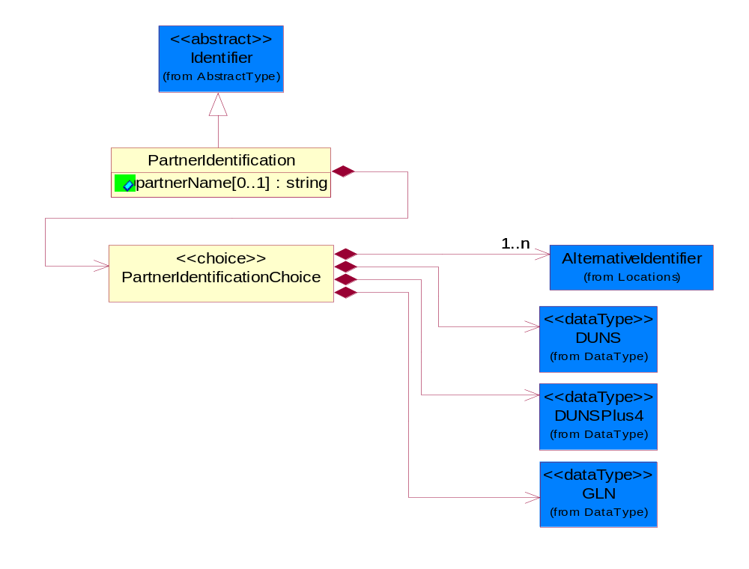
Figure ‎4-63 PartnerIdentification

Attribute | Type | Documentation
partnerName[0..1] | string | The name of the partner’s company/business.

Composition | Cardinality | Type | Documentation
PartnerIdentificationChoice | 1 | PartnerIdentificationChoice

PartnerIdentificationChoice
Composition | Cardinality | Type | Documentation
DUNS | 1 | DUNS | A number assigned by Dun and Bradstreet to identify a business location.
DUNSPlus4 | 1 | DUNSPlus4 | A identifier to specify a specific location within a business location.
AlternativeIdentifier | 1..n | AlternativeIdentifier | Identifies the specified code and the name of the organization that a code is utilized from.
GLN | 1 | GLN | Global Location Number (GLN) - A identifier to identify legal entities, trading parties and location.

ProductIdentification

ProductIdentification
The object provides the identifier(s) of a product.
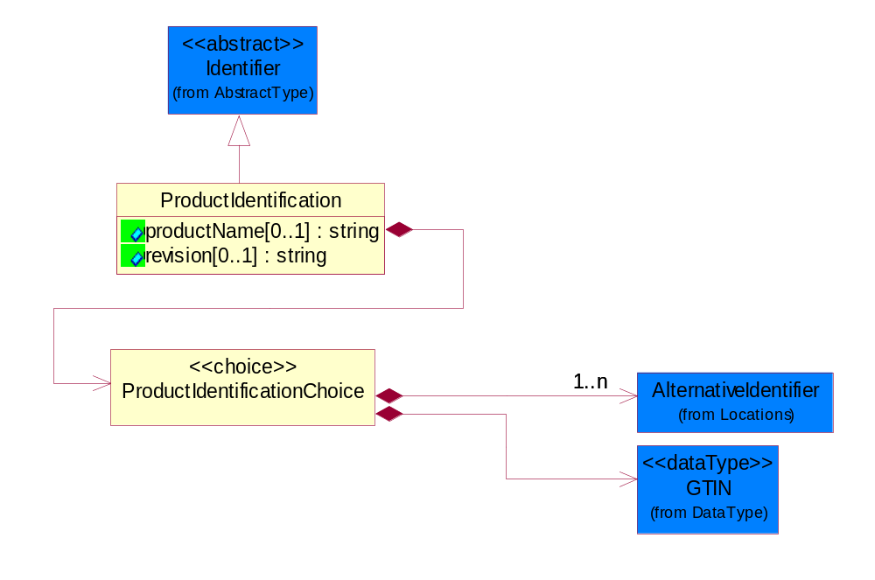
Figure ‎4-64 ProductIdentification

Attribute | Type | Documentation
productName[0..1] | string | The name of the product.
revision[0..1] | string | Referenced the specified product revision.

Composition | Cardinality | Type | Documentation
ProductIdentificationChoice | 1 | ProductIdentificationChoice

ProductIdentificationChoice
Composition | Cardinality | Type | Documentation
AlternativeIdentifier | 1..n | AlternativeIdentifier | Identifies the specified code and the name of the organization that a code is utilized from.
GTIN | 1 | GTIN | Global Trade Identification Number (GTIN).

CodeList

Country
For representation of Country name RosettaNet has adopted ISO 3166-3; 1999. Refer to the following web page to get the latest version of the standard:
http://www.iso.ch/iso/en/prods-services/iso3166ma/02iso-3166-code-lists/index.html

If you need more information about the ISO standard please contact ISO for more details.

CountrySubdivision
For representation of a Countries subdivisions RosettaNet has adopted ISO 3166-3; 1999. Refer to the following web page to get the latest version of the standard:
http://www.iso.ch/iso/en/prods-services/iso3166ma/02iso-3166-code-lists/index.html

If you need more information about the ISO standard please contact ISO for more details.

Language
For representation of Language name RosettaNet has adopted ISO 639-2; 1998. Refer to the following web page to get the latest version of the standard:

http://www.loc.gov/standards/iso639-2/iso639jac.html

If you need more information about the ISO standard please contact ISO for more details.

MimeTypeQualifier
The MIME type as defined by IANA.

Please refer to http://www.iana.org/assignments/media-types/ for a list of types.

Instance | Documentation
application/activemessage | [Shapiro]
application/andrew-inset | [Borenstein]
application/applefile | [Faltstrom]
application/atomicmail | [Borenstein]
application/batch-SMTP | [RFC2442]
application/beep+xml | [RFC3080]
application/cals-1840 | [RFC1895]
application/cnrp+xml | [RFCCNRP]
application/commonground | [Glazer]
application/cpl+xml
application/cybercash | [Eastlake]
application/dca-rft | [Campbell]
application/dec-dx | [Campbell]
application/dicom | [RFC3240]
application/dvcs | [RFC3029]
application/EDI-Consent | [RFC1767]
application/EDIFACT | [RFC1767]
application/EDI-X12 | [RFC1767]
application/eshop | [Katz]
application/font-tdpfr | [RFC3073]
application/http | [RFC2616]
application/hyperstudio | [Domino]
application/iges | [Parks]
application/index | [RFC2652]
application/index.cmd | [RFC2652]
application/index.obj | [RFC2652]
application/index.response | [RFC2652]
application/index.vnd | [RFC2652]
application/iotp | [RFC2935]
application/ipp | [RFC2910]
application/isup | [RFC3204]
application/mac-binhex40 | [Faltstrom]
application/macwriteii | [Lindner]
application/marc | [RFC2220]
application/mathematica | [Van Nostern]
application/msword | [Lindner]
application/news-message-id | [RFC1036,Spencer]
application/news-transmission | [RFC1036, Spencer]
application/ocsp-request | [RFC2560]
application/ocsp-response | [RFC2560]
application/octet-stream | [RFC2045,RFC2046]
application/oda | [RFC2045,RFC2046]
application/ogg | [RFC-walleij-ogg-mediatype-08.txt]
application/parityfec | [RFC3009]
application/pdf | [Lindner]
application/pgp-encrypted | [RFC3156]
application/pgp-keys | [RFC3156]
application/pgp-signature | [RFC3156]
application/pkcs10 | [RFC2311]
application/pkcs7-mime | [RFC2311]
application/pkcs7-signature | [RFC2311]
application/pkix-cert | [RFC2585]
application/pkixcmp | [RFC2510]
application/pkix-crl | [RFC2585]
application/postscript | [RFC2045,RFC2046]
application/prs.alvestrand.titrax-sheet | [Alvestrand]
application/prs.cww | [Rungchavalnont]
application/prs.nprend | [Doggett]
application/prs.plucker | [Janssen]
application/qsig | [RFC3204]
application/reginfo+xml | [RFC-ietf-sipping-reg-event-00.txt]
application/remote-printing | [RFC1486,Rose]
application/riscos | [Smith]
application/rtf | [Lindner]
application/sdp | [RFC2327]
application/set-payment | [Korver]
application/set-payment-initiation | [Korver]
application/set-registration | [Korver]
application/set-registration-initiation | [Korver]
application/sgml | [RFC1874]
application/sgml-open-catalog | [Grosso]
application/sieve | [RFC3028]
application/slate | [Crowley]
application/timestamp-query | [RFC3161]
application/timestamp-reply | [RFC3161]
application/tve-trigger | [Welsh]
application/vemmi | [RFC2122]
application/vnd.3gpp.pic-bw-large | [Meredith]
application/vnd.3gpp.pic-bw-small | [Meredith]
application/vnd.3gpp.pic-bw-var | [Meredith]
application/vnd.3gpp.sms | [Meredith]
application/vnd.3M.Post-it-Notes | [O'Brien]
application/vnd.accpac.simply.aso | [Leow]
application/vnd.accpac.simply.imp | [Leow]
application/vnd.acucobol | [Lubin]
application/vnd.acucorp | [Lubin]
application/vnd.adobe.xfdf | [Perelman]
application/vnd.aether.imp | [Moskowitz]
application/vnd.amiga.ami | [Blumberg]
application/vnd.anser-web-certificate-issue-initiation | [Mori]
application/vnd.anser-web-funds-transfer-initiation | [Mori]
application/vnd.audiograph | [Slusanschi]
application/vnd.blueice.multipass | [Holmstrom]
application/vnd.bmi | [Gotoh]
application/vnd.businessobjects | [Imoucha]
application/vnd.canon-cpdl | [Muto]
application/vnd.canon-lips | [Muto]
application/vnd.cinderella | [Kortenkamp]
application/vnd.claymore | [Simpson]
application/vnd.commerce-battelle | [Applebaum]
application/vnd.commonspace | [Chandhok]
application/vnd.contact.cmsg | [Patz]
application/vnd.cosmocaller | [Dellutri]
application/vnd.ctc-posml | [Kohlhepp]
application/vnd.cups-postscript | [Sweet]
application/vnd.cups-raster | [Sweet]
application/vnd.cups-raw | [Sweet]
application/vnd.curl | [Byrnes]
application/vnd.cybank | [Helmee]
application/vnd.data-vision.rdz | [Fields]
application/vnd.dna | [Searcy]
application/vnd.dpgraph | [Parker]
application/vnd.dreamfactory | [Appleton]
application/vnd.dxr | [Duffy]
application/vnd.ecdis-update | [Buettgenbach]
application/vnd.ecowin.chart | [Olsson]
application/vnd.ecowin.filerequest | [Olsson]
application/vnd.ecowin.fileupdate | [Olsson]
application/vnd.ecowin.series | [Olsson]
application/vnd.ecowin.seriesrequest | [Olsson]
application/vnd.ecowin.seriesupdate | [Olsson]
application/vnd.enliven | [Santinelli]
application/vnd.epson.esf | [Hoshina]
application/vnd.epson.msf | [Hoshina]
application/vnd.epson.quickanime | [Gu]
application/vnd.epson.salt | [Nagatomo]
application/vnd.epson.ssf | [Hoshina]
application/vnd.ericsson.quickcall | [Tidwell]
application/vnd.eudora.data | [Resnick]
application/vnd.fdf | [Zilles]
application/vnd.ffsns | [Holstage]
application/vnd.FloGraphIt | [Floersch]
application/vnd.framemaker | [Wexler]
application/vnd.fsc.weblaunch | [D.Smith]
application/vnd.fujitsu.oasys | [Togashi]
application/vnd.fujitsu.oasys2 | [Togashi]
application/vnd.fujitsu.oasys3 | [Okudaira]
application/vnd.fujitsu.oasysgp | [Sugimoto]
application/vnd.fujitsu.oasysprs | [Ogita]
application/vnd.fujixerox.ddd | [Onda]
application/vnd.fujixerox.docuworks | [Taguchi]
application/vnd.fujixerox.docuworks.binder | [Matsumoto]
application/vnd.fut-misnet | [Pruulmann]
application/vnd.grafeq | [Tupper]
application/vnd.groove-account | [Joseph]
application/vnd.groove-help | [Joseph]
application/vnd.groove-identity-message | [Joseph]
application/vnd.groove-injector | [Joseph]
application/vnd.groove-tool-message | [Joseph]
application/vnd.groove-tool-template | [Joseph]
application/vnd.groove-vcard | [Joseph]
application/vnd.hbci | [Hammann]
application/vnd.hhe.lesson-player | [Jones]
application/vnd.hp-HPGL | [Pentecost]
application/vnd.hp-hpid | [Gupta]
application/vnd.hp-hps | [Aubrey]
application/vnd.hp-PCL | [Pentecost]
application/vnd.hp-PCLXL | [Pentecost]
application/vnd.httphone | [Lefevre]
application/vnd.hzn-3d-crossword | [Minnis]
application/vnd.ibm.afplinedata | [Buis]
application/vnd.ibm.electronic-media | [Tantlinger]
application/vnd.ibm.MiniPay | [Herzberg]
application/vnd.ibm.modcap | [Hohensee]
application/vnd.ibm.secure-container | [Tantlinger]
application/vnd.informix-visionary | [Gales]
application/vnd.intercon.formnet | [Gurak]
application/vnd.intertrust.digibox | [Tomasello]
application/vnd.intertrust.nncp | [Tomasello]
application/vnd.intu.qbo | [Scratchley]
application/vnd.intu.qfx | [Scratchley]
application/vnd.irepository.package+xml | [Knowles]
application/vnd.is-xpr | [Natarajan]
application/vnd.japannet-directory-service | [Fujii]
application/vnd.japannet-jpnstore-wakeup | [Yoshitake]
application/vnd.japannet-payment-wakeup | [Fujii]
application/vnd.japannet-registration | [Yoshitake]
application/vnd.japannet-registration-wakeup | [Fujii]
application/vnd.japannet-setstore-wakeup | [Yoshitake]
application/vnd.japannet-verification | [Yoshitake]
application/vnd.japannet-verification-wakeup | [Fujii]
application/vnd.jisp | [Deckers]
application/vnd.kde.karbon | [Faure]
application/vnd.kde.kchart | [Faure]
application/vnd.kde.kformula | [Faure]
application/vnd.kde.kivio | [Faure]
application/vnd.kde.kontour | [Faure]
application/vnd.kde.kpresenter | [Faure]
application/vnd.kde.kspread | [Faure]
application/vnd.kde.kword | [Faure]
application/vnd.kenameaapp | [DiGiorgio-Haag]
application/vnd.koan | [Cole]
application/vnd.liberty-request+xml | [McDowell]
application/vnd.llamagraphics.life-balance.desktop | [White]
application/vnd.lotus-1-2-3 | [Wattenberger]
application/vnd.lotus-approach | [Wattenberger]
application/vnd.lotus-freelance | [Wattenberger]
application/vnd.lotus-notes | [Laramie]
application/vnd.lotus-organizer | [Wattenberger]
application/vnd.lotus-screencam | [Wattenberger]
application/vnd.lotus-wordpro | [Wattenberger]
application/vnd.mcd | [Gotoh]
application/vnd.mediastation.cdkey | [Flurry]
application/vnd.meridian-slingshot | [Wedel]
application/vnd.micrografx.flo | [Prevo]
application/vnd.micrografx.igx | [Prevo]
application/vnd.mif | [Wexler]
application/vnd.minisoft-hp3000-save | [Bartram]
application/vnd.mitsubishi.misty-guard.trustweb | [Tanaka]
application/vnd.Mobius.DAF | [Kabayama]
application/vnd.Mobius.DIS | [Kabayama]
application/vnd.Mobius.MBK | [Devasia]
application/vnd.Mobius.MQY | [Devasia]
application/vnd.Mobius.MSL | [Kabayama]
application/vnd.Mobius.PLC | [Kabayama]
application/vnd.Mobius.TXF | [Kabayama]
application/vnd.mophun.application | [Wennerstrom]
application/vnd.mophun.certificate | [Wennerstrom]
application/vnd.motorola.flexsuite | [Patton]
application/vnd.motorola.flexsuite.adsi | [Patton]
application/vnd.motorola.flexsuite.fis | [Patton]
application/vnd.motorola.flexsuite.gotap | [Patton]
application/vnd.motorola.flexsuite.kmr | [Patton]
application/vnd.motorola.flexsuite.ttc | [Patton]
application/vnd.motorola.flexsuite.wem | [Patton]
application/vnd.mozilla.xul+xml | [McDaniel]
application/vnd.ms-artgalry | [Slawson]
application/vnd.ms-asf | [Fleischman]
application/vnd.mseq | [Le Bodic]
application/vnd.ms-excel | [Gill]
application/vnd.msign | [Borcherding]
application/vnd.ms-lrm | [Ledoux]
application/vnd.ms-powerpoint | [Gill]
application/vnd.ms-project | [Gill]
application/vnd.ms-tnef | [Gill]
application/vnd.ms-works | [Gill]
application/vnd.ms-wpl | [Plastina]
application/vnd.musician | [Adams]
application/vnd.music-niff | [Butler]
application/vnd.netfpx | [Mutz]
application/vnd.noblenet-directory | [Solomon]
application/vnd.noblenet-sealer | [Solomon]
application/vnd.noblenet-web | [Solomon]
application/vnd.novadigm.EDM | [Swenson]
application/vnd.novadigm.EDX | [Swenson]
application/vnd.novadigm.EXT | [Swenson]
application/vnd.obn | [Hessling]
application/vnd.osa.netdeploy | [Klos]
application/vnd.palm | [Peacock]
application/vnd.pg.format | [Gandert]
application/vnd.pg.osasli | [Gandert]
application/vnd.powerbuilder6 | [Guy]
application/vnd.powerbuilder6-s | [Guy]
application/vnd.powerbuilder7 | [Shilts]
application/vnd.powerbuilder75 | [Shilts]
application/vnd.powerbuilder75-s | [Shilts]
application/vnd.powerbuilder7-s | [Shilts]
application/vnd.previewsystems.box | [Smolgovsky]
application/vnd.publishare-delta-tree | [Ben-Kiki]
application/vnd.pvi.ptid1 | [Lamb]
application/vnd.pwg-multiplexed | [RFC3391]
application/vnd.pwg-xhtml-print+xml | [Wright]
application/vnd.Quark.QuarkXPress | [Scheidler]
application/vnd.rapid | [Szekely]
application/vnd.s3sms | [Tarkkala]
application/vnd.sealed.net | [Lambert]
application/vnd.seemail | [Webb]
application/vnd.shana.informed.formdata | [Selzler]
application/vnd.shana.informed.formtemplate | [Selzler]
application/vnd.shana.informed.interchange | [Selzler]
application/vnd.shana.informed.package | [Selzler]
application/vnd.smaf | [Takahashi]
application/vnd.sss-cod | [Dani]
application/vnd.sss-dtf | [Bruno]
application/vnd.sss-ntf | [Bruno]
application/vnd.street-stream | [Levitt]
application/vnd.svd | [Becker]
application/vnd.swiftview-ics | [Widener]
application/vnd.triscape.mxs | [Simonoff]
application/vnd.trueapp | [Hepler]
application/vnd.truedoc | [Chase]
application/vnd.ufdl | [Manning]
application/vnd.uplanet.alert | [Martin]
application/vnd.uplanet.alert-wbxml | [Martin]
application/vnd.uplanet.bearer-choice | [Martin]
application/vnd.uplanet.bearer-choice-wbxml | [Martin]
application/vnd.uplanet.cacheop | [Martin]
application/vnd.uplanet.cacheop-wbxml | [Martin]
application/vnd.uplanet.channel | [Martin]
application/vnd.uplanet.channel-wbxml | [Martin]
application/vnd.uplanet.list | [Martin]
application/vnd.uplanet.listcmd | [Martin]
application/vnd.uplanet.listcmd-wbxml | [Martin]
application/vnd.uplanet.list-wbxml | [Martin]
application/vnd.uplanet.signal | [Martin]
application/vnd.vcx | [T.Sugimoto]
application/vnd.vectorworks | [Pharr]
application/vnd.vidsoft.vidconference | [Hess]
application/vnd.visio | [Sandal]
application/vnd.visionary | [Aravindakumar]
application/vnd.vividence.scriptfile | [Risher]
application/vnd.vsf | [Rowe]
application/vnd.wap.sic | [WAP-Forum]
application/vnd.wap.slc | [WAP-Forum]
application/vnd.wap.wbxml | [Stark]
application/vnd.wap.wmlc | [Stark]
application/vnd.wap.wmlscriptc | [Stark]
application/vnd.webturbo | [Rehem]
application/vnd.wrq-hp3000-labelled | [Bartram]
application/vnd.wt.stf | [Wohler]
application/vnd.wv.csp+wbxml | [Salmi]
application/vnd.xara | [Matthewman]
application/vnd.xfdl | [Manning]
application/vnd.yellowriver-custom-menu | [Yellow]
application/whoispp-query | [RFC2957]
application/whoispp-response | [RFC2958]
application/wita | [Campbell]
application/wordperfect5.1 | [Lindner]
application/x400-bp | [RFC1494]
application/xhtml+xml | [RFC3236]
application/xml | [RFC3023]
application/xml-dtd | [RFC3023]
application/xml-external-parsed-entity | [RFC3023]
application/zip | [Lindner]
audio/32kadpcm | [RFC2421,RFC2422]
audio/AMR | [RFC3267]
audio/AMR-WB | [RFC3267]
audio/basic | [RFC2045,RFC2046]
audio/CN | [RFC3389]
audio/DAT12 | [RFC3190]
audio/DVI4
audio/EVRC | [RFC-ietf-avt-evrc-smv-03.txt]
audio/EVRC0 | [RFC-ietf-avt-evrc-smv-03.txt]
audio/G.722.1 | [RFC3047]
audio/G722
audio/G723
audio/G726-16
audio/G726-24
audio/G726-32
audio/G726-40
audio/G728
audio/G729
audio/G729D
audio/G729E
audio/GSM
audio/GSM-EFR
audio/L16 | [RFC2586]
audio/L20 | [RFC3190]
audio/L24 | [RFC3190]
audio/L8
audio/LPC
audio/MP4A-LATM | [RFC3016]
audio/MPA
audio/mpa-robust | [RFC3119]
audio/mpeg | [RFC3003]
audio/parityfec | [RFC3009]
audio/PCMA
audio/PCMU
audio/prs.sid | [Walleij]
audio/QCELP
audio/RED
audio/SMV | [RFC-ietf-avt-evrc-smv-03.txt]
audio/SMV0 | [RFC-ietf-avt-evrc-smv-03.txt]
audio/telephone-event | [RFC2833]
audio/tone | [RFC2833]
audio/VDVI
audio/vnd.3gpp.iufp | [Belling]
audio/vnd.cisco.nse | [Kumar]
audio/vnd.cns.anp1 | [McLaughlin]
audio/vnd.cns.inf1 | [McLaughlin]
audio/vnd.digital-winds | [Strazds]
audio/vnd.everad.plj | [Cicelsky]
audio/vnd.lucent.voice | [Vaudreuil]
audio/vnd.nortel.vbk | [Parsons]
audio/vnd.nuera.ecelp4800 | [Fox]
audio/vnd.nuera.ecelp7470 | [Fox]
audio/vnd.nuera.ecelp9600 | [Fox]
audio/vnd.octel.sbc | [Vaudreuil]
audio/vnd.qcelp | [Lundblade]
audio/vnd.rhetorex.32kadpcm | [Vaudreuil]
audio/vnd.vmx.cvsd | [Vaudreuil]
image/cgm | Computer Graphics Metafile
image/g3fax | [RFC1494]
image/gif | [RFC2045,RFC2046]
image/ief | [RFC1314] Image Exchange Format
image/jpeg | [RFC2045,RFC2046]
image/naplps | [Ferber]
image/png | [Randers-Pehrson]
image/prs.btif | [Simon]
image/prs.pti | [Laun]
image/t38 | [RFC3362]
image/tiff | [RFC3302] Tag Image File Format
image/tiff-fx | [RFC3250] Tag Image File Format Fax eXtended
image/vnd.cns.inf2 | [McLaughlin]
image/vnd.djvu | [Bottou]
image/vnd.dwg | [Moline]
image/vnd.dxf | [Moline]
image/vnd.fastbidsheet | [Becker]
image/vnd.fpx | [Spencer]
image/vnd.fst | [Fuldseth]
image/vnd.fujixerox.edmics-mmr | [Onda]
image/vnd.fujixerox.edmics-rlc | [Onda]
image/vnd.globalgraphics.pgb | [Bailey]
image/vnd.mix | [Reddy]
image/vnd.ms-modi | [Vaughan]
image/vnd.net-fpx | [Spencer]
image/vnd.svf | [Moline]
image/vnd.wap.wbmp | [Stark]
image/vnd.xiff | [S.Martin]
message/delivery-status | [RFC1894]
message/disposition-notification | [RFC2298]
message/external-body | [RFC2045,RFC2046]
message/http | [RFC2616]
message/news | [RFC 1036, H.Spencer]
message/partial | [RFC2045,RFC2046]
message/rfc822 | [RFC2045,RFC2046]
message/s-http | [RFC2660]
message/sip | [RFC3261]
message/sipfrag | [RFC3420]
model/iges | [Parks]
model/mesh | [RFC2077]
model/vnd.dwf | [Pratt]
model/vnd.flatland.3dml | [Powers]
model/vnd.gdl | [Babits]
model/vnd.gs-gdl | [Babits]
model/vnd.gtw | [Ozaki]
model/vnd.mts | [Rabinovitch]
model/vnd.parasolid.transmit.binary | [Parasolid]
model/vnd.parasolid.transmit.text | [Parasolid]
model/vnd.vtu | [Rabinovitch]
model/vrml | [RFC2077]
multipart/alternative | [RFC2045,RFC2046]
multipart/appledouble | [Faltstrom]
multipart/byteranges | [RFC2068]
multipart/digest | [RFC2045,RFC2046]
multipart/encrypted | [RFC1847]
multipart/form-data | [RFC2388]
multipart/header-set | [Crocker]
multipart/mixed | [RFC2045,RFC2046]
multipart/parallel | [RFC2045,RFC2046]
multipart/related | [RFC2387]
multipart/report | [RFC1892]
multipart/signed | [RFC1847]
multipart/voice-message | [RFC2421,RFC2423]
text/calendar | [RFC2445]
text/css | [RFC2318]
text/directory | [RFC2425]
text/enriched | [RFC1896]
text/html | [RFC2854]
text/parityfec | [RFC3009]
text/plain | [RFC2646,RFC2046]
text/prs.lines.tag | [Lines]
text/rfc822-headers | [RFC1892]
text/richtext | [RFC2045,RFC2046]
text/rtf | [Lindner]
text/sgml | [RFC1874]
text/t140 | [RFC2793]
text/tab-separated-values | [Lindner]
text/uri-list | [RFC2483]
text/vnd.abc | [Allen]
text/vnd.curl | [Byrnes]
text/vnd.DMClientScript | [Bradley]
text/vnd.fly | [Gurney]
text/vnd.fmi.flexstor | [Hurtta]
text/vnd.in3d.3dml | [Powers]
text/vnd.in3d.spot | [Powers]
text/vnd.IPTC.NewsML | [IPTC]
text/vnd.IPTC.NITF | [IPTC]
text/vnd.latex-z | [Lubos]
text/vnd.motorola.reflex | [Patton]
text/vnd.ms-mediapackage | [Nelson]
text/vnd.net2phone.commcenter.command | [Xie]
text/vnd.sun.j2me.app-descriptor | [G.Adams]
text/vnd.wap.si | [WAP-Forum]
text/vnd.wap.sl | [WAP-Forum]
text/vnd.wap.wml | [Stark]
text/vnd.wap.wmlscript | [Stark]
text/xml | [RFC3023]
text/xml-external-parsed-entity | [RFC3023]
video/BMPEG
video/BT656
video/CelB
video/DV | [RFC3189]
video/H261
video/H263
video/H263-1998
video/H263-2000
video/JPEG
video/MP1S
video/MP2P
video/MP2T
video/MP4V-ES | [RFC3016]
video/mpeg | [RFC2045,RFC2046]
video/MPV
video/nv
video/parityfec | [RFC3009]
video/pointer | [RFC2862]
video/quicktime | [Lindner]
video/SMPTE292M | [RFC-avt-smpte292-video-08.txt]
video/vnd.fvt | [Fuldseth]
video/vnd.motorola.video | [McGinty]
video/vnd.motorola.videop | [McGinty]
video/vnd.mpegurl | [Recktenwald]
video/vnd.nokia.interleaved-multimedia | [Kangaslampi]
video/vnd.objectvideo | [Clark]
video/vnd.vivo | [Wolfe]

UnitOfMeasure
Code identifying a product unit of measure.

Instance | Documentation
10P | 10-pack.
1BF | 100 Board Feet.
1FC | 20 Foot Container.
1GR | Gram/Cubic Centimeter.
1GT | 10,000 Gallon Tankcar.
1KB | 25 Kilogram Bulk Bag.
1KD | 10 Kilogram Drum.
1KP | 1000-pack.
1PA | 20-Pack.
1PB | 50 Pound Bag.
1PD | 100 Pound Drum.
2FC | 40 Foot Container.
2GR | Gram/square meter.
2GT | 20,000 Gallon Tankcar.
2KB | 300 Kilogram Bulk Bag.
2KD | 15 Kilogram Drum.
2PA | 100-Pack.
3GR | Grams Per 100 Centimeters.
3KB | 500 Kilogram Bulk Bag.
3KD | 55 Gallon Drum.
4GR | Grams Per 100 Grams.
4KD | 115 Kilogram Drum.
50P | 50-pack.
5GR | Grams Per Cubic Centimeter.
6GR | Grams Per Square Centimeter.
7GR | Grams Per Square Meter.
ACR | Acre.
ACT | Actual Pounds.
ALU | Aluminum Pounds Only.
AMP | Ampere.
ASM | Angstrom.
BAB | Base Box.
BAC | Batch.
BAE | Bale.
BAG | Bag.
BAL | Ball.
BAN | Band.
BAP | Batting Pound.
BAR | Bar.
BAS | Basket.
BAT | Batt.
BAW | Base Weight.
BEA | Beam.
BEC | Becquerel/kilogram.
BEL | Belt.
BIL | Billet.
BIN | Bin.
BIT | Bit.
BKC | Bulk Car Load.
BLO | Block.
BOA | Board.
BOF | Board Feet.
BOL | Bolt.
BOT | Bottle.
BOX | Box.
BRD | Barrels Per Day.
BRE | Barrel.
BRI | Barrel (Imperial).
BRM | Barrels Per Minute.
BTF | British Thermal Units (BTUs) Per Cubic Foot.
BTP | British Thermal Units (BTUs) Per Pound.
BTU | British Thermal Unit (BTU).
BUC | Bucket.
BUD | Bushel, Dry Imperial.
BUK | Bunks.
BUL | Bulk.
BUN | Bundle.
BUP | Bulk Pack.
BUS | Bushel.
BYT | Bytes.
CAA | Carat.
CAB | Carboy.
CAC | Card.
CAD | Candela.
CAG | Cartridge.
CAK | Cask.
CAL | Calorie.
CAN | Can.
CAO | Carload.
CAR | Car.
CAS | Case.
CAT | Canister.
CAW | Catchweight.
CEL | Cell.
CEM | Centimeter.
CEP | Centipoise (CPS).
CET | Centiliter.
CGM | Centigram.
CHA | Chains (Land Survey).
CHE | Chest.
CNN | Connector.
COG | Coil Group.
COI | Coil.
COL | Coulomb.
COM | Composite Product Pounds (Total Weight).
CON | Cone.
COT | Container.
COV | Cover.
CRA | Crate.
CRT | Carton.
CSE | Cassette.
CUB | Cubic centimeter.
CUC | Cubic centimeter/second.
CUF | Cubic Foot.
CUI | Cubic inch.
CUM | Cubicmeter.
CUP | Cup.
CUY | Cubic yard.
CYC | Cycles.
CYL | Cylinder.
DAY | Day.
DCB | Decibels.
DCG | Decagram.
DCL | Deciliter.
DEA | Deal.
DEC | Decimeter.
DEF | Degree Fahrenheit.
DEG | Degree Celsius.
DEP | Dep. Factor.
DGM | Decigram.
DIE | Die.
DIL | Display.
DIP | Dispenser.
DOZ | Dozen.
DRA | Dram.
DRU | Drum.
DRY | Dry Pounds.
EAC | Each.
ELE | Electrical Capacitance.
FAR | Farads.
FFA | Femtofarad.
FLO | Fluid Ounce.
FOI | Fluid Ounce (Imperial).
FOO | Foot.
FOU | Fluid Ounce US.
FUU | Fuel Usage (Gallons).
GAL | Gallon.
GAS | Gage Systems.
GIH | Gigahertz.
GIJ | Gigajoules.
GIL | Gill (Imperial).
GOB | Gross Barrels.
GOG | Gross Gallons.
GOK | Gross Kilogram.
GOT | Gross Ton.
GOY | Gross Yard.
GRA | Gram.
GRG | Great Gross (Dozen Gross).
GRK | Grams Per Kilogram.
GRL | Grams Per Liter.
GRM | Grams Per Milliliter.
GRN | Grain.
GRO | Gross.
GRP | Group.
HAG | Half Gallon.
HAH | Half Hour.
HAL | Half Liter.
HAN | Hank.
HEA | Heat lots.
HEC | Hectare.
HEL | Hectoliter.
HEP | Hectopascal.
HER | Hertz.
HNY | Henry.
HOS | Hours.
HOU | Hour.
HUA | Hundredth of a Carat.
HUB | Hundred Boxes.
HUC | Hundred Count.
HUS | Hundred Sheets.
IMG | Imperial Gallons.
INC | Inch.
JAR | Jar.
JOI | Joint.
JOU | Joule.
KBY | Kilobyte.
KEG | Keg.
KEL | Kelvin.
KHO | Kilometer/hour.
KIC | Kilogram per cubic meter.
KIE | Kilometer.
KIG | Kilogram.
KIH | Kilohertz.
KIK | Kilobecquerel/Kilogram.
KIL | Kiloampere.
KIM | Kilogram/square meter.
KIO | Kiloohm.
KIS | Kilogramm pro Sekunde.
KIT | Kit.
KIV | Kilovolt.
KIW | Kilowatt.
KJL | Kilojoule.
KKG | Kilogram/Kilogram.
KUD | Kubikdezimeter.
KUM | Kubikmeter pro Sekunde.
KWH | Kilowatt-hour.
LIF | Lifts.
LIM | Link.
LIQ | Liquid Pounds.
LIT | Liter.
LOA | Load.
LOT | Lot.
LUG | Lug.
MAM | Milliamps/mm.
MAT | Mat.
MBY | Megabyte.
MCG | Microgram.
MCM | Milligrams Per Cubic Meter.
MCR | Micron.
MEG | Megagram.
MEH | Megahertz.
MEP | Megapascal.
MET | Meter.
MEW | Megawatt.
MGM | Milligram.
MIB | Million BTU's.
MIC | Mikrogram/cubic meter.
MIG | Micrograms Per Cubic Meter.
MIL | Mile.
MIM | Micrometer.
MIN | Minute.
MIP | Millipascal seconds.
MIS | Microsecond.
MIT | Miter.
MIV | Millivolt.
MIW | Milliwatt.
MJO | Millijoule.
MLA | Milliampere.
MLB | Millibar.
MLC | Milligram/cubic meter.
MLI | Milliliter.
MLK | Milligram/kilogram.
MLL | Milligram/Liter.
MLS | Miles.
MME | Millimeter.
MMH | Millimeter H20.
MMK | Millimol/kilogram.
MMO | Millimol.
MOK | Mol/kilogram.
MOL | Mol.
MON | Month.
MPH | Megagrams Per Hour.
MSC | Millisecond.
MSM | Milligrams Per Square Meter.
MTA | Millitesla.
MTQ | Meter pro Quadratsekunde.
MTS | Meters per second.
MUL | Multichip - When 2 or more dies (chips) are merged into one package.
MVS | Millivolts.
MVT | Millivolt.
NAA | Nanoamps.
NAM | Nanometer.
NAS | Nanosecond.
NEB | Net Barrels.
NEG | Net Gallons.
NEI | Net Imperial Gallons.
NEL | Net Liters.
NEW | Newton.
OCT | Ohm/ct.
OHM | Ohm.
OMM | Ohm/mm.
ONE | One.
OSQ | Ohm/sq.
OTP | One Thousand Pieces.
OUN | Ounce.
OVI | Ohm/via.
PAC | Parcel.
PAD | Pad.
PAG | Package.
PAI | Pail.
PAK | Pack (PAK).
PAL | Pallet.
PAN | Panel.
PAR | Pair.
PAS | Pascal.
PAT | Packet.
PEC | Percent.
PEG | Percentage.
PEH | Percent Per 1000 Hours.
PEN | Pennyweight.
PER | Per Hundred Pieces.
PEW | Percent Weight.
PFR | Picofarad.
PID | Pint U.S. Dry.
PIE | Piece.
PIL | Pint - US liquid.
PLA | Plate.
PLL | Pallet (Lift).
PLT | Pallete.
PLU | Pallet/Unit Load.
POF | Pounds Per Foot.
POG | Pounds Per Gallon.
PON | Pound.
POP | Pounds Per Piece of Product.
POS | Pounds Per 1000 Square Feet.
POT | Pounds Per Thousand.
PPB | Parts per billion (US).
PPM | Parts per million.
PPP | Pounds Per Pound of Product.
PSC | Picosecond.
PSS | Pascal second.
QUA | Quart - US liquid.
RAC | Rack.
REA | Ream of 500 Sheets.
REE | Reel.
RIN | Ring.
ROD | Rod.
ROL | Roll.
SAC | Sack.
SBB | Super Bulk Bag.
SEC | Second.
SET | Set.
SHE | Sheet.
SHI | Shipment.
SHM | Sheet - Metric measure.
SHO | Shot.
SID | Disk (Disc).
SKE | Skein.
SKI | Skid.
SLE | Sleeve.
SLI | Slip Sheet.
SMI | Square mile.
SMM | Square millimeter.
SPO | Spool.
SQF | Square foot.
SQI | Square inch.
SQK | Square kilometer.
SQM | Square meter.
SQS | Square meter/second.
SQU | Square.
SQY | Square Yard.
STI | Stick.
STM | Statute Mile.
STR | Strip.
TAB | Tablet.
TAN | Tank.
TAT | Tank Truck.
TES | Tesla.
THO | Thousand.
TNN | Tonne.
TON | Ton.
TOR | Torr.
TOT | Tote.
TRA | Train.
TRF | Track Foot.
TRL | Trailer.
TRO | Troy.
TRU | Truckload.
TRY | Tray.
TRZ | Troy OZ.
TUB | Tube.
ULU | Unitless Unit of Measure.
UNT | Unit.
USG | US gallon.
USP | US pound.
UST | US ton.
VIA | Vial.
VOL | Volt.
VTA | Volts (Alternating Current).
VTD | Volts (Direct Current).
VTM | Volts Per Meter.
WAF | Wafer.
WAR | Watt.
WEE | Week.
WRA | Wrap.
YAR | Yard.
YEA | Year.

System Structure

BusinessProcessIdentifier
A Business Process Identifier to uniquely define the TPIR-PIP 'role' within a Business Scenario at a company or MNC level. The identifier MUST be composed of alphanumeric characters only and its length MUST be between one and twelve characters.
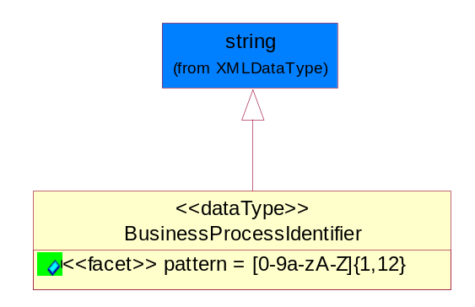
Figure ‎5-65 BusinessProcessIdentifier

Attribute | Type | Documentation
pattern |  | [0-9a-zA-Z]{1,12}

BusinessServiceInformation
The object allows the specification of the business service utilized within the partner company. This may or may not be the same as the information sent by the RNIF.
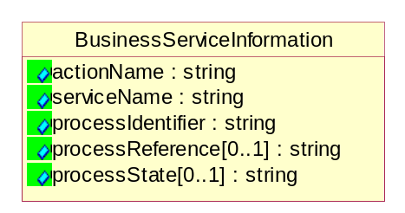
Figure ‎5-66 BusinessServiceInformation

Attribute | Type | Documentation
actionName | string | The name of Action. For RosettaNet usually any of Request/Confirm/Notify/Query/Response.
serviceName | string | The name of the Business Activity with the "Request/Confirm" part removed. E.g., for the Activity "Request Purchase Order"==> "Purchase Order".
processIdentifier | string | The name of the PIP e.g. Notify of Forecast Reply.
processReference[0..1] | string | The URN for the PIP that includes Cluster/Segment/Process pattern used to identify the interface process (such as PIP3A4)
processState[0..1] | string | The business process (or service) state of the sender of a document. When a service receives this document, the receiver may use the state as a precondition.

ContractInformation
A block of information used to correlate a contract in an executing choreography.
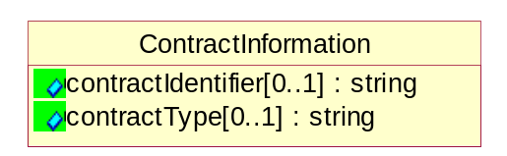
Figure ‎5-67 ContractInformation

Attribute | Type | Documentation
contractIdentifier[0..1] | string | Unique identification of a contract between the Sender and the Receiver
contractType[0..1] | string | The type of the contract: an attribute describing the type of the ContractIndentification. Valid values are URI, URN,ebXMLCPA, or other values defined by partners.

CorrelationInformation
A block of information used to correlate a requesting document to a responding document and to the contract in an executing choreography.
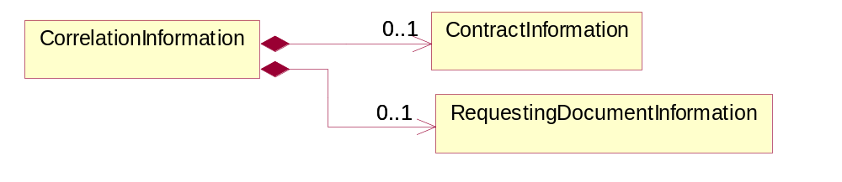
Figure ‎5-68 CorrelationInformation

Composition | Cardinality | Type | Documentation
ContractInformation | 0..1 | ContractInformation | A block of information used to correlate a contract in an executing choreography.
RequestingDocumentInformation | 0..1 | RequestingDocumentInformation | A block of information used to correlate a requesting document to a responding document in an executing choreography.

DocumentHeader
The object allows for the identification of the sender and receiver of the business document.
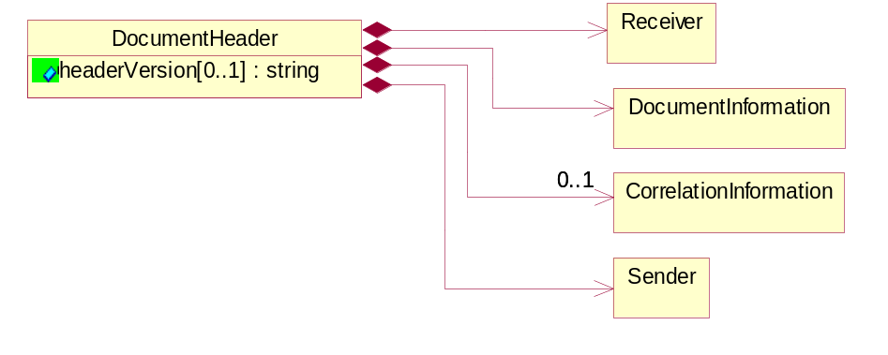
Figure ‎5-69 DocumentHeader

Attribute | Type | Documentation
headerVersion[0..1] | string | The UN/CEFACT version of the document header.

Composition | Cardinality | Type | Documentation
Sender | 1 | Sender | The object allows the identification of the initiating party of the business message.
CorrelationInformation | 0..1 | CorrelationInformation | A block of information used to correlate a requesting document to a responding document and to the contract in an executing choreography.
DocumentInformation | 1 | DocumentInformation | The object specifies information to identify the business document, a summary of attachments, and information about the business document security.
Receiver | 1 | Receiver | The object allows the identification of the receiving party of the business message.

DocumentIdentification
The object specifies all information necessary to identify the business document.
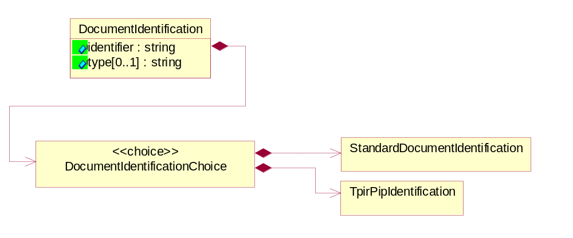
Figure ‎5-70 DocumentIdentification

Attribute | Type | Documentation
identifier | string | The unique identifier for the document being sent.
type[0..1] | string | Name of the Action Message

Composition | Cardinality | Type | Documentation
DocumentIdentificationChoice | 1 | DocumentIdentificationChoice

DocumentIdentificationChoice

Composition | Cardinality | Type | Documentation
StandardDocumentIdentification | 1 | StandardDocumentIdentification | The object specifies additional information necessary to identify the standard business document.
TpirPipIdentification | 1 | TpirPipIdentification | The object specifies all information necessary to uniquely identify a TPIR-PIP within a Registry or trading partner repository.

DocumentInformation
The object specifies information to identify the business document, a summary of attachments, and information about the business document security.
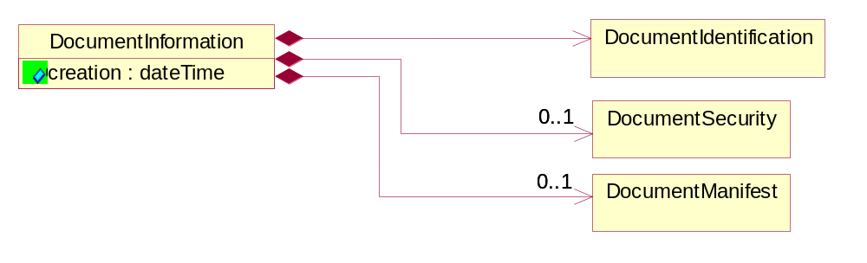
Figure ‎5-71 DocumentInformation

Attribute | Type | Documentation
creation | dateTime | The creation date and time of the specified Business Document (i.e. the Purchase Order date).

Composition | Cardinality | Type | Documentation
DocumentIdentification | 1 | DocumentIdentification | The object specifies all information necessary to identify the business document.
DocumentSecurity | 0..1 | DocumentSecurity | The object provides additional granularity in specifying business document security (this is in addition to the specified PIP security).
DocumentManifest | 0..1 | DocumentManifest | The block provides a brief summary of attachments and Service Content.

DocumentManifest
The block provides a brief summary of attachments and Service Content.
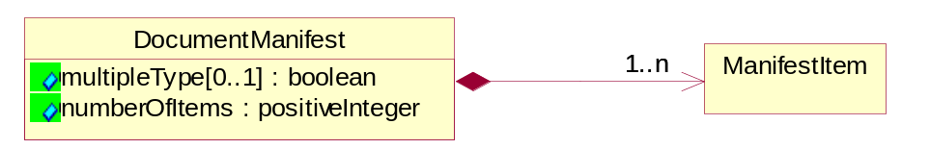
Figure ‎5-72 DocumentManifest

Attribute | Type | Documentation
multipleType[0..1] | boolean | Indicates whether the manifest contains documents of multiple types. True if yes, and False if no.
numberOfItems | positiveInteger | Total number of documents in the message. The physical count of the attachments in the payload plus the RosettaNet Business Message (for Service Content). The value of this field will be at least 1.

Composition | Cardinality | Type | Documentation
ManifestItem | 1..n | ManifestItem | The object provides details about the specific attachment(s).

DocumentSecurity
The object provides additional granularity in specifying business document security (this is in addition to the specified PIP security).
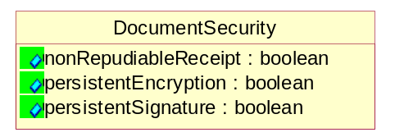
Figure ‎5-73 DocumentSecurity

Attribute | Type | Documentation
nonRepudiableReceipt | boolean | The value "true" will indicate that a signed acknowledgement for the business document is necessary.
persistentEncryption | boolean | The value "true" will indicate that the Business Document (including the header) needs to be encrypted when stored or transported.
persistentSignature | boolean | The value "true" will indicate that a signature is required to be stored with the document while stored or transported.

ManifestItem
The object provides details about the specific attachment(s).

Figure ‎5-74 ManifestItem

Attribute | Type | Documentation
description[0..1] | string | A description of the attachment.
length[0..1] | positiveInteger | The size of the attachment in bytes (i.e. 1 000 000 bytes)
universalResourceIdentifier | string | The generic set of all names/addresses that are short strings that refer to resources.

Composition | Cardinality | Type | Documentation
mimeTypeQualifier | 1 | MimeTypeQualifier | The MIME type as defined by IANA.  Please refer to http://www.iana.org/assignments/media-types/ for a list of types.
language | 0..1 | Language | For representation of Language name RosettaNet has adopted ISO 639-2; 1998. Refer to the following web page to get the latest version of the standard:  http://www.loc.gov/standards/iso639-2/iso639jac.html  If you need more information about the ISO standard please contact ISO for more details.

PipIdentifier
PIP Identification.[ i.e. PIP3A4]
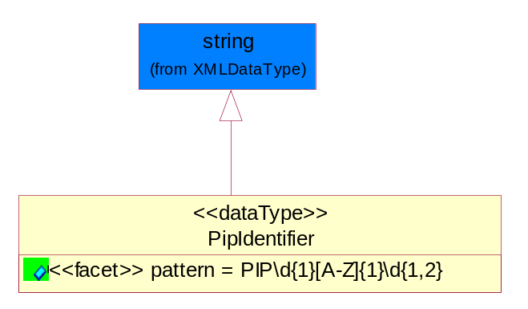
Figure ‎5-75 PipIdentifier

Attribute | Type | Documentation
pattern |  | PIP\d{1}[A-Z]{1}\d{1,2}

PipVersion
PIP version number (i.e. 02.02.00).
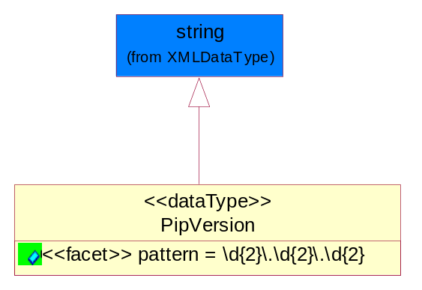
Figure ‎5-76 PipVersion

Attribute | Type | Documentation
pattern |  | \d{2}\.\d{2}\.\d{2}

Receiver
The object allows the identification of the receiving party of the business message.
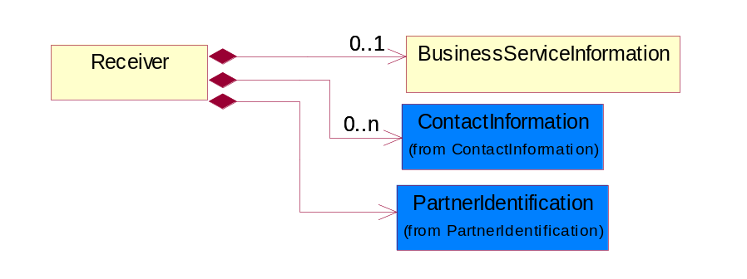
Figure ‎5-77 Receiver

Composition | Cardinality | Type | Documentation
BusinessServiceInformation | 0..1 | BusinessServiceInformation | The object allows the specification of the business service utilized within the partner company. This may or may not be the same as the information sent by the RNIF.
PartnerIdentification | 1 | PartnerIdentification | The business document must allow for the identity of one or more parties to the transaction.
ContactInformation | 0..n | ContactInformation | The business document must allow for the identification of the name of the department, service or individual to be contacted regarding the context of the business document.

RequestingDocumentInformation
A block of information used to correlate a requesting document to a responding document in an executing choreography.
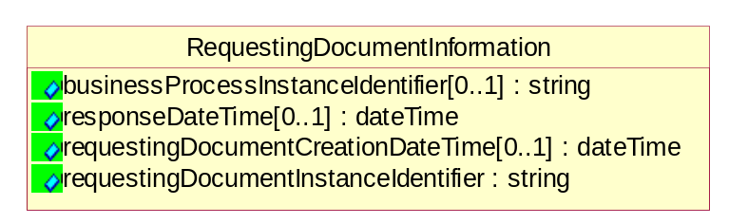
Figure ‎5-78 RequestingDocumentInformation

Attribute | Type | Documentation
businessProcessInstanceIdentifier[0..1] | string | The identifier for the public business process instance being sent that both the sender and receiver can identify.
responseDateTime[0..1] | dateTime | The expected time to receive the response. This can not be greater than the PIP TimeToPerform.
requestingDocumentCreationDateTime[0..1] | dateTime | The date-time of the requesting business document.
requestingDocumentInstanceIdentifier | string | The Business Document identification number that identifies the requesting Business Document.

Sender
The object allows the identification of the initiating party of the business message.
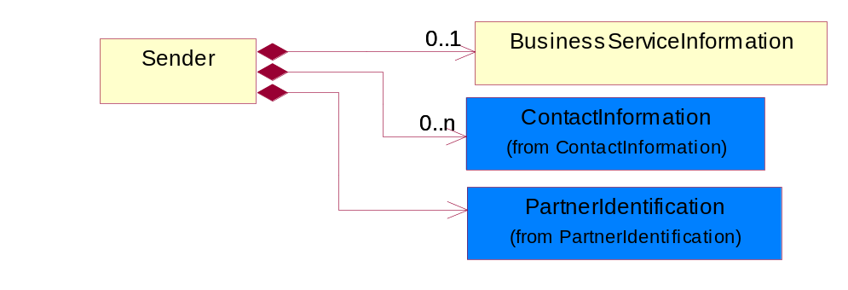
Figure ‎5-79 Sender

Composition | Cardinality | Type | Documentation
PartnerIdentification | 1 | PartnerIdentification | The business document must allow for the identity of one or more parties to the transaction.
BusinessServiceInformation | 0..1 | BusinessServiceInformation | The object allows the specification of the business service utilized within the partner company. This may or may not be the same as the information sent by the RNIF.
ContactInformation | 0..n | ContactInformation | The business document must allow for the identification of the name of the department, service or individual to be contacted regarding the context of the business document.

StandardDocumentIdentification
The object specifies additional information necessary to identify the standard business document.
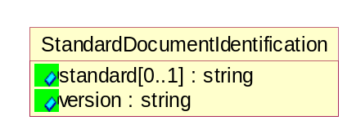
Figure ‎5-80 StandardDocumentIdentification

Attribute | Type | Documentation
standard[0..1] | string | Identifies the standard used to submit the business document. (e.g. RosettaNet).
version | string | PIP3A4v01.00

TpirPipIdentification
The object specifies all information necessary to uniquely identify a TPIR-PIP within a Registry or trading partner repository.


Figure ‎5-81 TpirPipIdentification

Attribute | Type | Documentation
partnerId | DUNSPlus4 | The Trading Partner Identification of MNC that is creating this TPIR PIP.
pipIdentifier | PipIdentifier | A TPIR PIP Identification [i.e., 3A4 ).
pipVersion | PipVersion | A TPIR PIP version number (i.e., 02.02.00)
tpirPipVersion | VersionIdentifier | A TPIR-PIP Version Number (i.e., major and minor version number as XX.XX).
tpirBusinessProcessIdentifier[0..1] | BusinessProcessIdentifier | A Business Process Identifier to uniquely define the TPIR-PIP 'role' within a Business Scenario at a company or MNC level. The identifier MUST be composed of alphanumeric characters only and its length MUST be between one and twelve characters.
uri[0..1] | anyURI | Describes the destination uri for the TPIR form.

Composition | Cardinality | Type | Documentation
fileType | 0..1 | TPIRFileType | Describes the file type of the TPIR form (PDF, XDP or XML).

VersionIdentifier
Version Number (i.e., major and minor version number as XX.XX).
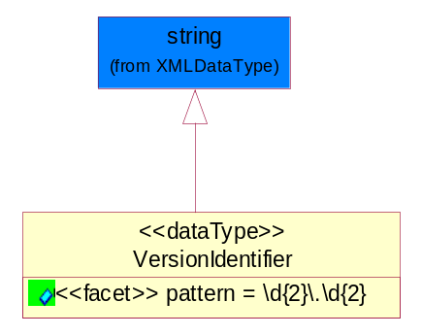
Figure ‎5-82 VersionIdentifier

Attribute | Type | Documentation
pattern |  | \d{2}\.\d{2}

CodeList

TPIRFileType
A code identifying the file type of TPIR form.

Name | Documentation
PDF | Portable Document Format.
XDP | XML Data Package.
XML | eXtensible Markup Language.

XML Data Type

anyURI
Represents a URI as defined by RFC 2396. An anyURI value can be absolute or relative, and may have an optional fragment identifier.

boolean
Represents Boolean values, which are either "true" or "false".

dateTime
Represents a specific instance of time.
The pattern for dateTime is CCYY-MM-DDThh:mm:ss where CC represents the century, YY the year, MM the month, and DD the day, preceded by an optional leading negative (-) character to indicate a negative number. If the negative character is omitted, positive (+) is assumed. The T is the date/time separator and hh, mm, and ss represent hour, minute, and second respectively. Additional digits can be used to increase the precision of fractional seconds if desired. For example, the format ss.ss... with any number of digits after the decimal point is supported. The fractional seconds part is optional.
This representation may be immediately followed by a "Z" to indicate Coordinated Universal Time (UTC) or to indicate the time zone. For example, the difference between the local time and Coordinated Universal Time, immediately followed by a sign, + or -, followed by the difference from UTC represented as hh:mm (minutes is required). If the time zone is included, both hours and minutes must be present.

decimal
A data type that contains decimal numbers scaled by a power of 10.

float
Represents single-precision 32-bit floating-point numbers.

integer
Represents a sequence of decimal digits with an optional leading sign (+ or -). This data type is derived from decimal.

positiveInteger
Represents an integer that is greater than zero. This data type is derived from nonNegativeInteger.

string
Represents character string.

