

Description of 7C7 Message

PIP® 7C7
Validated 11.11.00

Specification Information
Name | Description of 7C7 Message
PIP | Notify of Semiconductor Test Data
Cluster | Manufacturing
Segment | Distribute Manufacturing Information
Publication Date | 03 December 2007
Version Identifier | V11.11

Table of Content

1. Document Management 7
1.1 Legal Disclaimer 7
1.2 Copyright 7
1.3 Trademarks 7
1.4 Acknowledgments 7
1.5 Related Documents 8
1.6 Document Version History 8
1.7 Document Purpose 8
2. Interchange Model 9
2.1 SemiconductorTestDataNotification 9
2.1.1 Interchange Diagram 9
2.1.2 Dependency Diagram 9
2.1.3 BALocation 10
2.1.4 CalcFailReport 10
2.1.5 Die 11
2.1.6 DieReport 11
2.1.7 FabLocation 12
2.1.8 FinalTest 13
2.1.9 FinalTestLocation 13
2.1.10 FPReport 13
2.1.11 FunctionalPinReport 14
2.1.12 GangTest 15
2.1.13 LotReport 16
2.1.14 OtherLocation 18
2.1.15 PCM 18
2.1.16 PPReport 18
2.1.17 PPResult 19
2.1.18 PRReport 20
2.1.19 SemiconductorTestDataNotification 20
2.1.20 SetupReport 21
2.1.21 Sort 22
2.1.22 TestOperationDescription 23
2.1.23 TestOpIdentification 24
2.1.24 TestOpIdentificationChoice 25
2.1.25 TestReport 26
2.1.26 VectorReport 27
2.1.27 WaferSort 28
2.1.28 WaferSortLocation 28
2.1.29 YieldReport 29
3. Domain Model 30
3.1 Manufacturing 30
3.1.1 Manufacturing 30
3.1.1.1 Dependency Diagram 30
3.1.1.2 BuildInfoReport 30
3.1.1.3 ChipPeriodicity 31
3.1.1.4 Dimension 32
3.1.1.5 ECIDReport 32
3.1.1.6 FacilityLocation 33
3.1.1.7 FinalPackageReport 33
3.1.1.8 FloatCoordinate 34
3.1.1.9 HardwareSets 34
3.1.1.10 IntCoordinate 35
3.1.1.11 Lot 35
3.1.1.12 LotIdentifier 36
3.1.1.13 MeasurementUnit 37
3.1.1.14 MeasurementUnitChoice 37
3.1.1.15 Pin 37
3.1.1.16 ProprietaryUnits 38
3.1.1.17 SoftwareReport 38
3.1.1.18 Tester 39
3.1.1.19 TesterAttachment 39
3.1.1.20 TesterFEH 40
3.1.1.21 TestMap 40
3.1.1.22 TestParameter 42
3.1.1.23 TestSetup 43
3.1.1.24 TestSpecificationReport 44
3.1.1.25 TestTemperature 44
3.1.1.26 WaferCoordinate 45
3.1.2 CodeList 45
3.1.2.1 Axis 45
3.1.2.2 PCMParmType 45
3.1.2.3 Confidentiality 46
3.1.2.4 Status 46
3.1.2.5 LotType 46
3.1.2.6 CoordinateFlag 47
3.1.2.7 SortWeight 47
3.1.2.8 CompletionStatus 47
3.1.2.9 TestResult 47
3.1.2.10 ComponentType 47
3.2 Shared 49
3.2.1 Shared 49
3.2.1.1 Dependency Diagram 49
4. Universal Structure 50
4.1 ContactInformation 50
4.1.1 ContactInformation 50
4.2 DataType 50
4.2.1 Contact 50
4.2.2 DUNS 51
4.2.3 DUNSPlus4 51
4.2.4 GLN 52
4.2.5 GTIN 52
4.2.6 Hexadecimal 53
4.2.7 PercentAmount 53
4.3 Dates 54
4.3.1 StartAndEndDateTime 54
4.4 Locations 54
4.4.1 AlternativeIdentifier 54
4.4.2 Location 55
4.4.3 LocationChoice 55
4.4.4 PhysicalAddress 56
4.5 PartnerIdentification 58
4.5.1 PartnerIdentification 58
4.5.2 PartnerIdentificationChoice 58
4.6 ProductIdentification 59
4.6.1 ProductIdentification 59
4.6.2 ProductIdentificationChoice 60
4.7 CodeList 60
4.7.1 Country 60
4.7.2 CountrySubdivision 60
4.7.3 Language 60
4.7.4 MimeTypeQualifier 60
4.7.5 UnitOfMeasure 71
5. System Structure 84
5.1 BusinessProcessIdentifier 84
5.2 BusinessServiceInformation 84
5.3 ContractInformation 85
5.4 CorrelationInformation 85
5.5 DocumentHeader 86
5.6 DocumentIdentification 87
5.7 DocumentIdentificationChoice 87
5.8 DocumentInformation 88
5.9 DocumentManifest 88
5.10 DocumentSecurity 89
5.11 ManifestItem 89
5.12 PipIdentifier 90
5.13 PipVersion 91
5.14 Receiver 91
5.15 RequestingDocumentInformation 92
5.16 Sender 92
5.17 StandardDocumentIdentification 93
5.18 TpirPipIdentification 93
5.19 VersionIdentifier 94
5.20 CodeList 95
5.20.1 TPIRFileType 95
6. XML Data Type 96
6.1 anyURI 96
6.2 boolean 96
6.3 dateTime 96
6.4 decimal 96
6.5 float 96
6.6 integer 96
6.7 positiveInteger 96
6.8 string 96

Table of Figures

Figure 2-1 Interchange 9
Figure 2-2 Dependency 9
Figure 2-3 BALocation 10
Figure 2-4 CalcFailReport 10
Figure 2-5 Die 11
Figure 2-6 DieReport 11
Figure 2-7 FabLocation 12
Figure 2-8 FinalTest 13
Figure 2-9 FinalTestLocation 13
Figure 2-10 FPReport 13
Figure 2-11 FunctionalPinReport 14
Figure 2-12 GangTest 15
Figure 2-13 LotReport 16
Figure 2-14 OtherLocation 18
Figure 2-15 PCM 18
Figure 2-16 PPReport 18
Figure 2-17 PPResult 19
Figure 2-18 PRReport 20
Figure 2-19 SemiconductorTestDataNotification 20
Figure 2-20 SetupReport 21
Figure 2-21 Sort 22
Figure 2-22 TestOperationDescription 23
Figure 2-23 TestOpIdentification 24
Figure 2-24 TestReport 26
Figure 2-25 VectorReport 27
Figure 2-26 WaferSort 28
Figure 2-27 WaferSortLocation 28
Figure 2-28 YieldReport 29
Figure 3-1 Dependency 30
Figure 3-2 BuildInfoReport 30
Figure 3-3 ChipPeriodicity 31
Figure 3-4 Dimension 32
Figure 3-5 ECIDReport 32
Figure 3-6 FacilityLocation 33
Figure 3-7 FinalPackageReport 33
Figure 3-8 FloatCoordinate 34
Figure 3-9 HardwareSets 34
Figure 3-10 IntCoordinate 35
Figure 3-11 Lot 35
Figure 3-12 LotIdentifier 36
Figure 3-13 MeasurementUnit 37
Figure 3-14 Pin 37
Figure 3-15 ProprietaryUnits 38
Figure 3-16 SoftwareReport 38
Figure 3-17 Tester 39
Figure 3-18 TesterAttachment 39
Figure 3-19 TesterFEH 40
Figure 3-20 TestMap 40
Figure 3-21 TestParameter 42
Figure 3-22 TestSetup 43
Figure 3-23 TestSpecificationReport 44
Figure 3-24 TestTemperature 44
Figure 3-25 WaferCoordinate 45
Figure 3-26 Dependency 49
Figure 4-1 ContactInformation 50
Figure 4-2 Contact 50
Figure 4-3 DUNS 51
Figure 4-4 DUNSPlus4 51
Figure 4-5 GLN 52
Figure 4-6 GTIN 52
Figure 4-7 Hexadecimal 53
Figure 4-8 PercentAmount 53
Figure 4-9 StartAndEndDateTime 54
Figure 4-10 AlternativeIdentifier 54
Figure 4-11 Location 55
Figure 4-12 PhysicalAddress 56
Figure 4-13 PartnerIdentification 58
Figure 4-14 ProductIdentification 59
Figure 5-1 BusinessProcessIdentifier 84
Figure 5-2 BusinessServiceInformation 84
Figure 5-3 ContractInformation 85
Figure 5-4 CorrelationInformation 85
Figure 5-5 DocumentHeader 86
Figure 5-6 DocumentIdentification 87
Figure 5-7 DocumentInformation 88
Figure 5-8 DocumentManifest 88
Figure 5-9 DocumentSecurity 89
Figure 5-10 ManifestItem 89
Figure 5-11 PipIdentifier 90
Figure 5-12 PipVersion 91
Figure 5-13 Receiver 91
Figure 5-14 RequestingDocumentInformation 92
Figure 5-15 Sender 92
Figure 5-16 StandardDocumentIdentification 93
Figure 5-17 TpirPipIdentification 93
Figure 5-18 VersionIdentifier 94

Document Management

Legal Disclaimer
RosettaNet, its members, officers, directors, employees, or agents shall not be liable for any injury, loss, damages, financial or otherwise, arising from, related to, or caused by the use of this document or the specifications herein, as well as associated guidelines and schemas. The use of said specifications shall constitute your express consent to the foregoing exculpation.

Copyright
©2007 RosettaNet. All rights reserved. No part of this publication may be reproduced, stored in a retrieval system, or transmitted, in any form or by any means, electronic, mechanical, photocopying, recording, or otherwise, without the inclusion of this copyright notice. Any derivative works must cite the copyright notice. Any public redistribution or sale of this publication or derivative works requires prior written permission of the publisher.

Trademarks
RosettaNet, Partner Interface Process, PIP and the RosettaNet logo are trademarks or registered trademarks of "RosettaNet," a non-profit organization. All other product names and company logos mentioned herein are the trademarks of their respective owners. In the best effort, all terms mentioned in this document that are known to be trademarks or registered trademarks have been appropriately recognized in the first occurrence of the term.

Acknowledgments
This document has been prepared by RosettaNet (http://www.rosettanet.org/) from requirements gathered during the Milestone Program and in conformance with the methodology. Listed below are the legal entities that contributed to the design and development of this PIP.
Agere Systems | AIT
Amkor | ASE
Freescale Semiconductor (Motorola) | Intel
International Business Machines | National Semiconductor
NEC | ST Microelectronics
Taiwan Semiconductor Manufacturing Corp. | Texas Instruments (TI)

Related Documents
- Associated PIP Message Schemas (included with PIP Specification only)
- Description of Partner Interface Process for 7C7
- Message Structure

Document Version History
Version | Date | Description
Validated 11.11.00 | 03 December 2007 | Validated Version: Maintenance Program 2H2007

Document Purpose
The purpose of the document is to explain the structure, the association between objects, the content of objects and the definition for single elements to a non-technical audience.

Interchange Model

SemiconductorTestDataNotification

Interchange Diagram
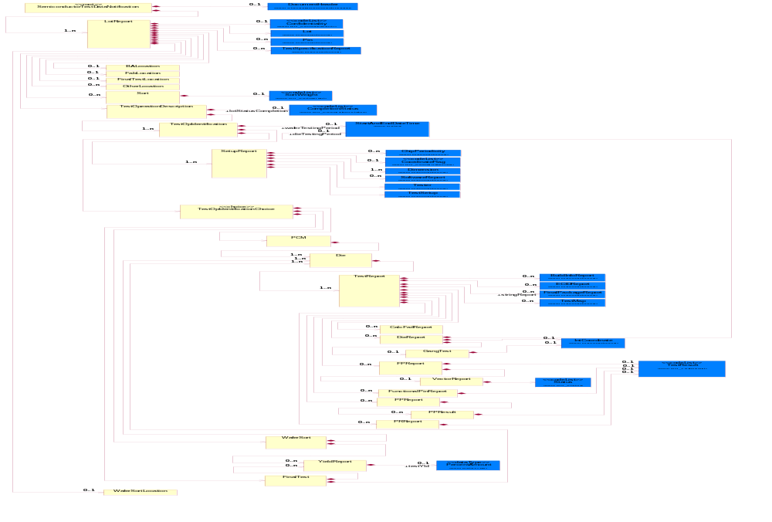
Figure 2-1 Interchange

Dependency Diagram
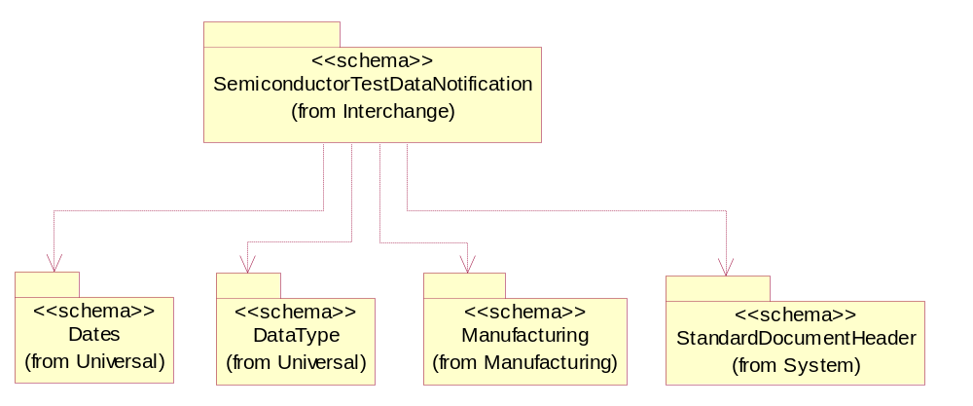
Figure 2-2 Dependency

BALocation
Describes where the wafer was sent for bond and assembly.
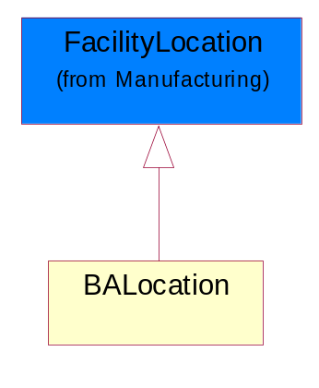
Figure 2-3 BALocation

CalcFailReport
A report that catalogs failing calculations that may be performed in determining the result of a test.
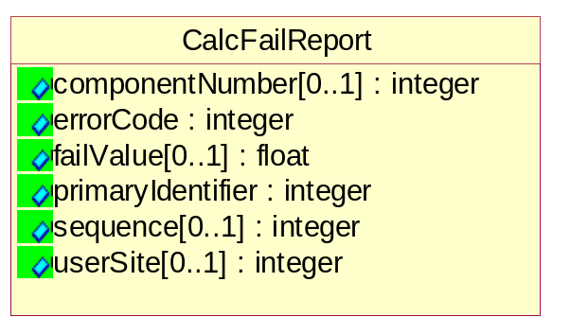
Figure 2-4 CalcFailReport

Attribute | Type | Documentation
componentNumber[0..1] | integer | A number associating a CalcFailReport to a specific component in BuildInfoReport.
errorCode | integer | A user defined code for how the calculation failed.
failValue[0..1] | float | The resultant failed value from the calculation test.
primaryIdentifier | integer | A reference back to TestSpecificationReport. This identifier references the electrical attributes only once per lot.
sequence[0..1] | integer | An index indicating at which step of the calculation that it failed.
userSite[0..1] | integer | A user-defined die coordinate represented as an integer which is often associated with the serial number assigned by the tester or prober executive.

Die
Reference optional data attributes to identify die on a wafer.
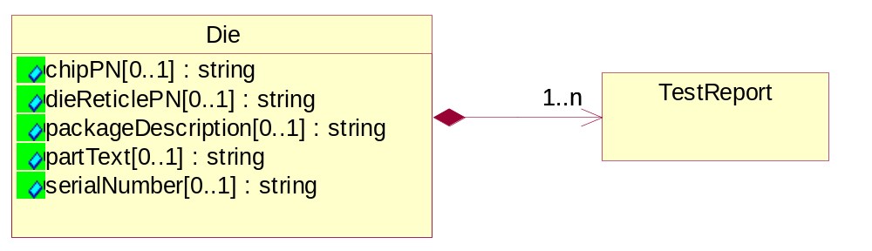
Figure 2-5 Die

Attribute | Type | Documentation
chipPN[0..1] | string | A string that describes the part number for the device.
dieReticlePN[0..1] | string | A string which defines the unique part numbers for die associated with a multi-project wafer.
packageDescription[0..1] | string | User definable element for package size (default=mm), package type (string), and pin count (Integer).
partText[0..1] | string | String. A user defined comment field to attach additional die information.
serialNumber[0..1] | string | An alphanumeric string that uniquely defines the numbering of packaged die.

Composition | Cardinality | Type | Documentation
TestReport | 1..n | TestReport | The common report for non-pin data collected at PCM, Wafer Sort and Final Test.

DieReport
References optional information to further identify a die on a wafer.
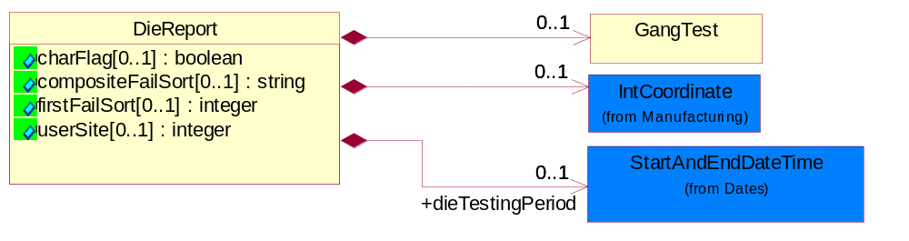
Figure 2-6 DieReport

Attribute | Type | Documentation
charFlag[0..1] | boolean | Used as a indicator for the presence of characterization data for a die.
compositeFailSort[0..1] | string | A user initiated failure override of first fail sort to allow for the collection of additional sort fail data. The additional sort fails can be combined in a comma separated list of sort numbers as a composite fail. The compositeFailSort describes the content of the data in the sortID tag.
firstFailSort[0..1] | integer | Described the sort ID for the first fail on the device. See content of data in sortID tag .
userSite[0..1] | integer | A user-defined die coordinate represented as an integer which is often associated with the serial number assigned by the tester or prober executive.

Composition | Cardinality | Type | Documentation
IntCoordinate | 0..1 | IntCoordinate | X, Y and Z Coordinate values.
GangTest | 0..1 | GangTest | Describes the test results for a group of die or packaged units, as in strip testing.
dieTestingPeriod | 0..1 | StartAndEndDateTime | Defines the start and end time for a die being tested.

FabLocation
Describes where the wafer was fabricated.
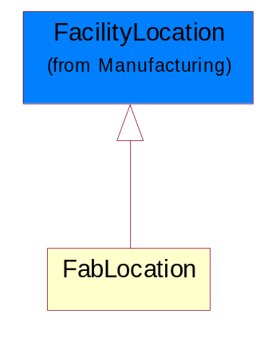
Figure 2-7 FabLocation

FinalTest
A test for packaged product that determines that the die functions and performs to the specification. This test also includes parametric and quality sort data.
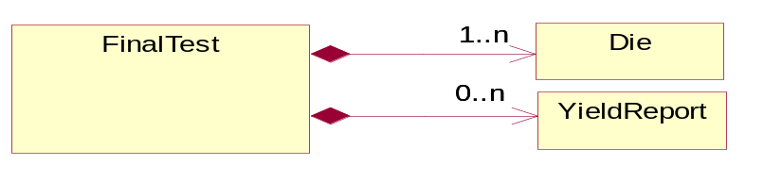
Figure 2-8 FinalTest

Composition | Cardinality | Type | Documentation
Die | 1..n | Die | Reference optional data attributes to identify die on a wafer.
YieldReport | 0..n | YieldReport | A report defining the yield from tests at Wafer Sort and Final Test.

FinalTestLocation
Describes where the packaged die was sent for final test.
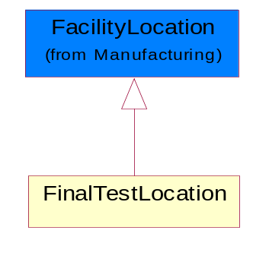
Figure 2-9 FinalTestLocation

FPReport
A report that collects functional pin test results. Valid status values are Passed, Failed.
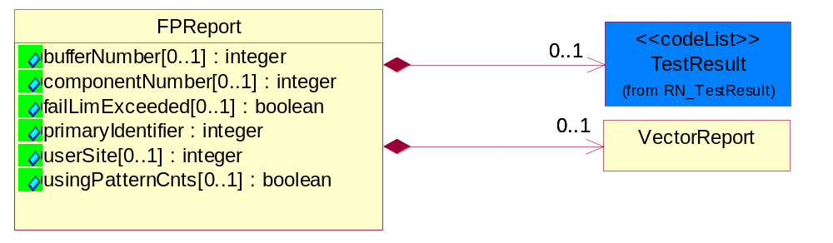
Figure 2-10 FPReport

Attribute | Type | Documentation
bufferNumber[0..1] | integer | Pattern buffer number.
componentNumber[0..1] | integer | A number associating a FPReport to a specific component in BuildInfoReport.
failLimExceeded[0..1] | boolean | Flag indicator to whether more fails exists than were datalogged. False = all fails datalogged; True = More fails present.
primaryIdentifier | integer | A reference back to TestSpecificationReport. This identifier references the electrical attributes only once per lot.
userSite[0..1] | integer | A user-defined die coordinate represented as an integer which is often associated with the serial number assigned by the tester or prober executive.
usingPatternCnts[0..1] | boolean | A flag indicator to whether failing addresses or counts were datalogged. True = using pattern counts; False = datalogging vector addresses.

Composition | Cardinality | Type | Documentation
VectorReport | 0..1 | VectorReport | A report for collecting functional results for a single vector or pattern count. Valid status values are: H=actual H, expect unknown L=actual L, expect unknown Z=actual Z, expected unknown A=actual H, expected L B=actual H, expect Z C=actual Z, expect H D=actual Z, expect L E=actual L, expect H F=actual L, expect Z.
TestResult | 0..1 | TestResult | Describes the test result for a parametric test.

FunctionalPinReport
A Pass/Fail per pin report of data logged bit results. Valid status options are: Passed, Failed High Limit, Fail Low Limit, Failed Screened and Failed Censor.
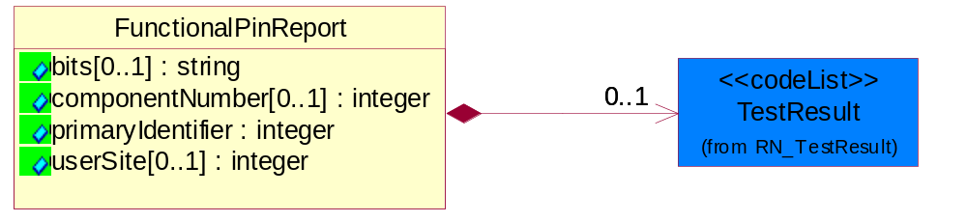
Figure 2-11 FunctionalPinReport

Attribute | Type | Documentation
bits[0..1] | string | Datalog values in series of bits (0s and 1s).
componentNumber[0..1] | integer | A number associating a FunctionalPinReport to a specific component in BuildInfoReport.
primaryIdentifier | integer | A reference back to TestSpecificationReport. This identifier references the electrical attributes only once per lot.
userSite[0..1] | integer | A user-defined die coordinate represented as an integer which is often associated with the serial number assigned by the tester or prober executive.

Composition | Cardinality | Type | Documentation
TestResult | 0..1 | TestResult | Describes the test result for a parametric test.

GangTest
Describes the test results for a group of die or packaged units, as in strip testing.
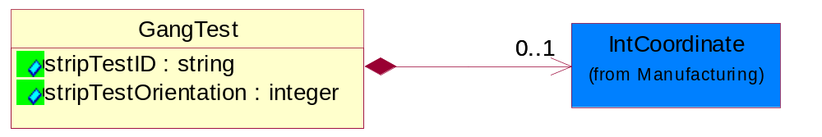
Figure 2-12 GangTest

Attribute | Type | Documentation
stripTestID | string | Identify the packaged die numbering on a strip.
stripTestOrientation | integer | Describes the orientation by strip test substrate: Valid values: 0, 90, 180, 270 degrees. Reference SEMI G81, Appendix 2.

Composition | Cardinality | Type | Documentation
IntCoordinate | 0..1 | IntCoordinate | X, Y and Z Coordinate values.

LotReport
A report that is common for reporting data collection for PCM, Wafer Sort and Final Test.
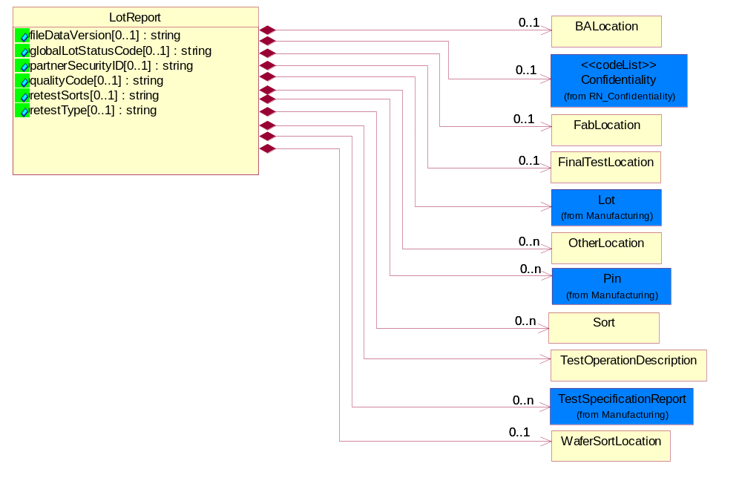
Figure 2-13 LotReport

Attribute | Type | Documentation
fileDataVersion[0..1] | string | User defined changes i.e. rules changes to content of data in the data file transfer. Examples: version update to loaders, parsers, or operating system, specification limits etc.
globalLotStatusCode[0..1] | string | Describes lot or sublot status.
partnerSecurityID[0..1] | string | An optional string that would indicate a project name to restrict access to the data to those employees working on that project.
qualityCode[0..1] | string | Designate a quality condition of a lot. This can be a proprietary label defined by the Foundry of the Test Services trading partner.
retestSorts[0..1] | string | A list of sort numbers from prior pass that will be retested in this pass.
retestType[0..1] | string | Describes how test data should be combined with prior data for the same LotID, test and level. Valid Options are:  First: Replace all previous data for test and level;  Sorts: Removal of module data from prior pass where sort matches a sort in a prior pass;  Chip: Replaces data on a by chip basis; TestReplace: replaces data on a wafer sort test basis (deletes prior data for wafer or parameter having a non-null retest value.

Composition | Cardinality | Type | Documentation
Lot | 1 | Lot | Describes the lot information.
Confidentiality | 0..1 | Confidentiality | A string which describes the level of security associated with the data, as defined by TPA.
TestOperationDescription | 1 | TestOperationDescription | Information that describes the manufacturing operation in further detail.
TestSpecificationReport | 0..n | TestSpecificationReport | Report that lists each test and their attributes at PCM, wafer sort and final test. e.g. Test name, electrical conditions, sort number, etc.
FabLocation | 0..1 | FabLocation | Describes where the wafer was fabricated.
BALocation | 0..1 | BALocation | Describes where the wafer was sent for bond and assembly.
FinalTestLocation | 0..1 | FinalTestLocation | Describes where the packaged die was sent for final test.
WaferSortLocation | 0..1 | WaferSortLocation | Describes where the wafer was sent for wafer sort test.
OtherLocation | 0..n | OtherLocation | Describes the location where the wafer or packaged die in a lot or sublot was sent for additional fabrication, assembly or testing.  This may be indicated by City, State, Country, Zip Code, DUNS, DUNS+4, or by proprietary label.
Pin | 0..n | Pin | Describes the optional attributes that provide additional pin identification information.
Sort | 0..n | Sort | Contains accumulated count for a sort at Wafer Sort and Final Test.

OtherLocation
Describes the location where the wafer or packaged die in a lot or sublot was sent for additional fabrication, assembly or testing.
This may be indicated by City, State, Country, Zip Code, DUNS, DUNS+4, or by proprietary label.
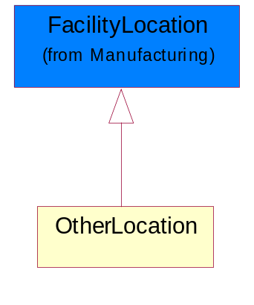
Figure 2-14 OtherLocation

PCM
Process Control Monitor: One of the major test modes which collects in-line parametric (electrical) data for the disposition of wafers in the Foundry based on technology criteria.
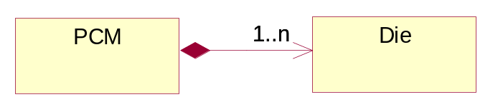
Figure 2-15 PCM

Composition | Cardinality | Type | Documentation
Die | 1..n | Die | Reference optional data attributes to identify die on a wafer.

PPReport
A report for datalogged per pin data. Per pin results relate data for tests which measure multiple pins in parallel such as leakage tests.
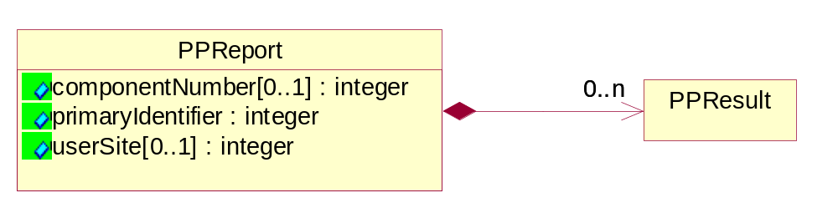
Figure 2-16 PPReport

Attribute | Type | Documentation
componentNumber[0..1] | integer | A number associating a PPReport to a specific component in BuildInfoReport.
primaryIdentifier | integer | An integer used as a reference back to TestSpecificationReport. This identifier references the electrical attributes only once per lot.
userSite[0..1] | integer | A user-defined die coordinate represented as an integer which is often associated with the serial number assigned by the tester or prober executive.

Composition | Cardinality | Type | Documentation
PPResult | 0..n | PPResult | A mesurement value for each pin in tests which measure multiple pins in parallel such as leakage tests. Valid status options for this report are: Failed High Limit, Failed Low Limit, Passed, Failed, Screened Value, Failed Censor.

PPResult
A mesurement value for each pin in tests which measure multiple pins in parallel such as leakage tests. Valid status options for this report are: Failed High Limit, Failed Low Limit, Passed, Failed, Screened Value, Failed Censor.
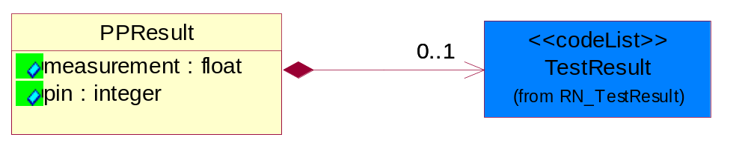
Figure 2-17 PPResult

Attribute | Type | Documentation
measurement | float | A data measurement that are collected from each pin measured.
pin | integer | A Pin IDs for each pin measured.

Composition | Cardinality | Type | Documentation
TestResult | 0..1 | TestResult | Describes the test result for a parametric test.

PRReport
A report that data logs parametric test results. The report collects non-per-pin data. Valid status options are: Failed High Limit, Failed Low Limit, Passed, Failed, Screened Value, Failed Censor.
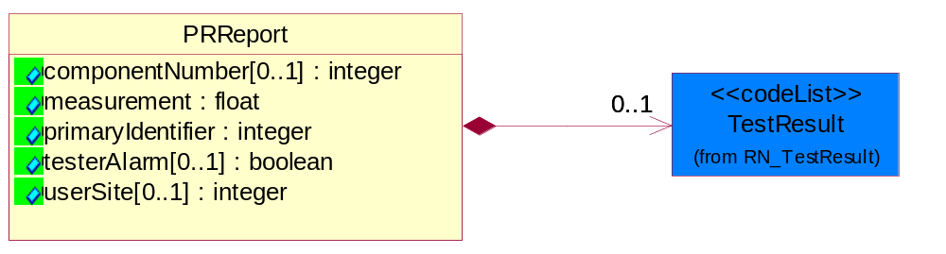
Figure 2-18 PRReport

Attribute | Type | Documentation
componentNumber[0..1] | integer | A number associating a PRReport to a specific component in BuildInfoReport.
measurement | float | Measurement in base units.
primaryIdentifier | integer | An integer used as a reference back to TestSpecificationReport. This identifier references the electrical attributes only once per lot.
testerAlarm[0..1] | boolean | An indicator status flag on whether the tester was in alarm during wafer sort or final test.
userSite[0..1] | integer | A user-defined die coordinate represented as an integer which is often associated with the serial number assigned by the tester or prober executive.

Composition | Cardinality | Type | Documentation
TestResult | 0..1 | TestResult | Describes the test result for a parametric test.

SemiconductorTestDataNotification
The message wrapper for SCTDE.
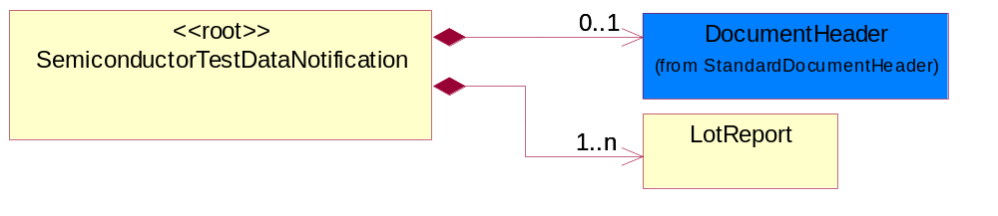
Figure 2-19 SemiconductorTestDataNotification

Composition | Cardinality | Type | Documentation
LotReport | 1..n | LotReport | A report that is common for reporting data collection for PCM, Wafer Sort and Final Test.
DocumentHeader | 0..1 | DocumentHeader | The object allows for the identification of the sender and receiver of the business document.

SetupReport
A report that describes setup information for the testing.
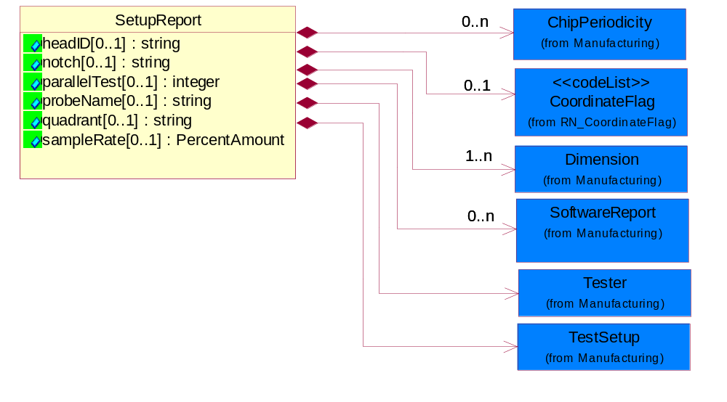
Figure 2-20 SetupReport

Attribute | Type | Documentation
headID[0..1] | string | Identifies the test head used for wafer sort and final test.
notch[0..1] | string | Describes the orientation of the wafer notch in a tester: Valid options are: 12 o’clock; 3 o’clock, 6 o’clock, 9 o’clock, notch up, notch down, notch right or notch left, Up=U, Down=D, Left=L, or Right=R, 0, 90, 180 or 270 degrees. Reference SEMI G81, Appendix 1.
parallelTest[0..1] | integer | Tthe number of devices or parallel tests for wafer sort.
probeName[0..1] | string | Describes the probe recipe or pattern file.
quadrant[0..1] | string | A user defined division of the wafer into 4 quadrants. Valid values: I, II, III, IV, Q1,Q2, Q3, Q4, Upper Left, Upper Right, Lower Left, Lower Right and User defined labels. Reference SEMI G81, Appendix 1.
sampleRate[0..1] | PercentAmount | Describes the percentage of die in wafer sort that are being tested under a characterization test plan.

Composition | Cardinality | Type | Documentation
Tester | 1 | Tester | Describe unique tester information for PCM, Wafer Sort and Final Test.
TestSetup | 1 | TestSetup | Describes the identification information for tester set-up.
Dimension | 1..n | Dimension | Describes the dimensional measurement range in X, Y or Z axis.
CoordinateFlag | 0..1 | CoordinateFlag | A status flag to indicate the coordinate measurement is for a single die on a reticle or a multi-chip die on a reticle.
ChipPeriodicity | 0..n | ChipPeriodicity | Dimensional. Describes the distance between chips in micron between established reference points in either the x- and or y-direction on a wafer.
SoftwareReport | 0..n | SoftwareReport | SoftwareReport describes software type, software name, software version and softwareBuildID.

Sort
Contains accumulated count for a sort at Wafer Sort and Final Test.
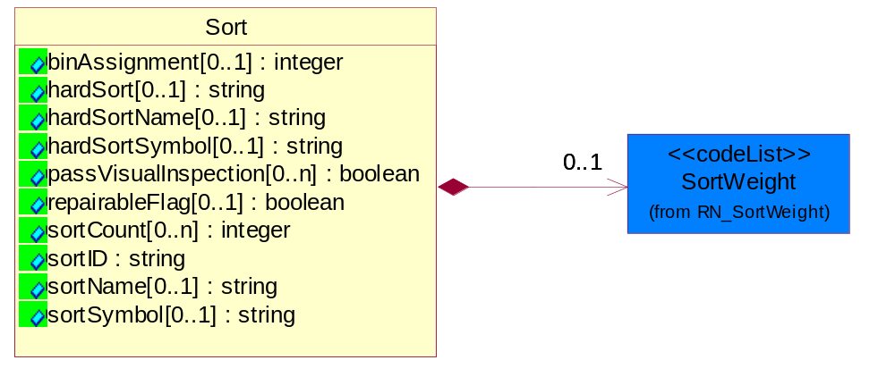
Figure 2-21 Sort

Attribute | Type | Documentation
binAssignment[0..1] | integer | A user defined integer designation for hard bins.
hardSort[0..1] | string | Represents the hard sort ID of the Sort test.
hardSortName[0..1] | string | Represents the hard sort name of the Sort Test.
hardSortSymbol[0..1] | string | A user defined grouping of hard sort fails on a wafer map.
passVisualInspection[0..n] | boolean | A user defined pass/fail quality control inspection flag of wafer after wafer sort.
repairableFlag[0..1] | boolean | A flag to indicate if product (die or module) are repairable based on user definition.
sortCount[0..n] | integer | A string that describes the number of counts for each sortID during a test.
sortID | string | The sortid represents the sort name of the Sort Test for which the firstFailSort and compositeFailSort are related to this sort identification.
sortName[0..1] | string | Describes the test in the SortID.
sortSymbol[0..1] | string | A user defined grouping of fails on a wafer map.

Composition | Cardinality | Type | Documentation
SortWeight | 0..1 | SortWeight | A relative representation of yield for a device or module.

TestOperationDescription
Information that describes the manufacturing operation in further detail.
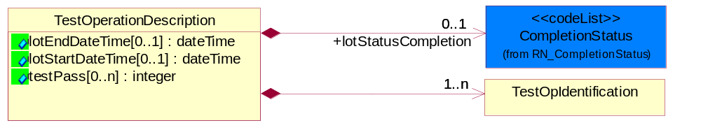
Figure 2-22 TestOperationDescription

Attribute | Type | Documentation
lotEndDateTime[0..1] | dateTime | Defines the end time of a lot for a test.
lotStartDateTime[0..1] | dateTime | Defines the start time of the lot for a test.
testPass[0..n] | integer | The number of times a test occurs. The test start and end time needs to be associated with each pass.

Composition | Cardinality | Type | Documentation
TestOpIdentification | 1..n | TestOpIdentification | Describes the manufacturing level of the lot and the test point.
lotStatusCompletion | 0..1 | CompletionStatus | Status completion of lot or sublot at the end of testing.

TestOpIdentification
Describes the manufacturing level of the lot and the test point.
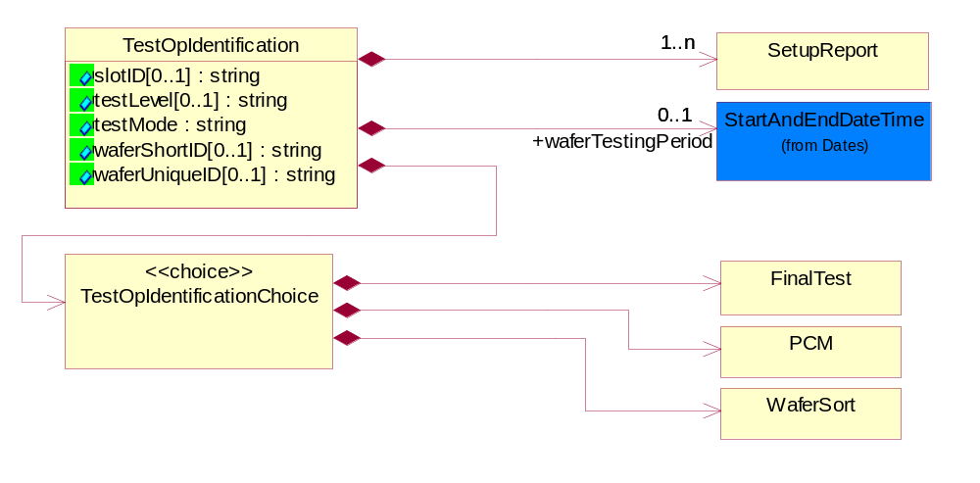
Figure 2-23 TestOpIdentification

Attribute | Type | Documentation
slotID[0..1] | string | Slot Identification Number for a particular wafer. Companies prefer to use a slot id to keep track of which slot in the carrier the wafer is in.
testLevel[0..1] | string | A string that describes the test in further detail. Label may change. This is user definable.
testMode | string | A string which is used to identify the type of test: PCM, Wafer Sort or Final Test. Within each major test type their may be multiple tests undertaken for each lot or sublot.
waferShortID[0..1] | string | Alternate identifier for the wafer unique ID. Companies prefer to use a wafer short name as the data key for their data analysis tools versus the wafer unique id.
waferUniqueID[0..1] | string | An alphanumeric string which describes the wafer serial number for traceability in a lot or sublot.

Composition | Cardinality | Type | Documentation
TestOpIdentificationChoice | 1 | TestOpIdentificationChoice | A Choice structure for the different type of test mode: PCM, Wafer Sort and Final Test.
SetupReport | 1..n | SetupReport | A report that describes setup information for the testing.
waferTestingPeriod | 0..1 | StartAndEndDateTime | Defines the start and end time for a wafer being tested.

TestOpIdentificationChoice
A Choice structure for the different type of test mode: PCM, Wafer Sort and Final Test.

Composition | Cardinality | Type | Documentation
PCM | 1 | PCM | Process Control Monitor: One of the major test modes which collects in-line parametric (electrical) data for the disposition of wafers in the Foundry based on technology criteria.
FinalTest | 1 | FinalTest | A test for packaged product that determines that the die functions and performs to the specification. This test also includes parametric and quality sort data.
WaferSort | 1 | WaferSort | One of the major test modes which collects data on the electrical performance of the integrated die. The test results may be shared as either reconciled information at the chip summary level or as raw test data. Test results may include parametric measurements and quality sort and/or pass/fail information.

TestReport
The common report for non-pin data collected at PCM, Wafer Sort and Final Test.
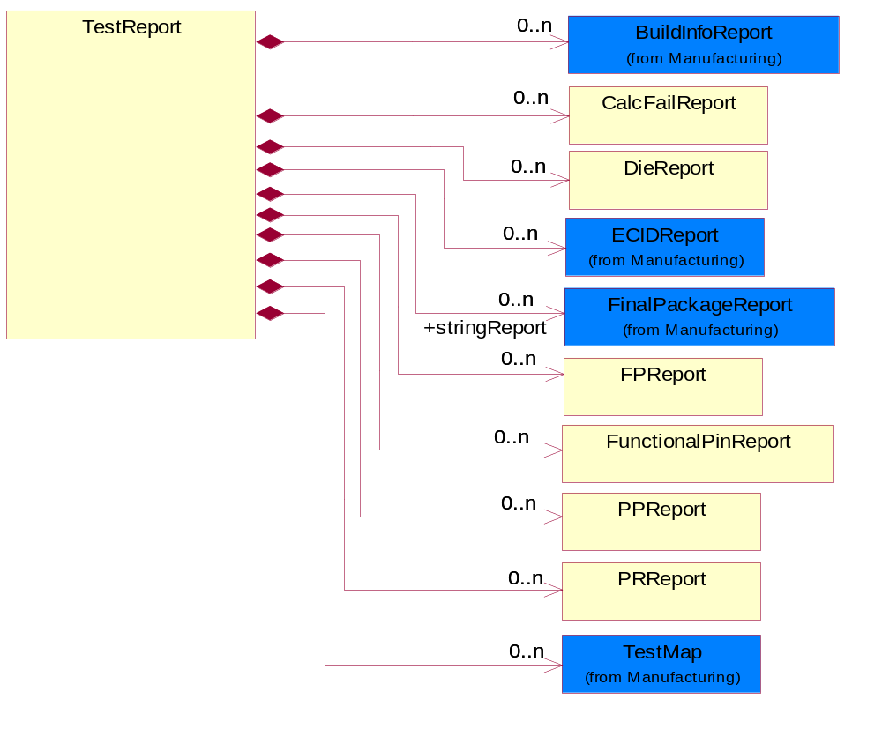
Figure 2-24 TestReport

Composition | Cardinality | Type | Documentation
DieReport | 0..n | DieReport | References optional information to further identify a die on a wafer.
PRReport | 0..n | PRReport | A report that data logs parametric test results. The report collects non-per-pin data. Valid status options are: Failed High Limit, Failed Low Limit, Passed, Failed, Screened Value, Failed Censor.
PPReport | 0..n | PPReport | A report for datalogged per pin data. Per pin results relate data for tests which measure multiple pins in parallel such as leakage tests.
FPReport | 0..n | FPReport | A report that collects functional pin test results. Valid status values are Passed, Failed.
FunctionalPinReport | 0..n | FunctionalPinReport | A Pass/Fail per pin report of data logged bit results. Valid status options are: Passed, Failed High Limit, Fail Low Limit, Failed Screened and Failed Censor.
CalcFailReport | 0..n | CalcFailReport | A report that catalogs failing calculations that may be performed in determining the result of a test.
ECIDReport | 0..n | ECIDReport | Report to collect electronic chip ID data.
TestMap | 0..n | TestMap | Describes the wafer orientation and configuration used by manufacturing test (metrology) equipment.
stringReport | 0..n | FinalPackageReport | A report that provides additional, optional information about a tested device. This class supports datalogging of string values based on a key/value pair approach.
BuildInfoReport | 0..n | BuildInfoReport | Options of obtaining more build information when building out the package.

VectorReport
A report for collecting functional results for a single vector or pattern count. Valid status values are: H=actual H, expect unknown L=actual L, expect unknown Z=actual Z, expected unknown A=actual H, expected L B=actual H, expect Z C=actual Z, expect H D=actual Z, expect L E=actual L, expect H F=actual L, expect Z.
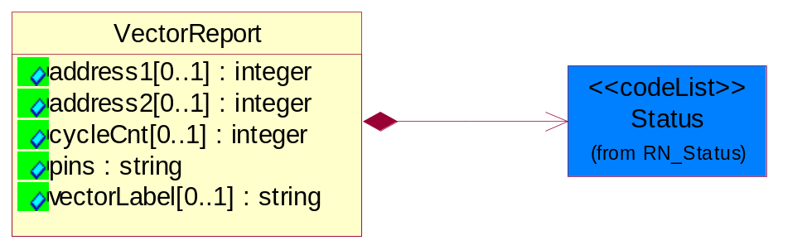
Figure 2-25 VectorReport

Attribute | Type | Documentation
address1[0..1] | integer | Failing tester primary address; integer.
address2[0..1] | integer | Failing tester secondary address; integer.
cycleCnt[0..1] | integer | Integer, Cycle count for ABIST/LBIST diagnostic data collection or the T0 count for a pattern.
pins | string | String. Comma separated list of Pin IDs as defined in PinReport.
vectorLabel[0..1] | string | String, Label for failing vector.

Composition | Cardinality | Type | Documentation
Status | 1 | Status | Describes the Status result for a vector test.

WaferSort
One of the major test modes which collects data on the electrical performance of the integrated die. The test results may be shared as either reconciled information at the chip summary level or as raw test data. Test results may include parametric measurements and quality sort and/or pass/fail information.
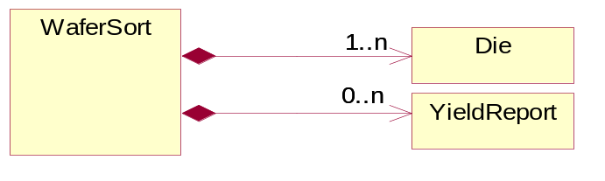
Figure 2-26 WaferSort

Composition | Cardinality | Type | Documentation
Die | 1..n | Die | Reference optional data attributes to identify die on a wafer.
YieldReport | 0..n | YieldReport | A report defining the yield from tests at Wafer Sort and Final Test.

WaferSortLocation
Describes where the wafer was sent for wafer sort test.
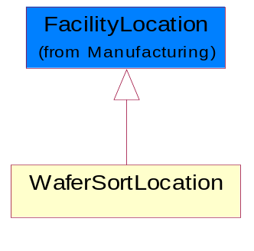
Figure 2-27 WaferSortLocation

YieldReport
A report defining the yield from tests at Wafer Sort and Final Test.
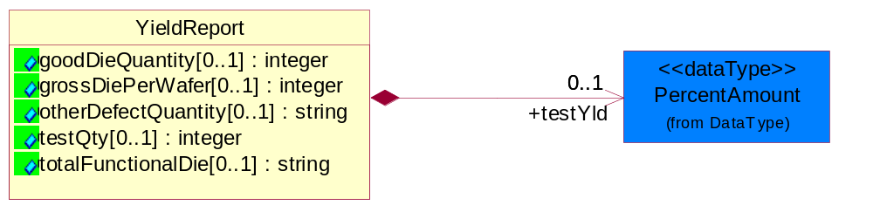
Figure 2-28 YieldReport

Attribute | Type | Documentation
goodDieQuantity[0..1] | integer | Integer that describes the number of die or packages that are functional in a lot or sublot.
grossDiePerWafer[0..1] | integer | Integer, Describes the number of complete die on a wafer.
otherDefectQuantity[0..1] | string | String. User defined Quality Control inspection at wafer sort and final test to identify defects. User defined Valid Values.
testQty[0..1] | integer | Used for calculation of yield for die and packaged die for a lot or sublot tested.
totalFunctionalDie[0..1] | string | String. User defined identifier on the level of functionality of die.

Composition | Cardinality | Type | Documentation
testYld | 0..1 | PercentAmount | A TPA defined calculation for yield at wafer sort and final test.

Domain Model

Manufacturing

Manufacturing

Dependency Diagram
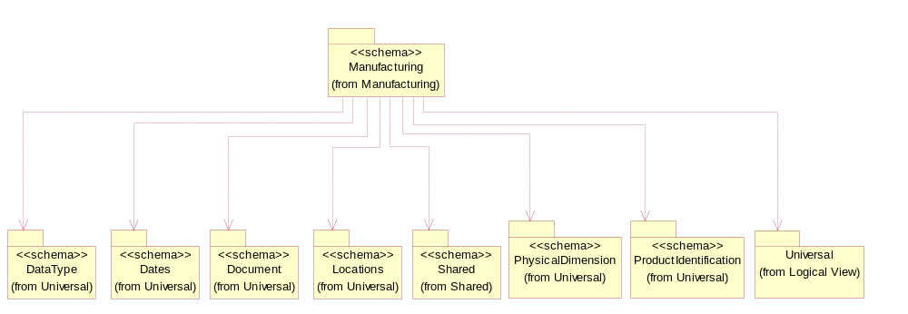
Figure 3-29 Dependency

BuildInfoReport
Options of obtaining more build information when building out the package.
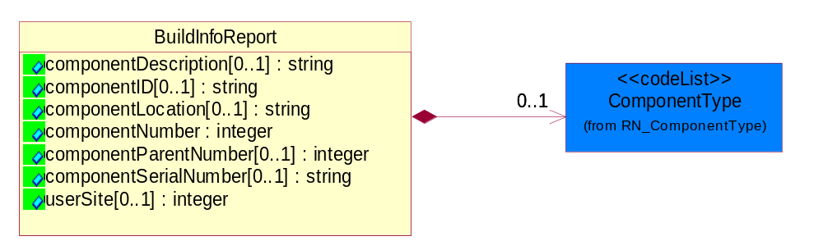
Figure 3-30 BuildInfoReport

Attribute | Type | Documentation
componentDescription[0..1] | string | A user defined description of the component.
componentID[0..1] | string | A unique identification of the component per the componentType (e.g. Frame, Card). Note: The ChipID may be identified by waferid/X/Y. This may be an actual component serial number or may be the primary ECID value waferid/X/Y. If there is an invalid ECID read, the value that is typically used is lotnum/seq/bad-waferid/bad-X/bad-Y or equivalent.
componentLocation[0..1] | string | The location of a sub-component on the parent component.
componentNumber | integer | A unique number associated with the component or subcomponent being tested relative to the device. In general the highest level of the componentNumber equals 0 and all identified subcomponents are componentNumber equal 1-n. Subsequent Reports can be associated to the sub-component via the componentNumber.
componentParentNumber[0..1] | integer | For the highest level of packaged component the value is null. For any sub-component, the corresponding componentNumber is from a previous BuildInfoReport.
componentSerialNumber[0..1] | string | A scribed serial number on the component.
userSite[0..1] | integer | Identifies the corresponding device site number (0-1).

Composition | Cardinality | Type | Documentation
ComponentType | 0..1 | ComponentType | Valid component values are: CAG, CHP, COR, CRD, FRM, MCM, MOD, NOD, SCM.

ChipPeriodicity
Dimensional. Describes the distance between chips in micron between established reference points in either the x- and or y-direction on a wafer.
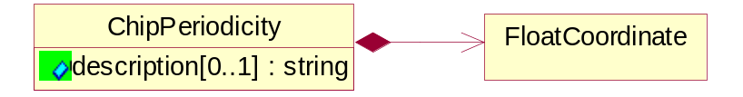
Figure 3-31 ChipPeriodicity

Attribute | Type | Documentation
description[0..1] | string | A string that describes the kind of chip periodicity is being defined.

Composition | Cardinality | Type | Documentation
FloatCoordinate | 1 | FloatCoordinate | X, Y and Z Coordinate values.

Dimension
Describes the dimensional measurement range in X, Y or Z axis.
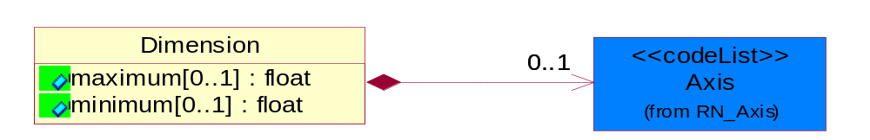
Figure 3-32 Dimension

Attribute | Type | Documentation
maximum[0..1] | float | Describes the maximum dimensional measurement for X, Y or Z axis.
minimum[0..1] | float | Describes the minimum dimensional measurement for X, Y or Z axis.

Composition | Cardinality | Type | Documentation
Axis | 0..1 | Axis | Indicate three dimensional direction.

ECIDReport
Report to collect electronic chip ID data.
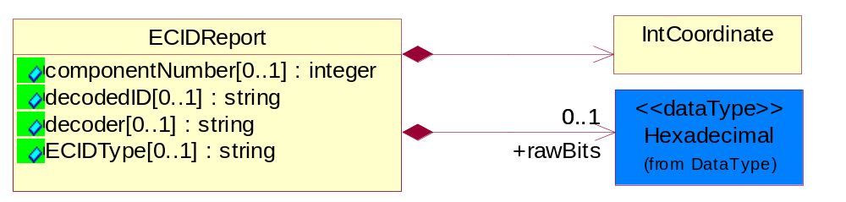
Figure 3-33 ECIDReport

Attribute | Type | Documentation
componentNumber[0..1] | integer | A number associating an ECIDReport to a specific component in BuildInfoReport.
decodedID[0..1] | string | Value that could represent waferID or lotID.
decoder[0..1] | string | Identifies the decoding scheme if ECID is used.
ECIDType[0..1] | string | When multiple types of electronic chip identification can be used, the ECIDTYPE field can be used to determine which type is being logged. e.g. Wafer_X_Y, MAC, GUID.

Composition | Cardinality | Type | Documentation
rawBits | 0..1 | Hexadecimal | Raw Bits data in hexadecimal format.
IntCoordinate | 1 | IntCoordinate | X, Y and Z Coordinate values.

FacilityLocation
Describes the location where a product is fabricated, manufactured, tested, packaged, etc.
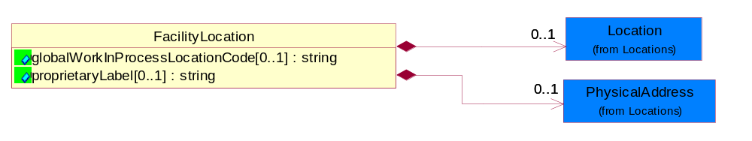
Figure 3-34 FacilityLocation

Attribute | Type | Documentation
globalWorkInProcessLocationCode[0..1] | string | References where fabrication, bond, assembly, test and related activities were performed on a lot or sublot.
proprietaryLabel[0..1] | string | User defined label to uniquely identify a facility that is represented in any of the scenarios.

Composition | Cardinality | Type | Documentation
Location | 0..1 | Location | The business document must specify a location.
PhysicalAddress | 0..1 | PhysicalAddress | The business document must provide a physical address for a party to the business transaction.

FinalPackageReport
A report that provides additional, optional information about a packaged device. This class supports additional information concerning die being assembled into a package and to a card. This is the last step in the assembly process.
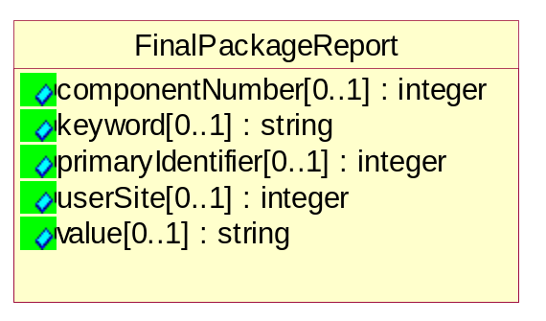
Figure 3-35 FinalPackageReport

Attribute | Type | Documentation
componentNumber[0..1] | integer | A number associating a key value pair to a specific component in BuildInfoReport.
keyword[0..1] | string | An optional keyword.
primaryIdentifier[0..1] | integer | Reference to link the test report to a lot.
userSite[0..1] | integer | Identifies the corresponding device site number.
value[0..1] | string | Any character string value necessary for defining ASCI test results off card testers.

FloatCoordinate
X, Y and Z Coordinate values.
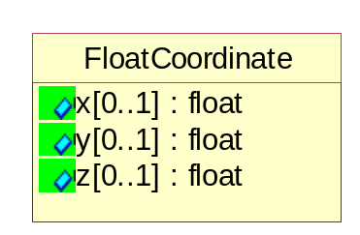
Figure 3-36 FloatCoordinate

Attribute | Type | Documentation
x[0..1] | float | Coordinate value for X-axis.
y[0..1] | float | Coordinate value for Y-axis.
z[0..1] | float | Coordinate value for Z-axis.

HardwareSets
Describes the unique attachments, handlers or probers that are associated to the tester.
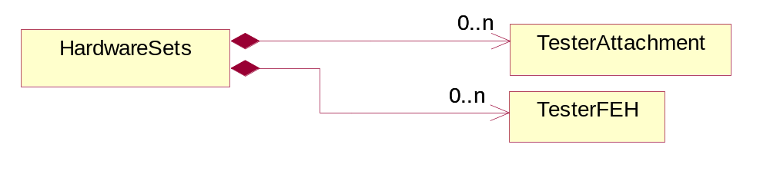
Figure 3-37 HardwareSets

Composition | Cardinality | Type | Documentation
TesterAttachment | 0..n | TesterAttachment | Describes the handlers or probers that are attached to the tester.
TesterFEH | 0..n | TesterFEH | Describes the unique attachments that can be associated to the tester.

IntCoordinate
X, Y and Z Coordinate values.
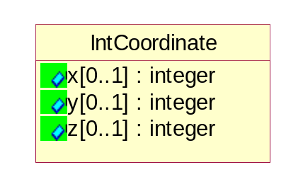
Figure 3-38 IntCoordinate

Attribute | Type | Documentation
x[0..1] | integer | Coordinate value for X-axis.
y[0..1] | integer | Coordinate value for Y-axis.
z[0..1] | integer | Coordinate value for Z-axis.

Lot
Describes the lot information.
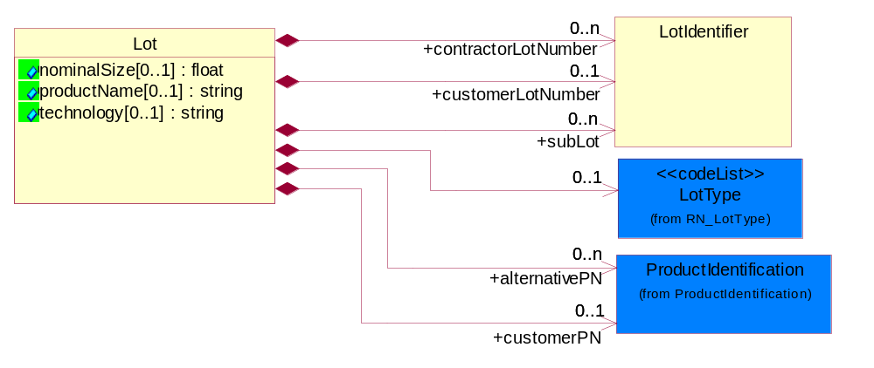
Figure 3-39 Lot

Attribute | Type | Documentation
nominalSize[0..1] | float | Describes the diameter of the wafer in mm, or inches.
productName[0..1] | string | A customer defined descriptor or code name for a part being fabricated or tested at a Foundry or Test Service trading partner. Example are Neptune, Big Dog, Antares 6.
technology[0..1] | string | An alphanumeric string that is associated with a fabrication technology. Example. CMOS8SF, MOS-11.

Composition | Cardinality | Type | Documentation
LotType | 0..1 | LotType | Describes the mode in which product was tested.
customerPN | 0..1 | ProductIdentification | A string which identifies Foundry defined, the Test Services defined or the customer proprietary defined part number for a wafer or packaged die.
alternativePN | 0..n | ProductIdentification | A user defined string to identify a part number for a wafer or packaged die which is associated with customerPN.
customerLotNumber | 0..1 | LotIdentifier | Customer defined alphanumeric string used to identify the lot.
contractorLotNumber | 0..n | LotIdentifier | User defined alphanumeric string which is associated with customer lot number.
subLot | 0..n | LotIdentifier | Alphanumeric string which describes a lot which has been separated from the Lot.

LotIdentifier
Description used to identify a lot.
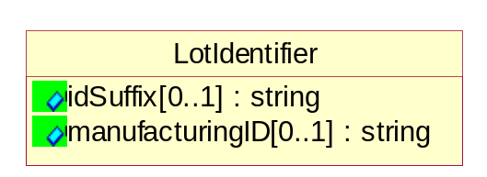
Figure 3-40 LotIdentifier

Attribute | Type | Documentation
idSuffix[0..1] | string | An alphanumeric string that could be used to identify a lot at a location. The suffix string is user defined. It can be used to identify a lot split, a bond assembly location, wafer sort or final test location.
manufacturingID[0..1] | string | Alphanumeric string which describes the lot.

MeasurementUnit
Describes the measurement unit.
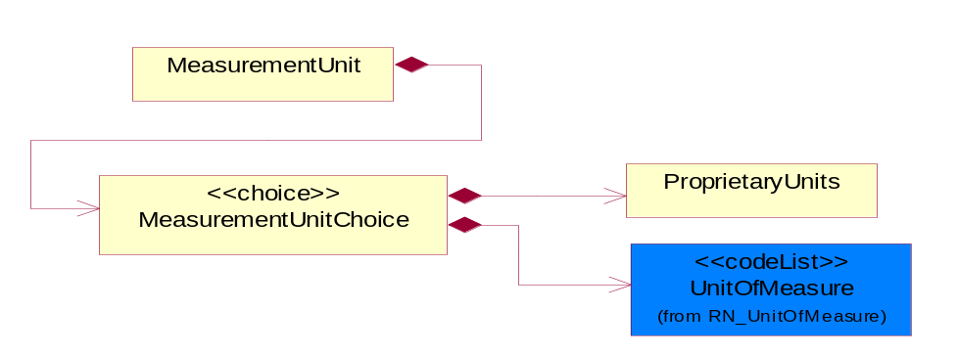
Figure 3-41 MeasurementUnit

Composition | Cardinality | Type | Documentation
MeasurementUnitChoice | 1 | MeasurementUnitChoice | Choice structure for describing the unit of measurement.

MeasurementUnitChoice
Choice structure for describing the unit of measurement.

Composition | Cardinality | Type | Documentation
UnitOfMeasure | 1 | UnitOfMeasure | Code identifying a product unit of measure.
ProprietaryUnits | 1 | ProprietaryUnits | Describes a class where the sender defines the units of measure for the test. These units are not listed in code list UnitOfMeasure.

Pin
Describes the optional attributes that provide additional pin identification information.
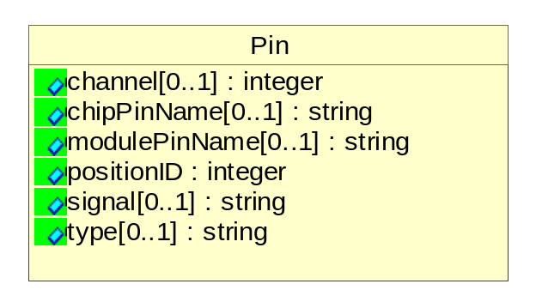
Figure 3-42 Pin

Attribute | Type | Documentation
channel[0..1] | integer | Integer, tester channel number.
chipPinName[0..1] | string | Alphanumeric string to describe the name of the pin.
modulePinName[0..1] | string | Alphanumeric string to describe the package pin name.
positionID | integer | Integer to reference ID for pin.
signal[0..1] | string | Alphanumeric string to describes name of signal pin.
type[0..1] | string | Alphanumeric string listing the driver/receiver book types.

ProprietaryUnits
Describes a class where the sender defines the units of measure for the test. These units are not listed in code list UnitOfMeasure.
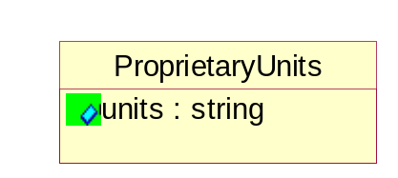
Figure 3-43 ProprietaryUnits

Attribute | Type | Documentation
units | string | Special description or code of the units for the measurement value.

SoftwareReport
SoftwareReport describes software type, software name, software version and softwareBuildID.
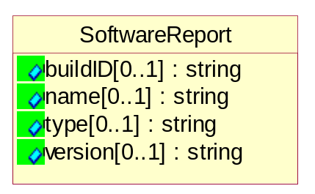
Figure 3-44 SoftwareReport

Attribute | Type | Documentation
buildID[0..1] | string | A string that identifies the build version of the software. Example: BuildID=Java, JDK, 118, o118-199990910.
name[0..1] | string | The name of software type. Examples: AIX, Windows.
type[0..1] | string | The type of software described by this item. Valid examples are: Operating system, OEM tool control, Software system, Local Software and user defined.
version[0..1] | string | The software version being utilized. Example: 4.1.3.

Tester
Describe unique tester information for PCM, Wafer Sort and Final Test.
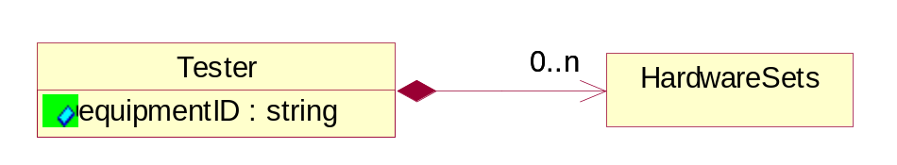
Figure 3-45 Tester

Attribute | Type | Documentation
equipmentID | string | An alphanumeric string to identify the tester used at PCM, wafer sort or final test.

Composition | Cardinality | Type | Documentation
HardwareSets | 0..n | HardwareSets | Describes the unique attachments, handlers or probers that are associated to the tester.

TesterAttachment
Describes the handlers or probers that are attached to the tester.
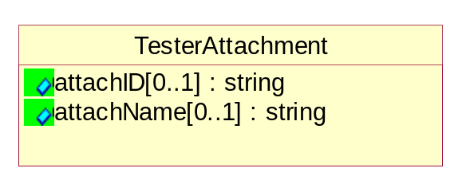
Figure 3-46 TesterAttachment

Attribute | Type | Documentation
attachID[0..1] | string | A string that defines the prober handler or any physical device/system that can be attached to the tester used in wafer sort or final test.
attachName[0..1] | string | A string to identify the tools attached to the tester system. e.g. Schlumberger 3100.

TesterFEH
Describes the unique attachments that can be associated to the tester.
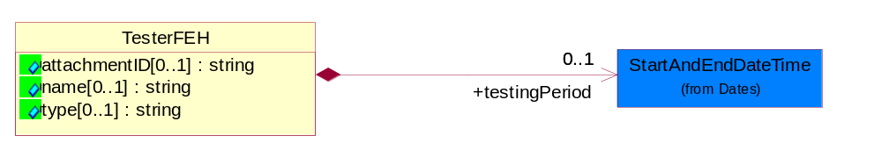
Figure 3-47 TesterFEH

Attribute | Type | Documentation
attachmentID[0..1] | string | String. A barcode, electronic ID or alphanumeric identifier for the FEHType used on a tester.
name[0..1] | string | A string that specifically labels the FEH type.
type[0..1] | string | A string that describes the type hardware. It can be an Attachment Sets or FEH (Front End Hardware) that is attached to a tester system. Example: Probe Heads, Sockets, BIB, DIB and user definable attachments.

Composition | Cardinality | Type | Documentation
testingPeriod | 0..1 | StartAndEndDateTime | Defines the start and end time for a wafer being tested.

TestMap
Describes the wafer orientation and configuration used by manufacturing test (metrology) equipment.
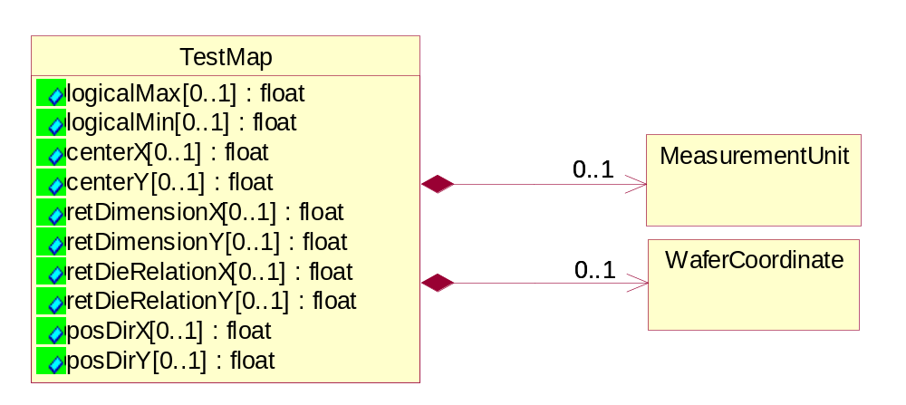
Figure 3-48 TestMap

Attribute | Type | Documentation
logicalMax[0..1] | float | The logiscal maximum dimensions. For PCM data, units are reticle index steps. For Wafer Sort and Final Test data, units are die index steps.
logicalMin[0..1] | float | The logiscal minimum dimensions. For PCM data, units are reticle index steps. For Wafer Sort and Final Test data, units are die index steps.
centerX[0..1] | float | The vector in X direction for index units form the (0,0) coordinate to the index containing the physical center of the wafer. For PCM data the index is reticle steps. For Wafer Sort and Final Test data the index is die steps.
centerY[0..1] | float | The vector in Y direction for index units form the (0,0) coordinate to the index containing the physical center of the wafer. For PCM data the index is reticle steps. For Wafer Sort and Final Test data the index is die steps.
retDimensionX[0..1] | float | The size of the reticle in the X direction , expressed in number of die incements.
retDimensionY[0..1] | float | The size of the reticle in the Y direction , expressed in number of die incements.
retDieRelationX[0..1] | float | The X coordinate of the center die within the center reticle.
retDieRelationY[0..1] | float | The Y coordinate of the center die within the center reticle.
posDirX[0..1] | float | The positive direction of the X-axis. Values illustrate Up (U), Down (D), Left (L)and Right (R).
posDirY[0..1] | float | The positive direction of the Y-axis. Values illustrate Up (U), Down (D), Left (L)and Right (R).

Composition | Cardinality | Type | Documentation
MeasurementUnit | 0..1 | MeasurementUnit | Describes the measurement unit.
WaferCoordinate | 0..1 | WaferCoordinate | The collection of business properties that describe the coordinate on a semiconductor wafer..

TestParameter
Describes optional attributes to provide additional information on the parameters of the test.
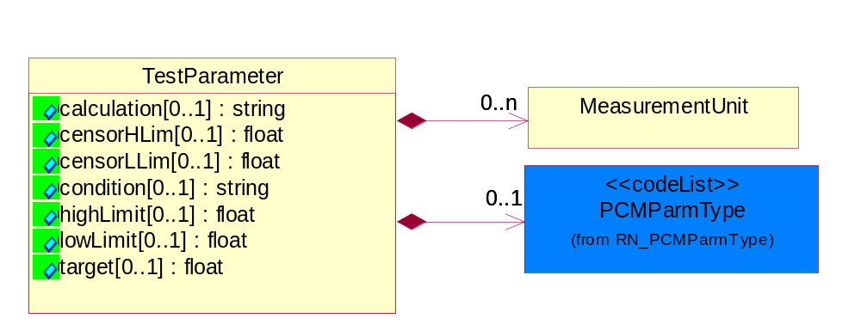
Figure 3-49 TestParameter

Attribute | Type | Documentation
calculation[0..1] | string | A string describing the mathematical expression to derive a result.
censorHLim[0..1] | float | FLOAT value for the high boundary for legitimate or valid test data.
censorLLim[0..1] | float | FLOAT value for the low boundary for legitimate or valid test data.
condition[0..1] | string | A string specifying the test parameter. Example: TestTemperature etc.
highLimit[0..1] | float | Describes the high limit value for a test specification.
lowLimit[0..1] | float | Describes the low limit value for a test specification.
target[0..1] | float | Describes the expected value for the test.

Composition | Cardinality | Type | Documentation
MeasurementUnit | 0..n | MeasurementUnit | Describes the measurement unit.
PCMParmType | 0..1 | PCMParmType | Used to identify whether a PCM parameter is part of the wafer acceptance test (WAT) or customer specific parameter (CSP) list. The WAT and CSP list is negotiated between the customer and the foundry for a given technology.

TestSetup
Describes the identification information for tester set-up.
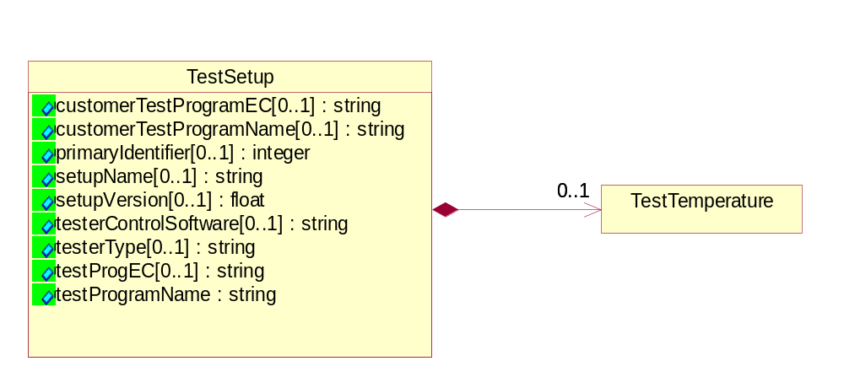
Figure 3-50 TestSetup

Attribute | Type | Documentation
customerTestProgramEC[0..1] | string | Customer Supplied Test Program EC. In a foundry model, the customer can have a different test program EC than the one used by the test house.
customerTestProgramName[0..1] | string | Customer Supplied Test Program Name. In a foundry model, the customer can have a different test program name than the one used by the test house.
primaryIdentifier[0..1] | integer | Reference to link the test report for a lot.
setupName[0..1] | string | A string that describes test conditions.
setupVersion[0..1] | float | Describes the version for the test conditions specified in setupName.
testerControlSoftware[0..1] | string | Describes the software and its version that control the tester.
testerType[0..1] | string | This object describes the tester model, version and ID number.
testProgEC[0..1] | string | A string that indicates the version number for the TestProgName (Req. #43) used for testing a lot or sublot.
testProgramName | string | A string that describes the test program for either a lot or sublot.

Composition | Cardinality | Type | Documentation
TestTemperature | 0..1 | TestTemperature | Temperature value in either Centigrade or Fahrenheit to identify at which a test is performed for lot or sublot.

TestSpecificationReport
Report that lists each test and their attributes at PCM, wafer sort and final test. e.g. Test name, electrical conditions, sort number, etc.
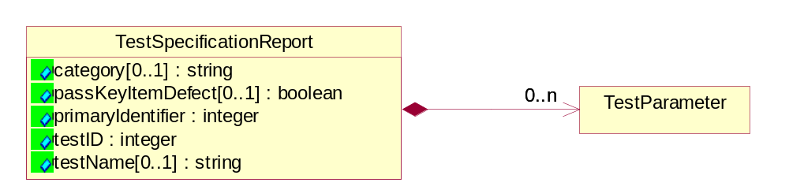
Figure 3-51 TestSpecificationReport

Attribute | Type | Documentation
category[0..1] | string | A string that describes a category of tests.
passKeyItemDefect[0..1] | boolean | A flag to identify if a failing parameter is PCM or optional.
primaryIdentifier | integer | Reference to link the test report for a lot.
testID | integer | An integer that uniquely identifies a test.
testName[0..1] | string | A string that describes the test.

Composition | Cardinality | Type | Documentation
TestParameter | 0..n | TestParameter | Describes optional attributes to provide additional information on the parameters of the test.

TestTemperature
Temperature value in either Centigrade or Fahrenheit to identify at which a test is performed for lot or sublot.
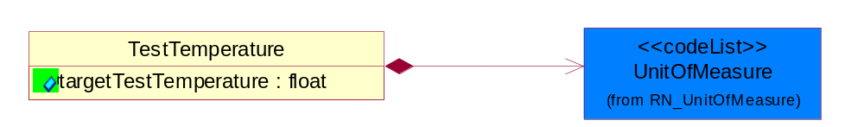
Figure 3-52 TestTemperature

Attribute | Type | Documentation
targetTestTemperature | float | The targeted temperature value in either Centigrade or Fahrenheit at which a test is performed for lot or sublot.

Composition | Cardinality | Type | Documentation
UnitOfMeasure | 1 | UnitOfMeasure | Code identifying a product unit of measure.

WaferCoordinate
The collection of business properties that describe the coordinate on a semiconductor wafer..
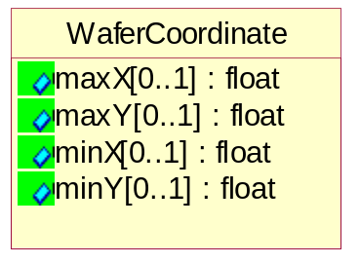
Figure 3-53 WaferCoordinate

Attribute | Type | Documentation
maxX[0..1] | float | The maximum X coordinate on a semiconductor wafer.
maxY[0..1] | float | The maximum Y coodinate on a semiconductor wafer.
minX[0..1] | float | The minimum X coodinate on a semiconductor wafer.
minY[0..1] | float | The minimum Y coodinate on a semiconductor wafer.

CodeList

Axis
Indicate three dimensional direction.

Name | Documentation
X | X-axis.
Y | Y-axis.
Z | Z-axis.

PCMParmType
Used to identify whether a PCM parameter is part of the wafer acceptance test (WAT) or customer specific parameter (CSP) list. The WAT and CSP list is negotiated between the customer and the foundry for a given technology.

Name | Documentation
CSP | Customer Specific Parameter.
PSR | Product Specification Limit.
WAT | Wafer Acceptance Test.
WLR | Wafer Level Reliability.

Confidentiality
A string which describes the level of security associated with the data, as defined by TPA.

Name | Documentation
CON | Confidential security level.
NON | No security restriction (None).
RES | Restricted security level.

Status
Describes the Status result for a vector test.

Name | Documentation
ATH | H=actual H.
EHD | expect H D=actual Z.
EHF | expect H F=actual L.
ELB | expected L B=actual H.
ELE | expect L E=actual L.
EUA | expected unknown A=actual H.
EUL | expect unknown L=actual L.
EUZ | expect unknown Z=actual Z.
EZC | expect Z C=actual Z.
EZZ | expect Z.

LotType
Describes the mode in which product was tested.

Name | Documentation
DEV | Development.
ENG | Engineering - State where product is made using test processes on non-production tools or equipment.
EUH | EUH type.
MFG | Manufacturing.
NCL | NonConformingLot - Lots affected by a nonconformity to preset quality characteristics.
PLT | Pilot - The first lot of the product (never produced at the dedicated subcontractor).
PPD | Pre-Production.
PQC | Process Qualification Check - Process to qualify manufacturing processes in preparation for volume manufacturing.
PRD | Production - State where product is made using all production tools, processes, equipment, environment, facility, and cycle time.
RND | Research and Development - Process for developing prototype products.
RWK | Rework - Parts sent back from further down the manufacturing line.
SVC | Service.
TST | Test - The manufacturing stage in which the packaged die is tested.

CoordinateFlag
A status flag to indicate the coordinate measurement is for a single die on a reticle or a multi-chip die on a reticle.

Name | Documentation
MUL | Multi-chip die on a reticle.
SIN | Single Die on a reticle.

SortWeight
A relative representation of yield for a device or module.

Name | Documentation
0 | Bad.
100 | All Good.
25 | 1/4 Good.
50 | 1/2 Good.
75 | 3/4 Good.

CompletionStatus
Describes the status of the lot or sublot at the end of testing.

Name | Documentation
ABO | Aborted: process has been terminated; data is invalid and is purged.
COM | Completed: all process have been completed; data is valid and can be migrated.
SUS | Suspend: process is partially done; data is valid and can be migrated.

TestResult
Describes the test result for a parametric test.

Name | Documentation
FAL | Failed.
FCS | Failed Censor.
FHL | Failed High Limit.
FLL | Failed Low Limit.
PAS | Passed.
SCV | Screened Valued.

ComponentType
Valid component values are: CAG, CHP, COR, CRD, FRM, MCM, MOD, NOD, SCM.

Name | Documentation
CAG | A cage containing multiple boards or cards.
CHP | A row chip or die.
COR | Core, a subcomponent of a chip (e.g. Mult-core processor).
CRD | A card or board containing multiple module (MCM or SCM).
FRM | A frame containing multiple cages and user definded.
MCM | A multi chip module.
MOD | Module, a single packaged chip (SCM-e.g. Single Chip Module) or set of chips (MCM - e.g. Multi-Chip Module). Use this code when SCM or MCM can not be determined.
NOD | Node, a grouping of cards within a cage. A node may include cards, memory, and cooling unit systems.
SCM | A single chip module.

Shared

Shared

Dependency Diagram
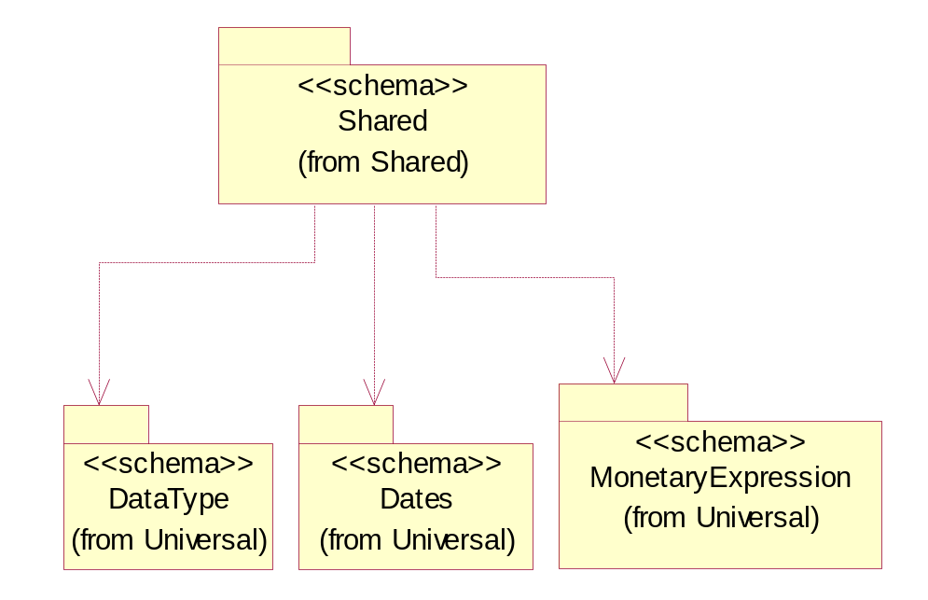
Figure 3-54 Dependency

Universal Structure

ContactInformation

ContactInformation
The business document must allow for the identification of the name of the department, service or individual to be contacted regarding the context of the business document.
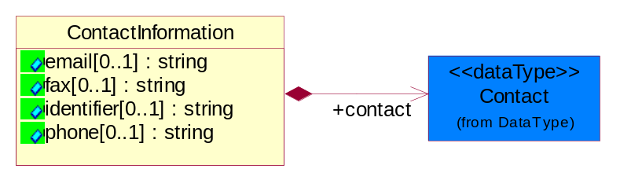
Figure 4-55 ContactInformation

Attribute | Type | Documentation
email[0..1] | string | The electronic mail for the specified contact.
fax[0..1] | string | The fax number for the specified contact.
identifier[0..1] | string | Identifies the role of the contact (i.e. Service Technician, Account Manager) in the Business Process.
phone[0..1] | string | The telephone number for the specified contact.

Composition | Cardinality | Type | Documentation
contact | 1 | Contact | The name of the department, service or individual to be contacted within the organization.

DataType

Contact
The name of the department, service or individual to be contacted within the organization.
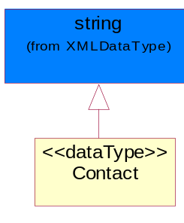
Figure 4-56 Contact

DUNS
A number assigned by Dun and Bradstreet to identify a business location.
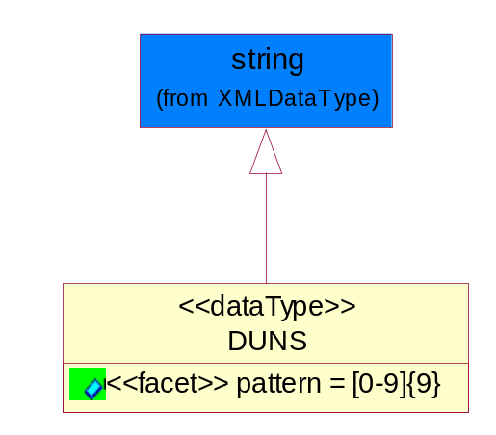
Figure 4-57 DUNS

Attribute | Type | Documentation
pattern |  | [0-9]{9}

DUNSPlus4
A identifier to specify a specific location within a business location.
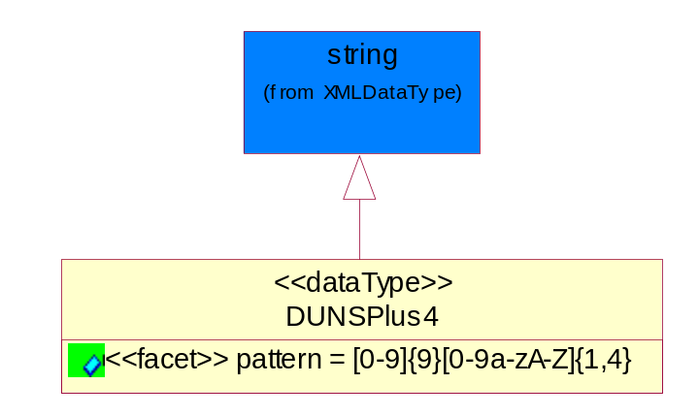
Figure 4-58 DUNSPlus4

Attribute | Type | Documentation
pattern |  | Data Universal Numbering System +4 (DUNS+4) number means the DUNS number assigned by Dun and Bradstreet, Inc. (D&B) plus an alphanumeric of length 4 suffix that may be assigned by a business concern.

GLN
Global Location Number (GLN) - A identifier to identify legal entities, trading parties and location.
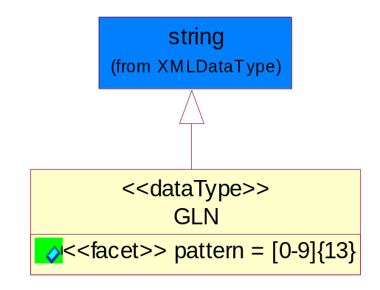
Figure 4-59 GLN

Attribute | Type | Documentation
pattern |  | [0-9]{13}

GTIN
Global Trade Identification Number (GTIN).
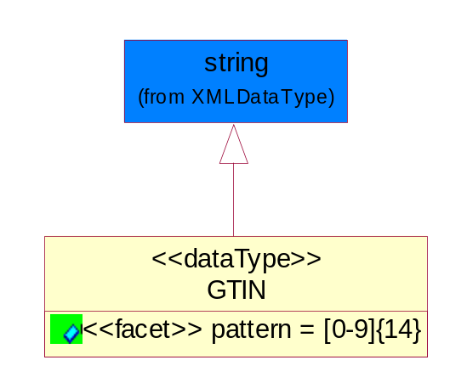
Figure 4-60 GTIN

Attribute | Type | Documentation
pattern |  | [0-9]{14}

Hexadecimal
Hexadecimal data type.
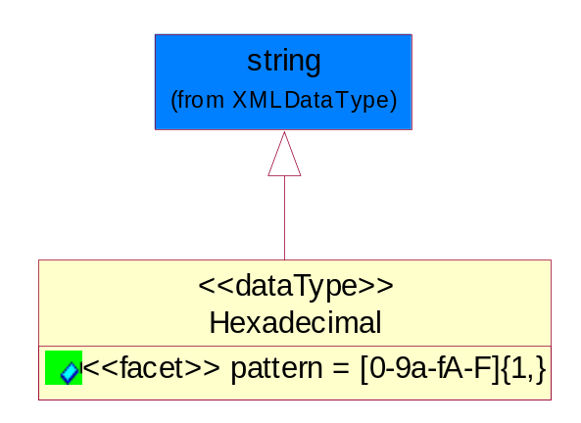
Figure 4-61 Hexadecimal

Attribute | Type | Documentation
pattern |  | [0-9a-fA-F]{1,}

PercentAmount
A number representing a percentage value, e.g. 75.125 represents 75 1/8 percent.
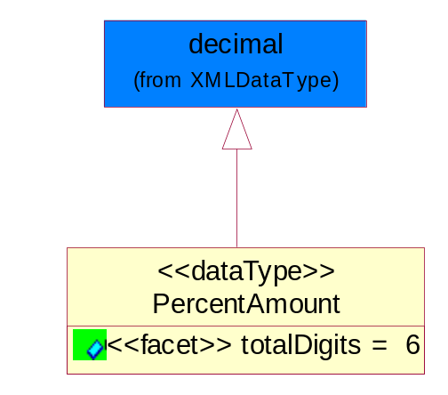
Figure 4-62 PercentAmount

Attribute | Type | Documentation
totalDigits |  | 6

Dates

StartAndEndDateTime
The start and end date time of a certain period.
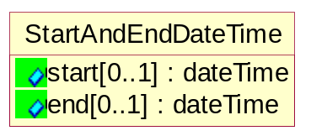
Figure 4-63 StartAndEndDateTime

Attribute | Type | Documentation
start[0..1] | dateTime | The start date time of a period.
end[0..1] | dateTime | The end date time of a period.

Locations

AlternativeIdentifier
Identifies the specified code and the name of the organization that a code is utilized from.
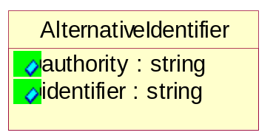
Figure 4-64 AlternativeIdentifier

Attribute | Type | Documentation
authority | string | The name of the organization that a code is utilized from.
identifier | string | The specified code to represent an entity (e.g. product, location, partner, etc.).

Location
The business document must specify a location.
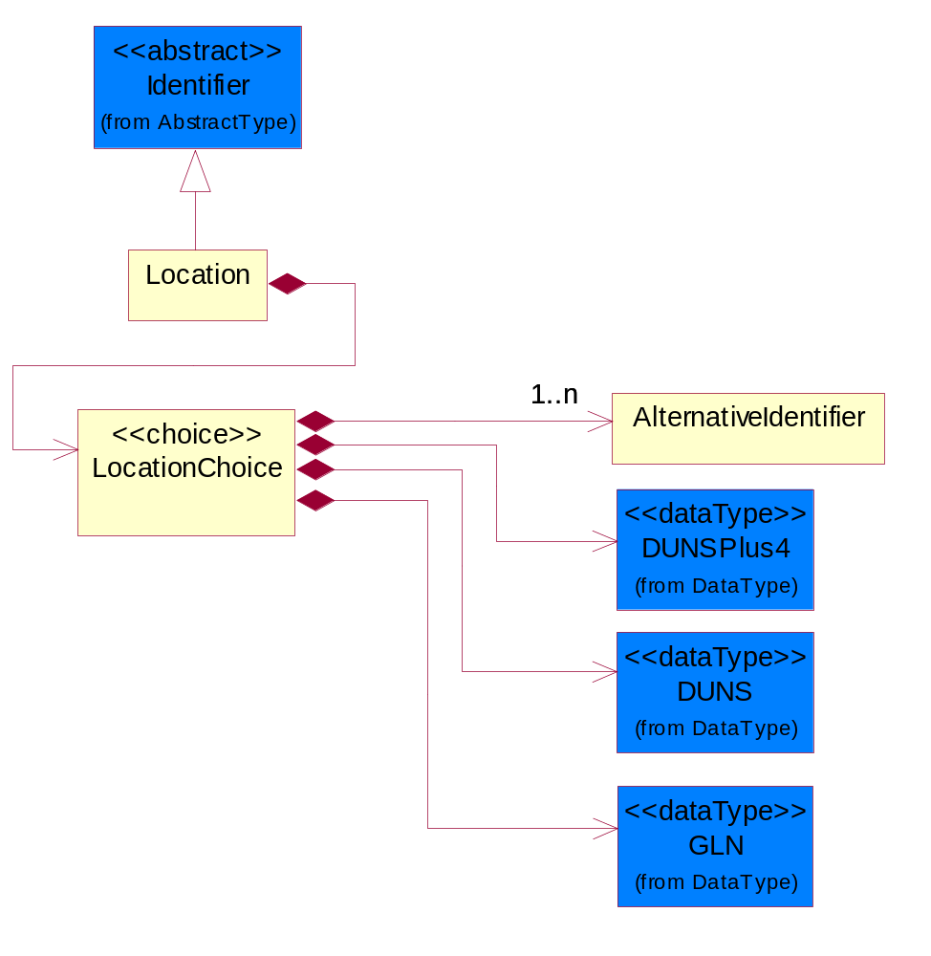
Figure 4-65 Location

Composition | Cardinality | Type | Documentation
LocationChoice | 1 | LocationChoice

LocationChoice

Composition | Cardinality | Type | Documentation
DUNSPlus4 | 1 | DUNSPlus4 | A identifier to specify a specific location within a business location.
DUNS | 1 | DUNS | A number assigned by Dun and Bradstreet to identify a business location.
AlternativeIdentifier | 1..n | AlternativeIdentifier | Identifies the specified code and the name of the organization that a code is utilized from.
GLN | 1 | GLN | Global Location Number (GLN) - A identifier to identify legal entities, trading parties and location.

PhysicalAddress
The business document must provide a physical address for a party to the business transaction.
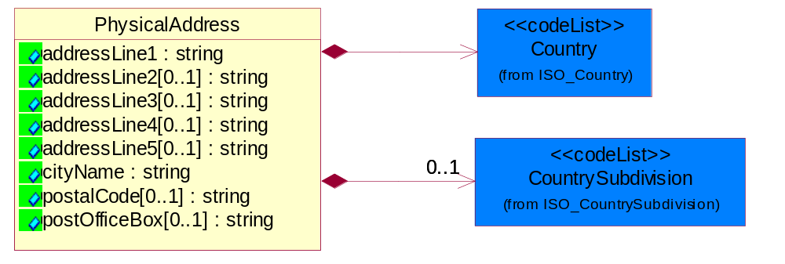
Figure 4-66 PhysicalAddress

Attribute | Type | Documentation
addressLine1 | string | The first line of a physical address.
addressLine2[0..1] | string | The second line of a physical address.
addressLine3[0..1] | string | The third line of a physical address.
addressLine4[0..1] | string | The fourth line of a physical address.
addressLine5[0..1] | string | The fifth line of a physical address.
cityName | string | The name of a city.
postalCode[0..1] | string | Identifying geographic location as specified by a national postal code.
postOfficeBox[0..1] | string | The Post Office Box identifier used to identify a party's post office box.

Composition | Cardinality | Type | Documentation
Country | 1 | Country | For representation of Country name RosettaNet has adopted ISO 3166-3; 1999. Refer to the following web page to get the latest version of the standard:  http://www.iso.ch/iso/en/prods-services/iso3166ma/02iso-3166-code-lists/index.html  If you need more information about the ISO standard please contact ISO for more details.
CountrySubdivision | 0..1 | CountrySubdivision | For representation of a Countries subdivisions RosettaNet has adopted ISO 3166-3; 1999. Refer to the following web page to get the latest version of the standard:  http://www.iso.ch/iso/en/prods-services/iso3166ma/02iso-3166-code-lists/index.html  If you need more information about the ISO standard please contact ISO for more details.

PartnerIdentification

PartnerIdentification
The business document must allow for the identity of one or more parties to the transaction.
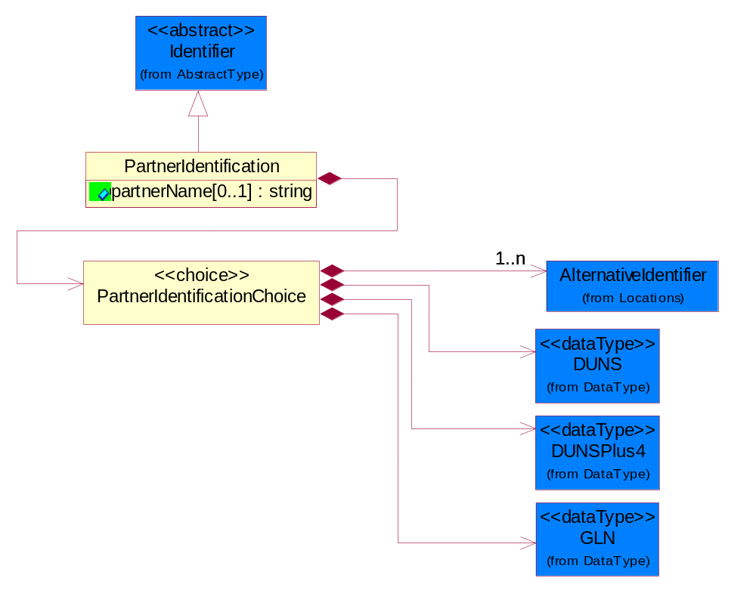
Figure 4-67 PartnerIdentification

Attribute | Type | Documentation
partnerName[0..1] | string | The name of the partner’s company/business.

Composition | Cardinality | Type | Documentation
PartnerIdentificationChoice | 1 | PartnerIdentificationChoice

PartnerIdentificationChoice

Composition | Cardinality | Type | Documentation
DUNS | 1 | DUNS | A number assigned by Dun and Bradstreet to identify a business location.
DUNSPlus4 | 1 | DUNSPlus4 | A identifier to specify a specific location within a business location.
AlternativeIdentifier | 1..n | AlternativeIdentifier | Identifies the specified code and the name of the organization that a code is utilized from.
GLN | 1 | GLN | Global Location Number (GLN) - A identifier to identify legal entities, trading parties and location.

ProductIdentification

ProductIdentification
The object provides the identifier(s) of a product.
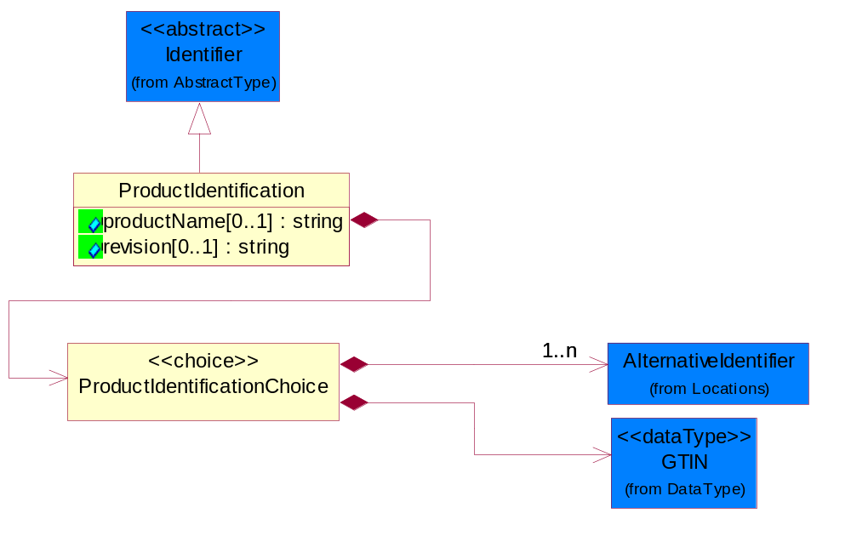
Figure 4-68 ProductIdentification

Attribute | Type | Documentation
productName[0..1] | string | The name of the product.
revision[0..1] | string | Referenced the specified product revision.

Composition | Cardinality | Type | Documentation
ProductIdentificationChoice | 1 | ProductIdentificationChoice

ProductIdentificationChoice

Composition | Cardinality | Type | Documentation
AlternativeIdentifier | 1..n | AlternativeIdentifier | Identifies the specified code and the name of the organization that a code is utilized from.
GTIN | 1 | GTIN | Global Trade Identification Number (GTIN).

CodeList

Country
For representation of Country name RosettaNet has adopted ISO 3166-3; 1999. Refer to the following web page to get the latest version of the standard:
http://www.iso.ch/iso/en/prods-services/iso3166ma/02iso-3166-code-lists/index.html

If you need more information about the ISO standard please contact ISO for more details.

CountrySubdivision
For representation of a Countries subdivisions RosettaNet has adopted ISO 3166-3; 1999. Refer to the following web page to get the latest version of the standard:
http://www.iso.ch/iso/en/prods-services/iso3166ma/02iso-3166-code-lists/index.html

If you need more information about the ISO standard please contact ISO for more details.

Language
For representation of Language name RosettaNet has adopted ISO 639-2; 1998. Refer to the following web page to get the latest version of the standard:

http://www.loc.gov/standards/iso639-2/iso639jac.html

If you need more information about the ISO standard please contact ISO for more details.

MimeTypeQualifier
The MIME type as defined by IANA.

Please refer to http://www.iana.org/assignments/media-types/ for a list of types.

Instance | Documentation
application/activemessage | [Shapiro]
application/andrew-inset | [Borenstein]
application/applefile | [Faltstrom]
application/atomicmail | [Borenstein]
application/batch-SMTP | [RFC2442]
application/beep+xml | [RFC3080]
application/cals-1840 | [RFC1895]
application/cnrp+xml | [RFCCNRP]
application/commonground | [Glazer]
application/cpl+xml
application/cybercash | [Eastlake]
application/dca-rft | [Campbell]
application/dec-dx | [Campbell]
application/dicom | [RFC3240]
application/dvcs | [RFC3029]
application/EDI-Consent | [RFC1767]
application/EDIFACT | [RFC1767]
application/EDI-X12 | [RFC1767]
application/eshop | [Katz]
application/font-tdpfr | [RFC3073]
application/http | [RFC2616]
application/hyperstudio | [Domino]
application/iges | [Parks]
application/index | [RFC2652]
application/index.cmd | [RFC2652]
application/index.obj | [RFC2652]
application/index.response | [RFC2652]
application/index.vnd | [RFC2652]
application/iotp | [RFC2935]
application/ipp | [RFC2910]
application/isup | [RFC3204]
application/mac-binhex40 | [Faltstrom]
application/macwriteii | [Lindner]
application/marc | [RFC2220]
application/mathematica | [Van Nostern]
application/msword | [Lindner]
application/news-message-id | [RFC1036,Spencer]
application/news-transmission | [RFC1036, Spencer]
application/ocsp-request | [RFC2560]
application/ocsp-response | [RFC2560]
application/octet-stream | [RFC2045,RFC2046]
application/oda | [RFC2045,RFC2046]
application/ogg | [RFC-walleij-ogg-mediatype-08.txt]
application/parityfec | [RFC3009]
application/pdf | [Lindner]
application/pgp-encrypted | [RFC3156]
application/pgp-keys | [RFC3156]
application/pgp-signature | [RFC3156]
application/pkcs10 | [RFC2311]
application/pkcs7-mime | [RFC2311]
application/pkcs7-signature | [RFC2311]
application/pkix-cert | [RFC2585]
application/pkixcmp | [RFC2510]
application/pkix-crl | [RFC2585]
application/postscript | [RFC2045,RFC2046]
application/prs.alvestrand.titrax-sheet | [Alvestrand]
application/prs.cww | [Rungchavalnont]
application/prs.nprend | [Doggett]
application/prs.plucker | [Janssen]
application/qsig | [RFC3204]
application/reginfo+xml | [RFC-ietf-sipping-reg-event-00.txt]
application/remote-printing | [RFC1486,Rose]
application/riscos | [Smith]
application/rtf | [Lindner]
application/sdp | [RFC2327]
application/set-payment | [Korver]
application/set-payment-initiation | [Korver]
application/set-registration | [Korver]
application/set-registration-initiation | [Korver]
application/sgml | [RFC1874]
application/sgml-open-catalog | [Grosso]
application/sieve | [RFC3028]
application/slate | [Crowley]
application/timestamp-query | [RFC3161]
application/timestamp-reply | [RFC3161]
application/tve-trigger | [Welsh]
application/vemmi | [RFC2122]
application/vnd.3gpp.pic-bw-large | [Meredith]
application/vnd.3gpp.pic-bw-small | [Meredith]
application/vnd.3gpp.pic-bw-var | [Meredith]
application/vnd.3gpp.sms | [Meredith]
application/vnd.3M.Post-it-Notes | [O'Brien]
application/vnd.accpac.simply.aso | [Leow]
application/vnd.accpac.simply.imp | [Leow]
application/vnd.acucobol | [Lubin]
application/vnd.acucorp | [Lubin]
application/vnd.adobe.xfdf | [Perelman]
application/vnd.aether.imp | [Moskowitz]
application/vnd.amiga.ami | [Blumberg]
application/vnd.anser-web-certificate-issue-initiation | [Mori]
application/vnd.anser-web-funds-transfer-initiation | [Mori]
application/vnd.audiograph | [Slusanschi]
application/vnd.blueice.multipass | [Holmstrom]
application/vnd.bmi | [Gotoh]
application/vnd.businessobjects | [Imoucha]
application/vnd.canon-cpdl | [Muto]
application/vnd.canon-lips | [Muto]
application/vnd.cinderella | [Kortenkamp]
application/vnd.claymore | [Simpson]
application/vnd.commerce-battelle | [Applebaum]
application/vnd.commonspace | [Chandhok]
application/vnd.contact.cmsg | [Patz]
application/vnd.cosmocaller | [Dellutri]
application/vnd.ctc-posml | [Kohlhepp]
application/vnd.cups-postscript | [Sweet]
application/vnd.cups-raster | [Sweet]
application/vnd.cups-raw | [Sweet]
application/vnd.curl | [Byrnes]
application/vnd.cybank | [Helmee]
application/vnd.data-vision.rdz | [Fields]
application/vnd.dna | [Searcy]
application/vnd.dpgraph | [Parker]
application/vnd.dreamfactory | [Appleton]
application/vnd.dxr | [Duffy]
application/vnd.ecdis-update | [Buettgenbach]
application/vnd.ecowin.chart | [Olsson]
application/vnd.ecowin.filerequest | [Olsson]
application/vnd.ecowin.fileupdate | [Olsson]
application/vnd.ecowin.series | [Olsson]
application/vnd.ecowin.seriesrequest | [Olsson]
application/vnd.ecowin.seriesupdate | [Olsson]
application/vnd.enliven | [Santinelli]
application/vnd.epson.esf | [Hoshina]
application/vnd.epson.msf | [Hoshina]
application/vnd.epson.quickanime | [Gu]
application/vnd.epson.salt | [Nagatomo]
application/vnd.epson.ssf | [Hoshina]
application/vnd.ericsson.quickcall | [Tidwell]
application/vnd.eudora.data | [Resnick]
application/vnd.fdf | [Zilles]
application/vnd.ffsns | [Holstage]
application/vnd.FloGraphIt | [Floersch]
application/vnd.framemaker | [Wexler]
application/vnd.fsc.weblaunch | [D.Smith]
application/vnd.fujitsu.oasys | [Togashi]
application/vnd.fujitsu.oasys2 | [Togashi]
application/vnd.fujitsu.oasys3 | [Okudaira]
application/vnd.fujitsu.oasysgp | [Sugimoto]
application/vnd.fujitsu.oasysprs | [Ogita]
application/vnd.fujixerox.ddd | [Onda]
application/vnd.fujixerox.docuworks | [Taguchi]
application/vnd.fujixerox.docuworks.binder | [Matsumoto]
application/vnd.fut-misnet | [Pruulmann]
application/vnd.grafeq | [Tupper]
application/vnd.groove-account | [Joseph]
application/vnd.groove-help | [Joseph]
application/vnd.groove-identity-message | [Joseph]
application/vnd.groove-injector | [Joseph]
application/vnd.groove-tool-message | [Joseph]
application/vnd.groove-tool-template | [Joseph]
application/vnd.groove-vcard | [Joseph]
application/vnd.hbci | [Hammann]
application/vnd.hhe.lesson-player | [Jones]
application/vnd.hp-HPGL | [Pentecost]
application/vnd.hp-hpid | [Gupta]
application/vnd.hp-hps | [Aubrey]
application/vnd.hp-PCL | [Pentecost]
application/vnd.hp-PCLXL | [Pentecost]
application/vnd.httphone | [Lefevre]
application/vnd.hzn-3d-crossword | [Minnis]
application/vnd.ibm.afplinedata | [Buis]
application/vnd.ibm.electronic-media | [Tantlinger]
application/vnd.ibm.MiniPay | [Herzberg]
application/vnd.ibm.modcap | [Hohensee]
application/vnd.ibm.secure-container | [Tantlinger]
application/vnd.informix-visionary | [Gales]
application/vnd.intercon.formnet | [Gurak]
application/vnd.intertrust.digibox | [Tomasello]
application/vnd.intertrust.nncp | [Tomasello]
application/vnd.intu.qbo | [Scratchley]
application/vnd.intu.qfx | [Scratchley]
application/vnd.irepository.package+xml | [Knowles]
application/vnd.is-xpr | [Natarajan]
application/vnd.japannet-directory-service | [Fujii]
application/vnd.japannet-jpnstore-wakeup | [Yoshitake]
application/vnd.japannet-payment-wakeup | [Fujii]
application/vnd.japannet-registration | [Yoshitake]
application/vnd.japannet-registration-wakeup | [Fujii]
application/vnd.japannet-setstore-wakeup | [Yoshitake]
application/vnd.japannet-verification | [Yoshitake]
application/vnd.japannet-verification-wakeup | [Fujii]
application/vnd.jisp | [Deckers]
application/vnd.kde.karbon | [Faure]
application/vnd.kde.kchart | [Faure]
application/vnd.kde.kformula | [Faure]
application/vnd.kde.kivio | [Faure]
application/vnd.kde.kontour | [Faure]
application/vnd.kde.kpresenter | [Faure]
application/vnd.kde.kspread | [Faure]
application/vnd.kde.kword | [Faure]
application/vnd.kenameaapp | [DiGiorgio-Haag]
application/vnd.koan | [Cole]
application/vnd.liberty-request+xml | [McDowell]
application/vnd.llamagraphics.life-balance.desktop | [White]
application/vnd.lotus-1-2-3 | [Wattenberger]
application/vnd.lotus-approach | [Wattenberger]
application/vnd.lotus-freelance | [Wattenberger]
application/vnd.lotus-notes | [Laramie]
application/vnd.lotus-organizer | [Wattenberger]
application/vnd.lotus-screencam | [Wattenberger]
application/vnd.lotus-wordpro | [Wattenberger]
application/vnd.mcd | [Gotoh]
application/vnd.mediastation.cdkey | [Flurry]
application/vnd.meridian-slingshot | [Wedel]
application/vnd.micrografx.flo | [Prevo]
application/vnd.micrografx.igx | [Prevo]
application/vnd.mif | [Wexler]
application/vnd.minisoft-hp3000-save | [Bartram]
application/vnd.mitsubishi.misty-guard.trustweb | [Tanaka]
application/vnd.Mobius.DAF | [Kabayama]
application/vnd.Mobius.DIS | [Kabayama]
application/vnd.Mobius.MBK | [Devasia]
application/vnd.Mobius.MQY | [Devasia]
application/vnd.Mobius.MSL | [Kabayama]
application/vnd.Mobius.PLC | [Kabayama]
application/vnd.Mobius.TXF | [Kabayama]
application/vnd.mophun.application | [Wennerstrom]
application/vnd.mophun.certificate | [Wennerstrom]
application/vnd.motorola.flexsuite | [Patton]
application/vnd.motorola.flexsuite.adsi | [Patton]
application/vnd.motorola.flexsuite.fis | [Patton]
application/vnd.motorola.flexsuite.gotap | [Patton]
application/vnd.motorola.flexsuite.kmr | [Patton]
application/vnd.motorola.flexsuite.ttc | [Patton]
application/vnd.motorola.flexsuite.wem | [Patton]
application/vnd.mozilla.xul+xml | [McDaniel]
application/vnd.ms-artgalry | [Slawson]
application/vnd.ms-asf | [Fleischman]
application/vnd.mseq | [Le Bodic]
application/vnd.ms-excel | [Gill]
application/vnd.msign | [Borcherding]
application/vnd.ms-lrm | [Ledoux]
application/vnd.ms-powerpoint | [Gill]
application/vnd.ms-project | [Gill]
application/vnd.ms-tnef | [Gill]
application/vnd.ms-works | [Gill]
application/vnd.ms-wpl | [Plastina]
application/vnd.musician | [Adams]
application/vnd.music-niff | [Butler]
application/vnd.netfpx | [Mutz]
application/vnd.noblenet-directory | [Solomon]
application/vnd.noblenet-sealer | [Solomon]
application/vnd.noblenet-web | [Solomon]
application/vnd.novadigm.EDM | [Swenson]
application/vnd.novadigm.EDX | [Swenson]
application/vnd.novadigm.EXT | [Swenson]
application/vnd.obn | [Hessling]
application/vnd.osa.netdeploy | [Klos]
application/vnd.palm | [Peacock]
application/vnd.pg.format | [Gandert]
application/vnd.pg.osasli | [Gandert]
application/vnd.powerbuilder6 | [Guy]
application/vnd.powerbuilder6-s | [Guy]
application/vnd.powerbuilder7 | [Shilts]
application/vnd.powerbuilder75 | [Shilts]
application/vnd.powerbuilder75-s | [Shilts]
application/vnd.powerbuilder7-s | [Shilts]
application/vnd.previewsystems.box | [Smolgovsky]
application/vnd.publishare-delta-tree | [Ben-Kiki]
application/vnd.pvi.ptid1 | [Lamb]
application/vnd.pwg-multiplexed | [RFC3391]
application/vnd.pwg-xhtml-print+xml | [Wright]
application/vnd.Quark.QuarkXPress | [Scheidler]
application/vnd.rapid | [Szekely]
application/vnd.s3sms | [Tarkkala]
application/vnd.sealed.net | [Lambert]
application/vnd.seemail | [Webb]
application/vnd.shana.informed.formdata | [Selzler]
application/vnd.shana.informed.formtemplate | [Selzler]
application/vnd.shana.informed.interchange | [Selzler]
application/vnd.shana.informed.package | [Selzler]
application/vnd.smaf | [Takahashi]
application/vnd.sss-cod | [Dani]
application/vnd.sss-dtf | [Bruno]
application/vnd.sss-ntf | [Bruno]
application/vnd.street-stream | [Levitt]
application/vnd.svd | [Becker]
application/vnd.swiftview-ics | [Widener]
application/vnd.triscape.mxs | [Simonoff]
application/vnd.trueapp | [Hepler]
application/vnd.truedoc | [Chase]
application/vnd.ufdl | [Manning]
application/vnd.uplanet.alert | [Martin]
application/vnd.uplanet.alert-wbxml | [Martin]
application/vnd.uplanet.bearer-choice | [Martin]
application/vnd.uplanet.bearer-choice-wbxml | [Martin]
application/vnd.uplanet.cacheop | [Martin]
application/vnd.uplanet.cacheop-wbxml | [Martin]
application/vnd.uplanet.channel | [Martin]
application/vnd.uplanet.channel-wbxml | [Martin]
application/vnd.uplanet.list | [Martin]
application/vnd.uplanet.listcmd | [Martin]
application/vnd.uplanet.listcmd-wbxml | [Martin]
application/vnd.uplanet.list-wbxml | [Martin]
application/vnd.uplanet.signal | [Martin]
application/vnd.vcx | [T.Sugimoto]
application/vnd.vectorworks | [Pharr]
application/vnd.vidsoft.vidconference | [Hess]
application/vnd.visio | [Sandal]
application/vnd.visionary | [Aravindakumar]
application/vnd.vividence.scriptfile | [Risher]
application/vnd.vsf | [Rowe]
application/vnd.wap.sic | [WAP-Forum]
application/vnd.wap.slc | [WAP-Forum]
application/vnd.wap.wbxml | [Stark]
application/vnd.wap.wmlc | [Stark]
application/vnd.wap.wmlscriptc | [Stark]
application/vnd.webturbo | [Rehem]
application/vnd.wrq-hp3000-labelled | [Bartram]
application/vnd.wt.stf | [Wohler]
application/vnd.wv.csp+wbxml | [Salmi]
application/vnd.xara | [Matthewman]
application/vnd.xfdl | [Manning]
application/vnd.yellowriver-custom-menu | [Yellow]
application/whoispp-query | [RFC2957]
application/whoispp-response | [RFC2958]
application/wita | [Campbell]
application/wordperfect5.1 | [Lindner]
application/x400-bp | [RFC1494]
application/xhtml+xml | [RFC3236]
application/xml | [RFC3023]
application/xml-dtd | [RFC3023]
application/xml-external-parsed-entity | [RFC3023]
application/zip | [Lindner]
audio/32kadpcm | [RFC2421,RFC2422]
audio/AMR | [RFC3267]
audio/AMR-WB | [RFC3267]
audio/basic | [RFC2045,RFC2046]
audio/CN | [RFC3389]
audio/DAT12 | [RFC3190]
audio/DVI4
audio/EVRC | [RFC-ietf-avt-evrc-smv-03.txt]
audio/EVRC0 | [RFC-ietf-avt-evrc-smv-03.txt]
audio/G.722.1 | [RFC3047]
audio/G722
audio/G723
audio/G726-16
audio/G726-24
audio/G726-32
audio/G726-40
audio/G728
audio/G729
audio/G729D
audio/G729E
audio/GSM
audio/GSM-EFR
audio/L16 | [RFC2586]
audio/L20 | [RFC3190]
audio/L24 | [RFC3190]
audio/L8
audio/LPC
audio/MP4A-LATM | [RFC3016]
audio/MPA
audio/mpa-robust | [RFC3119]
audio/mpeg | [RFC3003]
audio/parityfec | [RFC3009]
audio/PCMA
audio/PCMU
audio/prs.sid | [Walleij]
audio/QCELP
audio/RED
audio/SMV | [RFC-ietf-avt-evrc-smv-03.txt]
audio/SMV0 | [RFC-ietf-avt-evrc-smv-03.txt]
audio/telephone-event | [RFC2833]
audio/tone | [RFC2833]
audio/VDVI
audio/vnd.3gpp.iufp | [Belling]
audio/vnd.cisco.nse | [Kumar]
audio/vnd.cns.anp1 | [McLaughlin]
audio/vnd.cns.inf1 | [McLaughlin]
audio/vnd.digital-winds | [Strazds]
audio/vnd.everad.plj | [Cicelsky]
audio/vnd.lucent.voice | [Vaudreuil]
audio/vnd.nortel.vbk | [Parsons]
audio/vnd.nuera.ecelp4800 | [Fox]
audio/vnd.nuera.ecelp7470 | [Fox]
audio/vnd.nuera.ecelp9600 | [Fox]
audio/vnd.octel.sbc | [Vaudreuil]
audio/vnd.qcelp | [Lundblade]
audio/vnd.rhetorex.32kadpcm | [Vaudreuil]
audio/vnd.vmx.cvsd | [Vaudreuil]
image/cgm | Computer Graphics Metafile
image/g3fax | [RFC1494]
image/gif | [RFC2045,RFC2046]
image/ief | [RFC1314] Image Exchange Format
image/jpeg | [RFC2045,RFC2046]
image/naplps | [Ferber]
image/png | [Randers-Pehrson]
image/prs.btif | [Simon]
image/prs.pti | [Laun]
image/t38 | [RFC3362]
image/tiff | [RFC3302] Tag Image File Format
image/tiff-fx | [RFC3250] Tag Image File Format Fax eXtended
image/vnd.cns.inf2 | [McLaughlin]
image/vnd.djvu | [Bottou]
image/vnd.dwg | [Moline]
image/vnd.dxf | [Moline]
image/vnd.fastbidsheet | [Becker]
image/vnd.fpx | [Spencer]
image/vnd.fst | [Fuldseth]
image/vnd.fujixerox.edmics-mmr | [Onda]
image/vnd.fujixerox.edmics-rlc | [Onda]
image/vnd.globalgraphics.pgb | [Bailey]
image/vnd.mix | [Reddy]
image/vnd.ms-modi | [Vaughan]
image/vnd.net-fpx | [Spencer]
image/vnd.svf | [Moline]
image/vnd.wap.wbmp | [Stark]
image/vnd.xiff | [S.Martin]
message/delivery-status | [RFC1894]
message/disposition-notification | [RFC2298]
message/external-body | [RFC2045,RFC2046]
message/http | [RFC2616]
message/news | [RFC 1036, H.Spencer]
message/partial | [RFC2045,RFC2046]
message/rfc822 | [RFC2045,RFC2046]
message/s-http | [RFC2660]
message/sip | [RFC3261]
message/sipfrag | [RFC3420]
model/iges | [Parks]
model/mesh | [RFC2077]
model/vnd.dwf | [Pratt]
model/vnd.flatland.3dml | [Powers]
model/vnd.gdl | [Babits]
model/vnd.gs-gdl | [Babits]
model/vnd.gtw | [Ozaki]
model/vnd.mts | [Rabinovitch]
model/vnd.parasolid.transmit.binary | [Parasolid]
model/vnd.parasolid.transmit.text | [Parasolid]
model/vnd.vtu | [Rabinovitch]
model/vrml | [RFC2077]
multipart/alternative | [RFC2045,RFC2046]
multipart/appledouble | [Faltstrom]
multipart/byteranges | [RFC2068]
multipart/digest | [RFC2045,RFC2046]
multipart/encrypted | [RFC1847]
multipart/form-data | [RFC2388]
multipart/header-set | [Crocker]
multipart/mixed | [RFC2045,RFC2046]
multipart/parallel | [RFC2045,RFC2046]
multipart/related | [RFC2387]
multipart/report | [RFC1892]
multipart/signed | [RFC1847]
multipart/voice-message | [RFC2421,RFC2423]
text/calendar | [RFC2445]
text/css | [RFC2318]
text/directory | [RFC2425]
text/enriched | [RFC1896]
text/html | [RFC2854]
text/parityfec | [RFC3009]
text/plain | [RFC2646,RFC2046]
text/prs.lines.tag | [Lines]
text/rfc822-headers | [RFC1892]
text/richtext | [RFC2045,RFC2046]
text/rtf | [Lindner]
text/sgml | [RFC1874]
text/t140 | [RFC2793]
text/tab-separated-values | [Lindner]
text/uri-list | [RFC2483]
text/vnd.abc | [Allen]
text/vnd.curl | [Byrnes]
text/vnd.DMClientScript | [Bradley]
text/vnd.fly | [Gurney]
text/vnd.fmi.flexstor | [Hurtta]
text/vnd.in3d.3dml | [Powers]
text/vnd.in3d.spot | [Powers]
text/vnd.IPTC.NewsML | [IPTC]
text/vnd.IPTC.NITF | [IPTC]
text/vnd.latex-z | [Lubos]
text/vnd.motorola.reflex | [Patton]
text/vnd.ms-mediapackage | [Nelson]
text/vnd.net2phone.commcenter.command | [Xie]
text/vnd.sun.j2me.app-descriptor | [G.Adams]
text/vnd.wap.si | [WAP-Forum]
text/vnd.wap.sl | [WAP-Forum]
text/vnd.wap.wml | [Stark]
text/vnd.wap.wmlscript | [Stark]
text/xml | [RFC3023]
text/xml-external-parsed-entity | [RFC3023]
video/BMPEG
video/BT656
video/CelB
video/DV | [RFC3189]
video/H261
video/H263
video/H263-1998
video/H263-2000
video/JPEG
video/MP1S
video/MP2P
video/MP2T
video/MP4V-ES | [RFC3016]
video/mpeg | [RFC2045,RFC2046]
video/MPV
video/nv
video/parityfec | [RFC3009]
video/pointer | [RFC2862]
video/quicktime | [Lindner]
video/SMPTE292M | [RFC-avt-smpte292-video-08.txt]
video/vnd.fvt | [Fuldseth]
video/vnd.motorola.video | [McGinty]
video/vnd.motorola.videop | [McGinty]
video/vnd.mpegurl | [Recktenwald]
video/vnd.nokia.interleaved-multimedia | [Kangaslampi]
video/vnd.objectvideo | [Clark]
video/vnd.vivo | [Wolfe]

UnitOfMeasure
Code identifying a product unit of measure.

Instance | Documentation
10P | 10-pack.
1BF | 100 Board Feet.
1FC | 20 Foot Container.
1GR | Gram/Cubic Centimeter.
1GT | 10,000 Gallon Tankcar.
1KB | 25 Kilogram Bulk Bag.
1KD | 10 Kilogram Drum.
1KP | 1000-pack.
1M2 | 1/Square Meter (1/M2).
1PA | 20-Pack.
1PB | 50 Pound Bag.
1PD | 100 Pound Drum.
1PM | 1/minute (1/min).
22S | Square Millimeter/Second (mm2/s).
2FC | 40 Foot Container.
2GR | Gram/square meter.
2GT | 20,000 Gallon Tankcar.
2KB | 300 Kilogram Bulk Bag.
2KD | 15 Kilogram Drum.
2PA | 100-Pack.
3GR | Grams Per 100 Centimeters.
3KB | 500 Kilogram Bulk Bag.
3KD | 55 Gallon Drum.
3MH | Cubic Millimeters/Hour (mm3/hour).
4GR | Grams Per 100 Grams.
4KD | 115 Kilogram Drum.
50P | 50-pack.
5GR | Grams Per Cubic Centimeter.
6GR | Grams Per Square Centimeter.
7GR | Grams Per Square Meter.
ABC | Absorbance per centimeter (Absorbance per cm).
ABU | Absorbance per Unit (absorbance per unit).
ACC | Atoms per Cubic Centimeters (atoms per cu cm).
ACR | Acre.
ACS | Acidic strength/concentration.
ACT | Actual Pounds.
ACU | Activity unit (Activ.unit).
ALU | Aluminum Pounds Only.
AM1 | Ampoule.
AMN | Ångstroms/Minute (Ångst/min).
AMP | Ampere.
ANG | Angstrom (A).
APB | Atomic Parts per Billion (atomic ppb).
APG | API Specific Gravity (API Grav).
APM | Atomic Parts per Million (atomic ppm).
APT | Atomic Parts per Trillion (atomic ppt).
APU | APHA Units (apha).
ASC | Atoms per Square Centimeters (atoms per sq cm).
ASM | Angstrom.
ASY | Assembly (ASY).
ATG | Atmospheric gauge.
ATM | Atmosphere absolute.
ATP | Atomic %.
ATY | Activity.
BAB | Base Box.
BAC | Batch.
BAE | Bale.
BAG | Bag.
BAL | Ball.
BAN | Band.
BAP | Batting Pound.
BAR | Bar.
BAS | Basket.
BAT | Batt.
BAW | Base Weight.
BEA | Beam.
BEC | Becquerel/kilogram.
BEL | Belt.
BHP | Brake HP.
BIL | Billet.
BIN | Bin.
BIT | Bit.
BKC | Bulk Car Load.
BLN | Balance.
BLO | Block.
BOA | Board.
BOF | Board Feet.
BOL | Bolt.
BOT | Bottle.
BOX | Box.
BRB | Bar absolute.
BRD | Barrels Per Day.
BRE | Barrel.
BRI | Barrel (Imperial).
BRM | Barrels Per Minute.
BTF | British Thermal Units (BTUs) Per Cubic Foot.
BTP | British Thermal Units (BTUs) Per Pound.
BTU | British Thermal Unit (BTU).
BUB | Bubbler.
BUC | Bucket.
BUD | Bushel, Dry Imperial.
BUK | Bunks.
BUL | Bulk.
BUN | Bundle.
BUP | Bulk Pack.
BUS | Bushel.
BYT | Bytes.
C0W | Counts per Wafer (Counts/wf).
C3M | Cubic centimeter per minute (cm3/minute).
CAA | Carat.
CAB | Carboy.
CAC | Card.
CAD | Candela.
CAG | Cartridge.
CAK | Cask.
CAL | Calorie.
CAN | Can.
CAO | Carload.
CAR | Car.
CAS | Case.
CAT | Canister.
CAW | Catchweight.
CC2 | Centipoises per hour per square centimeters (cps per hr per sq cm).
CCC | Counts per Square Centimeters (Counts/cm2).
CD3 | Cubic decimeter (Cubic dec).
CEL | Cell.
CEM | Centimeter.
CEP | Centipoises (CPS).
CET | Centiliter.
CGM | Centigram.
CHA | Chains (Land Survey).
CHE | Chest.
CM2 | Square centimeter (cm2).
CMH | Centimeter/hour (cm/h).
CML | Colony/Milliliter (col/ml).
CMS | Centimeter/Second (cm/s).
CNN | Connector.
COG | Coil Group.
COI | Coil.
COL | Coulomb.
COM | Composite Product Pounds (Total Weight).
CON | Cone.
COT | Container.
COV | Cover.
CRA | Crate.
CRT | Carton.
CSE | Cassette.
CST | Centistokes.
CUB | Cubic centimeter.
CUC | Cubic centimeter/second.
CUF | Cubic Foot.
CUI | Cubic inch.
CUM | Cubic meter.
CUP | Cup.
CUY | Cubic yard.
CYC | Cycles.
CYL | Cylinder.
DAL | Dalton units (dalton).
DAY | Day.
DCB | Decibels.
DCG | Decagram.
DCL | Deciliter.
DCM | Defects per Square Centimeters (Defects/cm2).
DE1 | Defects.
DE2 | Degrees in Angles.
DE3 | Degree.
DEA | Deal.
DEC | Decimeter.
DEF | Degree Fahrenheit.
DEG | Degree Celsius.
DEP | Dep. Factor.
DFW | Defects per Wafer (Defects/Wafer).
DGM | Decigram.
DIE | Die.
DIL | Display.
DIP | Dispenser.
DNC | Dynes per centimeter (Dynes per cm).
DOZ | Dozen.
DPM | Parts per Million per Day (ppm per day).
DRA | Dram.
DRU | Drum.
DRY | Dry Pounds.
EAC | Each.
ELE | Electrical Capacitance.
EML | Enzyme Units/Milliliter (Enzyme/ml).
ENU | Enzyme Units (Enzy.Units).
EQ2 | Milliequivalent per 30 Kg (mequ/30Kg).
EQG | Milliequivalent per gram (milliequivalent per g).
EQK | Milliequivalent per Kilogram (mequ/Kg).
EQM | Milliequivalent per Millimeter (milliequivalent per mm).
FAR | Farads.
FFA | Femtofarad.
FIN | 1/32 inch.
FLO | Fluid Ounce.
FOI | Fluid Ounce (Imperial).
FOO | Foot.
FOU | Fluid Ounce US.
FPS | Feet per second (Feet/s).
FRH | Sales FT3 at 60°F per hour (FTR/hour).
FRM | Sales FT3 at 60°F per minute (FTR/min).
FTR | Sales FT3 at 60°F, 14.7 psia (SFT3_60F_S).
FTS | Sales FT3 at 70°F, 14.7 psia (SFT3_70F_S).
FTT | 1000 FT3 at 60°F, 14.7 psia (KFT3_60F_S).
FTU | 1000 FT3 at 70°F, 14.7 psia (KFT3_70F_S).
FUU | Fuel Usage (Gallons).
G2S | Gram square per second (g²/s).
GAI | Gram act. ingrd. (g act.ing).
GAL | Gallon.
GAS | Gage Systems.
GAU | Gram Gold.
GCL | Gardner Color.
GEG | Keim/Gramm (keim/g).
GEQ | Gram per Equivalent (g/Eq).
GGM | Gram per gram mole (g/gmole).
GHG | Gram per Hectogram (g/hg).
GIH | Gigahertz.
GIJ | Gigajoules.
GIL | Gill (Imperial).
GM4 | Gram per 100 Milliliters (g/100ml).
GME | Gram per Mole Equivalent (g/mole Eq).
GMO | Gram per Mol (g/mol).
GNL | Gram act.Ingrd per Liter (gai/liter).
GOB | Gross Barrels.
GOG | Gross Gallons.
GOH | Gigaohm (GOhm).
GOK | Gross Kilogram.
GOT | Gross Ton.
GOY | Gross Yard.
GPN | US Gallon per minute (gpm US).
GRA | Gram.
GRG | Great Gross (Dozen Gross).
GRK | Grams Per Kilogram.
GRL | Grams Per Liter.
GRM | Grams Per Milliliter.
GRN | Grain.
GRO | Gross.
GRP | Group.
HAG | Half Gallon.
HAH | Half Hour.
HAL | Half Liter.
HAN | Hank.
HEA | Heat lots.
HEC | Hectare.
HEL | Hectoliter.
HEP | Hectopascal.
HER | Hertz.
HGM | Hegman.
HNY | Henry.
HOS | Hours.
HOU | Hour.
HUA | Hundredth of a Carat.
HUB | Hundred Boxes.
HUC | Hundred Count.
HUS | Hundred Sheets.
HZM | Hertz per Minute (Hertz per min).
IH2 | Inches of Water Gauge (inH2O-g).
IHG | Inches of Mercury Gauge (inHg-g).
ILB | Inch pounds (in.lb).
IMG | Imperial Gallons.
INC | Inch.
IPS | Inch per second (inch / sec).
JAR | Jar.
JKG | Joule/Kilogram (J/kg).
JMO | Joule/Mol (J/mol).
JOI | Joint.
JOU | Joule.
KAI | Kilogram act. Ingrd. (kg ac.ing.).
KAK | kg act.ingrd. / kg (kai/kg).
KBY | Kilobyte.
KCM | Kilogram per cm2 gauge (kg/cm2-g).
KD3 | Kilogram per Cubic Decimeter (kg/dm3).
KEG | Keg.
KEL | Kelvin.
KGE | Container Fill Weight in Kg/Ea.
KGH | Kilogram per Hour (kg/h).
KGL | Kilograms per Liter (kg/L).
KGM | Kilogram/Mol (kg/mol).
KGS | Kilogram per Second (kg/s).
KHO | Kilometer/hour.
KIC | Kilogram per cubic meter.
KIE | Kilometer.
KIG | Kilogram.
KIH | Kilohertz.
KIK | Kilobecquerel/Kilogram.
KIL | Kiloampere.
KIM | Kilogram/square meter.
KIO | Kiloohm.
KIS | Kilogramm pro Sekunde.
KIT | Kit.
KIV | Kilovolt.
KIW | Kilowatt.
KJK | Kilojoule per kilogram (KJ/kg).
KJL | Kilojoule.
KJM | Kilojoule/Mol (KJ/mol).
KKG | Kilogram/Kilogram.
KMK | Cubic meter/Cubic meter (m3/m3).
KMN | Kelvin per Minute (K/min).
KMS | Kelvin per Second (K/s).
KNM | Kilonewton per square meter (kN/m2).
KNT | Kilonewton (ND).
KPA | Kilopascal (kPa).
KRU | Kreb Unit.
KTN | Kilotonne (kt).
KUD | Kubikdezimeter.
KUM | Kubikmeter pro Sekunde.
KVA | Kilovoltampere (kVA).
KWH | Kilowatt-hour.
KWR | Kilovolt ampere reactive hours (KVAH reac.).
LBH | US Pound per Hour (lb/hour).
LBM | US Pound per minute (lb/min).
LG2 | Liter per Gram per Centimeter (l/g/cm).
LGC | Liters per Gram-Centimeters (l/g-cm).
LHK | Liter per 100 km (l/100 km).
LIF | Lifts.
LIM | Link.
LIQ | Liquid Pounds.
LIT | Liter.
LMI | Liter per Minute (l/min).
LMS | Liter per Molsecond (l/mol.s).
LOA | Load.
LOT | Lot.
LPD | Light Point Defects per Wafer (LPD/Wafer).
LPH | Liter per hour (l/hr).
LUG | Lug.
M15 | Micron per 15 Square Millimeters (mu per 15 sq mm).
M20 | Micron per 20 Square Millimeters (mu per 20 sq mm).
M25 | Micron per 25 Square Millimeters (mu per 25 sq mm).
M26 | Micron per 26 by 8 Millimeters (mu per 26 by 8 mm).
M2G | Meters square per gram (m sq per gram).
M3A | Sales m3 at 15 °C, 1 atmos (Sm3_15C_S).
M3B | Sales m3 at 21 °C, 1 atmos (Sm3_21C_S).
M3C | Sales m3 at 10 °C, 1 atmos (Sm3_10C_S).
M3D | Sales m3 at 43 °C, 1 bar (Sm3_43C_D).
M3E | Sales m3 at 9 °C, 1 bar (Sm3_9C_D).
M3F | Sales m3 at 15 °C, 1 bar (Sm3_15C_D).
M3G | Sales m3 at 27 °C, 1 atmos (Sm3_27C_S).
M3H | Cubic Meter per Hour (m3/h).
M3J | Sales m3 at 35 °C, 1 atmos (Sm3_35C_S).
M3K | Cubic Meter/Kilogram (m3/Kg).
M3M | Milliliter per Cubic Meter (ml/m3).
M3N | Mol per Cubic Meter (Mol/m3).
MAM | Milliamps/mm.
MAT | Mat.
MBY | Megabyte.
MBZ | Meterbar per Second (m.bar/s).
MC2 | Millisecond per Centimeter (mS/cm).
MCA | Microampere (µA).
MCG | Microgram.
MCH | Micromhos (µmhos).
MCK | Microcuries per Kilogram (µci/kg).
MCL | Microcuries per Gaseous Liter (µc/l).
MCM | Milligrams Per Cubic Meter.
MCN | Metal Can.
MCP | Manifolded Cylinder Pack.
MCR | Micron.
MEG | Megagram.
MEH | Megahertz.
MEJ | Megajoule (MJ).
MEP | Megapascal.
MET | Meter.
MEW | Megawatt.
MFD | Microfarad (µF).
MGA | Milligram per Amp (mg per amp).
MGF | Milligram per Square Centimeter (mg/cm2).
MGG | Milligram per Gram (mg/g).
MGL | Microgram per Liter (µg/l).
MGM | Milligram.
MGO | Megohm (MOhm).
MGR | Micrograms per Gram (µg/g).
MGS | Milligram per Second (mg per sec).
MH1 | Millimeter per Hour (mm/h).
MHC | Micromhos per Centimeter (µmhos/cm).
MHR | Meter per Hour (m/h).
MHV | Megavolt.
MIB | Million BTU's.
MIC | Mikrogram/cubic meter.
MIG | Micrograms Per Cubic Meter.
MIL | Mile.
MIM | Micrometer.
MIN | Minute.
MIP | Millipascal seconds.
MIS | Microsecond.
MIT | Miter.
MIV | Millivolt.
MIW | Milliwatt.
MJM | Wobbe Number (MJ/m3).
MJO | Millijoule.
MKG | Milligrams of KOH per Gram (mg KOH per g).
MKL | Millimol per Gram (mmol/g).
ML1 | Milliliter per Liter (ml/l).
ML2 | Milliliter per Liter (ml/l).
ML3 | Mol per Liter (Mol/Liter).
ML4 | Millimol per Liter (Millimol/l).
MLA | Milliampere.
MLB | Millibar.
MLC | Milligram/cubic meter.
MLG | Milliliter per Gallon (ml per gal).
MLI | Milliliter.
MLK | Milligram/kilogram.
MLL | Milligram/Liter.
MLM | Mole per Mole (mole/mole).
MLP | Mole Percent (% mole).
MLR | Microliter (µl).
MLS | Miles.
MLW | Milliliter act. Ingr. (ml act.in.).
MM3 | Cubic Millimeter (mm3).
MMA | Millimeter per Year (mm/a).
MME | Millimeter.
MMG | Millimol/gram (mmol/g).
MMH | Millimeter H20.
MMK | Millimol/kilogram.
MMM | 0.000001 meter (1 millionth of a meter). (Micrometer/Micron).
MMN | Meter per Minute (m/min).
MMO | Millimol.
MMS | Millimeter per Second (mm/s).
MNM | Millinewton per meter (mN/m).
MNT | Meganewton (MN).
MOK | Mol/kilogram.
MOL | Mol.
MON | Month.
MPB | Mass parts per billion (ppb(m)).
MPG | Miles per Gallon (US) (Mi/Gal(US)).
MPH | Megagrams Per Hour.
MPM | Mass Parts per Million (ppm(m)).
MPT | Mass Parts per Trillion (ppt(m)).
MPZ | Meterpascal per Second (m.Pa/s).
MQG | Mircoequivalent per Gram (microeq/g).
MRF | Millifarad (mF).
MS1 | MilliSiemen per Centimeter (mS/cm).
MS2 | Meter per Second Squared (m/s2).
MS3 | Microsiemens per Centimeter (µS/cm).
MSC | Millisecond.
MSM | Milligrams Per Square Meter.
MTA | Millitesla.
MTQ | Meter pro Quadratsekunde.
MTR | Meter (m).
MTS | Meters per second.
MUL | Multichip - When 2 or more dies (chips) are merged into one package.
MVA | Megavoltampere (MVA).
MVS | Millivolts.
MVT | Millivolt.
MWH | Megawatt Hours (mwh).
MWR | Megavolt Ampere Reactive Hours (MVAH reac.).
MWT | Molecular Weight (mW).
MYS | Micro Siemens (mic. Siem.).
N2M | Newton/Square millimeter (N/mm2).
NAA | Nanoamps.
NAM | Nanometer.
NAS | Nanosecond.
NEB | Net Barrels.
NEG | Net Gallons.
NEI | Net Imperial Gallons.
NEL | Net Liters.
NEW | Newton.
NM2 | Newton per Square Meter (N/m²).
NM3 | Normal m3 at 0°C, 1 atmos (Normal m3).
NMH | Newton per Hour (N/h).
NMM | Newton per Millimeter (N/mm).
NMR | Normal m3 per Hour (Nm3/h).
NOL | Normality.
NPK | Nowpac Container (Nowpac).
NRG | Bar Gauge.
NRU | Nanofarad (nF).
NTU | Nephelometric Turbidity Units (NTU).
NTY | Equivalents per Liter (equ/l).
NUM | Numbers.
NWM | Newton per Meter (N/m).
NXM | Newton per 25 mm (N/25mm).
O2P | Percent Oxygen (% Oxygen).
OCT | Ohm/ct.
OHC | Ohm-Centimeter (ohm cm).
OHM | Ohm.
OMM | Ohm/mm.
ONE | One.
OPH | Operating hour (Oper. Hour).
OSQ | Ohm/sq.
OTP | One Thousand Pieces.
OUN | Ounce.
OVI | Ohm/via.
OZG | Ounce per Gallon (oz per gal).
PAC | Parcel.
PAD | Pad.
PAG | Package.
PAI | Pail.
PAK | Pack (PAK).
PAL | Pallet.
PAN | Panel.
PAR | Pair.
PAS | Pascal.
PAT | Packet.
PBA | PPBA Silicon (ppba Si).
PBW | Parts Per Billion by Weight (ppbw).
PC2 | Parts per Square Centimeters (part per sq cm).
PCA | Percent Active (% Active).
PCL | Picocuries per Liter (pCi/l).
PEC | Percent.
PEG | Percentage.
PEH | Percent Per 1000 Hours.
PEN | Pennyweight.
PER | Per Hundred Pieces.
PEW | Percent Weight.
PF3 | Per Cubic Foot (per cu ft).
PF4 | Particles per Cubic Feet (particles per cu ft).
PFA | Percent Failed Area (Failed Area %).
PFR | Picofarad.
PH | PH Factor (pH).
PI2 | Parts per Square Inch (part per sq in).
PID | Pint U.S. Dry.
PIE | Piece.
PIL | Pint - US liquid.
PL1 | Parts per Liter (parts per l).
PL2 | Parts per Milliliter (parts per ml).
PL3 | Part per Millilitre (Part/ml).
PLA | Plate.
PLI | Pounds per Linear Inch (lb/Lin. In).
PLL | Pallet (Lift).
PLR | Per Liter.
PLT | Palette.
PLU | Pallet/Unit Load.
PMA | Percent Mass (%(m)).
PMI | Per Mille (%0).
PML | Particles per Milliliter (particles/mL).
PMO | Per Mille mass (%0(mass)).
PMP | Parts Per Million Platinum (ppm Pt).
PMV | Parts Per Million (weight/Vol) (ppm (w/v)).
PMW | Parts Per Million by Weight (ppmw).
PNJ | Particles per Injection (particles per inj).
PNT | Points.
POF | Pounds Per Foot.
POG | Pounds Per Gallon.
PON | Pound.
POP | Pounds Per Piece of Product.
POR | Pores.
POS | Pounds Per 1000 Square Feet.
POT | Pounds Per Thousand.
PP3 | Parts per Million mole (ppm mole).
PP4 | Parts per Billion Mole (ppb mole).
PPB | Parts per billion (US).
PPF | Parts per Ft3 (Parts/Ft3).
PPH | Parts Per Hundred (pph).
PPM | Parts per million.
PPP | Pounds Per Pound of Product.
PPT | Parts per Trillion (ppt).
PRS | Number of Persons.
PSA | Pounds per Square Inch Absolute.
PSC | Picosecond.
PSG | Pound per Square Inch Gauge (psi gauge).
PSI | PSI Unit (PSI).
PSS | Pascal second.
PSV | Poise.
PTL | Particles per Liter (Part/Liter).
PWF | Particles per Wafer (particles/wf).
QML | Kilomol (kmol).
QUA | Quart - US liquid.
RAC | Rack.
REA | Ream of 500 Sheets.
REE | Reel.
RIN | Ring.
RLU | Relative Light Unit (RLU).
ROD | Rod.
ROL | Roll.
RPM | Revolutions per Minute (Revs/min).
SAC | Sack.
SBB | Super Bulk Bag.
SCL | Scales.
SEC | Second.
SET | Set.
SHE | Sheet.
SHI | Shipment.
SHM | Sheet - Metric measure.
SHO | Shot.
SID | Disk (Disc).
SIE | Siemens per Meter (Siemens/m).
SKE | Skein.
SKI | Skid.
SLE | Sleeve.
SLI | Slip Sheet.
SMI | Square mile.
SMM | Square millimeter.
SPO | Spool.
SQF | Square foot.
SQI | Square inch.
SQK | Square kilometer.
SQM | Square meter.
SQS | Square meter/second.
SQU | Square.
SQY | Square Yard.
STI | Stick.
STM | Statute Mile.
STP | Steps.
STR | Strip.
STU | Stabilizer Units (SU).
SVU | Say Bolt Viscosity Units (SVU).
TAB | Tablet.
TAN | Tank.
TAR | Target pieces (target).
TAT | Tank Truck.
TES | Tesla.
THO | Thousand.
TM3 | 1/Cubic Meter (1/m3).
TNN | Tonne.
TOM | Ton per Cubic Meter (t/m3).
TON | Ton.
TOR | Torr.
TOT | Tote.
TPT | Pass Test (Pass).
TRA | Train.
TRF | Track Foot.
TRL | Trailer.
TRO | Troy.
TRU | Truckload.
TRY | Tray.
TRZ | Troy OZ.
TUB | Tube.
ULU | Unitless Unit of Measure.
UNT | Unit.
USG | US gallon.
USP | US pound.
UST | US ton.
VAL | VO mat. (Value).
VAP | Voltampere (VA).
VHN | Vickers Micro-Hardness (VHN10).
VIA | Vial.
VMP | Molar %.
VOL | Volt.
VPB | Volume Parts per Billion (ppb(V)).
VPC | Percent Volume (%(V)).
VPM | Volume Parts per Million (ppm(V)).
VPR | Per Mille Volume (%O(V)).
VPT | Volume parts per Trillion (ppt(V)).
VTA | Volts (Alternating Current).
VTD | Volts (Direct Current).
VTM | Volts Per Meter.
WAF | Wafer.
WAR | Watt.
WEE | Week.
WPT | Parts Per Trillion by Weight (pptw).
WRA | Wrap.
YAR | Yard.
YEA | Year.

System Structure

BusinessProcessIdentifier
A Business Process Identifier to uniquely define the TPIR-PIP 'role' within a Business Scenario at a company or MNC level. The identifier MUST be composed of alphanumeric characters only and its length MUST be between one and twelve characters.
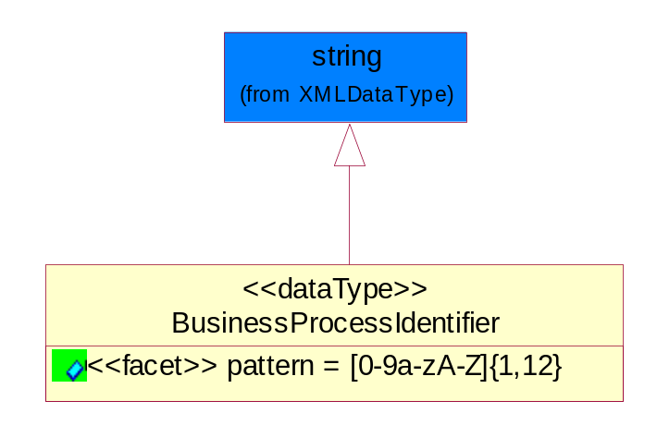
Figure 5-69 BusinessProcessIdentifier

Attribute | Type | Documentation
pattern |  | [0-9a-zA-Z]{1,12}

BusinessServiceInformation
The object allows the specification of the business service utilized within the partner company. This may or may not be the same as the information sent by the RNIF.
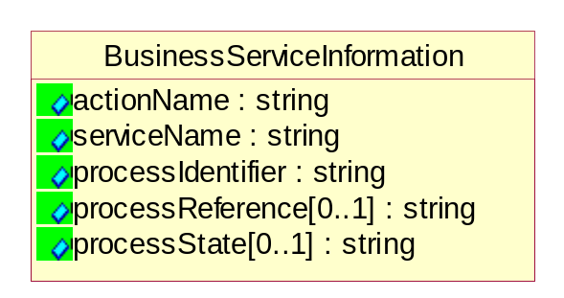
Figure 5-70 BusinessServiceInformation

Attribute | Type | Documentation
actionName | string | The name of Action. For RosettaNet usually any of Request/Confirm/Notify/Query/Response.
serviceName | string | The name of the Business Activity with the "Request/Confirm" part removed. E.g., for the Activity "Request Purchase Order"==> "Purchase Order".
processIdentifier | string | The name of the PIP e.g. Notify of Forecast Reply.
processReference[0..1] | string | The URN for the PIP that includes Cluster/Segment/Process pattern used to identify the interface process (such as PIP3A4)
processState[0..1] | string | The business process (or service) state of the sender of a document. When a service receives this document, the receiver may use the state as a precondition.

ContractInformation
A block of information used to correlate a contract in an executing choreography.

Figure 5-71 ContractInformation

Attribute | Type | Documentation
contractIdentifier[0..1] | string | Unique identification of a contract between the Sender and the Receiver
contractType[0..1] | string | The type of the contract: an attribute describing the type of the ContractIndentification. Valid values are URI, URN,ebXMLCPA, or other values defined by partners.

CorrelationInformation
A block of information used to correlate a requesting document to a responding document and to the contract in an executing choreography.
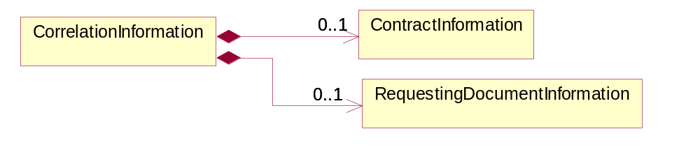
Figure 5-72 CorrelationInformation

Composition | Cardinality | Type | Documentation
ContractInformation | 0..1 | ContractInformation | A block of information used to correlate a contract in an executing choreography.
RequestingDocumentInformation | 0..1 | RequestingDocumentInformation | A block of information used to correlate a requesting document to a responding document in an executing choreography.

DocumentHeader
The object allows for the identification of the sender and receiver of the business document.
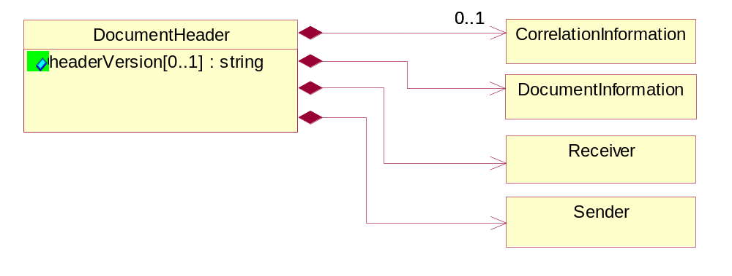
Figure 5-73 DocumentHeader

Attribute | Type | Documentation
headerVersion[0..1] | string | The UN/CEFACT version of the document header.

Composition | Cardinality | Type | Documentation
Sender | 1 | Sender | The object allows the identification of the initiating party of the business message.
CorrelationInformation | 0..1 | CorrelationInformation | A block of information used to correlate a requesting document to a responding document and to the contract in an executing choreography.
DocumentInformation | 1 | DocumentInformation | The object specifies information to identify the business document, a summary of attachments, and information about the business document security.
Receiver | 1 | Receiver | The object allows the identification of the receiving party of the business message.

DocumentIdentification
The object specifies all information necessary to identify the business document.
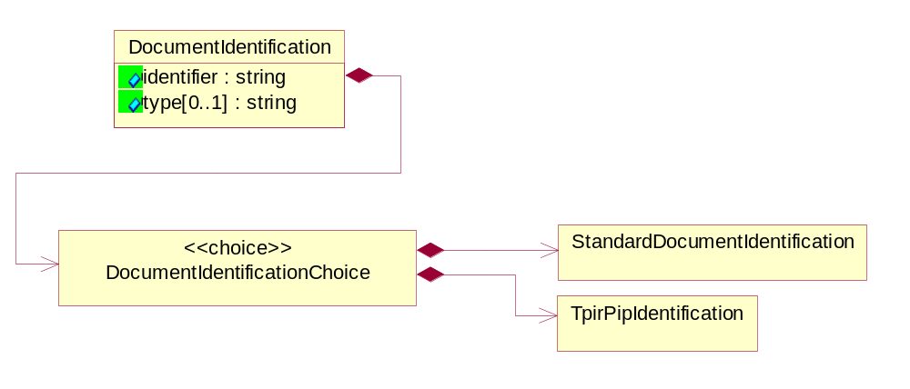
Figure 5-74 DocumentIdentification

Attribute | Type | Documentation
identifier | string | The unique identifier for the document being sent.
type[0..1] | string | Name of the Action Message

Composition | Cardinality | Type | Documentation
DocumentIdentificationChoice | 1 | DocumentIdentificationChoice

DocumentIdentificationChoice

Composition | Cardinality | Type | Documentation
StandardDocumentIdentification | 1 | StandardDocumentIdentification | The object specifies additional information necessary to identify the standard business document.
TpirPipIdentification | 1 | TpirPipIdentification | The object specifies all information necessary to uniquely identify a TPIR-PIP within a Registry or trading partner repository.

DocumentInformation
The object specifies information to identify the business document, a summary of attachments, and information about the business document security.
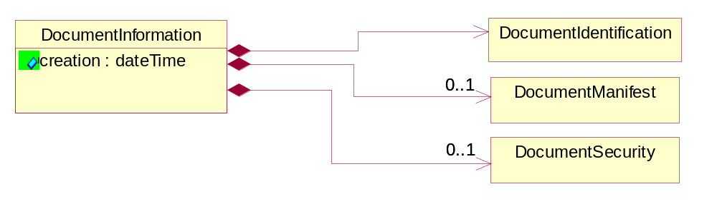
Figure 5-75 DocumentInformation

Attribute | Type | Documentation
creation | dateTime | The creation date and time of the specified Business Document (i.e. the Purchase Order date).

Composition | Cardinality | Type | Documentation
DocumentIdentification | 1 | DocumentIdentification | The object specifies all information necessary to identify the business document.
DocumentSecurity | 0..1 | DocumentSecurity | The object provides additional granularity in specifying business document security (this is in addition to the specified PIP security).
DocumentManifest | 0..1 | DocumentManifest | The block provides a brief summary of attachments and Service Content.

DocumentManifest
The block provides a brief summary of attachments and Service Content.
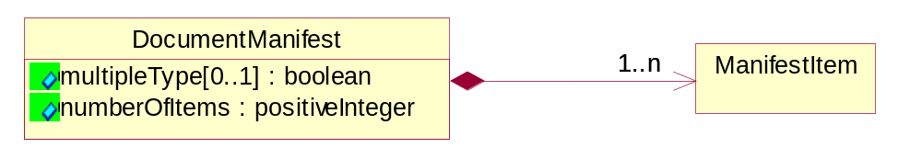
Figure 5-76 DocumentManifest

Attribute | Type | Documentation
multipleType[0..1] | boolean | Indicates whether the manifest contains documents of multiple types. True if yes, and False if no.
numberOfItems | positiveInteger | Total number of documents in the message. The physical count of the attachments in the payload plus the RosettaNet Business Message (for Service Content). The value of this field will be at least 1.

Composition | Cardinality | Type | Documentation
ManifestItem | 1..n | ManifestItem | The object provides details about the specific attachment(s).

DocumentSecurity
The object provides additional granularity in specifying business document security (this is in addition to the specified PIP security).

Figure 5-77 DocumentSecurity

Attribute | Type | Documentation
nonRepudiableReceipt | boolean | The value "true" will indicate that a signed acknowledgement for the business document is necessary.
persistentEncryption | boolean | The value "true" will indicate that the Business Document (including the header) needs to be encrypted when stored or transported.
persistentSignature | boolean | The value "true" will indicate that a signature is required to be stored with the document while stored or transported.

ManifestItem
The object provides details about the specific attachment(s).

Figure 5-78 ManifestItem

Attribute | Type | Documentation
description[0..1] | string | A description of the attachment.
length[0..1] | positiveInteger | The size of the attachment in bytes (i.e. 1 000 000 bytes)
universalResourceIdentifier | string | The generic set of all names/addresses that are short strings that refer to resources.

Composition | Cardinality | Type | Documentation
mimeTypeQualifier | 1 | MimeTypeQualifier | The MIME type as defined by IANA.  Please refer to http://www.iana.org/assignments/media-types/ for a list of types.
language | 0..1 | Language | For representation of Language name RosettaNet has adopted ISO 639-2; 1998. Refer to the following web page to get the latest version of the standard:  http://www.loc.gov/standards/iso639-2/iso639jac.html  If you need more information about the ISO standard please contact ISO for more details.

PipIdentifier
PIP Identification. [i.e. PIP3A4]
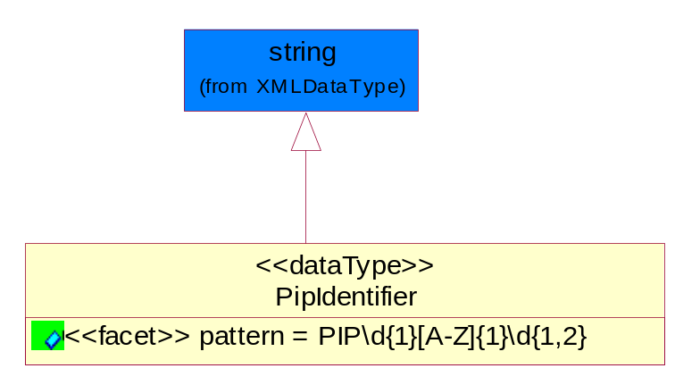
Figure 5-79 PipIdentifier

Attribute | Type | Documentation
pattern |  | PIP\d{1}[A-Z]{1}\d{1,2}

PipVersion
PIP version number (i.e. 02.02.00).
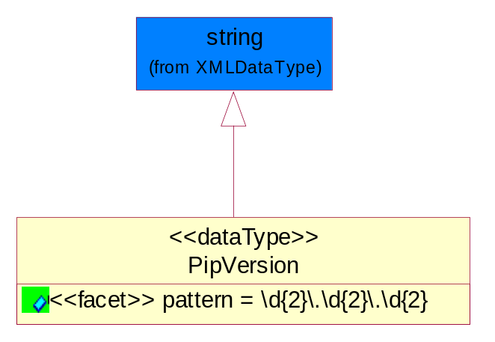
Figure 5-80 PipVersion

Attribute | Type | Documentation
pattern |  | \d{2}\.\d{2}\.\d{2}

Receiver
The object allows the identification of the receiving party of the business message.
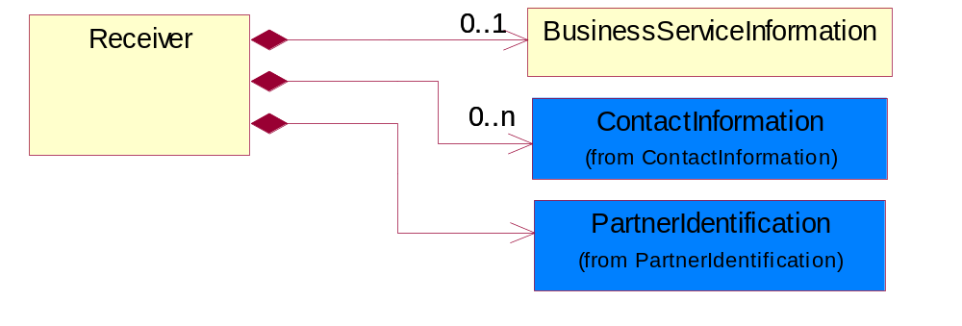
Figure 5-81 Receiver

Composition | Cardinality | Type | Documentation
BusinessServiceInformation | 0..1 | BusinessServiceInformation | The object allows the specification of the business service utilized within the partner company. This may or may not be the same as the information sent by the RNIF.
PartnerIdentification | 1 | PartnerIdentification | The business document must allow for the identity of one or more parties to the transaction.
ContactInformation | 0..n | ContactInformation | The business document must allow for the identification of the name of the department, service or individual to be contacted regarding the context of the business document.

RequestingDocumentInformation
A block of information used to correlate a requesting document to a responding document in an executing choreography.

Figure 5-82 RequestingDocumentInformation

Attribute | Type | Documentation
businessProcessInstanceIdentifier[0..1] | string | The identifier for the public business process instance being sent that both the sender and receiver can identify.
responseDateTime[0..1] | dateTime | The expected time to receive the response. This can not be greater than the PIP TimeToPerform.
requestingDocumentCreationDateTime[0..1] | dateTime | The date-time of the requesting business document.
requestingDocumentInstanceIdentifier | string | The Business Document identification number that identifies the requesting Business Document.

Sender
The object allows the identification of the initiating party of the business message.
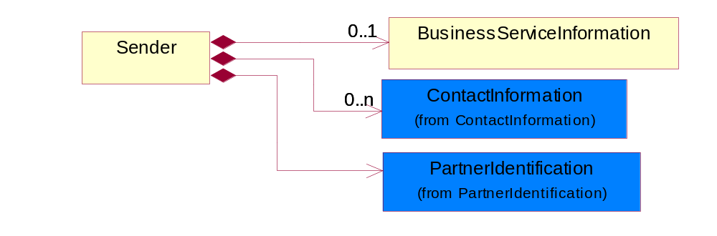
Figure 5-83 Sender

Composition | Cardinality | Type | Documentation
PartnerIdentification | 1 | PartnerIdentification | The business document must allow for the identity of one or more parties to the transaction.
BusinessServiceInformation | 0..1 | BusinessServiceInformation | The object allows the specification of the business service utilized within the partner company. This may or may not be the same as the information sent by the RNIF.
ContactInformation | 0..n | ContactInformation | The business document must allow for the identification of the name of the department, service or individual to be contacted regarding the context of the business document.

StandardDocumentIdentification
The object specifies additional information necessary to identify the standard business document.
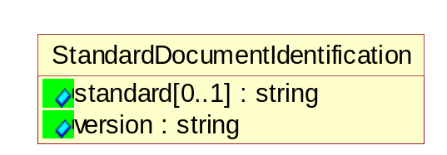
Figure 5-84 StandardDocumentIdentification

Attribute | Type | Documentation
standard[0..1] | string | Identifies the standard used to submit the business document. (e.g. RosettaNet).
version | string | PIP3A4v01.00

TpirPipIdentification
The object specifies all information necessary to uniquely identify a TPIR-PIP within a Registry or trading partner repository.

Figure 5-85 TpirPipIdentification

Attribute | Type | Documentation
partnerId | DUNSPlus4 | The Trading Partner Identification of MNC that is creating this TPIR PIP.
pipIdentifier | PipIdentifier | A TPIR PIP Identification [i.e., 3A4 ).
pipVersion | PipVersion | A TPIR PIP version number (i.e., 02.02.00)
tpirPipVersion | VersionIdentifier | A TPIR-PIP Version Number (i.e., major and minor version number as XX.XX).
tpirBusinessProcessIdentifier[0..1] | BusinessProcessIdentifier | A Business Process Identifier to uniquely define the TPIR-PIP 'role' within a Business Scenario at a company or MNC level. The identifier MUST be composed of alphanumeric characters only and its length MUST be between one and twelve characters.
uri[0..1] | anyURI | Describes the destination uri for the TPIR form.

Composition | Cardinality | Type | Documentation
fileType | 0..1 | TPIRFileType | Describes the file type of the TPIR form (PDF, XDP or XML).

VersionIdentifier
Version Number (i.e., major and minor version number as XX.XX).
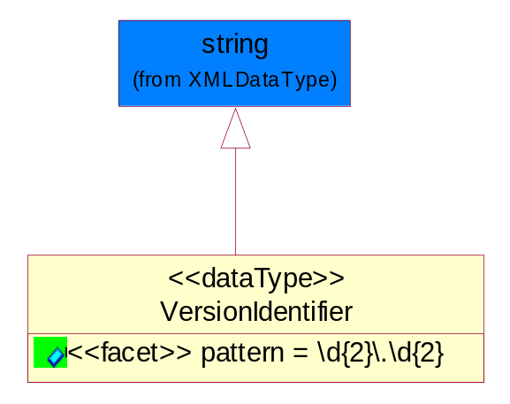
Figure 5-86 VersionIdentifier

Attribute | Type | Documentation
pattern |  | \d{2}\.\d{2}

CodeList

TPIRFileType
A code identifying the file type of TPIR form.

Name | Documentation
PDF | Portable Document Format.
XDP | XML Data Package.
XML | eXtensible Markup Language.

XML Data Type

anyURI
Represents a URI as defined by RFC 2396. An anyURI value can be absolute or relative, and may have an optional fragment identifier.

boolean
Represents Boolean values, which are either "true" or "false".

dateTime
Represents a specific instance of time.
The pattern for dateTime is CCYY-MM-DDThh:mm:ss where CC represents the century, YY the year, MM the month, and DD the day, preceded by an optional leading negative (-) character to indicate a negative number. If the negative character is omitted, positive (+) is assumed. The T is the date/time separator and hh, mm, and ss represent hour, minute, and second respectively. Additional digits can be used to increase the precision of fractional seconds if desired. For example, the format ss.ss... with any number of digits after the decimal point is supported. The fractional seconds part is optional.
This representation may be immediately followed by a "Z" to indicate Coordinated Universal Time (UTC) or to indicate the time zone. For example, the difference between the local time and Coordinated Universal Time, immediately followed by a sign, + or -, followed by the difference from UTC represented as hh:mm (minutes is required). If the time zone is included, both hours and minutes must be present.

decimal
A data type that contains decimal numbers scaled by a power of 10.

float
Represents single-precision 32-bit floating-point numbers.

integer
Represents a sequence of decimal digits with an optional leading sign (+ or -). This data type is derived from decimal.

positiveInteger
Represents an integer that is greater than zero. This data type is derived from nonNegativeInteger.

string
Represents character string.

