

Description of 7C8 Message

PIP® 7C8
Validated 11.00.00

Specification Information
Name | Description of 7C8 Message
PIP | Notify Of Semiconductor Process Data
Cluster | Manufacturing
Segment | Distribute Manufacturing Information
Publication Date | 31 October 2006
Version Identifier | V11.00

Table of Content

1. Document Management 7
1.1 Legal Disclaimer 7
1.2 Copyright 7
1.3 Trademarks 7
1.4 Acknowledgments 7
1.5 Related Documents 8
1.6 Document Version History 8
1.7 Document Purpose 8
2. Interchange Model 9
2.1 SemiconductorProcessDataNotification 9
2.1.1 Interchange Diagram 9
2.1.2 Dependency Diagram 10
2.1.3 AssemblyLotReport 10
2.1.4 AssemblyMeasurementReport 12
2.1.5 AssemblyProcess 12
2.1.6 BuildInfoReport 13
2.1.7 CarrierReport 14
2.1.8 Chip 14
2.1.9 DefectInformation 15
2.1.10 FinalPackageReport 16
2.1.11 IncomingWaferLotReport 16
2.1.12 InlineProcess 17
2.1.13 InlineProcessMeasurementReport 18
2.1.14 InlineSetupReport 18
2.1.15 LotReport 19
2.1.16 LotReportChoice 20
2.1.17 LotTimeStamp 21
2.1.18 MeasurementFeatureReport 21
2.1.19 MeasurementReport 22
2.1.20 OperationInformationReport 25
2.1.21 OpticalInspectionReport 26
2.1.22 Orientation 27
2.1.23 Package 27
2.1.24 PackageReport 28
2.1.25 PinInformation 29
2.1.26 SemiconductorProcessDataNotification 29
2.1.27 SoftwareReport 30
2.1.28 TestParameterInformation 30
3. Domain Model 32
3.1 Manufacturing 32
3.1.1 Manufacturing 32
3.1.1.1 Dependency Diagram 32
3.1.1.2 ChipPeriodicity 32
3.1.1.3 Dimension 33
3.1.1.4 ECIDReport 33
3.1.1.5 FacilityLocation 34
3.1.1.6 FloatCoordinate 34
3.1.1.7 IntCoordinate 35
3.1.1.8 Lot 35
3.1.1.9 LotIdentifier 36
3.1.1.10 MeasurementUnit 37
3.1.1.11 MeasurementUnitChoice 37
3.1.1.12 OperationGate 38
3.1.1.13 ProprietaryUnits 38
3.1.1.14 QuantityDetail 39
3.1.1.15 TestMap 40
3.1.1.16 TestSetup 41
3.1.1.17 TestTemperature 42
3.1.1.18 Wafer 42
3.1.1.19 WaferCoordinate 42
3.1.2 CodeList 43
3.1.2.1 Axis 43
3.1.2.2 Confidentiality 43
3.1.2.3 LotType 43
3.1.2.4 CompletionStatus 44
3.1.2.5 TestResult 44
3.1.2.6 ComponentType 44
4. Universal Structure 45
4.1 ContactInformation 45
4.1.1 ContactInformation 45
4.2 DataType 46
4.2.1 Contact 46
4.2.2 DUNS 46
4.2.3 DUNSPlus4 47
4.2.4 GLN 47
4.2.5 GTIN 48
4.2.6 Hexadecimal 48
4.2.7 PercentAmount 49
4.3 Locations 50
4.3.1 AlternativeIdentifier 50
4.3.2 Location 50
4.3.3 LocationChoice 51
4.3.4 PhysicalAddress 51
4.4 PartnerIdentification 53
4.4.1 PartnerIdentification 53
4.4.2 PartnerIdentificationChoice 54
4.5 PhysicalDimension 55
4.5.1 Linear 55
4.5.2 Measure 55
4.6 ProductIdentification 56
4.6.1 ProductIdentification 56
4.6.2 ProductIdentificationChoice 56
4.7 CodeList 57
4.7.1 Country 57
4.7.2 CountrySubdivision 57
4.7.3 Language 57
4.7.4 MimeTypeQualifier 57
4.7.5 UnitOfMeasure 68
5. System Structure 76
5.1 BusinessProcessIdentifier 76
5.2 BusinessServiceInformation 76
5.3 ContractInformation 77
5.4 CorrelationInformation 77
5.5 DocumentHeader 78
5.6 DocumentIdentification 79
5.7 DocumentIdentificationChoice 79
5.8 DocumentInformation 80
5.9 DocumentManifest 80
5.10 DocumentSecurity 81
5.11 ManifestItem 81
5.12 PipIdentifier 82
5.13 PipVersion 83
5.14 Receiver 83
5.15 RequestingDocumentInformation 84
5.16 Sender 84
5.17 StandardDocumentIdentification 85
5.18 TpirPipIdentification 85
5.19 VersionIdentifier 86
5.20 CodeList 87
5.20.1 TPIRFileType 87
6. XML Data Type 88
6.1 anyURI 88
6.2 boolean 88
6.3 dateTime 88
6.4 decimal 88
6.5 float 88
6.6 integer 88
6.7 positiveInteger 88
6.8 string 88

Table of Figures

Figure ‎2-1 Interchange 9
Figure ‎2-2 Dependency 10
Figure ‎2-3 AssemblyLotReport 10
Figure ‎2-4 AssemblyMeasurementReport 12
Figure ‎2-5 AssemblyProcess 12
Figure ‎2-6 BuildInfoReport 13
Figure ‎2-7 CarrierReport 14
Figure ‎2-8 Chip 14
Figure ‎2-9 DefectInformation 15
Figure ‎2-10 FinalPackageReport 16
Figure ‎2-11 IncomingWaferLotReport 16
Figure ‎2-12 InlineProcess 17
Figure ‎2-13 InlineProcessMeasurementReport 18
Figure ‎2-14 InlineSetupReport 18
Figure ‎2-15 LotReport 19
Figure ‎2-16 LotTimeStamp 21
Figure ‎2-17 MeasurementFeatureReport 21
Figure ‎2-18 MeasurementReport 22
Figure ‎2-19 OperationInformationReport 25
Figure ‎2-20 OpticalInspectionReport 26
Figure ‎2-21 Orientation 27
Figure ‎2-22 Package 27
Figure ‎2-23 PackageReport 28
Figure ‎2-24 PinInformation 29
Figure ‎2-25 SemiconductorProcessDataNotification 29
Figure ‎2-26 TestParameterInformation 30
Figure ‎3-1 Dependency 32
Figure ‎3-2 ChipPeriodicity 32
Figure ‎3-3 Dimension 33
Figure ‎3-4 ECIDReport 33
Figure ‎3-5 FacilityLocation 34
Figure ‎3-6 FloatCoordinate 34
Figure ‎3-7 IntCoordinate 35
Figure ‎3-8 Lot 35
Figure ‎3-9 LotIdentifier 36
Figure ‎3-10 MeasurementUnit 37
Figure ‎3-11 OperationGate 38
Figure ‎3-12 ProprietaryUnits 38
Figure ‎3-13 QuantityDetail 39
Figure ‎3-14 TestMap 40
Figure ‎3-15 TestSetup 41
Figure ‎3-16 TestTemperature 42
Figure ‎3-17 Wafer 42
Figure ‎4-1 ContactInformation 45
Figure ‎4-2 Contact 46
Figure ‎4-3 DUNS 46
Figure ‎4-4 DUNSPlus4 47
Figure ‎4-5 GLN 47
Figure ‎4-6 GTIN 48
Figure ‎4-7 Hexadecimal 48
Figure ‎4-8 PercentAmount 49
Figure ‎4-9 AlternativeIdentifier 50
Figure ‎4-10 Location 50
Figure ‎4-11 PhysicalAddress 51
Figure ‎4-12 PartnerIdentification 53
Figure ‎4-13 Linear 55
Figure ‎4-14 Measure 55
Figure ‎4-15 ProductIdentification 56
Figure ‎5-1 BusinessProcessIdentifier 76
Figure ‎5-2 BusinessServiceInformation 76
Figure ‎5-3 ContractInformation 77
Figure ‎5-4 CorrelationInformation 77
Figure ‎5-5 DocumentHeader 78
Figure ‎5-6 DocumentIdentification 79
Figure ‎5-7 DocumentInformation 80
Figure ‎5-8 DocumentManifest 80
Figure ‎5-9 DocumentSecurity 81
Figure ‎5-10 ManifestItem 81
Figure ‎5-11 PipIdentifier 82
Figure ‎5-12 PipVersion 83
Figure ‎5-13 Receiver 83
Figure ‎5-14 RequestingDocumentInformation 84
Figure ‎5-15 Sender 84
Figure ‎5-16 StandardDocumentIdentification 85
Figure ‎5-17 TpirPipIdentification 85
Figure ‎5-18 VersionIdentifier 86

Document Management

Legal Disclaimer
RosettaNet, its members, officers, directors, employees, or agents shall not be liable for any injury, loss, damages, financial or otherwise, arising from, related to, or caused by the use of this document or the specifications herein, as well as associated guidelines and schemas. The use of said specifications shall constitute your express consent to the foregoing exculpation.

Copyright
©2006 RosettaNet. All rights reserved. No part of this publication may be reproduced, stored in a retrieval system, or transmitted, in any form or by any means, electronic, mechanical, photocopying, recording, or otherwise, without the inclusion of this copyright notice. Any derivative works must cite the copyright notice. Any public redistribution or sale of this publication or derivative works requires prior written permission of the publisher.

Trademarks
RosettaNet, Partner Interface Process, PIP and the RosettaNet logo are trademarks or registered trademarks of "RosettaNet," a non-profit organization. All other product names and company logos mentioned herein are the trademarks of their respective owners. In the best effort, all terms mentioned in this document that are known to be trademarks or registered trademarks have been appropriately recognized in the first occurrence of the term.

Acknowledgments
This document has been prepared by RosettaNet (http://www.rosettanet.org/) from requirements gathered during the Milestone Program and in conformance with the methodology. Listed below are the legal entities that contributed to the design and development of this PIP.
Amkor | Freescale Semiconductor
International Business Machines (IBM) | Qualcomm
Texas Instruments | Samsung
Syntricity | Skytide

Related Documents
- Associated PIP Message Schemas (included with PIP Specification only)
- Description of Partner Interface Process for 7C8
- Message Structure

Document Version History
Version | Date | Description
Validated 11.00.00 | 31 October 2006 | Validated Version

Document Purpose
The purpose of the document is to explain the structure, the association between objects, the content of objects and the definition for single elements to a non-technical audience.

Interchange Model

SemiconductorProcessDataNotification

Interchange Diagram
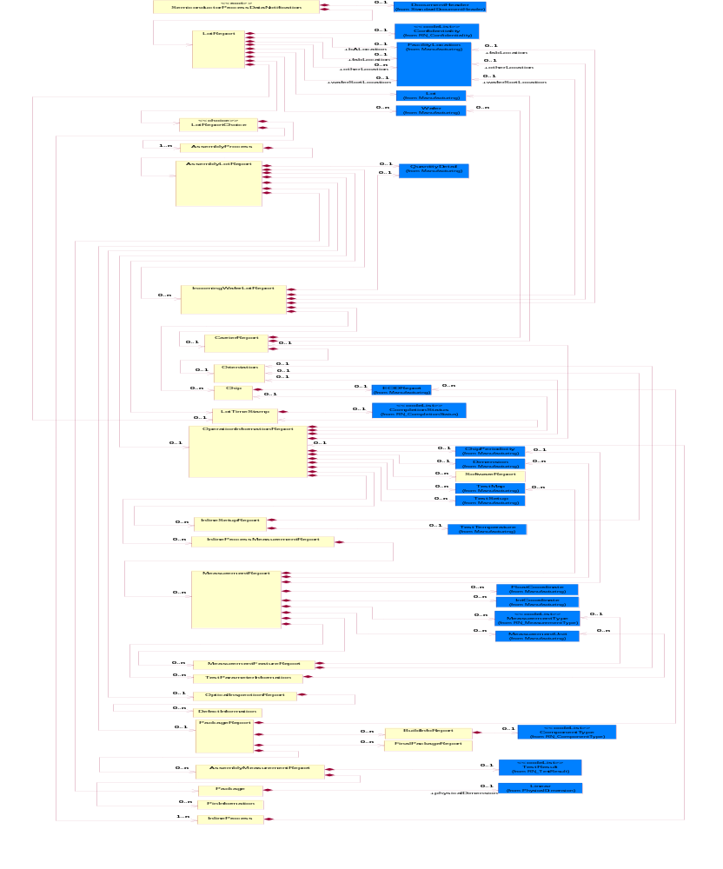
Figure ‎2-1 Interchange

Dependency Diagram
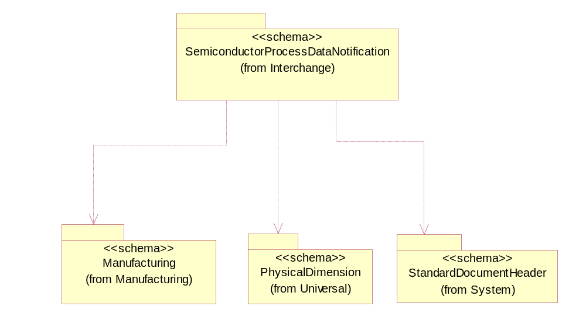
Figure ‎2-2 Dependency

AssemblyLotReport
A report that presents the assembly lot data information.
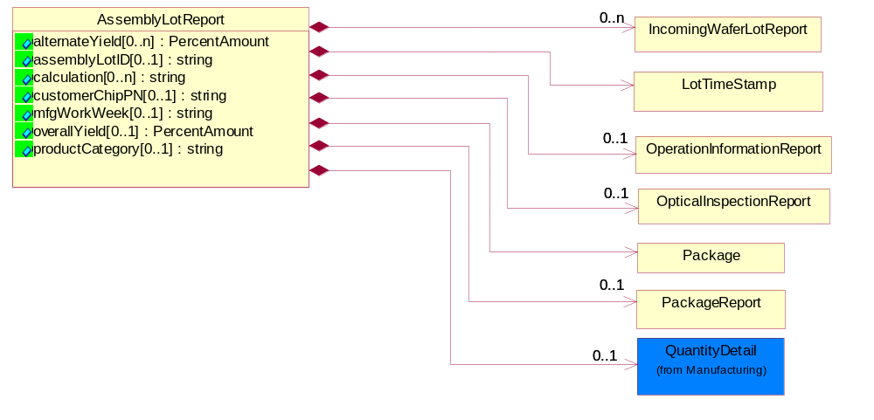
Figure ‎2-3 AssemblyLotReport

Attribute | Type | Documentation
alternateYield[0..n] | PercentAmount | The calculation of the overall yield calculation by an alternate method.
assemblyLotID[0..1] | string | An alphanumeric string that identifies the lot or lots of packaged part(s) (products(s) created during assembly.
calculation[0..n] | string | A string describing the mathematical expression to derive a result.
customerChipPN[0..1] | string | Customer proprietary product part number.
mfgWorkWeek[0..1] | string | Identification of the work week that the assembly process starts on an incoming wafer lot. The work week is identified by an integer ranging from 01 through 52.
overallYield[0..1] | PercentAmount | The overall yield of the assembly process.
productCategory[0..1] | string | The product category type which is associated with the lotID from the wafer manufacturer. Valid values: "Digital", "Analog", "RF Analog", "Memory", "Power Management", "Controller", "Logic", "Microprocessor" and other user defined.

Composition | Cardinality | Type | Documentation
OpticalInspectionReport | 0..1 | OpticalInspectionReport | The report of optical inspection done.
OperationInformationReport | 0..1 | OperationInformationReport | Report that provides information on the equipment used for a process or measurement.
LotTimeStamp | 1 | LotTimeStamp | Defines the lot start and end times for a measurement activity.
IncomingWaferLotReport | 0..n | IncomingWaferLotReport | Report that describes logistical information about the incoming wafer lot to assembly.
PackageReport | 0..1 | PackageReport | Report that describes the defects from package inspection. Associate with OpticalInspectionReport.
Package | 1 | Package | Report that describes key attributes of the packaging of the die.
QuantityDetail | 0..1 | QuantityDetail | A set of quantity details to select.

AssemblyMeasurementReport
Assembly process parametric measurements report.
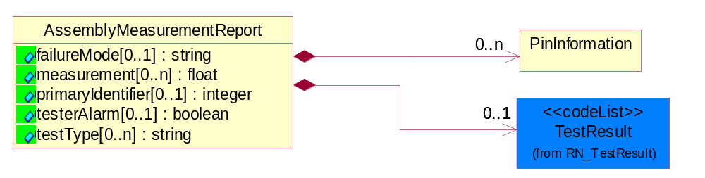
Figure ‎2-4 AssemblyMeasurementReport

Attribute | Type | Documentation
failureMode[0..1] | string | Identifies the type of failure observed in the assembly parametric test.
measurement[0..n] | float | Measurement in base unit.
primaryIdentifier[0..1] | integer | Identifier references the test attributes once per lot.
testerAlarm[0..1] | boolean | An indicator status flag on whether the tester (equipment) was in alarm during a test.
testType[0..n] | string | Describes the results of a assembly process parametric test. Valid types are: Wirebond Pull, BallShear, Tensile Strength and other user defined.

Composition | Cardinality | Type | Documentation
TestResult | 0..1 | TestResult | Describes the test result for a parametric test.
PinInformation | 0..n | PinInformation | Report that describes additional information about the pins on the package.

AssemblyProcess
Assembly process.
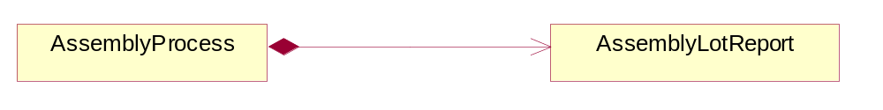
Figure ‎2-5 AssemblyProcess

Composition | Cardinality | Type | Documentation
AssemblyLotReport | 1 | AssemblyLotReport | A report that presents the assembly lot data information.

BuildInfoReport
Options of obtaining more build information when building out the package.
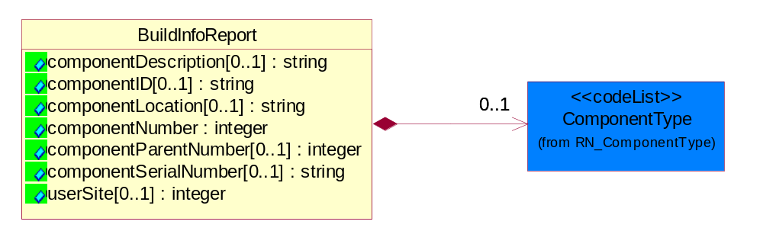
Figure ‎2-6 BuildInfoReport

Attribute | Type | Documentation
componentDescription[0..1] | string | A user defined description of the component.
componentID[0..1] | string | A unique identification of the component per the componentType (e.g. Frame, Card). Note: The ChipID may be idenitified by waferid/X/Y. This may be an actual component serial number or may be the primary ECID vlaue waferid/X/Y. If there is an invalid ECID read, the value that is typically used is lotnum/seq/bad-waferid/bad-X/bad-Y or equivalent.
componentLocation[0..1] | string | The logical location of a sub-component on the parent component.
componentNumber | integer | A unique number associated it the component or subcomponent being tested relative to the device whether in the assembly process. In general the highest level of the componentNumber equals 0 and all identified subcomponents are componentNumber equal 1-n. Subsequent ECID and TestResult Reports can be associated to the sub-component via the componentNumber and userSite defined.
componentParentNumber[0..1] | integer | For the highest level of packaged component the value is null. For any sub-component, the corresponding componentNumber from a previous BuildInfoReport.
componentSerialNumber[0..1] | string | A scribed serial number on the component.
userSite[0..1] | integer | Identifies the corresponding device site number (0-1).

Composition | Cardinality | Type | Documentation
ComponentType | 0..1 | ComponentType | Valid component values are: Chip, SCM, MCM, Card, Cage, Frame.

CarrierReport
A report that describes the material positioned in a holder.
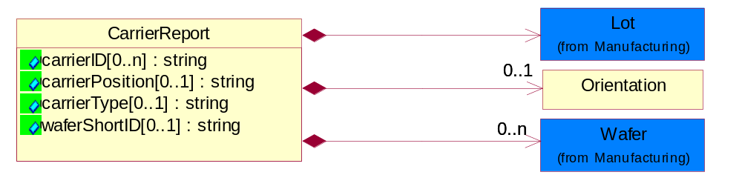
Figure ‎2-7 CarrierReport

Attribute | Type | Documentation
carrierID[0..n] | string | Identify the carrier used to transport the product during wafer manufacturing.
carrierPosition[0..1] | string | The position of the wafer within the carrier.
carrierType[0..1] | string | Describes the material holder. Valid values are carrier, tape and reel, package tray, boat, wafer tray and user defined values.
waferShortID[0..1] | string | An alternate identifier for the wafer unique ID.

Composition | Cardinality | Type | Documentation
Lot | 1 | Lot | Describes the lot information.
Wafer | 0..n | Wafer | Describes key reference attributes to identify a wafer.
Orientation | 0..1 | Orientation | Describes the orientation of the wafer on a tool or carrier.

Chip
Part number information about the chips on a wafer.
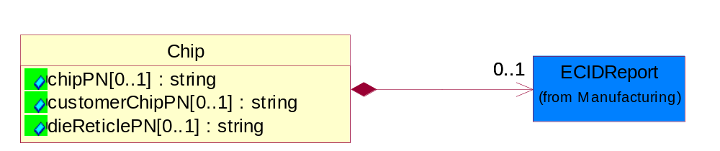
Figure ‎2-8 Chip

Attribute | Type | Documentation
chipPN[0..1] | string | A string that describes the part number of the chip.
customerChipPN[0..1] | string | Customer proprietary product part number.
dieReticlePN[0..1] | string | A string which defines the unique part numbers for a chips associated with a multi-project wafers.

Composition | Cardinality | Type | Documentation
ECIDReport | 0..1 | ECIDReport | Report to collect electronic chip ID data.

DefectInformation
A report that aggregates visual defect information collected during the assembly process.
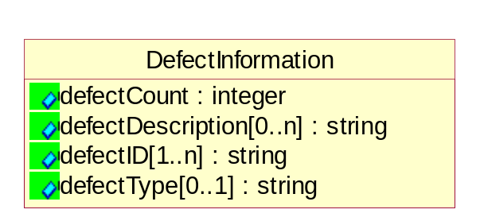
Figure ‎2-9 DefectInformation

Attribute | Type | Documentation
defectCount | integer | Quantity of defects associated with a defectID.
defectDescription[0..n] | string | User observation on the nature of a defect.
defectID[1..n] | string | Unique optical inspection identification for a defect type.
defectType[0..1] | string | Defines the type of optical defects collected within an OpticalInspectionReport. Valid values are: "2ndOptical", "3rdOptical", "DVI" and user defined.

FinalPackageReport
A report that provides additional, optional information about a packaged device. This class supports additional information concerning die being assembled into a package and to a card. This is the last step in the assembly process.
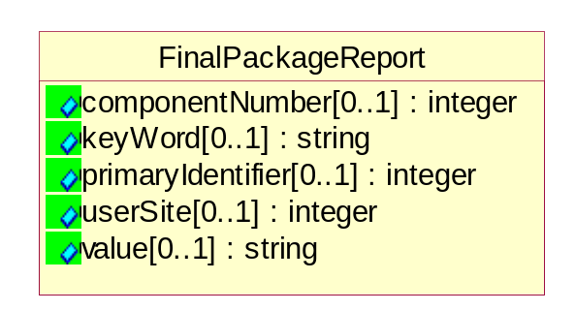
Figure ‎2-10 FinalPackageReport

Attribute | Type | Documentation
componentNumber[0..1] | integer | A number Associating a key value pair to a specific component in BuildInfoReport.
keyWord[0..1] | string | An optional keyword.
primaryIdentifier[0..1] | integer | Reference to link the test report to a lot.
userSite[0..1] | integer | Identifies the corresponding device site number.
value[0..1] | string | Any character string value necessary for defining ASCI test results off card testers.

IncomingWaferLotReport
Report that describes logistical information about the incoming wafer lot to assembly.
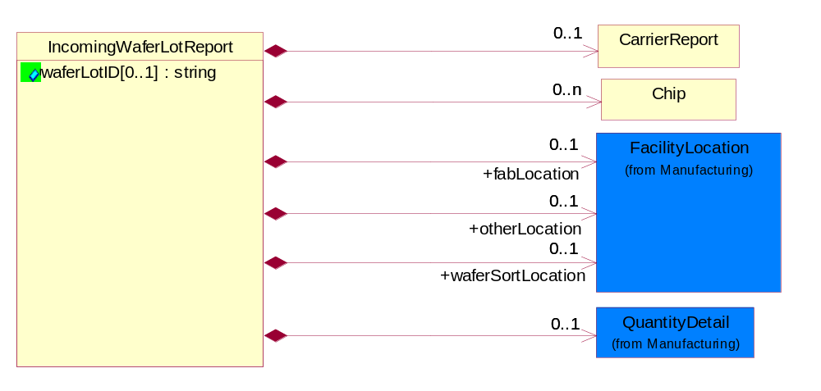
Figure ‎2-11 IncomingWaferLotReport

Attribute | Type | Documentation
waferLotID[0..1] | string | Unique identifier for the incoming wafer lot from the Wafer Manufacturer or Test Services partner.

Composition | Cardinality | Type | Documentation
CarrierReport | 0..1 | CarrierReport | A report that describes the material positioned in a holder.
Chip | 0..n | Chip | Part number information about the chips on a wafer.
waferSortLocation | 0..1 | FacilityLocation | Describes where the wafer was sent for wafer sort.
otherLocation | 0..1 | FacilityLocation | Describes the location where the wafer or packaged die in a lot or sublot was sent for additional fabrication, assembly or testing. This may be indicated by City, State, Country, Zip Code, DUNS, DUNS+4 or by proprietary label.
fabLocation | 0..1 | FacilityLocation | Describes where the wafer was fabricated.
QuantityDetail | 0..1 | QuantityDetail | A set of quantity details to select.

InlineProcess
Inline process.
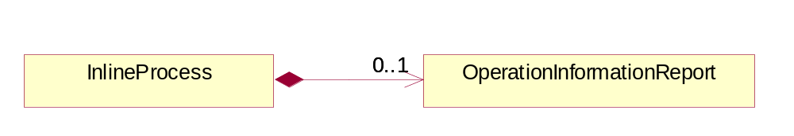
Figure ‎2-12 InlineProcess

Composition | Cardinality | Type | Documentation
OperationInformationReport | 0..1 | OperationInformationReport | Report that provides information on the equipment used for a process or measurement.

InlineProcessMeasurementReport
Report that describes a measurement or group of inline process measurements.
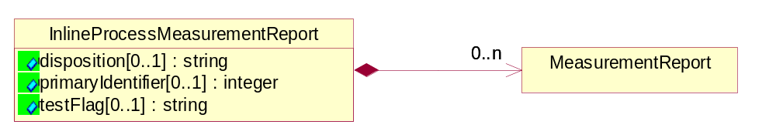
Figure ‎2-13 InlineProcessMeasurementReport

Attribute | Type | Documentation
disposition[0..1] | string | Disposition reason or result for an operation step. Valid values are: "Ship", "Hold", "Scrap", "Retest", "Other", "Null".
primaryIdentifier[0..1] | integer | Identifier references the test attributes once per lot.
testFlag[0..1] | string | Describes the intended use of the test. Valid values are: "Production", "Engineering", "Nominal", "SubNominal" and "Other".

Composition | Cardinality | Type | Documentation
MeasurementReport | 0..n | MeasurementReport | Report that collects all the measurement statistics.

InlineSetupReport
Report that provides set up information for MeasurementReport.
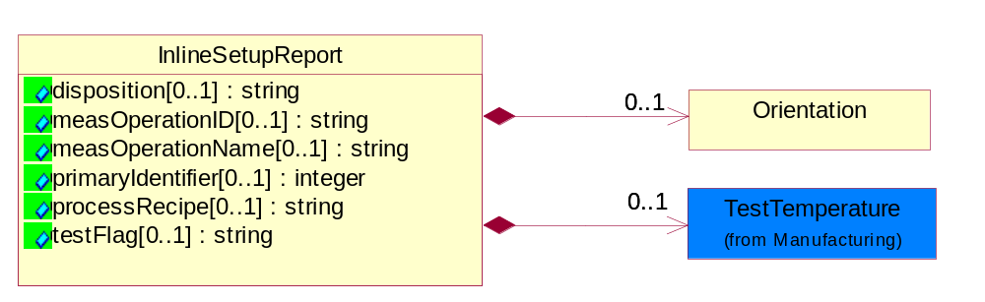
Figure ‎2-14 InlineSetupReport

Attribute | Type | Documentation
disposition[0..1] | string | Disposition reason or result for an operation step. Valid values are: "Ship", "Hold", "Scrap", "Retest", "Other", "Null".
measOperationID[0..1] | string | Operation number that corresponds to the measurement operation name.
measOperationName[0..1] | string | Name of the operation step. This correlates to the MES name of the operation step.
primaryIdentifier[0..1] | integer | Identifier references the test attributes once per lot.
processRecipe[0..1] | string | User defined recipe name associated with a tool.
testFlag[0..1] | string | Describes the intended use of the test. Valid values are: "Production", "Engineering", "Nominal", "SubNominal" and "Other".

Composition | Cardinality | Type | Documentation
TestTemperature | 0..1 | TestTemperature | Temperature value in either Centigrade or Fahrenheit to identify at which a test is performed for lot or sublot.
Orientation | 0..1 | Orientation | Describes the orientation of the wafer on a tool or carrier.

LotReport
Report that is common for reporting data collection for inline process and assembly process.
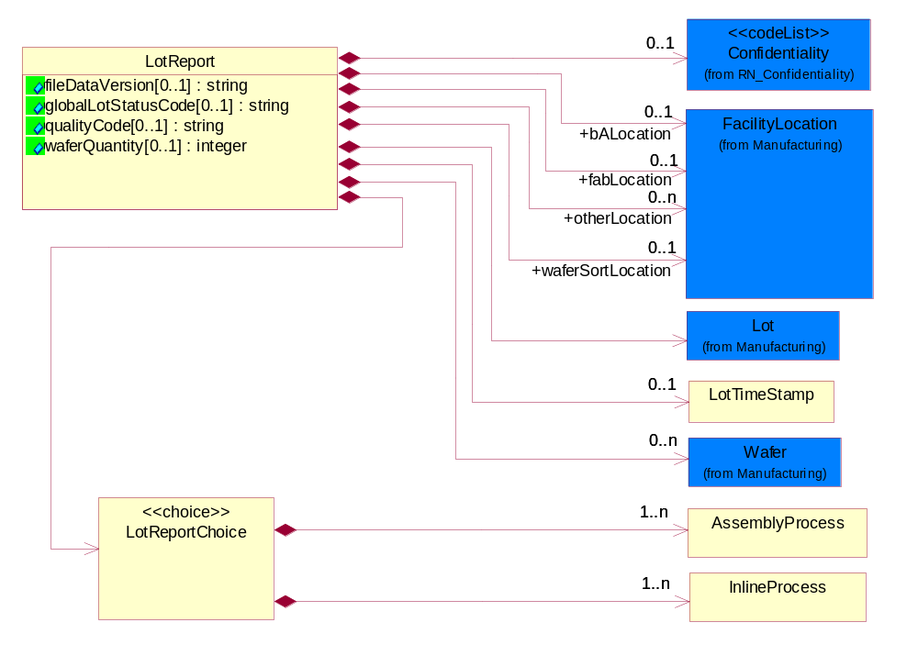
Figure ‎2-15 LotReport

Attribute | Type | Documentation
fileDataVersion[0..1] | string | User defined changes i.e. rules changes to content of data in the data file transfer. Examples: version update to loaders, parsers, or operating system, specification limits etc.
globalLotStatusCode[0..1] | string | Describes lot or sublot status.
qualityCode[0..1] | string | Designate a quality condition of a lot. This can be a proprietary label defined by the Foundry of the Test Services trading partner.
waferQuantity[0..1] | integer | Identifies the number of wafers associated in a lot.

Composition | Cardinality | Type | Documentation
Confidentiality | 0..1 | Confidentiality | A string which describes the level of security associated with the data, as defined by TPA.
LotTimeStamp | 0..1 | LotTimeStamp | Defines the lot start and end times for a measurement activity.
Lot | 1 | Lot | Describes the lot information.
Wafer | 0..n | Wafer | Describes key reference attributes to identify a wafer.
bALocation | 0..1 | FacilityLocation | Describes where the wafer was sent for bond and assembly.
waferSortLocation | 0..1 | FacilityLocation | Describes where the wafer was sent for wafer sort.
fabLocation | 0..1 | FacilityLocation | Describes where the wafer was fabricated.
otherLocation | 0..n | FacilityLocation | Describes the location where the wafer or packaged die in a lot or sublot was sent for additional fabrication, assembly or testing. This may be indicated by City, State, Country, Zip Code, DUNS, DUNS+4 or by proprietary label.
LotReportChoice | 1 | LotReportChoice | Choice Structure for describing Lot Report for Inline Process and Assembly Process.

LotReportChoice
Choice Structure for describing Lot Report for Inline Process and Assembly Process.

Composition | Cardinality | Type | Documentation
InlineProcess | 1..n | InlineProcess | Inline process.
AssemblyProcess | 1..n | AssemblyProcess | Assembly process.

LotTimeStamp
Defines the lot start and end times for a measurement activity.
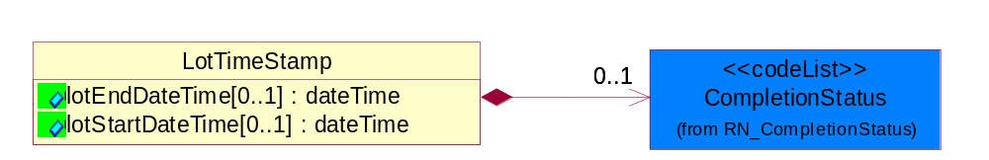
Figure ‎2-16 LotTimeStamp

Attribute | Type | Documentation
lotEndDateTime[0..1] | dateTime | Defines the end time of a lot for a test.
lotStartDateTime[0..1] | dateTime | Defines the start time of the lot for a test.

Composition | Cardinality | Type | Documentation
CompletionStatus | 0..1 | CompletionStatus | Describes the status of the lot or sublot at the end of testing.

MeasurementFeatureReport
Report that provides additional information about the inline measurement.
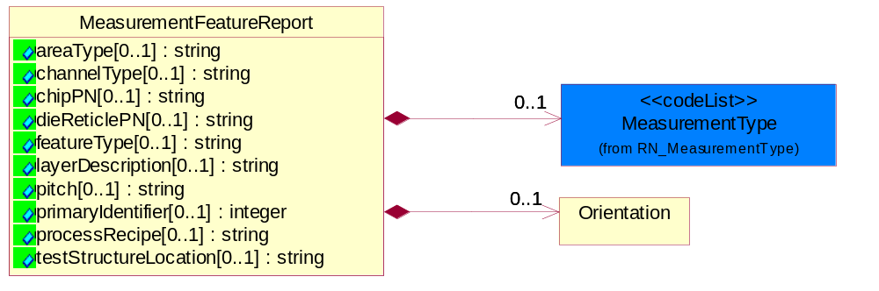
Figure ‎2-17 MeasurementFeatureReport

Attribute | Type | Documentation
areaType[0..1] | string | General description to identify the structure that is being measured being in an active area e.g. transistor area, over gate oxide or in an inactive area (poly over field). Valid values are "Active", "Inactive", "Null".
channelType[0..1] | string | Identifies device channel type. Valid values are: "N", "P", "Null" and "Other".
chipPN[0..1] | string | A string that describes the part number for the device.
dieReticlePN[0..1] | string | A string which defines the unique part numbers for die associated with a multi-project wafer.
featureType[0..1] | string | General description to identify the type of feature being measured. Valid values are: "Line", "Space", "Hole", "Post", "Null" and "Other".
layerDescription[0..1] | string | General description of the type of layer being measured. Valid values are: "Gate", "Contact", "Via", "Metal", "Diffusion", "Implant" and user defined.
pitch[0..1] | string | Distance in nm between two measurement artifacts.
primaryIdentifier[0..1] | integer | Identifier references the test attributes once per lot.
processRecipe[0..1] | string | User defined recipe name associated with a tool.
testStructureLocation[0..1] | string | Identifies the measurement structure as bining in the scribe line (street) or in the circuit (die or chip). Suggested values are: "scribe", "in-die", "null".

Composition | Cardinality | Type | Documentation
Orientation | 0..1 | Orientation | Describes the orientation of the wafer on a tool or carrier.
MeasurementType | 0..1 | MeasurementType | General category of measurement.

MeasurementReport
Report that collects all the measurement statistics.
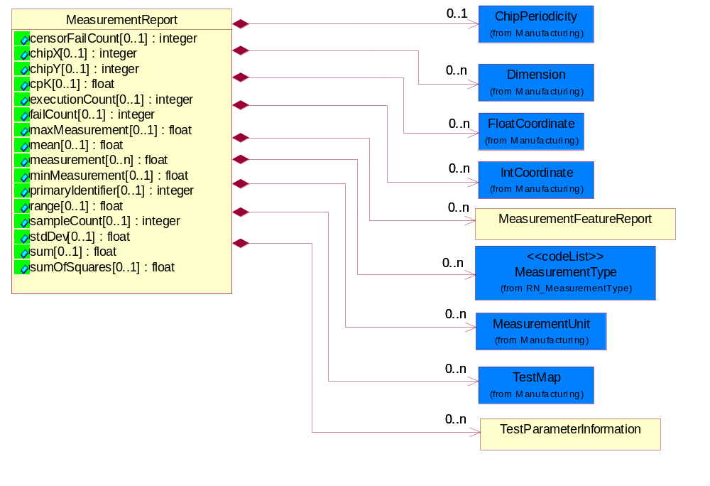
Figure ‎2-18 MeasurementReport

Attribute | Type | Documentation
censorFailCount[0..1] | integer | Number of measurements that are excluded by the censor limit.
chipX[0..1] | integer | Identifies the chip location in the x-direction on the wafer. Row designation is dependent upon orientation of the notch.
chipY[0..1] | integer | Identifies the chip location in the y-direction on the wafer. Row designation is dependent upon orientation of the notch.
cpK[0..1] | float | Calculated cpk for a process step or operation from the measurements in the file. Process capability, cpk, can be defined as the spread within which almost all of the parts or values within a distribution will fall, generally described as within +/- three (3) standard deviations or six (6) standard deviations.
executionCount[0..1] | integer | Number of measurements attempted.
failCount[0..1] | integer | Number of failing measurements.
maxMeasurement[0..1] | float | Maximum measurement collected from the measurements in the file.
mean[0..1] | float | Calculated mean from the measurements in the file. The arithmetic mean is equal to the sum of the measurements divided by n, the number of measurements in the group.
measurement[0..n] | float | Resultant value of the measurement.
minMeasurement[0..1] | float | Minimum measurement collected from the measurements in the file.
primaryIdentifier[0..1] | integer | Identifier references the test attributes once per lot.
range[0..1] | float | Calculated range from the measurements in the file. Range is calculated by subtracting the low value from the highest value of the data collected in a group.
sampleCount[0..1] | integer | Describes the number of measurements on a wafer or die.
stdDev[0..1] | float | Calculated standard deviation from the measurements in the file. The standard deviation of a set of n measurements is equal to the positive square root of the variance. The variance of a population of n measurements is a measure of dispersion defined as the average of the square of the deviations of the measurements about the mean.
sum[0..1] | float | calculated sum from the measurements in the file. A sum is the result of addition of n, the number of measurements in a group.
sumOfSquares[0..1] | float | Calculated sum of squares from the measurements in the file. The number of representations n of k by squares, allowing zeros and distinguishing signs and order, is denoted rk(n) . For example, consider the number of ways of representing 5 as the sum of two squares.

Composition | Cardinality | Type | Documentation
MeasurementUnit | 0..n | MeasurementUnit | Describes the measurement unit.
ChipPeriodicity | 0..1 | ChipPeriodicity | Dimensional. Describes the distance between chips in micron between established reference points in either the x- and or y-direction on a wafer.
MeasurementType | 0..n | MeasurementType | General category of measurement.
MeasurementFeatureReport | 0..n | MeasurementFeatureReport | Report that provides additional information about the inline measurement.
TestMap | 0..n | TestMap | Describes the wafer orientation and configuration used by manufacturing test (metrology) equipment.
TestParameterInformation | 0..n | TestParameterInformation | Describes optional attributes to provide additional information on the parameters of the test.
Dimension | 0..n | Dimension | Describes the dimensional measurement range in X, Y or Z axis.
FloatCoordinate | 0..n | FloatCoordinate | X, Y and Z Coordinate values.
IntCoordinate | 0..n | IntCoordinate | X, Y and Z Coordinate values.

OperationInformationReport
Report that provides information on the equipment used for a process or measurement.
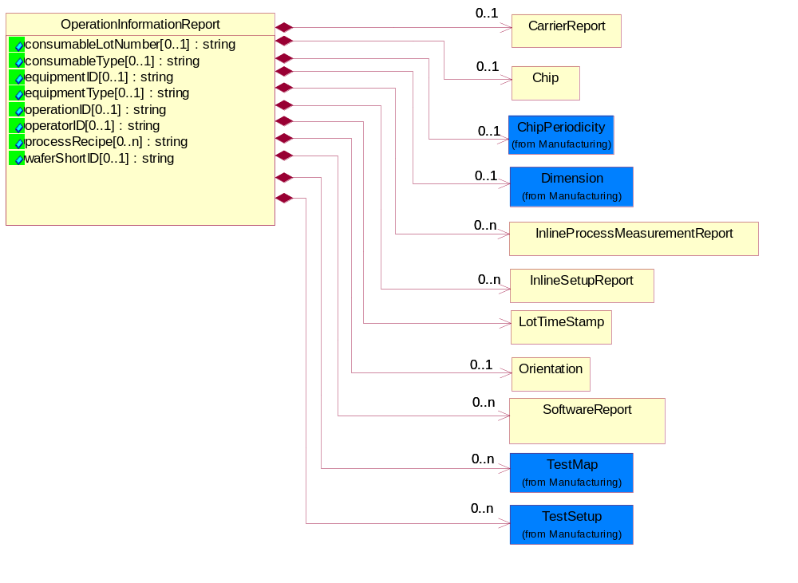
Figure ‎2-19 OperationInformationReport

Attribute | Type | Documentation
consumableLotNumber[0..1] | string | User defined consumable lot used in manufacturing.
consumableType[0..1] | string | User defined type of consumable used in the manufacturing process. Examples: chemicals, gases, solder type, substrate.
equipmentID[0..1] | string | Identifies the tool used during a process or measurement.
equipmentType[0..1] | string | Identifies the tool type for a processing step or measurement.
operationID[0..1] | string | Identifies the operation or process step.
operatorID[0..1] | string | Identifies the operator at a process step.
processRecipe[0..n] | string | User defined recipe name associated with a tool.
waferShortID[0..1] | string | Alternate identifier for the wafer unique ID.

Composition | Cardinality | Type | Documentation
CarrierReport | 0..1 | CarrierReport | A report that describes the material positioned in a holder.
Chip | 0..1 | Chip | Part number information about the chips on a wafer.
Dimension | 0..1 | Dimension | Describes the dimensional measurement range in X, Y or Z axis.
TestMap | 0..n | TestMap | Describes the wafer orientation and configuration used by manufacturing test (metrology) equipment.
LotTimeStamp | 1 | LotTimeStamp | Defines the lot start and end times for a measurement activity.
ChipPeriodicity | 0..1 | ChipPeriodicity | Dimensional. Describes the distance between chips in micron between established reference points in either the x- and or y-direction on a wafer.
Orientation | 0..1 | Orientation | Describes the orientation of the wafer on a tool or carrier.
InlineProcessMeasurementReport | 0..n | InlineProcessMeasurementReport | Report that describes a measurement or group of inline process measurements.
InlineSetupReport | 0..n | InlineSetupReport | Report that provides set up information for MeasurementReport.
TestSetup | 0..n | TestSetup | Describes the identification information for tester set-up.
SoftwareReport | 0..n | SoftwareReport | SoftwareReport describe software type, software name, software version and softwareBuildID.

OpticalInspectionReport
The report of optical inspection done.
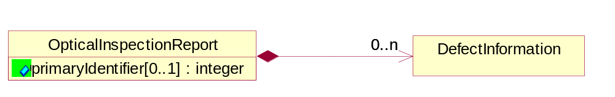
Figure ‎2-20 OpticalInspectionReport

Attribute | Type | Documentation
primaryIdentifier[0..1] | integer | Identifier references the test attributes once per lot.

Composition | Cardinality | Type | Documentation
DefectInformation | 0..n | DefectInformation | A report that aggregates visual defect information collected during the assembly process.

Orientation
Describes the orientation of the wafer on a tool or carrier.
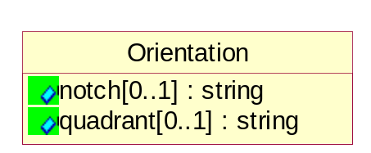
Figure ‎2-21 Orientation

Attribute | Type | Documentation
notch[0..1] | string | Describes the orientation of the wafer notch in a tester: Valid options are: 12 o’clock; 3 o’clock, 6 o’clock, 9 o’clock, notch up, notch down, notch right or notch left, Up=U, Down=D, Left=L, or Right=R, 0, 90, 180 or 270 degrees.
quadrant[0..1] | string | A user defined division of the wafer into 4 quadrants. Valid values: I, II, III, IV, Q1,Q2, Q3, Q4, Upper Left, Upper Right, Lower Left, Lower Right and User defined labels.

Package
Report that describes key attributes of the packaging of the die.
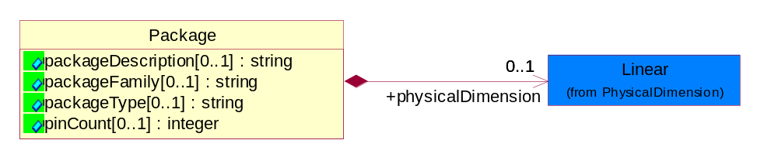
Figure ‎2-22 Package

Attribute | Type | Documentation
packageDescription[0..1] | string | Description of the package.
packageFamily[0..1] | string | User defined identification of the specific package family being used to assemble the product. Example: BGA, FBGA.
packageType[0..1] | string | User defined identification of the package type associated with the assembly lot. Example: Plastic, Organic, MCM.
pinCount[0..1] | integer | Identifies the number of pins on the package. The number of pins are determined by the packageFamily.

Composition | Cardinality | Type | Documentation
physicalDimension | 0..1 | Linear | The x and y dimensions of the physical package in mm.

PackageReport
Report that describes the defects from package inspection. Associate with OpticalInspectionReport.
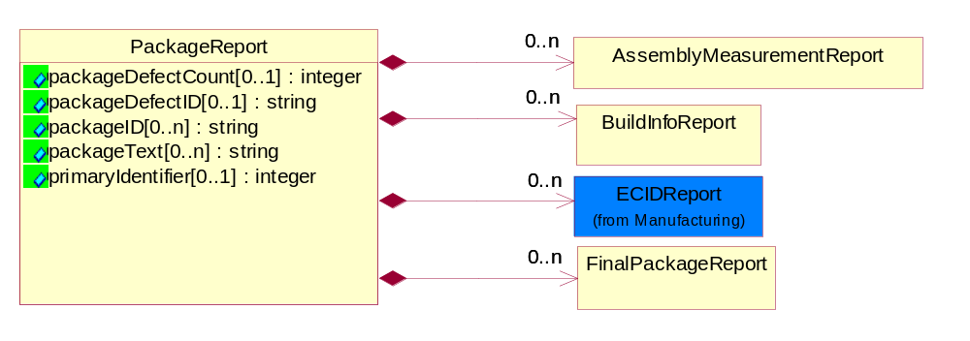
Figure ‎2-23 PackageReport

Attribute | Type | Documentation
packageDefectCount[0..1] | integer | Quantity of defects associated with a packageDefectID.
packageDefectID[0..1] | string | Unique defect code at the package level.
packageID[0..n] | string | Unique identifier for a package in an assembly lot. This is a user defined process.
packageText[0..n] | string | Comment field to provide information about the package and assembly lot.
primaryIdentifier[0..1] | integer | Reference to link the test report for a lot.

Composition | Cardinality | Type | Documentation
ECIDReport | 0..n | ECIDReport | Report to collect electronic chip ID data.
AssemblyMeasurementReport | 0..n | AssemblyMeasurementReport | Assembly process parametric measurements report.
BuildInfoReport | 0..n | BuildInfoReport | Options of obtaining more build information when building out the package.
FinalPackageReport | 0..n | FinalPackageReport | A report that provides additional, optional information about a packaged device. This class supports additional information concerning die being assembled into a package and to a card. This is the last step in the assembly process.

PinInformation
Report that describes additional information about the pins on the package.
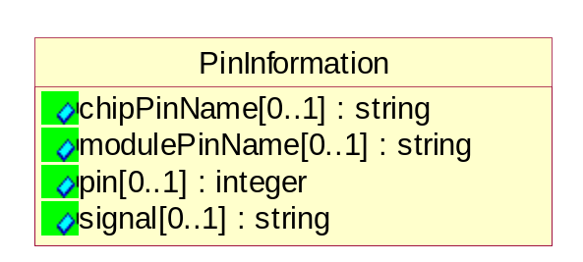
Figure ‎2-24 PinInformation

Attribute | Type | Documentation
chipPinName[0..1] | string | Alphanumeric string to describe the name of the pin.
modulePinName[0..1] | string | Alphanumeric string to describe the package pin name.
pin[0..1] | integer | Pin ID for each pin measured.
signal[0..1] | string | Alphanumeric string to describes the name of the signal pin.

SemiconductorProcessDataNotification
A message wrapper or root element for PIP7C8.
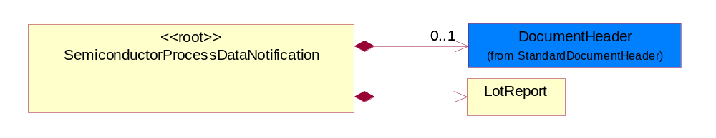
Figure ‎2-25 SemiconductorProcessDataNotification

Composition | Cardinality | Type | Documentation
DocumentHeader | 0..1 | DocumentHeader | The object allows for the identification of the sender and receiver of the business document.
LotReport | 1 | LotReport | Report that is common for reporting data collection for inline process and assembly process.

SoftwareReport
SoftwareReport describe software type, software name, software version and softwareBuildID.

Attribute | Type | Documentation
buildID[0..1] | string | A string that identifies the build version of the software. Example: BuildID=Java, JDK, 118, o118-199990910.
name[0..1] | string | The name of software type. Examples: AIX, Windows.
type[0..1] | string | The type of software described by this item. Valid examples are: Operating system, OEM tool control, Software system, Local Software and user defined.
version[0..1] | string | The software version being utilized. Example: 4.1.3.

TestParameterInformation
Describes optional attributes to provide additional information on the parameters of the test.
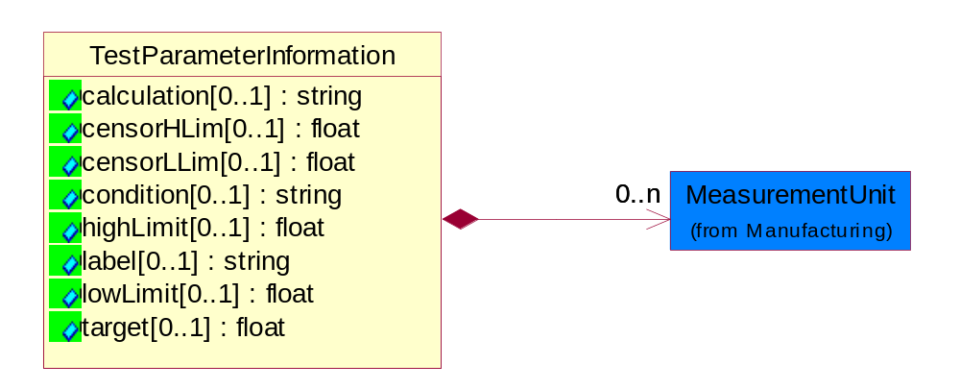
Figure ‎2-26 TestParameterInformation

Attribute | Type | Documentation
calculation[0..1] | string | A string describing the mathematical expression to derive a result.
censorHLim[0..1] | float | Float value for the high boundary for legitimate or valid test data.
censorLLim[0..1] | float | Float value for the low boundary for legitimate or valid test data.
condition[0..1] | string | A string specifying the test parameter, Example: Test temperature.
highLimit[0..1] | float | Describes the high limit value for a test specification.
label[0..1] | string | A string label to identify to the test parameter name.
lowLimit[0..1] | float | Describes the low limit value for a test specification.
target[0..1] | float | Describes the expected value for the test.

Composition | Cardinality | Type | Documentation
MeasurementUnit | 0..n | MeasurementUnit | Describes the measurement unit.

Domain Model

Manufacturing

Manufacturing

Dependency Diagram
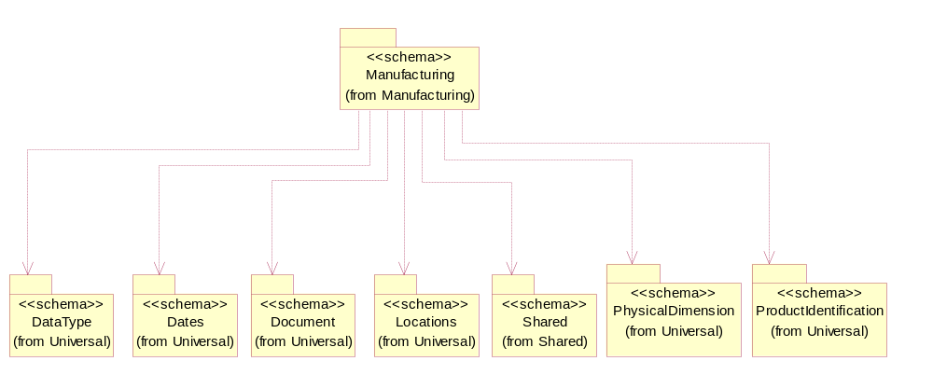
Figure ‎3-27 Dependency

ChipPeriodicity
Dimensional. Describes the distance between chips in micron between established reference points in either the x- and or y-direction on a wafer.

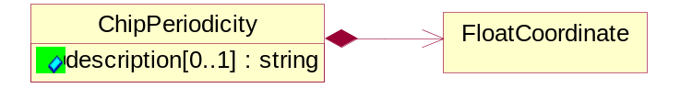
Figure ‎3-28 ChipPeriodicity

Attribute | Type | Documentation
description[0..1] | string | A string that describes the kind of chip periodicity is being defined.

Composition | Cardinality | Type | Documentation
FloatCoordinate | 1 | FloatCoordinate | X, Y and Z Coordinate values.

Dimension
Describes the dimensional measurement range in X, Y or Z axis.
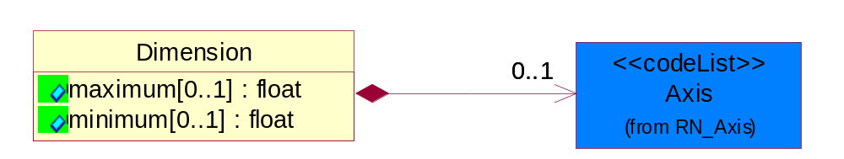
Figure ‎3-29 Dimension

Attribute | Type | Documentation
maximum[0..1] | float | Describes the maximum dimensional measurement for X, Y or Z axis.
minimum[0..1] | float | Describes the minimum dimensional measurement for X, Y or Z axis.

Composition | Cardinality | Type | Documentation
Axis | 0..1 | Axis | Indicate three dimensional direction.

ECIDReport
Report to collect electronic chip ID data.
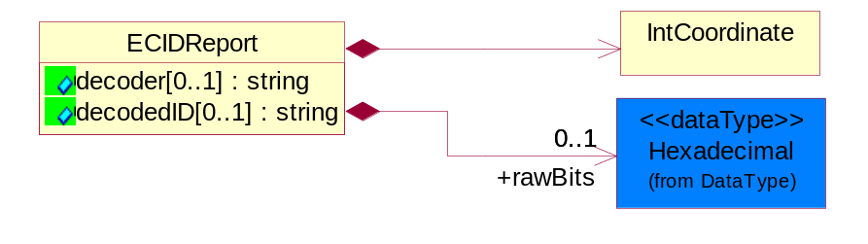
Figure ‎3-30 ECIDReport

Attribute | Type | Documentation
decoder[0..1] | string | Identifies the decoding scheme if ECID is used.
decodedID[0..1] | string | Value that could represent waferID or lotID.

Composition | Cardinality | Type | Documentation
rawBits | 0..1 | Hexadecimal | Hexadecimal data type.
IntCoordinate | 1 | IntCoordinate | X, Y and Z Coordinate values.

FacilityLocation
Describes the location where a product is fabricated, manufactured, tested, packaged, etc.
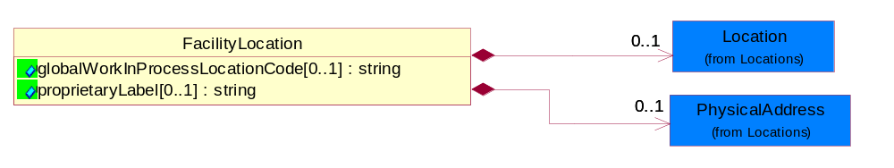
Figure ‎3-31 FacilityLocation

Attribute | Type | Documentation
globalWorkInProcessLocationCode[0..1] | string | References where fabrication, bond, assembly, test and related activities were performed on a lot or sublot.
proprietaryLabel[0..1] | string | User defined label to uniquely identify a facility that is represented in any of the scenarios.

Composition | Cardinality | Type | Documentation
Location | 0..1 | Location | The business document must specify a location.
PhysicalAddress | 0..1 | PhysicalAddress | The business document must provide a physical address for a party to the business transaction.

FloatCoordinate
X, Y and Z Coordinate values.
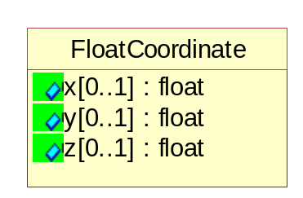
Figure ‎3-32 FloatCoordinate

Attribute | Type | Documentation
x[0..1] | float | Coordinate value for X-axis.
y[0..1] | float | Coordinate value for Y-axis.
z[0..1] | float | Coordinate value for Z-axis.

IntCoordinate
X, Y and Z Coordinate values.
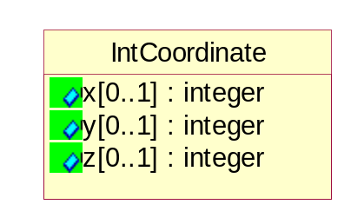
Figure ‎3-33 IntCoordinate

Attribute | Type | Documentation
x[0..1] | integer | Coordinate value for X-axis.
y[0..1] | integer | Coordinate value for Y-axis.
z[0..1] | integer | Coordinate value for Z-axis.

Lot
Describes the lot information.
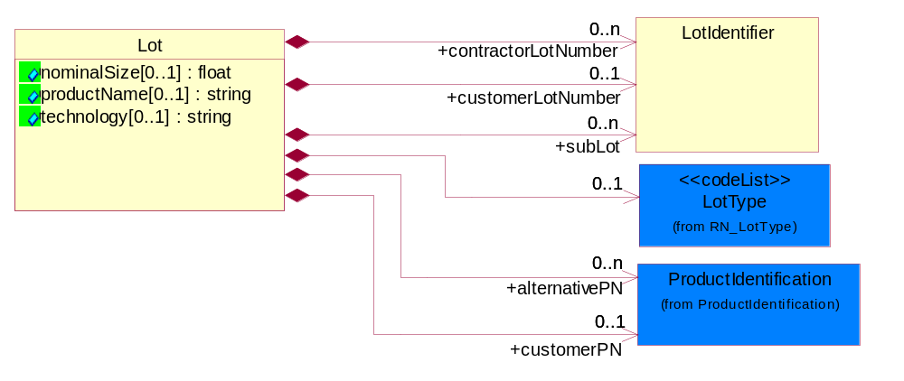
Figure ‎3-34 Lot

Attribute | Type | Documentation
nominalSize[0..1] | float | Describes the diameter of the wafer in mm, or inches.
productName[0..1] | string | A customer defined descriptor or code name for a part being fabricated or tested at a Foundry or Test Service trading partner. Example are Neptune, Big Dog, Antares 6.
technology[0..1] | string | An alphanumeric string that is associated with a fabrication technology. Example. CMOS8SF, MOS-11.

Composition | Cardinality | Type | Documentation
LotType | 0..1 | LotType | Describes the mode in which product was tested.
customerPN | 0..1 | ProductIdentification | A string which identifies Foundry defined, the Test Services defined or the customer proprietary defined part number for a wafer or packaged die
alternativePN | 0..n | ProductIdentification | A user defined string to identify a part number for a wafer or packaged die which is associated with customerPN.
customerLotNumber | 0..1 | LotIdentifier | Customer defined alphanumeric string used to identify the lot
contractorLotNumber | 0..n | LotIdentifier | User defined alphanumeric string which is associated with customer lot number.
subLot | 0..n | LotIdentifier | Alphanumeric string which describes a lot which has been separated from the Lot.

LotIdentifier
Description used to identify a lot.
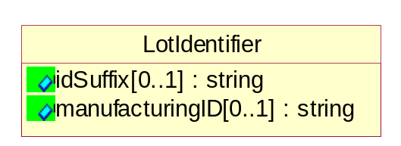
Figure ‎3-35 LotIdentifier

Attribute | Type | Documentation
idSuffix[0..1] | string | An alphanumeric string that could be used to identify a lot at a location. The suffix string is user defined. It can be used to identify a lot split, a bond assembly location, wafer sort or final test location.
manufacturingID[0..1] | string | Alphanumeric string which describes the lot.

MeasurementUnit
Describes the measurement unit.
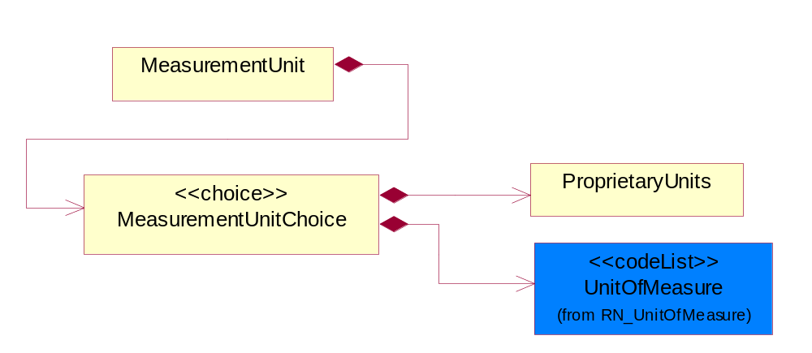
Figure ‎3-36 MeasurementUnit

Composition | Cardinality | Type | Documentation
MeasurementUnitChoice | 1 | MeasurementUnitChoice | Choice structure for describing the unit of measurement.

MeasurementUnitChoice
Choice structure for describing the unit of measurement.

Composition | Cardinality | Type | Documentation
UnitOfMeasure | 1 | UnitOfMeasure | Code identifying a product unit of measure.
ProprietaryUnits | 1 | ProprietaryUnits | Describes a class where the sender defines the units of measure for the test. These units are not listed in code list UnitOfMeasure.

OperationGate
The assembly process can be viewed as a series of operations. Inspections are performed at some of the operations and "bad" material is removed from the process. The OperationGate holds the name of that operation where the inspection is performed and the quantity information (inputs/output/rejects) for that operation. More specific defect counts can be viewed by looking at the OpticalInspectionReport where OpticalInspecationReport.DefectInformation.DefectType equals OperationGate.OperationGateDescription.
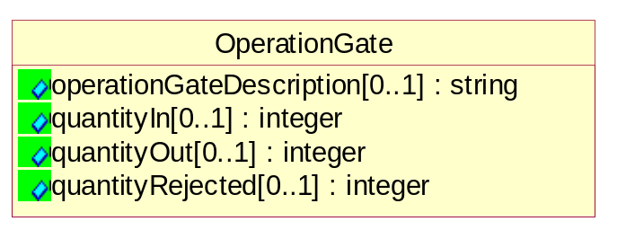
Figure ‎3-37 OperationGate

Attribute | Type | Documentation
operationGateDescription[0..1] | string | A user defined description of the operation or operation gate in the assembly process. This data attribute is associated with data attributes qualityIn and qualityOut.
quantityIn[0..1] | integer | The quantity of product in-gating or going into an assembly operation.
quantityOut[0..1] | integer | The quantity of product out-gating or exiting from an assembly operation.
quantityRejected[0..1] | integer | The quantity of product that was rejected (failed) from an assembly operation.

ProprietaryUnits
Describes a class where the sender defines the units of measure for the test. These units are not listed in code list UnitOfMeasure.
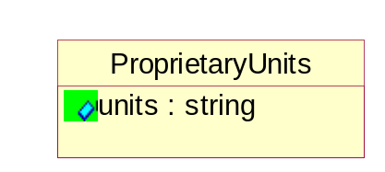
Figure ‎3-38 ProprietaryUnits

Attribute | Type | Documentation
units | string | Special description or code of the units for the measurement value.

QuantityDetail
A set of quantity details to select.
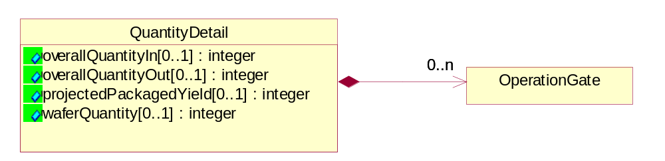
Figure ‎3-39 QuantityDetail

Attribute | Type | Documentation
overallQuantityIn[0..1] | integer | The quantity of incoming product for calculating overall assembly yield.
overallQuantityOut[0..1] | integer | The quantity of outgoing product for calculating overall assembly yield.
projectedPackagedYield[0..1] | integer | The projected package yield from an incoming wafer lot.
waferQuantity[0..1] | integer | Quantity or number of wafers in an incoming wafer lot.

Composition | Cardinality | Type | Documentation
OperationGate | 0..n | OperationGate | The assembly process can be viewed as a series of operations. Inspections are performed at some of the operations and "bad" material is removed from the process. The OperationGate holds the name of that operation where the inspection is performed and the quantity information (inputs/output/rejects) for that operation. More specific defect counts can be viewed by looking at the OpticalInspectionReport where OpticalInspecationReport.DefectInformation.DefectType equals OperationGate.OperationGateDescription.

TestMap
Describes the wafer orientation and configuration used by manufacturing test (metrology) equipment.
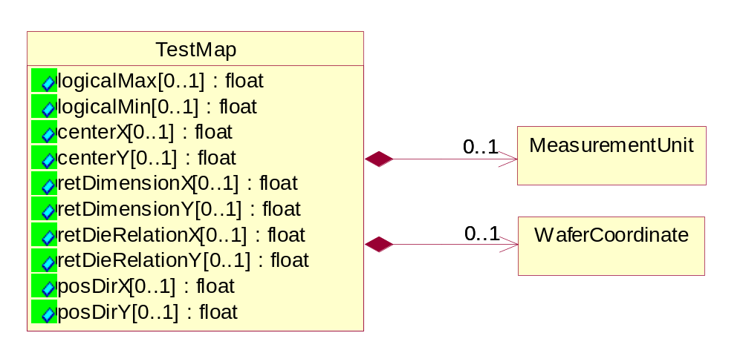
Figure ‎3-40 TestMap

Attribute | Type | Documentation
logicalMax[0..1] | float | The logiscal maximum dimensions. For PCM data, units are reticle index steps. For Wafer Sort and Final Test data, units are die index steps.
logicalMin[0..1] | float | The logiscal minimum dimensions. For PCM data, units are reticle index steps. For Wafer Sort and Final Test data, units are die index steps.
centerX[0..1] | float | The vector in X direction for index units form the (0,0) coordinate to the index containing the physical center of the wafer. For PCM data the index is reticle steps. For Wafer Sort and Final Test data the index is die steps.
centerY[0..1] | float | The vector in Y direction for index units form the (0,0) coordinate to the index containing the physical center of the wafer. For PCM data the index is reticle steps. For Wafer Sort and Final Test data the index is die steps.
retDimensionX[0..1] | float | The size of the reticle in the X direction , expressed in number of die incements.
retDimensionY[0..1] | float | The size of the reticle in the Y direction , expressed in number of die incements.
retDieRelationX[0..1] | float | The X coordinate of the center die within the center reticle.
retDieRelationY[0..1] | float | The Y coordinate of the center die within the center reticle.
posDirX[0..1] | float | The positive direction of the X-axis. Values illustrate Up (U), Down (D), Left (L)and Right (R).
posDirY[0..1] | float | The positive direction of the Y-axis. Values illustrate Up (U), Down (D), Left (L)and Right (R).

Composition | Cardinality | Type | Documentation
MeasurementUnit | 0..1 | MeasurementUnit | Describes the measurement unit.
WaferCoordinate | 0..1 | WaferCoordinate | The collection of business properties that describe the coordinate on a semiconductor wafer..

TestSetup
Describes the identification information for tester set-up.
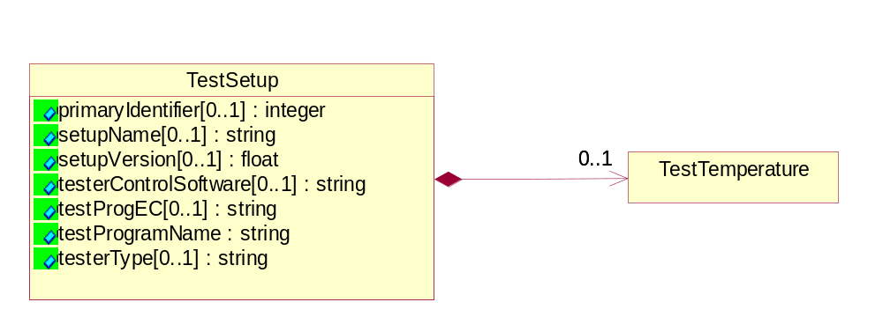
Figure ‎3-41 TestSetup

Attribute | Type | Documentation
primaryIdentifier[0..1] | integer | Reference to link the test report for a lot.
setupName[0..1] | string | A string that describes test conditions.
setupVersion[0..1] | float | Describes the version for the test conditions specified in setupName.
testerControlSoftware[0..1] | string | Describes the software and its version that control the tester.
testProgEC[0..1] | string | A string that indicates the version number for the TestProgName (Req. #43) used for testing a lot or sublot.
testProgramName | string | A string that describes the test program for either a lot or sublot.
testerType[0..1] | string | This object describes the tester model, version and ID number.

Composition | Cardinality | Type | Documentation
TestTemperature | 0..1 | TestTemperature | Temperature value in either Centigrade or Fahrenheit to identify at which a test is performed for lot or sublot.

TestTemperature
Temperature value in either Centigrade or Fahrenheit to identify at which a test is performed for lot or sublot.
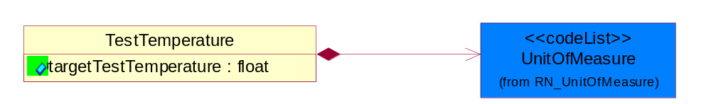
Figure ‎3-42 TestTemperature

Attribute | Type | Documentation
targetTestTemperature | float | The targeted temperature value in either Centigrade or Fahrenheit at which a test is performed for lot or sublot.

Composition | Cardinality | Type | Documentation
UnitOfMeasure | 1 | UnitOfMeasure | Code identifying a product unit of measure.

Wafer
Describes key reference attributes to identify a wafer.
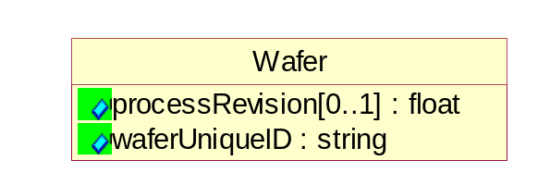
Figure ‎3-43 Wafer

Attribute | Type | Documentation
processRevision[0..1] | float | A decimal value, i.e. 1.0 that references the POR version.
waferUniqueID | string | An alphanumeric string which describes the wafer serial number for traceability in a lot or sublot.

WaferCoordinate
The collection of business properties that describe the coordinate on a semiconductor wafer.

Attribute | Type | Documentation
maxX[0..1] | float | The maximum X coordinate on a semiconductor wafer.
maxY[0..1] | float | The maximum Y coordinate on a semiconductor wafer.
minX[0..1] | float | The minimum X coordinate on a semiconductor wafer.
minY[0..1] | float | The minimum Y coordinate on a semiconductor wafer.

CodeList

Axis
Indicate three dimensional direction.

Name | Documentation
X | X-axis.
Y | Y-axis.
Z | Z-axis.

Confidentiality
A string which describes the level of security associated with the data, as defined by TPA.

Name | Documentation
CON | Confidential security level.
NON | No security restriction (None).
RES | Restricted security level.

LotType
Describes the mode in which product was tested.

Name | Documentation
DEV | Development.
ENG | Engineering - State where product is made using test processes on non-production tools or equipment.
EUH | EUH type.
MFG | Manufacturing.
NCL | NonConformingLot - Lots affected by a nonconformity to preset quality characteristics.
PLT | Pilot - The first lot of the product (never produced at the dedicated subcontractor).
PPD | Pre-Production.
PQC | Process Qualification Check - Process to qualify manufacturing processes in preparation for volume manufacturing.
PRD | Production - State where product is made using all production tools, processes, equipment, environment, facility, and cycle time.
RND | Research and Development - Process for developing prototype products.
RWK | Rework - Parts sent back from further down the manufacturing line.
SVC | Service.
TST | Test - The manufacturing stage in which the packaged die is tested.

CompletionStatus
Describes the status of the lot or sublot at the end of testing.

Name | Documentation
ABO | Aborted: process has been terminated; data is invalid and is purged.
COM | Completed: all process have been completed; data is valid and can be migrated.
SUS | Suspend: process is partially done; data is valid and can be migrated.

TestResult
Describes the test result for a parametric test.

Name | Documentation
FAL | Failed.
FCS | Failed Censor.
FHL | Failed High Limit.
FLL | Failed Low Limit.
PAS | Passed.
SCV | Screened Valued.

ComponentType
Valid component values are: Chip, SCM, MCM, Card, Cage, Frame.

Name | Documentation
CAG | A cage containing multiple boards or cards.
CHP | A row Chip or die.
CRD | A card or board containing multiple module (MCM or SCM).
FRM | A frame containing multiple cages and user definded.
MCM | A multi chip module.
SCM | A single Chip module.

Universal Structure

ContactInformation

ContactInformation
The business document must allow for the identification of the name of the department, service or individual to be contacted regarding the context of the business document.
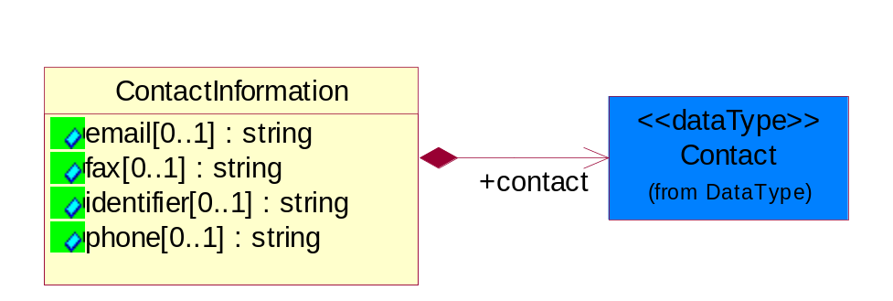
Figure ‎4-44 ContactInformation

Attribute | Type | Documentation
email[0..1] | string | The electronic mail for the specified contact.
fax[0..1] | string | The fax number for the specified contact.
identifier[0..1] | string | Identifies the role of the contact (i.e. Service Technician, Account Manager) in the Business Process.
phone[0..1] | string | The telephone number for the specified contact.

Composition | Cardinality | Type | Documentation
contact | 1 | Contact | The name of the department, service or individual to be contacted within the organization.

DataType

Contact
The name of the department, service or individual to be contacted within the organization.
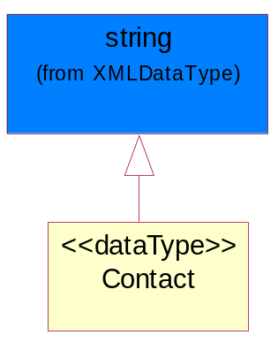
Figure ‎4-45 Contact

DUNS
A number assigned by Dun and Bradstreet to identify a business location.
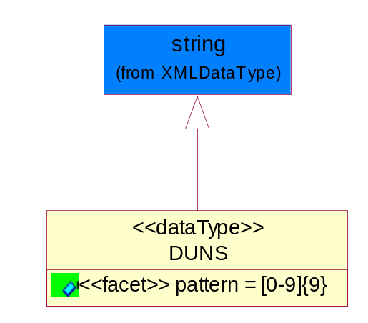
Figure ‎4-46 DUNS

Attribute | Type | Documentation
pattern |  | [0-9]{9}

DUNSPlus4
A identifier to specify a specific location within a business location.
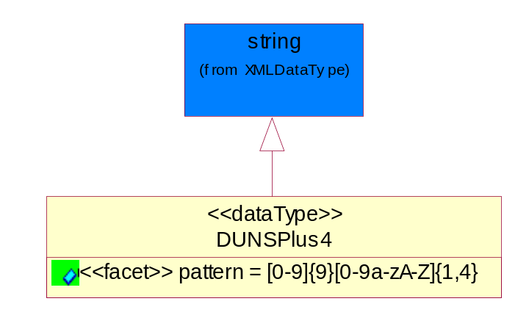
Figure ‎4-47 DUNSPlus4

Attribute | Type | Documentation
pattern |  | Data Universal Numbering System +4 (DUNS+4) number means the DUNS number assigned by Dun and Bradstreet, Inc. (D&B) plus an alphanumeric of length 4 suffix that may be assigned by a business concern.

GLN
Global Location Number (GLN) - A identifier to identify legal entities, trading parties and location.
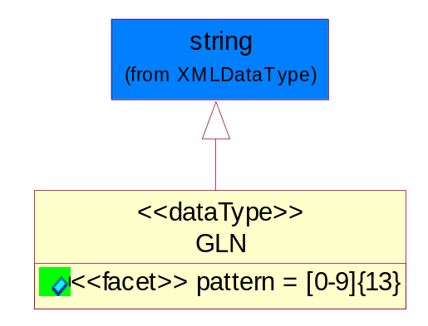
Figure ‎4-48 GLN

Attribute | Type | Documentation
pattern |  | [0-9]{13}

GTIN
Global Trade Identification Number (GTIN).
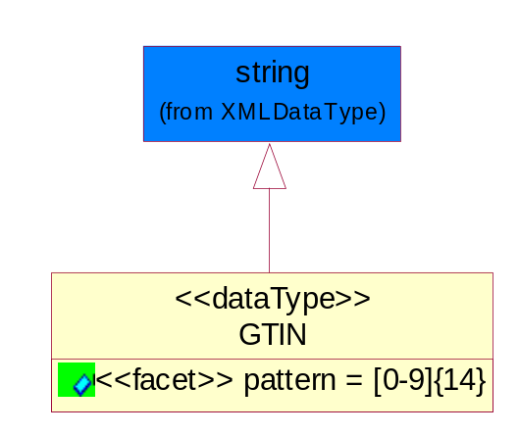
Figure ‎4-49 GTIN

Attribute | Type | Documentation
pattern |  | [0-9]{14}

Hexadecimal
Hexadecimal data type.
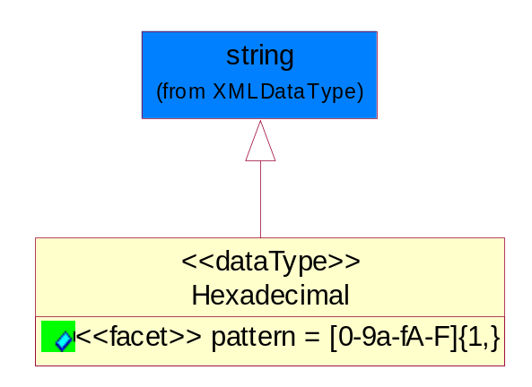
Figure ‎4-50 Hexadecimal

Attribute | Type | Documentation
pattern |  | [0-9a-fA-F]{1,}

PercentAmount
A number representing a percentage value, e.g. 75.125 represents 75 1/8 percent.
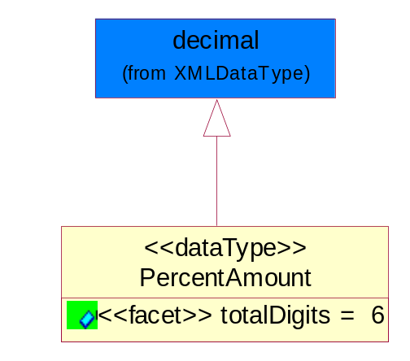
Figure ‎4-51 PercentAmount

Attribute | Type | Documentation
totalDigits |  | 6

Locations

AlternativeIdentifier
Identifies the specified code and the name of the organization that a code is utilized from.
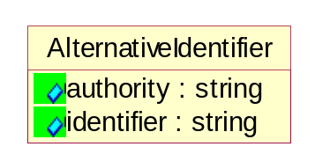
Figure ‎4-52 AlternativeIdentifier

Attribute | Type | Documentation
authority | string | The name of the organization that a code is utilized from.
identifier | string | The specified code to represent an entity (e.g. product, location, partner, etc.).

Location
The business document must specify a location.
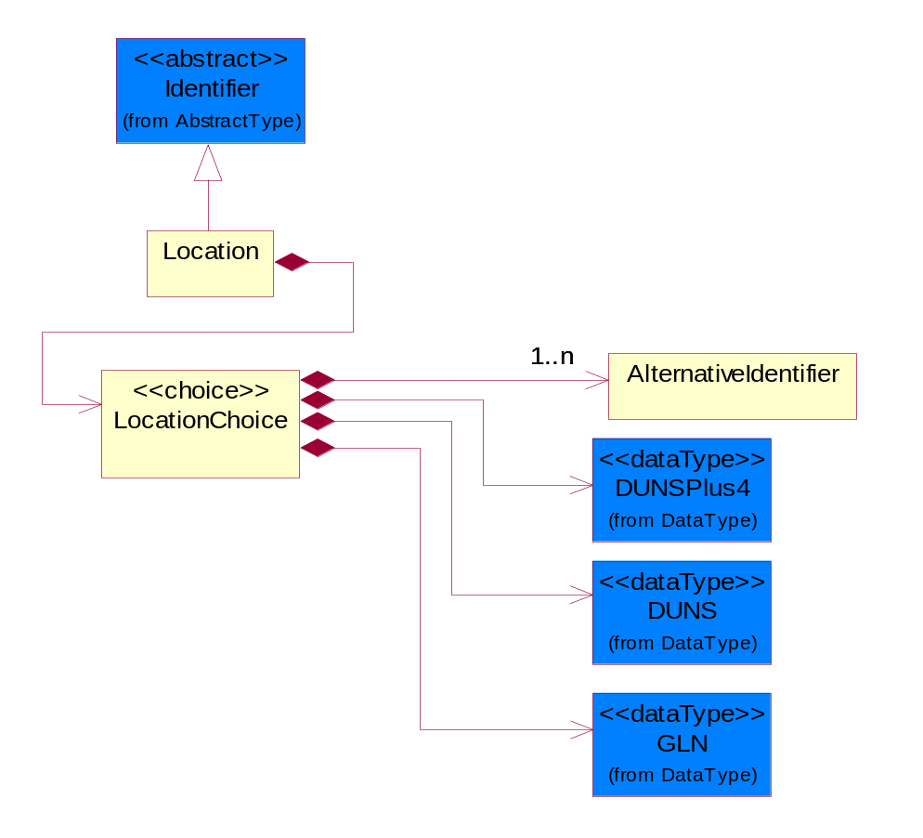
Figure ‎4-53 Location

Composition | Cardinality | Type | Documentation
LocationChoice | 1 | LocationChoice

LocationChoice

Composition | Cardinality | Type | Documentation
DUNSPlus4 | 1 | DUNSPlus4 | A identifier to specify a specific location within a business location.
DUNS | 1 | DUNS | A number assigned by Dun and Bradstreet to identify a business location.
AlternativeIdentifier | 1..n | AlternativeIdentifier | Identifies the specified code and the name of the organization that a code is utilized from.
GLN | 1 | GLN | Global Location Number (GLN) - A identifier to identify legal entities, trading parties and location.

PhysicalAddress
The business document must provide a physical address for a party to the business transaction.
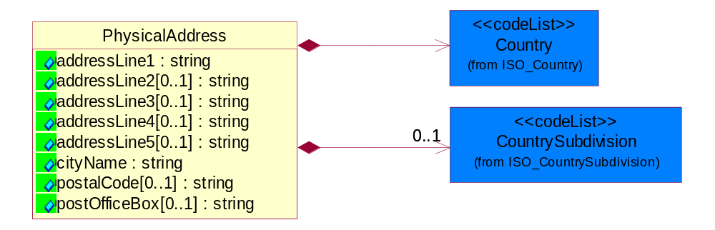
Figure ‎4-54 PhysicalAddress

Attribute | Type | Documentation
addressLine1 | string | The first line of a physical address.
addressLine2[0..1] | string | The second line of a physical address.
addressLine3[0..1] | string | The third line of a physical address.
addressLine4[0..1] | string | The fourth line of a physical address.
addressLine5[0..1] | string | The fifth line of a physical address.
cityName | string | The name of a city.
postalCode[0..1] | string | Identifying geographic location as specified by a national postal code.
postOfficeBox[0..1] | string | The Post Office Box identifier used to identify a party's post office box.

Composition | Cardinality | Type | Documentation
Country | 1 | Country | For representation of Country name RosettaNet has adopted ISO 3166-3; 1999. Refer to the following web page to get the latest version of the standard:  http://www.iso.ch/iso/en/prods-services/iso3166ma/02iso-3166-code-lists/index.html  If you need more information about the ISO standard please contact ISO for more details.
CountrySubdivision | 0..1 | CountrySubdivision | For representation of a Countries subdivisions RosettaNet has adopted ISO 3166-3; 1999. Refer to the following web page to get the latest version of the standard:  http://www.iso.ch/iso/en/prods-services/iso3166ma/02iso-3166-code-lists/index.html  If you need more information about the ISO standard please contact ISO for more details.

PartnerIdentification

PartnerIdentification
The business document must allow for the identity of one or more parties to the transaction.
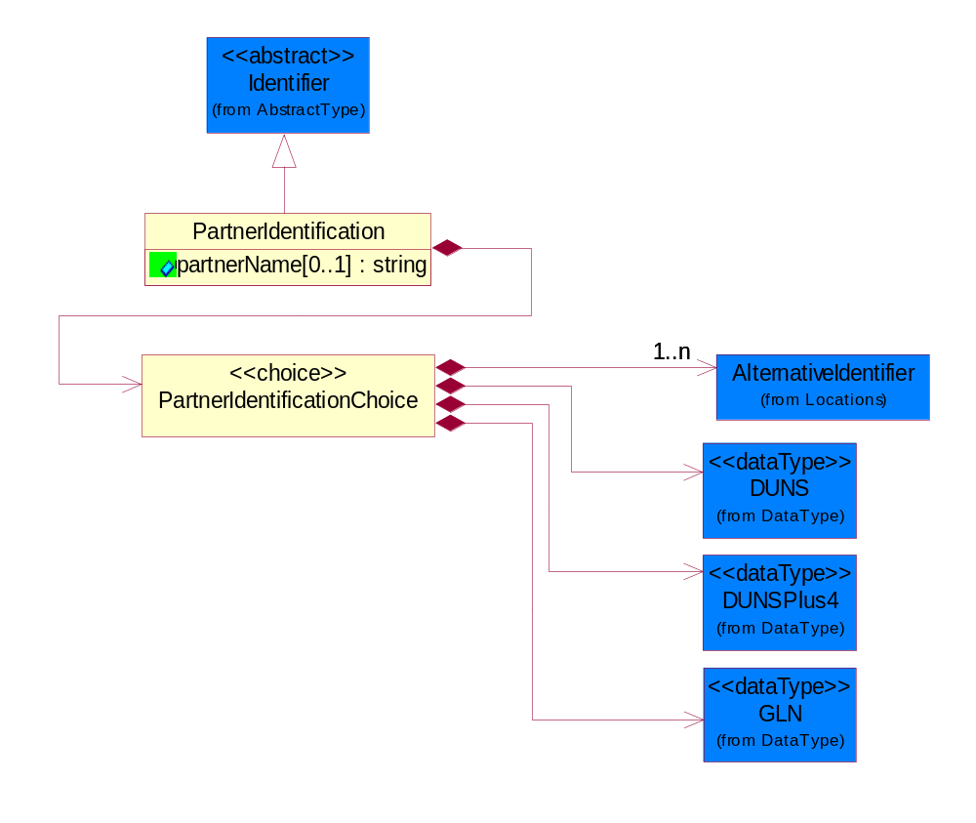
Figure ‎4-55 PartnerIdentification

Attribute | Type | Documentation
partnerName[0..1] | string | The name of the partner’s company/business.

Composition | Cardinality | Type | Documentation
PartnerIdentificationChoice | 1 | PartnerIdentificationChoice

PartnerIdentificationChoice

Composition | Cardinality | Type | Documentation
DUNS | 1 | DUNS | A number assigned by Dun and Bradstreet to identify a business location.
DUNSPlus4 | 1 | DUNSPlus4 | A identifier to specify a specific location within a business location.
AlternativeIdentifier | 1..n | AlternativeIdentifier | Identifies the specified code and the name of the organization that a code is utilized from.
GLN | 1 | GLN | Global Location Number (GLN) - A identifier to identify legal entities, trading parties and location.

PhysicalDimension

Linear
The business document must be able to express the linear dimensions of an object.
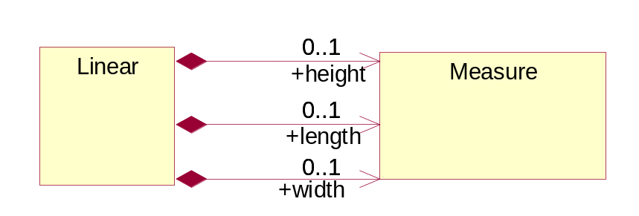
Figure ‎4-56 Linear

Composition | Cardinality | Type | Documentation
height | 0..1 | Measure | To express the height of an object.
length | 0..1 | Measure | To express the length of an object.
width | 0..1 | Measure | To express the weight of an object.

Measure
The business document must describe measurement information.
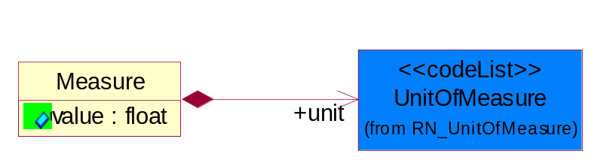
Figure ‎4-57 Measure

Attribute | Type | Documentation
value | float | The worth of an object in the specified unit of measure.

Composition | Cardinality | Type | Documentation
unit | 1 | UnitOfMeasure | To express the unit type of measurement.

ProductIdentification

ProductIdentification
The object provides the identifier(s) of a product.
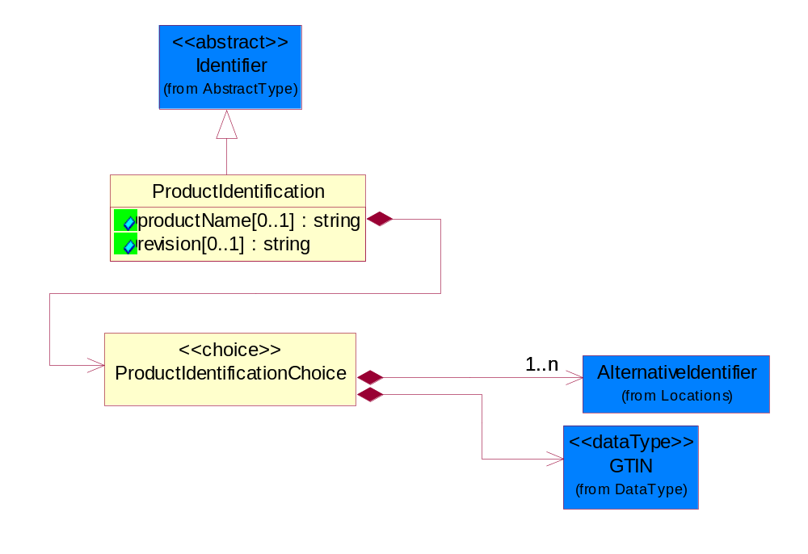
Figure ‎4-58 ProductIdentification

Attribute | Type | Documentation
productName[0..1] | string | The name of the product.
revision[0..1] | string | Referenced the specified product revision.

Composition | Cardinality | Type | Documentation
ProductIdentificationChoice | 1 | ProductIdentificationChoice

ProductIdentificationChoice

Composition | Cardinality | Type | Documentation
AlternativeIdentifier | 1..n | AlternativeIdentifier | Identifies the specified code and the name of the organization that a code is utilized from.
GTIN | 1 | GTIN | Global Trade Identification Number (GTIN).

CodeList

Country
For representation of Country name RosettaNet has adopted ISO 3166-3; 1999. Refer to the following web page to get the latest version of the standard:
http://www.iso.ch/iso/en/prods-services/iso3166ma/02iso-3166-code-lists/index.html

If you need more information about the ISO standard please contact ISO for more details.

CountrySubdivision
For representation of a Countries subdivisions RosettaNet has adopted ISO 3166-3; 1999. Refer to the following web page to get the latest version of the standard:
http://www.iso.ch/iso/en/prods-services/iso3166ma/02iso-3166-code-lists/index.html

If you need more information about the ISO standard please contact ISO for more details.

Language
For representation of Language name RosettaNet has adopted ISO 639-2; 1998. Refer to the following web page to get the latest version of the standard:

http://www.loc.gov/standards/iso639-2/iso639jac.html

If you need more information about the ISO standard please contact ISO for more details.

MimeTypeQualifier
The MIME type as defined by IANA.

Please refer to http://www.iana.org/assignments/media-types/ for a list of types.

Instance | Documentation
application/activemessage | [Shapiro]
application/andrew-inset | [Borenstein]
application/applefile | [Faltstrom]
application/atomicmail | [Borenstein]
application/batch-SMTP | [RFC2442]
application/beep+xml | [RFC3080]
application/cals-1840 | [RFC1895]
application/cnrp+xml | [RFCCNRP]
application/commonground | [Glazer]
application/cpl+xml
application/cybercash | [Eastlake]
application/dca-rft | [Campbell]
application/dec-dx | [Campbell]
application/dicom | [RFC3240]
application/dvcs | [RFC3029]
application/EDI-Consent | [RFC1767]
application/EDIFACT | [RFC1767]
application/EDI-X12 | [RFC1767]
application/eshop | [Katz]
application/font-tdpfr | [RFC3073]
application/http | [RFC2616]
application/hyperstudio | [Domino]
application/iges | [Parks]
application/index | [RFC2652]
application/index.cmd | [RFC2652]
application/index.obj | [RFC2652]
application/index.response | [RFC2652]
application/index.vnd | [RFC2652]
application/iotp | [RFC2935]
application/ipp | [RFC2910]
application/isup | [RFC3204]
application/mac-binhex40 | [Faltstrom]
application/macwriteii | [Lindner]
application/marc | [RFC2220]
application/mathematica | [Van Nostern]
application/msword | [Lindner]
application/news-message-id | [RFC1036,Spencer]
application/news-transmission | [RFC1036, Spencer]
application/ocsp-request | [RFC2560]
application/ocsp-response | [RFC2560]
application/octet-stream | [RFC2045,RFC2046]
application/oda | [RFC2045,RFC2046]
application/ogg | [RFC-walleij-ogg-mediatype-08.txt]
application/parityfec | [RFC3009]
application/pdf | [Lindner]
application/pgp-encrypted | [RFC3156]
application/pgp-keys | [RFC3156]
application/pgp-signature | [RFC3156]
application/pkcs10 | [RFC2311]
application/pkcs7-mime | [RFC2311]
application/pkcs7-signature | [RFC2311]
application/pkix-cert | [RFC2585]
application/pkixcmp | [RFC2510]
application/pkix-crl | [RFC2585]
application/postscript | [RFC2045,RFC2046]
application/prs.alvestrand.titrax-sheet | [Alvestrand]
application/prs.cww | [Rungchavalnont]
application/prs.nprend | [Doggett]
application/prs.plucker | [Janssen]
application/qsig | [RFC3204]
application/reginfo+xml | [RFC-ietf-sipping-reg-event-00.txt]
application/remote-printing | [RFC1486,Rose]
application/riscos | [Smith]
application/rtf | [Lindner]
application/sdp | [RFC2327]
application/set-payment | [Korver]
application/set-payment-initiation | [Korver]
application/set-registration | [Korver]
application/set-registration-initiation | [Korver]
application/sgml | [RFC1874]
application/sgml-open-catalog | [Grosso]
application/sieve | [RFC3028]
application/slate | [Crowley]
application/timestamp-query | [RFC3161]
application/timestamp-reply | [RFC3161]
application/tve-trigger | [Welsh]
application/vemmi | [RFC2122]
application/vnd.3gpp.pic-bw-large | [Meredith]
application/vnd.3gpp.pic-bw-small | [Meredith]
application/vnd.3gpp.pic-bw-var | [Meredith]
application/vnd.3gpp.sms | [Meredith]
application/vnd.3M.Post-it-Notes | [O'Brien]
application/vnd.accpac.simply.aso | [Leow]
application/vnd.accpac.simply.imp | [Leow]
application/vnd.acucobol | [Lubin]
application/vnd.acucorp | [Lubin]
application/vnd.adobe.xfdf | [Perelman]
application/vnd.aether.imp | [Moskowitz]
application/vnd.amiga.ami | [Blumberg]
application/vnd.anser-web-certificate-issue-initiation | [Mori]
application/vnd.anser-web-funds-transfer-initiation | [Mori]
application/vnd.audiograph | [Slusanschi]
application/vnd.blueice.multipass | [Holmstrom]
application/vnd.bmi | [Gotoh]
application/vnd.businessobjects | [Imoucha]
application/vnd.canon-cpdl | [Muto]
application/vnd.canon-lips | [Muto]
application/vnd.cinderella | [Kortenkamp]
application/vnd.claymore | [Simpson]
application/vnd.commerce-battelle | [Applebaum]
application/vnd.commonspace | [Chandhok]
application/vnd.contact.cmsg | [Patz]
application/vnd.cosmocaller | [Dellutri]
application/vnd.ctc-posml | [Kohlhepp]
application/vnd.cups-postscript | [Sweet]
application/vnd.cups-raster | [Sweet]
application/vnd.cups-raw | [Sweet]
application/vnd.curl | [Byrnes]
application/vnd.cybank | [Helmee]
application/vnd.data-vision.rdz | [Fields]
application/vnd.dna | [Searcy]
application/vnd.dpgraph | [Parker]
application/vnd.dreamfactory | [Appleton]
application/vnd.dxr | [Duffy]
application/vnd.ecdis-update | [Buettgenbach]
application/vnd.ecowin.chart | [Olsson]
application/vnd.ecowin.filerequest | [Olsson]
application/vnd.ecowin.fileupdate | [Olsson]
application/vnd.ecowin.series | [Olsson]
application/vnd.ecowin.seriesrequest | [Olsson]
application/vnd.ecowin.seriesupdate | [Olsson]
application/vnd.enliven | [Santinelli]
application/vnd.epson.esf | [Hoshina]
application/vnd.epson.msf | [Hoshina]
application/vnd.epson.quickanime | [Gu]
application/vnd.epson.salt | [Nagatomo]
application/vnd.epson.ssf | [Hoshina]
application/vnd.ericsson.quickcall | [Tidwell]
application/vnd.eudora.data | [Resnick]
application/vnd.fdf | [Zilles]
application/vnd.ffsns | [Holstage]
application/vnd.FloGraphIt | [Floersch]
application/vnd.framemaker | [Wexler]
application/vnd.fsc.weblaunch | [D.Smith]
application/vnd.fujitsu.oasys | [Togashi]
application/vnd.fujitsu.oasys2 | [Togashi]
application/vnd.fujitsu.oasys3 | [Okudaira]
application/vnd.fujitsu.oasysgp | [Sugimoto]
application/vnd.fujitsu.oasysprs | [Ogita]
application/vnd.fujixerox.ddd | [Onda]
application/vnd.fujixerox.docuworks | [Taguchi]
application/vnd.fujixerox.docuworks.binder | [Matsumoto]
application/vnd.fut-misnet | [Pruulmann]
application/vnd.grafeq | [Tupper]
application/vnd.groove-account | [Joseph]
application/vnd.groove-help | [Joseph]
application/vnd.groove-identity-message | [Joseph]
application/vnd.groove-injector | [Joseph]
application/vnd.groove-tool-message | [Joseph]
application/vnd.groove-tool-template | [Joseph]
application/vnd.groove-vcard | [Joseph]
application/vnd.hbci | [Hammann]
application/vnd.hhe.lesson-player | [Jones]
application/vnd.hp-HPGL | [Pentecost]
application/vnd.hp-hpid | [Gupta]
application/vnd.hp-hps | [Aubrey]
application/vnd.hp-PCL | [Pentecost]
application/vnd.hp-PCLXL | [Pentecost]
application/vnd.httphone | [Lefevre]
application/vnd.hzn-3d-crossword | [Minnis]
application/vnd.ibm.afplinedata | [Buis]
application/vnd.ibm.electronic-media | [Tantlinger]
application/vnd.ibm.MiniPay | [Herzberg]
application/vnd.ibm.modcap | [Hohensee]
application/vnd.ibm.secure-container | [Tantlinger]
application/vnd.informix-visionary | [Gales]
application/vnd.intercon.formnet | [Gurak]
application/vnd.intertrust.digibox | [Tomasello]
application/vnd.intertrust.nncp | [Tomasello]
application/vnd.intu.qbo | [Scratchley]
application/vnd.intu.qfx | [Scratchley]
application/vnd.irepository.package+xml | [Knowles]
application/vnd.is-xpr | [Natarajan]
application/vnd.japannet-directory-service | [Fujii]
application/vnd.japannet-jpnstore-wakeup | [Yoshitake]
application/vnd.japannet-payment-wakeup | [Fujii]
application/vnd.japannet-registration | [Yoshitake]
application/vnd.japannet-registration-wakeup | [Fujii]
application/vnd.japannet-setstore-wakeup | [Yoshitake]
application/vnd.japannet-verification | [Yoshitake]
application/vnd.japannet-verification-wakeup | [Fujii]
application/vnd.jisp | [Deckers]
application/vnd.kde.karbon | [Faure]
application/vnd.kde.kchart | [Faure]
application/vnd.kde.kformula | [Faure]
application/vnd.kde.kivio | [Faure]
application/vnd.kde.kontour | [Faure]
application/vnd.kde.kpresenter | [Faure]
application/vnd.kde.kspread | [Faure]
application/vnd.kde.kword | [Faure]
application/vnd.kenameaapp | [DiGiorgio-Haag]
application/vnd.koan | [Cole]
application/vnd.liberty-request+xml | [McDowell]
application/vnd.llamagraphics.life-balance.desktop | [White]
application/vnd.lotus-1-2-3 | [Wattenberger]
application/vnd.lotus-approach | [Wattenberger]
application/vnd.lotus-freelance | [Wattenberger]
application/vnd.lotus-notes | [Laramie]
application/vnd.lotus-organizer | [Wattenberger]
application/vnd.lotus-screencam | [Wattenberger]
application/vnd.lotus-wordpro | [Wattenberger]
application/vnd.mcd | [Gotoh]
application/vnd.mediastation.cdkey | [Flurry]
application/vnd.meridian-slingshot | [Wedel]
application/vnd.micrografx.flo | [Prevo]
application/vnd.micrografx.igx | [Prevo]
application/vnd.mif | [Wexler]
application/vnd.minisoft-hp3000-save | [Bartram]
application/vnd.mitsubishi.misty-guard.trustweb | [Tanaka]
application/vnd.Mobius.DAF | [Kabayama]
application/vnd.Mobius.DIS | [Kabayama]
application/vnd.Mobius.MBK | [Devasia]
application/vnd.Mobius.MQY | [Devasia]
application/vnd.Mobius.MSL | [Kabayama]
application/vnd.Mobius.PLC | [Kabayama]
application/vnd.Mobius.TXF | [Kabayama]
application/vnd.mophun.application | [Wennerstrom]
application/vnd.mophun.certificate | [Wennerstrom]
application/vnd.motorola.flexsuite | [Patton]
application/vnd.motorola.flexsuite.adsi | [Patton]
application/vnd.motorola.flexsuite.fis | [Patton]
application/vnd.motorola.flexsuite.gotap | [Patton]
application/vnd.motorola.flexsuite.kmr | [Patton]
application/vnd.motorola.flexsuite.ttc | [Patton]
application/vnd.motorola.flexsuite.wem | [Patton]
application/vnd.mozilla.xul+xml | [McDaniel]
application/vnd.ms-artgalry | [Slawson]
application/vnd.ms-asf | [Fleischman]
application/vnd.mseq | [Le Bodic]
application/vnd.ms-excel | [Gill]
application/vnd.msign | [Borcherding]
application/vnd.ms-lrm | [Ledoux]
application/vnd.ms-powerpoint | [Gill]
application/vnd.ms-project | [Gill]
application/vnd.ms-tnef | [Gill]
application/vnd.ms-works | [Gill]
application/vnd.ms-wpl | [Plastina]
application/vnd.musician | [Adams]
application/vnd.music-niff | [Butler]
application/vnd.netfpx | [Mutz]
application/vnd.noblenet-directory | [Solomon]
application/vnd.noblenet-sealer | [Solomon]
application/vnd.noblenet-web | [Solomon]
application/vnd.novadigm.EDM | [Swenson]
application/vnd.novadigm.EDX | [Swenson]
application/vnd.novadigm.EXT | [Swenson]
application/vnd.obn | [Hessling]
application/vnd.osa.netdeploy | [Klos]
application/vnd.palm | [Peacock]
application/vnd.pg.format | [Gandert]
application/vnd.pg.osasli | [Gandert]
application/vnd.powerbuilder6 | [Guy]
application/vnd.powerbuilder6-s | [Guy]
application/vnd.powerbuilder7 | [Shilts]
application/vnd.powerbuilder75 | [Shilts]
application/vnd.powerbuilder75-s | [Shilts]
application/vnd.powerbuilder7-s | [Shilts]
application/vnd.previewsystems.box | [Smolgovsky]
application/vnd.publishare-delta-tree | [Ben-Kiki]
application/vnd.pvi.ptid1 | [Lamb]
application/vnd.pwg-multiplexed | [RFC3391]
application/vnd.pwg-xhtml-print+xml | [Wright]
application/vnd.Quark.QuarkXPress | [Scheidler]
application/vnd.rapid | [Szekely]
application/vnd.s3sms | [Tarkkala]
application/vnd.sealed.net | [Lambert]
application/vnd.seemail | [Webb]
application/vnd.shana.informed.formdata | [Selzler]
application/vnd.shana.informed.formtemplate | [Selzler]
application/vnd.shana.informed.interchange | [Selzler]
application/vnd.shana.informed.package | [Selzler]
application/vnd.smaf | [Takahashi]
application/vnd.sss-cod | [Dani]
application/vnd.sss-dtf | [Bruno]
application/vnd.sss-ntf | [Bruno]
application/vnd.street-stream | [Levitt]
application/vnd.svd | [Becker]
application/vnd.swiftview-ics | [Widener]
application/vnd.triscape.mxs | [Simonoff]
application/vnd.trueapp | [Hepler]
application/vnd.truedoc | [Chase]
application/vnd.ufdl | [Manning]
application/vnd.uplanet.alert | [Martin]
application/vnd.uplanet.alert-wbxml | [Martin]
application/vnd.uplanet.bearer-choice | [Martin]
application/vnd.uplanet.bearer-choice-wbxml | [Martin]
application/vnd.uplanet.cacheop | [Martin]
application/vnd.uplanet.cacheop-wbxml | [Martin]
application/vnd.uplanet.channel | [Martin]
application/vnd.uplanet.channel-wbxml | [Martin]
application/vnd.uplanet.list | [Martin]
application/vnd.uplanet.listcmd | [Martin]
application/vnd.uplanet.listcmd-wbxml | [Martin]
application/vnd.uplanet.list-wbxml | [Martin]
application/vnd.uplanet.signal | [Martin]
application/vnd.vcx | [T.Sugimoto]
application/vnd.vectorworks | [Pharr]
application/vnd.vidsoft.vidconference | [Hess]
application/vnd.visio | [Sandal]
application/vnd.visionary | [Aravindakumar]
application/vnd.vividence.scriptfile | [Risher]
application/vnd.vsf | [Rowe]
application/vnd.wap.sic | [WAP-Forum]
application/vnd.wap.slc | [WAP-Forum]
application/vnd.wap.wbxml | [Stark]
application/vnd.wap.wmlc | [Stark]
application/vnd.wap.wmlscriptc | [Stark]
application/vnd.webturbo | [Rehem]
application/vnd.wrq-hp3000-labelled | [Bartram]
application/vnd.wt.stf | [Wohler]
application/vnd.wv.csp+wbxml | [Salmi]
application/vnd.xara | [Matthewman]
application/vnd.xfdl | [Manning]
application/vnd.yellowriver-custom-menu | [Yellow]
application/whoispp-query | [RFC2957]
application/whoispp-response | [RFC2958]
application/wita | [Campbell]
application/wordperfect5.1 | [Lindner]
application/x400-bp | [RFC1494]
application/xhtml+xml | [RFC3236]
application/xml | [RFC3023]
application/xml-dtd | [RFC3023]
application/xml-external-parsed-entity | [RFC3023]
application/zip | [Lindner]
audio/32kadpcm | [RFC2421,RFC2422]
audio/AMR | [RFC3267]
audio/AMR-WB | [RFC3267]
audio/basic | [RFC2045,RFC2046]
audio/CN | [RFC3389]
audio/DAT12 | [RFC3190]
audio/DVI4
audio/EVRC | [RFC-ietf-avt-evrc-smv-03.txt]
audio/EVRC0 | [RFC-ietf-avt-evrc-smv-03.txt]
audio/G.722.1 | [RFC3047]
audio/G722
audio/G723
audio/G726-16
audio/G726-24
audio/G726-32
audio/G726-40
audio/G728
audio/G729
audio/G729D
audio/G729E
audio/GSM
audio/GSM-EFR
audio/L16 | [RFC2586]
audio/L20 | [RFC3190]
audio/L24 | [RFC3190]
audio/L8
audio/LPC
audio/MP4A-LATM | [RFC3016]
audio/MPA
audio/mpa-robust | [RFC3119]
audio/mpeg | [RFC3003]
audio/parityfec | [RFC3009]
audio/PCMA
audio/PCMU
audio/prs.sid | [Walleij]
audio/QCELP
audio/RED
audio/SMV | [RFC-ietf-avt-evrc-smv-03.txt]
audio/SMV0 | [RFC-ietf-avt-evrc-smv-03.txt]
audio/telephone-event | [RFC2833]
audio/tone | [RFC2833]
audio/VDVI
audio/vnd.3gpp.iufp | [Belling]
audio/vnd.cisco.nse | [Kumar]
audio/vnd.cns.anp1 | [McLaughlin]
audio/vnd.cns.inf1 | [McLaughlin]
audio/vnd.digital-winds | [Strazds]
audio/vnd.everad.plj | [Cicelsky]
audio/vnd.lucent.voice | [Vaudreuil]
audio/vnd.nortel.vbk | [Parsons]
audio/vnd.nuera.ecelp4800 | [Fox]
audio/vnd.nuera.ecelp7470 | [Fox]
audio/vnd.nuera.ecelp9600 | [Fox]
audio/vnd.octel.sbc | [Vaudreuil]
audio/vnd.qcelp | [Lundblade]
audio/vnd.rhetorex.32kadpcm | [Vaudreuil]
audio/vnd.vmx.cvsd | [Vaudreuil]
image/cgm | Computer Graphics Metafile
image/g3fax | [RFC1494]
image/gif | [RFC2045,RFC2046]
image/ief | [RFC1314] Image Exchange Format
image/jpeg | [RFC2045,RFC2046]
image/naplps | [Ferber]
image/png | [Randers-Pehrson]
image/prs.btif | [Simon]
image/prs.pti | [Laun]
image/t38 | [RFC3362]
image/tiff | [RFC3302] Tag Image File Format
image/tiff-fx | [RFC3250] Tag Image File Format Fax eXtended
image/vnd.cns.inf2 | [McLaughlin]
image/vnd.djvu | [Bottou]
image/vnd.dwg | [Moline]
image/vnd.dxf | [Moline]
image/vnd.fastbidsheet | [Becker]
image/vnd.fpx | [Spencer]
image/vnd.fst | [Fuldseth]
image/vnd.fujixerox.edmics-mmr | [Onda]
image/vnd.fujixerox.edmics-rlc | [Onda]
image/vnd.globalgraphics.pgb | [Bailey]
image/vnd.mix | [Reddy]
image/vnd.ms-modi | [Vaughan]
image/vnd.net-fpx | [Spencer]
image/vnd.svf | [Moline]
image/vnd.wap.wbmp | [Stark]
image/vnd.xiff | [S.Martin]
message/delivery-status | [RFC1894]
message/disposition-notification | [RFC2298]
message/external-body | [RFC2045,RFC2046]
message/http | [RFC2616]
message/news | [RFC 1036, H.Spencer]
message/partial | [RFC2045,RFC2046]
message/rfc822 | [RFC2045,RFC2046]
message/s-http | [RFC2660]
message/sip | [RFC3261]
message/sipfrag | [RFC3420]
model/iges | [Parks]
model/mesh | [RFC2077]
model/vnd.dwf | [Pratt]
model/vnd.flatland.3dml | [Powers]
model/vnd.gdl | [Babits]
model/vnd.gs-gdl | [Babits]
model/vnd.gtw | [Ozaki]
model/vnd.mts | [Rabinovitch]
model/vnd.parasolid.transmit.binary | [Parasolid]
model/vnd.parasolid.transmit.text | [Parasolid]
model/vnd.vtu | [Rabinovitch]
model/vrml | [RFC2077]
multipart/alternative | [RFC2045,RFC2046]
multipart/appledouble | [Faltstrom]
multipart/byteranges | [RFC2068]
multipart/digest | [RFC2045,RFC2046]
multipart/encrypted | [RFC1847]
multipart/form-data | [RFC2388]
multipart/header-set | [Crocker]
multipart/mixed | [RFC2045,RFC2046]
multipart/parallel | [RFC2045,RFC2046]
multipart/related | [RFC2387]
multipart/report | [RFC1892]
multipart/signed | [RFC1847]
multipart/voice-message | [RFC2421,RFC2423]
text/calendar | [RFC2445]
text/css | [RFC2318]
text/directory | [RFC2425]
text/enriched | [RFC1896]
text/html | [RFC2854]
text/parityfec | [RFC3009]
text/plain | [RFC2646,RFC2046]
text/prs.lines.tag | [Lines]
text/rfc822-headers | [RFC1892]
text/richtext | [RFC2045,RFC2046]
text/rtf | [Lindner]
text/sgml | [RFC1874]
text/t140 | [RFC2793]
text/tab-separated-values | [Lindner]
text/uri-list | [RFC2483]
text/vnd.abc | [Allen]
text/vnd.curl | [Byrnes]
text/vnd.DMClientScript | [Bradley]
text/vnd.fly | [Gurney]
text/vnd.fmi.flexstor | [Hurtta]
text/vnd.in3d.3dml | [Powers]
text/vnd.in3d.spot | [Powers]
text/vnd.IPTC.NewsML | [IPTC]
text/vnd.IPTC.NITF | [IPTC]
text/vnd.latex-z | [Lubos]
text/vnd.motorola.reflex | [Patton]
text/vnd.ms-mediapackage | [Nelson]
text/vnd.net2phone.commcenter.command | [Xie]
text/vnd.sun.j2me.app-descriptor | [G.Adams]
text/vnd.wap.si | [WAP-Forum]
text/vnd.wap.sl | [WAP-Forum]
text/vnd.wap.wml | [Stark]
text/vnd.wap.wmlscript | [Stark]
text/xml | [RFC3023]
text/xml-external-parsed-entity | [RFC3023]
video/BMPEG
video/BT656
video/CelB
video/DV | [RFC3189]
video/H261
video/H263
video/H263-1998
video/H263-2000
video/JPEG
video/MP1S
video/MP2P
video/MP2T
video/MP4V-ES | [RFC3016]
video/mpeg | [RFC2045,RFC2046]
video/MPV
video/nv
video/parityfec | [RFC3009]
video/pointer | [RFC2862]
video/quicktime | [Lindner]
video/SMPTE292M | [RFC-avt-smpte292-video-08.txt]
video/vnd.fvt | [Fuldseth]
video/vnd.motorola.video | [McGinty]
video/vnd.motorola.videop | [McGinty]
video/vnd.mpegurl | [Recktenwald]
video/vnd.nokia.interleaved-multimedia | [Kangaslampi]
video/vnd.objectvideo | [Clark]
video/vnd.vivo | [Wolfe]

UnitOfMeasure
Code identifying a product unit of measure.

Instance | Documentation
10P | 10-pack.
1BF | 100 Board Feet.
1FC | 20 Foot Container.
1GR | Gram/Cubic Centimeter.
1GT | 10,000 Gallon Tankcar.
1KB | 25 Kilogram Bulk Bag.
1KD | 10 Kilogram Drum.
1KP | 1000-pack.
1PA | 20-Pack.
1PB | 50 Pound Bag.
1PD | 100 Pound Drum.
2FC | 40 Foot Container.
2GR | Gram/square meter.
2GT | 20,000 Gallon Tankcar.
2KB | 300 Kilogram Bulk Bag.
2KD | 15 Kilogram Drum.
2PA | 100-Pack.
3GR | Grams Per 100 Centimeters.
3KB | 500 Kilogram Bulk Bag.
3KD | 55 Gallon Drum.
4GR | Grams Per 100 Grams.
4KD | 115 Kilogram Drum.
50P | 50-pack.
5GR | Grams Per Cubic Centimeter.
6GR | Grams Per Square Centimeter.
7GR | Grams Per Square Meter.
ACR | Acre.
ACT | Actual Pounds.
ALU | Aluminum Pounds Only.
AMP | Ampere.
ASM | Angstrom.
BAB | Base Box.
BAC | Batch.
BAE | Bale.
BAG | Bag.
BAL | Ball.
BAN | Band.
BAP | Batting Pound.
BAR | Bar.
BAS | Basket.
BAT | Batt.
BAW | Base Weight.
BEA | Beam.
BEC | Becquerel/kilogram.
BEL | Belt.
BIL | Billet.
BIN | Bin.
BIT | Bit.
BKC | Bulk Car Load.
BLO | Block.
BOA | Board.
BOF | Board Feet.
BOL | Bolt.
BOT | Bottle.
BOX | Box.
BRD | Barrels Per Day.
BRE | Barrel.
BRI | Barrel (Imperial).
BRM | Barrels Per Minute.
BTF | British Thermal Units (BTUs) Per Cubic Foot.
BTP | British Thermal Units (BTUs) Per Pound.
BTU | British Thermal Unit (BTU).
BUC | Bucket.
BUD | Bushel, Dry Imperial.
BUK | Bunks.
BUL | Bulk.
BUN | Bundle.
BUP | Bulk Pack.
BUS | Bushel.
BYT | Bytes.
CAA | Carat.
CAB | Carboy.
CAC | Card.
CAD | Candela.
CAG | Cartridge.
CAK | Cask.
CAL | Calorie.
CAN | Can.
CAO | Carload.
CAR | Car.
CAS | Case.
CAT | Canister.
CAW | Catchweight.
CEL | Cell.
CEM | Centimeter.
CEP | Centipoise (CPS).
CET | Centiliter.
CGM | Centigram.
CHA | Chains (Land Survey).
CHE | Chest.
CNN | Connector.
COG | Coil Group.
COI | Coil.
COL | Coulomb.
COM | Composite Product Pounds (Total Weight).
CON | Cone.
COT | Container.
COV | Cover.
CRA | Crate.
CRT | Carton.
CSE | Cassette.
CUB | Cubic centimeter.
CUC | Cubic centimeter/second.
CUF | Cubic Foot.
CUI | Cubic inch.
CUM | Cubicmeter.
CUP | Cup.
CUY | Cubic yard.
CYC | Cycles.
CYL | Cylinder.
DAY | Day.
DCB | Decibels.
DCG | Decagram.
DCL | Deciliter.
DEA | Deal.
DEC | Decimeter.
DEF | Degree Fahrenheit.
DEG | Degree Celsius.
DEP | Dep. Factor.
DGM | Decigram.
DIE | Die.
DIL | Display.
DIP | Dispenser.
DOZ | Dozen.
DRA | Dram.
DRU | Drum.
DRY | Dry Pounds.
EAC | Each.
ELE | Electrical Capacitance.
FAR | Farads.
FFA | Femtofarad.
FLO | Fluid Ounce.
FOI | Fluid Ounce (Imperial).
FOO | Foot.
FOU | Fluid Ounce US.
FUU | Fuel Usage (Gallons).
GAL | Gallon.
GAS | Gage Systems.
GIH | Gigahertz.
GIJ | Gigajoules.
GIL | Gill (Imperial).
GOB | Gross Barrels.
GOG | Gross Gallons.
GOK | Gross Kilogram.
GOT | Gross Ton.
GOY | Gross Yard.
GRA | Gram.
GRG | Great Gross (Dozen Gross).
GRK | Grams Per Kilogram.
GRL | Grams Per Liter.
GRM | Grams Per Milliliter.
GRN | Grain.
GRO | Gross.
GRP | Group.
HAG | Half Gallon.
HAH | Half Hour.
HAL | Half Liter.
HAN | Hank.
HEA | Heat lots.
HEC | Hectare.
HEL | Hectoliter.
HEP | Hectopascal.
HER | Hertz.
HNY | Henry.
HOS | Hours.
HOU | Hour.
HUA | Hundredth of a Carat.
HUB | Hundred Boxes.
HUC | Hundred Count.
HUS | Hundred Sheets.
IMG | Imperial Gallons.
INC | Inch.
JAR | Jar.
JOI | Joint.
JOU | Joule.
KBY | Kilobyte.
KEG | Keg.
KEL | Kelvin.
KHO | Kilometer/hour.
KIC | Kilogram per cubic meter.
KIE | Kilometer.
KIG | Kilogram.
KIH | Kilohertz.
KIK | Kilobecquerel/Kilogram.
KIL | Kiloampere.
KIM | Kilogram/square meter.
KIO | Kiloohm.
KIS | Kilogramm pro Sekunde.
KIT | Kit.
KIV | Kilovolt.
KIW | Kilowatt.
KJL | Kilojoule.
KKG | Kilogram/Kilogram.
KUD | Kubikdezimeter.
KUM | Kubikmeter pro Sekunde.
KWH | Kilowatt-hour.
LIF | Lifts.
LIM | Link.
LIQ | Liquid Pounds.
LIT | Liter.
LOA | Load.
LOT | Lot.
LUG | Lug.
MAM | Milliamps/mm.
MAT | Mat.
MBY | Megabyte.
MCG | Microgram.
MCM | Milligrams Per Cubic Meter.
MCR | Micron.
MEG | Megagram.
MEH | Megahertz.
MEP | Megapascal.
MET | Meter.
MEW | Megawatt.
MGM | Milligram.
MIB | Million BTU's.
MIC | Mikrogram/cubic meter.
MIG | Micrograms Per Cubic Meter.
MIL | Mile.
MIM | Micrometer.
MIN | Minute.
MIP | Millipascal seconds.
MIS | Microsecond.
MIT | Miter.
MIV | Millivolt.
MIW | Milliwatt.
MJO | Millijoule.
MLA | Milliampere.
MLB | Millibar.
MLC | Milligram/cubic meter.
MLI | Milliliter.
MLK | Milligram/kilogram.
MLL | Milligram/Liter.
MLS | Miles.
MME | Millimeter.
MMH | Millimeter H20.
MMK | Millimol/kilogram.
MMO | Millimol.
MOK | Mol/kilogram.
MOL | Mol.
MON | Month.
MPH | Megagrams Per Hour.
MSC | Millisecond.
MSM | Milligrams Per Square Meter.
MTA | Millitesla.
MTQ | Meter pro Quadratsekunde.
MTS | Meters per second.
MUL | Multichip - When 2 or more dies (chips) are merged into one package.
MVS | Millivolts.
MVT | Millivolt.
NAA | Nanoamps.
NAM | Nanometer.
NAS | Nanosecond.
NEB | Net Barrels.
NEG | Net Gallons.
NEI | Net Imperial Gallons.
NEL | Net Liters.
NEW | Newton.
OCT | Ohm/ct.
OHM | Ohm.
OMM | Ohm/mm.
ONE | One.
OSQ | Ohm/sq.
OTP | One Thousand Pieces.
OUN | Ounce.
OVI | Ohm/via.
PAC | Parcel.
PAD | Pad.
PAG | Package.
PAI | Pail.
PAK | Pack (PAK).
PAL | Pallet.
PAN | Panel.
PAR | Pair.
PAS | Pascal.
PAT | Packet.
PEC | Percent.
PEG | Percentage.
PEH | Percent Per 1000 Hours.
PEN | Pennyweight.
PER | Per Hundred Pieces.
PEW | Percent Weight.
PFR | Picofarad.
PID | Pint U.S. Dry.
PIE | Piece.
PIL | Pint - US liquid.
PLA | Plate.
PLL | Pallet (Lift).
PLT | Pallete.
PLU | Pallet/Unit Load.
POF | Pounds Per Foot.
POG | Pounds Per Gallon.
PON | Pound.
POP | Pounds Per Piece of Product.
POS | Pounds Per 1000 Square Feet.
POT | Pounds Per Thousand.
PPB | Parts per billion (US).
PPM | Parts per million.
PPP | Pounds Per Pound of Product.
PSC | Picosecond.
PSS | Pascal second.
QUA | Quart - US liquid.
RAC | Rack.
REA | Ream of 500 Sheets.
REE | Reel.
RIN | Ring.
ROD | Rod.
ROL | Roll.
SAC | Sack.
SBB | Super Bulk Bag.
SEC | Second.
SET | Set.
SHE | Sheet.
SHI | Shipment.
SHM | Sheet - Metric measure.
SHO | Shot.
SID | Disk (Disc).
SKE | Skein.
SKI | Skid.
SLE | Sleeve.
SLI | Slip Sheet.
SMI | Square mile.
SMM | Square millimeter.
SPO | Spool.
SQF | Square foot.
SQI | Square inch.
SQK | Square kilometer.
SQM | Square meter.
SQS | Square meter/second.
SQU | Square.
SQY | Square Yard.
STI | Stick.
STM | Statute Mile.
STR | Strip.
TAB | Tablet.
TAN | Tank.
TAT | Tank Truck.
TES | Tesla.
THO | Thousand.
TNN | Tonne.
TON | Ton.
TOR | Torr.
TOT | Tote.
TRA | Train.
TRF | Track Foot.
TRL | Trailer.
TRO | Troy.
TRU | Truckload.
TRY | Tray.
TRZ | Troy OZ.
TUB | Tube.
ULU | Unitless Unit of Measure.
UNT | Unit.
USG | US gallon.
USP | US pound.
UST | US ton.
VIA | Vial.
VOL | Volt.
VTA | Volts (Alternating Current).
VTD | Volts (Direct Current).
VTM | Volts Per Meter.
WAF | Wafer.
WAR | Watt.
WEE | Week.
WRA | Wrap.
YAR | Yard.
YEA | Year.

System Structure

BusinessProcessIdentifier
A Business Process Identifier to uniquely define the TPIR-PIP 'role' within a Business Scenario at a company or MNC level. The identifier MUST be composed of alphanumeric characters only and its length MUST be between one and twelve characters.
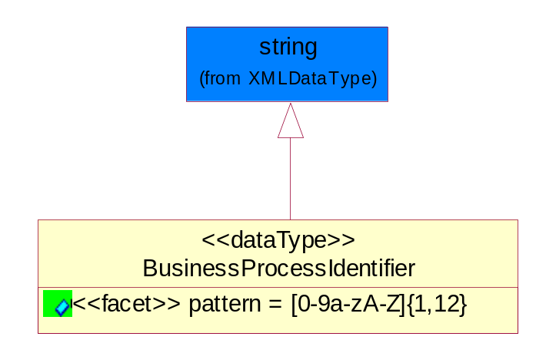
Figure ‎5-59 BusinessProcessIdentifier

Attribute | Type | Documentation
pattern |  | [0-9a-zA-Z]{1,12}

BusinessServiceInformation
The object allows the specification of the business service utilized within the partner company. This may or may not be the same as the information sent by the RNIF.
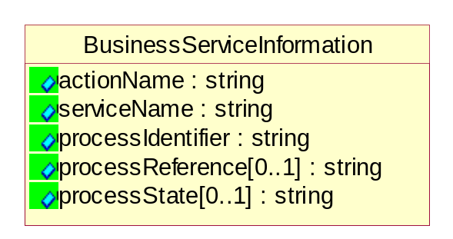
Figure ‎5-60 BusinessServiceInformation

Attribute | Type | Documentation
actionName | string | The name of Action. For RosettaNet usually any of Request/Confirm/Notify/Query/Response.
serviceName | string | The name of the Business Activity with the "Request/Confirm" part removed. E.g., for the Activity "Request Purchase Order"==> "Purchase Order".
processIdentifier | string | The name of the PIP e.g. Notify of Forecast Reply.
processReference[0..1] | string | The URN for the PIP that includes Cluster/Segment/Process pattern used to identify the interface process (such as PIP3A4)
processState[0..1] | string | The business process (or service) state of the sender of a document. When a service receives this document, the receiver may use the state as a precondition.

ContractInformation
A block of information used to correlate a contract in an executing choreography.

Figure ‎5-61 ContractInformation

Attribute | Type | Documentation
contractIdentifier[0..1] | string | Unique identification of a contract between the Sender and the Receiver
contractType[0..1] | string | The type of the contract: an attribute describing the type of the ContractIndentification. Valid values are URI, URN,ebXMLCPA, or other values defined by partners.

CorrelationInformation
A block of information used to correlate a requesting document to a responding document and to the contract in an executing choreography.
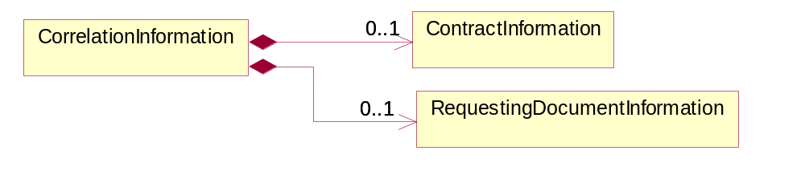
Figure ‎5-62 CorrelationInformation

Composition | Cardinality | Type | Documentation
ContractInformation | 0..1 | ContractInformation | A block of information used to correlate a contract in an executing choreography.
RequestingDocumentInformation | 0..1 | RequestingDocumentInformation | A block of information used to correlate a requesting document to a responding document in an executing choreography.

DocumentHeader
The object allows for the identification of the sender and receiver of the business document.
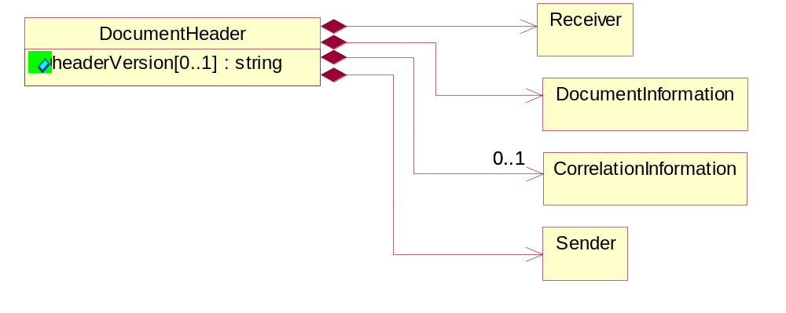
Figure ‎5-63 DocumentHeader

Attribute | Type | Documentation
headerVersion[0..1] | string | The UN/CEFACT version of the document header.

Composition | Cardinality | Type | Documentation
Sender | 1 | Sender | The object allows the identification of the initiating party of the business message.
CorrelationInformation | 0..1 | CorrelationInformation | A block of information used to correlate a requesting document to a responding document and to the contract in an executing choreography.
DocumentInformation | 1 | DocumentInformation | The object specifies information to identify the business document, a summary of attachments, and information about the business document security.
Receiver | 1 | Receiver | The object allows the identification of the receiving party of the business message.

DocumentIdentification
The object specifies all information necessary to identify the business document.
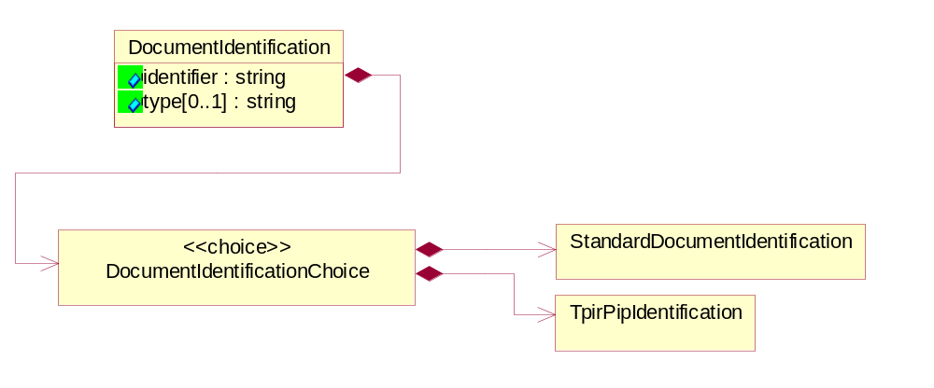
Figure ‎5-64 DocumentIdentification

Attribute | Type | Documentation
identifier | string | The unique identifier for the document being sent.
type[0..1] | string | Name of the Action Message

Composition | Cardinality | Type | Documentation
DocumentIdentificationChoice | 1 | DocumentIdentificationChoice

DocumentIdentificationChoice

Composition | Cardinality | Type | Documentation
StandardDocumentIdentification | 1 | StandardDocumentIdentification | The object specifies additional information necessary to identify the standard business document.
TpirPipIdentification | 1 | TpirPipIdentification | The object specifies all information necessary to uniquely identify a TPIR-PIP within a Registry or trading partner repository.

DocumentInformation
The object specifies information to identify the business document, a summary of attachments, and information about the business document security.
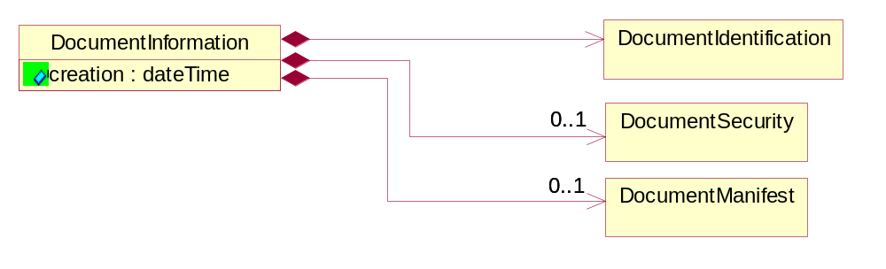
Figure ‎5-65 DocumentInformation

Attribute | Type | Documentation
creation | dateTime | The creation date and time of the specified Business Document (i.e. the Purchase Order date).

Composition | Cardinality | Type | Documentation
DocumentIdentification | 1 | DocumentIdentification | The object specifies all information necessary to identify the business document.
DocumentSecurity | 0..1 | DocumentSecurity | The object provides additional granularity in specifying business document security (this is in addition to the specified PIP security).
DocumentManifest | 0..1 | DocumentManifest | The block provides a brief summary of attachments and Service Content.

DocumentManifest
The block provides a brief summary of attachments and Service Content.
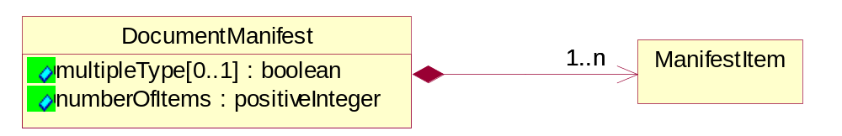
Figure ‎5-66 DocumentManifest

Attribute | Type | Documentation
multipleType[0..1] | boolean | Indicates whether the manifest contains documents of multiple types. True if yes, and False if no.
numberOfItems | positiveInteger | Total number of documents in the message. The physical count of the attachments in the payload plus the RosettaNet Business Message (for Service Content). The value of this field will be at least 1.

Composition | Cardinality | Type | Documentation
ManifestItem | 1..n | ManifestItem | The object provides details about the specific attachment(s).

DocumentSecurity
The object provides additional granularity in specifying business document security (this is in addition to the specified PIP security).

Figure ‎5-67 DocumentSecurity

Attribute | Type | Documentation
nonRepudiableReceipt | boolean | The value "true" will indicate that a signed acknowledgement for the business document is necessary.
persistentEncryption | boolean | The value "true" will indicate that the Business Document (including the header) needs to be encrypted when stored or transported.
persistentSignature | boolean | The value "true" will indicate that a signature is required to be stored with the document while stored or transported.

ManifestItem
The object provides details about the specific attachment(s).

Figure ‎5-68 ManifestItem

Attribute | Type | Documentation
description[0..1] | string | A description of the attachment.
length[0..1] | positiveInteger | The size of the attachment in bytes (i.e. 1 000 000 bytes)
universalResourceIdentifier | string | The generic set of all names/addresses that are short strings that refer to resources.

Composition | Cardinality | Type | Documentation
mimeTypeQualifier | 1 | MimeTypeQualifier | The MIME type as defined by IANA.  Please refer to http://www.iana.org/assignments/media-types/ for a list of types.
language | 0..1 | Language | For representation of Language name RosettaNet has adopted ISO 639-2; 1998. Refer to the following web page to get the latest version of the standard:  http://www.loc.gov/standards/iso639-2/iso639jac.html  If you need more information about the ISO standard please contact ISO for more details.

PipIdentifier
PIP Identification.[ i.e. PIP3A4]
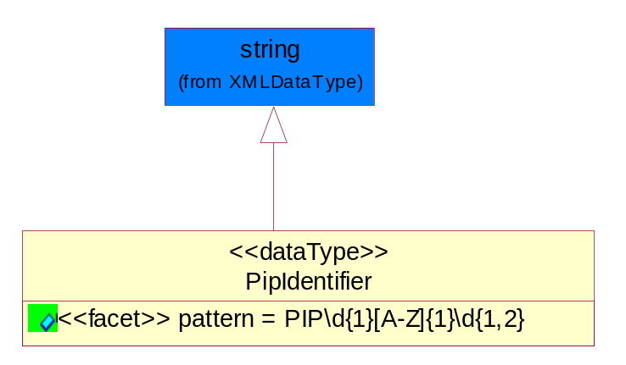
Figure ‎5-69 PipIdentifier

Attribute | Type | Documentation
pattern |  | PIP\d{1}[A-Z]{1}\d{1,2}

PipVersion
PIP version number (i.e. 02.02.00).
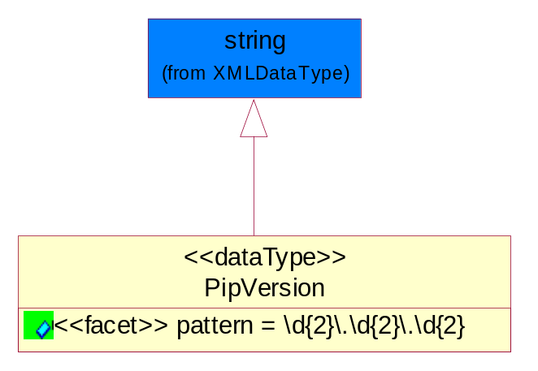
Figure ‎5-70 PipVersion

Attribute | Type | Documentation
pattern |  | \d{2}\.\d{2}\.\d{2}

Receiver
The object allows the identification of the receiving party of the business message.
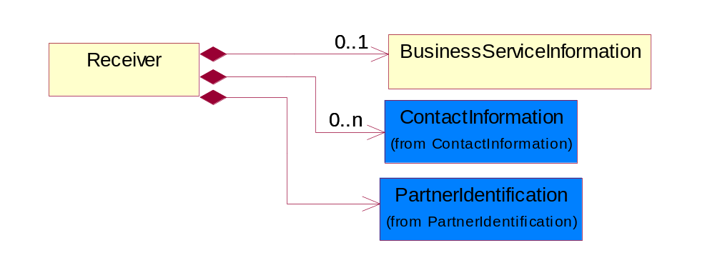
Figure ‎5-71 Receiver

Composition | Cardinality | Type | Documentation
BusinessServiceInformation | 0..1 | BusinessServiceInformation | The object allows the specification of the business service utilized within the partner company. This may or may not be the same as the information sent by the RNIF.
PartnerIdentification | 1 | PartnerIdentification | The business document must allow for the identity of one or more parties to the transaction.
ContactInformation | 0..n | ContactInformation | The business document must allow for the identification of the name of the department, service or individual to be contacted regarding the context of the business document.

RequestingDocumentInformation
A block of information used to correlate a requesting document to a responding document in an executing choreography.

Figure ‎5-72 RequestingDocumentInformation

Attribute | Type | Documentation
businessProcessInstanceIdentifier[0..1] | string | The identifier for the public business process instance being sent that both the sender and receiver can identify.
responseDateTime[0..1] | dateTime | The expected time to receive the response. This can not be greater than the PIP TimeToPerform.
requestingDocumentCreationDateTime[0..1] | dateTime | The date-time of the requesting business document.
requestingDocumentInstanceIdentifier | string | The Business Document identification number that identifies the requesting Business Document.

Sender
The object allows the identification of the initiating party of the business message.
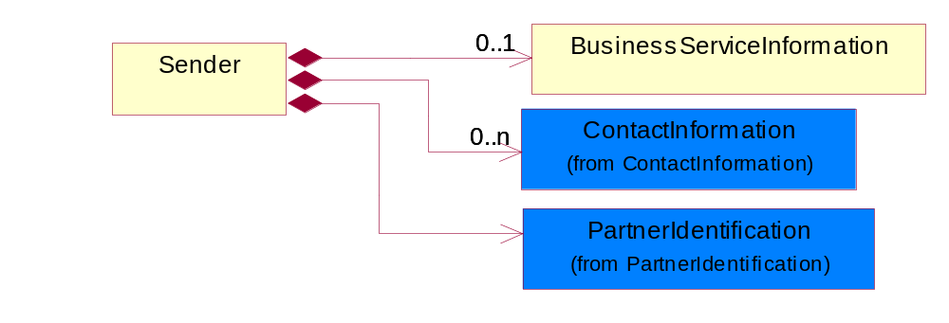
Figure ‎5-73 Sender

Composition | Cardinality | Type | Documentation
PartnerIdentification | 1 | PartnerIdentification | The business document must allow for the identity of one or more parties to the transaction.
BusinessServiceInformation | 0..1 | BusinessServiceInformation | The object allows the specification of the business service utilized within the partner company. This may or may not be the same as the information sent by the RNIF.
ContactInformation | 0..n | ContactInformation | The business document must allow for the identification of the name of the department, service or individual to be contacted regarding the context of the business document.

StandardDocumentIdentification
The object specifies additional information necessary to identify the standard business document.
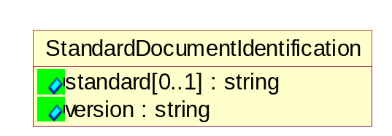
Figure ‎5-74 StandardDocumentIdentification

Attribute | Type | Documentation
standard[0..1] | string | Identifies the standard used to submit the business document. (e.g. RosettaNet).
version | string | PIP3A4v01.00

TpirPipIdentification
The object specifies all information necessary to uniquely identify a TPIR-PIP within a Registry or trading partner repository.

Figure ‎5-75 TpirPipIdentification

Attribute | Type | Documentation
partnerId | DUNSPlus4 | The Trading Partner Identification of MNC that is creating this TPIR PIP.
pipIdentifier | PipIdentifier | A TPIR PIP Identification [i.e., 3A4 ).
pipVersion | PipVersion | A TPIR PIP version number (i.e., 02.02.00)
tpirPipVersion | VersionIdentifier | A TPIR-PIP Version Number (i.e., major and minor version number as XX.XX).
tpirBusinessProcessIdentifier[0..1] | BusinessProcessIdentifier | A Business Process Identifier to uniquely define the TPIR-PIP 'role' within a Business Scenario at a company or MNC level. The identifier MUST be composed of alphanumeric characters only and its length MUST be between one and twelve characters.
uri[0..1] | anyURI | Describes the destination uri for the TPIR form.

Composition | Cardinality | Type | Documentation
fileType | 0..1 | TPIRFileType | Describes the file type of the TPIR form (PDF, XDP or XML).

VersionIdentifier
Version Number (i.e., major and minor version number as XX.XX).
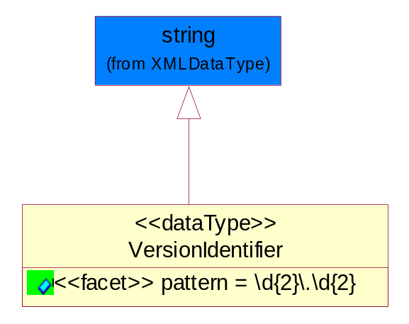
Figure ‎5-76 VersionIdentifier

Attribute | Type | Documentation
pattern |  | \d{2}\.\d{2}

CodeList

TPIRFileType
A code identifying the file type of TPIR form.

Name | Documentation
PDF | Portable Document Format.
XDP | XML Data Package.
XML | eXtensible Markup Language.

XML Data Type

anyURI
Represents a URI as defined by RFC 2396. An anyURI value can be absolute or relative, and may have an optional fragment identifier.

boolean
Represents Boolean values, which are either "true" or "false".

dateTime
Represents a specific instance of time.
The pattern for dateTime is CCYY-MM-DDThh:mm:ss where CC represents the century, YY the year, MM the month, and DD the day, preceded by an optional leading negative (-) character to indicate a negative number. If the negative character is omitted, positive (+) is assumed. The T is the date/time separator and hh, mm, and ss represent hour, minute, and second respectively. Additional digits can be used to increase the precision of fractional seconds if desired. For example, the format ss.ss... with any number of digits after the decimal point is supported. The fractional seconds part is optional.
This representation may be immediately followed by a "Z" to indicate Coordinated Universal Time (UTC) or to indicate the time zone. For example, the difference between the local time and Coordinated Universal Time, immediately followed by a sign, + or -, followed by the difference from UTC represented as hh:mm (minutes is required). If the time zone is included, both hours and minutes must be present.

decimal
A data type that contains decimal numbers scaled by a power of 10.

float
Represents single-precision 32-bit floating-point numbers.

integer
Represents a sequence of decimal digits with an optional leading sign (+ or -). This data type is derived from decimal.

positiveInteger
Represents an integer that is greater than zero. This data type is derived from nonNegativeInteger.

string
Represents character string.

