

Description of
Partner Interface Process® for 7C8

Validated 11.00.00

Specification Information
Name | Notify Of Semiconductor Process Data
Cluster | Manufacturing
Segment | Distribute Manufacturing Information
Publication Date | 31 October 2006
Version Identifier | V11.00

Table of Contents
1 Document Management 4
1.1 Legal Disclaimer 4
1.2 Copyright 4
1.3 Trademarks 4
1.4 Acknowledgments 4
1.5 Related Documents 5
1.6 Document Version History 5
1.7 Document Structure 5
2 Business Process 6
2.1 Business Process Definition 6
2.1.1 Executive Summary 6
2.1.2 Business Process Description 6
2.2 PIP Scope Description 6
2.2.1 Inline Process Data 6
2.2.2 Assembly Process Data 7
3 PIP Business Document 9
3.1 PIP Business Process Flow Diagram 9
3.2 PIP Start State 10
3.3 PIP End States 10
3.4 Partner Role Description 11
3.5 Business Process Activity Controls 11
4 Network and Implementation Specification 12
4.1 Business Action and Business Signal Specifications 12
4.2 Business Transaction Dialog Specification 12
4.2.1 Message Exchange Controls 13
4.2.2 Communications Specification 13

List of Figures:
Figure 1: Activity Diagram of Notify Of Semiconductor Process Data 9
Figure 2: Sequence Diagram of Notify Of Semiconductor Process Data 12

List of Tables:
Table 1: PIP Business Documents 9
Table 2: PIP Start State 10
Table 3: PIP End State 10
Table 4: PIP Failure State 10
Table 5: Partner Role Descriptions 11
Table 6: Business Activity Descriptions 11
Table 7: Business Activity Performance Controls 11
Table 8: Network Component Specification 12
Table 9: Business Action – Business Document Mapping 12
Table 10: Message Exchange Control 13
Table 11: Dialog: Service-Service 13

Document Management

Legal Disclaimer
RosettaNet™, its members, officers, directors, employees, or agents shall not be liable for any injury, loss, damages, financial or otherwise, arising from, related to, or caused by the use of this document or the specifications herein, as well as associated guidelines and schemas. The use of said specifications shall constitute your express consent to the foregoing exculpation.

Copyright
©2006 RosettaNet. All rights reserved. No part of this publication may be reproduced, stored in a retrieval system, or transmitted, in any form or by any means, electronic, mechanical, photocopying, recording, or otherwise, without the prior written permission of the publisher. Printed in the United States of America.

Trademarks
RosettaNet, Partner Interface Process, PIP and the RosettaNet logo are trademarks or registered trademarks of "RosettaNet," a non-profit organization. All other product names and company logos mentioned herein are the trademarks of their respective owners. In the best effort, all terms mentioned in this document that are known to be trademarks or registered trademarks have been appropriately recognized in the first occurrence of the term.

Acknowledgments
This document has been prepared by RosettaNet (http://www.rosettanet.org/) from requirements gathered during the Milestone Program and in conformance with the methodology. Listed below are the legal entities that contributed to the design and development of this PIP.
Amkor | Freescale Semiconductor
International Business Machines (IBM) | Qualcomm
Texas Instruments | Samsung
Syntricity | Skytide

Related Documents
- Associated PIP Message Schemas (included within the PIP Specification package only)
- Description of 7C8 Message
- Messages Structure
- XML instance of ebXML BPSS for PIP 7C8

Document Version History
Version | Date | Description
Validated 11.00.00 | 31 October 2006 | Validated Version

Document Structure
A Partner Interface Process (PIP) Specification is comprised of the following two parts:
- Business Process. Captures the semantics of the business process and the flow of the message exchange between roles as they perform business activities.
- Network and Implementation Specification. Specifies the network protocol message formats and communications requirements between peer-protocols supported by network components in the RosettaNet Implementation Framework.

Business Process

Business Process Definition
The Semiconductor In-Line Process Data Exchange process enables foundry and other inline process partners to deliver semiconductor process and assembly process data to customers and to other data consumers including chip designers. The purpose is to gain efficiencies by defining a common vocabulary and structure for the transmission of process and assembly data. This standard will help reduce design development time and improve product manufacturability by providing standardized data in a commonly understood manner.

Executive Summary
The Semiconductor In-Line Process Data Exchange process supports the sending of process and assembly result information to a trading partner for the following semiconductor processes:
Inline Process Data: Data is taken from a various stages of the semiconductor manufacturing process which may include measuring film thickness, overlay/alignment, and critical dimensions. The process data transferred between trading partners is contractually negotiated.

Assembly Yield Process Data: Data is taken during the assembly process (die, packages and cards) which includes yield data during optical inspections, singulation (e.g. wafer saw yield, punch yield), shear and pull data for wire bond and C4 processing on various package types, and final inspection yield. Incoming wafer lot id and assembly lot id information is associated. Assembly yield data transferred between the trading partners is contractually negotiated.

Business Process Description
Process data is used as a manufacturing monitor which is collected at various operational steps of the semiconductor manufacturing process. Not all data that is collected is passed onto the customer, only a negotiated sub-set. The analysis of this type of data can help the Wafer Manufacturer or the Test Services trading partner and the Customer independently or together drive to improve manufacturing steps, chip or package design and test methods. Sections 3.3.1 and 3.3.2 describe at a high-level the data collection and transfer process for in-line and assembly process data.

PIP Scope Description

Inline Process Data
- Wafers are fabricated at a Wafer Manufacturer.
- Inline process data is collected at various operations.
- A contractually negotiated sub-set of inline process data is delivered to the Customer.
- Data is transferred to the Customer via B2B.
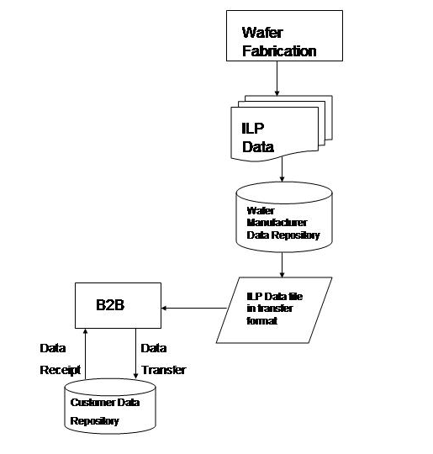

Assembly Process Data
- Wafer is shipped from Wafer Manufacturer to Test Services partner for assembly services.
- Customer provides Test Services partner with packaging specifications.
- Test Services partner prepares die from wafer for assembly into a package.
- Assembly process data may be transferred to the Customer via contractual agreement.
- Data is transferred to the Customer via B2B
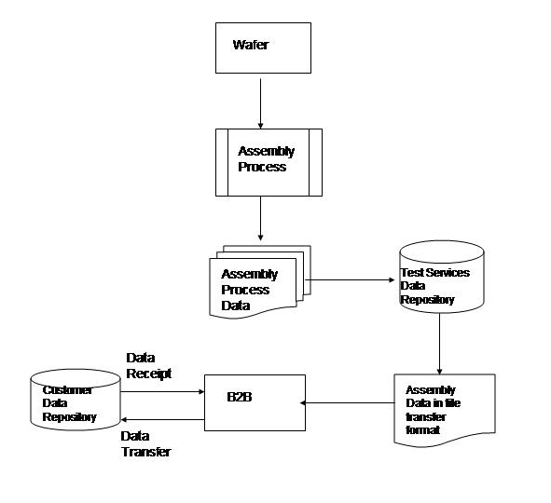

PIP Business Document
Business Document are generated and exchanged by roles performing activities in this PIP. Business Document is listed and defined in Table 1.
Table 1: PIP Business Documents
Business Document | Description
Semiconductor Process Data Notification | A Request to notify a semiconductor process data issuer for semiconductor process data.

PIP Business Process Flow Diagram
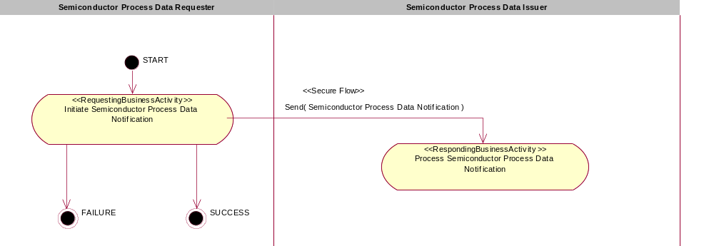

Figure 1: Activity Diagram of Notify Of Semiconductor Process Data

PIP Start State
The start state is comprised of the following conditions:
Table 2: PIP Start State
 | Approved | Exist |  | Valid | Non-Repudiated | Retry Count | Authorized
 | Approved | Party | In Backend system
TPA |  |  | 
Sending Partner |  |  |  | 
Receiving Partner |  | 
Business Document |  |  |  |  |  |  | 

PIP End States
The end state is comprised of the following conditions:
Table 3: PIP End State
 | Approved | Exist |  | Valid | Non-Repudiated | Retry Count | Authorized
 | Approved | Party | In Backend system
Acknowledgment of Receipt |  |  |  |  | 
Receiving Partner |  |  |  |  |  |  | 

The PIP failure state is comprised of one or more of the following conditions
Table 4: PIP Failure State
 | NO | Exceeded
Success | 
Retry Count |  | 

Partner Role Description
Table 5 describes the partner roles in this PIP:
Table 5: Partner Role Descriptions
Role Name | Role Description
Semiconductor Process Data Requester | A customer or chip designer who requests for semiconductor process and assembly process data from wafer manufacturer or test services trading partner.
Semiconductor Process Data Issuer | A wafer manufacturer or test service trading partner sends semiconductor process and assembly process data to customer or chip designer.

Business Process Activity Controls
Table 6 describes the interaction between roles performing business activity in this PIP.
Table 6: Business Activity Descriptions
Role  Name | Activity Name | Activity Description
Semiconductor Process Data Requester | Initiate Semiconductor Process Data Notification | The semiconductor process data requester send Semiconductor Process Data Notification to semiconductor process data issuer to address the request for semiconductor process data.

Table 7 details the security, audit and process controls relating to activity performed in the PIP.
Table 7: Business Activity Performance Controls
Role  Name | Activity  Name | Acknowledgment  of Receipt |  | Time to Perform | Retry Count | Is Authorization Required? | Non-Repudiation of Origin and Content?
Role  Name | Activity  Name | Non-Repudiation Required? | Time to Acknowledge
Semiconductor Process Data Requester | Initiate Semiconductor Process Data Notification | Y | 2hrs | N/A | 3 | Y | Y

Network and Implementation Specification
Each network component maps into a role of the PIP model. Table 8 specifies the mapping between roles and network components.
Table 8: Network Component Specification
Network Component | Classification | Maps to Role in Business Process
Semiconductor Process Data Requester Service | Business Service | Semiconductor Process Data Requester
Semiconductor Process Data Issuer Service | Business Service | Semiconductor Process Data Issuer

Business Action and Business Signal Specifications
Each business action maps to a Business Document of the PIP model. Table 9 specifies the mapping between Business Documents and business actions.
Table 9: Business Action – Business Document Mapping
Business Action | Business Document | Document Function
Semiconductor Process Data Notification Action | Semiconductor Process Data Notification | Request

Business Transaction Dialog Specification
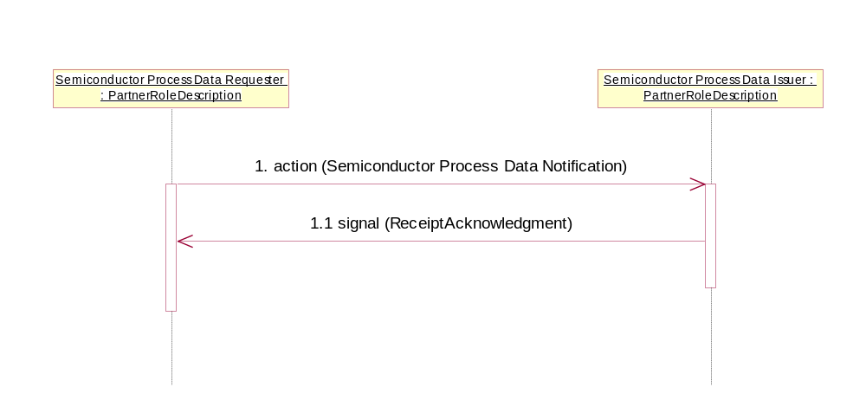

Figure 2: Sequence Diagram of Notify Of Semiconductor Process Data

Message Exchange Controls
Table 10: Message Exchange Control
# | Name |  | Time to Acknowledge Receipt Signal |  | Time to Respond to Action |  | Included in Time to Perform | Is Authorization Required? | Is Non-Repudiation Required? | Is Secure Transport Required?
1. |  | Semiconductor Process Data Notification Action |  | 2hrs |  | N/A | N/A | Y | Y | Y
1.1. |  | Receipt Acknowledgment |  | N/A |  | N/A | N/A | Y | Y | Y

Communications Specification
Table 11: Dialog: Service-Service
# | Business Message | Digital Signature Required? | SSL Required?
1. | Semiconductor Process Data Notification | N | Y
1.1. | Receipt Acknowledgment | N | Y

