**Titan Games & Hobbies: Magic the Gathering Database**

**Report 1**

Sam Bishop

Dieringer Scott

Michael Mason

Rashid Talib

**Table of Contents**

1. *Introduction*
   * Page 3
2. *Interviewee Signature*
   * Page 4
3. *Target Business*
   * Page 5
4. *Business Process*
   * Page 5
5. *User Requirements*
   * Page 6
6. *ERD & Schema*
   * Page 7
7. *Gantt Chart for Project Plan*
   * Page 8
8. *Meeting Log*
   * Page 8

**Introduction**

Titan Games and Hobbies needs an updated database to catalog their Magic the Gathering trading card inventory. A significant portion of their Magic the gathering sales is done by selling individual cards and they may have several thousand unique cards in their inventory at any given time. Some of these cards can cost hundreds of dollars so maintaining an accurate inventory is crucial. The database team will consist of Sam Bishop, Dieringer Scott, and Rashid Taleb. Brian Marx is the point of contact at Titan Games and Hobbies.

Brian Marx said the most important part of the project is designing the database to be user friendly and intuitive. Uploading trading cards to any sort of database is difficult because the cards collector number must be entered manually. Brian also wants to track the average purchase price and a record of cards bought for each customer.

Magic the Gathering is a card game based on the idea of two or more wizards battling using creatures, enchantments and sorcery. Creatures, enchantments, and sorcery are represented by cards of those types. The main goal of the games is to play with a deck that will defeat your opponents. Each player may compile a unique deck consisting of any grouping of cards which is why it is very important that each card is carefully catalogued by Titan Games and Hobbies.

The first phase of the project will be the database and GUI design. The design process will be handled as a group. A meeting will be scheduled to discuss the database design and a meeting will be scheduled to discuss the GUI design. Phase 2 will be in two parts. Rashid and Michael will write the MySQL code building the database and search queries. Sam and Dieringer will write the Java GUI and the code connecting the MySQL code to the interface. The last phase of the project will be writing the user manual and the marketing pamphlet. The pamphlet will be done as a team with each member getting a section. The manual for each part of the program will be written by the developer who wrote the code corresponding to it.

More information on each of the topics mentioned above is contained in the documents to follow. This is an especially exciting project for the team because all members grew up playing the game. In the next few weeks a working prototype will be created, and unit and integration testing will begin. The team is looking forward to working on this project.

**Interviewee Signature**

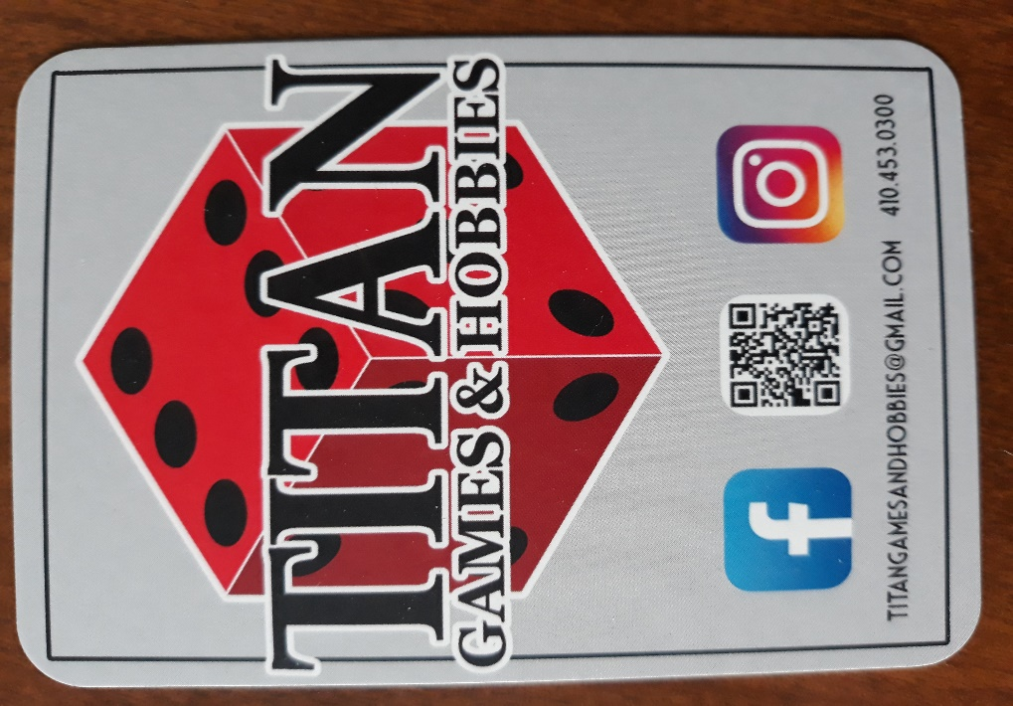

**Target Business**

Titan Games & Hobbies

Location: 1924-C, Greenspring Dr, Lutherville-Timonium, MD 21093

Business Description: A locally owned hobby shop with a single branch. The venue is targeted mostly towards the buying and selling of “Magic The Gathering” (MTG) products as well as the sale of “Warhammer” products. The store also sells board games and RPG products (such as DnD manuals) and runs events for MTG and Warhammer.

**Business Process**

The part of Titan that we are interested in aiding is the buying and selling of MTG “singles.” These are cards which have already been opened and are being traded on a value determined by the general MTG market.

Titan buys cards from players and posts them up for sale to other customers (priced against the market to turn a profit). This requires that all the cards be visible or at least that they are all logged. We are attempting to aid in the latter by developing a useable database for Titan.

This model (being a common one across the world) could benefit very well from such a system, so this is a great opportunity to aid other businesses as well.

**User Requirements**

User Requirements: Magic the Gathering Database

1. The database will store the following information about each card:
   1. Name
   2. Color
   3. Type
   4. Foil or Not Foil
   5. Set
   6. Release Date
   7. Condition
   8. Quantity
   9. Sub Class of Creatures
   10. Sub Class of Planeswalkers
   11. Miscellaneous Sub Class: any card that is not a Creature or Planeswalker
2. Database will store the following customer information:
   1. Name
   2. Email
   3. Phone Number
   4. Average purchase
   5. List of all cards purchased
   6. Loyalty Points
3. Users will be able to search for cards by set.
4. Users will be able to search for cards by color.
5. Users will be able to search for cards by type.
6. Users will be able to search for cards by mana cost.
7. Users will be able to search for cards by name.
8. Users will be able to search for cards by power.
9. Users will be able to search for cards by toughness.
10. Users will be able to search for customers by name.
11. Users will be able to search for customers by email.
12. Users will be able to search for customers by phone number.

Cards will be listed by name in alphabetical order when searched for.

**ERD & Schema**

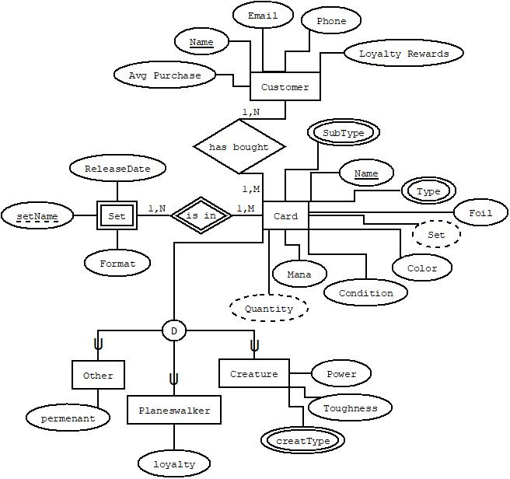

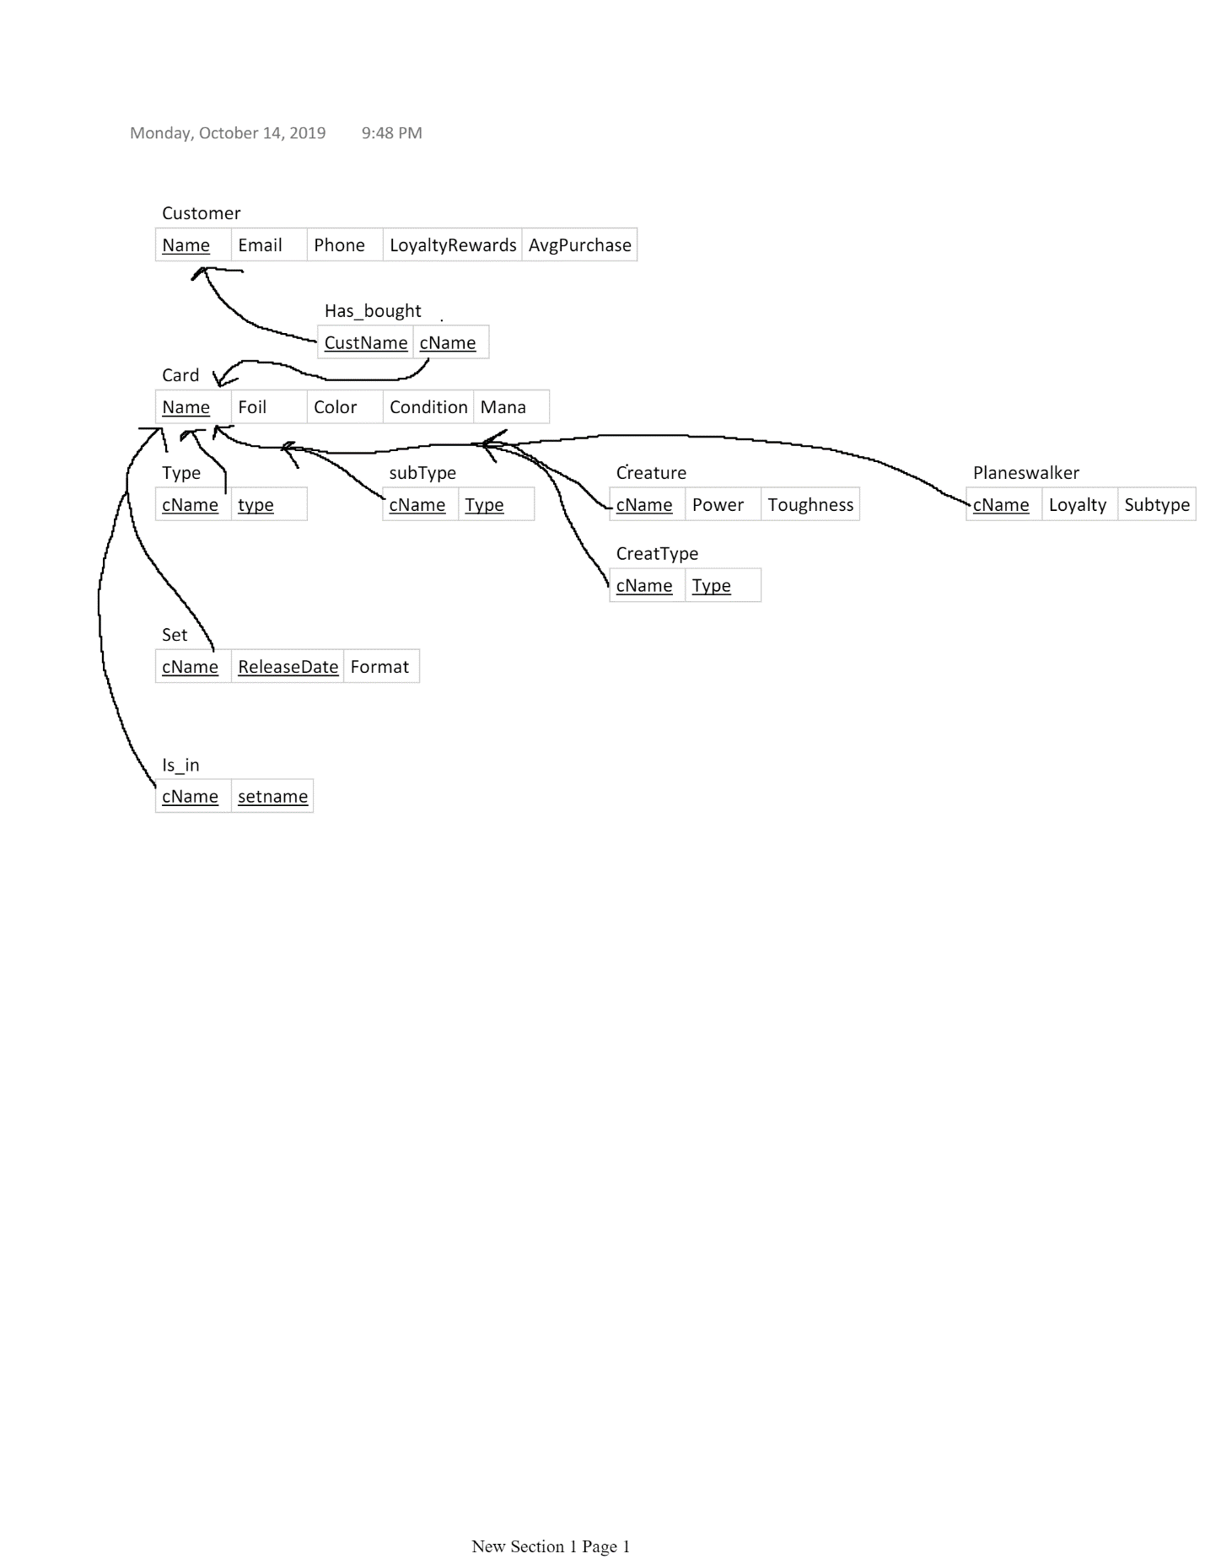

**Gantt Chart for Project Plan**

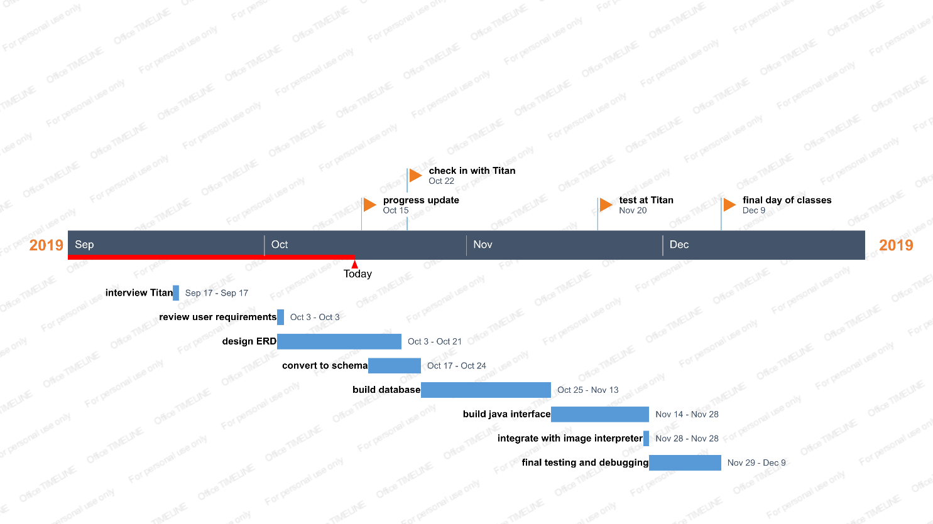

**Meeting Log**