Predicting Classical Composers from MIDI Data Using Deep Learning

Christina Sadiq, Jackson Kenyon, Dylan Scott-Dawkins
AAI-510: Neural Networks and Deep Learning
University of San Diego
Bilgenur Baloglu
August 10, 2026
Team 5

Introduction
Classical composers are often identifiable by consistent patterns in melody, harmony, and rhythm, even to listeners without formal music training. This project uses deep learning to predict the composer of a piece of classical music from its MIDI file, restricted to four composers: Bach, Beethoven, Chopin, and Mozart. Two model architectures are compared, a Long Short-Term Memory network trained on note sequences and a Convolutional Neural Network trained on piano-roll images, with the goal of evaluating which representation is better suited to the task.
Before either model can be trained, the raw dataset has to be reduced to the composers of interest and converted into a form a neural network can consume. This section documents that work: filtering the source dataset down to the four target composers, parsing MIDI files into note sequences for the LSTM, converting MIDI files into piano-roll matrices for the CNN, and building the train, validation, and test splits, including the augmentation used to reduce class imbalance in the training set. This pipeline produced the inputs that both models were trained on.

Data Preprocessing and Feature Extraction

Dataset and Filtering
The project used the MIDI Classic Music dataset from Kaggle (Blanderbuss, n.d.), which contains MIDI files organized by composer across 136 folders and roughly 145 MB uncompressed. Per project requirements, only four composers were retained: Bach, Beethoven, Chopin, and Mozart. A filtering script (filter_dataset.py) walked each of the four composer folders recursively, since several folders contain nested subfolders, and copied every .mid file into a standardized directory structure (data/raw/<composer>/) with cleaned filenames. Spaces, apostrophes, and other characters that complicate file handling on Windows were stripped from filenames, and duplicate names were disambiguated with a numeric suffix. A small number of Beethoven files were distributed as .zip archives rather than plain .mid files; the script unzips these in place before collecting files. A manifest file (manifest.csv), built with pandas (McKinney, 2010), records the composer, cleaned filename, and original source path for every file, so any file can be traced back to its origin in the raw download.
Filtering produced 1,637 MIDI files: 1,024 Bach, 220 Beethoven, 136 Chopin, and 257 Mozart. The class distribution is heavily imbalanced, with Bach accounting for roughly 63% of the dataset and Chopin under 10%. This imbalance was addressed later through training-set augmentation rather than through changes to the raw data.

MIDI Parsing for the LSTM Model
pretty_midi parsed each filtered MIDI file into a note sequence. Notes from every non-drum track were pooled and sorted by start time, giving one chronological sequence per piece instead of one per voice. Each note kept four values: pitch, duration, velocity, and offset (time since the previous note, zero for the first). We cached these arrays per piece as compressed .npz files so later runs skip re-parsing.
Sequence length ranged from about 80 notes to over 40,000, since note density varies by composer and by piece. We left that alone at parsing and pushed padding and truncation to the model stage. Two of the 1,637 files failed to parse (corrupted key-signature metadata) and were dropped, leaving 1,635 usable files.

Piano-Roll Conversion for the CNN Model
For the CNN track, each MIDI file was converted into a piano-roll matrix, a pitch-by-time grid where each cell holds the velocity of a note active at that time step. pretty_midi's built-in piano-roll function was used with a sampling rate of 4 time steps per second. Higher rates (10 and 100 steps per second) were tested first but produced excessively large files, since some pieces run over 20 minutes; 4 steps per second kept file sizes manageable without discarding information that a piano-roll image would meaningfully use. The pitch axis was trimmed from the full 128-value MIDI range down to 21 through 108, the range of an 88-key piano, since the remaining values are silent for essentially all pieces in the dataset. Values were stored as 8-bit unsigned integers rather than floating point, cutting file size by a factor of four, since MIDI velocity already fits within a 0 to 127 range.
The same two files that failed MIDI parsing for the LSTM track failed here as well, for the same underlying reason, confirming the files themselves were corrupted rather than pipeline-specific. This left 1,635 usable piano-roll files, with the pitch axis fixed at 88 rows across every file and the time axis varying by piece length. The full set of piano-roll files totals approximately 134 MB.

Train, Validation, and Test Split with Augmentation
A single split was built and used by both the LSTM and CNN tracks, so that results from the two models would be directly comparable. Files were split 70% train, 15% validation, and 15% test, stratified by composer so each split preserved the overall class proportions. The split was performed on the intersection of files that had been successfully processed by both the LSTM and CNN pipelines, 1,635 files in total, producing 1,144 training files, 245 validation files, and 246 test files.
Because Bach outnumbers Chopin by roughly 7.5 to 1 in the raw data, pitch-shift augmentation was applied to the training set to reduce this imbalance before training. Each note's pitch was shifted by a fixed number of semitones; for the LSTM representation this meant adding an offset to the pitch array, and for the piano-roll representation it meant shifting rows up or down with zero-fill at the edges. Shift amounts were chosen per composer based on how much each one needed: no shifting for Bach, shifts of -1 and +1 semitones for Beethoven and Mozart, and shifts of -2, -1, +1, and +2 semitones for Chopin, which had the smallest starting count. This brought the training set from 717/153/95/179 (Bach/Beethoven/Chopin/Mozart) to 717/459/475/537, narrowing the gap between the smallest and largest classes substantially without fully equalizing them. Augmentation was applied only to the training set; the validation and test sets were left untouched and kept their original, imbalanced composer distribution, since evaluating on an artificially rebalanced set would not reflect the distribution the model would face in practice.
A later review of the split, conducted by a teammate during model development, found that the random file-level split allowed movements or sections of the same multi-movement work to land in different splits, for example one movement of a symphony in the training set and another movement of the same symphony in the test set. This creates a risk of the model learning to recognize a specific work rather than a composer's general style. An estimated 14 to 16% of validation and test rows shared a work with a training file. A work-grouped alternative split was built separately to address this, without modifying the original split described above, so that both sets of results remain reproducible and comparable.

Model Architecture and Training (LSTM)
The LSTM takes two input streams. Pitch goes through an embedding layer (128 vocabulary, 16 dimensions, padding masked) instead of a raw float, since a composer's harmonic language sits in the intervals between pitches, not their absolute height. Duration, velocity, and offset feed in as continuous values, concatenated with the pitch embedding at every timestep. Each sequence is capped at the first 500 note events, zero-padded and masked when shorter. That combined sequence runs through a 128-unit LSTM (full sequences returned), 0.3 dropout, a 64-unit LSTM, another 0.3 dropout, then a 4-class softmax. We trained with sparse categorical cross-entropy and Adam at lr=0.0005, clipping gradients at 1.0 after an early run diverged mid-training. Class weights came from the unaugmented counts: augmentation already rebalances the classes, so weighting on top would double-correct. Single-split training ran up to 100 epochs with early stopping (patience 12) and LR reduction on a validation-loss plateau; cross-validation folds used a tighter 60-epoch budget.
On the original file-level split, the LSTM hit 48.8% accuracy (macro precision 51.2%, macro recall 32.3%) against a 62.6% always-Bach baseline. Since the leakage review found 14-16% of validation/test rows shared a work with a training file, we re-ran the LSTM on the work-grouped split: 5-fold cross-validation plus a holdout set no fold ever trains on. Cross-validation accuracy came to 55.4% (SD 6.2%), macro F1 40.9% (SD 6.2%), folds ranging 47.5% to 63.0%; the final holdout scored 45.3% accuracy and 42.6% macro F1 against a 62.4% baseline. Figure 1 (matplotlib; Hunter, 2007) shows the single-split training curves; Figure 2 and Table 1 show the holdout confusion matrix and per-class breakdown.
The LSTM does not beat the majority-class baseline on either split. The per-class results show why: Bach precision is 0.91 but recall only 0.42, meaning the model is usually right when it predicts Bach but fails to predict Bach for most true Bach pieces, with the dominant error being 76 of 146 Bach holdout files misclassified as Mozart (Figure 2). The model is also not converged: three of the five cross-validation folds hit the 60-epoch cap while validation accuracy was still improving, so the architecture's ceiling has not yet been measured. Full training histories, per-fold metrics, and the defect log from model development are in the accompanying project notebooks (05_lstm_model.ipynb and 08_cross_validation.ipynb).
Table 1
LSTM Per-Class Results on the Work-Grouped Holdout Set
Composer | Precision | Recall | F1 | n
Bach | .91 | .42 | .57 | 146
Beethoven | .26 | .19 | .22 | 32
Chopin | .50 | .68 | .58 | 19
Mozart | .22 | .70 | .34 | 37

Figure 1
LSTM Training and Validation Curves (Single Split)
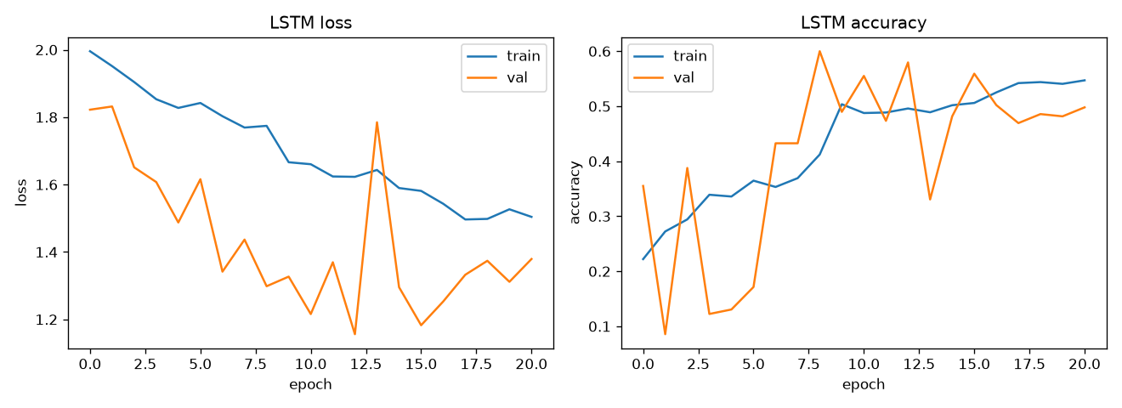
Figure 2
LSTM Confusion Matrix on the Work-Grouped Holdout Set
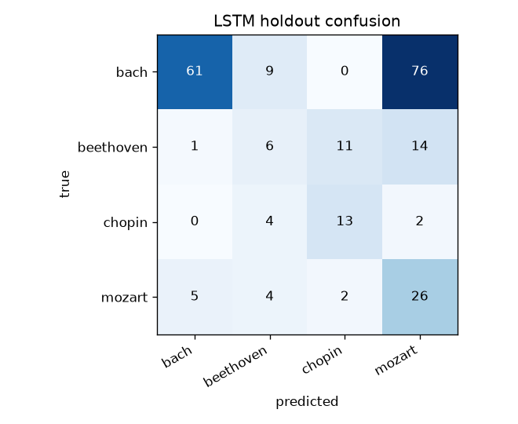

Model Architecture and Training (CNN)
For the convolutional neural network (CNN) model, we sought to exploit the two-dimensional structure of the piano-roll representation by allowing the network to analyze musical information across both pitch and time. This representation allows the CNN model to process the musical data as a two-dimensional structure, similar to image processing with a CNN model.
The CNN model architecture consisted of four convolutional blocks. Each block contained a convolutional layer, batch normalization, a ReLU activation function, and a max-pooling layer. The number of convolutional filters increased progressively from 16 to 32, 64, and finally 128 filters across the four blocks. This progression allowed the earlier layers to identify relatively local patterns while the deeper layers could combine those features into increasingly complex representations of the music.
The first convolutional layer used 16 filters with a kernel size of (12, 1). Because the first dimension corresponds to pitch and the second corresponds to time, this kernel examines 12 adjacent pitch values at a single time position. This allows the model to identify local vertical relationships between pitches, which can capture characteristics such as simultaneous notes, intervals, and portions of chord structures. The use was intended to allow the network to identify harmonic and vertical relationships within the piano roll representation.
The second convolutional layer used 32 filters with a (1, 16) kernel. In contrast to the first layer, this kernel operates primarily across the time dimension while holding the pitch position constant. At the four-step-per-second sampling rate, 16-time positions correspond to approximately four seconds of music. This allows the model to identify patterns in note activity like rhythmic structures.
The third and fourth convolutional layers used standard (3, 3) kernels. The kernels allow the network to combine the extracted pitch and time features from the first two layers across both dimensions simultaneously. With 64 filters in the third layer and 128 filters in the fourth layer, the deeper layers can learn increasingly complex combinations of pitch and time patterns, potentially understanding higher level characteristics such as chord movement, rhythm and harmony, and recurring musical structure. Each convolutional layer was followed by batch normalization, a ReLU activation function, and max pooling. The pooling operations progressively reduced the spatial dimensions of the feature maps while retaining the strongest features.
After the fourth convolutional block, the resulting feature maps were flattened into a one-dimensional tensor. The flattened representation was then passed to a fully connected layer containing 256 neurons. This layer was followed by batch normalization, ReLU activation, and a dropout layer. Finally, a second fully connected layer reduced the representation to four output values corresponding to the four composer classes: Bach, Beethoven, Chopin, and Mozart. The final layer produced the probabilities used to determine the predicted composer.
For model training, cross-entropy loss was used as the classification criterion. Because the dataset contained substantially more Bach compositions than compositions from the other three composers, class weighting was incorporated into the loss function to reduce the influence of this imbalance. This was intended to prevent the model from achieving high overall accuracy simply by favoring the majority Bach class. The model was implemented in TensorFlow (TensorFlow Developers, n.d.) and trained using the Adam optimizer with an initial learning rate of 0.001. An early-stopping procedure was also implemented.
The initial CNN was trained for a max of 30 epochs and achieved a training accuracy of 84.59% and a validation accuracy of 88.16%. When evaluated on the previously unseen test data, the model achieved an accuracy of 85.37%. Although these results demonstrated that the model could successfully distinguish between the four composers, the performance indicated that additional optimization could improve the model.
To improve the model, the Optuna hyperparameter optimization library (Optuna Developers, n.d.) was used. An optimization objective was established to maximize validation accuracy by searching for more effective learning rate and dropout rate values. Twenty optimization trials were conducted, with each trial training and evaluating a model using a different combination of the selected hyperparameters. The optimal parameters were relatively close to the original settings, suggesting that the initial architecture and training configuration were already reasonable. However, the optimized parameters produced a meaningful improvement when evaluated on the test data, increasing accuracy to 92.28%.
The optimized model's classification report, generated with scikit-learn (Pedregosa et al., 2011), is presented in Table 1. The model performed particularly well on Bach, achieving a precision of 0.97, recall of 0.98, and an F1-score of 0.98. Chopin also achieved strong performance, with an F1-score of 0.92. Beethoven and Mozart were more difficult for the model to distinguish, with F1-scores of 0.77 and 0.82, respectively. These results indicate that the model was generally effective at identifying the composers but had greater difficulty with composers whose musical characteristics share similarities. We can gain additional insights into the difficulty the model had with certain composers when looking at the confusion matrix in Figure 3.
Table 2
CNN Per-Class Results against Test Data
 | Precision | Recall | F1-Score | Support
Bach | 0.97 | 0.98 | 0.98 | 154
Beethoven | 0.70 | 0.85 | 0.77 | 33
Chopin | 0.95 | 0.90 | 0.92 | 20
Mozart | 0.91 | 0.74 | 0.82 | 39
Accuracy |  |  | 0.92 | 246
Macro Avg | 0.88 | 0.87 | 0.87 | 246
Weighted Avg | 0.92 | 0.92 | 0.92 | 246

Figure 3
CNN Confusion Matrix on the Test Dataset
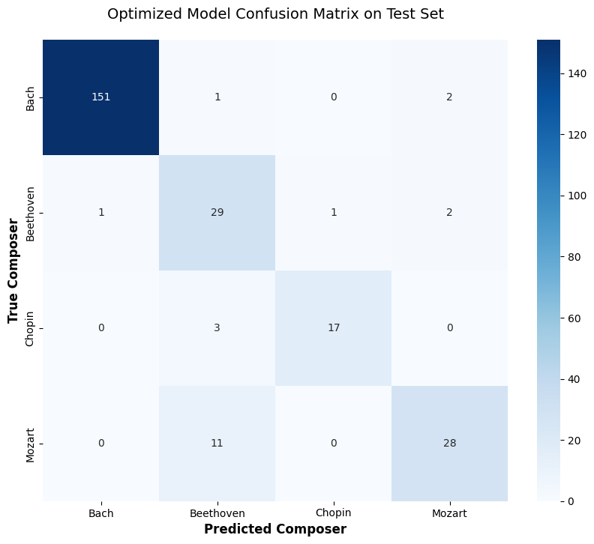

Model Comparison
The CNN and LSTM models produced substantially different results when classifying compositions by composer, with the CNN achieving stronger performance against our evaluation metrics. The optimized CNN achieved an overall accuracy of 92% with F1-scores of .98 for Bach, 0.77 for Beethoven, 0.92 for Chopin, and 0.82 for Mozart. In comparison, the LSTM performed worse, especially with Beethoven and Mozart, with F1-scores of 0.22 and 0.34 respectively. These results suggest that the CNN was better suited for the representation and characteristics of the dataset.
An important consideration in the comparison of the models is the distinct methods that the data was represented for each model. The CNN model received the compositions as two-dimensional spatial piano roll representations. Time acts as one dimension and pitch is the other. However, the LSTM model received the compositions as sequential representations of midi events, with pitch represented through an embedding and duration, velocity, and offset provided as continuous features. This focuses on the relationships between events over time, but simultaneous notes and their vertical harmonic relationships are less represented than the piano roll representation.
The differences in composer errors provide additional evidence for the importance of these representations. In the CNN, the largest errors involved Bach being classified as Beethoven or Mozart and Mozart being classified as Beethoven. These errors suggest that even the CNN had difficulty distinguishing composers whose musical characteristics overlap. The LSTM exhibited, however, considerably more severe confusion among these composers. The most prominent errors were Bach being classified as Mozart, Beethoven being classified as Mozart, and Beethoven being classified as Chopin. The LSTM’s Mozart results were informative: Mozart had a recall of 0.7 but a precision of only 0.22. This indicates the model was guessing Mozart significantly more often than it is represented in the dataset.
The difference in the Bach results also illustrates the advantage of the piano roll representation of sheet music. The LSTM had recall of 0.42 for Bach, while the CNN had a recall of 0.98. Bach’s compositions frequently contain multiple independent melodic lines occurring simultaneously (Abdi et al., 2020). These relationships are better suited for the piano roll data representation because multiple voices appear as vertically and horizontally organized note patterns. The CNN model can then identify the structure of these overlapping voices directly. When the same data is represented as a sequence of midi events, the model must guess these relationships from each event. This makes identifying Bach’s structural style difficult to recognize, leading to underperformance.
The confusion between Mozart and Beethoven is present in both models. This similarity is musically meaningful because both composers share characteristics and Beethoven’s early work was strongly influenced by Mozart (Gee, 2022). When presented as the two-dimensional piano roll images, their compositions share similar structures, leading to the CNN model occasionally classifying Mozart pieces as Beethoven. Moreover, due to the linear sequence of midi events for the LSTM model the higher-level relationships that separate the two composers are lost, leading to the model guessing Mozart when the true piece is Beethoven.
Overall, the results suggest that the performance of the CNN model was due to the combination of input representation and architecture, rather than the CNN architecture alone. The CNN model was able to build relationships between pitch, time, and notes directly within its convolutional filters by exploiting the two-dimensional spatial structure of the piano rolls. The LSTM model provided a different representation that emphasized sequences, but this representation appears to have obscured harmonic and structural relationships that were important for classification of composers. Therefore, while the application of LSTMs can be effective for modeling sequential musical information, the results indicate that the two-dimensional piano roll representation and convolutional neural network combination was a more effective approach for identifying the style and characteristics of each composer.

Conclusion
This project evaluated the ability of two deep learning models, Long-Short Term Memory (LSTM) and Convolutional Neural Networks (CNN), in identifying four Classical composers from the MIDI classic music dataset from Kaggle. The two models represented two different approaches for processing the music. The results of the models demonstrated that the approach had a significant impact on the performance of classification of the four composers. The CNN model utilized the approach of processing the music as a two-dimensional piano roll of pitch and time while the LSTM utilized the approach of processing the music as a sequential series of MIDI events.
Looking at the results of each model, the CNN model outperformed the LSTM model. The CNN model was able to achieve a 92.28% test accuracy compared with the 45.3% accuracy on the work-grouped LSTM evaluation. The CNN model performed well with Bach and Chopin, while struggling with Beethoven and Mozart. The LSTM model also struggled with Beethoven and Mozart and frequently classified Bach and Beethoven pieces as Mozart. These results suggest that the spatial relationship between time and pitch in the two-dimensional piano roll approach provided the CNN model with more useful information in classifying composers.
Future work could improve the comparison by training both models on the same work-grouped data split and further optimizing the LSTM model architecture. Additional approaches could include representations that preserve simultaneous notes, different piano roll resolutions and segment lengths, and testing other architectures. These improvements could help determine the stronger approach of data representation and/ or the stronger model architecture.

AI Disclosure
Generative AI tools (including Claude and ChatGPT) were used extensively throughout the drafting and revision of this report to help align the writing, formatting, and reported results with the outputs of our analysis notebook. AI-assisted scripts and tools were also used to repeatedly re-check tedious, repetitive tasks such as formatting consistency, citation/reference formatting, and numbering. All analysis, modeling, and conclusions remain the work and responsibility of the team.

References
Abdi, H., et al. (2020). Bach, Mozart, and Beethoven: Sorting piano excerpts based on perceived similarity using DiSTATIS.
Blanderbuss. (n.d.). MIDI classic music [Data set]. Kaggle. https://www.kaggle.com/datasets/blanderbuss/midi-classic-music
Gee, H. (2022, May 3). Mozart vs. Beethoven vs. Bach: How are they different? Orchestra Central. https://orchestracentral.com/mozart-vs-beethoven-vs-bach/
Hunter, J. D. (2007). Matplotlib: A 2D graphics environment. Computing in Science & Engineering, 9(3), 90–95. https://doi.org/10.1109/MCSE.2007.55
McKinney, W. (2010). Data structures for statistical computing in Python. In Proceedings of the 9th Python in Science Conference (pp. 56–61).
Optuna Developers. (n.d.). Optuna: A hyperparameter optimization framework [Computer software]. https://optuna.org/
Pedregosa, F., Varoquaux, G., Gramfort, A., Michel, V., Thirion, B., Grisel, O., Blondel, M., Prettenhofer, P., Weiss, R., Dubourg, V., Vanderplas, J., Passos, A., Cournapeau, D., Brucher, M., Perrot, M., & Duchesnay, E. (2011). Scikit-learn: Machine learning in Python. Journal of Machine Learning Research, 12, 2825–2830.
Raffel, C., & Ellis, D. P. W. (2014). Intuitive analysis, creation and manipulation of MIDI data with pretty_midi. In Proceedings of the 15th International Society for Music Information Retrieval Conference: Late-Breaking and Demo Papers.

