Predicting Classical Composers from MIDI Data Using Deep Learning

Christina Sadiq, Jackson Kenyon, Dylan Scott-Dawkins
AAI-510: Neuronal Networks and Deep Learning
University of San Diego
Team 5

Introduction
Classical composers are often identifiable by consistent patterns in melody, harmony, and rhythm, even to listeners without formal music training. This project uses deep learning to predict the composer of a piece of classical music from its MIDI file, restricted to four composers: Bach, Beethoven, Chopin, and Mozart. Two model architectures are compared, a Long Short-Term Memory network trained on note sequences and a Convolutional Neural Network trained on piano-roll images, with the goal of evaluating which representation is better suited to the task.
Before either model can be trained, the raw dataset has to be reduced to the composers of interest and converted into a form a neural network can consume. This section documents that work: filtering the source dataset down to the four target composers, parsing MIDI files into note sequences for the LSTM, converting MIDI files into piano-roll matrices for the CNN, and building the train, validation, and test splits, including the augmentation used to reduce class imbalance in the training set. This pipeline produced the inputs that both models were trained on.

Data Preprocessing and Feature Extraction

Dataset and Filtering
The project used the MIDI Classic Music dataset from Kaggle (Blanderbuss, n.d.), which contains MIDI files organized by composer across 136 folders and roughly 145 MB uncompressed. Per project requirements, only four composers were retained: Bach, Beethoven, Chopin, and Mozart. A filtering script (filter_dataset.py) walked each of the four composer folders recursively, since several folders contain nested subfolders, and copied every .mid file into a standardized directory structure (data/raw/<composer>/) with cleaned filenames. Spaces, apostrophes, and other characters that complicate file handling on Windows were stripped from filenames, and duplicate names were disambiguated with a numeric suffix. A small number of Beethoven files were distributed as .zip archives rather than plain .mid files; the script unzips these in place before collecting files. A manifest file (manifest.csv) records the composer, cleaned filename, and original source path for every file, so any file can be traced back to its origin in the raw download.
Filtering produced 1,637 MIDI files: 1,024 Bach, 220 Beethoven, 136 Chopin, and 257 Mozart. The class distribution is heavily imbalanced, with Bach accounting for roughly 63% of the dataset and Chopin under 10%. This imbalance was addressed later through training-set augmentation rather than through changes to the raw data.

MIDI Parsing for the LSTM Model
Each filtered MIDI file was parsed into a sequence of notes using the pretty_midi library. For every file, notes from all non-drum instrument tracks were pooled and sorted by start time, producing a single chronological sequence per piece rather than separate sequences per voice. Four arrays were extracted per note: pitch (MIDI note number), duration (note end time minus start time), velocity, and offset (time elapsed since the previous note's start, with the first note assigned an offset of zero). These four arrays were saved per piece as a compressed .npz file, avoiding the need to re-parse MIDI files on every subsequent run.
Sequence length varied widely across the dataset, from roughly 80 notes to over 40,000, since piece length and note density differ substantially by composer and by piece. This variation was left unresolved at the parsing stage and flagged as a requirement for the model-building step, which would need to apply padding or truncation to produce fixed-length model inputs. Two of the 1,637 files failed to parse due to corrupted key-signature metadata and were excluded, leaving 1,635 usable files for the LSTM pipeline.

Piano-Roll Conversion for the CNN Model
For the CNN track, each MIDI file was converted into a piano-roll matrix, a pitch-by-time grid where each cell holds the velocity of a note active at that time step. pretty_midi's built-in piano-roll function was used with a sampling rate of 4 time steps per second. Higher rates (10 and 100 steps per second) were tested first but produced excessively large files, since some pieces run over 20 minutes; 4 steps per second kept file sizes manageable without discarding information that a piano-roll image would meaningfully use. The pitch axis was trimmed from the full 128-value MIDI range down to 21 through 108, the range of an 88-key piano, since the remaining values are silent for essentially all pieces in the dataset. Values were stored as 8-bit unsigned integers rather than floating point, cutting file size by a factor of four, since MIDI velocity already fits within a 0 to 127 range.
The same two files that failed MIDI parsing for the LSTM track failed here as well, for the same underlying reason, confirming the files themselves were corrupted rather than pipeline-specific. This left 1,635 usable piano-roll files, with the pitch axis fixed at 88 rows across every file and the time axis varying by piece length. The full set of piano-roll files totals approximately 134 MB.

Train, Validation, and Test Split with Augmentation
A single split was built and used by both the LSTM and CNN tracks, so that results from the two models would be directly comparable. Files were split 70% train, 15% validation, and 15% test, stratified by composer so each split preserved the overall class proportions. The split was performed on the intersection of files that had been successfully processed by both the LSTM and CNN pipelines, 1,635 files in total, producing 1,144 training files, 245 validation files, and 246 test files.
Because Bach outnumbers Chopin by roughly 7.5 to 1 in the raw data, pitch-shift augmentation was applied to the training set to reduce this imbalance before training. Each note's pitch was shifted by a fixed number of semitones; for the LSTM representation this meant adding an offset to the pitch array, and for the piano-roll representation it meant shifting rows up or down with zero-fill at the edges. Shift amounts were chosen per composer based on how much each one needed: no shifting for Bach, shifts of -1 and +1 semitones for Beethoven and Mozart, and shifts of -2, -1, +1, and +2 semitones for Chopin, which had the smallest starting count. This brought the training set from 717/153/95/179 (Bach/Beethoven/Chopin/Mozart) to 717/459/475/537, narrowing the gap between the smallest and largest classes substantially without fully equalizing them. Augmentation was applied only to the training set; the validation and test sets were left untouched and kept their original, imbalanced composer distribution, since evaluating on an artificially rebalanced set would not reflect the distribution the model would face in practice.
A later review of the split, conducted by a teammate during model development, found that the random file-level split allowed movements or sections of the same multi-movement work to land in different splits, for example one movement of a symphony in the training set and another movement of the same symphony in the test set. This creates a risk of the model learning to recognize a specific work rather than a composer's general style. An estimated 14 to 16% of validation and test rows shared a work with a training file. A work-grouped alternative split was built separately to address this, without modifying the original split described above, so that both sets of results remain reproducible and comparable.

Model Architecture and Training (LSTM)
Our LSTM model takes two inputs. Pitch is fed through an embedding layer (128 vocabulary, 16 dimensions, with masking on the padding value) rather than scaled as a floating-point magnitude, since a composer's harmonic language lives in the intervals between pitch classes rather than in absolute pitch height. Duration, velocity, and offset are fed as continuous features and concatenated with the pitch embedding at every timestep. Each input sequence is the first 500 note events of a piece, zero-padded and masked where shorter. The concatenated sequence passes through a 128-unit LSTM layer returning full sequences, dropout of 0.3, a second 64-unit LSTM layer, dropout of 0.3, and a final 4-class softmax output. We trained with sparse categorical cross-entropy loss and the Adam optimizer at a learning rate of 0.0005 with gradient-norm clipping at 1.0, which became necessary after an early version diverged partway through training. Class weights were computed from the unaugmented training counts, since the pitch-shift augmentation described above already rebalances the class ratio and weighting on top of it would double-correct. Single-split training ran for up to 100 epochs with early stopping on validation accuracy (patience 12) and learning-rate reduction on a validation-loss plateau; the cross-validation folds described below used a shorter 60-epoch budget per fold.
On the original file-level split, the LSTM reached 48.8% accuracy, with macro precision of 51.2% and macro recall of 32.3%, against a majority-class (always-Bach) baseline of 62.6%. Because the work-leakage review above found that 14-16% of validation and test rows shared a work with a training file, we re-evaluated the LSTM on the work-grouped split using 5-fold cross-validation plus a held-out test set that no training fold ever touches. Cross-validation accuracy was 55.4% (SD 6.2%) with macro F1 of 40.9% (SD 6.2%) across folds ranging from 47.5% to 63.0%, and the final holdout evaluation scored 45.3% accuracy and 42.6% macro F1 against a 62.4% majority-class baseline on that split. Figure 1 shows the single-split training curves; Figure 2 and Table 1 show the holdout confusion matrix and per-class results.
The LSTM does not beat the majority-class baseline on either split. The per-class results show why: Bach precision is 0.91 but recall only 0.42, meaning the model is usually right when it predicts Bach but fails to predict Bach for most true Bach pieces, with the dominant error being 76 of 146 Bach holdout files misclassified as Mozart (Figure 2). The model is also not converged: three of the five cross-validation folds hit the 60-epoch cap while validation accuracy was still improving, so the architecture's ceiling has not yet been measured. Full training histories, per-fold metrics, and the defect log from model development are in the accompanying project notebooks (05_lstm_model.ipynb and 08_cross_validation.ipynb).
Table 1
LSTM Per-Class Results on the Work-Grouped Holdout Set
Composer | Precision | Recall | F1 | n
Bach | .91 | .42 | .57 | 146
Beethoven | .26 | .19 | .22 | 32
Chopin | .50 | .68 | .58 | 19
Mozart | .22 | .70 | .34 | 37

Figure 1
LSTM Training and Validation Curves (Single Split)
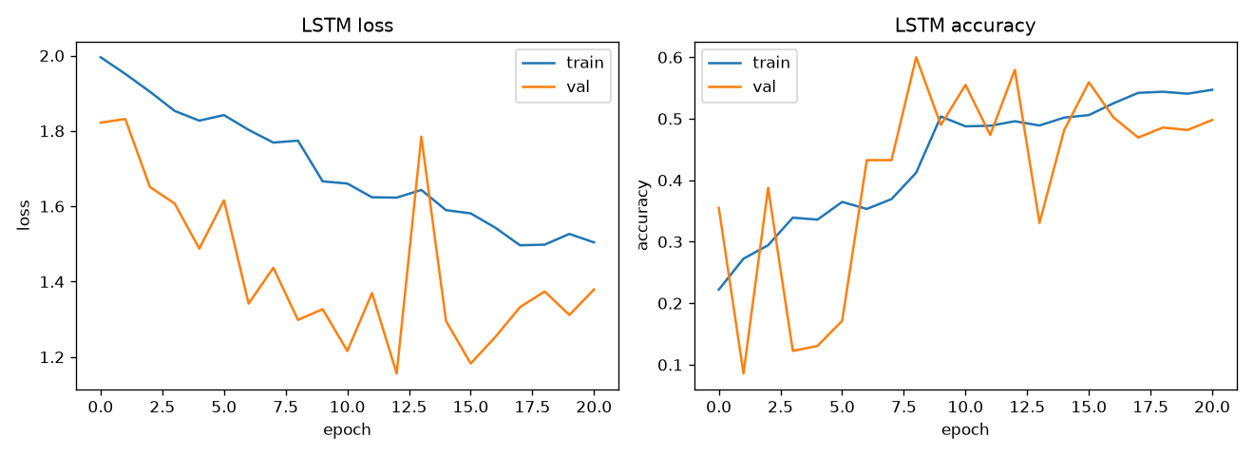
Figure 2
LSTM Confusion Matrix on the Work-Grouped Holdout Set
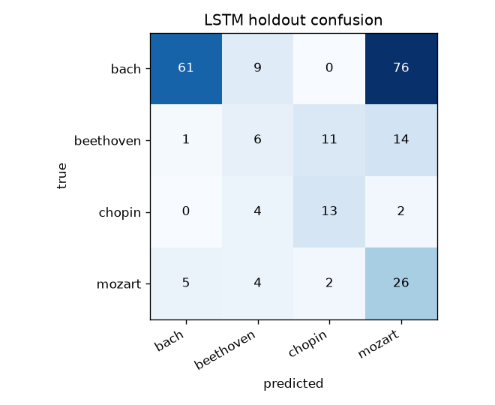

Model Architecture and Training (CNN)
In designing and building our Convolutional Neural Network (CNN) model, we specifically wanted to focus on processing our music tensors through time and notes to build the strongest model possible. First, in defining our architecture, we used 4 different groups of convolutional, batch normalization, ReLU, and pooling layers in our feature engineering portion of the model. After the 4 groups, we flatten to a single dimensional layer. Then we apply a linear transformation to the new one dimensional tensor, add a batch normalization layer after that and finally one more linear transformation layer to lead to the output of 4 classes.
For our criterion, we used Cross Entropy Loss to measure the loss, while also using a weighted class tensor to account for the overwhelming number of Bach pieces compared to the rest. For our optimization function, we used the Adam optimizer with a learning rate of 0.001 and a model parameter object that will pass in optimized hyperparameters we will cover later. The model was trained using 15 epochs and evaluated the model against our validation set to generate an training accuracy of 83.26% and validation accuracy of 82.86%.

Model Comparison
[Unassigned: compare LSTM and CNN results and discuss which representation performed better and why.]

Conclusion
[Team: summarize the project, highlight key findings across both models, and suggest future improvements once all sections are complete.]
Here is optimized CNN model for reference:
Classification Report (Optimized Model on Test Set):

precision recall f1-score support

Bach 0.97 0.88 0.93 154
Beethoven 0.67 0.55 0.60 33
Chopin 0.70 0.95 0.81 20
Mozart 0.56 0.74 0.64 39

accuracy 0.82 246
macro avg 0.72 0.78 0.74 246
weighted avg 0.84 0.82 0.83 246

References
Blanderbuss. (n.d.). MIDI classic music [Data set]. Kaggle. https://www.kaggle.com/datasets/blanderbuss/midi-classic-music
Raffel, C., & Ellis, D. P. W. (2014). Intuitive analysis, creation and manipulation of MIDI data with pretty_midi. In Proceedings of the 15th International Society for Music Information Retrieval Conference, Late Breaking and Demo Papers.
McKinney, W. (2010). Data structures for statistical computing in Python. In Proceedings of the 9th Python in Science Conference (pp. 56-61).
Pedregosa, F., Varoquaux, G., Gramfort, A., Michel, V., Thirion, B., Grisel, O., Blondel, M., Prettenhofer, P., Weiss, R., Dubourg, V., Vanderplas, J., Passos, A., Cournapeau, D., Brucher, M., Perrot, M., & Duchesnay, E. (2011). Scikit-learn: Machine learning in Python. Journal of Machine Learning Research, 12, 2825-2830.

