**Terrestrial Regional Ecosystem Exchange Simulator (TREES)**

**WORKSHOP – MODULE 1 – GETTING STARTED**

**Instructors:** Scott Mackay ([dsmackay@buffalo.edu](mailto:dsmackay@buffalo.edu))

Mitchell Hitchcock ([mchitchc@buffalo.edu](mailto:mchitchc@buffalo.edu))

**Date:** January 5, 2021

**Time:** 2.5 Hour session

**Location:** On Zoom

**MODULE 1: PART I. Review TREES, theory, inputs and outputs**

Described in trees_documentation.pdf and TREES-inputs&outputs-2020.xlsx

1. input driver file
2. input parameter file
3. ‘param_mod’ parameter file
4. main simulation output file (.sim extension)
5. hydraulic outputs (.hyd extension)
6. leaf sub-model output file (.leaf extension)

**MODULE 1: PART II. Setting up your machine to run TREES**

The following are needed for the hands-on portion of this workshop:

1. trees3 executable – must be compiled from source. From main workshop folder, enter into the terminal:

cd Model-Code

make trees3

1. R
2. Rstudio

**MODULE 1: PART III. Running TREES with fixed parameters: An example with *Brassica rapa***

***Description of experiment:*** This exercise comes from a study on *Brassica rapa* that developed a new growth module based on the emergence and expansion of individual leaves (Wang *et al.*, 2019). We will be running simulation on the Chinese Cabbage (CC) under well-watered conditions for both low and high initial microbiome treatments.

***Running TREES:*** We will now review the files found in the Examples/Brassica folder and run simulations for both treatments.

1. Check that parameter and driver files are located where you expect
2. From the main workshop folder, enter into the terminal:

cd Examples/Brassica

1. Run TREES by typing into terminal:

../../Model-Code/trees3 < in_cc_ww.txt

1. Repeat step 3 using in_cc_lowN.txt instead of in_cc_ww.txt

***Plotting results:*** Now that both simulations have been run, we will have a look at our results. We will first plot half-hourly output from the model, and then we will run a script to aggregate the data to a daily time step. This is useful for presenting results from simulations over long time series. Open the script Plot_TREES_results.R and follow the instructions to load scripts and load calls to create plots for Brassica. The plots are in Graphics/ccLeaf.pdf (see **Figure 1**).

Open the script Aggregate_to_daily.R and follow the instructions for Chinese cabbage. Go back to Plot_TREES_results.R and load lines to plot daily CC values. Results are in Graphics/cc.pdf (see **Figure 2**).

|  |  |
| --- | --- |
|  |  |
| **Figure 1.** Dark and light colors respectively represent high and low microbiome (or high and low nitrogen). Tan represents fine roots. C:N is carbon-to-nitrogen ratio. SLA is specific leaf area. | **Figure 2.** Leaf (green) and fine root (tan) carbon, with the dashed line representing total fine root carbon, for the high microbiome simulation. GPP is gross primary production. The blue line is transpiration and red line is critical transpiration. |

***Short discussion:*** Think about the following questions and we will discuss the answers as a group.

1. Leaf growth – What could cause the third leaf of cc_ww (dark lines) to be larger than the first two leaves? What could cause the decline in the size of the fourth leaf? Why do the cc_lowN leaves decline in size with time?
2. C:N and SLA – What effect does having low nitrogen have on C:N and SLA?

**MODULE 1: PART IV. Running TREES with variable parameters: Piñon pine groundwater access**

***Description of experiment:*** This exercise comes from a study on *Pinus edulis* growing on a hydrologic refugia near Los Alamos, New Mexico (Mackay *et al.*, 2020). All trees survived in a region of widespread pinon mortality because they had roots that accessed groundwater from within bedrock fractures. Here we will use one year of this study, parameterized for control (ambient conditions), both with and without groundwater access. To modify the structure of the root system we are using two hydraulic module parameter files, pine_mod for the simulation with bedrock roots, and pine_mod_noGW for the simulation with roots only in the soil layers.

***Running TREES:*** We will now review the files found in the Examples/Pinon folder and run simulations for ambient and ambient with no groundwater access.

1. Check that parameter and driver files are located where you expect
2. In your terminal, set your working directory to the Pinon folder
3. Run TREES for the three treatments as follows:
   1. ../../Model-Code/trees3 < in1r
   2. ../../Model-Code/trees3 < in2r

***Plotting results:*** Use Aggregate_to_Daily.R in Rstudio to create daily output files for both Pinon simulations, and then create Pinon plots using Plot_TREES_results.R. Open the pinon2.pdf (**Figure 3**).

|  |
| --- |
|  |
| **Figure 3.** Non-structural carbon (NSC; green=leaf, dark tan = stem, light tan = roots), leaf water potential, and percent loss of hydraulic conductance (PLC). Solid lines are trees with bedrock groundwater access, and the dashed lines are trees lacking bedrock water access. Refilling was allowed on days 209 and 257. |

***Short discussion:*** Think about the following questions and we will discuss the answers together as a group.

1. Leaf water potential plots – What happens to predawn and midday water potential when bedrock groundwater access is removed?
2. PLC and NSC – Are these trees more likely to die from hydraulic issues or lack of carbon?

**MODULE 1: PART V. Running TREES with variable parameters: Comparing Maize lines**

***Description of experiment:*** For this exercise we will simulate three nested association lines (NAM) of maize, using data from Colorado. The lines differ in vulnerability to cavitation and photosynthesis parameters. B73 has a comparatively lower maximum Rubisco carboxylation rate, *V*cmax, higher PEP carboxylation rate, *V*pmax, and high vulnerability to cavitation, MO18W has high *V*cmax, high *V*pmax, and low vulnerability to cavitation, and CML103 has high *V*cmax, low *V*pmax, and high vulnerability to cavitation. Nighttime refilling of xylem occurs due to positive pressure in the roots if soil water potential is higher than -0.3 MPa. Refilling of the canopy is halted on the date of expansion of the 8th leaf (V8, day 182) to simulate the effect of a maturing canopy no longer dominated by expanding new leaves.

***Running TREES:*** We will now review the files found in the Examples/Maize folder and run simulations for ambient and ambient with no groundwater access.

1. Check that parameter and driver files are located where you expect
2. In your terminal, set your working directory to the Maize folder
3. Run TREES for the three treatments as follows:
   1. ../../Model-Code/trees3 < inB73
   2. ../../ Model-Code/trees3 < inMO18W
   3. ../../ Model-Code/trees3 < inCML103

***Plotting results:*** Use Aggregate_to_Daily.R in Rstudio to create daily output files for both Maize simulations, and then create Maize plots using Plot_TREES_results.R. Open the graphics file, B73&MO18W&CML103.pdf (**Figure 4**).

|  |
| --- |
|  |
| **Figure 4**. Leaf and fine root carbon (open circles are observed), gross primary production, and transpiration (blue) and critical transpiration (red). |

***Short discussion:*** Think about the following question and we will discuss the answer together as a group.

What evidence is there that leaf carbon dynamics may be more limited by hydraulics than by photosynthetic rate?

**PART VI. Wrap-up**

Thank you for attending the first module of our TREES hands-on workshop! If you are interested in a deeper understanding of TREES, come back for the second module where we will learn how to prepare data for input to the model, as well as more sophisticated integration of TREES with R.

**Terrestrial Regional Ecosystem Exchange Simulator (TREES)**

**WORKSHOP – MODULE 2 – WORKING WITH DATA**

**Instructors:** Scott Mackay ([dsmackay@buffalo.edu](mailto:dsmackay@buffalo.edu))

Mitchell Hitchcock ([mchitchc@buffalo.edu](mailto:mchitchc@buffalo.edu))

**Date:** January 6, 2021

**Time:** 2.5 Hour session

**Location:** On Zoom

**MODULE 2: PART I. Constructing a TREES Driver File**

The following are needed for the hands-on portion of this workshop:

1. trees3 executable – must be compiled from source
2. R
3. Rstudio
4. Familiarity with the structure of the TREES input files (see trees_documentation.pdf).

***Description of Experiment.*** The purpose of this part of the workshop is to learn how to construct a TREES driver file from a text file containing micrometeorological data. To illustrate this process we will work our way through the R script, create_driver_file.R, which contains instructions for reading a particular meteorological file and converting it into a format that is readable by the model. The script must be tailored to the data provided, which may come with different column headings and variables in different units. The R code must be modified to read the column headings of your data, and unit conversions must be included.

***Running TREES:*** We will now review the files found in the Examples/Maize folder and run simulations for ambient and ambient with no groundwater access.

1. Check that the new driver file, treesMet.txt, is located where you expect
2. In your terminal, set your working directory to the Maize folder
3. Run TREES for the three treatments as follows:
   1. ../../ Model-Code/trees3 < inTest

***Short Discussion:*** TREES should run to completion using the new driver file and the MO18W.p parameter file. You will notice that leaf area fails to get to 1.0. The reason for this is that we are using the meteorological inputs without added irrigation events, which are included in the LIRFcorn_2013_grow_irrigated.txt driver.

An easy way to view the results is to modify R scripts, Aggregate_to_Daily.R and Plot_TREES_Results.R to produce a daily file for the test.sim output and plot the results, respectively.

**MODULE 2: Part II. Running TREES using easyR_TREES and plotting results**

***Description of experiment:*** This exercise will start with an example we have previously used to introduce us to a fast way to run multiple simulations of TREES with varying parameter values. To do this we will use easyR_TREES which is a collection of functions to run TREES from R and to make common graphs from the results. The examples being used are the previously seen Chinese Cabbage and a new example using Wisconsin Fast Plant from a, currently unpublished, study comparing soil microbial treatments(Brock 2018 personal communications).

***Running easyR_TREES:*** Open up easyR_TREES.R in RStudio and set your working directory to the folder you downloaded from github. TIP: use ctrl/cmnd + enter to run lines in Rtudio. Run_easrR_TREES() is the main function to run TREES simulations.

1. Run the two lines that source the functions we will need. If your working directory is correct this should work. If any packages are missing they should automatically be installed here.
2. Look over the first Run_easyR_TREES() function and read the comments for each argument.
3. You should not need to change anything for this example except the N_cores argument. Make N_cores the number of cores you wish to use to run TREES simulations in parallel. (No more than 1-total number of cores)
4. Run this line and you should start seeing the TREES cout in the console.

***Plotting results:*** The next function in the script is Leaf_Area_Plot() this script will plot the leaf areas for each leaf of each plant, under each new value, and for each driver specified. In this case it was only one driver so only one figure will be produced. Immediately after this function is one called Sim_Plot(). This function will plot any output specified from the .sim file generated by TREES.

1. Run Leaf_Area_Plot(). All except the last three arguments should match what was in Run_easyR_TREES(). The figures will be in the easyR_TREES/Outputs/Figures folder. Open and make sure they resemble figure A below.
2. Run Sim_Plot(). This is similar to Leaf_Area_Plot() except you have to specify a column from the .sim file to plot. Check the output matched figure B below and then try plotting a different sim output. See TREES-inputs&outputs-2020.xlsx for some ideas of what you can plot.
3. Change the Which_Sim argument in Sim_Plot() from LAI to PlantNstat and then to waterStress and RLA. You should have 5 graphs total.

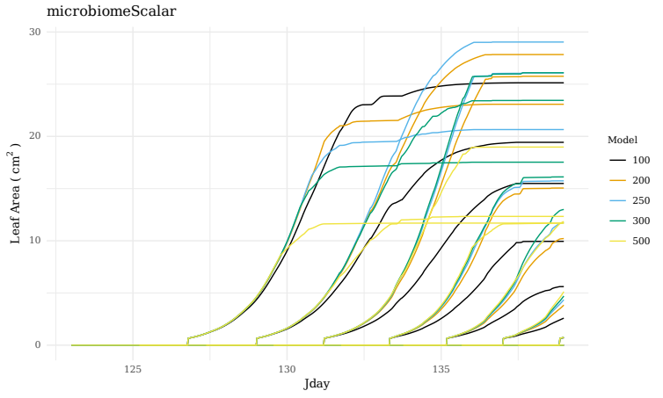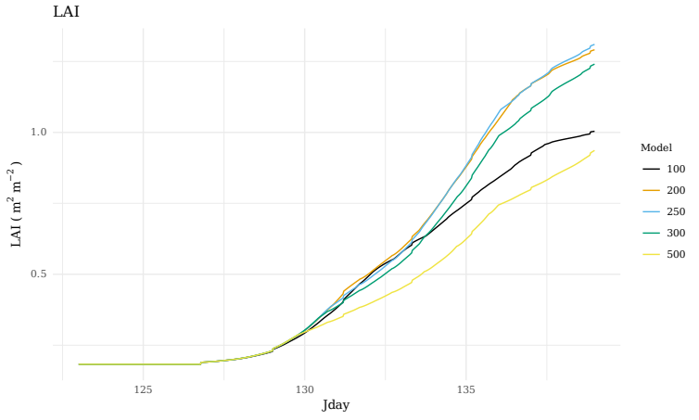

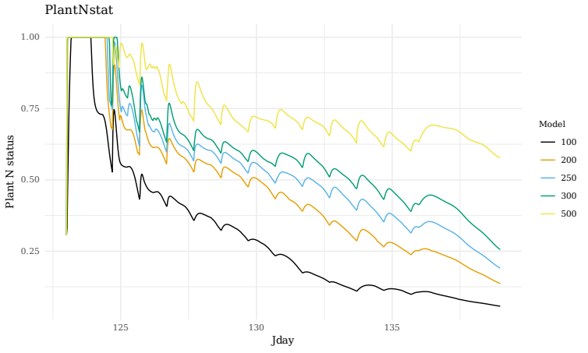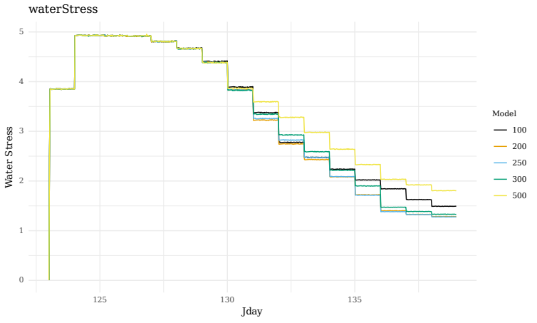

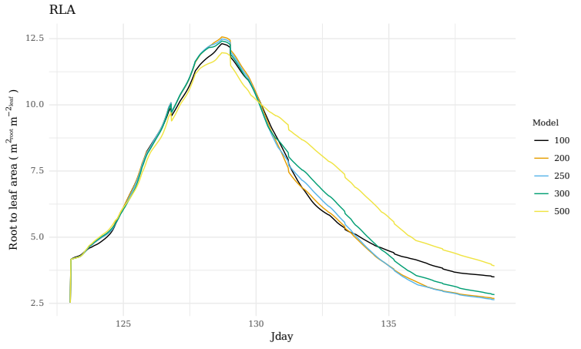

**Figure 5:** waterStress and PlantNstat are unitless and all other units are indicated in the y-axis.

***Short discussion:*** Think about the following questions and we will discuss the answers together as a group.

1. Looking at the leaf area and LAI plots what kind of response does the model show to an increasing microbiome scalar?
2. Looking at the other diagnostic plots; why might this be?

***Running with multiple drivers:***Fast plant data was generated from 6 different blocks which resulted in 6 slightly different driver files. easyR_TREES can take in multiple driver files and run the parameter file with any new values over each of them. To do this a vector of the driver names (without extensions or paths) is passed to the Drivers argument.

***Plotting results with and without experimental data:***The experimental data this model is based on comes from a low microbial biomass so we will again adjust the microbiomeScalar but this time we will compare it to actual experimental data.

1. Run Leaf_Area_Plot like we did before and you will get one plot for each driver.
2. Now lets read in some experimental data and look at how it should be formatted by running the lines starting with Exp_data and ending with head(Exp_data)
3. Now we can plot with the experimental data and see which setting best fits the data.

***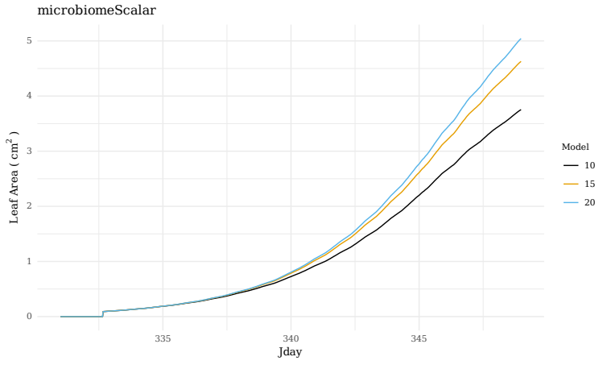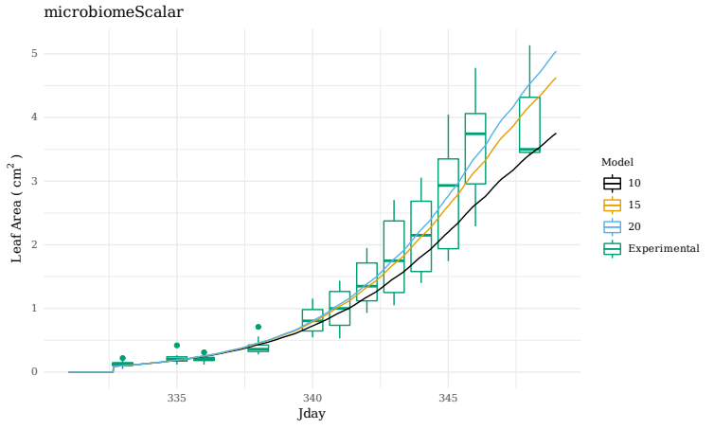*Figure 6:** Left shows the model results only and right shows the results with experimental data in the form of boxplots. These are from only one of the drivers and note that running the same function again without changing the title may result in overwriting the figures.

***Short discussion:*** Think about the following question and we will discuss the answers together as a group.

1. Even across a range of microbiome scalars there appears to be more variation than stochasticity in this parameter could account for. What other potentially stochastic parameters could be cause this?

***Running with gamma on:*** The leaf growth parameters are a potential source of stochastic parameters so we can explore those by turning on the gamma leaf growth module. Note the number of iterations will be very unrealistic due to limitations of time. A realistic situation would call for running thousands of simulations to generate a distribution of results. Double check the N_cores is set appropriately for your computer and run the Run_easyR_TREES line. Notice Use_Gamma is TRUE and Itter is a vector of 1 through 5.

***Plotting results:*** The plotting functions are already designed to handle Gamma being on so running the plotting functions with Use_Gamma as TRUE will generate a plot of your distribution of results.

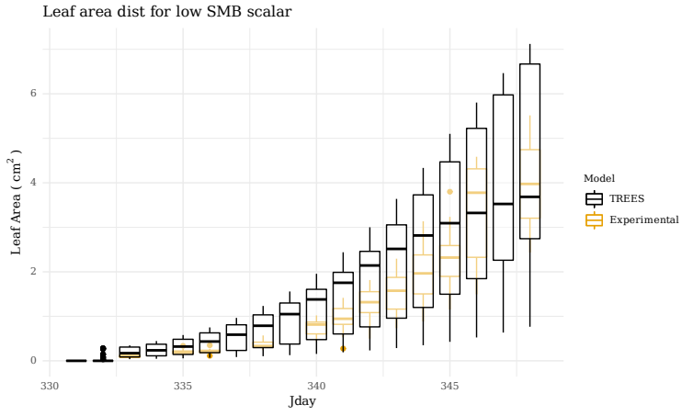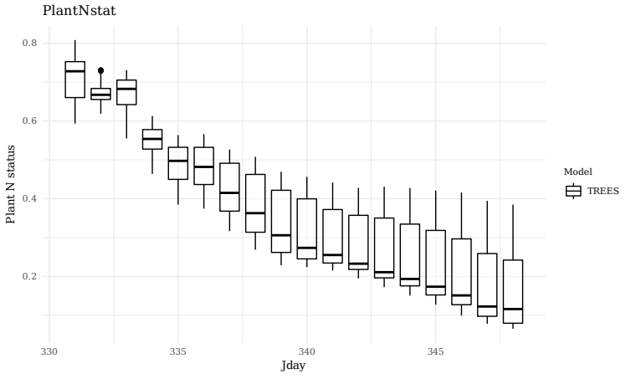

**Figure 3:** Left shows the distribution of leaf area and right shows the distribution for Plant N status for 5 iterations of TREES with the stochastic leaf module on.

***Short discussion:*** Think about the following question and we will discuss the answers together as a group.

1. What other potentially stochastic parameters do you think could be driving the variation seen experimentally?
2. How would you track or constrain these parameters experimentally?

**References**

Mackay, D.S., P.R. Savoy, C. Grossiord, X. Tai, J.R. Pleban, D.R. Wang, N.G. McDowell, H.D. Adams, and J.S. Sperry. 2020. Conifers depend on established roots during drought: results from a coupled model of carbon allocation and hydraulics. *New Phytologist*, 225(2), 679-692, doi:  
10.1111/nph.16043.

Wang, D.R., C.R. Guadagno, X. Mao, D.S. Mackay, J.R. Pleban, R.L. Baker, C. Weinig, J.-L. Jannink, and B.E. Ewers. 2019. A framework for genomics-informed ecophysiological modeling in plants. *Journal of Experimental Botany*, 70(9), 2561-2574, doi: 10.1093/jxb/erz090.