BLITTER DISK II ADAPTER
Beginner Build and Wiring Manual
Revision B - Prototype
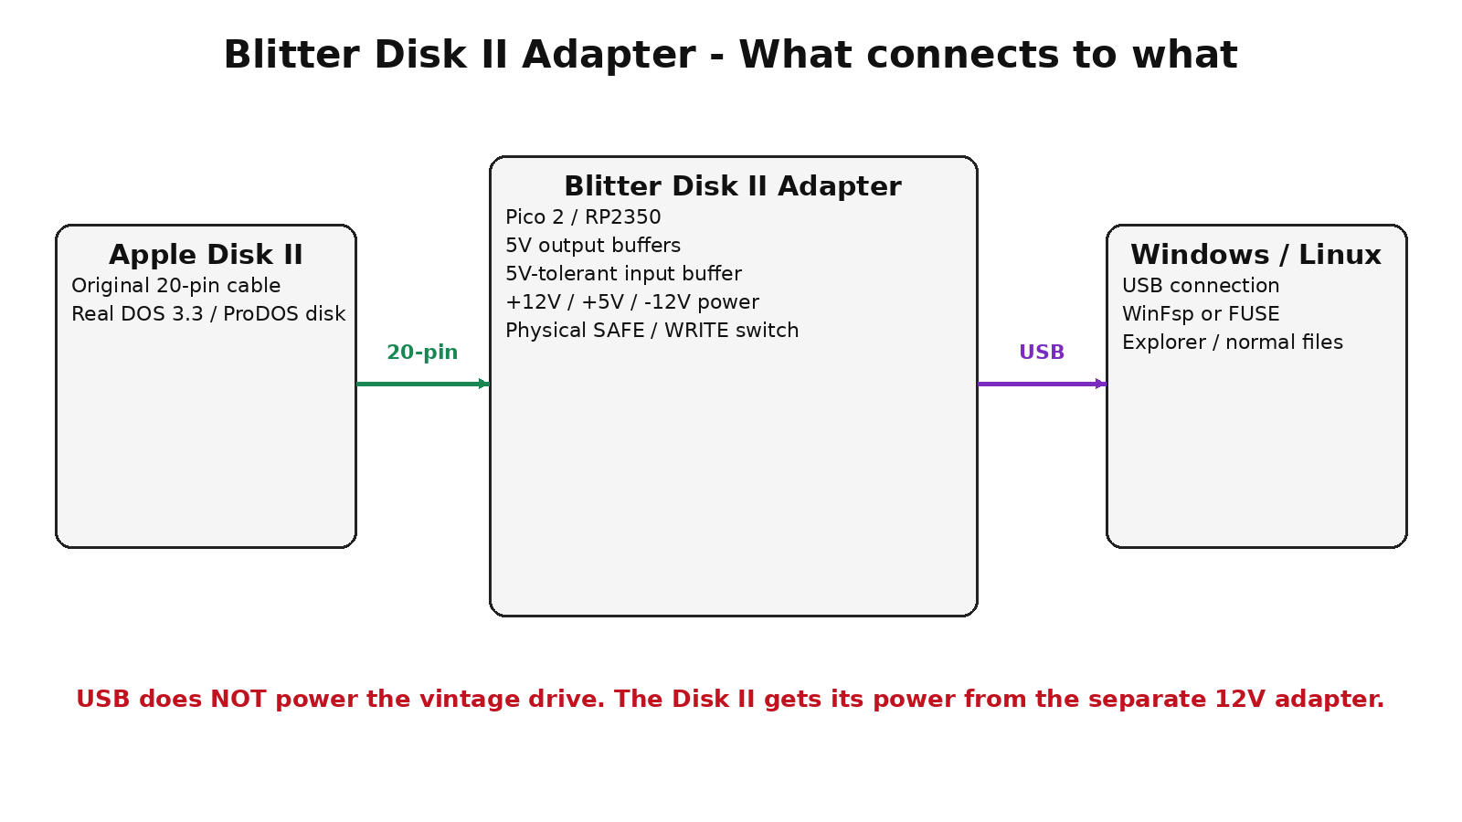
Project conceived and directed by Darren Crawford
A hardware and software project intended to let modern Windows and Linux computers work with original Apple Disk II drives and, ultimately, live-mount real DOS 3.3 and ProDOS disks.
WARNING: Revision B is a prototype design and has not yet been bench-qualified on vintage hardware. Build and test the adapter with the Disk II unplugged. Only connect an original drive after every voltage and continuity test in this manual passes.
Never hot-plug the original Disk II 20-pin cable. Power everything OFF before connecting or disconnecting the drive.

1. What this project is
The Blitter Disk II Adapter is intended to sit between an original Apple Disk II floppy drive and a modern Windows or Linux computer. The USB side talks to a Raspberry Pi Pico 2. The Pico handles the time-critical Disk II signals, while PC software will eventually expose DOS 3.3 and ProDOS files through WinFsp on Windows or FUSE on Linux.
This manual is deliberately written for a first-time electronics builder. It does not assume that you already know how to read a schematic. Where practical, it tells you exactly which physical pin connects to which other physical pin.

What Revision B hardware provides
- Original 20-pin Disk II drive connector.
- Separate +12V, +5V and -12V rails for the vintage drive.
- 3.3V-to-5V buffered control signals from the Pico 2.
- 5V-tolerant buffering for data coming back from the drive.
- Automatic output disconnect during Pico reset or power-up.
- A hardware SAFE / WRITE switch that can force writing off independently of software.
Important scope: this document describes the hardware adapter. The live DOS 3.3 / ProDOS filesystem driver and Pico firmware are separate software work that must be completed and tested before the finished system can mount disks.

2. Safety rules - read these before buying parts
WARNING: The Disk II connector carries +12V, +5V and -12V on adjacent pins. A reversed cable or one misplaced wire can damage irreplaceable vintage hardware.
- Never connect or disconnect the 20-pin Disk II cable while any power source is on.
- Never power the original Disk II from USB. Use the separate regulated 12V supply described here.
- Do not connect Pico pin 40 (VBUS) to the adapter +5V drive rail.
- Build and verify the three power rails before installing the logic ICs.
- Use the physical SAFE position for initial tests and when reading valuable original disks.
- Before attaching a drive, use a multimeter to verify every J2 power pin against ground.
- If any measurement differs substantially from +12V, +5V or -12V, stop and fix the power section first.
- Do not use an unknown or unregulated 12V wall wart.
- Prefer a keyed 20-pin header so the drive cable cannot be installed backwards.

About pin numbering
In this manual, "Pico pin" means the physical 1-to-40 pin number printed in the official Raspberry Pi Pico 2 pinout. "GP" means the RP2350 GPIO name. IC pin numbers refer to the physical DIP package pin numbers.

3. Parts and tools

Main parts
Ref | Part | What to buy | Qty
U3 | Raspberry Pi Pico 2 with headers | RP2350 module; official 40-pin Pico format | 1
U4,U5 | SN74AHCT125N | PDIP-14 quad 3-state buffer; 5V powered; TTL-compatible inputs | 2
U6 | SN74LVC245AN | PDIP-20 octal transceiver; 3.3V powered; inputs accept 5.5V | 1
Q1 | 2N3904 | NPN transistor; verify E/B/C pinout for your manufacturer | 1
J1 | 5.5x2.1mm DC jack or screw terminal | 12V input | 1
J2 | 2x10 0.1-inch shrouded/keyed IDC header | Original Disk II cable connector | 1
SW1 | SPDT ON-ON toggle switch | Physical SAFE / WRITE selector | 1
F1 | 2A fuse or resettable PTC | Protect +12V input | 1
D1 | 1.5KE15A TVS diode (recommended) | Cathode/banded end to +12V, anode to GND | 1
U7 | 5V buck converter module | 12V input; adjustable/reg 5.0V; >=2A | 1
U8 | Regulated isolated 12V-to-12V DC/DC module | 2W minimum; creates -12V rail | 1
R1-R7 | 100 ohm 1/4W | Series resistors on seven drive-output signal lines | 7
R8,R9 | 1K 1/4W | RDDATA and WRPROT input series resistors | 2
R10 | 4.7K 1/4W | GP11 to Q1 base | 1
R11 | 100K 1/4W | Q1 base pulldown | 1
R12 | 10K 1/4W | OE_N pullup to +5V | 1
R13 | 1K 1/4W | +5V to SAFE throw of SW1 | 1
C1,C2,C3 | 0.1uF ceramic | One directly across each logic IC supply | 3
C4 | 220uF 25V electrolytic | +12V bulk capacitor near J2 | 1
C5 | 470uF 10V electrolytic | +5V bulk capacitor near J2 | 1
C6 | 22uF 25V electrolytic | -12V bulk; positive lead to GND | 1
C7-C9 | 0.1uF ceramic | One on each J2 power rail | 3
BOARD | Perfboard or custom PCB | Do not use solderless breadboard for final drive-power wiring | 1
PSU | 12V regulated wall adapter | 2A minimum, center-positive if using barrel jack | 1

Recommended tools
- Temperature-controlled soldering iron and rosin-core electronics solder.
- Digital multimeter with DC voltage and continuity/beep modes.
- Small wire cutters and wire strippers.
- Fine hookup wire, preferably several colors.
- Perfboard or prototype PCB with enough room for two 14-pin ICs, one 20-pin IC, Pico headers and power modules.
- IC sockets for U4, U5 and U6. Strongly recommended for beginners.
- A label maker or permanent marker for identifying J2 pin 1, SAFE / WRITE, +12V and GND.

4. Learn the Disk II connector before wiring anything
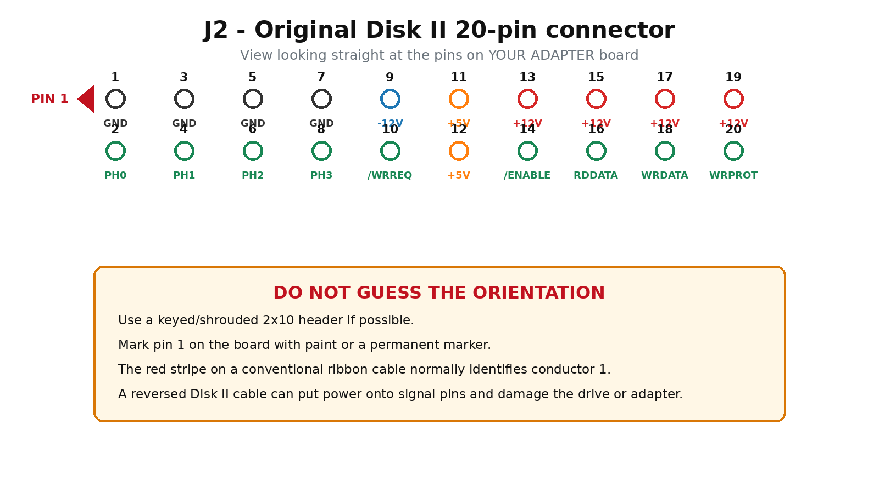
The odd-numbered pins are one row and the even-numbered pins are the other row. Use the drawing above as a board-side mating-face view. If you use a shrouded keyed header, orient the key so your ribbon cable pin 1 lands on J2 pin 1.
J2 pin | Signal | Meaning
1 | GND | Ground
2 | PH0 | Stepper phase 0
3 | GND | Ground
4 | PH1 | Stepper phase 1
5 | GND | Ground
6 | PH2 | Stepper phase 2
7 | GND | Ground
8 | PH3 | Stepper phase 3
9 | -12V | Negative supply
10 | /WRREQ | Write request, active LOW
11 | +5V | Drive +5V
12 | +5V | Drive +5V
13 | +12V | Drive +12V
14 | /ENABLE | Drive enable, active LOW
15 | +12V | Drive +12V
16 | RDDATA | Read data from drive
17 | +12V | Drive +12V
18 | WRDATA | Write data to drive
19 | +12V | Drive +12V
20 | WRPROT | Write-protect sense
WARNING: Do not use the connector drawing from a different Apple drive family, Macintosh drive, DuoDisk D-19 adapter, or generic PC floppy cable. This manual is specifically for the original Disk II 20-pin ribbon-cable interface.

5. Pico 2 pins used
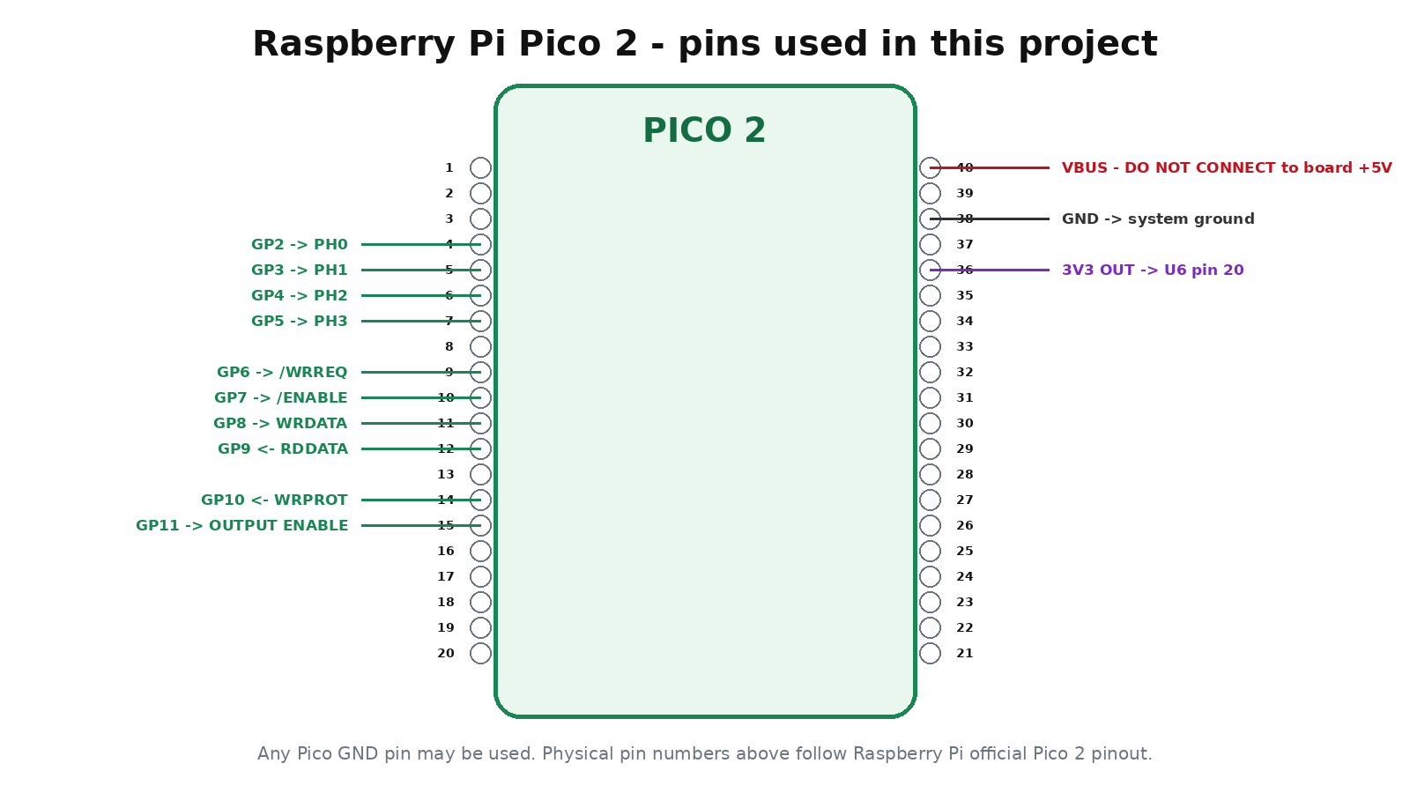
Physical pin | Pico name | Direction | Purpose
4 | GP2 | Output | PH0
5 | GP3 | Output | PH1
6 | GP4 | Output | PH2
7 | GP5 | Output | PH3
9 | GP6 | Output | /WRREQ
10 | GP7 | Output | /ENABLE
11 | GP8 | Output | WRDATA
12 | GP9 | Input | RDDATA
14 | GP10 | Input | WRPROT
15 | GP11 | Output | Global buffer enable
36 | 3V3 OUT | Power | U6 3.3V supply
38 | GND | Power | System ground
40 | VBUS | Do not use | Do NOT connect to adapter +5V

6. Build order at a glance
- Build the +12V, +5V and -12V power section with J2 still empty.
- Test all three rails with the multimeter.
- Install the Pico 2 and establish a common ground.
- Install U4 and U5 output buffers, Q1 output-enable safety circuit and SW1 SAFE/WRITE switch.
- Install U6 input buffer.
- Wire J2 signal pins one group at a time.
- Perform continuity tests with all power disconnected.
- Power the adapter with NO Disk II attached and repeat voltage tests at J2.
- Only then attach a known-good Disk II, with SW1 in SAFE.
- Use simple test firmware before attempting disk imaging or filesystem mounting.

7. Step 1 - build the power section
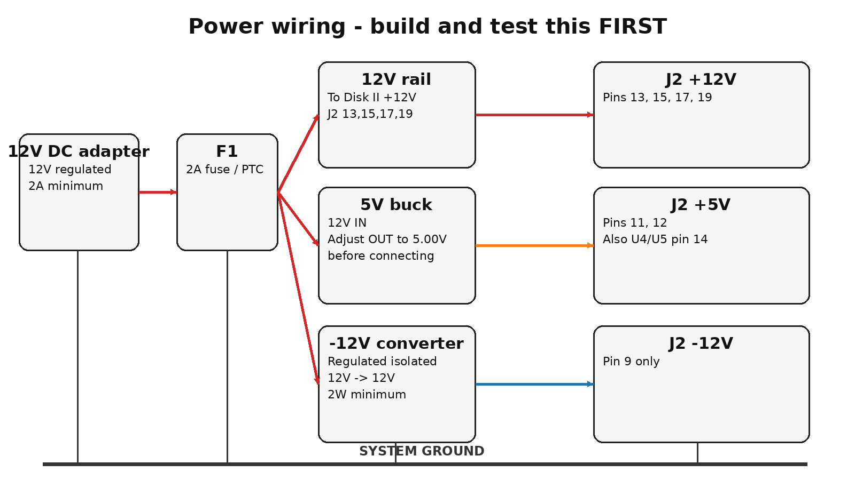

7.1 Wire the 12V input
- Connect the positive terminal of J1 (12V input) to one side of F1, the 2A fuse or resettable PTC.
- Call the other side of F1 the +12V DRIVE rail.
- Connect J1 negative directly to SYSTEM GROUND.
- If using the recommended 1.5KE15A TVS diode, connect its banded end (cathode) to the +12V DRIVE rail and its non-banded end (anode) to SYSTEM GROUND.

7.2 Wire +12V to J2
- Connect J2 pin 13 to the +12V DRIVE rail.
- Connect J2 pin 15 to the +12V DRIVE rail.
- Connect J2 pin 17 to the +12V DRIVE rail.
- Connect J2 pin 19 to the +12V DRIVE rail.

7.3 Build the +5V rail
- Connect the buck converter IN+ to the +12V DRIVE rail.
- Connect buck IN- to SYSTEM GROUND.
- Before connecting the buck output to anything else, power the board and adjust/verify the output is 5.00V.
- After the output is correct, connect buck OUT+ to the +5V rail and OUT- to SYSTEM GROUND.
- Connect J2 pins 11 and 12 to +5V.
WARNING: An adjustable buck module can arrive set above 5V. Measure and adjust it before connecting it to J2 or the logic ICs.

7.4 Build the -12V rail
- Use a regulated isolated 12V-to-12V DC/DC converter rated at least 2W.
- Connect its input + to the +12V DRIVE rail and its input - to SYSTEM GROUND.
- On the isolated OUTPUT side, connect the converter +OUT to SYSTEM GROUND.
- The isolated converter -OUT is now the -12V rail.
- Connect that -12V rail only to J2 pin 9 and to the -12V filtering capacitors.
WARNING: Do not confuse the converter input negative with its isolated output negative. You create -12V by grounding the isolated OUTPUT positive terminal.

7.5 Add bulk capacitors near J2
- +12V: 220uF/25V electrolytic from +12V to GND, plus 0.1uF ceramic.
- +5V: 470uF/10V electrolytic from +5V to GND, plus 0.1uF ceramic.
- -12V: 22uF/25V electrolytic from -12V to GND, plus 0.1uF ceramic. On the -12V electrolytic, the POSITIVE leg goes to GND and the NEGATIVE leg goes to -12V.

8. Step 2 - power-only test, NO DRIVE CONNECTED
WARNING: J2 must be empty for this entire test.
Set your multimeter to DC volts. Put the black probe on J2 pin 1 or another known SYSTEM GROUND point. Apply only the external 12V supply.
Measure | Expected | Meaning
J2 1,3,5,7 | 0V / ground | Continuity to system ground
J2 13,15,17,19 | about +12V | Drive motor / analog supply
J2 11,12 | +5.0V | Logic supply
J2 9 | about -12V | Negative analog supply

Pass condition
All four ground pins are ground, both +5V pins are about +5.0V, all four +12V pins are about +12V, and pin 9 is negative relative to ground at approximately -12V.
WARNING: If pin 9 reads +12V instead of -12V, stop. The isolated converter output is referenced backwards. Do not connect a drive.

9. Step 3 - install the Pico 2 and establish ground
- Mount the Pico 2 so the USB connector remains accessible.
- Connect Pico physical pin 38 (GND) to SYSTEM GROUND. You may use another Pico GND pin if that is easier.
- Do not connect Pico pin 40 VBUS to the board +5V rail.
- Leave Pico pin 36 3V3 OUT unconnected until U6 is installed.
The PC USB ground and the drive power-supply ground become common through the Pico ground wire. This common reference is required for the logic signals.

10. Step 4 - build the drive-control output buffers
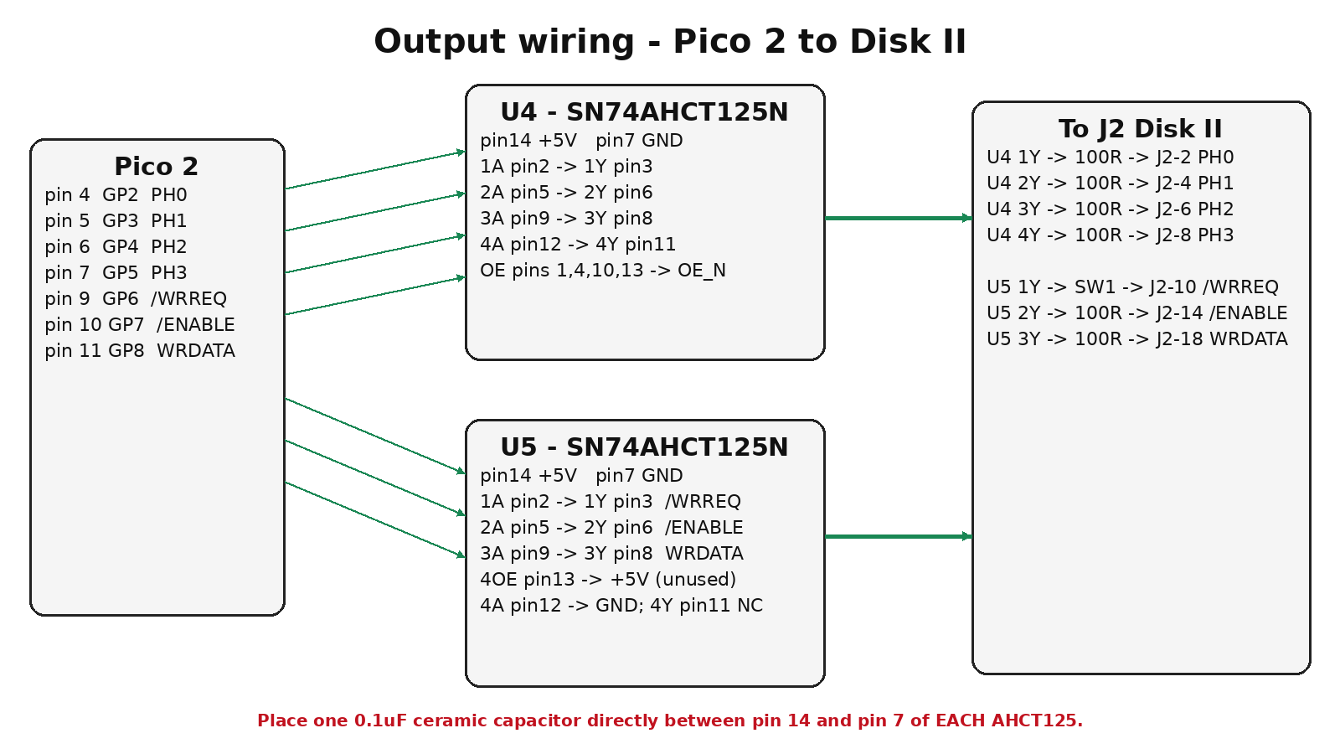
Install U4 and U5 in sockets if possible. With the notch facing upward, DIP pin 1 is at the upper-left and numbering proceeds counter-clockwise.

10.1 Power U4 and U5
- U4 pin 14 -> +5V.
- U4 pin 7 -> SYSTEM GROUND.
- Place a 0.1uF ceramic capacitor directly between U4 pin 14 and pin 7.
- U5 pin 14 -> +5V.
- U5 pin 7 -> SYSTEM GROUND.
- Place a 0.1uF ceramic capacitor directly between U5 pin 14 and pin 7.

10.2 Wire U4 - PH0 through PH3
From Pico | AHCT125 input | AHCT125 output | Series | To Disk II
Pico pin 4 GP2 | U4 pin 2 (1A) | U4 pin 3 (1Y) | 100R | J2 pin 2 PH0
Pico pin 5 GP3 | U4 pin 5 (2A) | U4 pin 6 (2Y) | 100R | J2 pin 4 PH1
Pico pin 6 GP4 | U4 pin 9 (3A) | U4 pin 8 (3Y) | 100R | J2 pin 6 PH2
Pico pin 7 GP5 | U4 pin 12 (4A) | U4 pin 11 (4Y) | 100R | J2 pin 8 PH3
Do not ground the U4 OE pins yet. Tie U4 pins 1, 4, 10 and 13 together. Name that wire OE_N. It will be controlled by Q1 in the next step.

10.3 Wire U5 - write, enable and write data
From Pico | U5 input | U5 output | Destination
Pico pin 9 GP6 | U5 pin 2 (1A) | U5 pin 3 (1Y) | to SW1 WRITE through 100R
Pico pin 10 GP7 | U5 pin 5 (2A) | U5 pin 6 (2Y) | 100R -> J2 pin 14
Pico pin 11 GP8 | U5 pin 9 (3A) | U5 pin 8 (3Y) | 100R -> J2 pin 18
Tie U5 OE pins 1, 4 and 10 to OE_N. The fourth channel is unused: connect U5 pin 13 (4OE) to +5V, connect U5 pin 12 (4A) to GND, and leave U5 pin 11 (4Y) unconnected.

11. Step 5 - build the automatic output-enable safety circuit
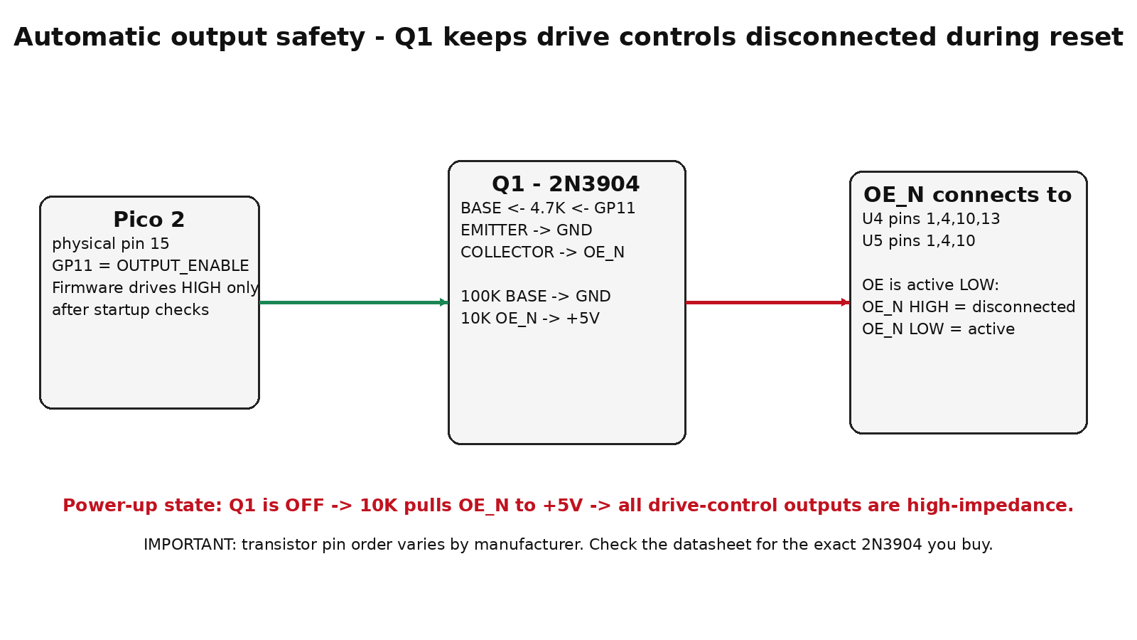
This circuit deliberately disconnects the Pico from the Disk II control inputs until firmware explicitly enables the buffers.
- Connect a 10K resistor from OE_N to +5V. This makes the default state DISABLED.
- Connect Q1 collector to OE_N.
- Connect Q1 emitter to SYSTEM GROUND.
- Connect Pico physical pin 15 (GP11) through a 4.7K resistor to Q1 base.
- Connect a 100K resistor from Q1 base to SYSTEM GROUND.
WARNING: 2N3904 lead order is not guaranteed by the words "flat side left/right." Check the datasheet for the exact manufacturer and package you buy before soldering emitter, base and collector.

How it works
GP11 LOW or floating -> Q1 is off -> 10K pulls OE_N HIGH -> AHCT125 outputs are disconnected. GP11 HIGH -> Q1 pulls OE_N LOW -> AHCT125 outputs become active. Firmware must keep GP11 low until its startup state is safe.

12. Step 6 - install the physical SAFE / WRITE switch
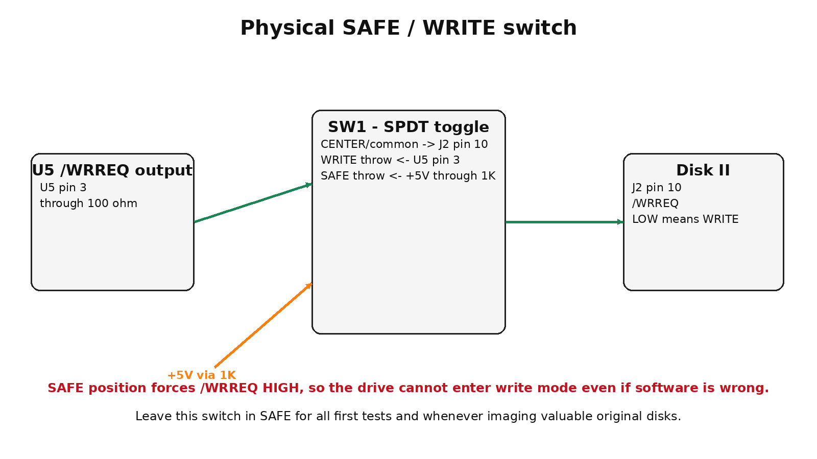
- Use an SPDT ON-ON toggle switch. Identify the common terminal with a continuity tester if the switch is not clearly marked.
- Connect SW1 common to J2 pin 10 (/WRREQ).
- Connect the WRITE throw to U5 pin 3 through a 100 ohm resistor.
- Connect the SAFE throw to +5V through a 1K resistor.
- Label the switch positions clearly: SAFE and WRITE.
WARNING: For every initial test, leave SW1 in SAFE. In SAFE, J2 pin 10 is forced HIGH, so the drive should not be commanded to write even if the firmware has a bug.

13. Step 7 - build the read-data input buffer
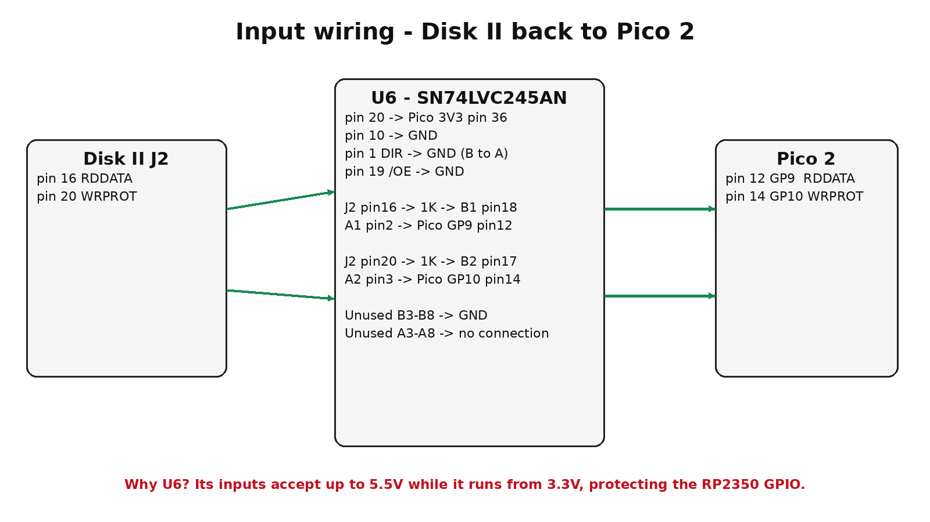
U6 protects the 3.3V RP2350 from the Disk II return signals. Use the SN74LVC245A specifically or another part whose datasheet explicitly allows 5.5V on its inputs while powered at 3.3V.
- Install U6 SN74LVC245AN in a 20-pin socket.
- U6 pin 20 -> Pico physical pin 36 (3V3 OUT).
- U6 pin 10 -> SYSTEM GROUND.
- U6 pin 1 DIR -> SYSTEM GROUND. This selects B-to-A direction.
- U6 pin 19 /OE -> SYSTEM GROUND.
- J2 pin 16 RDDATA -> 1K series resistor -> U6 pin 18 (B1).
- U6 pin 2 (A1) -> Pico physical pin 12 / GP9.
- J2 pin 20 WRPROT -> 1K series resistor -> U6 pin 17 (B2).
- U6 pin 3 (A2) -> Pico physical pin 14 / GP10.
- Tie unused U6 B inputs pins 16,15,14,13,12,11 to GND. Leave unused A outputs pins 4 through 9 unconnected.
- Place a 0.1uF ceramic capacitor directly between U6 pin 20 and pin 10.

14. Step 8 - finish grounds and power wiring
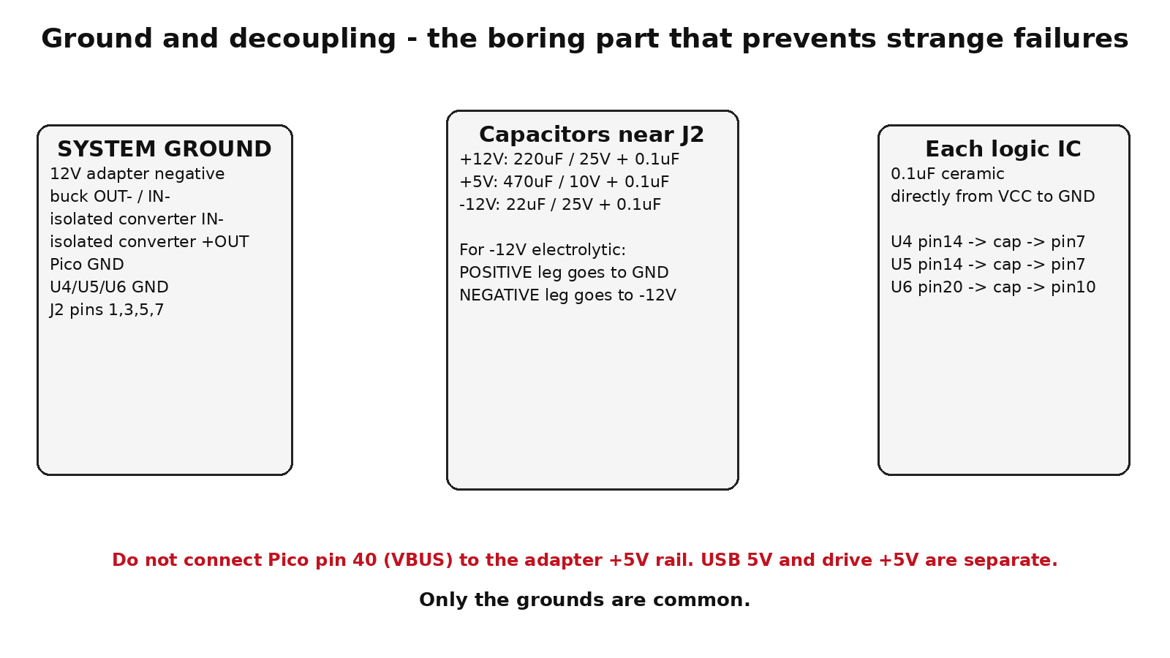
Connect J2 pins 1, 3, 5 and 7 to SYSTEM GROUND. Confirm there is a low-resistance connection between all of these points, Pico GND, U4/U5/U6 ground, buck ground and the 12V adapter negative terminal.
WARNING: The adapter +5V drive rail is NOT Pico VBUS. Do not join them. Pico pin 36 provides only 3.3V for U6. U4 and U5 are powered from the drive-side +5V buck converter.

15. Complete point-to-point wiring checklist
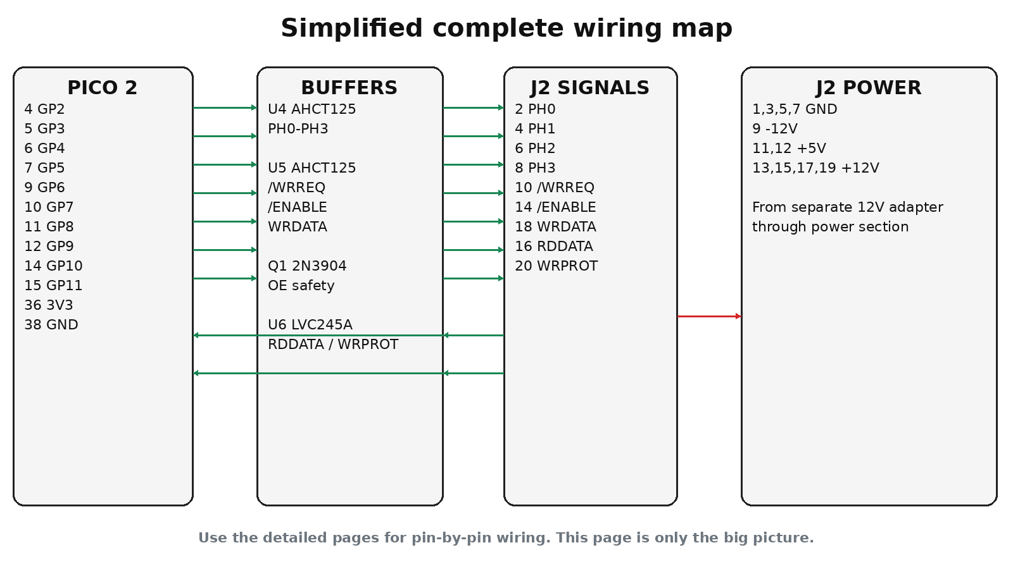
From | To | Notes
Pico pin 4 / GP2 | U4 pin 2 (1A) | PH0 source
U4 pin 3 (1Y) | 100R | then J2 pin 2 PH0
Pico pin 5 / GP3 | U4 pin 5 (2A) | PH1 source
U4 pin 6 (2Y) | 100R | then J2 pin 4 PH1
Pico pin 6 / GP4 | U4 pin 9 (3A) | PH2 source
U4 pin 8 (3Y) | 100R | then J2 pin 6 PH2
Pico pin 7 / GP5 | U4 pin 12 (4A) | PH3 source
U4 pin 11 (4Y) | 100R | then J2 pin 8 PH3
Pico pin 9 / GP6 | U5 pin 2 (1A) | /WRREQ source
U5 pin 3 (1Y) | 100R then SW1 WRITE throw | SW1 common -> J2 pin 10
+5V | 1K then SW1 SAFE throw | SW1 common -> J2 pin 10
Pico pin 10 / GP7 | U5 pin 5 (2A) | /ENABLE source
U5 pin 6 (2Y) | 100R | then J2 pin 14 /ENABLE
Pico pin 11 / GP8 | U5 pin 9 (3A) | WRDATA source
U5 pin 8 (3Y) | 100R | then J2 pin 18 WRDATA
Pico pin 15 / GP11 | 4.7K | Q1 base
Q1 base | 100K | GND
Q1 emitter | GND
Q1 collector | OE_N
+5V | 10K | OE_N
OE_N | U4 pins 1,4,10,13 | all U4 output-enables
OE_N | U5 pins 1,4,10 | three used U5 output-enables
+5V | U5 pin 13 | disable unused ch4
GND | U5 pin 12 | unused ch4 input
J2 pin 16 RDDATA | 1K then U6 pin 18 (B1)
U6 pin 2 (A1) | Pico pin 12 / GP9
J2 pin 20 WRPROT | 1K then U6 pin 17 (B2)
U6 pin 3 (A2) | Pico pin 14 / GP10
U6 pin 1 DIR | GND | B -> A
U6 pin 19 /OE | GND | enabled
U6 pin 20 VCC | Pico pin 36 3V3 OUT
U6 pin 10 | GND
U6 pins 16,15,14,13,12,11 (B3-B8) | GND | unused inputs
+5V | U4 pin 14; U5 pin 14
GND | U4 pin 7; U5 pin 7
J2 pins 1,3,5,7 | GND
J2 pin 9 | -12V
J2 pins 11,12 | +5V
J2 pins 13,15,17,19 | +12V
Pico GND (e.g. pin 38) | SYSTEM GND | common reference
Pico pin 40 VBUS | NO CONNECTION to adapter +5V | do not backfeed USB

16. Step 9 - continuity test with ALL POWER OFF
WARNING: Unplug USB and the 12V adapter. The Disk II must still be disconnected.
- Use continuity mode and confirm J2 pins 1,3,5,7 connect to GND.
- Confirm J2 pins 13,15,17,19 connect to the +12V rail and DO NOT beep to GND.
- Confirm J2 pins 11,12 connect to the +5V rail and DO NOT beep to GND.
- Confirm J2 pin 9 connects only to the -12V rail and does not beep to +12V or +5V.
- Confirm J2 pin 2 traces to U4 PH0 output, pin 4 to PH1, pin 6 to PH2 and pin 8 to PH3.
- Confirm J2 pin 14 traces to U5 /ENABLE output.
- Confirm J2 pin 18 traces to U5 WRDATA output.
- Confirm J2 pin 10 traces to SW1 common.
- In SAFE, SW1 common should connect through about 1K to +5V and should be disconnected from the U5 /WRREQ output.
- In WRITE, SW1 common should connect to the U5 /WRREQ output path and be disconnected from the SAFE +5V path.
- Confirm J2 pin 16 goes only toward U6 B1 and J2 pin 20 goes only toward U6 B2.

17. Step 10 - powered J2 test with NO DRIVE
WARNING: The original Disk II remains unplugged.
Set SW1 to SAFE. Apply the external 12V supply, then connect USB to the Pico. Before loading any firmware that enables GP11, re-check the J2 power rails.
J2 pin(s) | Expected
1,3,5,7 | 0V / ground
11,12 | +5.0V
13,15,17,19 | about +12V
9 | about -12V
10 in SAFE | HIGH, approximately +5V
With GP11 low or unconfigured, U4/U5 outputs should remain high impedance because OE_N is pulled high. If you have a logic probe or oscilloscope, this is a good time to verify that OE_N sits near +5V before firmware enables Q1.

18. First connection to a real Disk II
WARNING: Only do this after every continuity and voltage test has passed. Use a known-good drive and a non-valuable scratch disk first.
- Shut down USB and unplug the 12V adapter.
- Set SW1 to SAFE.
- Check J2 pin 1 orientation and the ribbon-cable red stripe twice.
- Connect the Disk II cable fully and squarely.
- Apply the external 12V supply.
- Connect USB to the Pico.
- Use test firmware that keeps GP11 output-enable disabled by default.
- First test only drive enable and head stepping. Do not attempt writing.
- Then test RDDATA with a scratch DOS 3.3 or ProDOS disk.
- Only after reliable reads are demonstrated should SW1 be moved to WRITE for controlled write testing on a disposable disk.

Recommended firmware progression
- Firmware A: report Pico alive; never enable outputs.
- Firmware B: enable buffers and pulse only /ENABLE; verify motor behavior.
- Firmware C: perform controlled PH0-PH3 stepping and return to track zero.
- Firmware D: capture RDDATA timing while spinning a scratch disk.
- Firmware E: decode DOS 3.3 / ProDOS sectors and verify read-only imaging.
- Firmware F: controlled writing with verification.
- Only then: host-side live filesystem mounting.

19. What the finished Windows/Linux software should do
Once the hardware and firmware are proven, the host software can present a real Disk II floppy as an ordinary mounted filesystem.

Windows target
Use WinFsp to expose the mounted disk as a drive letter such as A: or a folder mount. Explorer operations such as copy, rename and delete are translated into DOS 3.3 or ProDOS changes and then written back to the real floppy.

Linux target
Use FUSE to mount the disk under a path such as /media/blitterdisk. Normal commands such as ls, cp, mv and rm become filesystem operations on the real floppy.

Filesystem behavior
- ProDOS: real subdirectories, file types, auxiliary types, block allocation and free-space reporting.
- DOS 3.3: flat directory; mkdir should return "not supported" rather than inventing directories the Apple cannot read.
- Read caching: avoid unnecessary head movement.
- Write-back with explicit flush/eject: combine changes safely rather than bouncing the head for every tiny PC write.
- Preserve Apple II metadata through extended attributes or side metadata on the host.

20. Troubleshooting
Symptom | Likely cause | First check
No +5V at J2 11/12 | Buck converter not adjusted, missing ground, fuse/input wiring | Disconnect everything from +5V and measure buck by itself.
J2 pin 9 is +12V | Isolated converter output reference reversed | Power off; ground converter +OUT and use -OUT as -12V.
Pico resets when drive starts | Ground/power noise or accidental USB/drive 5V connection | Check grounds, bulk capacitors and confirm VBUS is not tied to +5V.
Drive motor always runs | /ENABLE wiring or firmware state wrong | Keep GP11 disabled; verify J2 pin14 path and U5 channel.
Head chatters violently | PH0-PH3 order/wiring wrong | Power off and trace J2 pins 2,4,6,8 back to U4/Pico.
Reads are random | RDDATA input path, ground noise, firmware timing | Verify U6 direction/OE/power and capture signal on J2 16.
Disk appears write-protected always | WRPROT path wrong or sensor state misread | Trace J2 20 -> U6 B2 -> A2 -> GP10.
Drive writes unexpectedly | SW1 not actually in SAFE or switch wired wrong | Power off; continuity-test SW1 common/throws and force J2 10 high in SAFE.

21. Design notes for experienced reviewers
This revision intentionally uses readily understandable, through-hole-friendly logic. The AHCT125 parts convert 3.3V Pico outputs into TTL-compatible 5V drive controls and provide a common high-impedance safety state through their OE pins. TI recommends pulling OE high for a high-impedance state during power-up/down. The LVC245A is powered at 3.3V and its datasheet specifies inputs accepting up to 5.5V, making it suitable as the return-signal protection layer.
Revision B intentionally does not claim that the analog timing, firmware, write pulse generation or live filesystem software is complete. Those portions must be implemented and validated on test media. Community review of the hardware before a PCB spin is encouraged.

22. References used for Revision B
Raspberry Pi Pico 2 official pinout: https://datasheets.raspberrypi.com/pico/Pico-2-Pinout.pdf
Raspberry Pi Pico 2 datasheet: https://datasheets.raspberrypi.com/pico/pico-2-datasheet.pdf
Texas Instruments SN74AHCT125 datasheet/product information: https://www.ti.com/product/SN74AHCT125
Texas Instruments SN74LVC245A datasheet/product information: https://www.ti.com/product/SN74LVC245A
Apple Disk II 20-pin interface pinout summary, referencing Apple documentation: https://en.wikipedia.org/wiki/Disk_II
tinyDiskII open-source design - useful precedent for AHCT/LVC buffering: https://github.com/GLGPrograms/tinyDiskII
FloppyExerciser - modern open-source Disk II drive-interface precedent: https://github.com/schlae/FloppyExerciser

23. Publication credit
BLITTER DISK II ADAPTER
Original project concept, project direction and publication credit: Darren Crawford
The Blitter Disk II Adapter is a Darren Crawford project for the Apple II enthusiast community.
Revision B is an engineering prototype. Anyone building it should independently verify the design and use a non-valuable test disk and known-good drive for initial testing.

