Daniel Crawford (dsc160130)

Abhishek Thurlapati (vxt160630)

Swamynathan Singaravelu (sxs123030)

CS 6301.003

Dr. Nagar

May 8, 2021

**Assignment 5 Report**

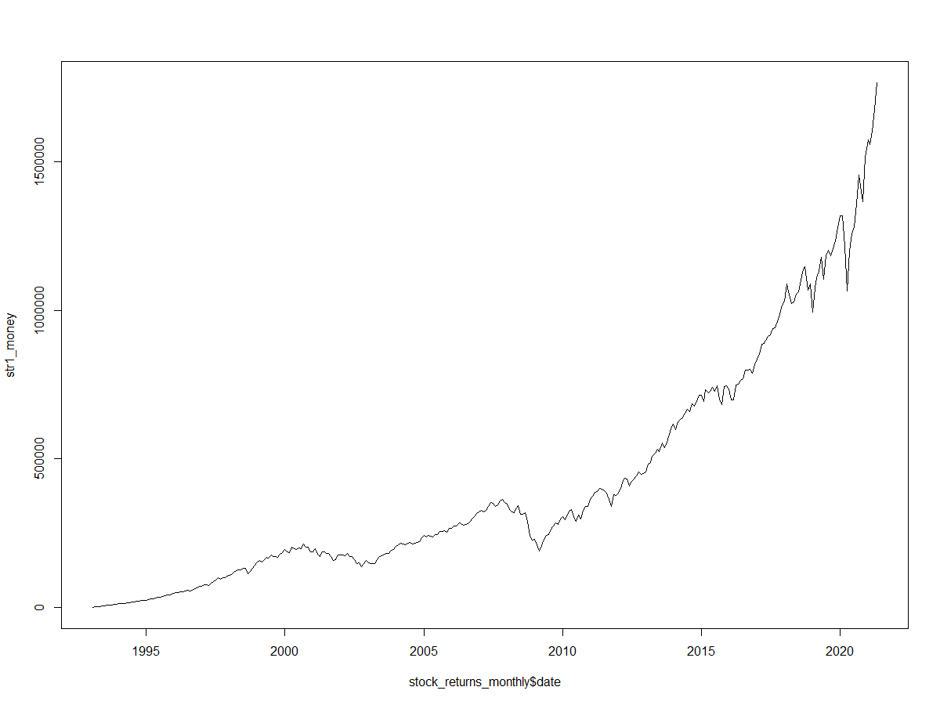

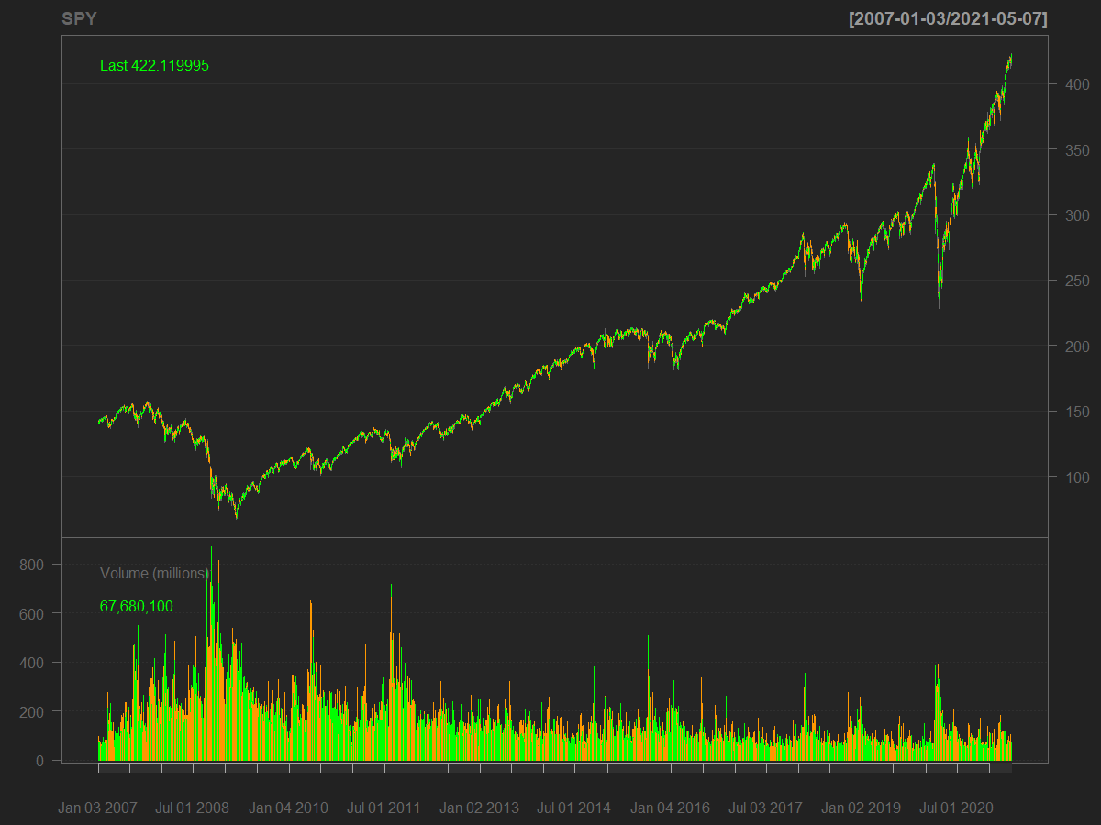

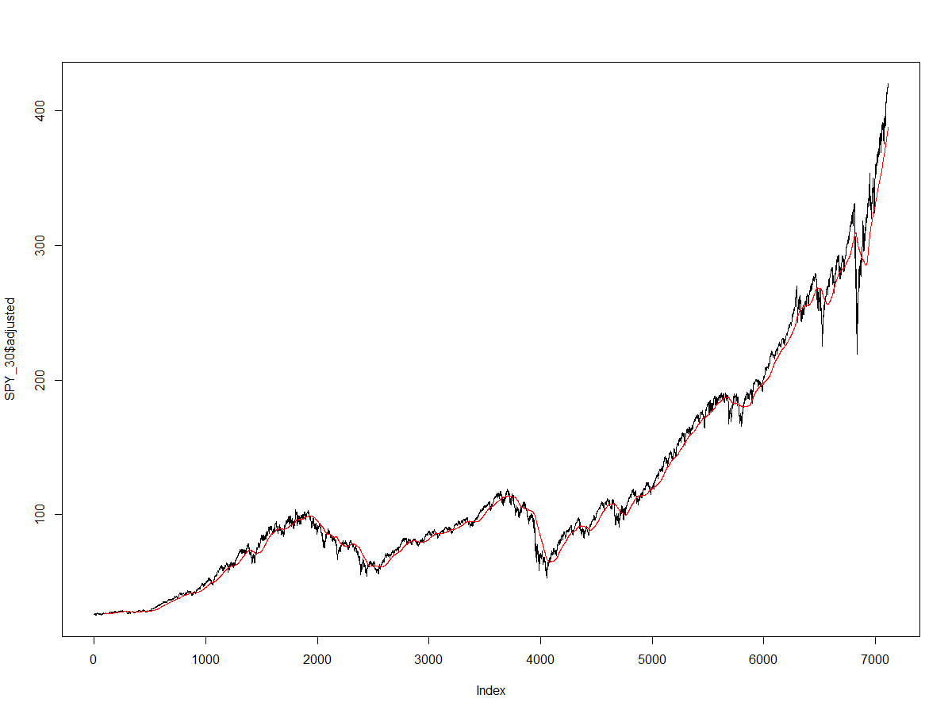

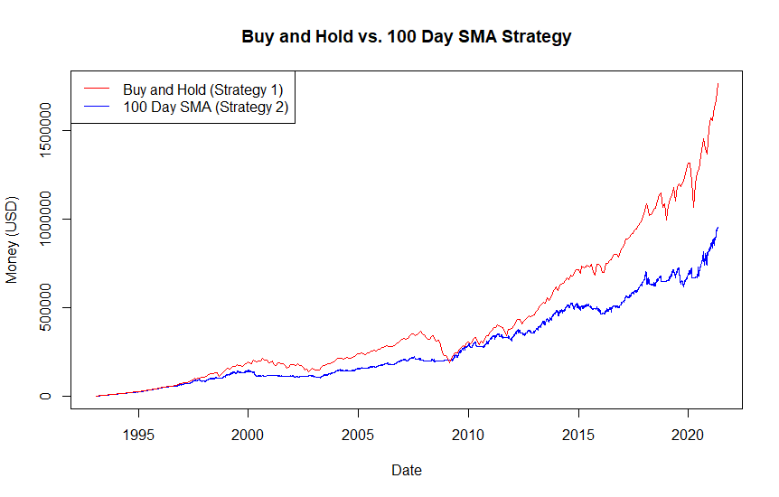

**Analysis**

Based on the results seen above, we came to the conclusion that the Buy and Hold strategy was the better of the two strategies. We analyzed the financial statistics of SPDR S&P 500 trust (SPY) over the course of 30 year period. We were somewhat surprised to see that the Buy and Hold strategy outperformed the 100 Day SMA average. Our initial thought process was that the SMA should provide a good estimation or prediction of the health of the stock market and will be much better indicator of major shifts and downturns. Using these estimations, we believed we could make investments using our seed money of $1000 in the SPY. However, our program has shown that the Buy & Hold strategy (tried and tested for a reason) showed that the markets course correct over time (especially a large window like 30 years) and will produce much greater return on investment than the 100 Day SMA strategy. Additionally, we did also notice that the Buy & Hold strategy might be less of a hassle in the long run due to various fees for brokerage that might need to be made in active investing.