CS 3354 Homework 5

Daniel Crawford



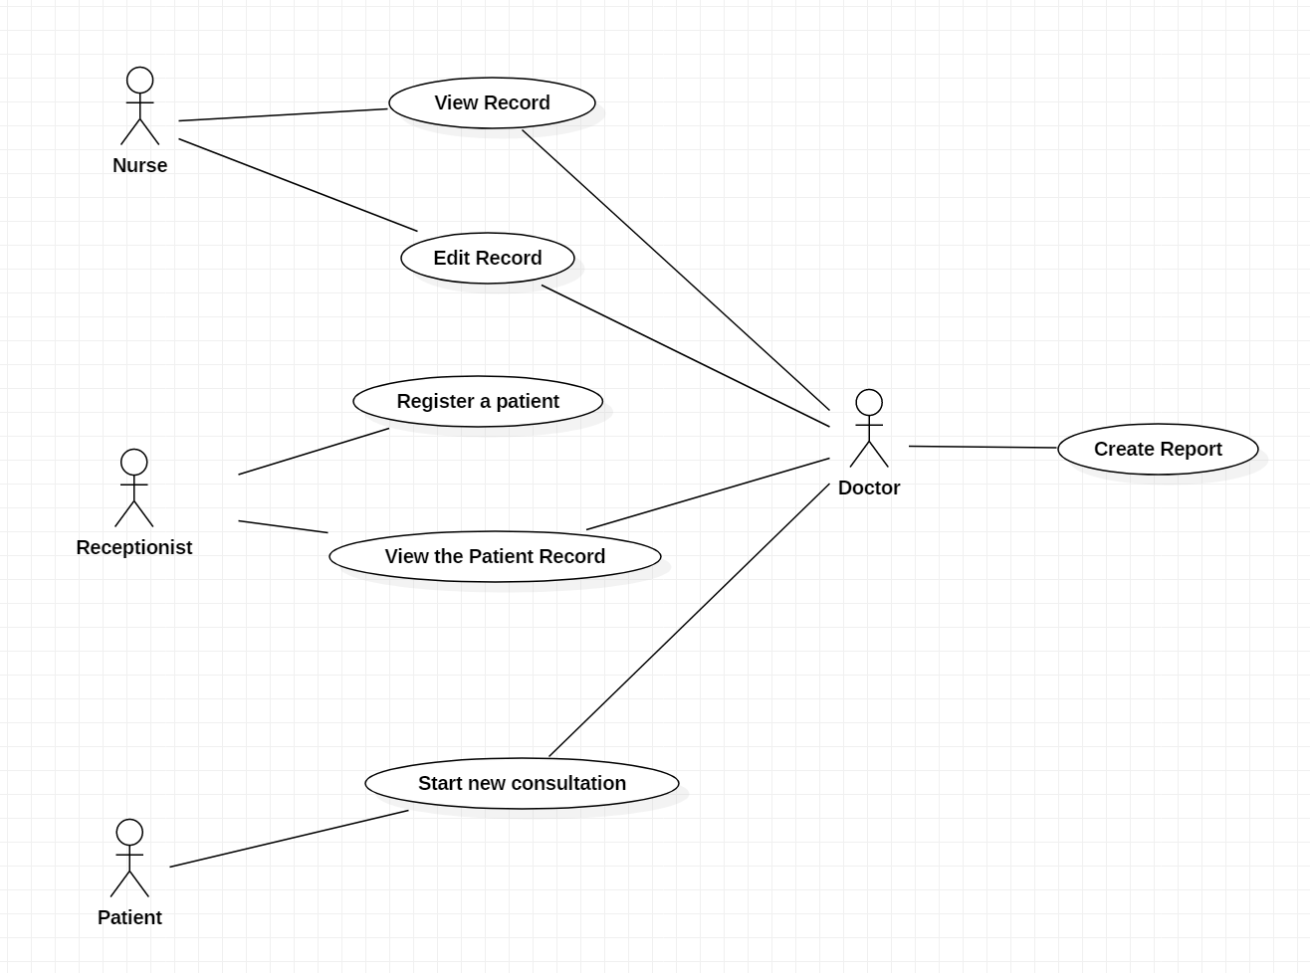



|  |  |
| --- | --- |
| System | Mentcare System |
| Use Case | View Record |
| Actors | Nurse, Receptionist, Doctor |
| Data | After every visit with the doctor, the record of a patient is updated with their prescriptions, diagnosis’s, and general health information such as their weight. Other data will consist of the time of the appointment, and then generally any important medical history of the patient. |
| Stimulus | The Nurse or Receptionist connects to the website then requests information |
| Response | Encrypted Patient record is sent back to the user. |
| Comments | Some of the requirements of this system is that the Nurses and Receptionists need to be able to access this system quickly, and it should be reliable. This means the website that the medical faculty access should give priority access to them. |

|  |  |
| --- | --- |
| System | Mentcare System |
| Use Case | Start new consultation |
| Actors | Patient, Doctor |
| Data | Website will hold patient appointment data including their time of appointment and what their issue is. The doctor can then view this issue. |
| Stimulus | Patient submits data for consultation, or Doctor accesses website |
| Response | Consultation data is set for patient, or encrypted data is sent over to the Doctor. |
| Comments | Consultations should be easily accessible by patients, so they should have a view of open times from when they register on the website. Doctor should also have quick access to these documents by showing only the appointments in a time interval. |

1. Tuleap Open ALM is a project management tool but is also an application lifecycle management tool. This means it supports the agile software development process. For this program, the GNU General Public License fits well for the program’s needs. By being open source completely, the program can have limitless functionality thanks to the thousands of developers that will use the software. Functionality in the program in this sense means that if the program is missing support for some device then the users can implement that themselves. Afterwards, the company can then integrate this into their program and other users can use it in the future. The GPL works for this project very well because this software wants to be as open source as possible, or to be general, free software. Of course, free software does not mean the software has to be free, it just means that the software has to have its code accessible to every. The GPL license was literally built for this exact functionality, and the copyleft license makes sure everything built under Tuleap Open ALM contains this licensing. To continue this benefit, if everything built under the application is free software, it means that the software can become infinitely maintainable. If every developer can see every function within the program, then they can adjust each feature to meet new demands and add additional functionality that is desired. Next, the GPL license offers legal permission to copy, distribute and modify it. This means that the Tuleap Open ALM project can modified and built on top of another program legally, without the limits of proprietary software causing the software to deny the user’s ability to change the program. Another motivation towards using the GPL license is that software patents become annoying and limits the programs usefulness due to legal issues. Within the GPL license protects the programs ability to remain free, so the software patent cannot force software to become closed-source. Basically, GPL maintains the integrity of the Tuleap Open ALM design process, so they can continue from the benefits of open source by using this license and continue to gain functionality thanks to the copyleft property of the license. For my own projects, I believe that Tuleap Open ALM would be incredibly helpful to me within a team. Open ALM is built under the forge system functionalities so it can track bugs, consolidate communications with people such as customers, developers and third partes. Another feature is the support of the Scrum framework. Since Scrum is a very popular approach to creating programs in an agile development process, I know I could use this program to plan out software sprints. Thanks to the license model, I am also able to implement my own version of the modified software if I chose to do so. For example, if I wanted to use an agile framework that Open ALM does not support, such as Crystal, then I could build on top of the program and implement it myself. Then, thanks to the GPL license, other developers can add more functionality to that framework.