CS 4347.004
Daniel Crawford

4.2)
superclass of a subclass: A superclass of a subclass gives the subclass all of its attributes. It is a generalization of a bunch of subclasses which fit into one entity.
superclass/subclass relationship: Subclasses inherits all attributes and relationships from their superclasses.
IS-A relationship: Used to associate objects from several independent classes.
Specialization: Process of defining a set of subclasses of an entity type.
Generalization: Process of defining a superclass from a couple of common entities.
Category: A shared subclass which there is one or more distinct superclass/subclass relationships, each relationship has a single superclass and shared subclass leads to multiple inheritance.
specific (local) attributes: Attributes that apply only to entities of a particular subclass, attached to that subclass.
specific relationships: Similar to specific attributes, except it has to do with specific relationships for an entity in a subclass.

\
4.20)
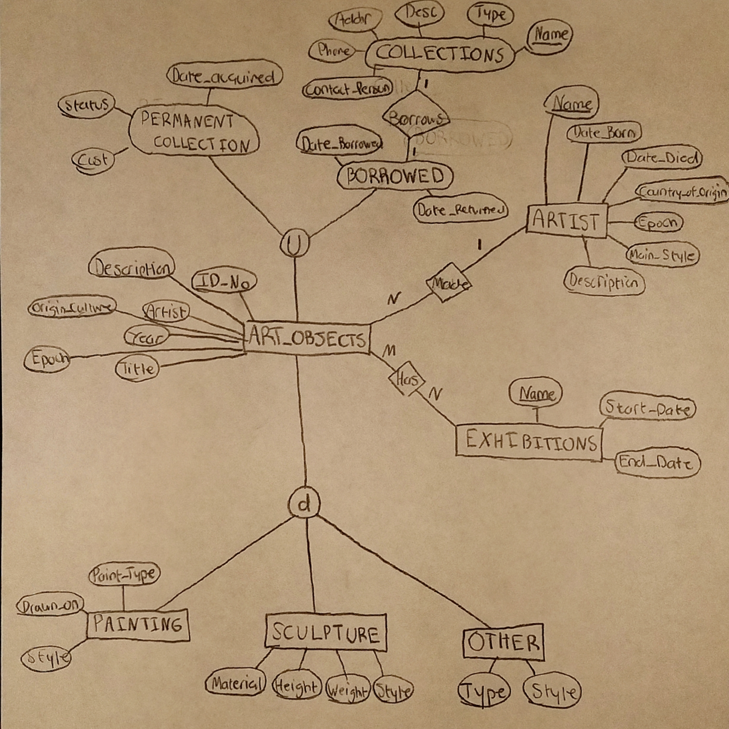
First of all, it was unclear the connection was between origin of culture and epoch were for ART_OBJECTS. Collections and Artists are made as relations instead of attributes, because if they were attributes then they would be redundant. I designed the EER diagram with classes and categories because the problem described them that way. Because it wanted to categorize art objects, I made it so that ART_OBJECTS are either BORROWED or part of the PERMANENT_COLLECTION, and it can decide what kind of art it is at the bottom.

PACKET)

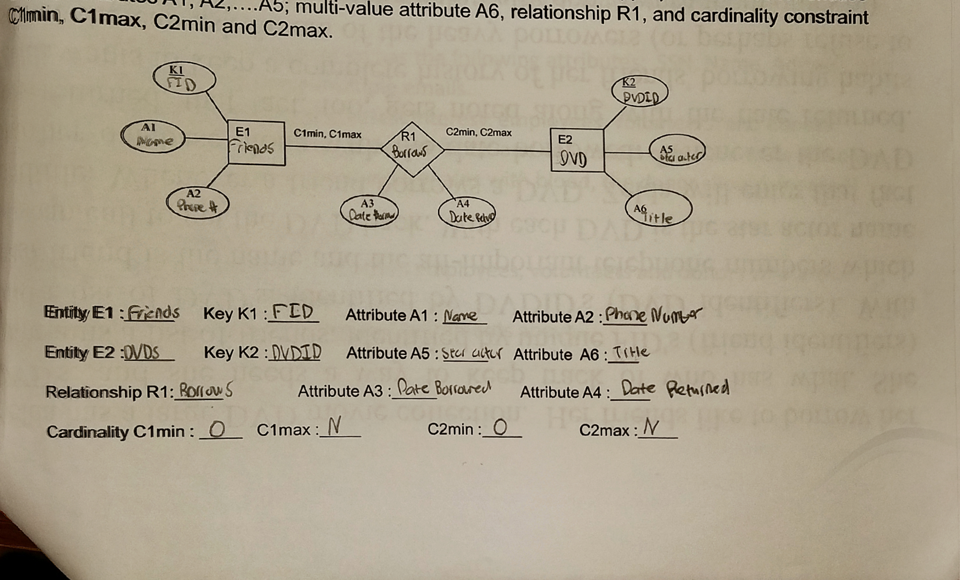
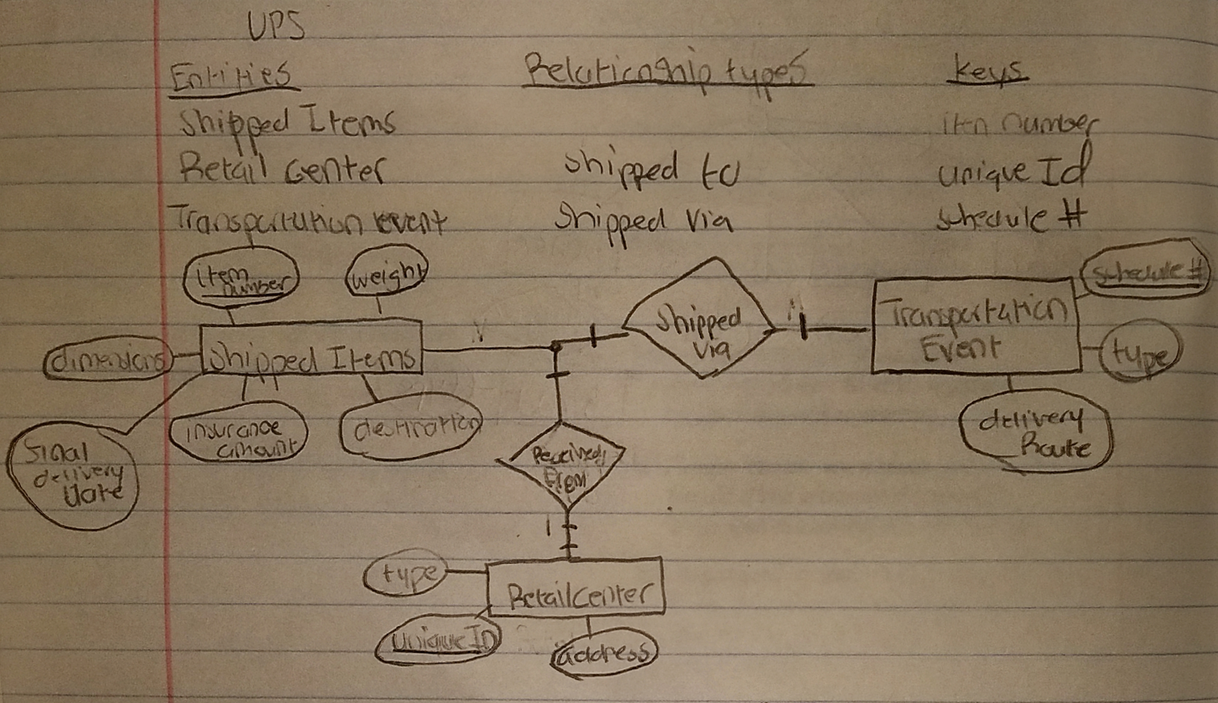

Business Rule for Scholarship Application Database: Only 1 school can be associated with M multiple applications. A applicant cannot have multiple schools which they are attending at once within, however they can use the school multiple times across different applications.



