EduNexus Institute of Technology
Department of Engineering
ME301 – Mechanics of Vibrations — Sample text मापदंड 🔬 with symbols: ∴ A ⊂ B, P ⇒ Q, damping ζ and ξ, em—dash, café
End Semester Examination
Date: 2026-08-17 Time: 180 Minutes Max Marks: 30

Instructions:
1. All questions carry marks as indicated. Sample text मापदंड 🔬 with symbols: ∴ A ⊂ B, P ⇒ Q, damping ζ and ξ, em—dash, café

SECTION A
Attempt all questions.
Answer using proper notation.
Q.1 [10M] [CO1] [BTL3]
A Sample text मापदंड 🔬 with symbols: ∴ A ⊂ B, P ⇒ Q, damping ζ and ξ, em—dash, café. Given the table below:
Trial | Load (N) | Deflection (mm) | Stress (MPa) | Remarks
1 | 100 | 0.42 | 12.5 | within limit
2 | 200 | 0.88 | 25.1 | within limit
3 | 300 | 1.31 | 37.8 | within limit
4 | 400 | 1.79 | 50.2 | near yield
5 | 500 | 2.35 | 62.9 | yield onset
6 | 600 | 3.02 | 75.4 | plastic
7 | 700 | 3.91 | 88.0 | plastic
8 | 800 | 5.20 | 100.6 | necking
9 | 900 | 7.10 | 113.1 | necking
10 | 1000 | 9.85 | 125.7 | fracture
Find deflection at 500N using 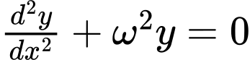.
Attached image below shows the setup.

Answer: Using  and 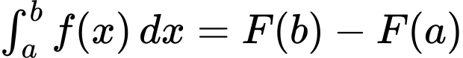, boundary condition 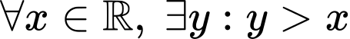, reaction , system 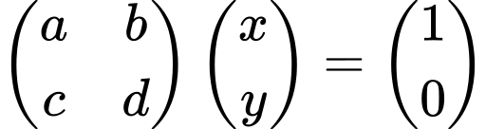.

Q.2 [5M]
(a) Which damping ratio gives fastest return without oscillation? Sample text मापदंड 🔬 with symbols: ∴ A ⊂ B, P ⇒ Q, damping ζ and ξ, em—dash, café [CO2] [BTL2]
(a) < 1
(b) = 1
(c) > 1
(d) = 0
Answer: (b) = 1

Q.3 [15M] [CO3] [BTL4]
Tabulate the following results:
Trial | Load (N) | Deflection (mm) | Stress (MPa) | Remarks
1 | 100 | 0.42 | 12.5 | within limit
2 | 200 | 0.88 | 25.1 | within limit
3 | 300 | 1.31 | 37.8 | within limit
4 | 400 | 1.79 | 50.2 | near yield
5 | 500 | 2.35 | 62.9 | yield onset
6 | 600 | 3.02 | 75.4 | plastic
7 | 700 | 3.91 | 88.0 | plastic
8 | 800 | 5.20 | 100.6 | necking
9 | 900 | 7.10 | 113.1 | necking
10 | 1000 | 9.85 | 125.7 | fracture
Answer: See table.

