Guru Nanak Dev Engineering College
Punjab Govt

Hello
 | L.K. Gujral PTU, Jalandhar  Genesis  on | 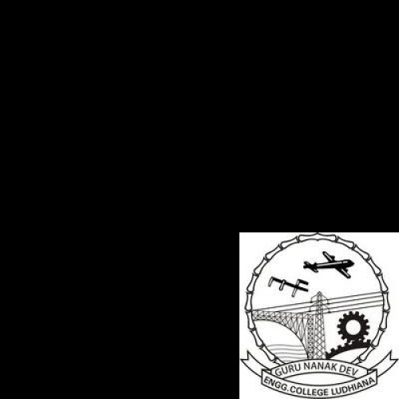
Rangoli Making

It is certified that Mr. Rakesh Kumar Budhiraja
of Techno, Ludhiana
has attended the Genesis on Rangoli Making
held at Guru Nanak Dev Engineering College.

Dr. H.S. Rai | Sukhjit Singh Sehra | Priyanka Arora
(Dean) | (Training Coordinator) | (Assistant Professor)

