Edward Street - User Guide

**login.html**

-Depending on the user role, the user will get different privileges. They enter their user name, and password, which must be longer than 6 characters.

- Users are directed to this form every time they try to access a protected resource without a valid cookie in order to get authenticated.

**index.html**

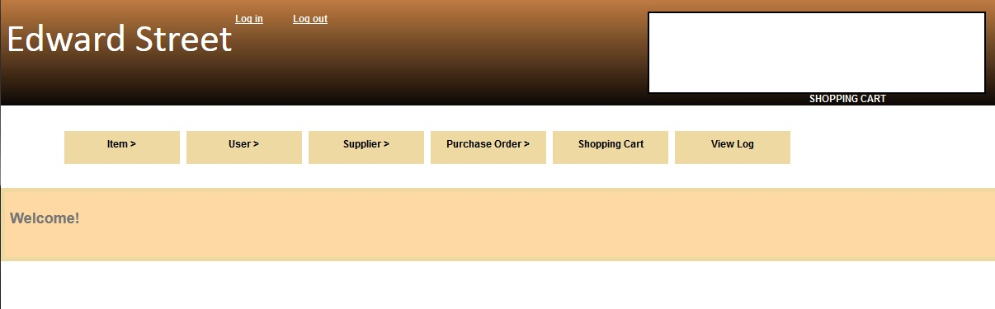

-The main web page. It contains links on the top for the user to click and perform actions depending on the user role.

- Any messages or updates can/will be shown on this page.

**createitem.html**

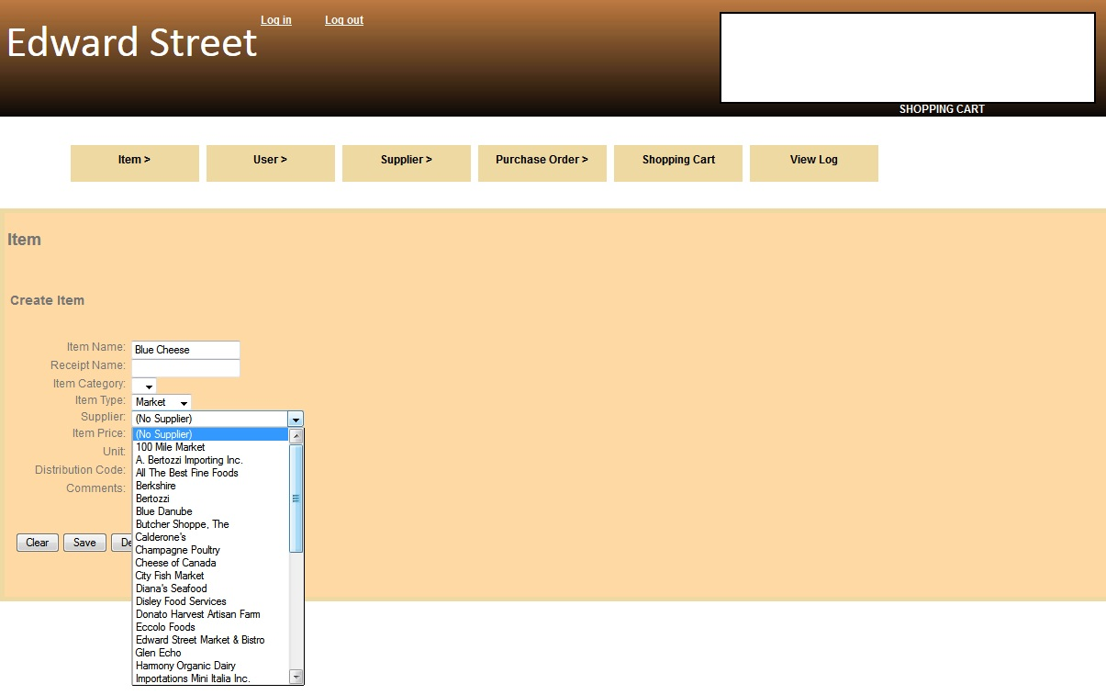

-This page is used to create an item for the purpose of placing orders, adding to a supplier, etc.

The steps to create an item:

1. Enter an Item name
2. Enter the receipt name
3. Select the item category. The categories are **meat**, **cheese**, and **fish**.
4. Select the item type. This determines whether the item will end up being used by the **bistro** (restaurant) or if the item will be sold in the **market**.
5. Enter the item price, in CAD
6. Enter the unit, which is the scalar property of the item(grams, ounces, boxes, etc)
7. Enter the distribution code, used for supplier’s code designation for the item, it can be a numeric field of any length
8. Enter any comments in the comment field
9. The user may save the creation to the database by clicking Save

**edititem.html**

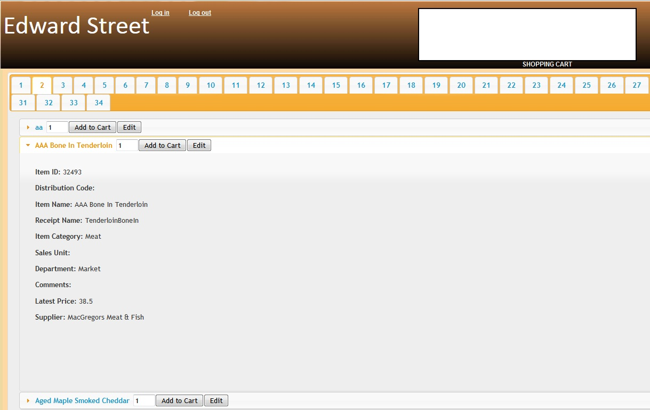

-This page is for editing the items available in the database. The user can select from a list of items displayed on the page, and click on the tabs to display more items. The tabs limit the amount of items displayed. The user may choose to either edit the item by clicking ‘Edit’ or they may add it to the shopping cart by clicking the ‘Add to Cart’ button. All the fields from createitem.html may be edited, if the user chooses to edit an item. If the user adds to the shopping cart, it is displayed on the white box on top of the menu, and it is stored in a shopping cart, viewable if the user clicks the ‘Shopping Cart’ link.

**createuser.html**

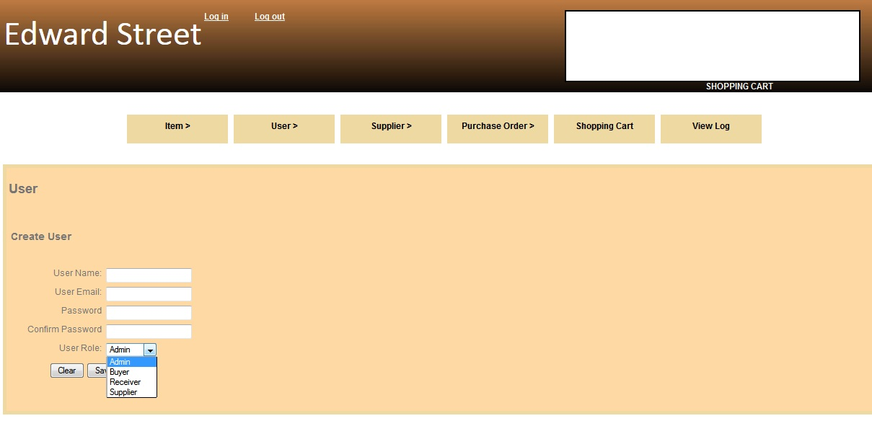

-This page is used to create a new user for the website. The user must belong to a certain role (i.e. administrator) if they would create a new user.

The steps to create a user:

1. Enter a user name. The user name must only contain alphanumeric characters.
2. Enter a user email. The email must be syntactically correct, with the @ sign and .com
3. Enter a password for the user. The length has a limit between 6 and 20 characters.
4. Enter the same password under confirm password
5. Select the role for the user being created
6. The user may save the newly created user to the database by clicking Save

**edituser.html**

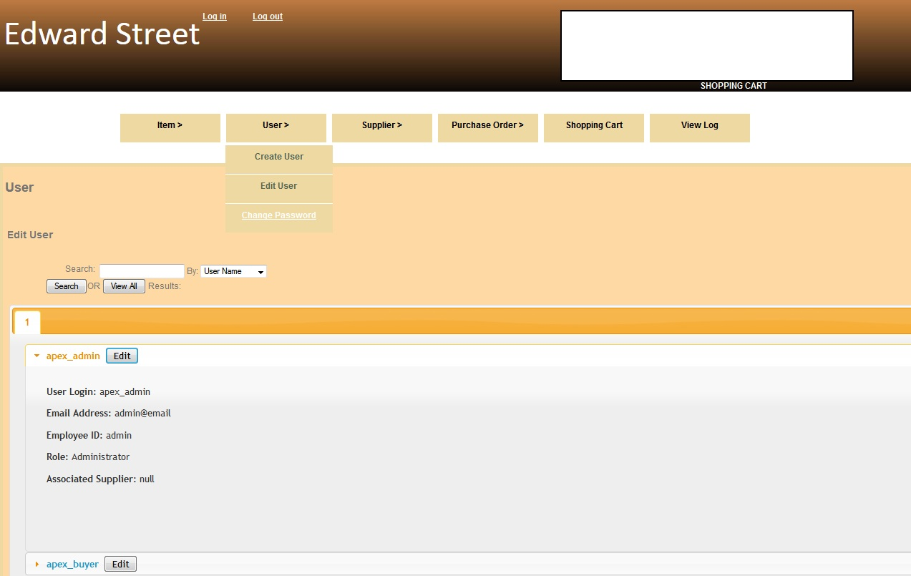

-Used for editing any existing users contained in the database. They may select the user from the list by clicking the ‘Edit’ button, and editing their User Name, Email Address, or User Role. The user may choose to save this to the database by clicking Save. Deletion of a user is permanent.

**editaccount.html**

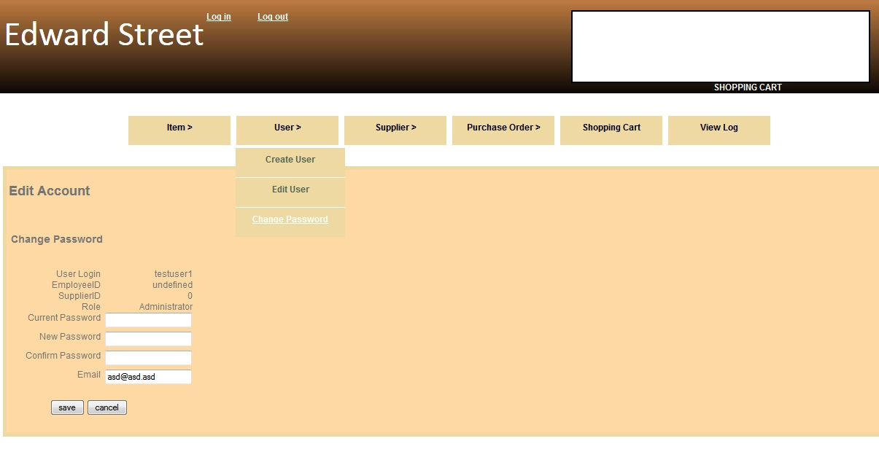

-This is where any user may choose to edit their account details like their password. They simply enter the current password, a new password (6 – 20 characters), and confirm the new password, and the email address. The user may save their details to the database by clicking Save.

**createsupplier.html**

-This is where a user may create a supplier to be used for placing orders or associating items to them. The user must have administrative privileges in order to perform this.

The steps to create a new supplier:

1. Enter a Supplier Name. This would be the company name for the supplier.
2. Enter the Supplier’s Legal Name. This would be the main person who is in charge of the company.
3. Enter a Lead Time. This would be the times that the Supplier may deliver their items.
4. Select Delivery Dates. They are days that the Supplier would be delivering on.
5. Enter any comments for suppliers under Supplier Comments
6. Enter any other comments under Other comments
7. The user may choose to save to the database by clicking Save

**editsupplier.html**

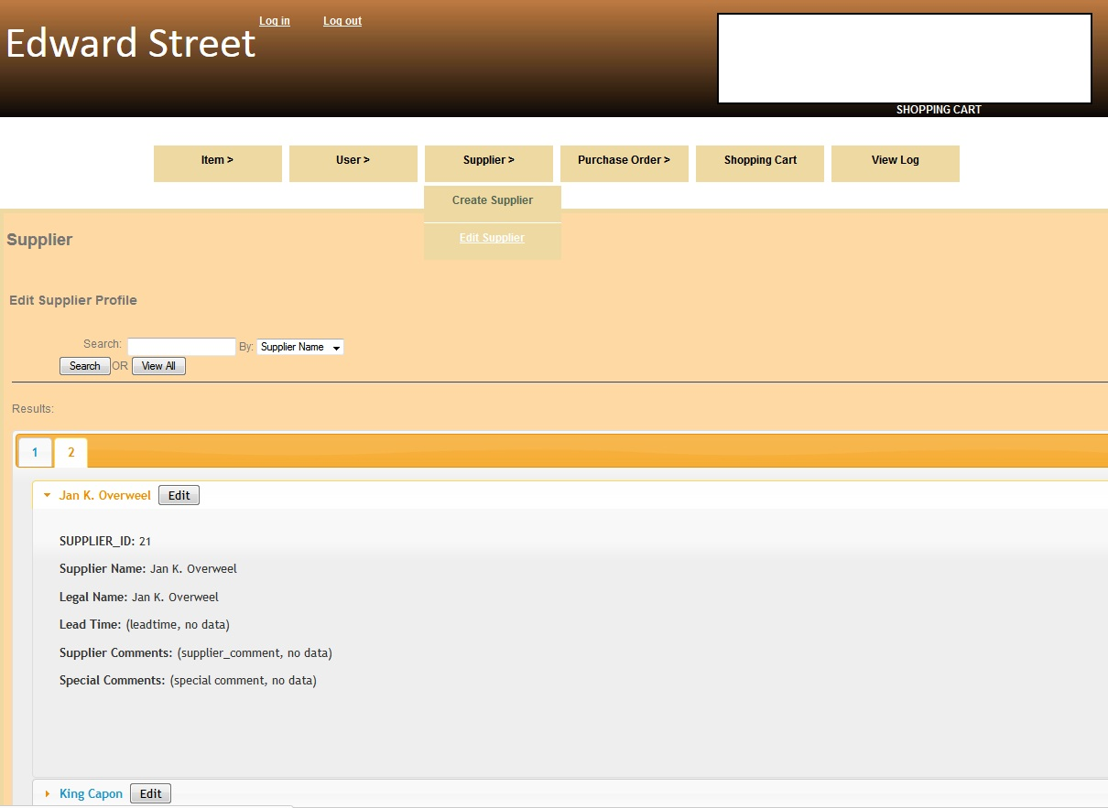

-Used for editing any existing supplier. The user must have administrative privileges in order to do so. The user would select a supplier from the list, and more suppliers are listed in other tabs. The user would click on ‘Edit’ to edit a Supplier. All the fields can be edited, Supplier Name, Legal Name, Lead Time, Delivery Dates, Supplier and Other Comments. The user may choose to save to the database by clicking Save.

**createpo.html**

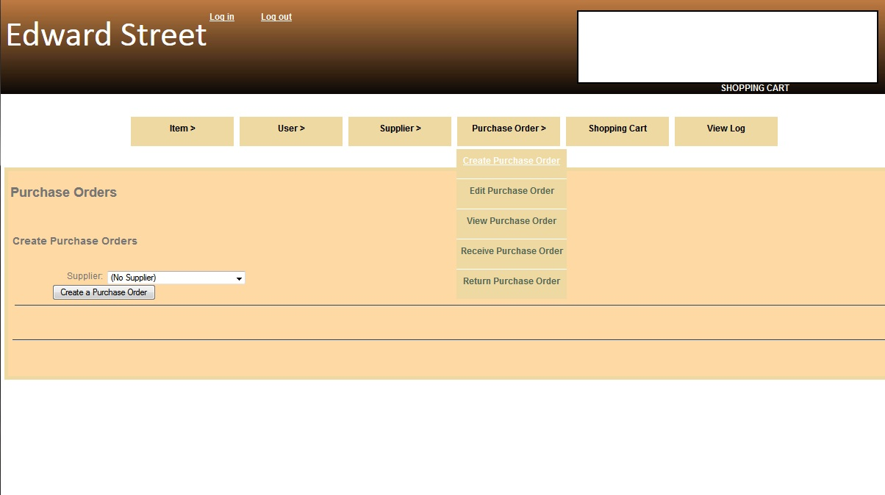

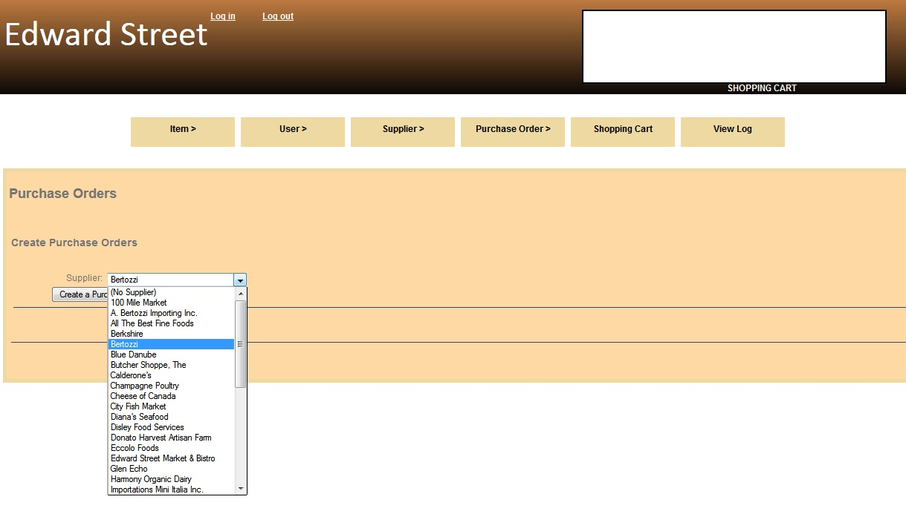

-This page is used to create a purchase order. The purchase order may or may not be complete, as the purchase order may be stored as queued (not ready for order).

The steps to create a purchase order:

1. Select a supplier from the drop down list.
2. Click ‘Create a Purchase Order’. More fields are displayed:
3. Delivery Date, where the user may select from a Calendar
4. Delivery Time, where the user can enter the time for the order to be delivered
5. Reference Number, for use with referencing the order
6. Comments for entering any other information.

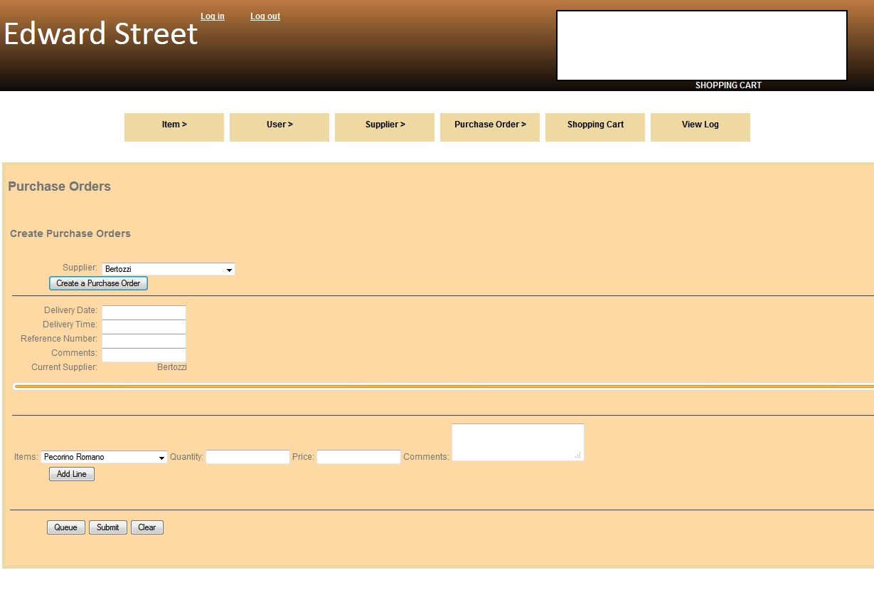

Each supplier that is selected is stored in a tab, where the user may switch between the tabs.

The user may add purchase order lines to the purchase order, and the purchase order lines with items from their respective suppliers are stored under that same supplier tab

The steps to add purchase order lines:

1. Select the Item from the drop down list
2. Enter the Quantity to be ordered
3. Enter the Price
4. Enter any Comments
5. Click ‘Add Line’ to add a line to a purchase order.

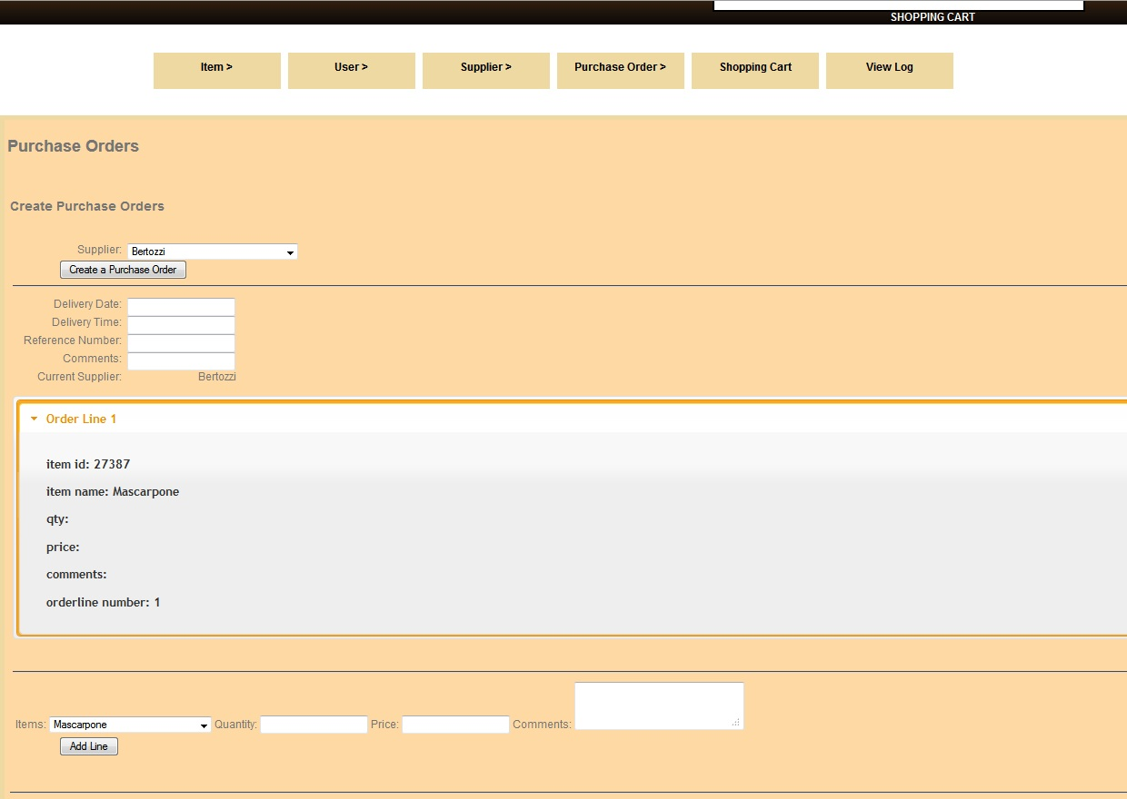

The user may submit the order by clicking ‘Submit’, but only if the purchase order is complete. Otherwise, the user may click on ‘Queue’ to hold the order and complete it later.

**editpo.html**

-This page is used to edit a purchase order. If the order has been put on Queue, it will be displayed on this page. The user may edit the item, quantity, price and comments, or add / remove a supplier.

**viewpo.html**

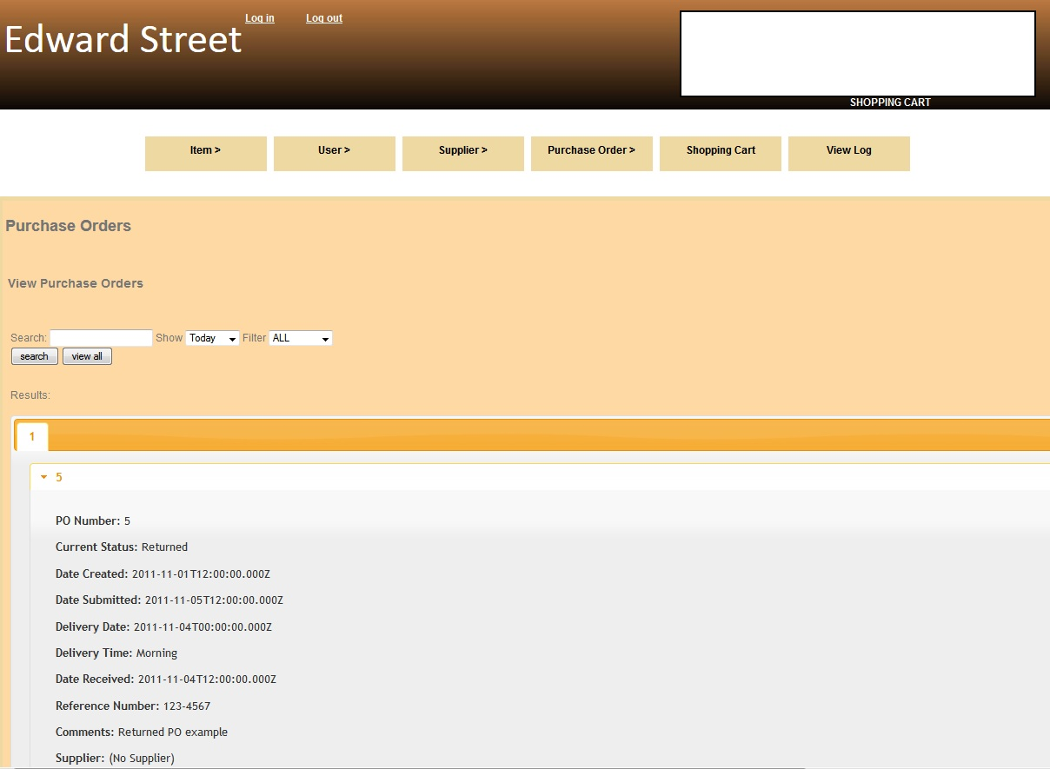

-Used to view a purchase order. The user may filter to see All purchase orders, Queued, Submitted. Received, Returned, or Cancelled purchase orders.

**receivepo.html**

-This page is used for receiving purchase orders. The user simply clicks on an order from the list and the order is received.

**returnpo.html**

- This page is used for returning purchase orders. The user clicks on an order from the list, and clicks confirm to return the purchase order.

**shoppingcart.html**

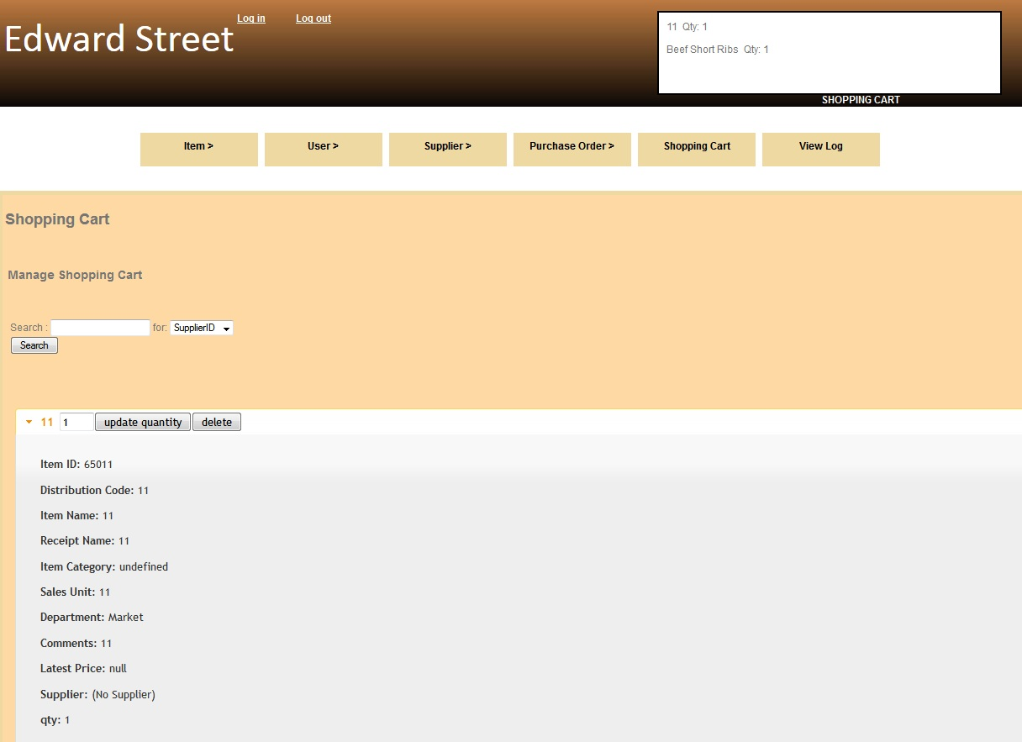

-Used for viewing, editing or removing items from a shopping cart. If any items are added to the shopping cart, it will be displayed in the list. The user may edit the quantity by filling in the textbox where the number is, and click on ‘update quantity’. To delete from the shopping cart, the user clicks ‘delete’, and it is removed from the shopping cart. The shopping cart items are persisted across the page.