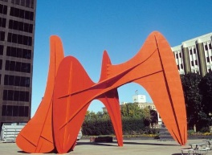

1. Where is the above sculpture, named “La Grande Vitesse”, located?
   1. Rosa Parks Circle
   2. East Grand Rapids
   3. **Calder Plaza**
   4. Van Andel Arena

1. What is the name of the world renowned art showcase that takes place in Grand Rapids each year?
   1. **Art Prize**
   2. Festival of the Arts
   3. Calder Art Competition
   4. Artfest
2. What is the name of the Grand Rapids hockey team?
   1. Falcons
   2. Lions
   3. Eagles
   4. **Gryphons**
3. Which of the following bars is famous for their idea to ferment their beer in whiskey barrels?
   1. HopCat
   2. **Founders**
   3. J. Gardella’s
   4. Stellas
4. How many bridges cross the Grand River in the Grand Rapids area?
   1. 3
   2. 5
   3. **7**
   4. 9