In this practice we are going to see basic network configurations in Windows, Ubuntu Desktop and Ubuntu Server systems.

Daniel Sánchez Fernández – 21/04/23

ConfigLinuxWin

Implantación de Sistemas Operativos

Contents

Practice Objectives and Materials 2

Configuration in Windows 2

Names, addressing systems and name resolution 2

Names 2

Adressing systems 3

Name resolution 6

Basic Firewall Settings 7

Offline file settings 8

Operations on the network icon 11

Configuration in Ubuntu (Desktop) 13

Names, addressing systems and name resolution 13

Addressing systems and name resolution 13

Device name 15

Firewall Configuration 16

Network configuration in Ubuntu Server 17

Addressing systems and name resolution 17

Ifupdown 17

Netplan 18

Name resolution 19

Conclusion: 19

Copyrights 19

Social networks 19

Webgraphy 19

# Practice Objectives and Materials

* Configure basic networking on Windows, Ubuntu Desktop (Graphical) and Ubuntu Server (Non-graphical) systems:
  + Names, addressing systems and name resolution.
  + Basic firewall configuration (Windows and Ubuntu Desktop)
  + Offline file configuration (Windows)
  + Operations on the network icon (Windows):
    - Repair, enable/disable, status, properties, bridged connection (Investigate what it is and what it is for), etc.

# Configuration in Windows

* I am going to start the practice by showing the configuration in Windows

## Names, addressing systems and name resolution

* This practice is to determine the network configuration of a client (Windows), so we do not have to create a name resolution server but show how to put it in the network interface.
* Let's start with the basic configuration:

### Names

* The names allow us to identify a node in a network, they are also known as "Hostnames" and can be configured from the Windows configuration:
  + To view or configure it, we will go to "Settings > About".

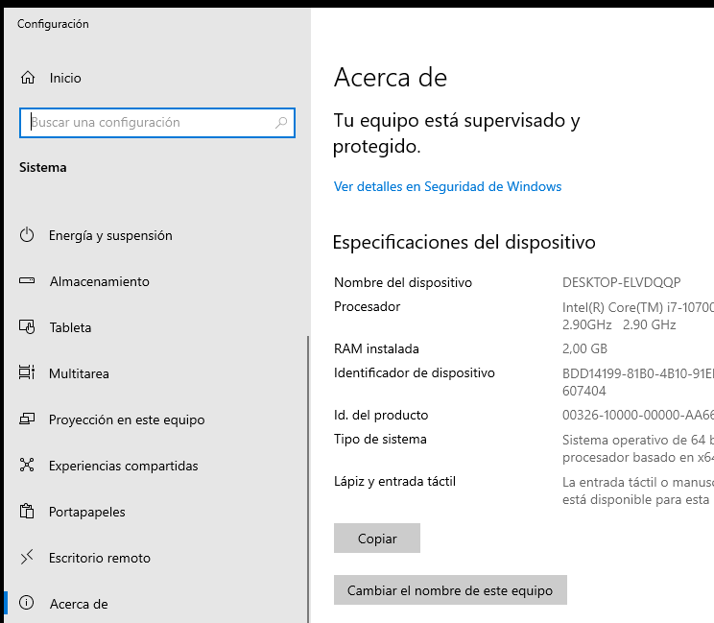

Here you can see the current name of my device and other parameters of interest

* We will be able to change the name of the equipment by clicking on "Change the name of this device".

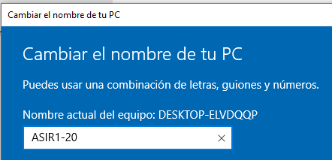

We give it the identifying name we like for our device

* After that, click "Next" and you will be asked to restart the system.

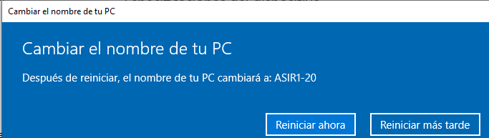

We restart now and check the changes

* Let's check if the changes have been applied

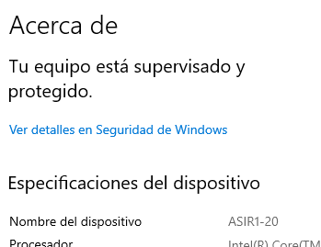

We see that the name has been changed correctly

* Let's go to the addressing systems

### Adressing systems

* To do this, right click on the network (bottom right) and go to "Open network and Internet settings".

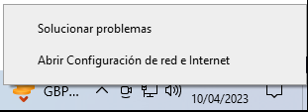

It takes us to the network configuration

* After that, select the interface whose parameters you want to modify and click on "Change adapter options".

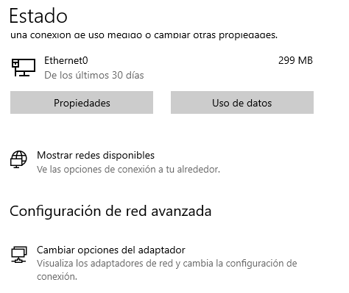

Click on "Change adapter options" to go to the advanced configuration of the network interface.

* A menu will open with all our physical network interfaces. Select the interface to be modified > right click > properties

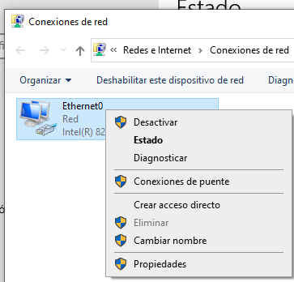

It will take us to the parameters and properties of the adapter

* Once here, we can access the element we want to modify by "double clicking" on it.

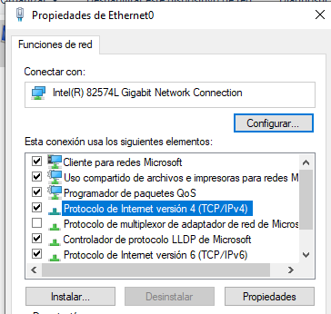

To modify the "IPv4" address, double click on "Internet Protocol version 4 (TCP/IPv4)".

* Once inside, we will see the "general" parameters of the network interface, from where we can see them and modify them manually or dynamically (with DHCP or the APIPA protocol).

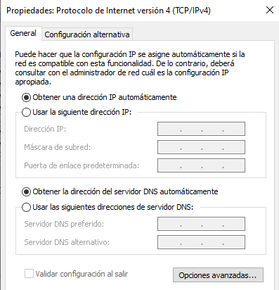

Click here to leave the network configuration on automatic (DHCP/APIPA)

Click here to add a manual address

The same applies to the DNS servers, but I will talk about them later

* We are now going to assign a manual network

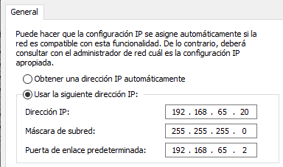

Check "Use the following IP address" and enter the static IP address you want, the network mask that corresponds to it and the gateway that will serve us to go to the Internet, routers, routing ... (Default route).

* Once this is checked, we apply and check the changes with an "Ipconfig" in the terminal.

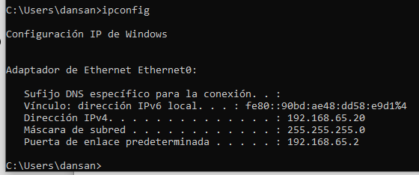

We see that the parameters have been saved according to how we have configured them.

* Let's go now to the name resolution (DNS) configuration

### Name resolution

* The DNS configuration will indicate the server we will use to translate domain names (FQDN) into IP addresses so we can connect to them. Currently I don't have any domain servers set up, so I'm going to try going out to the internet and show what happens:

As we can see, I have no Internet access



* Let's go back to the adapter configuration to use a DNS name server that will allow us to go out to the Internet:

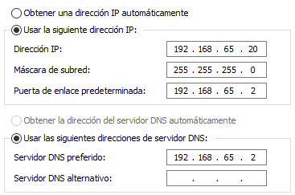

We can use a local and private server (For example, this is the one of my router).

This DNS if it is well configured will allow us to go out to internet or communicate with internal domains of our network (here I show how it lets me go out to internet).

We can also see how I give it a domain name and it responds with an IP address.

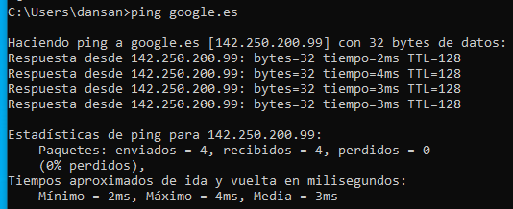

* The other option is to use a public server, for example Google's server (8.8.8.8).

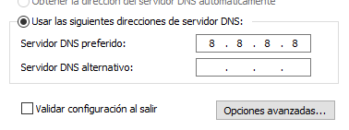

Now I am using a public server, and as you can see, it also lets me go out to the internet.

Each server has its advantages and depending on your network you will be more interested in using a public or private server.

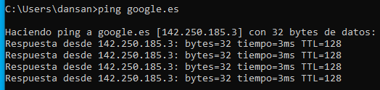

* To see the DNS servers that we have on a host, we can do "ipconfig /all".

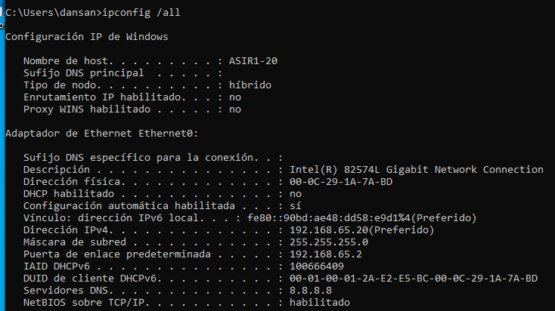

Here you can see more network configuration, such as MAC address, server and DHCP configuration (if you have it enabled) ...

* You can also add an alternate server, in case the main server does not find an answer, the alternate server will see if it has one. In the case of Google, its alternative server is "4.4.4.4".
* This completes the basic configuration of the network parameters in Windows.

## Basic Firewall Settings

* To access the Firewall settings, go to "Control Panel > System and Security > Windows Defender Firewall".

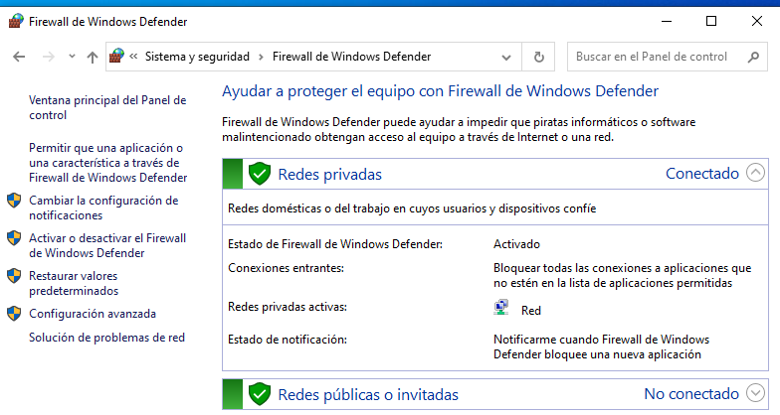

Here it will show us if we have activated or deactivated the firewall and other options.

We will be able to deactivate it pressing in "Activate or deactivate the Firewall of Windows Defender".

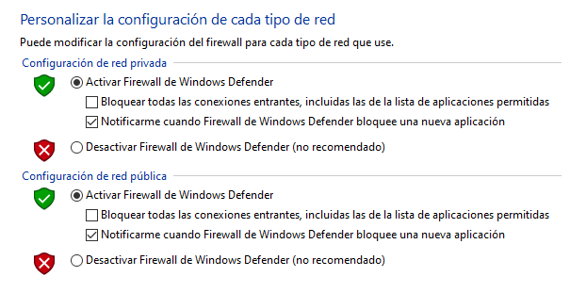

This will lead us to the customization of each type of network. You can mark the deactivation if necessary.

* Disable the Firewall, it will allow us to make tests for example in network diagnostics or in laboratory tests.
* If we click on the second option under "Enable or disable" we can go to the advanced Firewall settings.
* Here we can enable or disable it, set new inbound rules or outbound rules and also view the existing rules.
* I am going to go into the inbound rules and show how they look like

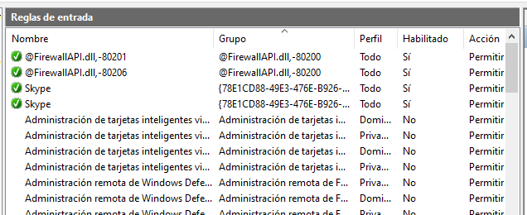

Here are the input rules (Enabled or not and to which profile and group they belong).

* On the right, we can add a new rule if we wish to do so

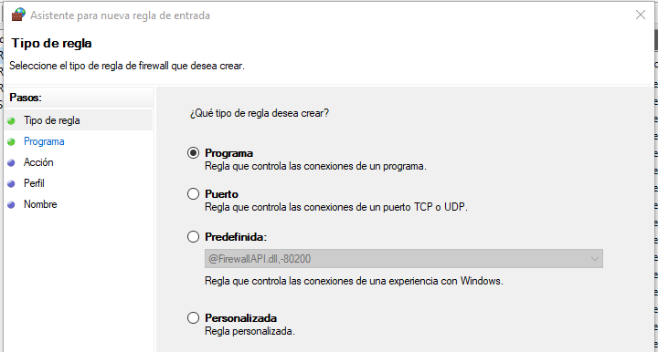

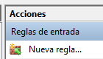

* With this, we will be able to define a new rule and choose who it affects.
* Finally, we can choose an existing rule and modify it by double-clicking on it.

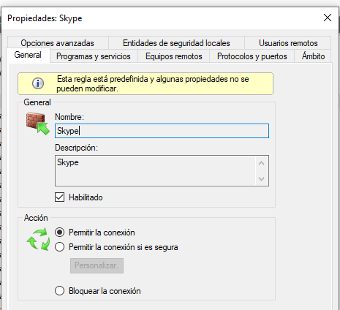

We can view parameters, options, allow (or not) the connection, enable/disable...

## Offline file Settings

* Offline Files is a utility that allows us to synchronize files and folders over a network, so that copies of network files and folders are created and stored on the computer. This allows us to access them even when we are not connected to the network.
* To enable it, the first step is to synchronize the network drive to the local drive.

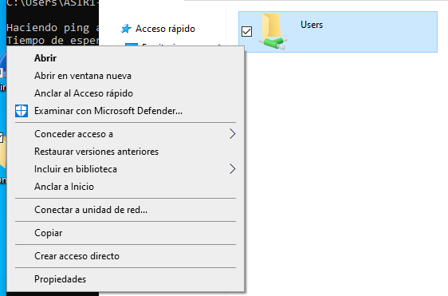

We must click on "Connect to network drive..." (The "Users" folder is a random folder that I have shared to show this section).

* that, we mark on which "network drive" we want it to be stored

In this case, it will be saved on the "Z:" drive in the folder "\\DESKTOP-2G9C44S\Users".

* If I now go to "This computer", a new disk appears under "Network locations".

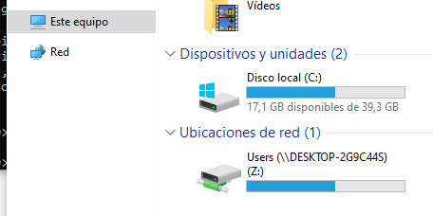

This disk will have what we have instructed it to store (in this case, it stores the entire local disk (C:)).

* I will now show how I can access even if I am offline.

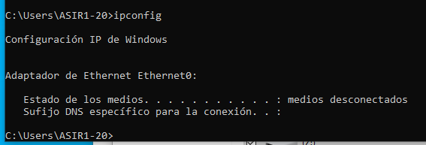

The media are offline, so I am not on any network.

* Let's go now to the file explorer

The disk is still located there, let's try to access it.

Indeed, I can enter and read the disk.

* See what happens if however, I go to the network tab

This section is empty and complains that it is not connected to any network.

* We can also configure the allowed cache in the shared folder configuration, go to "properties > sharing > advanced sharing > cache".

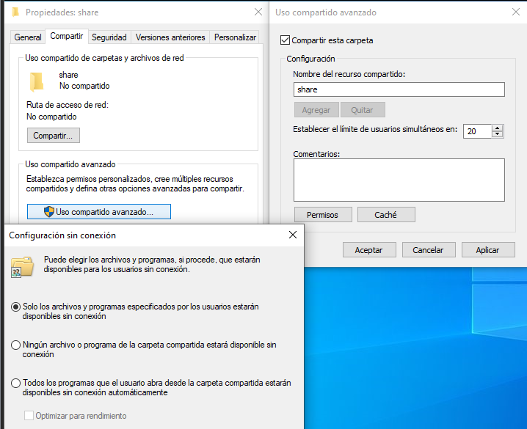

In sharing, we must go to "advanced sharing" and from there share the folder and go to "Cache", after that we will open an offline configuration menu where we can choose which files are or are not allowed offline.

* This will allow us a better control as network administrators with our users.

## Operations on the network icon

* We are now going to show different options on the network icon and why they are relevant
* To do this, we go back to where we were before (Adapter options) and click "right click" instead of double click on the adapter we want to interact with.

This will open a context menu with several options that I am going to explain now:

* Disable/Activate: Allows us to deactivate the network adapter, so that it stops receiving and processing information. When doing this, if we type "ipconfig" in the CMD, nothing will appear.

Adapter disabled

No IP configuration

* To re-enable it, "Right click > enable".
* Status: Shows us a general summary of our network adapter, the connectivity protocols we have enabled (IPv4/IPv6), whether the Ethernet adapter is enabled or not, how long it has been enabled, what speeds it supports and finally shows us the network activity it has had.

We will be able to see more details or options with the buttons (although most of these buttons can also be found in the context menu of the card by clicking on "right click")

If we click on "Details", it will show a more detailed description of the network interface and its connections.

* Diagnose: Will open the Windows problem detector and start searching for problems with the card.

As this card does not have any problem, an error that it could not identify the problem is displayed.

* Bridge connection: Allows us to connect segments of different topologies (different network interfaces) and architectures (e.g. Ethernet with Wi-Fi), we will see this section in better depth in future practices (Routing).

If we select a single network interface, an error will occur, since it requires interconnecting several network interfaces with each other

* Create shortcut, delete or rename: They do exactly what their name implies.

For convenience when managing adapters

* Finally, properties: It is the same as double-clicking twice on the adapter, it will open a menu with configurations of different types of the adapter, such as IPv4, IPv6, Network Sharing....

These options can be accessed by double-clicking on them.

* If we click on "Install...", we will be able to install new network elements; of type "Client", "Service" or "Protocol".

This is an example of the "Service" element

* With uninstall, it is the opposite. We will be able to uninstall an element of the network, I do not recommend doing this if you do not know very well what you are doing because it can cause major problems in the network configuration and the device itself.
* This concludes the Windows part.

# Configuration in Ubuntu (Desktop)

## Names, addressing systems and name resolution

### Addressing systems and name resolution

* Let's now start an "Ubuntu Desktop" machine, here, in the upper right corner will appear the network icon, click on the > wired connected > wired network configuration.

Clicking here will take us to the configuration of our network interfaces.

* Once here, click on the interface you want to modify and click on the cogwheel

Press the cogwheel to configure the interface

* After that, a details tab will appear and we will have to move to the parameters we want to modify.

We can go to "Identity", "IPv4", "IPv6" or "security", for this practice we are interested in going to "IPv4".

* Once in "IPv4" we check "manual" to configure our network interface.

We check manual

* Once here, we will be able to determine a static IP address, the DNS server of our choice and static routes for routing.

With this, we would have already configured our static IP and a private DNS server.

* After that we apply the changes and "turn off" and "turn on" the network adapter.
* We can go to a terminal to confirm the changes.

We can see that the changes have been made correctly

* Let's go now with the Host name change

### Device name

* You can find this name in files called "/etc/hostname" and "/etc/hosts".

You can see here the name of my machine

* We can modify it with "sudo nano" and then we will have to reboot

Here we can see the name change, now we restart.

After rebooting, we can see that the machine name has been changed correctly.

* Let's go now to the firewall configuration

## Firewall Configuration

* Here we can use "Iptables" or "ufw", in this case I will use "ufw" as it is simpler to start with and allows less complex functionalities for beginners.

Here we can see all the options of the "ufw" command, we are going to highlight in this practice; enable, disable, deny, allow and delete.

* The first thing to do is to activate it, this is done with "ufw enable".

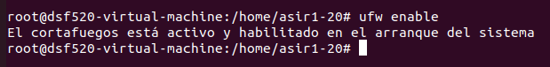

* We can allow a port with the option "Allow".

This will add the rule that allows us to use socket 22 (SSH).

With this, we will remove the rule that we just added

* Podremos quitar la norma con “deny”

* We can also set more complex rules



* This rule allows to use the TCP protocol through the gateway to any connection to port 22.
* We will be able to see all the rules with "status".

Here we see the three rules that I have added, whether they are allowed or not allowed and from where they are produced

* We can also delete a rule with the "delete" option and the number that identifies the rule.

As we can see, I have deleted the second rule

* Finally, we can disable the firewall again with "disable".



* With this, I have already shown the basic operation of this command to make firewall in Ubuntu, I leave the page from which I have documented in case you want more information on the subject
  + <https://ubuntu.com/server/docs/security-firewall>
* With this I finish the part of "Ubuntu Desktop".

# Network configuration in Ubuntu Server

## Addressing systems and name resolution

* In this section it is not necessary to talk about the names since they are configured the same as in Ubuntu Desktop ("hostname" and "hosts" files).
* I am going to do this with two network configuration systems: "Netplan" and "ifupdown".

### Ifupdown

* For this, I will show the configuration made in a previous practice and explain how to configure it, we will go to the file "/etc/network/interfaces".

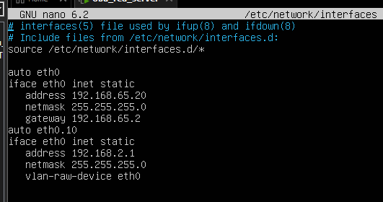

First, we mark the network interface (eth0 in my case), we mark "static" to indicate a static IP, "address" to mark the ip, "netmask" for the netmask and finally "gateway" for the default gateway.

Below is the configuration of a VLAN or virtual interface.

We will be able to see the configuration with an "ifconfig".

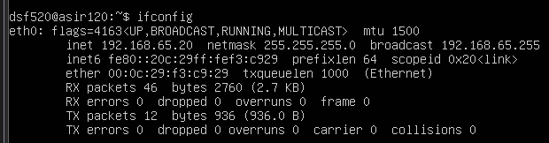

* The addressing servers (DNS) are shown in another file (which I will show later)

### Netplan

* It is configured in the file "/etc/netplan/00-installer-config.yaml".

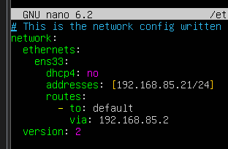

First, we determine the network interface (ens33), we decide whether or not we want "DHCP" (dhcp true/false/yes/no). After that, we mark the static address of the machine and finally we determine the static routes (in this case I determine the default gateway, but other routes can be determined).

* After that, we run a command "netplan apply", now let's check the IP address and the routing table

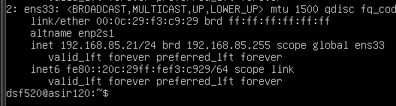

Here we can see the correctly configured IP address

* And now let's show the routing table, for this we must install "net-tools" and then I will show the table with "route -n".

We can see that the default gateway is the one I have configured in netplan

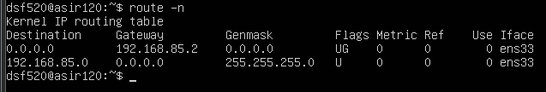

* Let’s go now to the name resolution servers "DNS".

### Name resolution

* To configure them, we will go to the netplan configuration file:

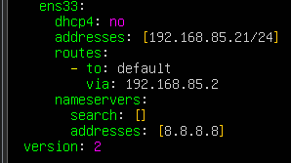

To modify it, we open the netplan configuration file and add "nameservers", in "search" we put the search domain (in my case I don't have any) and in Addresses, the DNS server address (in this case, I use Google's).

* We will be able to see the configuration with "resolvectl status", this will show us the DNS configuration (stored in "/etc/resolv.conf").

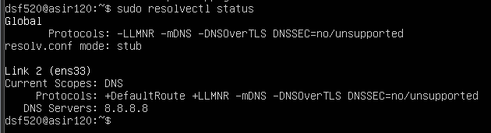

Here is the configuration we have set up

* With this, I finish the Ubuntu Server part and with it, the practice.

# Conclusion:

* Knowing about how to configure the network in various operating systems is very necessary and even imperative to be able to perform a good function as computer professionals and network technicians.

# Copyrights

* All the practice has been carried out and tested by me: Daniel Sánchez Fernández - ASIR1-20, with the information provided by the professor and indicated in the webgraphy of the document.

# Social networks

* LinkedIn
  + <https://www.linkedin.com/in/daniel-s%C3%A1nchez-fern%C3%A1ndez-6b948923a/>

# Webgraphy

<https://ubuntu.com/server/docs/security-firewall>

<https://recoverit.wondershare.es/computer-backup/enable-offline-files-in-windows-10.html>