RnPC: Radionuclide Production Calculations

By Simon Ferguson, simon.ferguson@ualberta.ca

# Getting Started

RnPC is a graphical user interface that can be used for radionuclide production calculations. It is programmed in matlab. The philosophy behind the program is to be versatile and able to adapt to many different calculations.

In order to use the GUI, download and install the Matlab Runtime from the following link and follow instruction guidelines.

* <https://www.mathworks.com/products/compiler/mcr/>

# Downloading the GUI

The executable file should be put in a directory with the necessary data folders. It can be downloaded from **

# RnPC Introduction – Example Use

This is a short introduction to using the GUI. Start the GUI by running RnPC.exe.

## Cross Sections Tab:

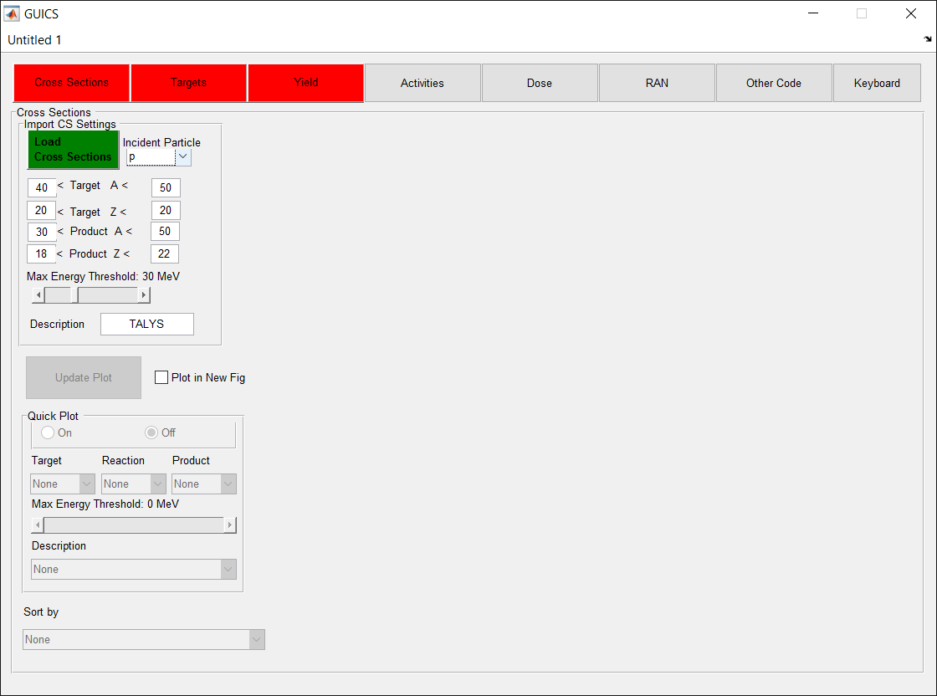

* Load Cross Sections
  + To do this, select the appropriate settings in the ‘Import CS Settings’ Panel.
    - For example, the settings above will only import certain cross-sections, based on if the incident particle is a proton (‘p’), if the target and product isotopes have certain mass and Z numbers, and if the reaction cross section energy threshold is below 30 MeV. It will label these cross-sections as being from ‘TALYS’ (the default).
* Click on the green ‘Load cross sections’ button. This will open the window prompt. Select the folder top folder of all the cross sections. In the data provided, it is located at: $GUI_DIRECTORY$/DATA/TALYS
  + Note that this directory currently contains all the proton and deuteron induced cross-sections for Calcium and Titanium. If you select the top folder, it will take a while to go through all of them. You can increase the speed by selecting the cross sections of interest and putting them in a new folder.
* The cross-sections are now displayed in the table and other functions in the ‘Cross Sections’ tab are now available. You can plot cross section by selecting the plot checkboxes individually in the table, or by turning quickplot ‘on’ and using the dropdown menus and sliders. The table can be sorted by each column using the ‘sort by’ pulldown menu. Note that once you have the desired combinations of cross-sections to plot, you must use the ‘update plot’ button.
* See data details for how to download more cross-sections from TENDL.

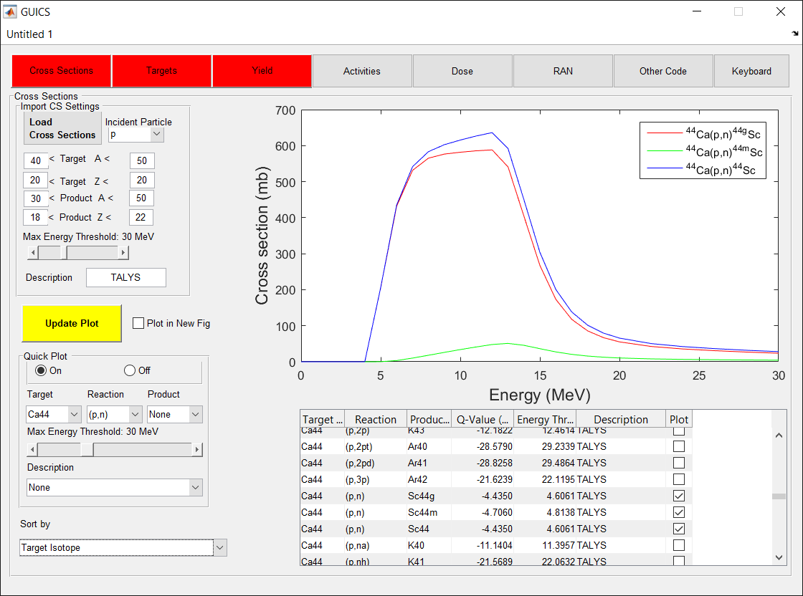

## Targets & Isotopes Tab

* Once the cross-sections are loaded, the ‘Targets’ tab can be selected and you can load the isotopes into the database by clicking the green ‘Load Isotopes button’. This allows the GUI to associate isotopes with their half-lives, daughter isotopes and decay fractions. The user file which defines this can be found under $GUI_DIRECTORY$/DATA and has the extension ‘.isod’. The provided file is ‘Isotopes.isod’.
  + The data in this file can be observed in the table that appears on this tab.

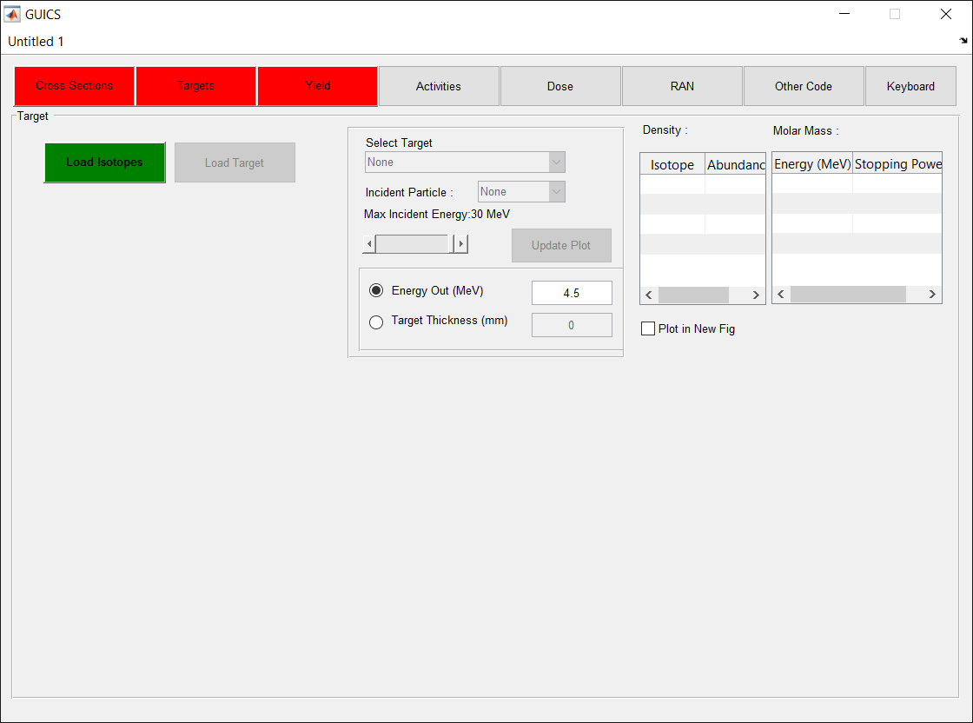

* The targets should be loaded next, which can be done by clicking the green ‘Load Target’ button. The user file which defines targets can be found under $GUI_DIRECTORY$/DATA and has the extension ‘.tgt’. The provided file is ‘Targets.tgt’.

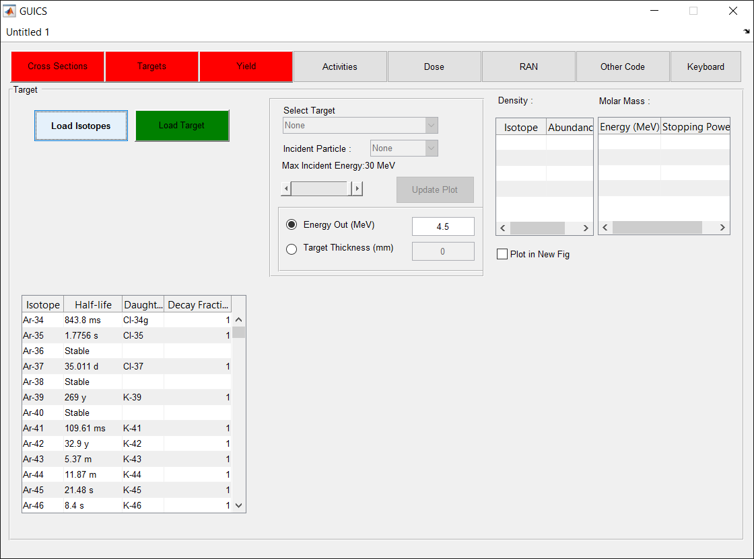

* Once targets are loaded, the user can plot the stopping power and particle range for the different particles associated with the target, by clicking the yellow ‘update plot’ button. They can also look at the isotopes which are included in each target and their relative abundance.
  + For example, in the image below, the stopping power is being plotted for the protons in natural calcium, and the range is being plotted as a function of degrading the proton energy to the energy out (4.5 MeV).

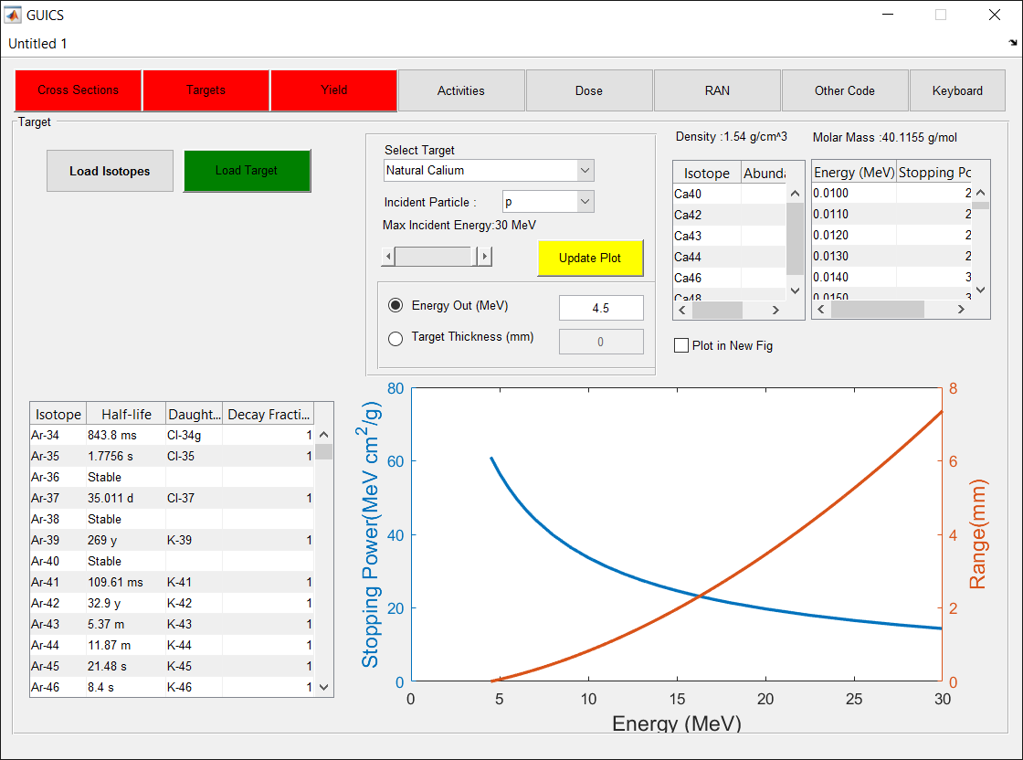

## Yield Tab

* Once targets are loaded, the saturated yields can now be calculated. In the ‘Calculate Sat Yield Settings’ tab, select the appropriate setting and click the green ‘Calculate yield’ button.
  + Select the target, incident particle, and range of energies over which the saturated yields will be calculated. Also, if you only want to use a subset of the imported cross-sections, use the ‘CS type’ drop down menu to select the description with which they were imported. Note that using a wider energy range and a larger amount of cross-sections will increase computation times.

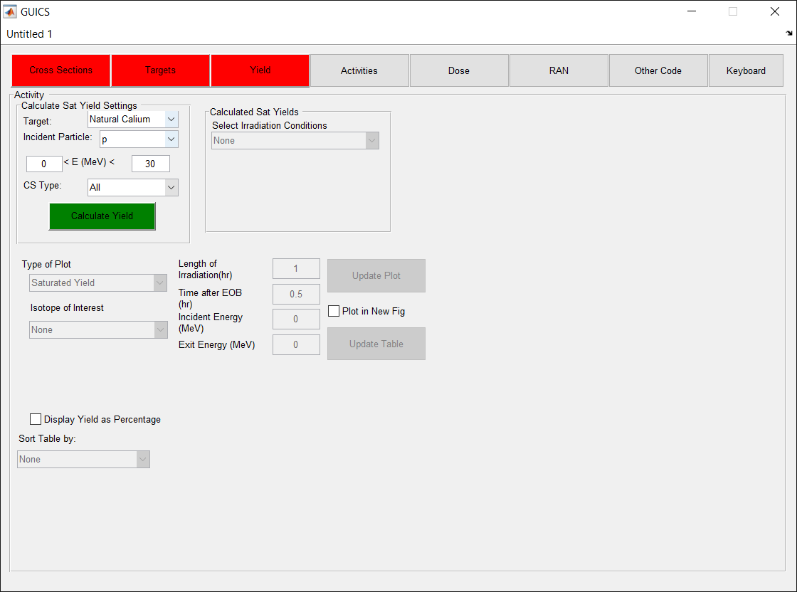

* Once the saturation yields have been calculated, it can then be selected from the ‘Calculated Sat yields’ panel. The user can then plot different graphs by modifying the plot settings, as well as create a table with the yields of the isotopes at different time points. You must click the yellow ‘Update Plot’ and ‘Update Table’ buttons to update each respectively.

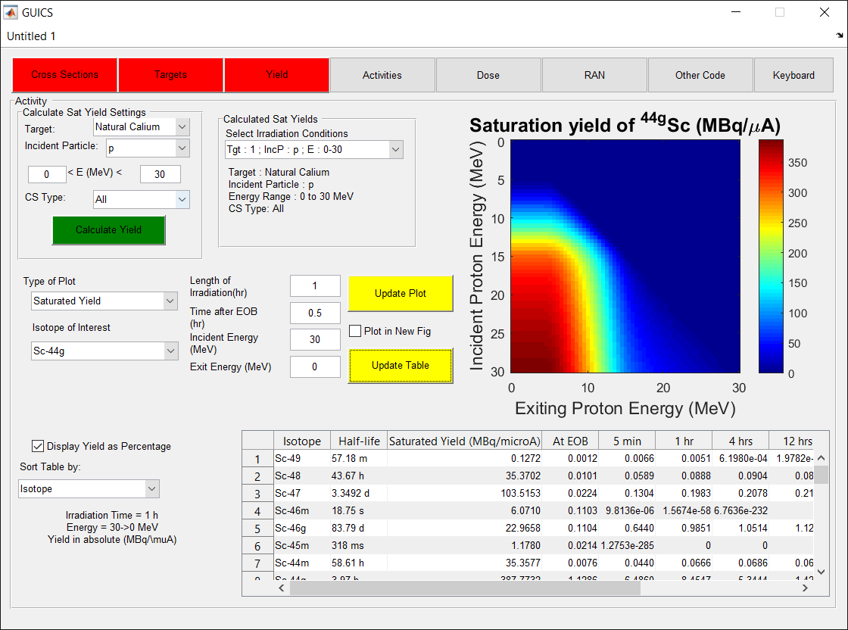

# Example Calculation

Production of scandium-44g from natural and enriched calcium targets.

# Data Details

## Nuclide Library

Nuclide information for half-lives and decay chains are taken from NUDAT v 2.7.

* Data was downloaded from <http://www.nndc.bnl.gov/nudat2/index.jsp>
* Imported data can be verified on target tab in the table. To verify decay and branching.
* If in doubt, should check half-life and branching of nuclides of interest.

## Cross Section library

The cross-sections files used in the examples are taken from TENDL-2014. This is the default file format that is used for cross-sections.

* If the same cross section is added multiple times, it may be used multiple times in the calculation of saturation yield. Ensure that the cross-section type is different for each same excitation function added in order to prevent this.

### Downloading TENDL files individually

The TENDL-2014 files can be obtained by visiting <ftp://ftp.nrg.eu/pub/www/talys/tendl2014/tendl2014.html>. For example, the 44gCa(p,n)44gSc file can be obtained at: <ftp://ftp.nrg.eu/pub/www/talys/tendl2014/proton_html/Ca/ProtonCa44xs.html> and saved by right clicking and selecting “Save link as”.

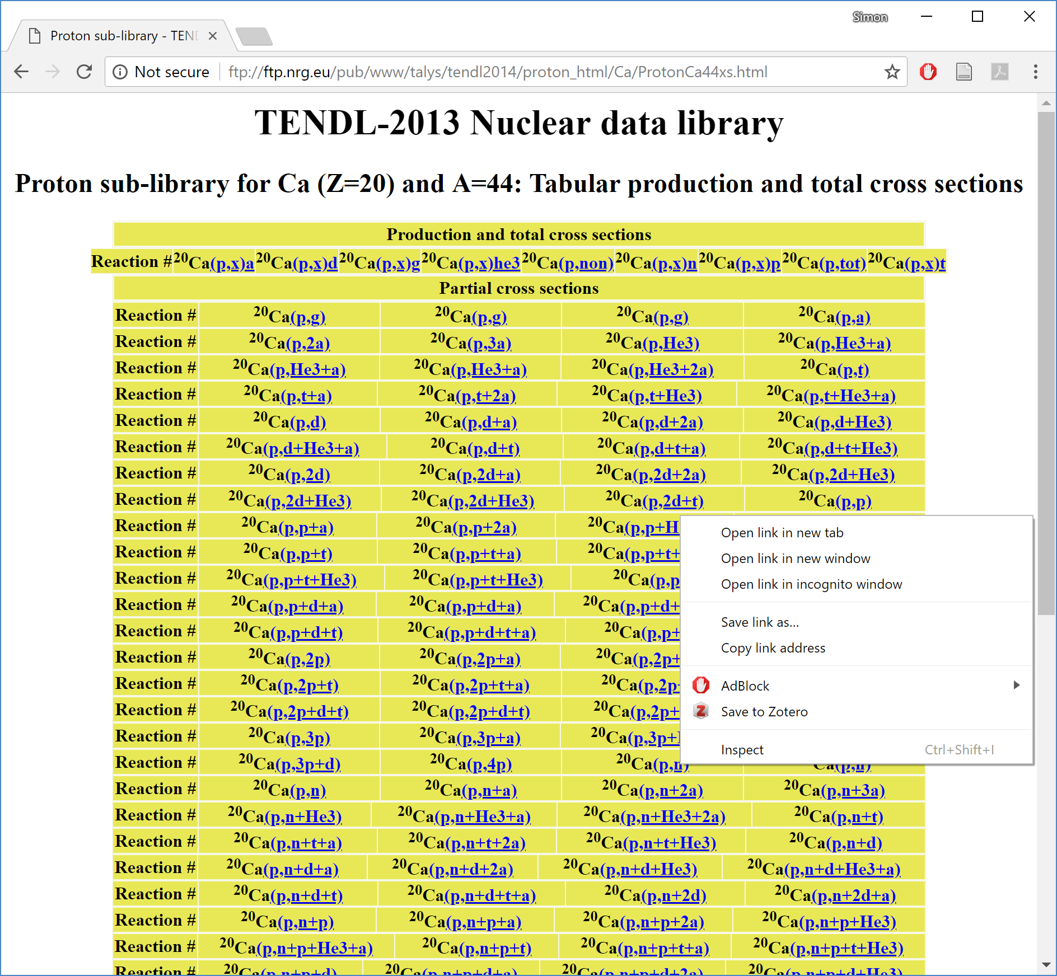

You can also use the getTENDL.exe utility to download all the files associated with a given radionuclide.

Save all “.xs” files in one folder.

** See ftp download procedure or save files manually.

To download all the .xs files for a given isotope, one can use ftp commands in the command shell.

ftp ftp.nrg.eu

prompt

cd pub/www/talys/tendl2014/proton_file/Zn/067/xs

mget *Requirements:

These will download all the files for proton

* Extension must be .xs to be imported
* Must be formatted the same as TENDL-2014

#### File format

### User cross-section data

Requirements:

* Copy data from EXFOR or similar source, with energy in first column and cross-section (in mb) in second column
* When modifying, care should be taken to have the same header format. Should be copied and pasted, and modified carefully. To not change formatting.

#### File format

For total cross-sections (that aren’t split between ground and metastable states vs. for level (matched with nuclide by energy level.

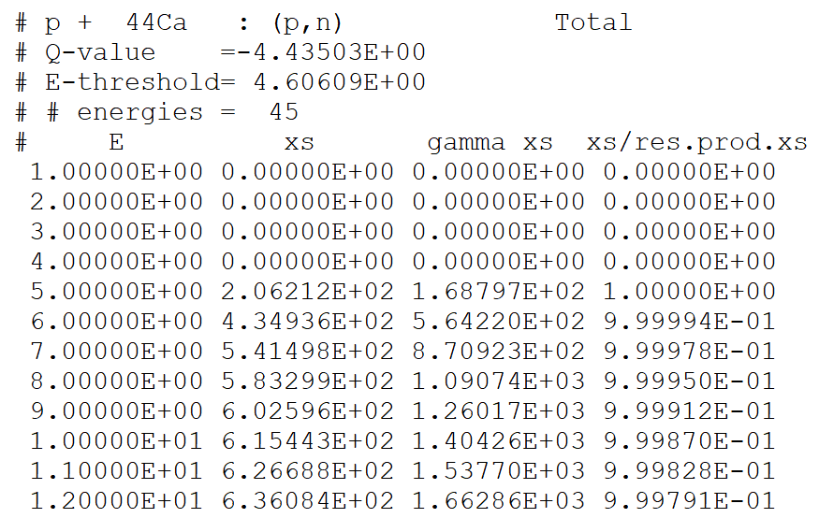

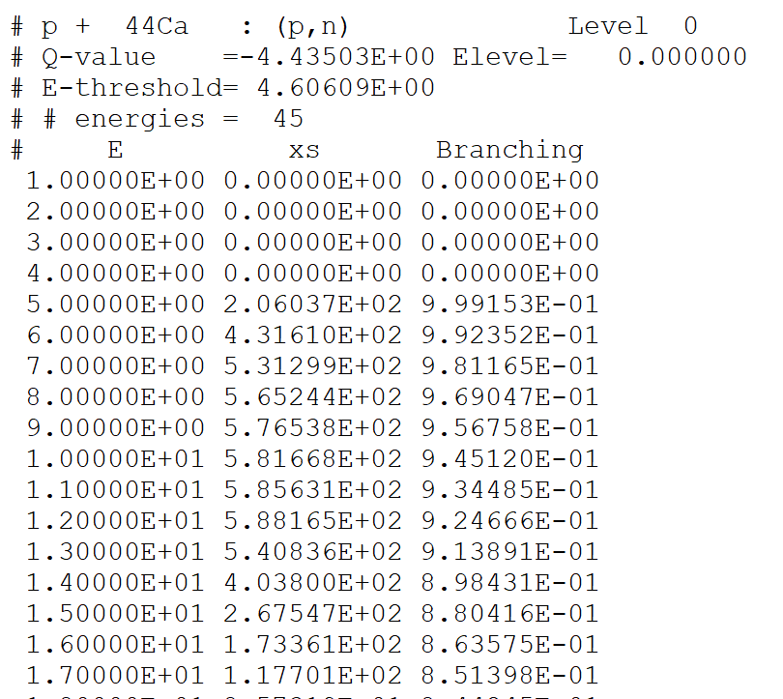

## Target library

### Target file formatting

#### TGT File format

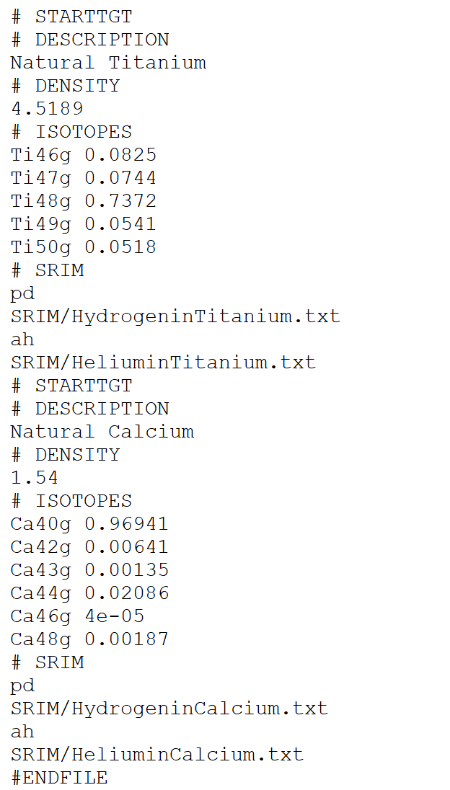

### Using SRIM for stopping power

Download SRIM from :

* It is recommended to output stopping power up to 100 MeV
* Note: Density and stopping power required for calculation of target thickness
* If SRIM file is specified, density is updated by value in SRIM file. This can be overwritten by defining the “# DENSITY” tag underneath the “# SRIM” tag.

#### SRIM File format

