Week04 No1

## HOMEWORK INSTRUCTIONS
Convert these three mathematical formula to C# expressions. Use the following four lines of code and initial values of a, b, c, r, and theta to compute x1, volume and f:
double x1, volume, f;
double a = 1.0, b=2.83, c=1.2;
double r=1.0;
double theta=0.523599;
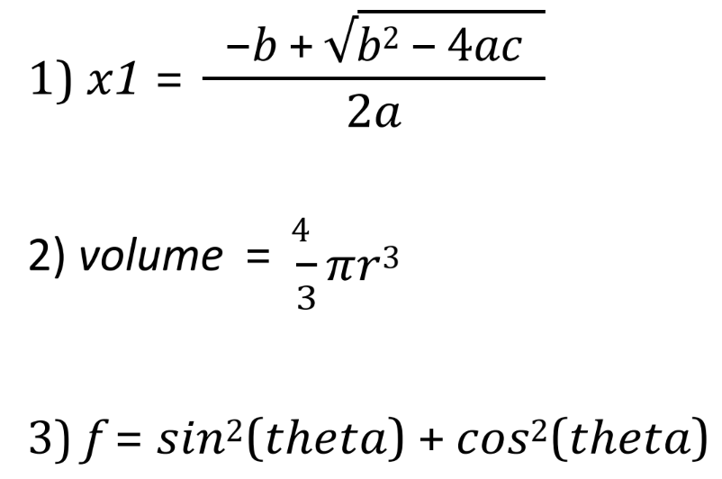
## GRADING RUBRIC (35 points)
- Quadratic formula (x1): 10 points
- Sphere volume (volume): 10 points
- Trigonometric identity (f): 10 points
- Declarations & displaying results: 5 points

## SAMPLE SOLUTION
/*
* CSC180 Week04 Programming Assignment
* 1. Convert these three mathematical formula to C# expressions. Use the following four lines of code below to compute and display the result:
double x1, volume, f;
double a = 1.0, b=2.83, c=1.2;
double r=1.0;
double theta=0.523599;
*/

using System;
class Program
{
static void Main(string[] args)
{
double x1, volume;
double a = 1.0, b = 2.83, c = 1.2;
double r = 1.0;
double theta = 0.523599;
x1 = (-b + Math.Sqrt(Math.Pow(b, 2.0) - 4.0 * a * c)) / (2.0 * a);
volume = (4.0 / 3.0) * Math.PI * Math.Pow(r, 3.0);
f = Math.Pow(Math.Sin(theta), 2.0) + Math.Pow(Math.Cos(theta), 2.0);
Console.WriteLine($"x1={x1:0.00}, volume={volume:0.00}, f={f:0.00}");
}
}

## STUDENT1 SUBMISSION TO GRADE
using System;
namespace homework_week04
{
internal class _1
{
public static void Main()
{
double x1, volume, f;
double a = 1.0;
double b = 2.83;
double c = 1.2;
double r = 1.0;
double theta = 0.523599;
double discriminant = b * b - 4.0 * a * c;

x1 = (-b + Math.Sqrt(discriminant)) / (2.0 * a);
Console.WriteLine($"x1 = {x1}");

volume = 4.0 / 3.0 * Math.PI * Math.Pow(r, 3);
Console.WriteLine($"volume = {volume}");

double s = Math.Sin(theta);
double ctheta = Math.Cos(theta);
f = (s * s) + (ctheta * ctheta);
Console.WriteLine($"f = {f}");
}
}
}

## STUDENT2 SUBMISSION TO GRADE
using System;

namespace FormulaProgram
{
class Program
{
static void Main(string[] args)
{
double x1, volume, f;
double a = 1.0, b = 2.83, c = 1.2;
double r = 1.0;
double theta = 0.523599;

// quadratic formula
x1 = (-b + Math.Sqrt(b * b - 4 * a * c)) / (2 * a);

// volume of a sphere
volume = (4.0 / 3.0) * Math.PI * Math.Pow(r, 3);

// trig expression
f = r * Math.Cos(theta); // incorrect formula, but I allow student to re-submit for partial credit

Console.WriteLine("x1 = " + x1);
Console.WriteLine("volume = " + volume);
Console.WriteLine("f = " + f);

Console.ReadLine();
}
}
}

