**Team members:** Derek Gorthy, Jack Dinkel, Michael Swisher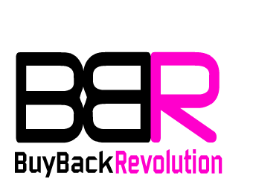

**Title:** BuyBack Revolution Website and Tools Development

**Description:** BBR is a website that will give customers pricing information on used and damaged phones. It will ask users information about their phone and, using our personal database and information from competitors, give the customer an estimate including our own purchase price.

**Vision statement:** To develop an industry-changing price calculator tool for customers looking to get the highest price for their used personal device.

**Automated Unit Testing:** The unit testing is done through a Python script using the unittest library and functions. The pricing estimate tool has several different aspects it uses to estimate the value of a phone, including the phone model, carrier, condition, age, box, frame, insurance policy, overall damage, etc. Each aspect of the pricing estimate tool is individually tested a minimum of three times to verify that the calculations are correct and the tool behaves as expected. This amounts to a total of 31 different tests, all of which are passed.

The testing code is contained in our git repository and can be downloaded or viewed from GitHub. The path to the test code from the main repository directory is:

*SoftwareDevProject > Python Test Script > test.py*

All the test code is stored in *test.py*. To run the test simply navigate to the *Python Test Script* directory and run *test.py*with the command:

python test.py

After the command is run, the test should run successfully and report 31 successful tests:

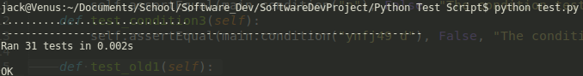

**User Acceptance Tests:**

**Version control system:** Github (<https://github.com/JackDinkel/SoftwareDevProject>)