|  |
| --- |
| **sportyshoes.com**  **Application Screenshots** |

**Version History:**

|  |  |
| --- | --- |
| Author: | Shanmugam D |
| Purpose: | Screenshots of the application |
| Date: | 13th November, 2022 |
| Version: | 1.0 |

**Table of Content:**

User Experience: 3

Main Page: 3

User Sign Up: 4

User Sign In: 5

Invalid Login: 5

User Main Page: 6

View Cart and Place Order: 7

Order Detail: 8

Admin User Experience: 9

Admin Login: 10

Invalid Admin Login: 11

Admin Main Page: 12

View Users: 13

Edit User Details: 14

Add New User: 15

View Products: 16

Edit Product Details: 17

Add New Product: 18

Purchase Report: 19

View Purchase Report: 20

# User Experience:

## Main Page:

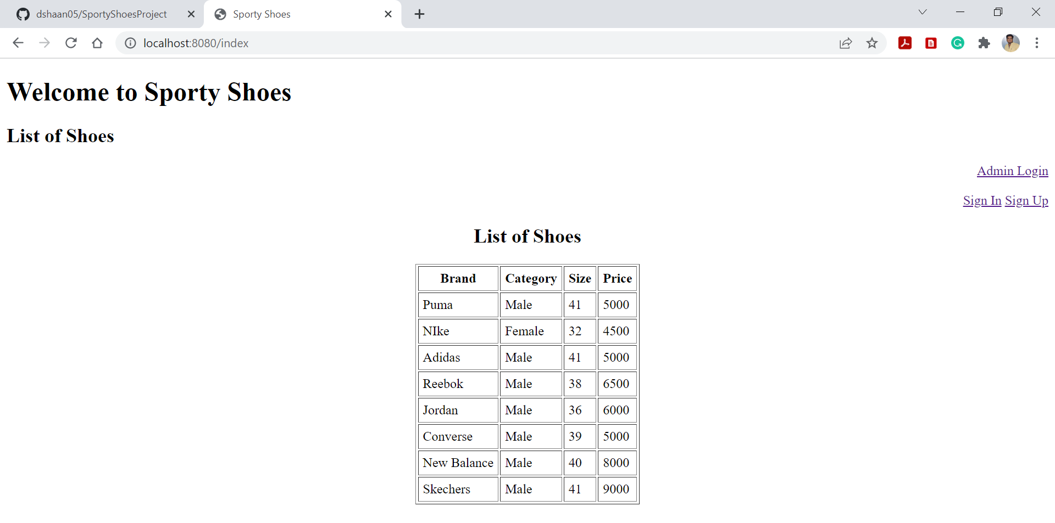

## User Sign Up:

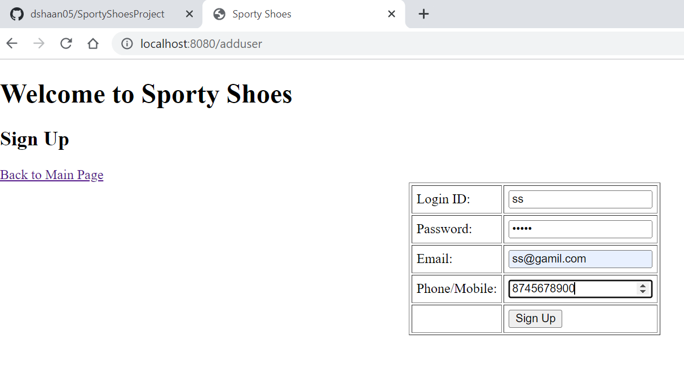

## User Sign In:

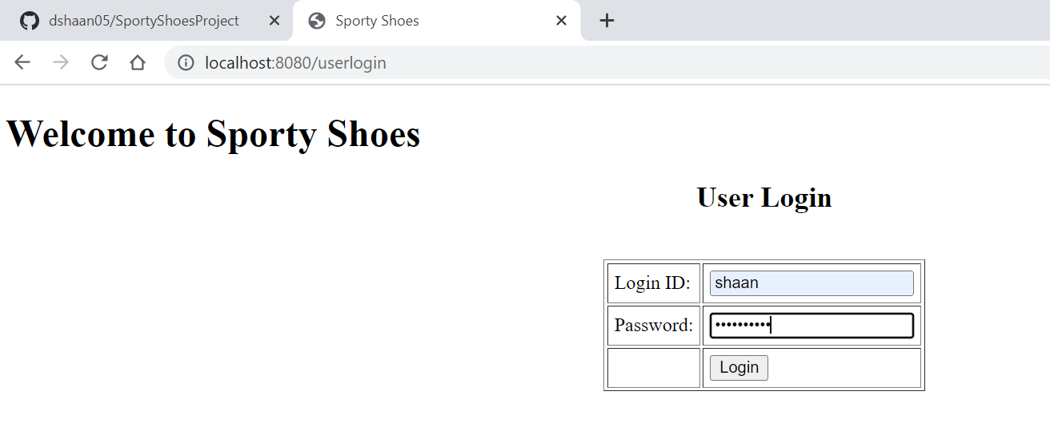

### Invalid Login:

Click Login

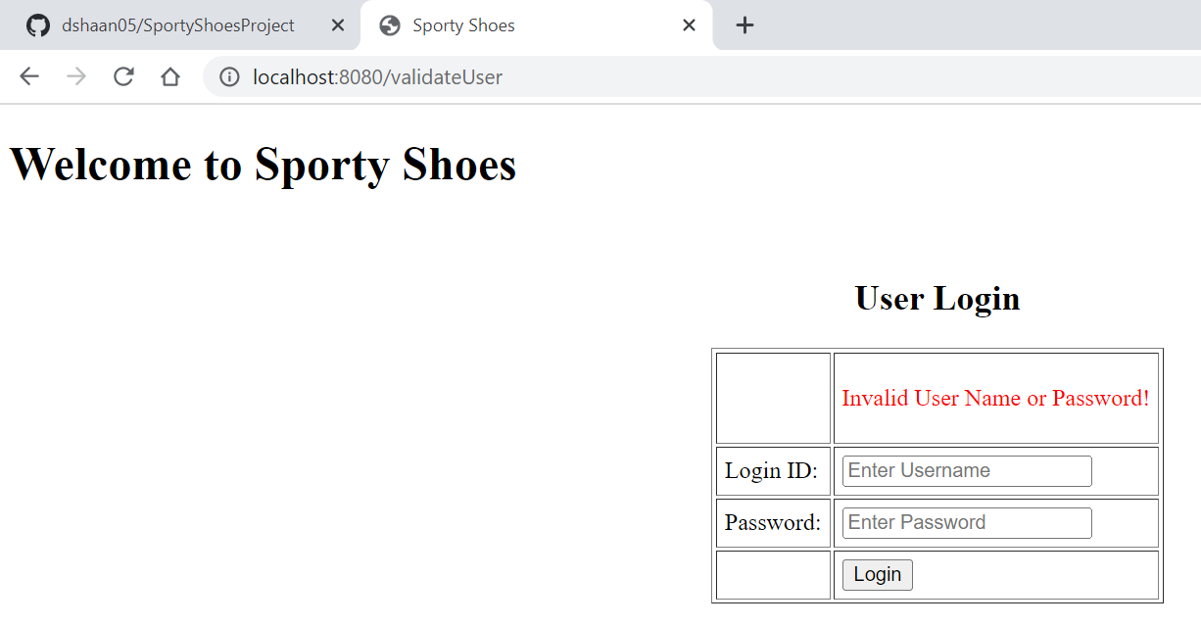

## User Main Page:

Users have options to view items, add items to cart and sign out

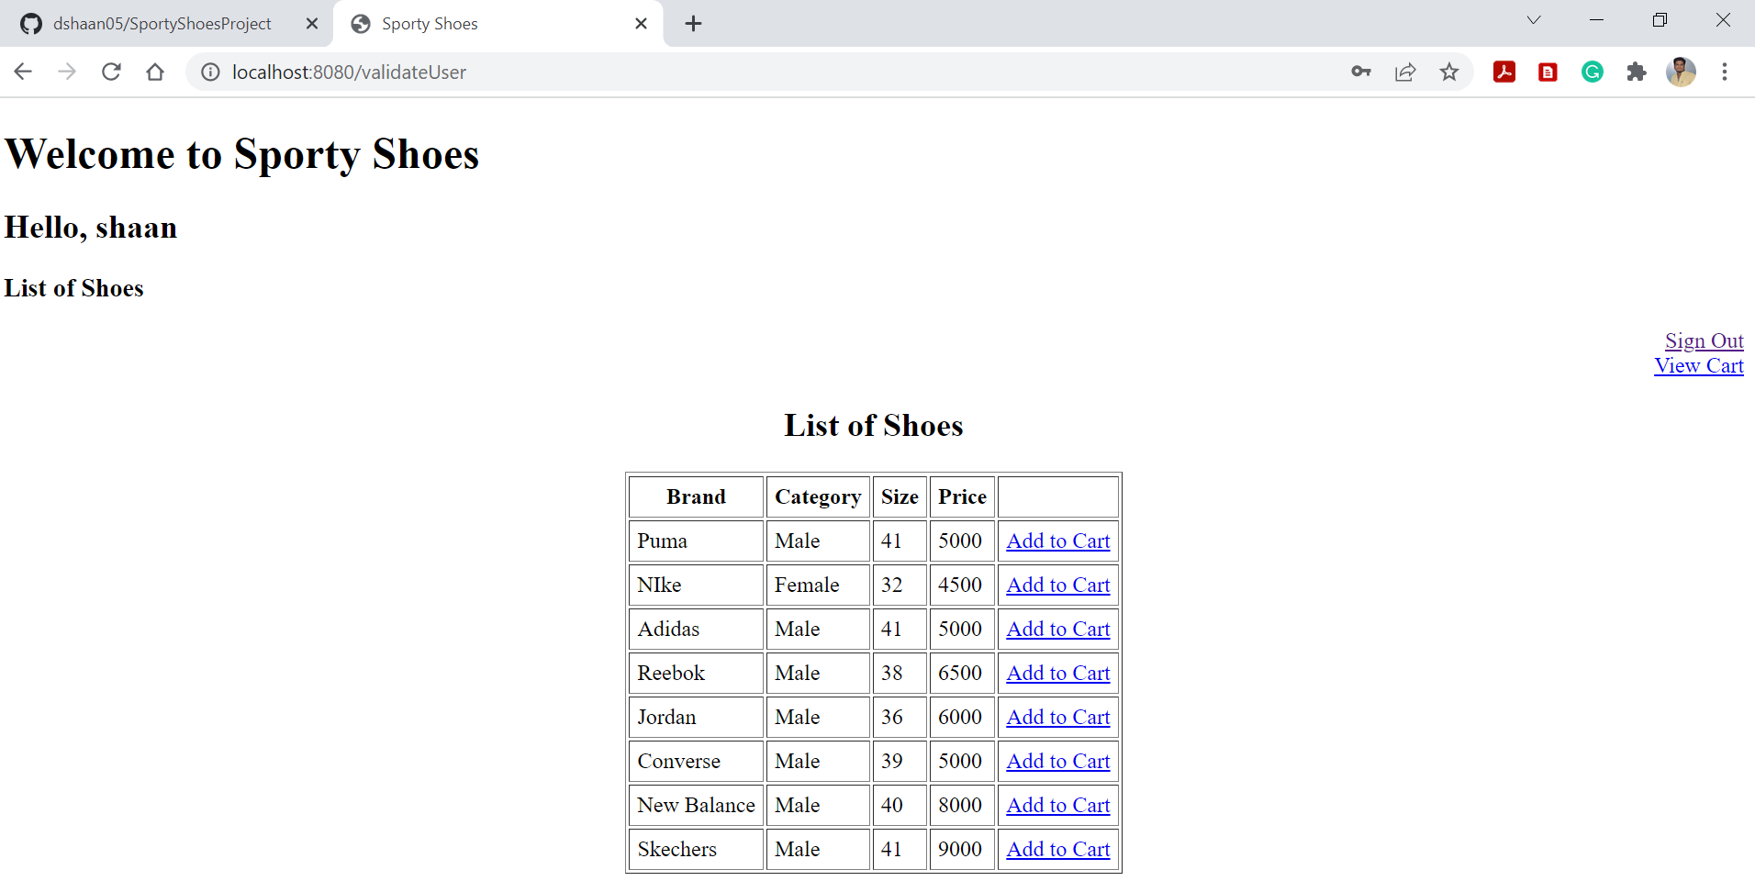

## View Cart and Place Order:

Users have options to view cart, place order, add more items and sign out

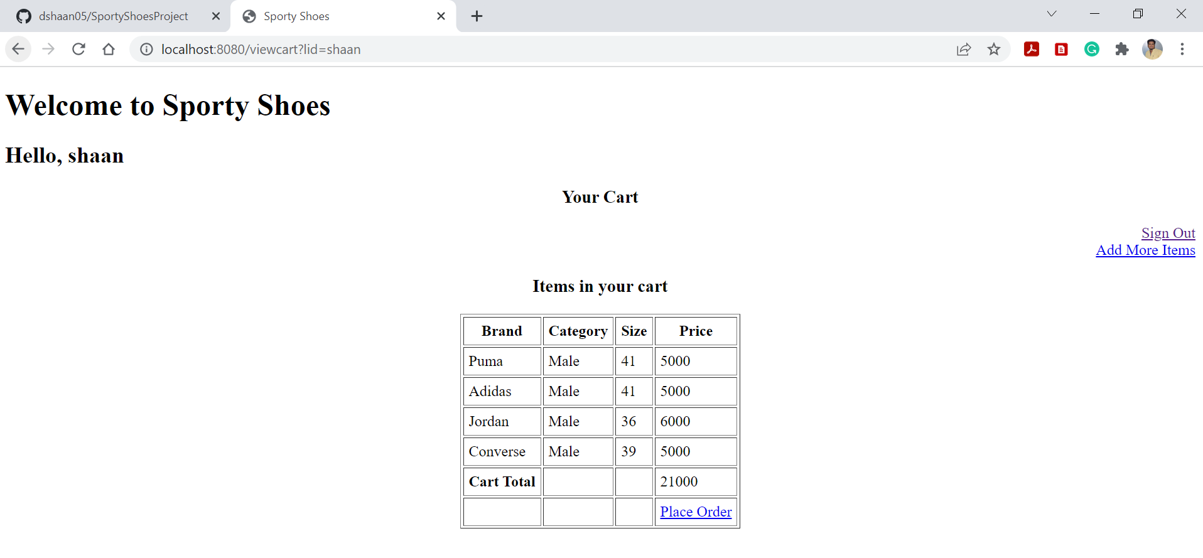

## Order Detail:

Users have option to view order details, continue shopping and sign out

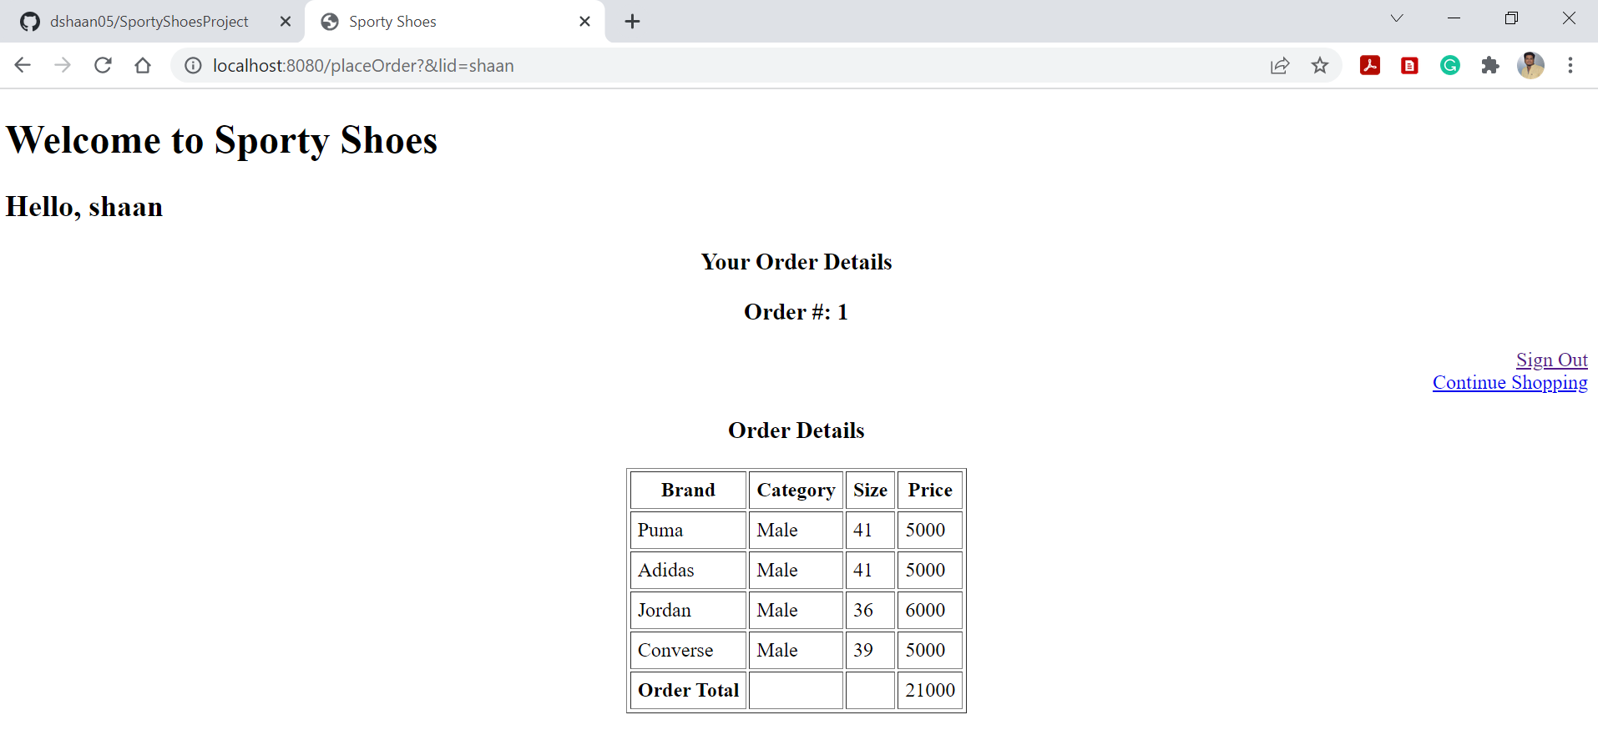

# Admin User Experience:

Click on Admin Login



## Admin Login:

Only admin user can login on the admin portal, admin have options to login or sign out

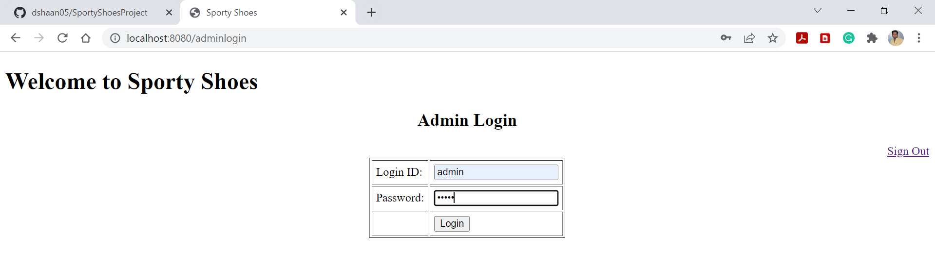

### Invalid Admin Login:

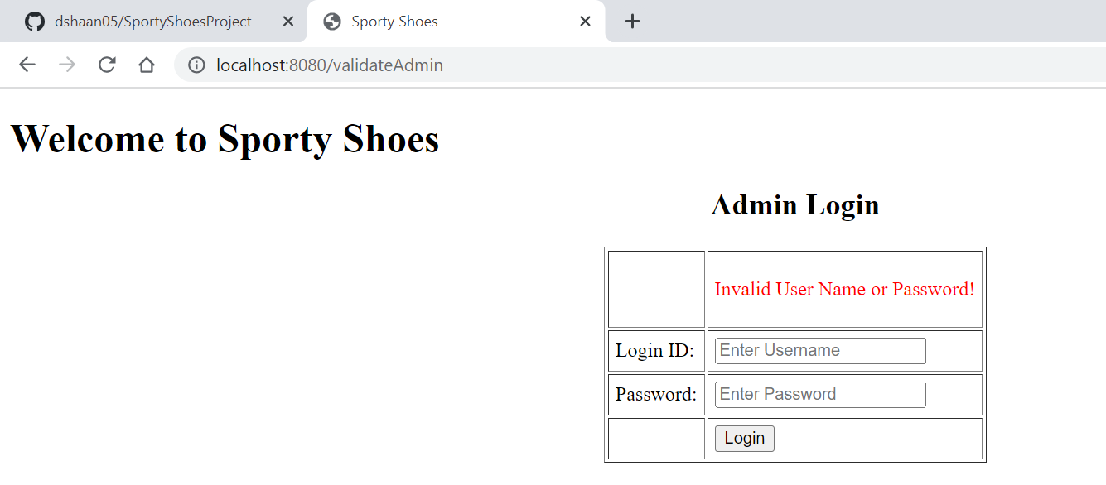

# Admin Main Page:

Admin have options to manage users, products, produce purchase reports and sign out.

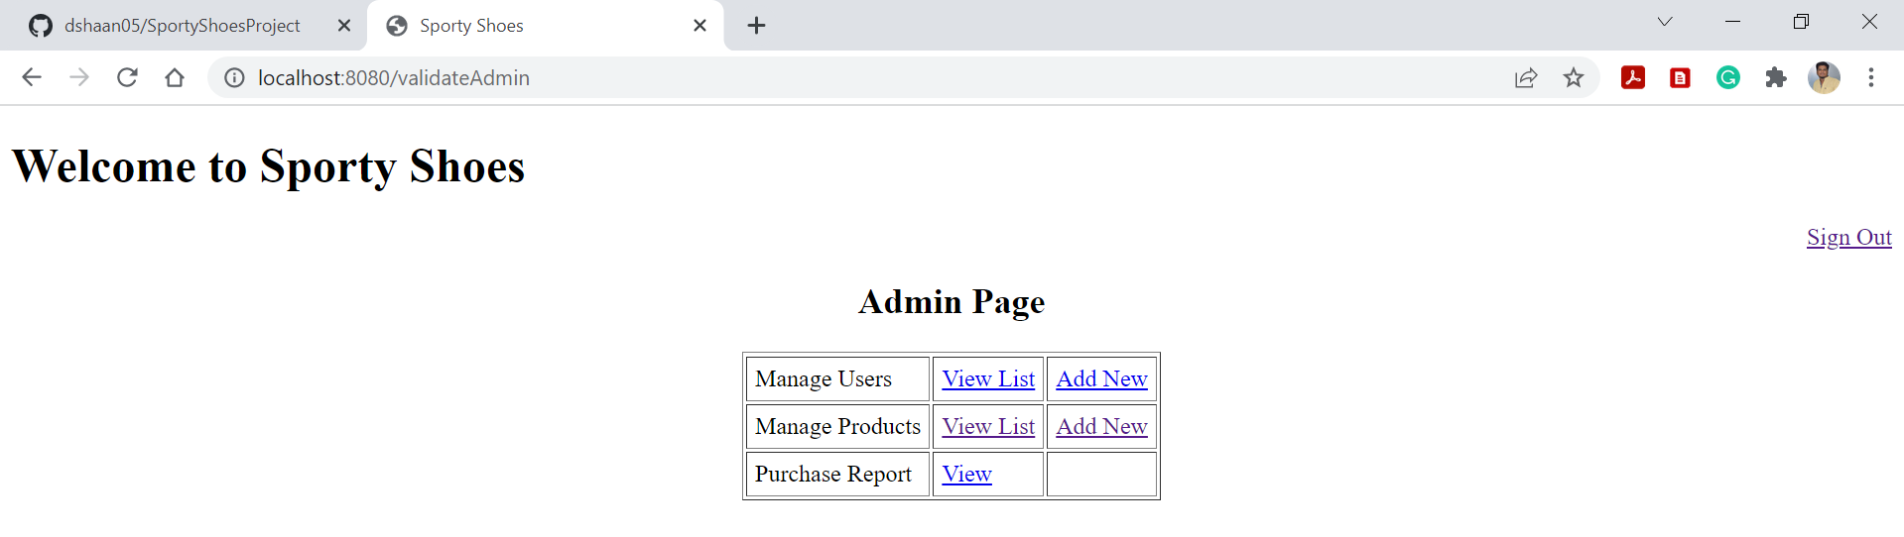

## View Users:

Admin have options to view users, edit user details and back to admin page.

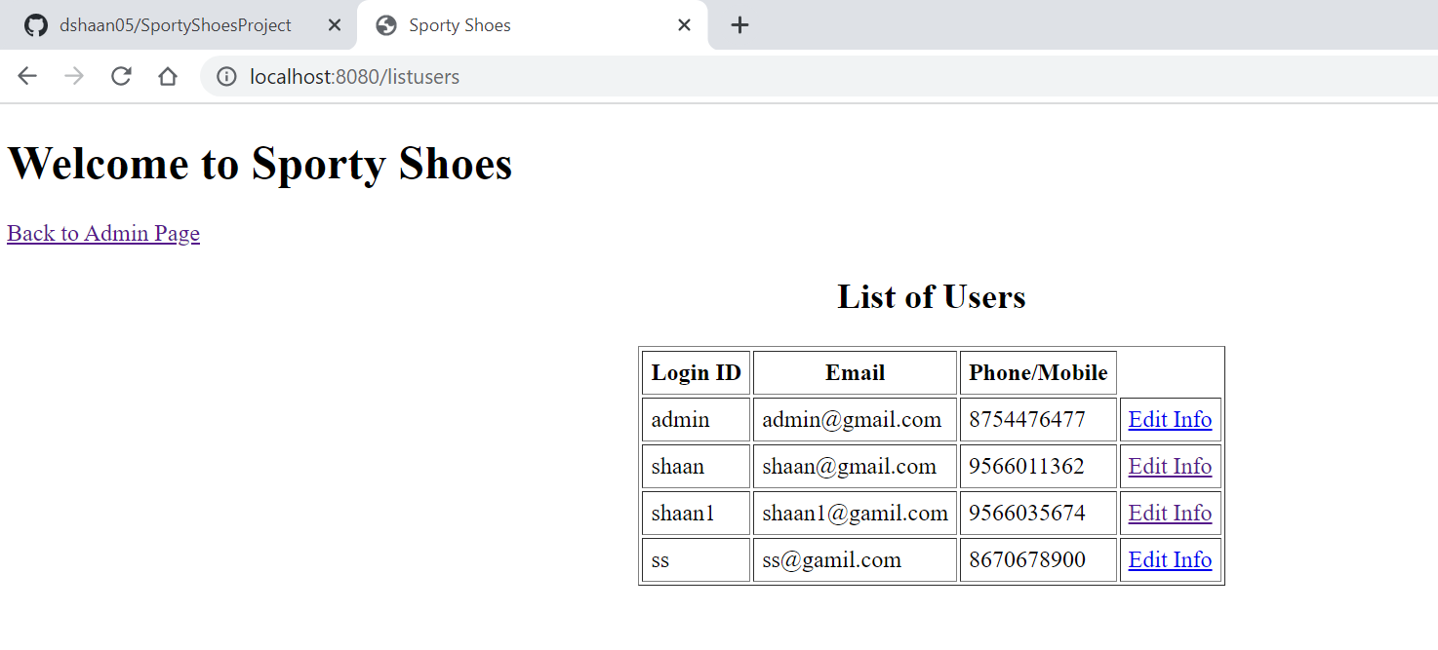

### Edit User Details:

Admin have options to edit user information including the password.

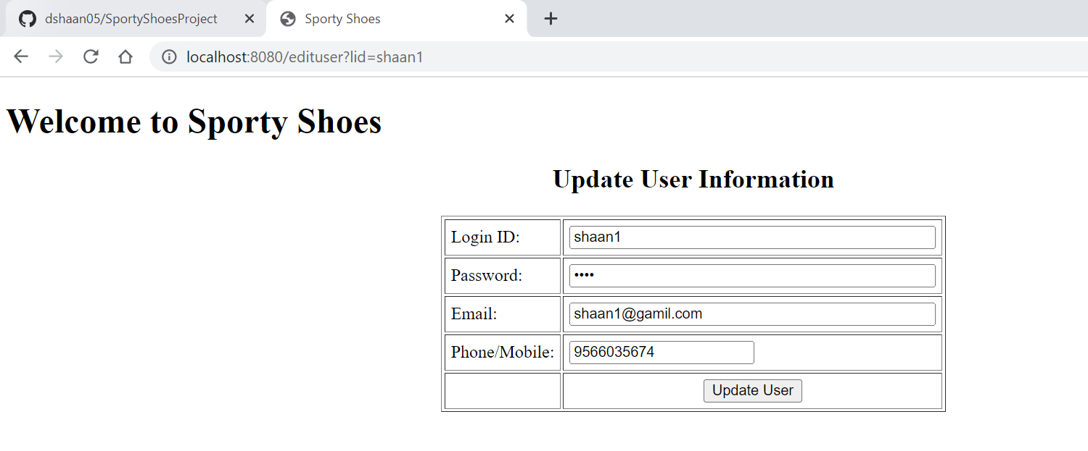

## Add New User:

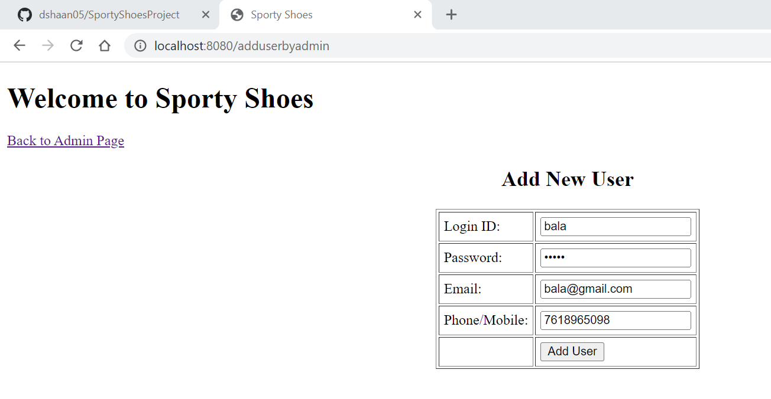

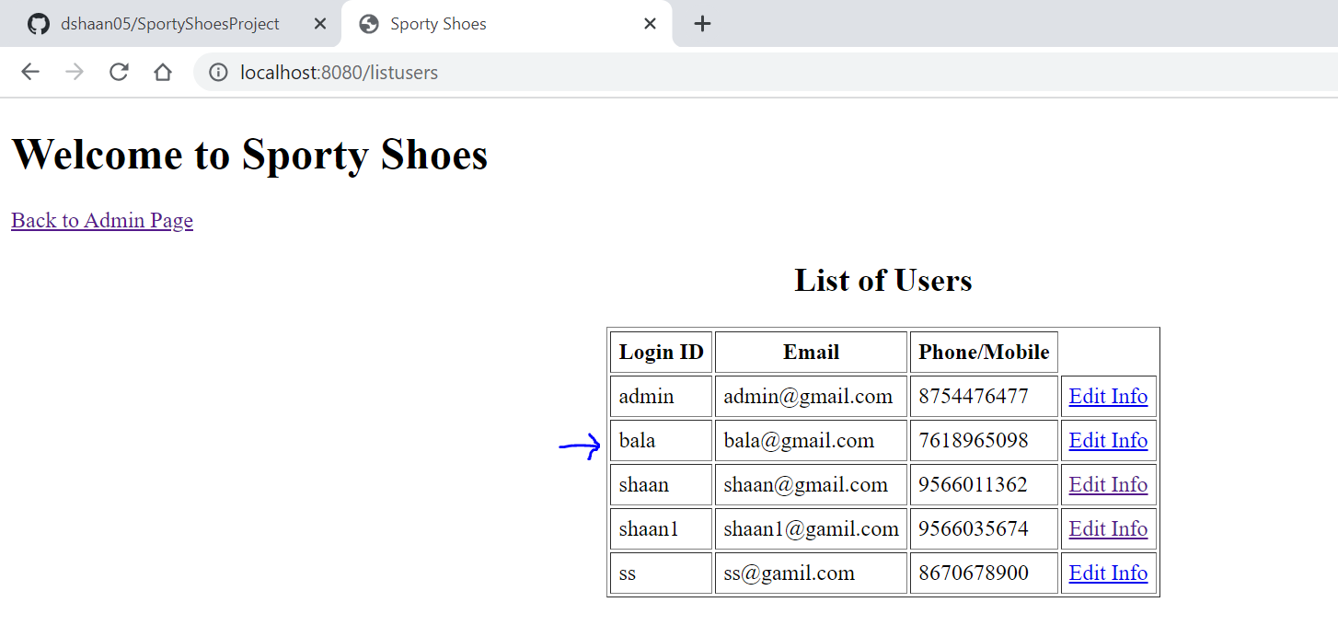

## View Products:

Admin have options to view all products and edit product information

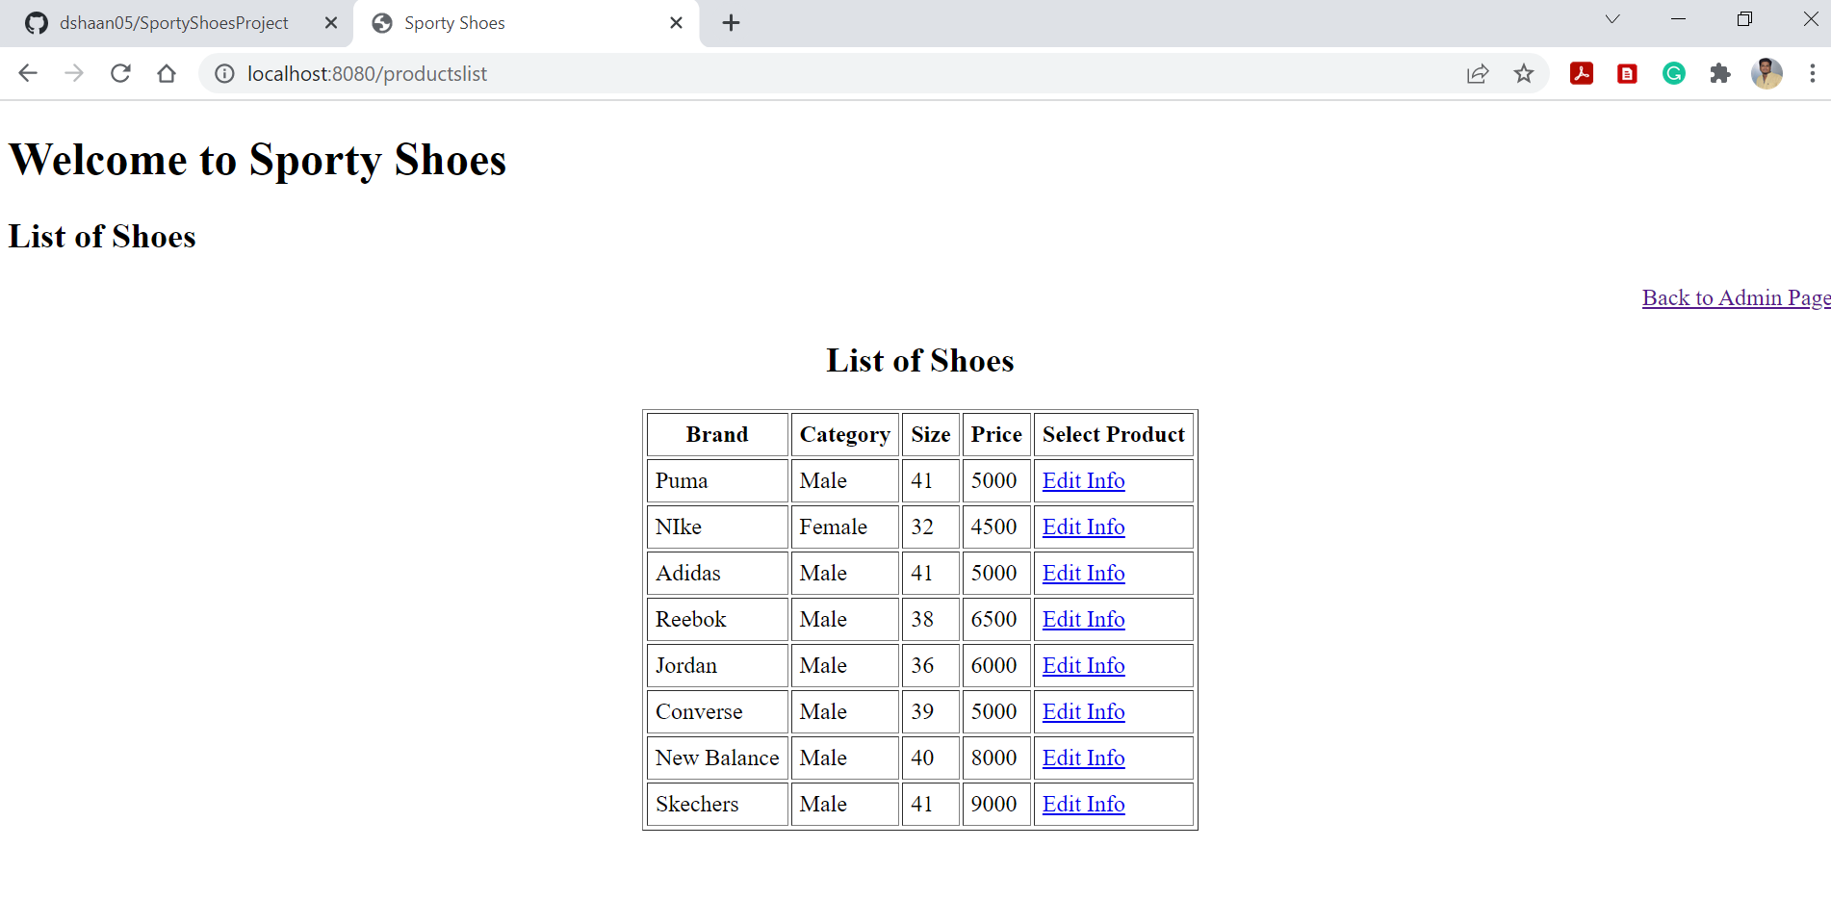

#### Edit Product Details:

Update product information

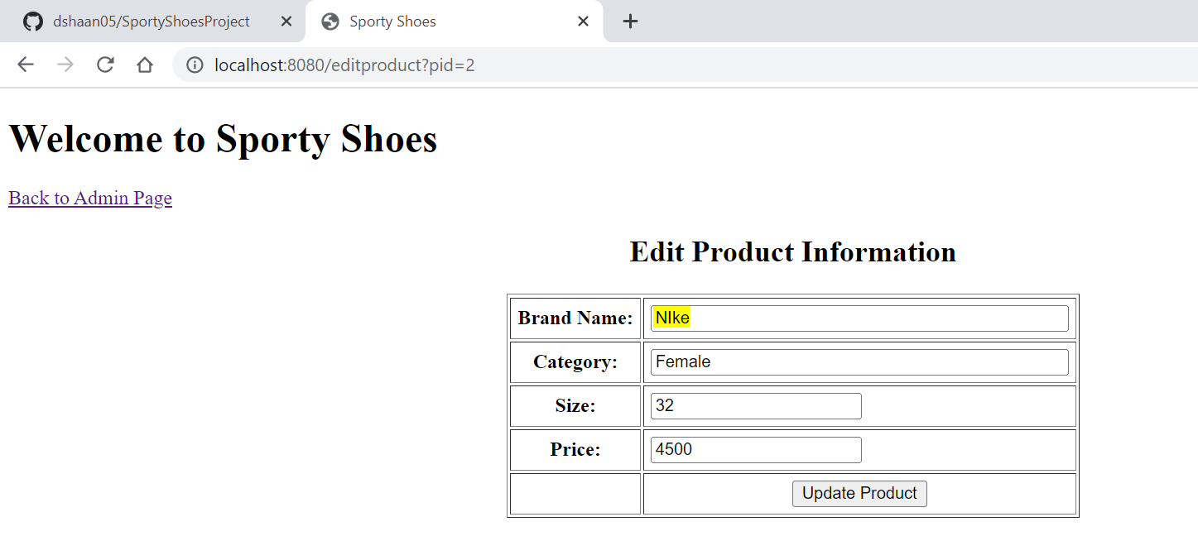

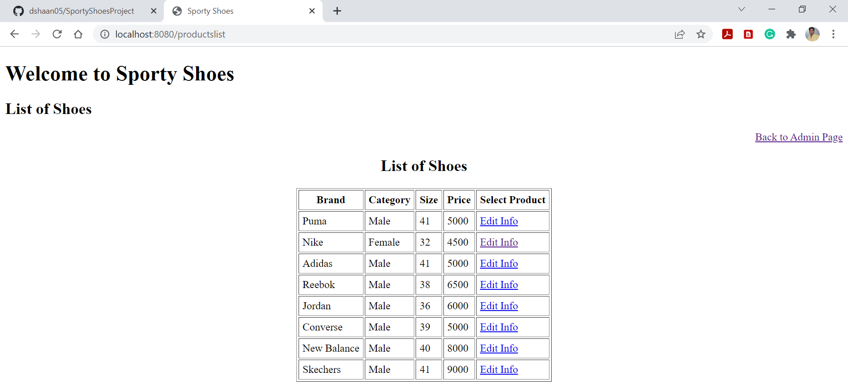

## Add New Product:

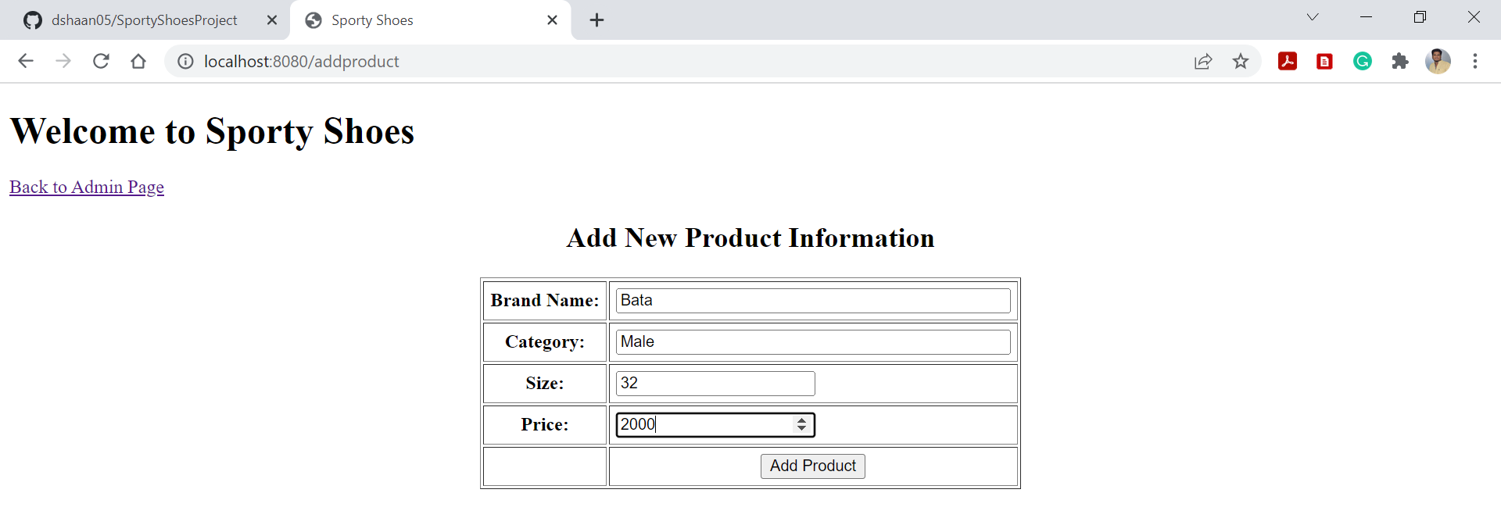

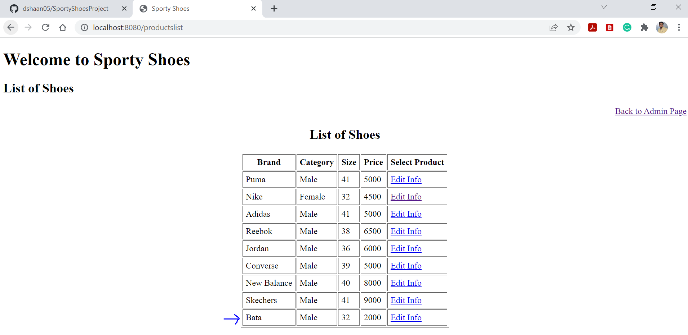

## Purchase Report:

Admin have to provide the search criteria like brand name, date of purchase and click “Show Report”

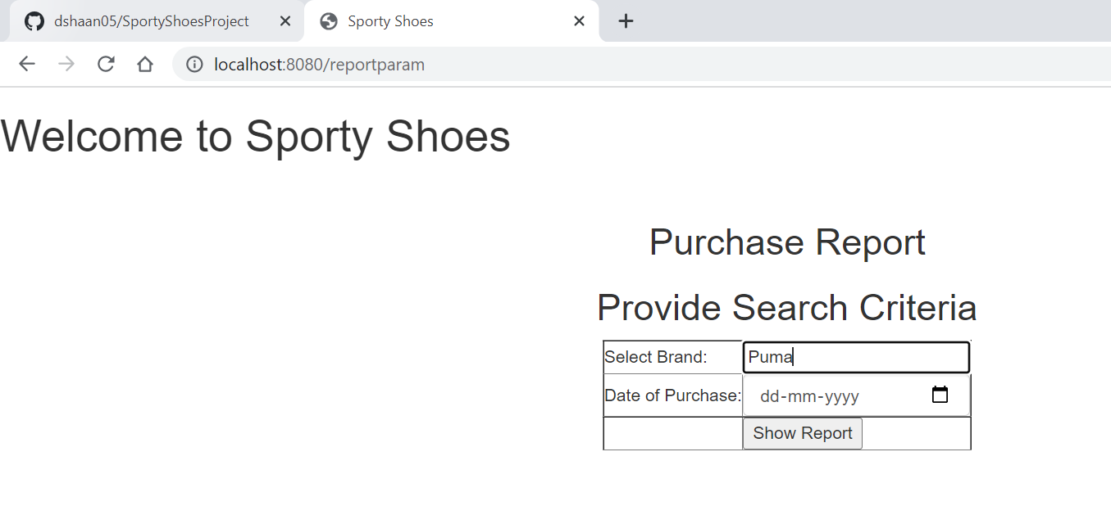

Select date of purchase from the calendar

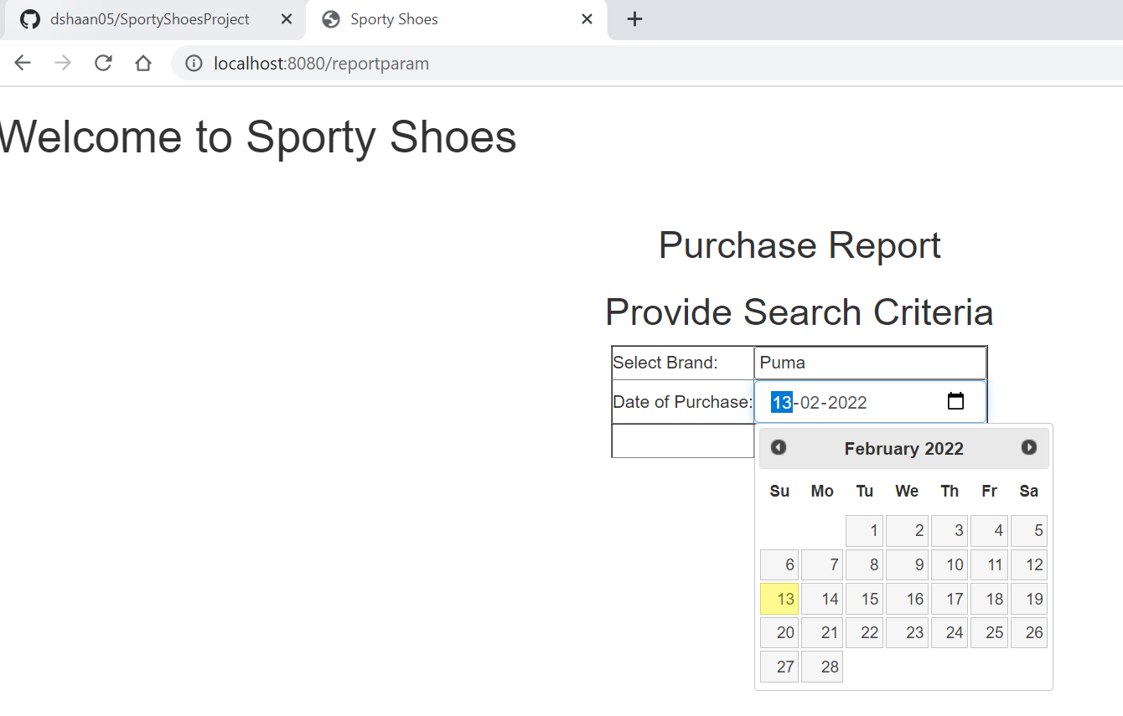

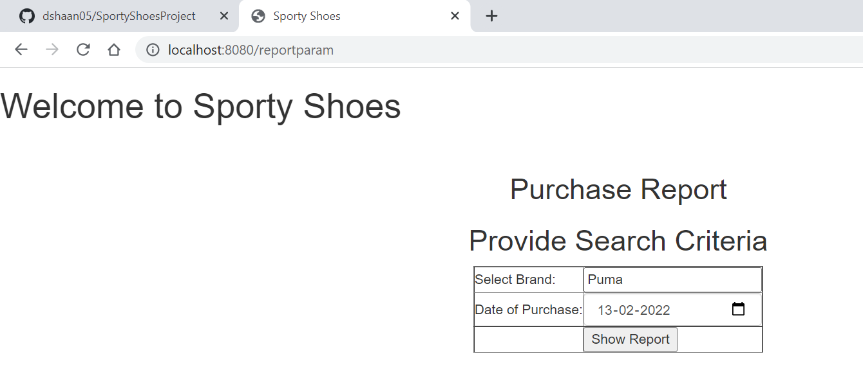

### View Purchase Report:

Admin have options to view purchase details, change search and go back to admin main page

