**SRS document**

**Group 11**

Benjamin Arhen

Shafia Dudekula

**Project Title**

Creation of Online Games, Simulation Exercises, and/or Videos for Leadership & Psychology Experiments

**Introduction**

Our project aims to provide a platform for researchers to carry out leadership and psychological experiments. The project will make use of latest technology to create a user-friendly platform that is intuitive and offers a smooth experience for both participants and researchers. Users to take part in video simulations, online games, and training exercises that will be embedded in a website. The platform will allow researchers to plan and carry out studies that examine participants' reactions to various leadership and psychological challenges.

**Problem**

Currently, we conduct leadership and psychological experiments using in-person interviews and tests. To execute the experiment, there are several expenses associated with things like resources and technical staff. It poses the risk of introducing some sort of human error into the test as well. Using an online platform reduces setup costs by just needing to develop the website once. As no people are involved, there is no chance of human error during testing.

**Goal**

* Create a library of online games, simulation exercises, and videos that can be used in various leadership and psychology experiments.
* Embed the developed games and exercises into website that will be used by researchers.
* Some of the features that will be developed as part of this project are collaborative games, personality assessments, surveys, video case studies, simulation games.
* Enable researchers to easily conduct experiments using the platform.

**Constraints**

There are several constraints that could affect the proposed system for developing psychological games, simulation exercises, and videos for use in psychology experiments. Here are a few potential constraints:

1. Ethical Constraints: The development and use of psychological experiments involves ethical considerations, including informed consent, confidentiality, and privacy. The system must be designed to ensure that all ethical requirements are met and that participants are treated with respect and dignity.
2. Technical Constraints: The development of games, simulation exercises, and videos requires specialized technical expertise, including knowledge of software development, multimedia design, and psychology research methods. The system must be designed to support the technical requirements of the development team, and ensure that the resulting products are of high quality.
3. Resource Constraints: The development of psychological experiments can be time-consuming and expensive. The system must be designed to optimize the use of available resources, including staff time and tech infrastructure.
4. Data Management Constraints: The system must be designed to manage large volumes of data generated by the experiments, including participant responses, experiment configurations, and other metadata. The system must ensure the accuracy, completeness, and security of the data, while also making it accessible to authorized users.
5. Accessibility Constraints: The system must be designed to accommodate a wide range of users, including those with disabilities, participants with limited technical skills etc. The system must ensure that all users can access and participate in the experiments, regardless of their background or abilities.

**Requirement glossary**

**Basic Research**

In psychology, research conducted for the sake of achieving a more detailed and accurate understanding of human behaviour, without necessarily trying to address any particular problem.

**Consent Form**

A document informing participants of procedure, risks, and benefits of the research that is signed during the process of informed consent.

**Debriefing**

The process of informing research participants as soon as possible of the purpose of the study, revealing deception, and correcting misconceptions they may have as a result of participating in the study.

**Experiment**

A study in which the researcher manipulates the independent variable.

**Informed Consent**

Researchers obtain and document people’s agreement to participate in a study after having informed them of everything that might reasonably be expected to affect their decision.

**Random Assignment**

A method of controlling extraneous variables across conditions by using a random process to decide which participants will be tested in the different conditions.

**Variable**

A quantity or quality that varies across people or situations.

**User requirement**

* Assign task #1 to user based on data collected from user or randomly.
* User should be able to view, enter and submit data for task #1.
* User should be presented with results screen for task #1.
* User should be able to view, enter and submit data for task #2.
* Collect information about time taken by user to complete task #2.
* User should be presented with results screen for task #2.

**System requirements**

1. The software should allow researchers to create and manage psychological experiments that involve games, simulation exercises, and videos.
2. The software should provide a feature for researchers to customize the games, exercises, and videos to measure various psychological concepts.
3. The software should allow participants to access and participate in experiments through an online platform.
4. The software should provide real-time feedback to participants during experiments and record their responses and data.
5. The software should allow researchers to analyze and interpret data collected from experiments and generate reports.

**Nonfunctional requirements**

1. The software should have a high level of performance, with quick response times and minimal downtime.
2. The software should be secure and protect participant data from unauthorized access or data breaches.
3. The software should be scalable, able to handle a growing number of experiments and participants.
4. The software should be compatible with various web browsers and devices to ensure accessibility for all participants.
5. The software should have a user-friendly interface that is easy to navigate and use, with clear instructions and feedback for researchers and participants.

**Technical requirements**

Front-End: HTML, CSS, JavaScript, ReactJS

Back-End: C#

Database: MySQL

Deployment/Hosting: GitHub pages

Version Control: Git

Project Management: Jira

**Project risks**

There are several risks that could potentially affect the proposed system. Here are some examples:

1. Data privacy and security risks: As the system would likely be storing and processing sensitive data related to participants' psychological states and behaviors, there would be a significant risk of data privacy and security breaches. This could include unauthorized access to the system or data, data theft, or data loss due to system failures.
2. Ethical risks: Psychological experiments can raise ethical considerations, particularly if they involve vulnerable populations (such as children or individuals with mental health conditions). There is a risk that the experiments conducted through the proposed system could be seen as unethical, which could damage the reputation of the researchers or the organization.
3. Technical risks: The system would need to be highly reliable and available to ensure that participants can access the experiments and researchers can access the data they need. If the system experiences technical issues or downtime, this could impact the quality and validity of the experiments, and potentially harm the reputation of the researchers or the organization.
4. Legal risks: Depending on the jurisdiction in which the system is developed and used, there may be legal requirements and constraints related to data privacy, security, and confidentiality. Failure to comply with these requirements could result in legal liability for the organization or researchers.
5. User adoption risks: The success of the system would depend in part on the willingness of participants and researchers to adopt and use it. If the system is difficult to use, poorly designed, or lacks key features or functionality, this could limit its adoption and impact the success of the experiments conducted through it.

**Use Case Diagram**

In the use case diagram below, there are two primary actors: the researcher and the participant. The researcher can create, manage, and customize experiments through the system, while the participant can access experiments, participate in them, and submit responses.

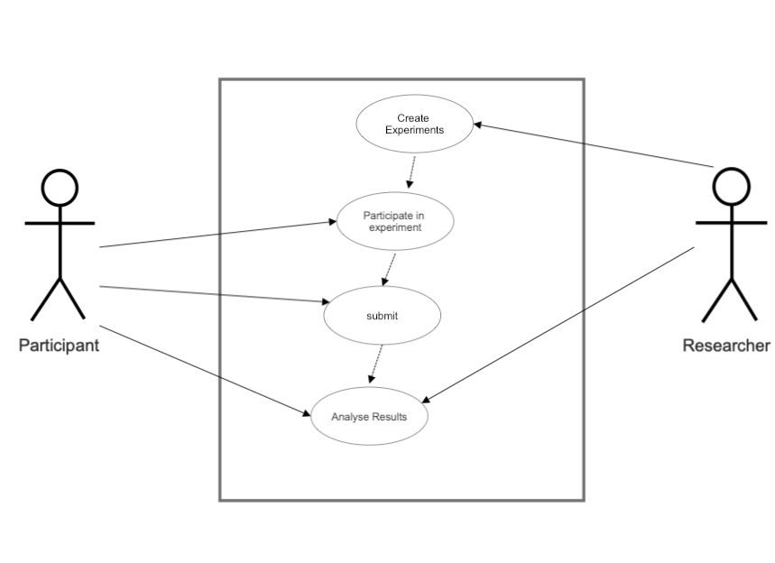

**Project management**

**Meetings** – We will check on our progress and have daily status meetings to address any issues that may arise. If more meetings are required, they will be scheduled and communicated via phone or email. Depending on the team's availability, meetings would be held both online and in person.

**Tasks assignment** – Team members will pick stories from Trello board based on priority. If a team member is unable to complete their task by the set deadline, we will meet to discuss the situation, assist each other, and make every effort to finish it on time.

**Resolving conflict** – Since our team consists of only two people and voting may not always produce the best solution, we will first ask our TA for assistance with the problem. If they are unable to do so, we will set up a meeting with Dr. V to discuss the issue and try to come up with a solution.