**PROJECT REPORT**

**PHD AUTOMOBILES**

**ABSTRACT:-**

The ever growing world of Automobiles exists as more and more number of humans resort to private transport every year. This web based application provides you with a booking service to book your favourite car.

**INTRODUCTION:-**

Our web based application helps the company to interact with the customers interested in buying cars.

With the application the customers can book a car and an appointment with the company to personally visit and check the car. A call will be given to the customer once the booking is done. The customers can select different models. Different selection of colours are also available.

Along with this we also provide various services like oiling, car wash, engine check-up etc.

All in all this is the one destination for your car.

**NEED:-**

Until now we just had the age old method of visiting the actual location of company and then checking the car. But this involved a lot of iterations as the customer had to go to the company multiple times to get quotes, specifications, test drive, finalization, payment etc.

Thus to eliminate the amount of travelling that is involved in the above concept, we introduce web based booking service.

**SCOPE:-**

The scope is this web application is very huge. The manual system

has some drawbacks which can be overcome by using the web based

software.

The following reasons explain by it is needed.

* Customers can fetch the car details and cost of the car along with all the specifications very easily from the website.
* Web based service reduces the time involved, traveling involved, paper wastage along with the manual work.
* The Employees can have a simple look at the database and know about the tasks assigned to them easily.
* The Manager and the DBA can have a good control over the data, and can assign the work accordingly.

**PROBLEM STATEMENT:-**

The project is a Car Booking and Service providing profitable model.

With the ease of online usage and the wide spread World Wide Web it becomes feasible for everyone to use the service sitting at their particular apartments.

We import the cars from the respective brands as per the bookings made and then the customers can visit have a test drive and confirm the booking.  
In future if there are any issues we provide services for that too.

**FUNTIONAL REQUIREMENTS for the Website:-**

1. HTML: used for the basic layout of the web application.
2. CSS: Used for styling our web application.
3. JAVASCRIPT: Used to create the logic of the web application.
4. PHP: For frontend-backend connectivity.
5. MySql: For Storing the database.

**NON- FUNCTIONAL REQUIREMENTS:-**

1.**PHD Automobile Showroom:**

The website manages this particular Car Company.

2. **Manager:**

The main head of the Showroom is the manager and manages the functioning of the Showroom

3. **Database Administrator:**

The Data maintained in the database is managed by the DBA. Various inputs into the Database are made by the DBA and his team.

4. **Brands and Cars** This includes all the brands and cars that we have in the showroom.

5. **Customer:** The record of each customer is maintained for reference, giving them services, bookings and their feedbacks, etc.

6. **Employees:** Staff is needed to run the bookings and services smoothly by distributing work among them.

**METHODOLOGY and VIEW:-**

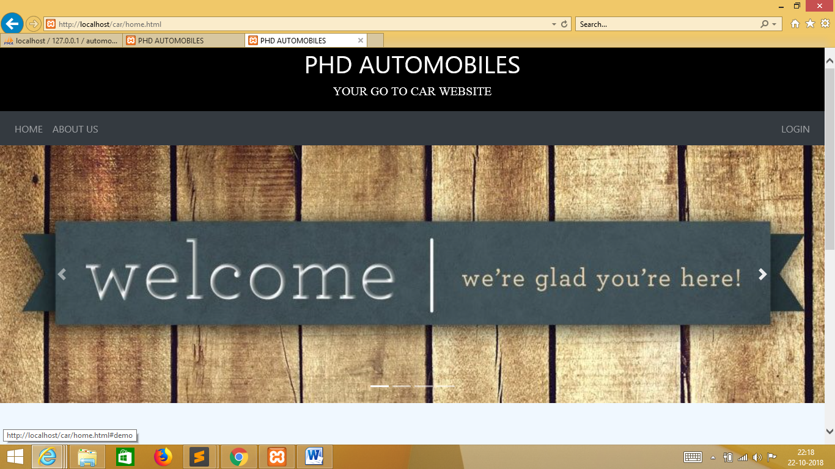

**HOME PAGE**

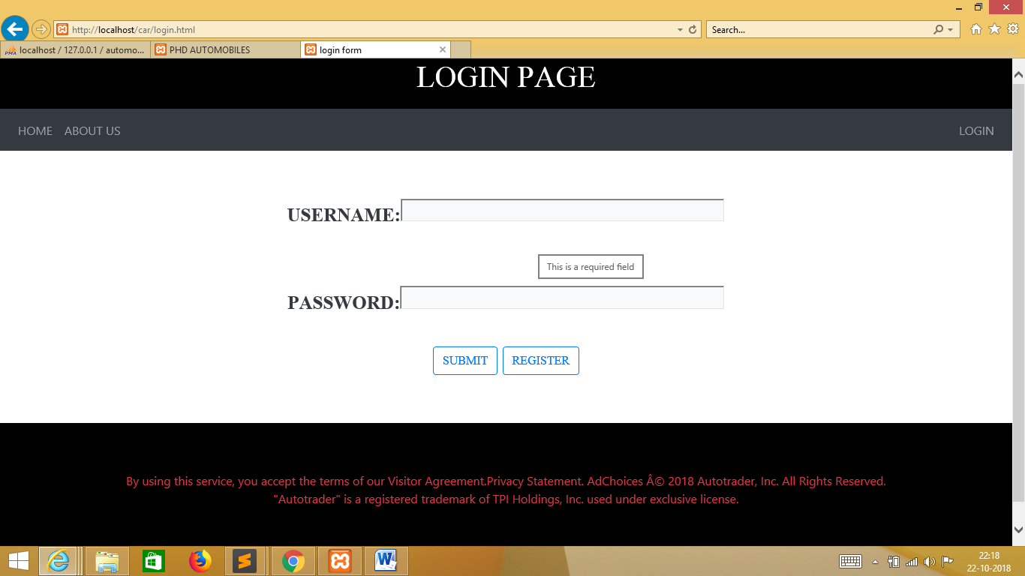

**LOGIN PAGE**

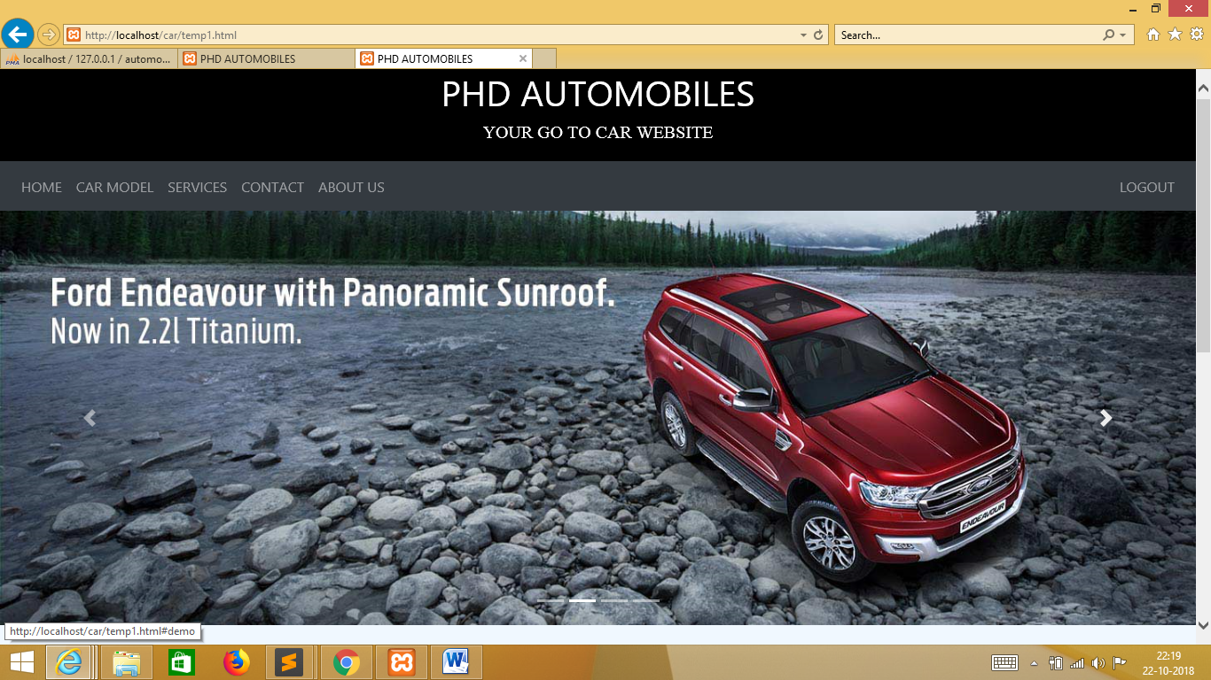

**HOME PAGE (AFTER LOGGING IN)**

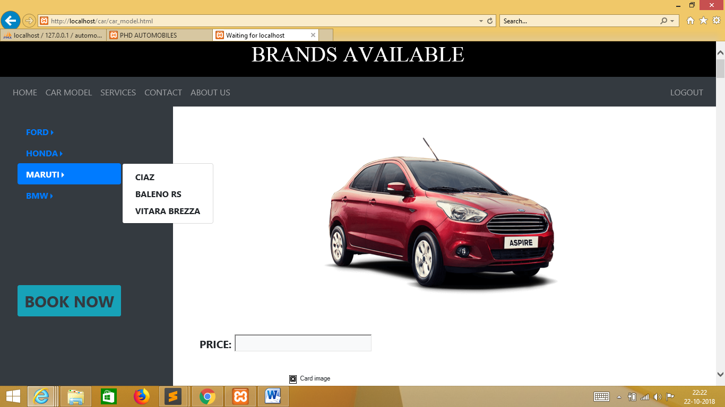  
**CAR SELECTION FROM VARIOUS OPTIONS**

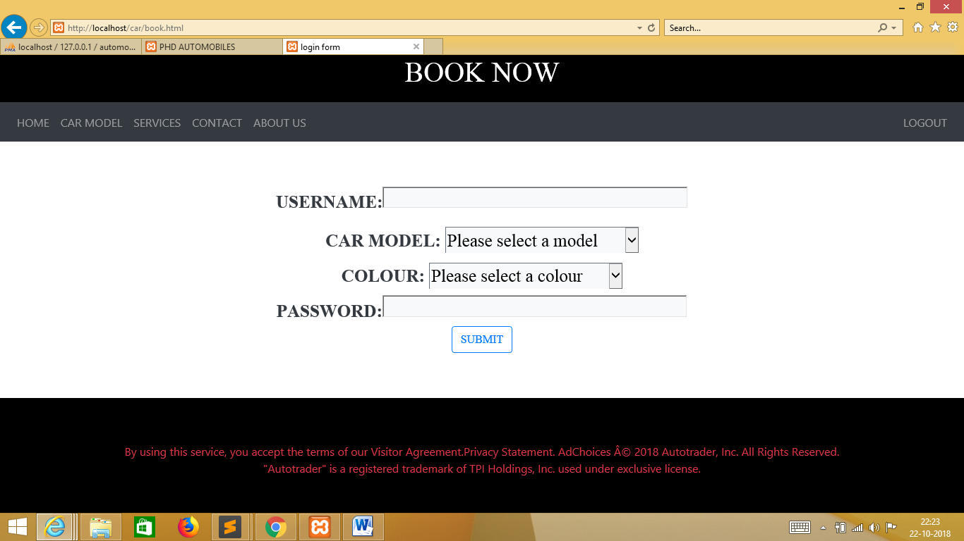

**CAR BOOKING**

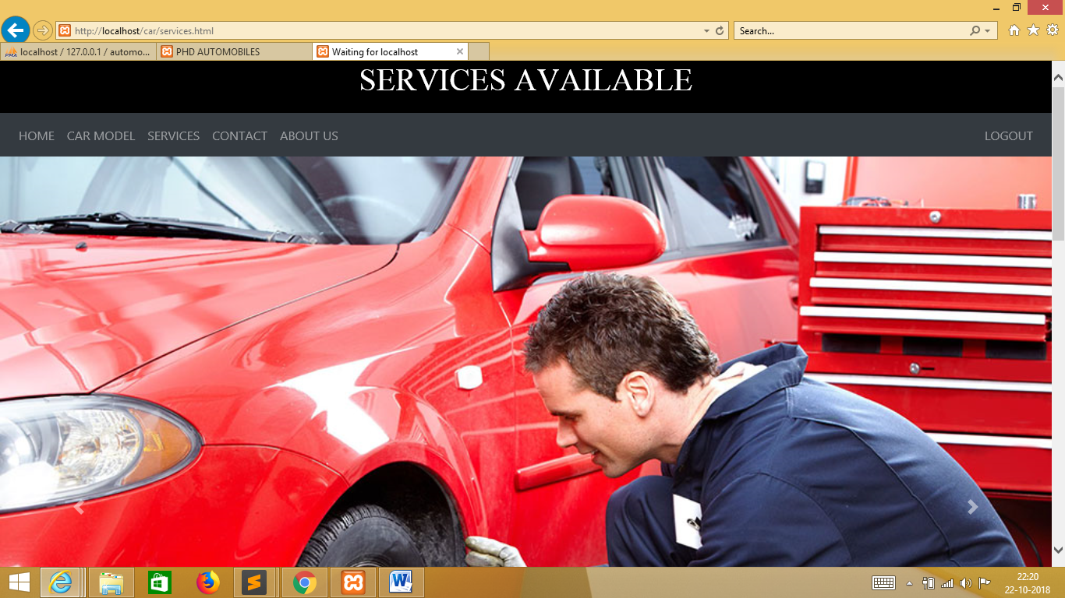

**SERVICES PROVIDED**