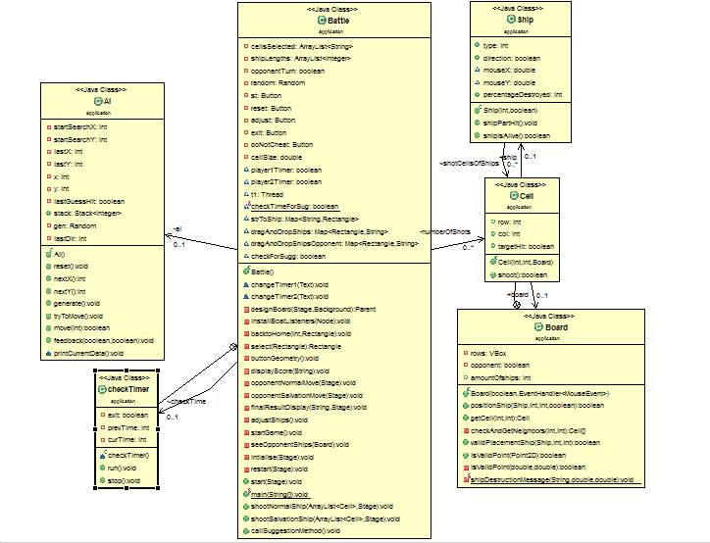

**Architectural Style**: An *architectural style* defines a family of architectures constrained by component vocabulary e.g., Layers and cells between them, Topology such as Stack of layers and semantic constraints such as a layer may only talk to its adjacent layers.

* **Event Driven Architecture**: The battleship game is developed based on the event driven architecture. In EDA the components do not invoke each other explicitly, but generate signals called events. To receive events, objects can receive events at ports (statically or dynamically bound) or can register for event notification (e.g. via callback). This architecture supports the Java Swing provision of user interface related functionality.

**Advantages of EDA:**

* It supports components reuse because of less coupling between the modules.
* System can be evolved easily by registering new components at construction time or run time.

The listeners used in various source files are listed below and perform the following functionalities:

|  |  |
| --- | --- |
| FILE | EVENTS |
| Battle.java | Mouse Events for positioning ships and hitting on boards |
| Board.java | No mouse events included |
| Ship.java | No mouse events included |
| AI.java | No mouse events included |

**Checked Exceptions**:

Checked exceptions are forced by compiler and used to indicate exceptional conditions that are out of the control of the program.

**Unchecked Exceptions**:

Unchecked exceptions are occurred during runtime, the occurrences of which are not checked by the compiler. They will come into life/occur into your program, once any buggy code is executed.

**UDP:**

UDP uses a simple connectionless communication model with a minimum of protocol mechanisms.

UDP provides checksums for data integrity, and port numbers for addressing different functions at the source and destination of the datagram.

It has no handshaking dialogues, and thus exposes the user's program to any unreliability of the underlying network; there is no guarantee of delivery, ordering, or duplicate protection.

If error-correction facilities are needed at the network interface level, an application may use Transmission Control Protocol (TCP) or Stream Control Transmission Protocol (SCTP) which are designed for this purpose.

**2 Player Description**: -

We use UDP to establish connection between the two machines on which the 2 players play the game.

The connection is established once both players place their ships and then they press the P2P (Player to Player) button.

Once the connection is established players are prompted to choose game style as usual.

After that, either players can start hitting the opponent players ships on their respective opponent boards.

Scenario 1) Send: -

If player 1 chooses a coordinate on Opponent board to shoot, those coordinates are sent via the UDP socket to player 2.

Player 2 receives this message and parses it to extract the coordinates. Using these coordinates Player 2 hits on his/her own board.

Scenario 2) Receive: -

Now the player 2 sends the feedback to player 1 stating whether the cell which player 1 chose is a hit or a miss.

As per the feedback received on the socket, player 1 parses it again and checks If it is a hit or not.

**LOAD AND SAVE:**

In the save functionality the details of the ship placed with their length and direction is being stored in the string with a delimiter. After which the hit part of the cell is stored as well as miss and Normal part. This are all done using “ ,” delimiter .Once clicking on save all this information is stored in the text files .The details will include the player ship information and also the opponent ship information.

In the load functionality the details that are being saved are retrieved in the same manner and is parsed accordingly. Firstly, the player board is placed, its hits and missed on his board and then the opponent board details are being placed and other details are added accordingly. Once the data is being parsed and all the information is put on the board then by clicking on resume the game begins.