**Efficiency Calculation of LaBr3:Ce using Geant4**

**A PROJECT REPORT**

***Submitted by***

**DARSHAN K SHAH**

***In fulfilment for the award of the degree***

***Of***

**BACHELOR OF ENGINEERING**

***In***

CE-IT Department



LDRP-ITR ,Gandhinagar

**Gujarat Technological University, Ahmedabad**

May, 2013

**a**

**CERTIFICATE**

Date:

**This is to certify that the dissertation entitled “EFFICIENCY CALCULATION OF LaBr3:Ce USING GEANT4 ” has been carried out by DARSHAN K SHAH under my guidance in fulfilment of the degree of Bachelor of Engineering in Electronics and Communications (8th Semester) of Gujarat Technological University, Ahmedabad during the academic year 2013-14.**

**External Guide: Internal Guide:**

Dipak Kumar Panda Chirag Pandya

Scientist – SD Lecturer

Planetary Science Division CE-IT Department

Physical Research Laboratory LDRP-ITR,Gandhinagar

**Head of the Department**

Prof. AK Goyal

H.O.D.

CE-IT Department

LDRP-ITR,Gandhinagar

CE-IT Department

LDRP-ITR

Gandhinagar-15

**b**

**Acknowledgement**

I place on record and warmly acknowledge the continuous encouragement, invaluable supervision, timely suggestions and inspired guidance offered by our guide **Chirag Pandya,** Lecturer,LDRP-ITR,Gandhinagar of and external guide **Dipak Kumar Panda**, Scientist –SD, Planetary Science Division, Physical Research Laboratory Ahmedabad in bringing this report to a successful completion.

An assemblage of this nature could never have been attempted with my reference to and inspiration from the works of others whose details are mentioned in references section. I acknowledge my indebtedness to all of them. Further, I would like to express my feeling towards parents who directly or indirectly encouraged and motivated me during this dissertation.

**Darshan K Shah(100300107012)**

**CE-IT Dept.,**

**LDRP-ITR,Gandhinagar-15**

**i**

**Abstract**

*Gamma ray spectroscopy is an important technique used for remote sensing studies of chemical composition of planetary surfaces, and has been used to study surface composition of the Moon, Mars and Asteroids at various spatial resolutions. Elements on the surface of the moon, planets and satellites in the solar system are constantly bombarded by cosmic radiations and the excited nuclei in turn emit photons. By studying this radiation pattern, we can know the elemental composition of these bodies as each element has a characteristic emission pattern. The chemical composition gives us clues to the origin and evolution of these bodies. Accuracy of such a detector should be as high as possible.*

*Gamma-ray spectral analyses with a 38 mm × 38 mm LaBr3(Ce) detector show that the LaBr3(Ce) has much better gamma-ray peak resolution and full-energy peak counting efficiency but worse detection sensitivity. The LaBr3(Ce) detector has relatively high intrinsic radiation background due to the naturally occurring La radioisotope in lanthanum. Although this La background is entirely below the energy of 1,500 keV, additional background is in the energy region between 1,500 keV and 2,750 keV. The manufacturer attributes this radiation to alpha particles emitted by the five short-lived progeny of an Ac impurity. Comparative values for peak resolution, full-energy peak counting efficiency, and detection sensitivity are reported for Ba, Na, Co, and Cs.*

**ii**

**CONTENT**

Chapter 1: ORGANIZATION PROFILE 1

1.1 Introduction to PRL 1

1.2 PHYSICAL RESEARCH LABORATORY 1

1.3 PLANETARY SCIENCE DIVISION 3

Chapter: 2 INTRODUCTION 4

2.1 overview 4

2.2 objective of project 5

Chapter: 3 INTRODUCTION to Scintillator Detectors 6

3.1 operation of scintillator detectors 6

3.2 types of scintillator detectors 7

3.2.1 organic based 7

3.2.2 inorganic based 7

3.3 key properties of scintillator detectors 8

3.3.1 energy resolution 8

3.3.2 fast time response 9

Chapter: 4 Geant4 software 10

4.1 overview of geant4 functionality 10

4.2 detector construction 11

4.3 physics list 12

4.4 primary generator action 13

4.4.1 particle gun vs general particle source 14

Chapter: 5 interaction of gamma-rays with material 16

5.1 photo-electric effect 16

5.2 Compton effect 17

5.3 pair production 17

5.4 self activity and intrinsic background energy of detector 18

5.5 actinide contamination 19 5.6 Alpha decay 20 5.7 beta decay 22 5.7.1 electron emission 22 5.7.2 electron capture 22 5.7.3 positron emission 23

5.7.4 gamma emission 23

Chapter: 6 Result and Conclusion 24

• REFERENCEs 26

**iii**

**LIST OF FIGURES**

|  |  |  |
| --- | --- | --- |
| **Fig. No.** | **Title** | **Page No.** |
| 1.1 | Organizational Chart of Department of Space,India | 02 |
| 2.1 | Calculation of Energy Resolution | 08 |
| 2.2 | Difference between Solid Volume , Logical Volume and Physical Volume | 11 |
| 2.3 | Cross Section of LaBr3:Ce Detector having Aluminium Casing of 0.5 mm thickness | 12 |
| 2.4 | Different Physics Processes available in standard EM model | 13 |
| 2.5 | Geant4 class categories | 15 |
| 2.6 | Photo-electric Effect | 17 |
| 2.7 | Compton Scattering | 18 |
| 2.8 | Pair Production | 18 |
| 2.9 | Three Basic Interaction Mechanisms | 19 |
| 2.10 | Radioactive Decay of 138 La isotope | 19 |
| 3.1 | Intrinsic Energy Background from Saint-Gobain | 20 |
| 3.2 | Simulated Intrinsic Background of LaBr3:Ce Detector | 20 |
| 3.3 | Decay due to contamination of 227Ac | 21 |
| 3.4 | Gamma Energy spectrum due to contamination of 227Ac | 18 |
| 3.5 | Simulated Spectrum for 137Cs (661.6 keV) placed on the LaBr3(Ce) Detector | 24 |
| 4.1  4.3 | Simulated Spectrum for 60Co (1173.21 keV and 1332.47 keV) placed on the LaBr3(Ce) Detector  Simulated Spectrum for 133Ba (80.998 keV , 302.85 keV and 356 keV) placed on the LaBr3(Ce) Detector | 25  25 |

I**v**

**1**

**ORGANIZATION PROFILE**

* 1. **Physical Research Laboratory**

The Physical Research Laboratory (PRL) is a National Research Institute for space and allied sciences, supported mainly by [Department of Space](http://en.wikipedia.org/wiki/Department_of_Space), [Government of India](http://en.wikipedia.org/wiki/Government_of_India). This research laboratory has ongoing research programmes in [astronomy](http://en.wikipedia.org/wiki/Astronomy) and [astrophysics](http://en.wikipedia.org/wiki/Astrophysics), [Earth sciences](http://en.wikipedia.org/wiki/Earth_sciences), [Solar System](http://en.wikipedia.org/wiki/Solar_System) studies and [theoretical physics](http://en.wikipedia.org/wiki/Theoretical_physics). It manages the [Udaipur Solar Observatory](http://en.wikipedia.org/wiki/Udaipur_Solar_Observatory) and is located in [Ahmedabad](http://en.wikipedia.org/wiki/Ahmedabad) It is known as the cradle of [space sciences](http://en.wikipedia.org/wiki/Space_sciences) in India, the Physical Research Laboratory (PRL) was founded on 11 November 1947 by Dr. [Vikram Sarabhai](http://en.wikipedia.org/wiki/Vikram_Sarabhai" \o "Vikram Sarabhai).The institute was formally established at the [M.G. Science Institute](http://en.wikipedia.org/w/index.php?title=M.G._Science_Institute&action=edit&redlink=1), Ahmedabad, with support from the Karmkshetra Educational Foundation and the Ahmedabad Education Society. [Prof. Kalpathi Ramakrishna Ramanathan](http://en.wikipedia.org/wiki/K._R._Ramanathan" \o "K. R. Ramanathan) was the first Director of the institute. The initial focus was research on [cosmic rays](http://en.wikipedia.org/wiki/Cosmic_rays) and the properties of the [upper atmosphere](http://en.wikipedia.org/wiki/Upper_atmosphere). Research areas were expanded to include [theoretical physics](http://en.wikipedia.org/wiki/Theoretical_physics) and [radio physics](http://en.wikipedia.org/wiki/Radio_physics) later with grants from the [Atomic Energy Commission](http://en.wikipedia.org/wiki/United_States_Atomic_Energy_Commission).

Today PRL is actively involved in research, related to five major fields of science. PRL is also instrumental in the PLANEX planetary science and exploration programme.

PRL research encompasses astrophysics, Solar System and cosmic radiation.

* **Astronomy and astrophysics**: Current research programmes include studies on star formation, evolution of [intermediate mass stars](http://en.wikipedia.org/w/index.php?title=Intermediate_mass_stars&action=edit&redlink=1), [photometric](http://en.wikipedia.org/wiki/Photometry_(astronomy)) and [polar metric](http://en.wikipedia.org/wiki/Polarimetric) studies of [active galaxies](http://en.wikipedia.org/wiki/Active_galaxies) and BL Lac objects and [high angular resolution](http://en.wikipedia.org/w/index.php?title=High_angular_resolution&action=edit&redlink=1) studies by [lunar occultation](http://en.wikipedia.org/w/index.php?title=Lunar_occulations&action=edit&redlink=1), study on [circumstellar structure](http://en.wikipedia.org/w/index.php?title=Circumstellar_structure&action=edit&redlink=1" \o "Circumstellar structure (page does not exist)). The astronomical observations are taken through a 1.2 m telescope that is located in [Mount Abu](http://en.wikipedia.org/wiki/Mount_Abu). The laboratory has also undertaken solar photospheric and chromospheric studies under the [International Global Oscillations Network Group](http://en.wikipedia.org/w/index.php?title=International_Global_Oscillations_Network_Group&action=edit&redlink=1) (GONG) project at Udaipur Solar Observatory. A 12 ft [SPAR](http://en.wikipedia.org/wiki/SPAR) telescope is being used in this project.
* **Planetary sciences and PLANEX**: study of planetary sciences and exploration
* **Planetary atmospheres and aeronomy:** The institute has been recently investigating the electric and magnetic fields, plasma instabilities and the dynamics of the upper atmosphere are being carried out by elegant radio, optical and plasma diagnostic techniques. The role of trace gases in the chemical and radiative properties of the Earth's atmosphere and their impact on climate, ionization and electrodynamical parameters of the middle atmosphere are a few of the topics which are also being studied actively.
* **Earth Science:** Studies that are particularly related to [geochronology](http://en.wikipedia.org/wiki/Geochronology), [geochemistry](http://en.wikipedia.org/wiki/Geochemistry), [glaciology](http://en.wikipedia.org/wiki/Glaciology), [oceanography](http://en.wikipedia.org/wiki/Oceanography) and [palaeoclimatology](http://en.wikipedia.org/wiki/Palaeoclimatology) are carried out in this institute. [Isotope geology](http://en.wikipedia.org/wiki/Isotope_geology) is one of the most actively researched upon subjects.
* [**Theoretical physics**](http://en.wikipedia.org/wiki/Theoretical_physics): Current research programmes include neutrino physics, physics beyond standard model, standard and non-standard CP violation, Fermion masses, super-symmetry, baryogenesis, phenomenology of higher dimensional theories, QCD and quark gluon plasma, colour superconductivity, chiral symmetry breaking, study of quantum chaos in nuclear energy levels, group theoretical models and nuclear structures, study of atomic Rydberg states, stark spectroscopy of atomic levels, stability analysis of synchronized structures in coupled map networks.

1

* **Quantum optics and quantum information*:*** Production and characterization of entangled states, cavity QED, realization of quantum gates and networks, storage and retrieval of quantum information, subluminal and superluminal propagation of light, dynamics of Bose-Einstein condensates and cold Fermions, non-commutative field theory, [solitons](http://en.wikipedia.org/wiki/Solitons" \o "Solitons), optical resonators and optical fibers are currently studied theoretically. Experimental study of optical vortices is also pursued.

.

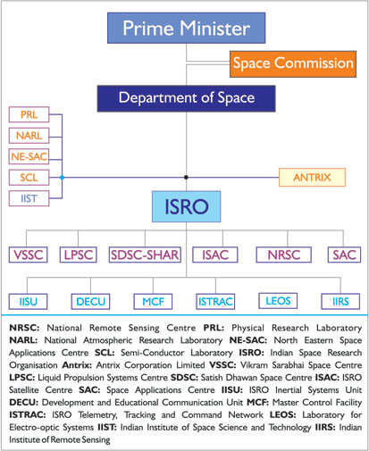

**Fig 1:Organizational Chart of Department of Space,India**

**2**

**1.2 Planetary Sciences Division**

**Overview:**

Here research programmes involve the applications of stable and radioactive isotopes to characterize and determine time scales of processes occurring in the early solar system.

**Research Programmes:**

* Petrographic, chemical and isotopic studies of Meteorites to understand cosmic ray exposure and evolutionary history
* Solar X-ray and fluorescence emission from Lunar Surface
* Reflectance Spectroscopy of Terrestrial and Lunar samples
* Isotope cosmochemistry and early solar system processes
* Study of presolar grains to understand various nucleosynthetic processes and stellar evolution
* Galactic chemical evolution

**Facilities:**

* Noble Gas Mass Spectrometer
* Inductively coupled Plasma Mass Spectrometer (ICPMS)
* Electron Microprobe (EPMA)
* X-ray Fluorescence Spectrometer (XRF)
* Secondary Ion Mass Spectrometer (SIMS)
* Nano Secondary Ion Mass Spectrometer (NanoSIMS)
* Multicollector Inductively coupled Plasma Mass Spectrometer (MC-ICPMS)

**3**

**2**

**INTRODUCTION**

**2. Introduction**

The cerium- doped lanthanum bromide material is an inorganic scintillator.It has gained special interest due to their excellent scintillation properties. LaBr3(Ce) is the most promising material with a light output of about 61 photons/keV, a fast decay time of about 16 ns, a density of 5.08 gm/cm3 and an emission wavelength of 380 nm. The very high light yield results in an energy resolution of about 3% (FWHM) at 662 keV. This is the best for any scintillator. The fast decay time with no intense slow components provides a time resolution of about 300 ps. The high density of LaBr3(Ce) and high atomic number of Lanthanum result in higher detection efficiencies in comparison to NaI(Tl). Another very attractive feature of these crystals is their negligible variation of light output within the temperature range −20 to +60 °C. All these properties open up a very wide usage of these scintillators in nuclear spectroscopy, geological applications, medical imaging, astronomical applications.

**2.1 Objective of Project**

The present work aims to determine the absolute efficiencies of a 38 mm x 38 mm cylindrical LaBr3(Ce) detector for close source-to-detector geometry. The experimental determination of efficiency calibration of LaBr3(Ce) scintillators for close source-to-detector geometry is useful in gamma-ray spectroscopy. In the present work, the absolute total efficiency and the absolute photo-peak efficiency of a 38 mm×38 mm cylindrical LaBr3(Ce) detector measured using calibrated point sources of 137Cs and 60Co placed on the top of the detector surface. Monte Carlo simulations of the efficiencies for the above sources have been carried out using the radioactive-decay module available in GEANT4 simulation toolkit considering the detector in a realistic geometry.

In the present work, the Monte Carlo simulation of Geant4 has been implemented. The toolkit has been developed at CERN for high-energy physics experiments and simulates all relevant physical processes taking place in matter along the passage of elementary particles from the source to the detector of any configuration. The geometrical information, as provided by the manufacturer, describing the LaBr3(Ce) crystal was incorporated in the detector construction class. The gamma-rays from the source lose part of their energy in the aluminium casing of the crystal before they hit the crystal. For each event, the energy deposited in the detector has been calculated and the output files in text format (.txt) were generated for each simulation. The general particle source (GPS) module has been used as particle generator. The simulations were carried out for large number of events (of the order of 106), under the assumption of an isotropic point source placed at the centre of the front surface of the detector, taking all possible physics processes into account.

4

GEANT4 toolkit offers the simulation of the decay of a radioactive source by defining each gamma transition, internal-conversion line and beta-decay spectrum individually. However, the toolkit also offers a radioactive-decay module, which generates all the decay components radiated from specified radioactive source using information provided by Evaluated Nuclear Structure Data File (ENSDF). Here we have used Geant4, based on the radioactive-decay module, to generate the Monte Carlo emission spectra. The absolute detection efficiency and the absolute photo-peak efficiency can be defined as

View the MathML source

View the MathML source

**5**

**3**

**Introduction To Scintillator Detectors**

**3. Introduction To Scintillator Detectors**

Historically, the scintillator NaI(Tl) was the first general-purpose detector for gamma-ray spectroscopy, demonstrated by Hofstadter in 1948. It is still preferred to more expensive HPGe detectors for some applications where high efficiency is more important than energy resolution (e.g. medical imaging, Compton suppression). Scintillators are available in form of

solids, liquids, and even gases. They can be fabricated easily in a large range of sizes and shapes and a range of materials, thus useful for detecting all types of ionizing radiation, including fast neutrons (organics with hydrogen) and slow neutrons (Li, B, Gd).

The sensitive volume of a scintillation detector is a luminescent material (a solid, liquid, or gas) that is viewed by a device that detects the gamma-ray-induced light emissions [usually a photomultiplier tube (PMT)]. The scintillation material may be organic or inorganic, but the inorganic materials are more commonly used. Examples of organic scintillators are anthracene, plastics, and liquids. The latter two are less efficient than anthracene. The standard scintillation material is the anthracene, against which other scintillators are compared. Some common inorganic scintillation materials are sodium iodide (NaI), cesium iodide (CsI), zinc sulphide (ZnS), and lithium iodide (LiI). The most common scintillation detectors are solid, and the most popular are the inorganic crystals NaI and CSI. A new scintillation material, bismuth germanate, commonly referred to as BGO, has become popular in applications where its high gamma counting efficiency is taken into consideration.

**3.1 Operation of Scintillator Detectors**

When gamma rays interact in scintillator material, ionized or excited atoms in the scintillator material “relax” to a lower-energy state and emit photons of light. In a pure inorganic scintillator crystal, the return of the atom to lower-energy states with the emission of a photon is an inefficient process. Also the emitted photons are usually too high in energy to lie in the range of wavelengths to which the PMT is sensitive. Small amounts of impurities called activators are added to all scintillators to enhance the emission of visible photons.

Crystal de-excitations channelled through these impurities give rise to photons that can activate the PMT. One important consequence of luminescence through activator impurities is that the bulk scintillator crystal is transparent to the scintillation light. A common example of scintillator activation encountered in gamma-ray measurements is cerium dopped LaBr3(Ce).

The scintillation light is emitted isotropically, so the scintillator is typically surrounded with reflective material, such as MgO to minimize the loss of light and then is optically coupled to

the photocathode of a PMT. Scintillation photons which are incident on the photocathode liberate electrons through the photoelectric effect. These photoelectrons are then accelerated by a strong electric field in the PMT. As these photoelectrons are accelerated, they collide with electrodes in the tube releasing additional electrons. These electrodes are known as dynodes. This increased electron flux is then further accelerated to collide with succeeding electrodes, causing a large multiplication (by a factor of 104 or more) of the electron flux from its initial value at the photocathode surface. Finally, the amplified charge burst arrives at the output electrode (anode) of the tube. The anode passes the electrons to preamplifier to convert energy of electrons to a voltage pulse. The amplitude of this charge surge is proportional to the initial amount of charge liberated at the photocathode of the PMT, the constant of proportionality is the gain of the PMT.

6

Due to photoelectric effect, the initial number of photoelectrons liberated at the photocathode, is proportional to the amount of light incident on the phototube, which, in turn, is proportional to the amount of energy deposited in the scintillator by the gamma ray. Here it is assumed that no photon is lost from the scintillator volume. Thus, an output signal is produced that is proportional to the energy deposited by the gamma ray in the scintillation medium.

**3.2 Types of Scintillators**

**3.2.1 Organic-based**

The scintillation mechanism in organic materials is of fluorescence type. The fluorescence mechanism in organic materials arises from transitions in the energy levels of a single molecule and therefore the fluorescence can be observed independently of the physical state Practical organic scintillators are organic molecules which have symmetry properties associated with the electron structure. Liquid and plastic materials with Low density and Z, low and non-linear light output, high hydrogen content are used for organic-based scintillator detectors. Its properties are fast neutron detection, fast decay times, pulse-shape discrimination between different types of particles. Types of organic scintillators:

* Pure organic crystals: Anthracene, Stilbene
* Liquid organic solutions: by dissolving an organic scintillator in a solvent
* Plastic scintillators: dissolving & polymerizing

**3.2.1 Inorganic-based**

Crystals such as alkali-halide which has High density and Z, high and more linear light output, are used in Inorganic Scintillators. It has slower decay times. The scintillation mechanism depends on the structure of the crystal lattice. In a pure inorganic crystal lattice such as NaI, electrons are only allowed to occupy selected energy bands. The forbidden band or band gap is the range of energies in which electrons can never be found in the pure crystal. In the pure crystal, absorption of energy can elevate electrons from the valence band to the conduction band leaving a gap in the valence band. However, the return of an electron to the valence band with the emission of a photon is an inefficient process. Few photons are released per decay, the energy is emitted by other mechanisms. In addition, band gap widths in pure crystals are such that the resulting emitted photon is too high to lie within the visible range. Small amounts of impurities are therefore added to the crystal. Cerium(Ce) is added to LaBr3 in trace amounts. The impurities are called activators, they create special sites in the lattice at which the band gap structure, the energy structure, is modified. The energy structure of the overall crystal is not changed.

Types of inorganic scintillators:

* Alkali halide: NaI(Tl), CsI(Tl), CsI(Na), LiI(Ei)
* Other slow Inorganics: BGO, CdWO4, ZnS(Ag)
* Cerium-Activated Fast Inorganics: GSO, YAP, YAG, LSO, LuAP, LaBr3

**7**

**3.3 Key Properties of Scintillators:**

There are many desired properties of scintillations, such as high density, fast operation speed, low cost, radiation hardness, production capability and durability of operational parameters. The main properties are as follows:

* Energy Resolution
* Fast Time Response

**3.3.1 Energy Resolution**

The resolution of a detector is a measure of its ability to resolve two peaks that are close together in energy. The parameter used to specify the detector resolution is the full width of the (full-energy) photopeak at half its maximum height (FWHM). Small FWHM results in high resolution The more complex a gamma-ray spectrum is the more desirable it is to have the best energy resolution possible. The quality of a given scintillation counting system is often characterized by the magnitude of its energy resolution. The system resolution is a measure of the photopeak sharpness.

Resolution is defined as the ratio of the full width at half maximum (FWHM) of the full energy peak (called the “photopeak” when dealing with photon detectors) to the energy midpoint of the full energy peak. Thus, the resolution is dimensionless fraction conventionally expressed as percentage. With a small resolution, the detector is able to separate two radiations whose energies are close together.

% resolution = Typically at 662 keV the percentage energy resolution is around 10%.

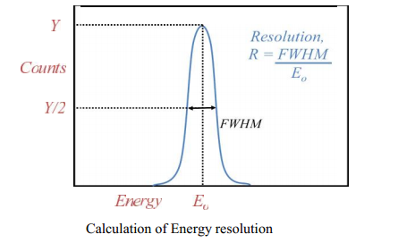

**Fig 2. Calculation of Energy Resolution**

**8**

**3.3.2 Fast Time Response**

High operating speed is needed for good resolution of spectra. Short decay times are important for the measurement of time intervals and for the operation in fast coincidence circuits. High density and fast response time can allow detection of rare events in particle physics. Particle energy deposited in the material of a scintillator is proportional to the scintillator’s response.

**9**

**4**

**GEANT4 Software**

**4. GEANT4 Software**

GEANT4 stands for “Geometry and Tracking” . GEANT4 is a toolkit developed by engineers and scientists at CERN and other institutions worldwide, to simulate the passage of various types of particles and radiation through different mediums using software and object-orientation technology in C++, which has a huge energy range from the eV to TeV scale. The toolkit has a hierarchical structure of domains that are linked together when the program is compiled with a GNU makefile. Several domains that are necessary to construct a physics case include the following:

• The geometry and material of the detector used.

• Particle interaction within the detector medium or other matter

.

• Tracking of the particle. i.e. how many steps to move the particle.

• The hit pattern, event and track management.

• Visualisation and user interface framework.

**Installing Geant4 on Windows and Fedora 17**

Here are the three pieces of software required for building Geant4 in Windows and Linux.

1) Microsoft Visual C++:

Microsoft C++ is the compiler that is recommended for Geant4 on Windows.

2) gcc 4.1.2 (for SLC4 or RedHat 4) or gcc 4.3.2 (for SLC5 or RedHat 5):

gcc is the compiler that is recommended for Geant4 on Linux.  Users have also had success with some other gcc versions, but there is no guarantee.

To check your version, type: gcc –v.

3)Cygwin:

Cygwin is a Linux shell environment that runs on top of Windows. While it is possible to run Geant4 without this,the officially supported way to run Geant4 on Windows is with Cygwin. By requiring Cygwin, we obtain a common, Linux-like baseline for all of our users.  This greatly simplifies installation and configuration support. Cygwin provides essential tools such as the make utility. Cygwin also provides a C++ compiler,but Cygwin compiler does work for Geant4, the Microsoft compiler produces significantly faster-running code.  The Microsoft compiler is therefore the officially supported Geant4 solution.

10

4) CLHEP:

CLHEP stands for “A Class Library For High Energy Physics”. CLHEP is a set of base libraries that have long provided great functionality for the particle physics community.  They provide things like matrix manipulations, four-vector tools and lists of particle properties.  The Geant4 collaboration has chosen to use these libraries rather than re-invent them. CLHEP and Geant4 both come out of the particle physics communities, they are separate products.

**4.1 Overview of Geant4 Functionality**

Because of its general purpose nature, Geant4 is well suited for development of computational tools for analyzing the passage of radiation thru matter in several multi- disciplinary areas, besides High-Energy Physics, which has been the origin of GEANT4.

These include:

* Space applications where it is used to study interactions between the natural space radiation environment and space hardware or astronauts;
* Medical applications where interactions of radiations used for treatment are simulated.
* Radiation effects in microelectronics where ionizing effects on semiconductor devices are modelled.
* Nuclear Physics & Engineering.

Simplest GEANT4 simulation needs three classes, and a Main class to run,

* Geometry
* Primary Generator Action
* Physics List

**4.2 Detector Construction**

Geometry is an analysis of the physical layout of the experiment, including detectors, absorbers, etc., and considering how this layout will affect the path of particles in the experiment. We first design the entire experimental situation / Hall which in GEANT4 terminology is referred to as WORLD.

11

We then define all objects within the world, i.e. we specify the

* + Shape
  + Size
  + Material
  + Position

We have various options to specify the shape of the experimental layout, which also includes the detector. For shape and size details, we define the Solid Volume. Then we specify a Logical Volume, which shall have all the details of the materials to be used. Materials are defined based upon their chemical structure. We initially define the element(s), and then construct the material from them. Hence, we require the information / details regarding the assigned weighted quantities of element to material, their atomic number, molar mass, density to name a few. The placement of the various experimental quantities is achieved using the Physical Volume.

This is summarized as below:

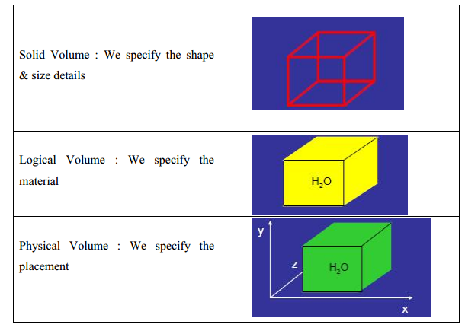

**Fig 3. Difference between Solid Volume , Logical Volume and Physical Volume**

12

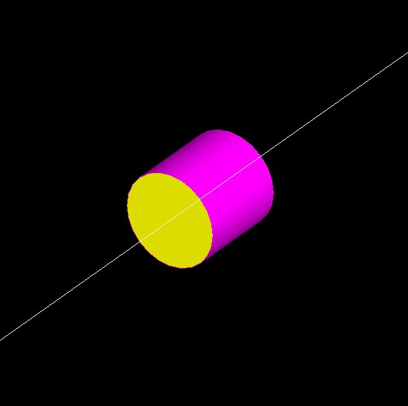

**Fig.4 Cross Section of LaBr3:Ce Detector having Aluminium Casing of 0.5 mm thickness**

**4.3 Physics List**

It is one of the mandatory user class (abstract class) and its pure virtual methods are:

* ConstructParticles()
* ConstructProcesses()
* SetCuts()

Physics List in Geant4 doesn’t “automatically” include any physics processes. You need to explicitly tell Geant4 what physical interactions would be relevant to the particular simulation. Physics List is a set of consistent physics models for each particle in application. We need to specify the “particles” (gamma is also considered as a particle) and then associate the processes with these particular particles. The process takes care of the interactions, decay and even transportation of the radiations. Process may consist of several models, cross- sections etc. with different energy ranges.

A process does two things:

* It decides when and where an interaction will occur
* And it generates the final state (changes momentum, generates secondary etc)

13

For example if we consider ”gammas”, them the modes of interaction are Photo-electric, Compton & Pair Production, which would have to be included in the Physics List. We also define the Cut value, a value which defines the extent to which a particle is tracked. Cuts are defined in distance and converted into energy based on the material. Stationary sources can be defined there using random numbers to generate isotropic distributions.

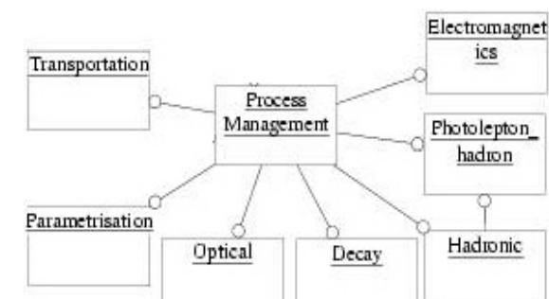

**Fig.5 Different Physics Processes available in standard EM model**

**4.4 PrimaryGeneratorAction**

This class is one of mandatory user classes to control the generation of primaries. This class itself should NOT generate primaries but invoke GeneratePrimaryVertex() method of primary generator(s) to make primaries.

Constructor used in Primary Generator Action class:

* Instantiate primary generator(s)
* Set default values to it(them)

GeneratePrimaries() method

* Randomize particle-by-particle value(s)
* Set these values to primary generator(s)
* Invoke GeneratePrimaryVertex() method of primary generator(s)

**14**

**4.4.1 Particle Gun vs. General Particle Source**

|  |  |
| --- | --- |
| Particle Gun | General Particle Source |
| Simple and naive | Powerful |
| Shoot one track at a time | Controlled by UI commands |
| Easy to handle. | Almost impossible to control through Set methods |
| Use set methods to alternate track by track or event by event values. | Capability of shooting particles from a surface of a volume |
|  | Capability of randomizing kinetic energy, position and/or direction |

**Table 1: Diffence between Particle gun and general particle source**

If we need to shoot primary particles from a surface of a volume, either outward or inward or complicated distribution, not flat or simple Gaussian, GPS is the choice.

The Geant4 toolkit is available for a variety of operating systems:

* Linux on PC with g++ (gcc compiler)
* MacOSX with g++ (gcc compiler)
* Windows/XP with MicroSoft Visual C++

15

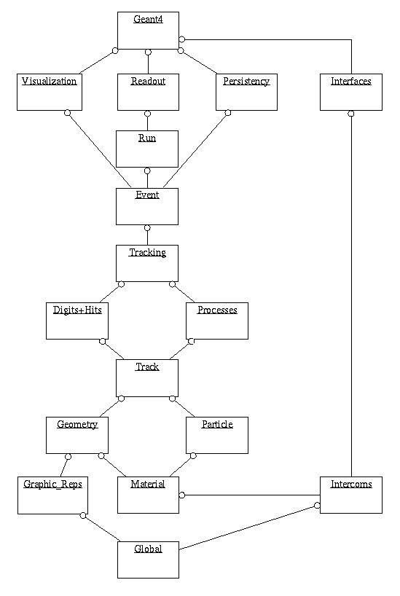

**Fig. 6 Geant4 class categories**

16

**5**

**Interaction of Gamma Rays with Matter**

**5. Interaction of Gamma Rays with Matter**

In nature, majority of elements are stable, but a few of high atomic weight from Polonium (atomic energy 84) onward, e.g. Radium(88), Thorium(90), and Uranium(92) entirely consist of unstable nuclides, which are responsible for radioactivity. These unstable elements undergo spontaneous change, i.e. radioactive decay at definite rates. These radioactive decays are associated with the emission of electrically charged particles, either an Alpha particle, i.e. a helium nucleus, which is positively charged, or a Beta particle, i.e. an electron. In many instances, Gamma radiation accompanies the particle emission. Beside these, neutrons, positrons (positive electron) & also the fission products are radioactive too. The general term radiation is used to include both material particles and true electromagnetic radiation. In this thesis we should concentrate on gamma ray as the radiation which interacts with the matter. It is a common practice to express gamma radiation in terms of its photon energy. Nuclear excitation energies are generally in the range from 0.1 to 10 MeV in case of gamma rays which is much higher than the other particle radiations.

As gamma radiation passes through an object, three possible fates await each photon,

* It can penetrate the section of matter without interacting.
* It can interact with the matter and be completely absorbed by depositing its energy.
* It can interact and be scattered or deflected from its original direction and deposit part

of its energy.

In case gamma rays interact with an absorbing material, there are five mechanisms of interaction, among which namely, the photoelectric effect, the Compton scattering and pair production are important & will be considered in this paper. Beside these gamma rays of sufficiently high energy can eject neutrons from nuclei & can even cause fission of heavy element. While considering matter with which the gamma rays interact, we assume that the matter is homogenous and isotropic. The atomic nucleus is fixed, and hence the recoil momentum is neglected, and the electrons are considered as quasi-free, i.e. except for photoelectric effect the binding energy is neglected.

Thus major interactions of Gamma rays with matter which are of relevance in radiation detection are:

i) Photo-electric effect

ii) Compton effect and

iii) Pair production

17

**5.1 Photo-electric Effect:**

The photoelectric effect is the ejection of an electron from a material after a photon has been absorbed by that material. Here the incident ray interacts with the entire atom, the γ ray disappears, and one of the atomic electrons is ejected from the atom. The atom recoils in this process, but carries with it very little kinetic energy. The kinetic energy of the ejected photoelectron is therefore equal to the energy of the photon (γ ray) less the binding energy of the electron to atom. In the photoelectric effect, a Gamma ray photon with energy greater than the binding energy of an orbital electron in an atom interacts with the electron in such a way that the whole energy of the Gamma ray is transferred to the electron which is ejected from the atom. If E is the energy of the Gamma ray photon, and B is the binding energy of the electron in the atom, then the difference, (E-B) is carried off as kinetic energy by the ejected electron. The emitted electron, called photo-electron, behaves like a Beta particle of the same energy in its passage through matter. For Gamma rays of high energy, the photoelectrons are mainly expelled in the forward direction, i.e. in the same direction of the incident Gamma ray photon. But for low energy rays, the emission is large in the direction at right angles.

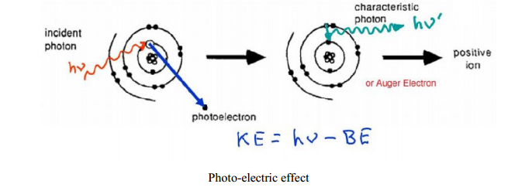

**Fig.8 Photo-electric Effect**

**5.2 Compton Effect:**

In Compton interaction, a Gamma ray photon makes an elastic collision with an electron of the absorbing material such as election behaves like a free electron, because its binding energy is much less than the photon energy. In this collision both momentum and energy are conserved, and part of the energy of the incident photon is transferred to the electron. Another photon of lower energy is scattered and is moved off in a new direction, so that it seems the incident photon is deflected from its initial path.

Compton scattering is the interaction of a high energy photon with an electron, and the resulting “scattered” photon which has a reduced frequency, and therefore reduced energy.

This effect is depicted pictorially below.

18

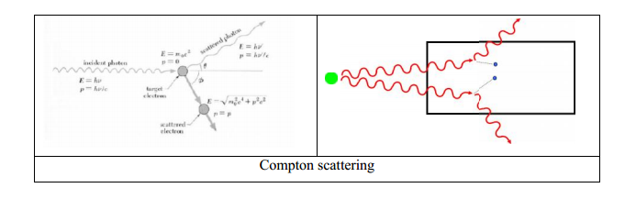

**Fig.9 Compton Scattering**

**5.3 Pair Production**

When a Gamma ray photon with energy more than 1.02 MeV passes near the nucleus of an atom, the photon can be annihilated in the strong electric field with the formation of an electron-positron pair.

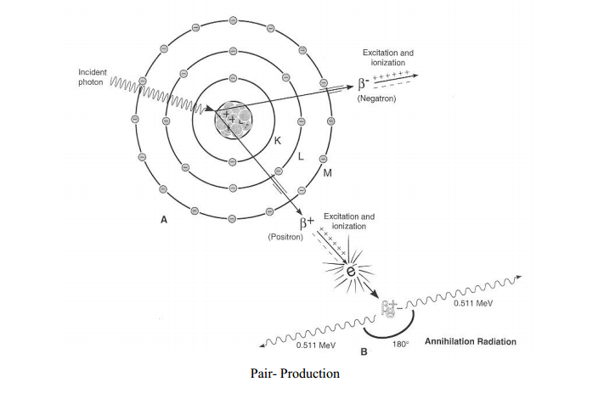

**Fig.10 Pair Production**

19

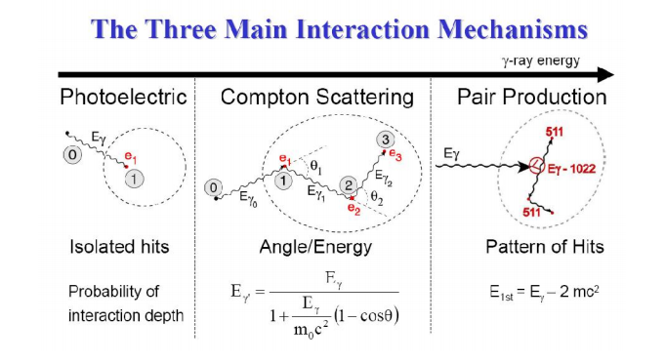

**Fig.11 Three Basic Interaction Mechanisms**

**5.4 Self Activity and Background energy Spectrum of LaBr3(Ce):**

The self-activity within LaBr3(Ce) scintillators is due to the presence of the radioisotope 138La, a naturally occurring isotope with an abundance of 0.09 % and a large half life of 1.05x1011 years. In 66.4 % of its decays, 138La undergoes electron capture to an excited state of 138Ba via photon emission of a 1436 keV -ray. However, X-rays at 32 and 5 keV occur due to the reoccupation of the K and L electron shell orbital in barium, and displace the 1436 keV line due to their coincident nature. The remainder of 138La decays 33.6% of the time via beta emission to 138Ce, emitting a 789 keV gamma-ray from the 2+ state.



**Fig 12 Radioactive Decay of 138 La isotope**

20



**Fig.13 Intrinsic Energy Background from Saint-Gobain**

Energy(keV)

**Fig.14 Simulated Intrinsic Background of LaBr3:Ce Detector**

**5.5 Actinide Contamination**

The presence of naturally occurring alpha-contamination can be measured, as 227Ac is in the same periodic group (group IIIB) as Lanthanum, which results in four broad peaks in the background spectra. Of these decays, long lived 227Ac is the contributing element (1/2 = 21.2 years), which beta-decays to 227Th, and subsequently alpha -decays to 207Tl, as shown in figure 4.1. A spectrum with 4096 channels is enlarged to show both 227Ac contamination and the 4.44 MeV gamma-ray with escape peaks in below figure.

21

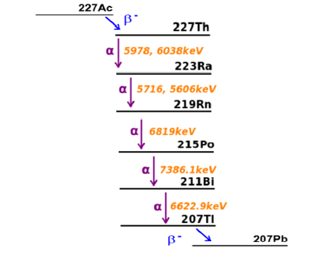

**Fig.15 Decay due to contamination of 227Ac**

By comparing the true values of these alpha energies and their measured energies,extraction of the properties of alpha -scintillation in the detector can be achieved.When calibrated with gamma rays,alpha-particles were found to produce 65 % less light. This quenching for alpha -particles is possibly due to the sensitivity of the scintillation mechanism for various particles.



**Fig.16 Gamma Energy spectrum due to contamination of 227Ac**

22

**5.6 Alpha decay**

Alpha Decay is usually restricted to the heavier elements in the periodic table. (Only a handful of nuclides with atomic numbers less than 83 emit an alpha-particle.) The product of alpha-decay is easy to predict if we assume that both mass and charge are conserved in nuclear reactions. Alpha decay of the 238U "parent" nuclide, for example, produces 234Th as the "daughter" nuclide.

alpha decay

The sum of the mass numbers of the products (234 + 4) is equal to the mass number of the parent nuclide (238), and the sum of the charges on the products (90 + 2) is equal to the charge on the parent nuclide.

**5.7 Beta Decay**

There are three different modes of beta decay:

|  |
| --- |
| * Electron emission |
| * Electron capture |
| * Positron emission |

**5.7.1 Electron emission**

Electron emission is literally the process in which an electron is ejected or emitted from the nucleus. When this happens, the charge on the nucleus increases by one. Electron emitters are found throughout the periodic table, from the lightest elements (3H) to the heaviest (255Es). The product of electron-emission can be predicted by assuming that both mass number and charge are conserved in nuclear reactions. If 40K is aelectron-emitter, for example, the product of this reaction must be 40Ca.

electron emission

**5.7.2 Electron Capture**

Nuclei can also decay by capturing one of the electrons that surround the nucleus. Electron capture leads to a decrease of one in the charge on the nucleus. The energy given off in this reaction is carried by an x-ray photon, which is represented by the symbol hv, where h is Planck's constant and v is the frequency of the x-ray. The product of this reaction can be predicted, once again, by assuming that mass and charge are conserved.

electron capture

23

The electron captured by the nucleus in this reaction is usually a 1s electron because electrons in this orbital are the closest to the nucleus.

**5.7.3 Positron Emission**

A third form of beta decay is called **positron emission**. The positron is the antimatter equivalent of an electron. It has the same mass as an electron, but the opposite charge. Positron decay produces a daughter nuclide with one less positive charge on the nucleus than the parent.

positron emission

Positrons have a very short life-time. They rapidly lose their kinetic energy as they pass through matter. As soon as they come to rest, they combine with an electron to form two gamma-ray photons in a matter-antimatter annihilation reaction.

gamma ray 

Thus, although it is theoretically possible to observe a fourth mode of beta decay corresponding to the capture of a positron, this reaction does not occur in nature.

**5.7.4 Gamma Emission**

The daughter nuclides produced by alpha-decay are often obtained in an excited state. The excess energy associated with this excited state is released when the nucleus emits a photon in the gamma-ray portion of the electromagnetic spectrum. Most of the time, the gamma-ray is emitted within 10-12 seconds after the alpha-particle. In some cases, gamma decay is delayed, and a short-lived, or **metastable**, nuclide is formed, which is identified by a small letter m written after the mass number. 60mCo, for example, is produced by the electron emission of 60Fe.

electron emission of iron

The metastable 60mCo nuclide has a half-life of 10.5 minutes. Since electromagnetic radiation carries neither charge nor mass, the product of gamma-ray emission by60mCo is 60Co.

gamma ray emission

24

**6**

**Results and Conclusion**

**6. Results and Conclusion**

For efficiency measurements, it is essential to calibrate the detector accurately. This has been achieved using various gamma-ray sources, namely, 133Ba (80.998, 302.85, 356 keV), 22Na (511 keV), 137Cs (661.6 keV) and 60Co (1173.21, 1332.47 keV). The efficiency measurements have been made using calibrated point sources of 60Co and 137Cs placed on top of the detector surface. In order to avoid the scattered gamma-rays entering into the detector the materials in near proximity of the source–detector setup were removed. Fig. 17 shows the measured energy spectrum for 137Cs together with the simulated one. The simulated spectrum has been generated for the number of events determined by the calibrated source strength and the duration of measurement using low-energy EM model. In addition, the energy-resolution model could successfully reproduce the observed response of the detector for the whole energy region of the measured spectrum. [Fig.](http://www.sciencedirect.com/science/article/pii/S0168900209016349#fig3) 18 shows the similar spectra for 60Co.

**Energy(keV)**

**Fig. 17 Simulated Spectrum for 137Cs (661.6 keV) placed on the LaBr3(Ce) Detector**

25

**Energy(keV)**

**Fig.18 Simulated Spectrum for 60Co (1173.21 keV and 1332.47 keV) placed on the LaBr3(Ce) Detector**

**Energy(keV)**

**Fig. 19 Simulated Spectrum for 133Ba (80.998 keV , 302.85 keV and 356 keV) placed on the LaBr3(Ce) Detector**

26

Here is the Efficiency calculation of LaBr3:Ce detector for gamma-rays ranging from 100 keV to 8 MeV. The distance between gamma ray point source and detector is 20 cm.

|  |  |  |  |  |
| --- | --- | --- | --- | --- |
| **Energy(keV)** | **Counts(1000)** | **Counts(10000)** | **Counts(100000)** | **Efficiency** |
| 100 | 965 | 9701 | 97027 | 0.965 |
| 500 | 787 | 7791 | 77345 | 0.779 |
| 1000 | 544 | 5400 | 53683 | 0.54 |
| 2000 | 375 | 3533 | 34627 | 0.3733 |
| 3000 | 252 | 2433 | 24402 | 0.24 |
| 4000 | 190 | 1928 | 19075 | 0.19 |
| 5000 | 149 | 1558 | 15735 | 0.1558 |
| 6000 | 129 | 1332 | 13371 | 0.133 |
| 7000 | 129 | 1209 | 11827 | 0.118 |
| 8000 | 90 | 1018 | 10638 | 0.117 |

**Table 2: Efficiecy Of LaBr3:Ce**

27

**REFERENCES**

1. **C.M. Rosza, et al., Performance summary: BrilLanCe™ scintillators LaCl3 and LaBr3, Saint Gobain crystals, available at 〈**[**www.detectors.saint-gobain.com**](http://www.sciencedirect.com/science?_ob=RedirectURL&_method=externObjLink&_locator=url&_cdi=271580&_issn=01689002&_origin=article&_zone=art_page&_plusSign=%2B&_targetURL=http%253A%252F%252Fwww.detectors.saint-gobain.com)**〉.**
2. **GEANT4 Home Page 〈**[**http://geant4.web.cern.ch/geant4/〉**](http://geant4.web.cern.ch/geant4/〉)
3. **General Particle Source Manual**
4. **Radioactive decay in GEANT4**
5. **G. Anil Kumar et al./Nuclear Instruments and Methods in Physics Research A 609 (2009 ) 183-186**
6. **A Giaz et al./Nuclear Instruments and Methods in Physics Research A 729 (2013) 910-921**

28