Create a report in Microsoft Word and answer the following questions.

1. Given the provided data, what are three conclusions we can draw about Kickstarter campaigns?

Based on the following stack chart we can come to the conclusion that in a big picture the projects with the Kickstarter are more successful than failed. Also per the following graph if we look into the results by main or parent category, it is notable that the Theater and Music categories have been running more successful campaigns than Journalism, Game or Food.

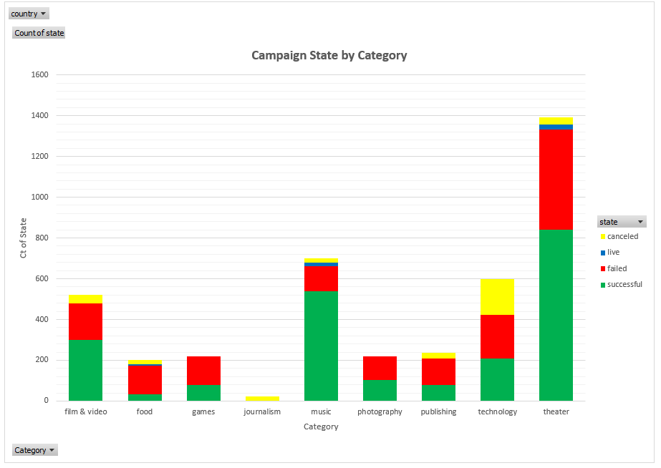

Also, by filtering this graph through the different countries and analyze them by the main category we can conclude that US out of all the countries run the most successful and failed campaigns. Also, although Theater and Music categories are considered as the most successful parent category campaigns, but we can only conclude this for US since music category for GB has a

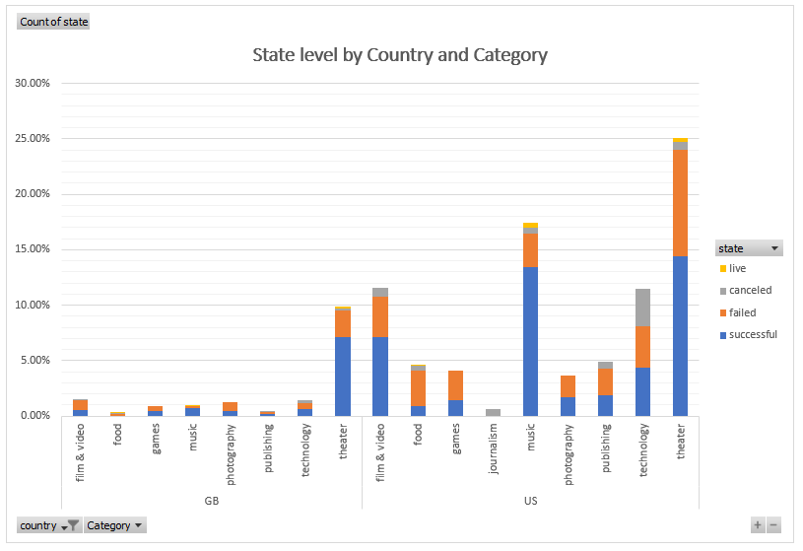

* Starting May the successful campaigns start some gradual decrease and by December according to our line graph we can see there is an over lap between the failed and successful campaigns

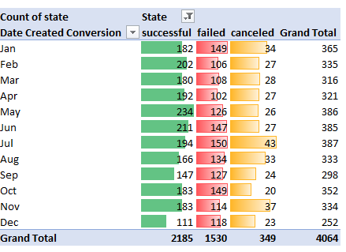

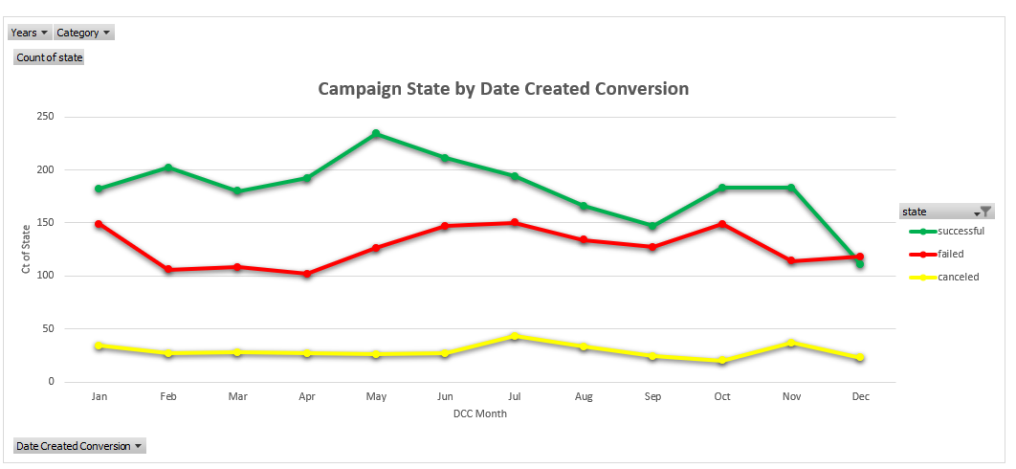

As we can observe from the plot, most projects have a past success rate between

0.5 and 1 and only 2 projects have past success rate below 0. We would expect creators

22

who have a high past success rate to be more experienced in Kickstarter and have more

supporters in the Kickstarter community. As a result, they will have a higher probability of

success for their new projects. Creators who have a high past success rate may also have

more motivations to start new projects. In addition, past success rate can serve as the

“resume” for creators and may influence the choice of backers. Backers will likely to have

more faith in creators with high past success rates.

1. **What are some limitations of this dataset?**
2. One of the limitations of the data set to consider is the fact that the currency rate for each one of the available countries will be different and we will need to convert them to the USD $ to have a better understanding of the different states for our campaigns.

**Example:** Based on today’s rate the total of $22345 NZD= $14306.39 and the goal for this campaign was $20000 which has not been met. Therefore, considering this campaign as successful is not completely accurate.



1. Normally it is expected to assume that the total amount of pledges is related to number of backers. But we are forgetting the fact that if a backer has pledged a large amount this might affect the accuracy of our analysis. I expect the larger the total number of backers, the more pledges there are.
2. It will be beneficial if we were able to analyze the available data by different states in each country and get more analysis in a more granular level. In that case we would have a better insight regarding the success level by state and we might find some trends if we review them by Date Created Conversion (Month) or even Parent category.
3. **What are some other possible tables and/or graphs that we could create?**

* Analyzing the projects by the duration of conversion by utilizing the date created conversion and date ended conversion. Then we might be able to find any possible trends or outlier within the duration of successful/failed projects. Or we can run the correlation analysis to see if the duration between the date created and date ended have any relation to the state of the campaign.

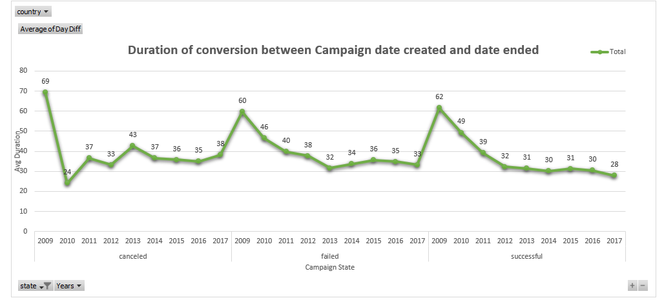

* Also I would focus more on the successful status to see