**Infrastructure Monitoring**

To start with on Infra monitoring front – we are going to have below tools

*Node Exporter*: This is kind of plugin which needs to be installed on the machine where host monitoring needs to be done [ For technology monitoring, there are separate plugins which needs to be installed as well e.g. KAFKA, Mongo etc. ]

*Prometheus DB*: Prometheus DB will be configured to listen to data generated by Node Exporter based on configured frequency and store them. Prometheus also come with UI where you can explore data and run queries on top of them.

*Grafana UI*: Because UI given by Prometheus is not good and configurable for different kind of dashboard – we are going to use ready UI where we can plugin Prometheus as data source and configure graphs on required data.

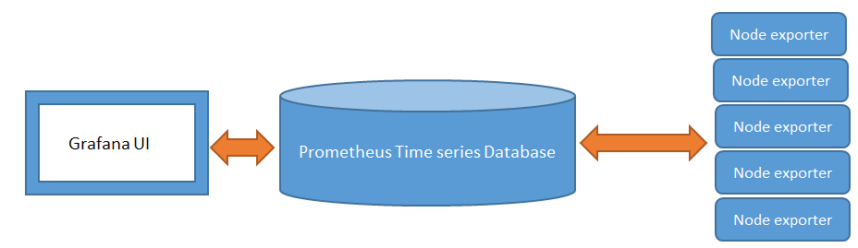

Installation for basic monitoring

1. **Download**
   1. Go to <https://prometheus.io/download/> - we need to download tar version based on operating system and bits accordingly.

prometheus-2.1.0.linux-amd64.tar.gz for Linux 64 bit system - <https://github.com/prometheus/prometheus/releases/download/v2.1.0/prometheus-2.1.0.linux-amd64.tar.gz>

* 1. you will be able to find node exporter plugin on the same page on Prometheus itself.

Below is download link for tar version of node exporter Linux 64 bits.

<https://github.com/prometheus/node_exporter/releases/download/v0.15.2/node_exporter-0.15.2.linux-amd64.tar.gz>

* 1. Download grafana from <https://grafana.com/grafana/download> based on your operating system. Latest stable version as on Feb 2018 is 4.6.3 which was released last month. Download link as given below :

<https://s3-us-west-2.amazonaws.com/grafana-releases/release/grafana-4.6.3.linux-x64.tar.gz>

1. Installation/Configuration
   1. **Node Exporter**
2. tar –xzvf node_exporter-0.15.2.linux-amd64.tar.gz
3. cd node_exporter-0.15.2.linux-amd64
4. nohup ./node_exporter & [ & to start process in background ]
5. check nohup logs to see if it’s started properly. It starts by default on 9100.
6. If you have 9100 port open to be accessed by outside – check http://<IP_ADDRESS>:9100/metrics and you will be able to see last metrics collected and their values accordingly.
   1. **Prometheus**
7. tar –xzvf prometheus-2.1.0.linux-amd64.tar.gz
8. cd prometheus-2.1.0.linux-amd64
9. Attaching sample yml file which needs to be updated



1. Below configuration will have to have details of all the node exporters you have



1. nohup ./prometheus & [ & to start process in background ]
2. It starts on 9090 (based on what you have configured in yml file), try opening http://<IP-ADDRESS>:9090/ if you have 9090 port access from outside and you will be able to see basic UI of Prometheus where you can run queries against data you have in DB and create graphs as well on top of them.
   1. **Grafana**
3. tar –xzvf grafana-4.6.3.linux-x64.tar.gz
4. cd grafana-4.6.3/bin
5. nohup ./grafana-server & [ & to start the process in background ]
6. default port of grafana is 3000 – please ask admin to open 3000 port at least so that you can access Grafana UI from outside from browser.
7. Open http://<IP-ADDRESS>:3000/
8. Create Data source with proemetheus

HTTP URL with 9090 prometheus DB port

1. You can import ready made basic dashboard as well from dashboard tab
2. Click on ‘ADD’ and you will be able to see your dashboard and data.
3. Initial username password are admin/admin

*Snapshots From Grafana*:

This is how your dashboard will look like an d you will also be able to view all the servers in drop down if you have configured ready made dashboard. All the reports in dashboard can be managed easily with drag drop functionality.

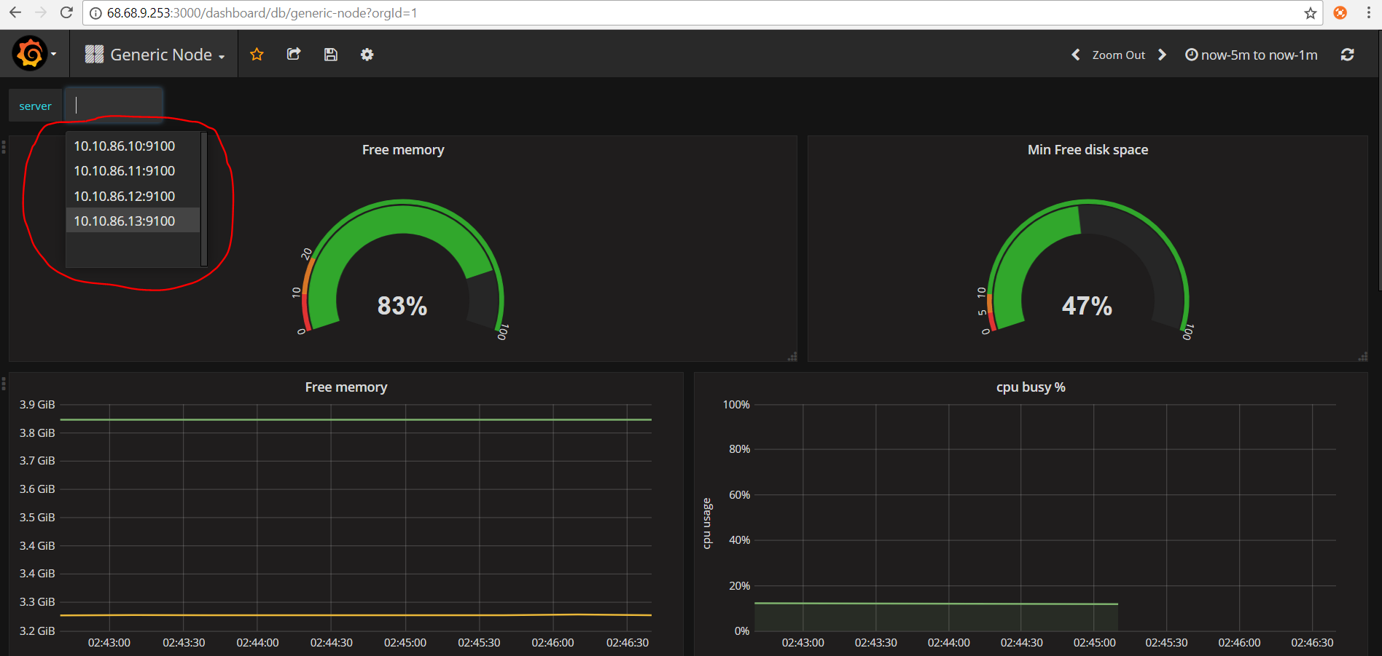

Multiple dashboard for selection and change

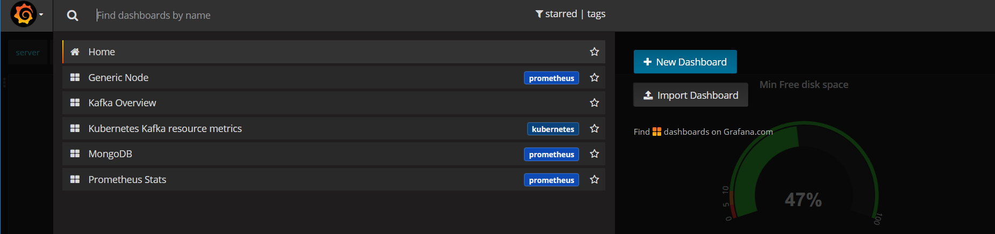

Time range and refresh can be changed easily

