Darshan Shimpi
Project 1
PBHLT 7101
2/17/2026

1. Introduction
Within this project we are setting up an exploratory data analysis of physical measurements of military personnel and the relationships between these measurements/variables. The purpose of this project is mainly to give us the foundations of understanding how to prepare and explore a dataset for analysis purposes as well as to give us more practice analyzing data and understanding how to create meaningful figures, graphs, and analyses from a new dataset. The data used for this analysis comes from the ANSUR-II dataset which consists of data from a 2012 survey by the U.S. Army to measure demographic and anthropometric measures of personnel representing the US army. Anthropometric measures in this dataset refer to physical measurements of the body size and shape of individuals who were surveyed. Respondents include active duty, reserves, and national guard members of the US Army force.
The dataset itself consists of 7,031 observations over 29 variables. These 29 variables consist of 8 string variables and 21 numeric variables representing anthropometric measurements, dates, subject numbers, and categorical variables for various demographic characteristics. The data itself is used within the real world to help with the “design and sizing of clothing and personal protective equipment” for US army personnel but also to help with calculations and simulations of how human bodies may respond to life threatening occurrences which could come up from various situations within the army.

2. Data Preparation

2.1 Data Analysis Plan
- Organize the project
  - Put all of the documents for the project in one synced folder including the original dataset, codebooks, the assignment description, and any files we begin putting together (do file, project report, etc.)
  - Save dataset as project_data_v0
- Change Missing Values to Stata MV Types and Add UID
  - For each variable go through and change the following (change the value AND label)
    - -77 -> .a to represent “not recorded”
    - -88 -> .b to represent “refused measurement”
    - -99 -> .c to represent “unknown missing”
  - Create Unique ID for each record
    - Label this “Unique Key” and make it so that each record in the dataset has a unique key value
  - Save dataset as project_data_v1
- Inspect and Correct Data
  - Go through each variable and find invalid/suspicious values
  - For each value, make a reasonable correction to the special missing values we’ve noted (or come up with a new one) and document the changes
    - Change them to a special missing value
    - Note somewhere in the codebook that “this missing value indicates that the value was invalid/suspicious.”
  - For any changed/suspected value, use a new indicator variable “is_suspect?” and set it to 1 to indicate the suspicion
  - Note that any records where the legal age is below 18 should not be allowed
    - Create an indicator variable “is_adult?” based on age >= 18 and mark those records also as suspect
    - Drop any that have that indicator variable == 0
  - Save dataset as project_data_v2
- Identify and Remove Duplicates
  - Go through and check for duplicate observations based on some set criteria
    - Most likely it will be based on all measurements being equal between multiple records
    - See the duplicate command for more help
  - Then we will just flag these with another “is_duplicate?” indicator variable and remove them from future analysis
  - Save as project_data_v3
- Label Variables and Values
  - Go through each variable and add a label to help keep track of what it represents
  - For categorical variables, label each level of them
  - Save as project_data_v4
- Create New Variables
  - New Unique Key
    - See step 2
  - Continuous BMI Variable based on weight in kg / square of height in meters
  - Categorical BMI variable using standard definitions for obese, overweight, normal weight, underweight
  - Season variable
    - Use splits based on solstices and equinoxes for fun
  - Numerical categorical variables using encode
    - Gender
    - Birth State
      - No longer a requirement as of 2/17/2026
    - Preferred Hand
  - Categorical body type based on height, weight, and other measurements
    - Document rationale
    - Different algorithm for women and men
    - Between 3 – 6
    - Label
  - Save as project_data_final
- Generate Sample Characteristics
  - Generate stats for the anthropometric measures within the sample and summarize those measures in a table organized by body part.
    - Note the number of missing values and suspicious values for each variable
  - Create a figure that shows the differences in % of total height attributable to the height to hip by gender
    - Calculate the value %
    - Describe in a paragraph
- Describe relationships between anthropometric measures
  - Relationship between measures of stature
    - Describe in a short paragraph:
      - Assess the level of correlation between the measures of stature
      - Identify the two measures that are most highly correlated and provide a figure that demonstrates the relationship between these measures
    - Describe the results and differences between men and women in a table and paragraph:
      - Assess level of correlation between overall height (stature) and the other measures of stature, stratified by sex
      - Which are highly correlated with overall height?
  - Relationship between actual and reported height/weight
    - Compare self-reported weight to measured weight
      - Describe distribution of the difference
      - Provide a figure that demonstrates how these two measures differ
    - Show extent to which the difference between reported and measured weight varies by sex
      - Figure
    - Compare self-reported height to measured height
      - Describe distribution of the difference
      - Provide a figure that demonstrates how these two measures differ
    - Summarize above findings in a paragraph
      - Discuss in terms of the bias associated with using reported weight and height in lieu of measuring weight and height.
  - Relationship between derived “body type” and weight/BMI
    - Describe with a paragraph and figure/table
      - Compare the distributions of weight and BMI for each of the body types created above
      - Focus on how well the body types describe differences in weight and obesity
- Organize all data, code, and files into the folder appropriately and continue with write-up

3. Sample Characteristics

3.1 Anthropometric Characteristics
Table 3.1. Anthropometric Measurements Demographics
 | Count | Mean (SD) | Min | Max | Suspicious Values | Missing Values
Measures of Trunk Circumference
Chest Circumference | 6,107 | 102.225 (10.056) | 69.5 | 146.9 | 0 | 1
Waist Circumference | 6,107 | 91.466 (11.421) | 61.1 | 137.9 | 0 | 1
Hip Breadth | 6,107 | 34.838 (2.530) | 26.4 | 47.3 | 0 | 1
Hip Breadth, Sitting | 6,107 | 38.571 (3.239) | 28.0 | 54.1 | 0 | 1
Bicristal (Pelvic) Breadth | 6,107 | 27.472 (1.922) | 19.7 | 36.2 | 0 | 1
Stature
Measured Height | 6,107 | 171.46 (8.998) | 140.9 | 199.3 | 0 | 1
Knee Height | 6,107 | 47.551 (3.308) | 34.6 | 61.2 | 0 | 1
Height to Neck Cervical | 6,107 | 147.768 (8.429) | 118.4 | 173.8 | 0 | 1
Height to Hip | 6,107 | 88.277 (5.440) | 66.0 | 109.5 | 0 | 1
Waist Height | 6,107 | 103.156 (6.271) | 80.5 | 124.5 | 0 | 1
Functional Leg Length | 6,107 | 110.213 (6.847) | 83.5 | 131.6 | 0 | 1
Foot Length | 6,107 | 26.307 (1.738) | 19.8 | 32.3 | 0 | 1
Forward Arm Reach | 6,107 | 78.985 (5.376) | 60.2 | 99.8 | 0 | 1
Arm Span | 6,107 | 176.409 (11.084) | 132.3 | 212.1 | 0 | 1
Measured Weight (kg) | 6,068 | 79.707 (15.654) | 35.8 | 144.2 | 40 | 0
Other
Self Reported Weight (lbs) | 6,107 | 174.82 (33.576) | 86.0 | 321.0 | 1 | 0
Self Reported Height (in) | 6,108 | 68.269 (3.869) | 56.0 | 94.0 | 0 | 0

Table 3.1. Anthropometric Measurements Demographics. For all measurements listed, units are in centimeters (cm) unless stated otherwise within the measurement name. Note: Demographics are listed for observations not identified as potential duplicates (6,108 of the original 7,031 observations for the dataset).
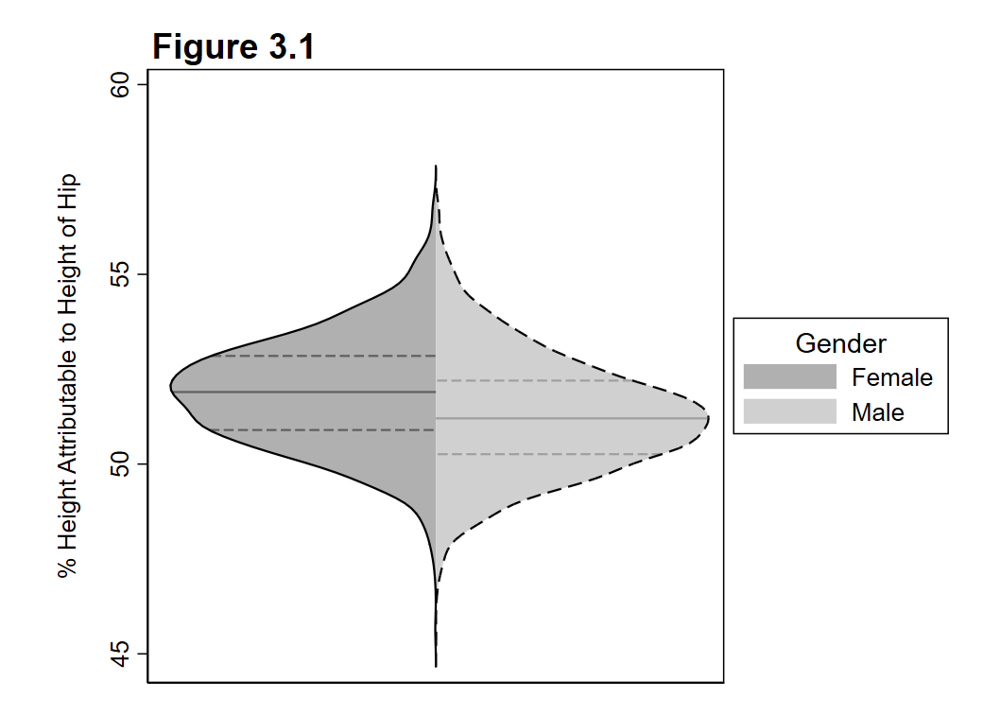
Figure 3.1. Percent of Height Attributable to Height of Hip by Gender. A split violin plot displaying the distribution of percentages for the height attributable to the height of the hip of individuals based on their gender.
When we look at the percent of height attributable to the height of hip by gender, we can see that, although the distributions look similar, there is a slight difference between the two. Namely, that female individuals tend to have a higher percentage of their height attributable to the height of their hip. Both genders have this median percentage above 50%, however, both lie somewhere in between 50 – 55% leading us to believe that for the sample, the median is most likely between that range as well. The ranges of the distribution don’t seem to vary between the two genders, with the most extreme values on both being quite similar, however, the first quartile of the women’s distribution is just barely below the median for men. This, again, supports the conclusion that women tend to have a higher attribution of their height from the height of their hip than men do.

3.2 Data Quality Assessment
Data quality issues found within the sample included out of range values, potential duplicates, and misspellings of possible values. When looking through the data, the first step was to ensure that each of the data points was only for a participant who was an adult (with age greater than or equal to 18). Then, for each variable present within the dataset, values were investigated using the “summ” command to ensure values were only within valid ranges. Numerical variables with suspicious values were noted by replacing the value with “.d” and setting the “is_suspicious” indicator variable to 1. This included when DOD race was 7, the weight of individuals in pounds was 0, thumbtipreach was above 5,000, and weightkg was above 500. Afterwards, string type variables were inspected using the “tab“ command and it was found that writing preference had values of “Either han” which should most likely be “Either hand (No preference)” according to the codebook. These values were recorded as suspicious using the “is_suspicious” indicator variable and then replaced with “Either hand (No preference)”.
Finally, duplicate records were identified using the gender, span, waistcircumfrence, chestcircumfrence, weightkg, stature, and subjectnumericrace variables. Of these, there were about 921 records identified to be a potential duplicate of another record. These records were tagged with the “is_duplicate” indicator variable set to 1 and then dropped from the final dataset to ensure that our figures and tables were free from potential duplicates.

4. Relationships Between Anthropometric Structures

4.1 Relationships Between Measures of Stature
Running the following command allows us to assess the linear correlations between the different measures of stature. We will not include stature within this analysis as the next paragraph will specifically delve into stature and the other measures of stature by gender. Using the command:
correlate kneeheightmidpatella cervicaleheight trochanterionheight waistheightomphalion functionalleglength footlength thumbtipreach span weightkg
We can obtain a correlation matrix for our different measures of stature and see which pair of measures has the highest correlation coefficient. The output of the code can be found in the appendix as an inline comment. Within the correlation matrix, it was found that neck cervical height and waist height have the highest correlation coefficient among the pairs at 0.9414. A heatplot of the two variables can be found below in Figure 4.1 which highlights the linear relationship between the two variables as well as the high density of points which lie along a linear path between the two. This relationship indicates to us that, within our sample, the height of an individual’s waist height could be described as just a linear transformation of their neck cervical height meaning the two are in some proportion to one another.
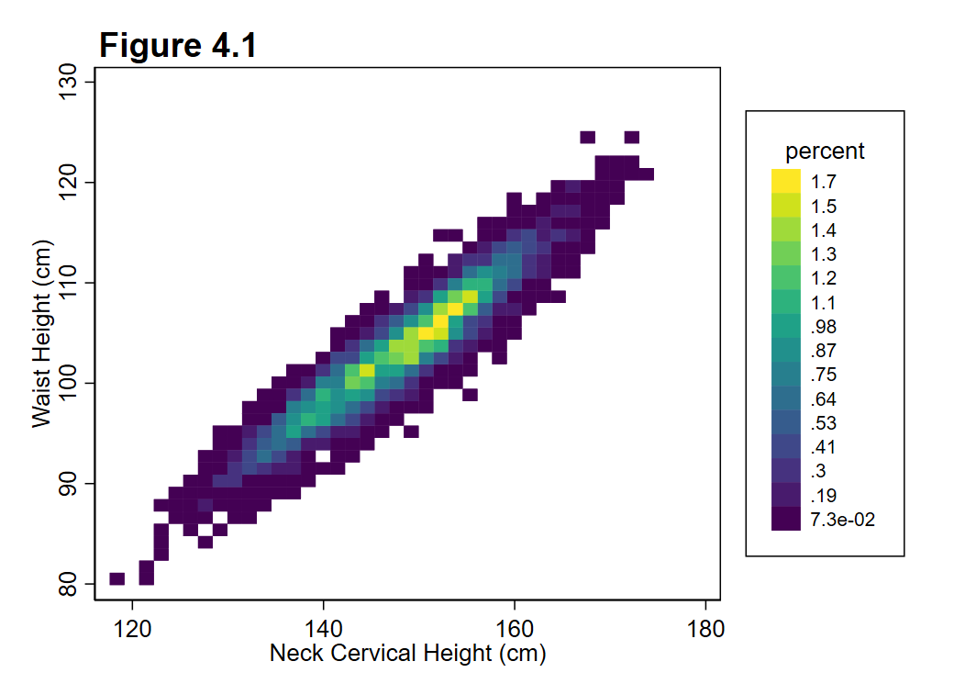 Figure 4.1. Heatplot of Neck Cervical Height and Waist Height. A simple heatplot displaying the neck cervical height and the waist height within our sample. Percentage of the population is used for the coloring to identify areas of high density.

Table 4.1. Stature Correlation Coefficients by Gender
Measure of Stature | Male | Female | Difference
Knee Height | 0.8334 | 0.8432 | 0.0098
Height to Neck Cervical | 0.9841 | 0.9843 | 0.0002
Height to Hip | 0.8501 | 0.8578 | 0.0077
Waist Height | 0.9085 | 0.9088 | 0.0003
Functional Leg Length | 0.8179 | 0.8323 | 0.0144
Foot Length | 0.7181 | 0.7219 | 0.0038
Forward Arm Reach | 0.6912 | 0.6710 | 0.0202
Arm Span | 0.8230 | 0.8190 | 0.0040
Measured Weight (kg) | 0.4689 | 0.5334 | 0.0645

Table 4.1. Stature Correlation Coefficients by Gender. A table displaying the differing correlation coefficients between stature and the measures of stature stratified by gender within our sample. The difference between the correlation coefficients is also displayed as a separate column to help understand which measures of stature have differences between the genders listed.
We can see within our sample that the Height to Neck Cervical and Waist Height have the highest correlations with stature according to the table for both men and women. Within the table, however, we can also see that measured weight, functional leg length, and forward arm reach have the largest differences in correlation coefficient between men and women. For each of these there is a difference of > 0.01 in their correlation coefficient. However, the only one of these that seems to be largely correlated with stature is functional leg length. For both men and women we can see that the correlation coefficient is above 0.8, however, for women it is closer to 0.83 while for men it is about 0.82. This difference isn’t too large, however, most of the differences between men and women in the sample for correlation coefficients are not large anyways as seen in the table.

4.2. Relationships Between Actual and Reported Height and Weight

4.3. Relationships Between Derived ‘Body Type’ and Weight/BMI

Appendix

