Darshan Shimpi
March 2, 2026 PBHLT-6101
Project 1

Darshan Shimpi
Project 1
PBHLT 6101
3/2/2026

1. Introduction
Within this project we are setting up an exploratory data analysis of physical measurements of military personnel and the relationships between these measurements/variables. The purpose of this project is mainly to give us the foundations of understanding how to prepare and explore a dataset for analysis purposes as well as to give us more practice analyzing data and understanding how to create meaningful figures, graphs, and analyses from a new dataset. The data used for this analysis comes from the ANSUR-II dataset which consists of data from a 2012 survey by the U.S. Army to measure demographic and anthropometric measures of personnel representing the US army. Anthropometric measures in this dataset refer to physical measurements of the body size and shape of individuals who were surveyed. Respondents include active duty, reserves, and national guard members of the US Army force.
The dataset itself consists of 7,031 observations over 29 variables. These 29 variables consist of 8 string variables and 21 numeric variables representing anthropometric measurements, dates, subject numbers, and categorical variables for various demographic characteristics. The data itself is used within the real world to help with the “design and sizing of clothing and personal protective equipment” for US army personnel but also to help with calculations and simulations of how human bodies may respond to life threatening occurrences which could come up from various situations within the army.

2. Data Preparation

2.1 Data Analysis Plan
- Organize the project
  - Put all of the documents for the project in one synced folder including the original dataset, codebooks, the assignment description, and any files we begin putting together (do file, project report, etc.)
  - Save dataset as project_data_v0
- Change Missing Values to Stata MV Types and Add UID
  - For each variable go through and change the following (change the value AND label)
    - -77 -> .a to represent “not recorded”
    - -88 -> .b to represent “refused measurement”
    - -99 -> .c to represent “unknown missing”
  - Create Unique ID for each record
    - Label this “Unique Key” and make it so that each record in the dataset has a unique key value
  - Save dataset as project_data_v1
- Inspect and Correct Data
  - Go through each variable and find invalid/suspicious values
  - For each value, make a reasonable correction to the special missing values we’ve noted (or come up with a new one) and document the changes
    - Change them to a special missing value
    - Note somewhere in the codebook that “this missing value indicates that the value was invalid/suspicious.”
  - For any changed/suspected value, use a new indicator variable “is_suspect?” and set it to 1 to indicate the suspicion
  - Note that any records where the legal age is below 18 should not be allowed
    - Create an indicator variable “is_adult?” based on age >= 18 and mark those records also as suspect
    - Drop any that have that indicator variable == 0
  - Save dataset as project_data_v2
- Identify and Remove Duplicates
  - Go through and check for duplicate observations based on some set criteria
    - Most likely it will be based on all measurements being equal between multiple records
    - See the duplicate command for more help
  - Then we will just flag these with another “is_duplicate?” indicator variable and remove them from future analysis
  - Save as project_data_v3
- Label Variables and Values
  - Go through each variable and add a label to help keep track of what it represents
  - For categorical variables, label each level of the values
  - Save as project_data_v4
- Create New Variables
  - New Unique Key
    - See step 2
  - Continuous BMI Variable based on weight in kg / square of height in meters
  - Categorical BMI variable using standard definitions for obese, overweight, normal weight, underweight
  - Season variable
    - Use splits based on the month
  - Numerical categorical variables using encode
    - Gender
    - Birth State
      - No longer a requirement as of 2/17/2026
    - Preferred Hand
  - Categorical body type based on height, weight, and other measurements
    - Document rationale
    - Different algorithm for women and men
    - Between 3 – 6
    - Label
  - Save as project_data_final
- Generate Sample Characteristics
  - Generate stats for the anthropometric measures within the sample and summarize those measures in a table organized by body part.
    - Note the number of missing values and suspicious values for each variable
  - Create a figure that shows the differences in % of total height attributable to the height to hip by gender
    - Calculate the value %
    - Describe in a paragraph
- Describe relationships between anthropometric measures
  - Relationship between measures of stature
    - Describe in a short paragraph:
      - Assess the level of correlation between the measures of stature
      - Identify the two measures that are most highly correlated and provide a figure that demonstrates the relationship between these measures
    - Describe the results and differences between men and women in a table and paragraph:
      - Assess level of correlation between overall height (stature) and the other measures of stature, stratified by sex
      - Which are highly correlated with overall height?
  - Relationship between actual and reported height/weight
    - Compare self-reported weight to measured weight
      - Describe distribution of the difference
      - Provide a figure that demonstrates how these two measures differ
    - Show extent to which the difference between reported and measured weight varies by sex
      - Figure
    - Compare self-reported height to measured height
      - Describe distribution of the difference
      - Provide a figure that demonstrates how these two measures differ
    - Summarize above findings in a paragraph
      - Discuss in terms of the bias associated with using reported weight and height in lieu of measuring weight and height.
  - Relationship between derived “body type” and weight/BMI
    - Describe with a paragraph and figure/table
      - Compare the distributions of weight and BMI for each of the body types created above
      - Focus on how well the body types describe differences in weight and obesity
- Organize all data, code, and files into the folder appropriately and continue with write-up

3. Sample Characteristics

3.1 Anthropometric Characteristics
Table 3.1. Anthropometric Measurements Demographics
 | Count | Mean (SD) | Min | Max | Suspicious Values | Missing Values
Measures of Trunk Circumference
Chest Circumference | 6,107 | 102.225 (10.056) | 69.5 | 146.9 | 0 | 1
Waist Circumference | 6,107 | 91.466 (11.421) | 61.1 | 137.9 | 0 | 1
Hip Breadth | 6,107 | 34.838 (2.530) | 26.4 | 47.3 | 0 | 1
Hip Breadth, Sitting | 6,107 | 38.571 (3.239) | 28.0 | 54.1 | 0 | 1
Bicristal (Pelvic) Breadth | 6,107 | 27.472 (1.922) | 19.7 | 36.2 | 0 | 1
Stature
Measured Height | 6,107 | 171.46 (8.998) | 140.9 | 199.3 | 0 | 1
Knee Height | 6,107 | 47.551 (3.308) | 34.6 | 61.2 | 0 | 1
Height to Neck Cervical | 6,107 | 147.768 (8.429) | 118.4 | 173.8 | 0 | 1
Height to Hip | 6,107 | 88.277 (5.440) | 66.0 | 109.5 | 0 | 1
Waist Height | 6,107 | 103.156 (6.271) | 80.5 | 124.5 | 0 | 1
Functional Leg Length | 6,107 | 110.213 (6.847) | 83.5 | 131.6 | 0 | 1
Foot Length | 6,107 | 26.307 (1.738) | 19.8 | 32.3 | 0 | 1
Forward Arm Reach | 6,107 | 78.985 (5.376) | 60.2 | 99.8 | 0 | 1
Arm Span | 6,107 | 176.409 (11.084) | 132.3 | 212.1 | 0 | 1
Measured Weight (kg) | 6,068 | 79.707 (15.654) | 35.8 | 144.2 | 40 | 0
Other
Self Reported Weight (lbs) | 6,107 | 174.82 (33.576) | 86.0 | 321.0 | 1 | 0
Self Reported Height (in) | 6,108 | 68.269 (3.869) | 56.0 | 94.0 | 0 | 0

Table 3.1. Anthropometric Measurements Demographics. For all measurements listed, units are in centimeters (cm) unless stated otherwise within the measurement name. Note: Demographics are listed for observations not identified as potential duplicates (6,108 of the original 7,031 observations for the dataset).
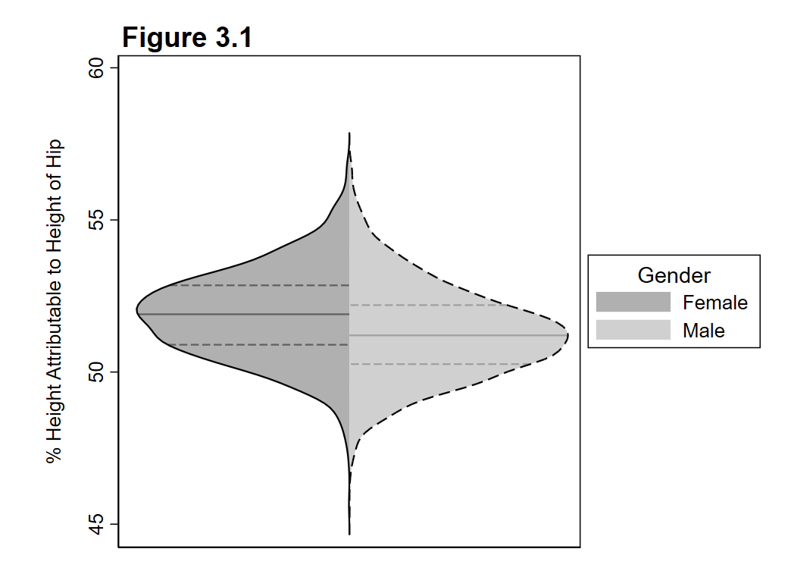
Figure 3.1. Percent of Height Attributable to Height of Hip by Gender. A split violin plot displaying the distribution of percentages for the height attributable to the height of the hip of individuals based on their gender.
When we look at the percent of height attributable to the height of hip by gender, we can see that, although the distributions look similar, there is a slight difference between the two. Namely, that female individuals tend to have a higher percentage of their height attributable to the height of their hip. Both genders have this median percentage above 50%, however, both lie somewhere in between 50 – 55% leading us to believe that for the sample, the median is most likely between that range as well. The ranges of the distribution don’t seem to vary between the two genders, with the most extreme values on both being quite similar, however, the first quartile of the women’s distribution is just barely below the median for men. This, again, supports the conclusion that women tend to have a higher attribution of their height from the height of their hip than men do.

3.2 Data Quality Assessment
Data quality issues found within the sample included out of range values, potential duplicates, and misspellings of possible values. When looking through the data, the first step was to ensure that each of the data points was only for a participant who was an adult (with age greater than or equal to 18). Then, for each variable present within the dataset, values were investigated using the “summ” command to ensure values were only within valid ranges. Numerical variables with suspicious values were noted by replacing the value with “.d” and setting the “is_suspicious” indicator variable to 1. This included when:
- DOD race was 7
- The weight of individuals in pounds was 0
- Thumbtipreach was above 5,000
- weightkg was above 500
Afterwards, string type variables were inspected using the “tab“ command and it was found that writing preference had values of “Either han” which should most likely be “Either hand (No preference)” according to the codebook. These values were recorded as suspicious using the “is_suspicious” indicator variable and then replaced with “Either hand (No preference)”.
Finally, duplicate records were identified using the gender, span, waistcircumfrence, chestcircumfrence, weightkg, stature, and subjectnumericrace variables. Of these, there were about 921 records identified to be a potential duplicate of another record. These records were tagged with the “is_duplicate” indicator variable set to 1 and then dropped from the final dataset to ensure that our figures and tables were free from potential duplicates.

4. Relationships Between Anthropometric Structures

4.1 Relationships Between Measures of Stature
Running the following command allows us to assess the linear correlations between the different measures of stature. We will not include stature within this analysis as the next paragraph will specifically delve into stature and the other measures of stature by gender. Using the command:
correlate kneeheightmidpatella cervicaleheight trochanterionheight waistheightomphalion functionalleglength footlength thumbtipreach span weightkg
We can obtain a correlation matrix for our different measures of stature and see which pair of measures has the highest correlation coefficient. The output of the code can be found in the appendix as an inline comment. Within the correlation matrix, it was found that neck cervical height and waist height have the highest correlation coefficient among the pairs at 0.9414. A heatplot of the two variables can be found below in Figure 4.1 which highlights the linear relationship between the two variables as well as the high density of points which lie along a linear path between the two. This relationship indicates to us that, within our sample, the height of an individual’s waist height could be described as just a linear transformation of their neck cervical height meaning the two are in some proportion to one another.
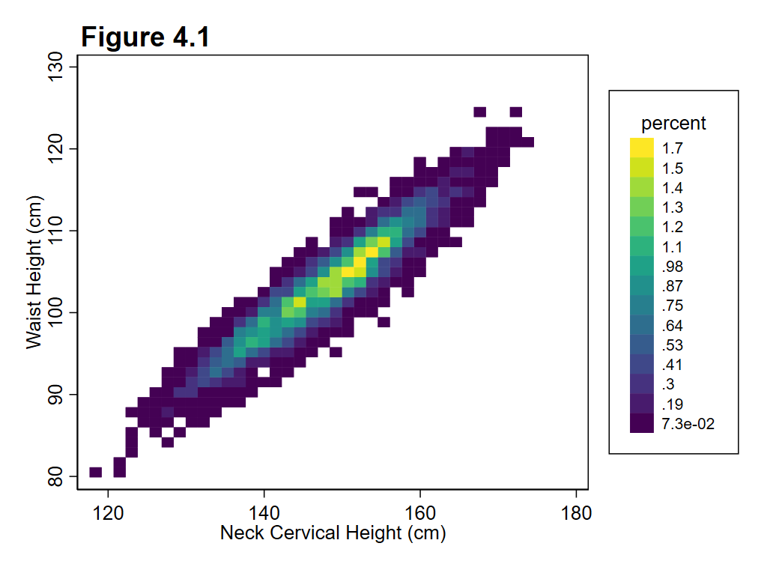 Figure 4.1. Heatplot of Neck Cervical Height and Waist Height. A simple heatplot displaying the neck cervical height and the waist height within our sample. Percentage of the population is used for the coloring to identify areas of high density.

Table 4.1. Stature Correlation Coefficients by Gender
Measure of Stature | Male | Female | Difference
Knee Height | 0.8334 | 0.8432 | 0.0098
Height to Neck Cervical | 0.9841 | 0.9843 | 0.0002
Height to Hip | 0.8501 | 0.8578 | 0.0077
Waist Height | 0.9085 | 0.9088 | 0.0003
Functional Leg Length | 0.8179 | 0.8323 | 0.0144
Foot Length | 0.7181 | 0.7219 | 0.0038
Forward Arm Reach | 0.6912 | 0.6710 | 0.0202
Arm Span | 0.8230 | 0.8190 | 0.0040
Measured Weight (kg) | 0.4689 | 0.5334 | 0.0645

Table 4.1. Stature Correlation Coefficients by Gender. A table displaying the differing correlation coefficients between stature and the measures of stature stratified by gender within our sample. The difference between the correlation coefficients is also displayed as a separate column to help understand which measures of stature have differences between the genders listed.
We can see within our sample that the Height to Neck Cervical and Waist Height have the highest correlations with stature according to the table for both men and women. Within the table, however, we can also see that measured weight, functional leg length, and forward arm reach have the largest differences in correlation coefficient between men and women. For each of these there is a difference of > 0.01 in their correlation coefficient. However, the only one of these that seems to be largely correlated with stature is functional leg length. For both men and women we can see that the correlation coefficient is above 0.8, however, for women it is closer to 0.83 while for men it is about 0.82. This difference isn’t too large, however, most of the differences between men and women in the sample for correlation coefficients are not large anyways as seen in the table.

4.2. Relationships Between Actual and Reported Height and Weight
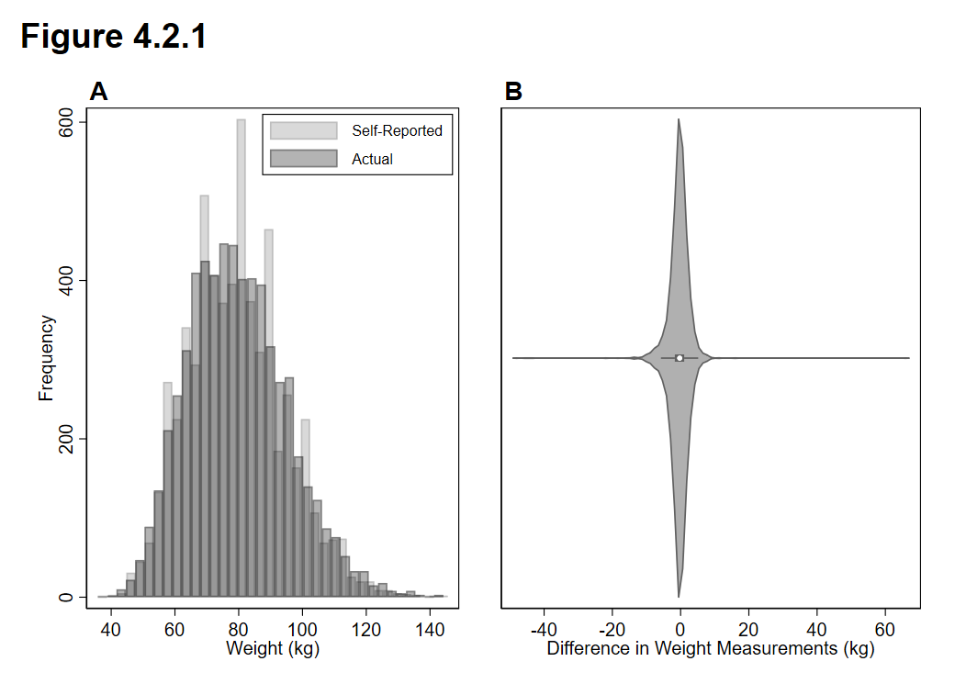
Figure 4.2.1 Distributions and Difference of Self-Reported and Actual Weight (kg). A multi-figure plot displaying the distributions of self-reported and actual weight as well as the difference between self-reported and actual weight for the sample in kilograms. Graph A. An overlay of the distributions of the two weight measurements. Graph B. A violin plot displaying the distribution of the individual differences between the two measurements for the sample. Calculation was performed as self-reported weight – actual weight.

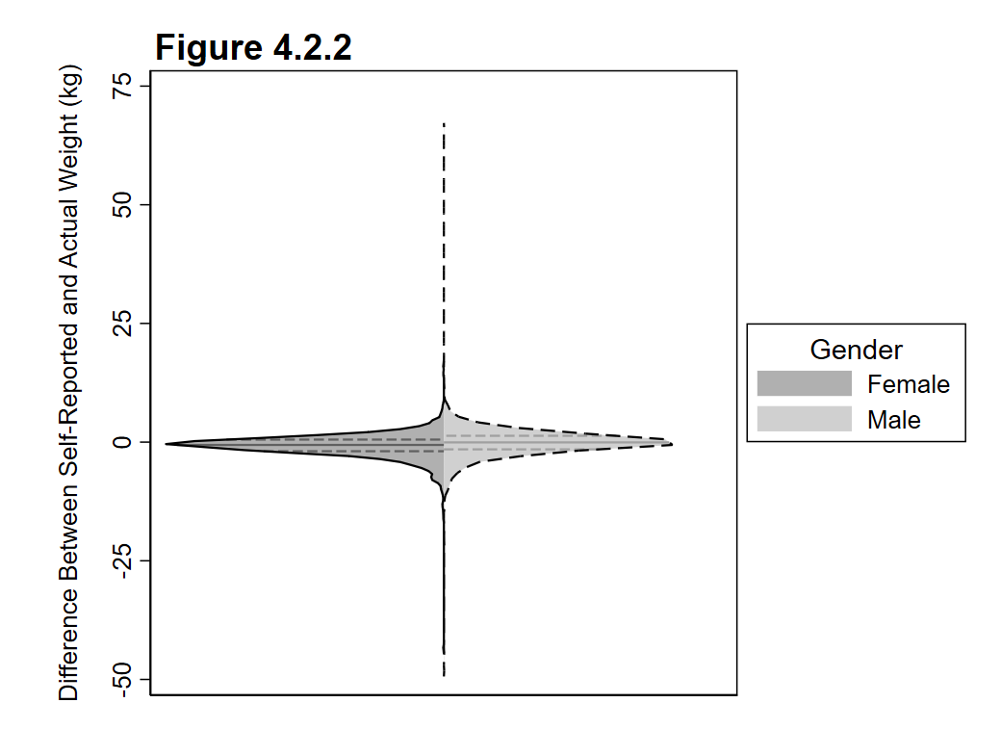
Figure 4.2.2. Difference Between Self-Reported and Actual Weight (kg) by Gender. A split violin-plot displaying the difference in distribution between male and female respondents for their measurement difference in weight. Measurement difference was calculated as self-reported weight – actual weight.
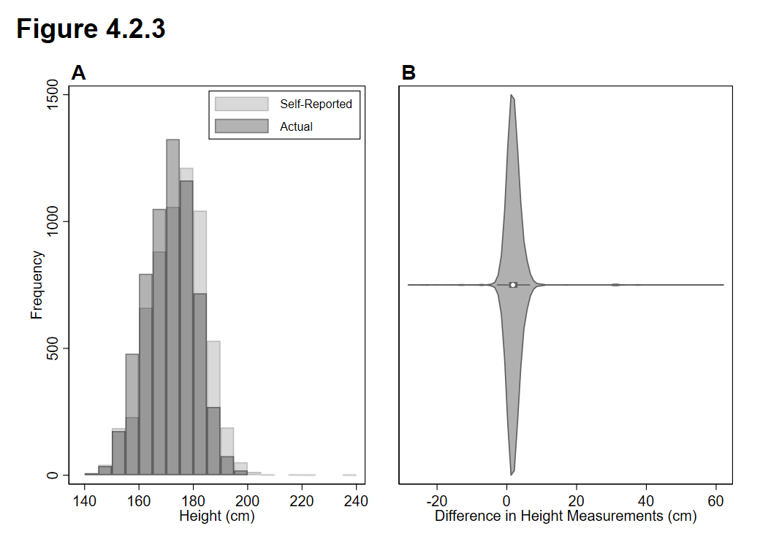
Figure 4.2.3. Distributions and Difference of Self-Reported and Actual Height (cm). A multi-figure plot displaying the distributions of self-reported and actual height as well as the difference between self-reported and actual height for the sample in centimeters. Graph A. An overlay of the distributions of the two height measurements. Graph B. A violin plot displaying the distribution of the individual differences between the two measurements for the sample. Calculation was performed as self-reported height – actual height.
Analysis
Overall, when we look at self-reported and measured metrics we see small differences between the two measurements for most individuals. When looking at the difference between self-reported and measured weight for the sample, we can see that most individuals reported about the same weight that was measured for them. The distributions of the two measurements are similar with the main obvious difference being that more individuals are self-reporting weights towards the mean. The differences between the two measurements are where we can get a clearer picture of the different distributions. The median and average difference for the sample sits just below 0 (the average is -0.44 kg while the median is -0.26 kg). This seems to indicate that most people are biased towards under-reporting their weight, however, not by much. We can even see that outliers exist on both ends of the spectrum, with some individuals under-reporting their weight by over 40kg, while others are over-reporting their weight by over 50 kg. These, however, are quite rare and seem to most likely be user-errors from the sample itself. Figure 4.2.2. illustrates the difference between self-reported and actual weight at the gender level. We can see that the distributions between men and women within the sample are quite similar, however, women tend to be slightly closer to accurate self-reporting of their weight. Men tend to slightly over-report their weight according to the graph, however, we can also see that the furthest outliers on both ends of the graph are from the male distribution. This seems to indicate that, for some reason or another, there is a bit more perhaps error-proneness in self-reporting for men compared to women. Somewhat opposingly, individuals tend to over-report their height with a bias towards self-reporting a taller height than their actual measured height. Overall, these discrepancies could be due to societal pressures and the beauty standards put in place for individuals to be tall and thin.

4.3. Relationships Between Derived ‘Body Type’ and Weight/BMI
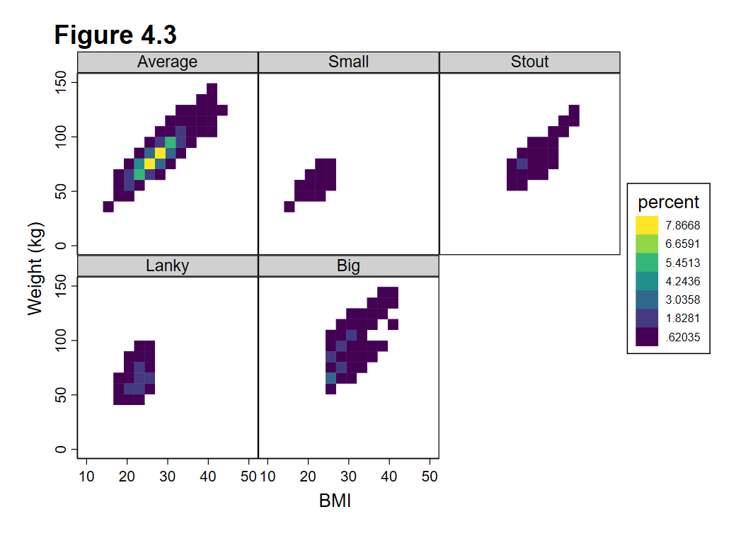
Figure 4.3. Heatmaps of Weight and BMI for Different Body Types. A collection of heatmaps displaying the distribution of BMI and measured weight for individuals within each body type category.
Displayed in Figure 4.3 are heatmaps of the weight and BMI calculations for our various different body types. Since our body types were based on BMI, height percentiles, and leg proportion we can find our BMI distributions are split up pretty distinctly. Namely, notice that small and lanky body types have any individuals that are of normal weight or underweight while big and stout are comprised of individuals that are overweight or obese. Past that, however, we can notice that “big” comprises a large distribution of weight and BMI combinations. Average, of course, contains the most individuals and has the largest spread of BMI vs weight, however, we can see the measurements seem to have a constrained linear relationship, with many data points lying close to one another on a simple line. This is reflective of the fact that this “average” body type is supposed to represent the average of the population. In terms of describing the differences between weight and obesity, these body types do merely an OK job at describing these differences. Since BMI is used to calculate the body type, individuals with a “stout” or “big” body type are guaranteed to be either overweight or obese while individuals that are “lanky” or “small” are required to be underweight or normal weight. This allows for variation of weight within these body categories (as noted in the “big” category), however, does not allow for many differences to be identified in BMI and weight through just the categories alone.

Appendix
Code for dataset preparation and analysis:
** Name: Darshan Shimpi
** Title: Project 1 Code
** Date Last Modified: 3/2/2026
*
*
*
*
*
**************************************************
* Clear out existing data
clear
* Navigate to our folder and load the dataset
cd "C:\Users\darsh\OneDrive\Documents\PBHLT 7101\Project 1"
use "ansur2allV2.dta"

* Save the dataset as v0
save project_data_v0, replace

** Change missing values and add Unique ID

* Grab all numeric variables and it'll store them into `r(varlist)'
ds, has(type numeric)

* Go through and replace missing values appropriately
foreach var of varlist `r(varlist)'{
replace `var' = .a if `var' == -77
replace `var' = .b if `var' == -88
replace `var' = .c if `var' == -99
}

* Create Unique ID (grabbed from online at "https://www.reddit.com/r/stata/comments/yrauxz/create_unique_id/")
set seed 27
gen u_id = sum(runiformint(1,5))

* Save dataset as v1
save project_data_v1, replace

*********************************************************
** Inspect and correct data

* a.) Go through each variable and find invalid/suspicious values

** First our numerics
ds, has(type numeric)

foreach var of varlist `r(varlist)'{
summ `var', detail
}

* Example:
// age
// -------------------------------------------------------------
// Percentiles Smallest
// 1% 18 17
// 5% 19 17
// 10% 20 18 Obs 7,031
// 25% 23 18 Sum of wgt. 7,031
//
// 50% 28 Mean 30.06756
// Largest Std. dev. 8.805637
// 75% 37 58
// 90% 43 58 Variance 77.53925
// 95% 47 58 Skewness .7301577
// 99% 53 58 Kurtosis 2.635243

* b.) For each value, make a reasonable correction to the special missing values we've noted (or come up with a new one) and document the changes

gen is_suspicious = 0

* We'll note our changes/suspicions here per variable:
*** Numeric variables
** Age
* Two less than 18 which isn't allowed (Change in part D.)

* Replace the age with our suspicious value indicator (.d) and change is suspicious
gen is_adult = 1
replace is_adult = 0 if age < 18
replace age = .d if age < 18
replace is_suspicious = 1 if age == .d

** Subject Numeric Race
* No suspicious values

** DOD Race
* 7 is not a legal value
replace dodrace = .d if dodrace == 7
replace is_suspicious = 1 if dodrace == .d

** Weight lbs
* Two individuals with a weight of 0 seem a bit too skinny
replace weightlbs = .d if weightlbs == 0
replace is_suspicious = 1 if weightlbs == .d

** heightin
* No suspicious values

** Thumbtipreach
* There are a about 10 or so values above 5000 for thumb tip reach which seems like quite the long reach
replace thumbtipreach = .d if thumbtipreach > 5000
replace is_suspicious = 1 if thumbtipreach > 5000

** span, footlength, kneeheightmidpatella, waistheightomphalion, functionalleglength, cervicaleheight, trochanterionheight, stature, waistcircumference, chestcircumference, bicristalbreadth, hipbreadth, and hipbreadthsitting all have no suspicious values

* weightkg
* About 39 individuals have a weightkg above 500 kg which seems a bit too heavy

replace weightkg = .d if weightkg > 500
replace is_suspicious = 1 if weightkg == .d

* date
* Nothing suspicious here

** Then our string variables
ds, has(type string)

foreach var of varlist `r(varlist)'{
tab `var', missing
}

* We'll note our changes/suspicions here per variable:
*** String variables

* Ethnicity, Gender, Component, Branch
** No suspicious values

* Writing Preference
** 25 records with value "Either han" which should most likely be "Either hand (No preference)"
replace is_suspicious = 1 if writingpreference == "Either han"
replace writingpreference = "Either hand (No preference)" if writingpreference == "Either han"

* Installation, Test Date, Strdate
** No suspicious values

* c.) Changed the is_suspicious = 1 if a value was changed above!

* d.) Note that any records where the legal age is below 18 should not be allowed

** ii.) Drop any that have that is_adult == 0
drop if is_adult == 0

* e.) Save dataset as project_data_v2
save project_data_v2, replace
*********************************************************
** Identify and Remove Duplicates

** To identify duplicates we'll use the duplicate command and base it off of the gender, span, waistcircumference, chestcircumference, weightkg, stature, and subjectnumericrace

** First, we know that there should be 6,068 records according to the documentation. We started with 7,031.

duplicates report gender span waistcircumference chestcircumference weightkg stature subjectnumericrace

** This gives us
/*

--------------------------------------
Copies | Observations Surplus
----------+---------------------------
1 | 5187 0
2 | 1842 921
--------------------------------------

*/
* If we add up 5,187 + 921 = 6,068 so we can hopefully assume that we've found the correct duplicates based on these fields. So let's go ahead and tag the ones we believe to be duplicates using the same criteria

duplicates tag gender span waistcircumference chestcircumference weightkg stature subjectnumericrace, gen(is_duplicate)

* Drop them using the same duplicates command
duplicates drop gender span waistcircumference chestcircumference weightkg stature subjectnumericrace , force

* Convert all mm measurements to cm measurements
foreach var of varlist thumbtipreach - hipbreadthsitting {
replace `var' = `var' / 10
}

* Save as project_data_v3
save project_data_v3, replace

*********************************************************
** Label Variables and Values
label data "This dataset consists of survey data from the ANSUR-II dataset which consists of responses to a 2012 survey by the U.S. Army to measure demographic and anthropometric measures of personnel representing the US army."

label variable subjectnumericrace "A single or multi-digit code indicating a subject's self-reported race or races. Where 1 = White, 2 = Black, 3 = Hispanic, 4 = Asian, 5 = Native American, 6 = Pacific Islander, 8 = Other"

label variable dodrace "A single digit indicating a subject's self-reported preferred single race where selecting multiple races is not an option. Where 1 = White, 2 = Black, 3 = Hispanic, 4 = Asian, 5 = Native American, 6 = Pacific Islander, 8 = Other"

label variable ethnicity "Self-reported ethinicty of the individual"

label variable gender "Male or Female gender for the individual"

label variable age "Age of the respondent (years)"

label variable component "Which portion of the army the respondent came from: Army National Guard, Army Reserve, or Regular Army"

label variable branch "Which branch of the army the respondent came from: Combat Arms, Combat Support, or Combat Service Support"

label variable writingpreference "Which hand the respondent prefers to write with."

label variable installation "U.S. army installation/camp where the measurements occurred."

label variable test_date "Date the measurements took place"

label variable weightlbs "Weight in pounds of the respondent (self-reported)"

label variable heightin "Height in inches of the respondent (self-reported)"

label variable thumbtipreach "Forward arm reach of the respondent in cm"

label variable span "Arm span length of the respondent in cm"

label variable footlength "Length of foot of the respondent in cm"

label variable kneeheightmidpatella "Height of the knee of the respondent in cm"

label variable waistheightomphalion "Height of the waist of the respondent in cm"

label variable functionalleglength "Functional leg length of the respondent in cm"

label variable cervicaleheight "Height of the neck cervical of the respondent in cm"

label variable trochanterionheight "Height to hip of the respondent in cm"

label variable stature "Measured height of the respondent in cm"

label variable waistcircumference "Waist circumfrence of the respondent in cm"

label variable chestcircumference "Chest circumfrence of the respondent in cm"

label variable bicristalbreadth "Pelvic breadth of the respondent in cm"

label variable hipbreadth "Hip breadth of the respondent in cm"

label variable hipbreadthsitting "Hip breadth while sitting of the respondent in cm"

label variable weightkg "Measured weight of the respondent in kg"

label variable date "Date of the testing of the respondent in date format"

label variable strdate "Date of the testing of the respondent in string format"

label variable u_id "Unique id for the respondent"

label variable is_suspicious "Indicator variable representing whether or not measurements from the respondent are suspicious. 1 = Yes 0 = No"

label variable is_adult "Indicator variable representing whether or not the respondent is an adult (>= 18 years of age). 1 = Yes 0 = No"

label variable is_duplicate "Indicator variable representing whether or not the response may be a duplicate of another response in the dataset based off the gender, span, waistcircumference, chestcircumference, weightkg, stature, and subjectnumericrace for the response. 1 = Potential Duplicate 0 = Unique"

** Label our categorical variable values
* Grab all numeric variables and it'll store them into `r(varlist)'
ds, has(type numeric)

* Go through and replace missing values appropriately
label define missing_value_labels .a "Not Recorded" .b "Refused Measurement" .c "Unknown Missing" .d "Suspicious Value"

foreach var of varlist `r(varlist)'{
label values `var' missing_value_labels
}

* Now go through the categorical variables and label them accordingly

* Label DOD Race Values

label define dodrace_labels 1 "White" 2 "Black" 3 "Hispanic" 4 "Asian" 5 "Native American" 6 "Pacific Islander" 8 "Other" .d "Suspicious Value"
label values dodrace dodrace_labels

* Label Is Suspicious Values
label define is_suspicious_labels 0 "Not Suspicious" 1 "Suspicious"
label values is_suspicious is_suspicious_labels

* Label Is Adult Values
label define is_adult_labels 0 "Minor" 1 "Adult"
label values is_adult is_adult_labels

* Label Is Duplicate Values
label define is_duplicate_labels 0 "Unique Record" 1 "Potential Duplicate"
label values is_duplicate is_duplicate_labels

* Save as project_data_v4
save project_data_v4, replace

***************************************************************
* Create New Variables

* Continuous BMI Variable from weight in kg divided by the height in meters squared
gen bmi = weightkg / ((stature/100)^2)
* We have some missing values from weightkg that are all suspicious values so let's appropriately replace them and label them
replace bmi = .d if bmi == .
label define bmi_sus_labels .d "Suspicious Value"
label values bmi bmi_sus_labels
label variable bmi "Body Mass Index (BMI) of the individual calculated from their weight in KG dvided by the square of their height in meters"

* Categorical BMI Variable from BMI with labels
* Use splits from https://www.nhlbi.nih.gov/calculate-your-bmi
recode bmi (0/18.499999999 = 0) (18.5/24.9999999 = 1) (25/29.999999999 = 2) (30/max = 3) (missing = .d), gen(bmi_cat)
label define bmi_cat_labels 0 "Underweight" 1 "Healthy" 2 "Overweight" 3 "Obese" .d "Suspicious Value"
label values bmi_cat bmi_cat_labels
label variable bmi_cat "BMI Categories for the individual based on the splits from the NIH."

* Season variable
* We will use months to determine the season consider the following definitions for our seasons:
* December, January, February - Winter
* March, April, May - Spring
* June, July, August - Summer
* September, October, November - Autumn

gen month_of_testing = month(date)
label variable month_of_testing "Month in which the testing occurred for the collected response"

recode month_of_testing (1 2 12 = 1) (3/5 = 2) (6/8 = 3) (9/11 = 4), gen(season_of_testing)
label define season_labels 1 "Winter" 2 "Spring" 3 "Summer" 4 "Autumn"

label values season_of_testing season_labels
label variable season_of_testing "Season in which the testing occurred for the collected response based on month of the year."

* Numerical Categorical Variable of Gender
encode gender, generate(gender_num)
label variable gender_num "Numerical representation of the gender of the respondent."

* Numerical Categorical Variable of Preferred Hand
encode writingpreference, generate(writingpreference_num)
label variable writingpreference_num "Numerical representation of the writing preference of the respondent."

* Categorical body type based on height, weight, gender, and other measurements
* Let's split the body types into Stout (1), Regular (0), and Lanky (2)
* Percentiles were taken from https://dqydj.com/height-percentile-calculator-for-men-and-women/
* Stout will be for individuals that have a BMI of overweight or obese and are below the 30th percentile for height by gender (171 cm for Men, 158cm for Women) and their legs (trochanterionheight) make up less than 51% of their stature
* Small will be for individuals that have a BMI of regular or underweight and are below the 30th percentile for height by gender (171 cm for Men, 158cm for Women) and their legs
* Lanky will be for individuals that have a BMI of regular or underweight and are above the 70th percentile (179 cm for Men, 166cm for Women) and their legs make up more than 51% of their stature
* Big will be for individuals that have a BMI of overweight or obese and are above the 70th percentile (179 cm for Men, 166cm for Women) AND their legs make up more than 51% of their stature.
* Average will be for any other individual who doesn't meet these criteria

* Set everyone to average
gen body_category = 0

* Set small for the individuals meeting the criteria
replace body_category = 1 if gender == "Male" & (bmi_cat == 0 | bmi_cat == 1) & stature < 171 & (trochanterionheight / stature < 0.51)
replace body_category = 1 if gender == "Female" & (bmi_cat == 0 | bmi_cat == 1) & stature < 158 & (trochanterionheight / stature < 0.51)

* Set stout for the individuals meeting the criteria
replace body_category = 2 if gender == "Male" & (bmi_cat == 2 | bmi_cat == 3) & stature < 171 & (trochanterionheight / stature < 0.51)
replace body_category = 2 if gender == "Female" & (bmi_cat == 2 | bmi_cat == 3) & stature < 158 & (trochanterionheight / stature < 0.51)

* Set lanky for the individuals meeting the criteria
replace body_category = 3 if gender == "Male" & (bmi_cat == 0 | bmi_cat == 1) & stature > 179 & (trochanterionheight / stature > 0.51)
replace body_category = 3 if gender == "Female" & (bmi_cat == 0 | bmi_cat == 1) & stature < 166 & (trochanterionheight / stature > 0.51)

* Set big for the individuals meeting the criteria
replace body_category = 4 if gender == "Male" & (bmi_cat == 2 | bmi_cat == 3) & stature > 179 & (trochanterionheight / stature > 0.51)
replace body_category = 4 if gender == "Female" & (bmi_cat == 2 | bmi_cat == 3) & stature < 166 & (trochanterionheight / stature > 0.51)

label define body_category_labels 0 "Average" 1 "Small" 2 "Stout" 3 "Lanky" 4 "Big"
label values body_category body_category_labels
label variable body_category "Simple category for the body type of an individual based on BMI, Gender, Height Percentiles, and Hip to Height Ratio"

* Save as project_data_final
save project_data_final, replace

Code for Figures and Tables

** Name: Darshan Shimpi
** Title: Project 1 Figure Code
** Date Last Modified: 3/2/2026
*
*
*
*
*
**************************************************
* Clear out existing data
clear
* Navigate to our folder and load the dataset
cd "C:\Users\darsh\OneDrive\Documents\PBHLT 7101\Project 1"

use project_data_final

* Get quick summary statistics on everything for the first table
sum
* Then get the suspicious and missing values for each variable of interest
foreach var in chestcircumference waistcircumference hipbreadth hipbreadthsitting bicristalbreadth {
tab `var' if `var' >100000, missing
}

** Figure creation
* Create variable for height attributable to height to hip
gen perc_height_attr_to_hip = 100 * trochanterionheight / stature

set scheme s1mono
* Create a split violin plot for the percent of height attributable to height to hip by gender
violinplot perc_height_attr, vertical fill split(gender) key(fill) legend(subtitle("Gender") position(3) cols(1)) ytitle("% Height Attributable to Height of Hip", margin(medium)) title({bf:Figure 3.1},position(11)) xlabel(,nogrid) ylabel(,nogrid)

*******************************************************
* Relationships between anthropometric measures

* Assess the level of correlation between the measures of stature
correlate kneeheightmidpatella cervicaleheight trochanterionheight waistheightomphalion functionalleglength footlength thumbtipreach span weightkg
************* OUTPUT *********************
/*

| kneehe~a cervic~t trocha~t waisth~n functi~h footle~h thumbt~h span weightkg
-------------+---------------------------------------------------------------------------------
kneeheight~a | 1.0000
cervicaleh~t | 0.9030 1.0000
trochanter~t | 0.9255 0.8880 1.0000
waistheigh~n | 0.9134 0.9414 0.9118 1.0000
functional~h | 0.8759 0.9022 0.8655 0.8787 1.0000
footlength | 0.8077 0.8503 0.7695 0.8068 0.8003 1.0000
thumbtipre~h | 0.7945 0.8250 0.7771 0.7815 0.8320 0.7873 1.0000
span | 0.8732 0.9079 0.8594 0.8835 0.8720 0.8627 0.8811 1.0000
weightkg | 0.5833 0.6794 0.5361 0.5320 0.6902 0.6682 0.6478 0.6414 1.0000

*/

*** We can see that waistheightomphalion and cervicaleheight have the highest correlation coefficient using the correlate command. We can then make a figure to show this too:

heatplot waistheightomphalion cervicaleheight, xtitle("Neck Cervical Height (cm)") ytitle("Waist Height (cm)") title({bf:Figure 4.1}, position(11)) xlabel(,nogrid) ylabel(,nogrid) legend(size(small) bmargin(medium) region(margin(medium))) keylabels(, format(%4.0g))

********************
* Now let's check WITH stature and see if there are any differences by gender
correlate stature kneeheightmidpatella cervicaleheight trochanterionheight waistheightomphalion functionalleglength footlength thumbtipreach span weightkg if gender == "Male"
/*
| stature kneehe~a cervic~t trocha~t waisth~n functi~h footle~h thumbt~h span weightkg
-------------+------------------------------------------------------------------------------------------
stature | 1.0000
kneeheight~a | 0.8334 1.0000
cervicaleh~t | 0.9841 0.8572 1.0000
trochanter~t | 0.8501 0.8981 0.8698 1.0000
waistheigh~n | 0.9085 0.8701 0.9157 0.8843 1.0000
functional~h | 0.8179 0.8084 0.8458 0.8114 0.8125 1.0000
footlength | 0.7181 0.6925 0.7253 0.6758 0.6931 0.6608 1.0000
thumbtipre~h | 0.6912 0.6981 0.7263 0.6997 0.6759 0.7462 0.6524 1.0000
span | 0.8230 0.8000 0.8386 0.8135 0.8178 0.7894 0.7492 0.8119 1.0000
weightkg | 0.4689 0.3866 0.5067 0.3480 0.3088 0.5363 0.4835 0.4833 0.4468 1.0000

*/
correlate stature kneeheightmidpatella cervicaleheight trochanterionheight waistheightomphalion functionalleglength footlength thumbtipreach span weightkg if gender == "Female"
/*

| stature kneehe~a cervic~t trocha~t waisth~n functi~h footle~h thumbt~h span weightkg
-------------+------------------------------------------------------------------------------------------
stature | 1.0000
kneeheight~a | 0.8432 1.0000
cervicaleh~t | 0.9843 0.8664 1.0000
trochanter~t | 0.8578 0.9168 0.8786 1.0000
waistheigh~n | 0.9088 0.8802 0.9234 0.8897 1.0000
functional~h | 0.8323 0.8341 0.8497 0.8484 0.8289 1.0000
footlength | 0.7219 0.7315 0.7262 0.7184 0.7016 0.7124 1.0000
thumbtipre~h | 0.6710 0.6853 0.6904 0.6935 0.6573 0.7338 0.6535 1.0000
span | 0.8190 0.8319 0.8309 0.8423 0.8284 0.8132 0.7726 0.8064 1.0000
weightkg | 0.5334 0.4719 0.5344 0.4697 0.3866 0.6011 0.5364 0.5090 0.5002 1.0000
*/

* This is hard to look at BUT we only care about the stature correlations so we'll put only those into our table in a separate program to make it easier to compare the male and female results.

*************************
* Compare the self reported weight vs actual weight
* First we'll have to convert our self-reported weight from lbs to kgs
gen weight_lbs_to_kg = weightlbs / 2.205
gen diff_self_actual_weight = weight_lbs_to_kg - weightkg

twoway (histogram weight_lbs_to_kg, color(gray%30) frequency) (histogram weightkg, color(black%30) frequency), legend(order(1 "Self-Reported" 2 "Actual" ) position(0) bplacement(neast) cols(1) size(*0.8)) name(weight_diff_hists, replace) xtitle("Weight (kg)") title({bf:A}, position(11))

* Old plot of just the violin plot
// violinplot diff_self_actual_weight , vertical fill ytitle("Difference Between Self-Reported and Actual Weight (kg)", margin(medium)) title({bf:Figure 4.2.1}, position(11)) name(weight_diff_vio)

violinplot diff_self_actual_weight , fill xtitle("Difference in Weight Measurements (kg)",) name(weight_diff_vio, replace) title({bf:B}, position(11))

gr combine weight_diff_hists weight_diff_vio, title({bf:Figure 4.2.1}, position(11)) col(2)

* And do a comparison by gender
violinplot diff_self_actual_weight, vertical fill split(gender) key(fill) legend(subtitle("Gender") position(3) cols(1)) ytitle("Difference Between Self-Reported and Actual Weight (kg)", margin(medium)) title({bf:Figure 4.2.2},position(11)) xlabel(,nogrid) ylabel(-50(25)75,nogrid)

* Compare the self reported height vs actual height
* First we'll have to convert our self-reported height from in to cms
gen height_in_to_cm = heightin * 2.54
gen diff_self_actual_height = height_in_to_cm - stature

* Make a two way histogram for the heights
twoway (histogram height_in_to_cm, color(gray%30) frequency width(5) start(140)) (histogram stature, color(black%30) frequency width(5) start(140)), legend(order(1 "Self-Reported" 2 "Actual" ) position(0) bplacement(neast) cols(1) size(*0.8)) name(height_diff_hists, replace) xtitle("Height (cm)") title({bf:A}, position(11))

violinplot diff_self_actual_height , fill xtitle("Difference in Height Measurements (cm)",) name(height_diff_vio, replace) title({bf:B}, position(11))

gr combine height_diff_hists height_diff_vio, title({bf:Figure 4.2.3}, position(11)) col(2)

* Old plot of just the violin plot
// violinplot diff_self_actual_height, vertical fill ytitle("Difference Between Self-Reported and Actual Height (cm)", margin(medium)) title({bf:Figure 4.2.3}, position(11))

********
* Compare the distributions of weight and BMI for each of the body types you created. Describe your findings in a paragraph with a figure and/or table. Focus on how well your body types describe differences in weight and obesity.

heatplot weightkg bmi, by(body_category,title({bf:Figure 4.3}, position(11)) compact note("")) bins(12) xtitle("BMI", margin(small)) ytitle("Weight (kg)", margin(small)) xlabel(,nogrid) ylabel(,nogrid) levels(7)

