Assignment 2: Design Document

COMP 4981

Daniel Shin

Table of Contents

**State Diagram**1

**Pseudocode**2

**Client**2

**Server**2

State Diagram

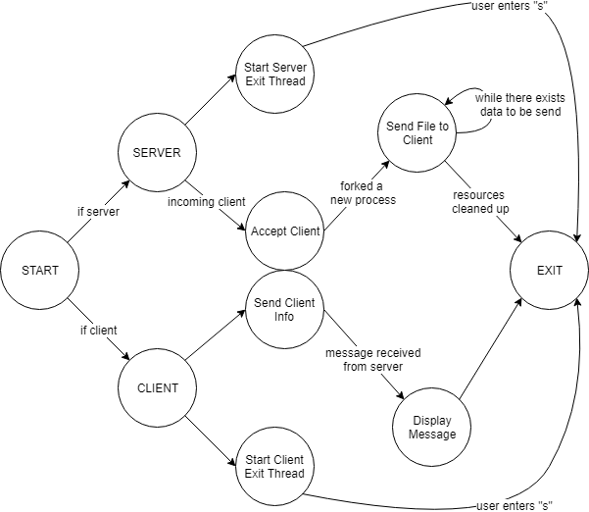

Pseudocode

START

* If user executes the program as a server, start the server.
* If user executes the program as a client, start the client.
* If the user does not provide command line arguments, display the user guide.

# CLIENT

* Parse the command line arguments provided to the client.
  + Server queue id,
  + Priority, and
  + File name
* Create a new thread that monitors for user input of “s”.
  + If “s” has been inputted, exit the program.
* Initialize the client structure with the received arguments.
* Send the server:
  + Process id,
  + Priority, and
  + File name
* Read the messages send by the server through the message queue.
* Print the console.
* Exit if the whole file has been read.

# SERVER

* Create a new thread that monitors for user input of “s”.
* Initialize:
  + Message queue, and
  + Semaphore
* If there exist incoming clients wanting to connect, get its information and store in a client_info structure.
* Fork a new process to read the file name received.
  + Inside the child process, until the file has been read:
    - Acquire the semaphore,
    - Send the contents of the file priority level many times, and
    - Release the semaphore
* Clean up the acquired resources and exit:
  + Free the message queue and the semaphore.