

CMOS VLSI PROJECT – MATRIX KEYBOARD SCANNER

atharva deshmukh (1MS17EC013)

GAUrav S (1MS17EC029)

Bhuvan SR (1MS17EC016)

jp hitesh (1MS17EC040)

Introduction

A Matrix Keyboard Scanning Algorithm is an algorithm that is used to search a keyboard matrix to determine if any of the keys are pressed.

# Circuit Implementation

* The keyboard matrix scanner circuit consists of a 4*4 matrix of switches, each corresponding to a particular value (i.e. 0,1…E,F).
* The rows and columns each have a separate processing unit.
* The rows and column of the matrix circuit are fed as inputs to 4-input OR gates.
* The outputs of the 4-input OR gates are fed into a 4:2 Encoder which are implemented in the form of OR gates.
* The output of the 4:2 Encoder is fed as inputs to a 4-bit binary display.

# Basic Working

* The rows and columns of the circuit all read low.
* When a switch is activated, the corresponding row and column goes high.
* The combination of 4-input OR gates identifies the switch activated.
* The 4:2 Encoder then converts the input to its corresponding 2-bit Binary value for the row and column respectively.
* These outputs are then fed into a 4-bit binary display which displays the corresponding Hexadecimal value of the key activated.

The Circuit was implemented in Dsch 3.5 and the gate level and transistor level circuits were constructed as follows

# Gate Level

Gate level diagram of the Matrix Keyboard Scanner circuit.

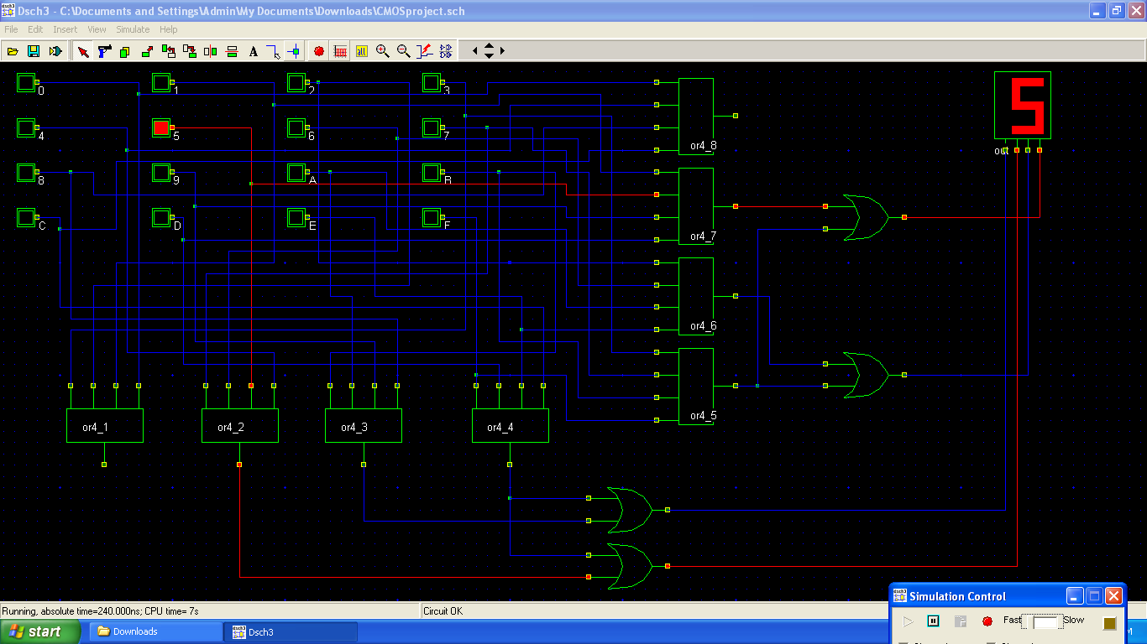

# Transistor Level

Transistor level diagram for 4 input and 2 input OR gate.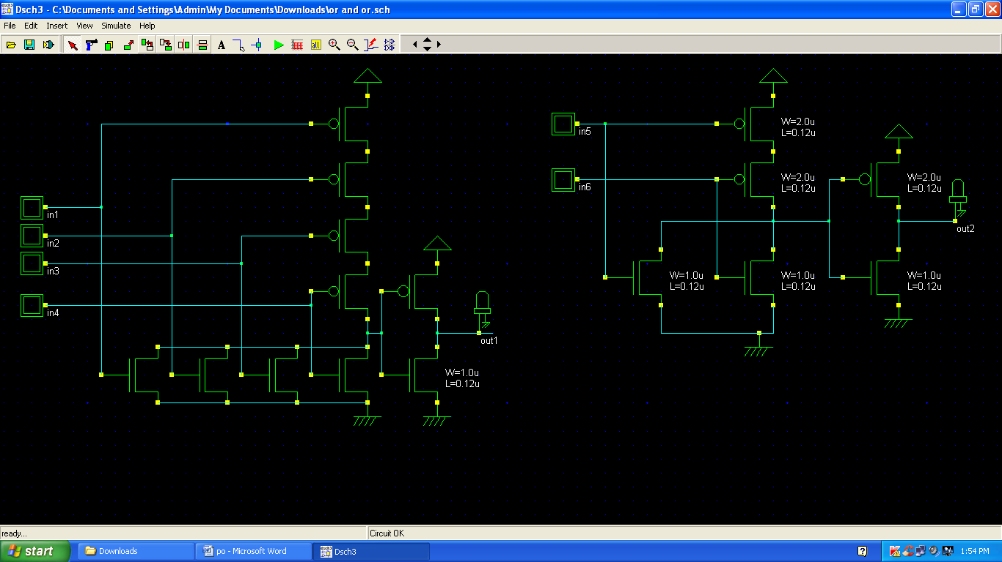

Transistor level diagram for the Matrix Keyboard Scanner circuit.

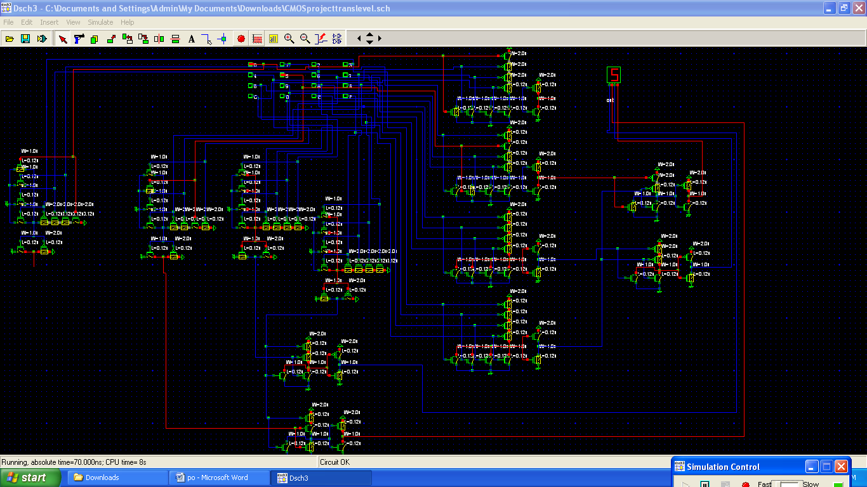

# Layout

Layout for 4-input OR gate and 2-input OR gate.

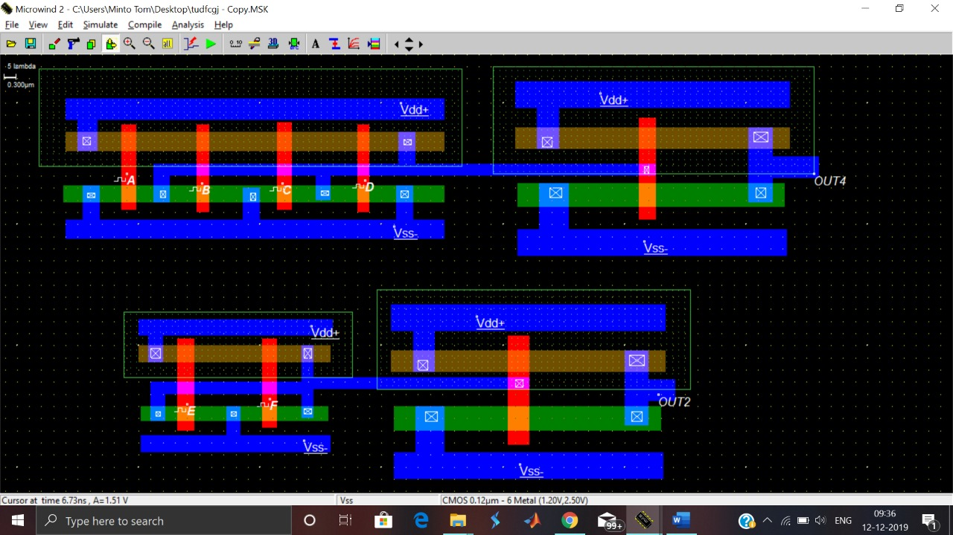

Waveform for 4-input OR gate and 2-input OR gate.

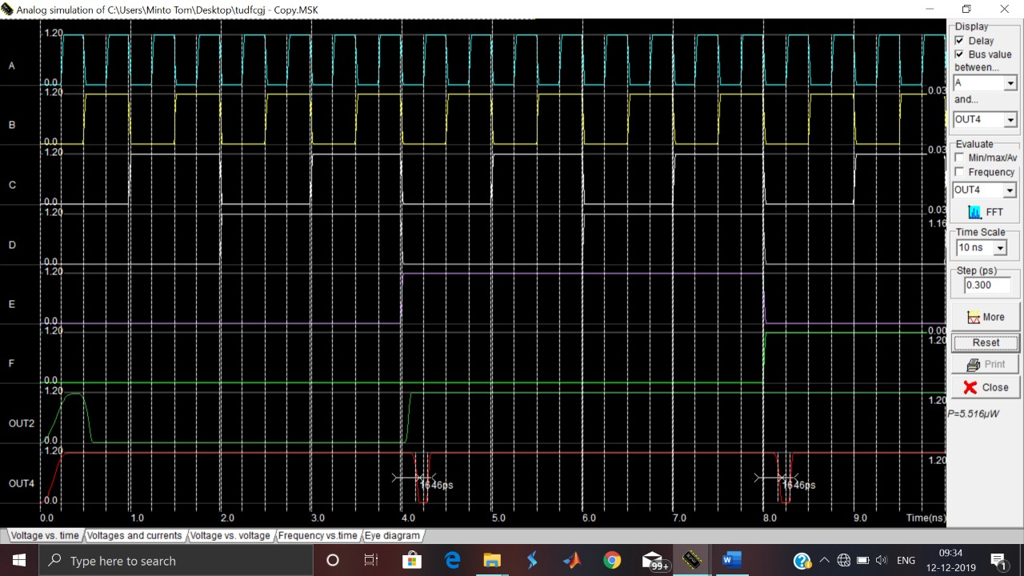

Layout for the Matrix Keyboard Scanner.

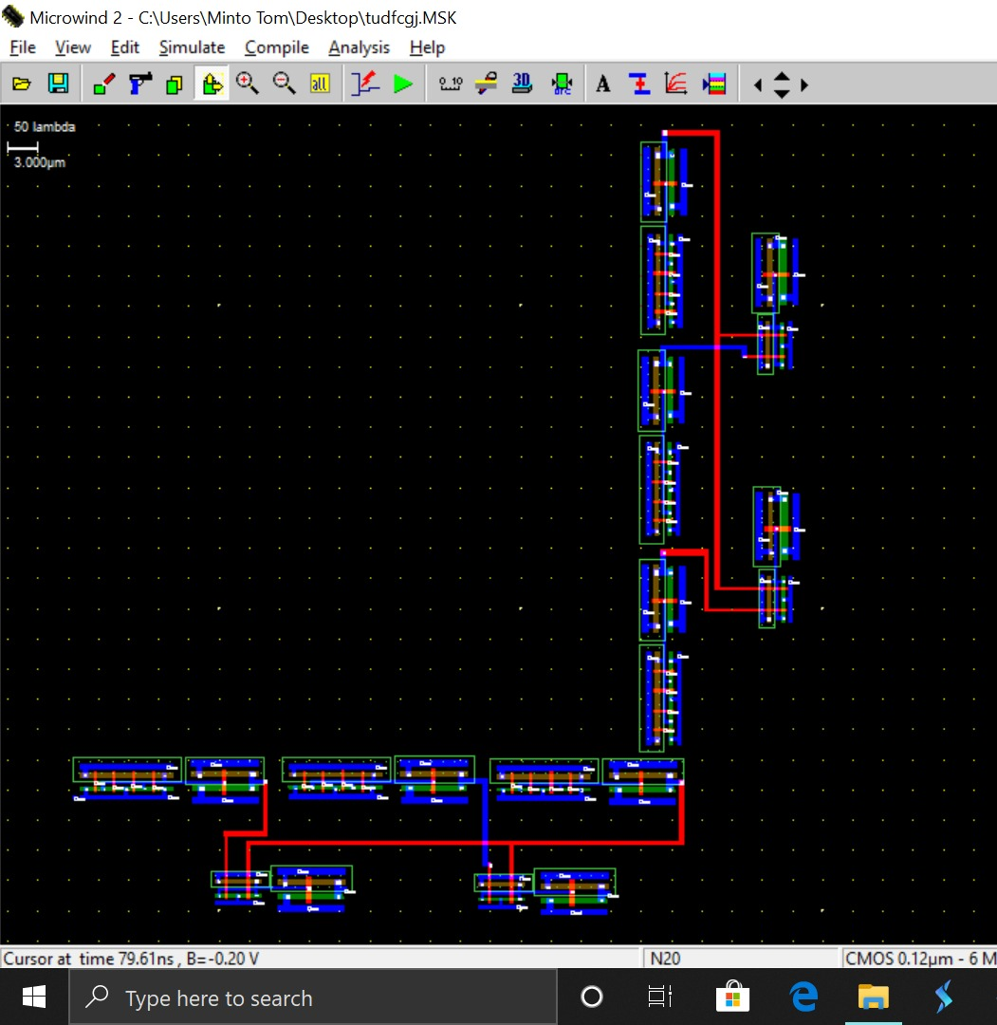

Waveforms for the Keyboard Matrix Scanner Circuit

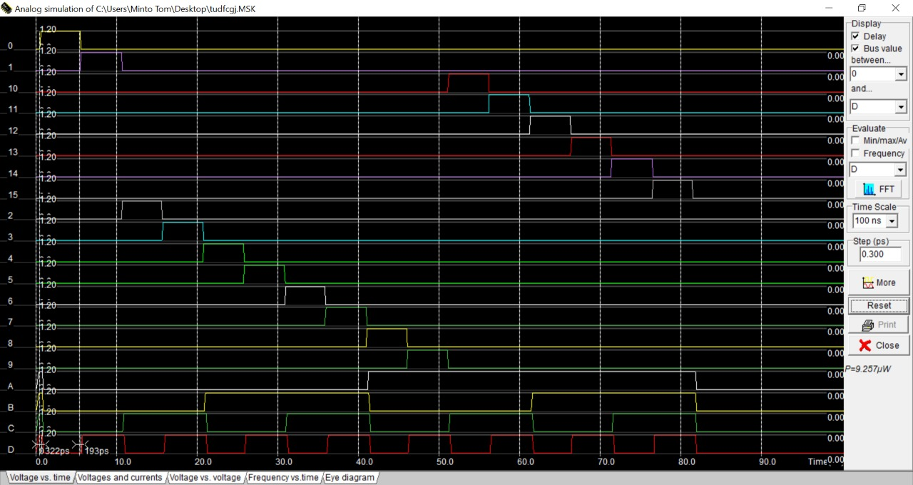

# Conclusion

Hence, the Keyboard Matrix Scanner was Designed, Constructed and Implemented using Dsch3 for both Gate level, Transistor Level diagram and Layout diagram.

# References

* [www.learningaboutelectronics.com/Articles/How-does-a-matrix-keyboard-scanning-algorithm-work](http://www.learningaboutelectronics.com/Articles/How-does-a-matrix-keyboard-scanning-algorithm-work)
* [www.microwind.net](http://www.microwind.net)
* <https://en.wikipedia.org/wiki/Keyboard_matrix_circuit>
* CMOS VLSI design (4th Edition) – Neil Weste