ACH Case Tracking Phase I
Architecture/Design Document

Table of Contents
1 Introduction 3
2 Design Goals 4
3 System Behavior 4
4 Logical View 5
4.1 High-Level Design (Architecture) 5
4.2 Mid-Level Design 6
4.3 Detailed Class Design 8
5 Process View 11
6 Development View 12
7 Physical View 12
8 Use Case View 12

Change History
Version: <x.y>
Modifier: <Name>
Date: mm/dd/yyyy
Description of Change: <What was modified/added?>
______________________________________________________
Version: <x.y>
Modifier: <Name>
Date: mm/dd/yyyy
Description of Change: <What was modified/added?>

Introduction

Architecture and Design
The purpose of the architecture/design document is to explain the organization of the code. A well-written architecture document will make it easier for new programmers to become familiar with the code.

The architecture/design document should identify major system components and describe their static attributes and dynamic patterns of interaction.

Software architecture and designs are typically expressed with a mix of UML models (class and sequence diagrams being the two most common) and prose. Dataflow diagrams are also helpful for understanding the interaction between components and overall flow of data through the system.
About this Template
This template suggests one way of documenting a software system’s architecture/design. You aren’t required to include every section in this template nor all the content in the sections you do include. However, the document you do submit should pass the following checklist:
- Are design objectives clearly stated? For example, if performance is more important than reusability, this should be made clear at the start of the design specification.
- Does the architecture partition the implementation into clearly defined subsystems or modules with well-defined interfaces?
- Does the architecture express in a clear way the main patterns of communication between subsystems and modules?
- Does the architecture satisfy the requirements?
- Is the architecture traceable to requirements?
- Any models created should either be expressed with a well-known modeling language, or if a well-known modeling language isn't used, the syntax and semantics of the symbols that are used should be defined.

This document describes the architecture and design for the ACH Case Tracking Phase I application being developed for Commerce Bank. The purpose of ACH Case Tracking Phase I will be to enhance visibility into various types of Government Reclamation requests received. This will allow the ACH Department to limit their risk of missing a requests, resulting in a loss to the bank. The ACH Case Tracking application will feature a friendly UI with a main menu that allows users to navigate to a manual case creation screen, import cases from a NACHA file, or search for specific cases according to various parameters.

The purpose of this document is to describe the architecture and design of the ACH Case Tracking Phase I application in a way that addresses the interests and concerns of all major stakeholders. For this application the major stakeholders are:

- Users and the customer – they want assurances that the architecture will provide for system functionality and exhibit desirable non-functional quality requirements such as usability, reliability, etc.
- Developers – they want an architecture that will minimize complexity and development effort.
- Project Manager – the project manager is responsible for assigning tasks and coordinating development work. He or she wants an architecture that divides the system into components of roughly equal size and complexity that can be developed simultaneously with minimal dependencies. For this to happen, the modules need well-defined interfaces. Also, because most individuals specialize in a particular skill or technology, modules should be designed around specific expertise. For example, all UI logic might be encapsulated in one module. Another might have all business logic.
- Maintenance Programmers – they want assurance that the system will be easy to evolve and maintain on into the future.

The architecture and design for a software system is complex and individual stakeholders often have specialized interests. There is no one diagram or model that can easily express a system’s architecture and design. For this reason, software architecture and design is often presented in terms of multiple views or perspectives [IEEE Std. 1471]. Here the architecture of the <product name> application is described from 4 different perspectives [1995 Krutchen]:

- Logical View – major components, their attributes and operations. This view also includes relationships between components and their interactions. When doing OO design, class diagrams and sequence diagrams are often used to express the logical view.
- Process View – the threads of control and processes used to execute the operations identified in the logical view.
- Development View – how system modules map to development organization.
- Use Case View – the use case view is used to both motivate and validate design activity. At the start of design the requirements define the functional objectives for the design. Use cases are also used to validate suggested designs. It should be possible to walk through a use case scenario and follow the interaction between high-level components. The components should have all the necessary behavior to conceptually execute a use case.

Design Goals
There is no absolute measure for distinguishing between good and bad design. The value of a design depends on stakeholder priorities. For example, depending on the circumstances, an efficient design might be better than a maintainable one, or vise versa. Therefore, before presenting a design it is good practice to state the design priorities. The design that is offered will be judged according to how well it satisfies the stated priorities.

The design priorities for the ACH Case Tracking Phase I application are:
- The design should minimize complexity and development effort.
- The design should be based on MVC design, which focuses on modularity and a separation of concerns. It is a design that reduces complexity by removing unnecessary dependencies between the modules.
- Closely related to the idea of separation of concerns is scalability. The design should be scalable.

System Behavior
The use case view is used to both drive the design phase and validate the output of the design phase. The architecture description presented here starts with a review of the expect system behavior in order to set the stage for the architecture description that follows. For a more detailed account of software requirements, see the requirements document.

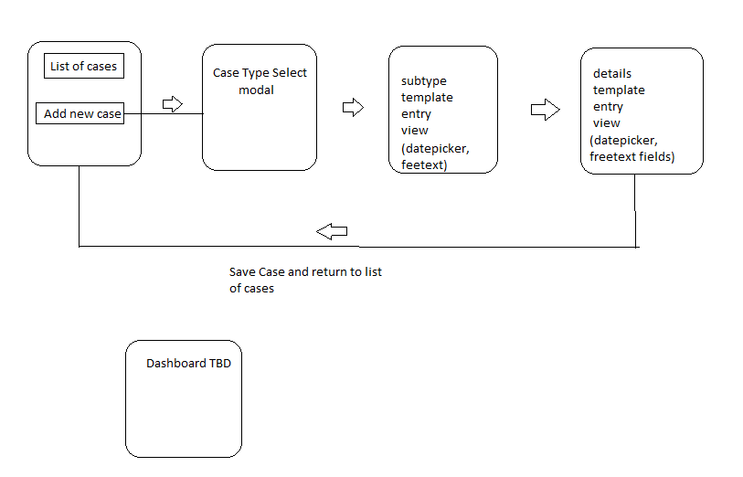

Logical View
The logical view describes the main functional components of the system. This includes modules, the static relationships between modules, and their dynamic patterns of interaction.

In this section the modules of the system are first expressed in terms of high level components (architecture) and progressively refined into more detailed components and eventually classes with specific attributes and operations.

High-Level Design (Architecture)
The high-level view or architecture consists of 4 major components:
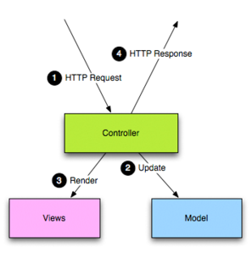
System Architecture
- The CaseController extracts data from the HTTP request and reads or updates the model, which contains information on ACH cases. It then controls the views to change the presentation of the model.
- The Database is a central repository for data ACH case information.
- The models store data that is retrieved according to commands from the controller and is displayed in the view.
- The views render the model into a form suitable for interaction. It also contains code for gathering dynamic data.

Mid-Level Design

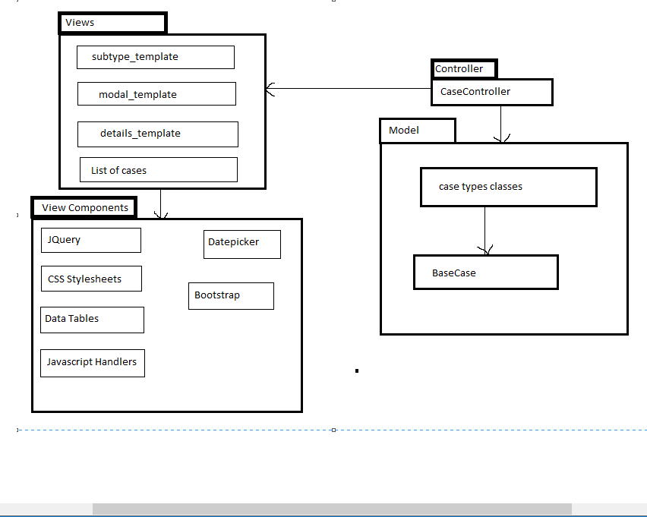

Detailed Class Design
<For a few key classes you might want to show associations, attributes and methods.>

Process View

<Where are the threads of control in the application?>

Physical View
<Where will major components be physically deployed?>

Use Case View
<Sketch architecturally significant use cases.>

