**OS Lab Assignment 2**

**TY-AI-A**

Name: Shreya Das

Division: A

Batch: Batch 1

Roll Number: 29

PRN: 12111305

Problems to be solved:

1. Change your password to a password you would like to use for the remainder of the semester.

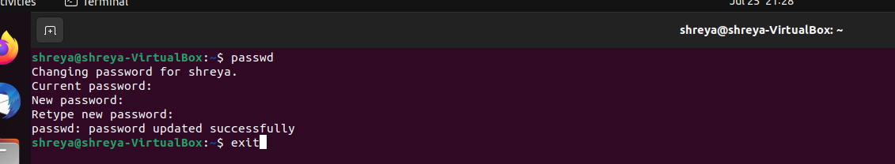

1. Display the system’s date.

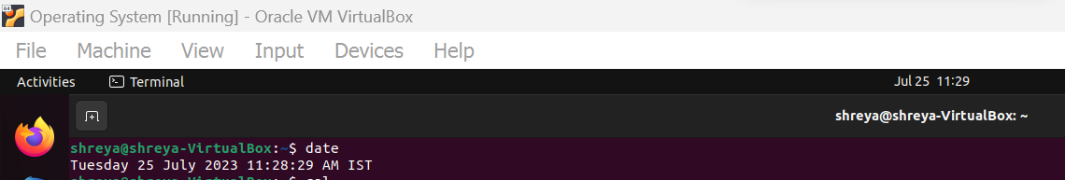

1. Count the number of lines in the /etc/passwd file.

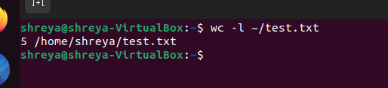

1. Find out who else is on the system.

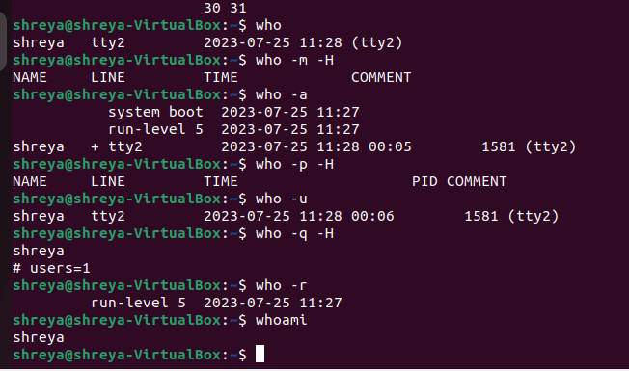

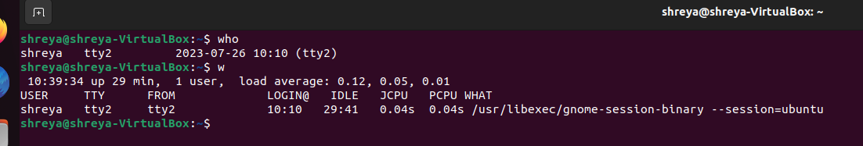

1. Direct the output of the man pages for the date command to a file named mydate.

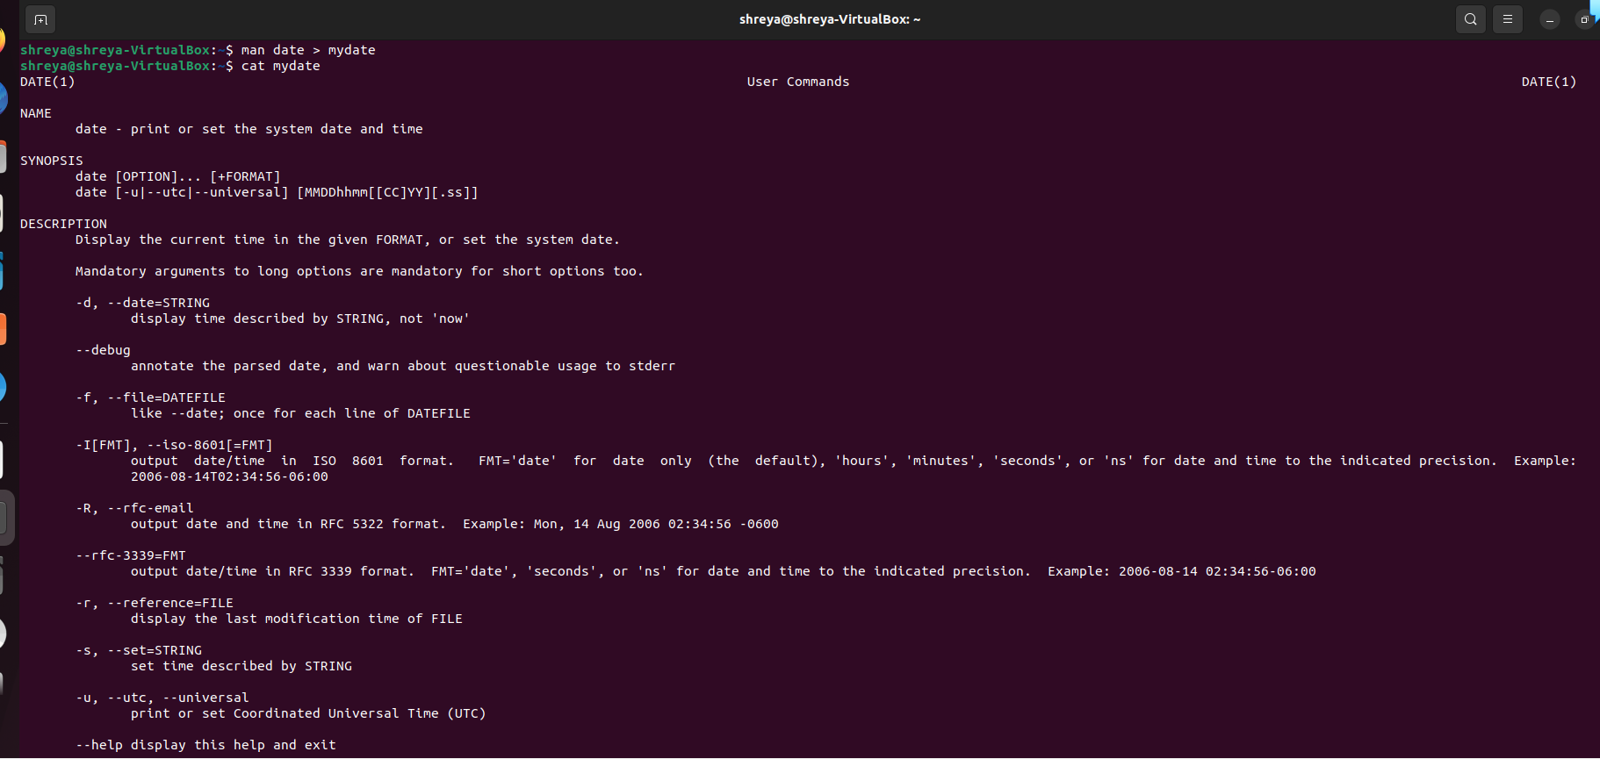

1. Create a subdirectory called mydir.

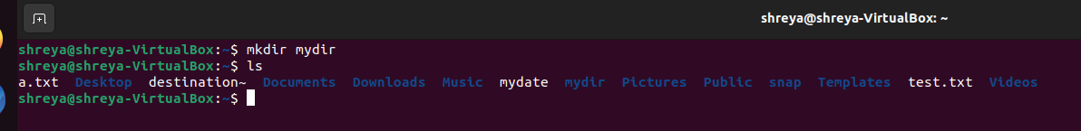

1. Move the file mydate into the new subdirectory.

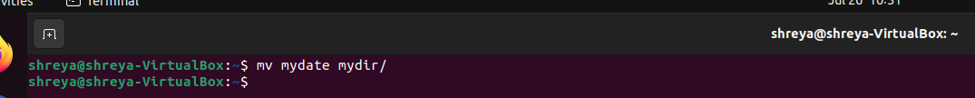

1. Go to the subdirectory mydir and copy the file mydate to a new file called ourdate.

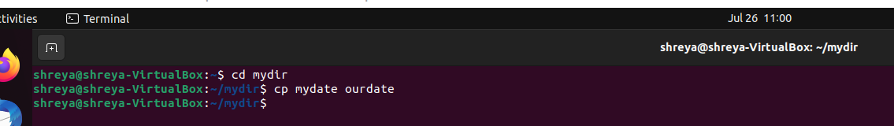

1. List the contents of mydir.

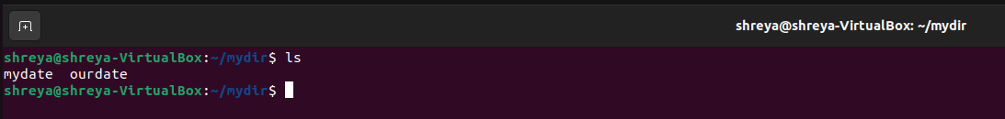

1. Do a long listing on the file ourdate and note the permissions.

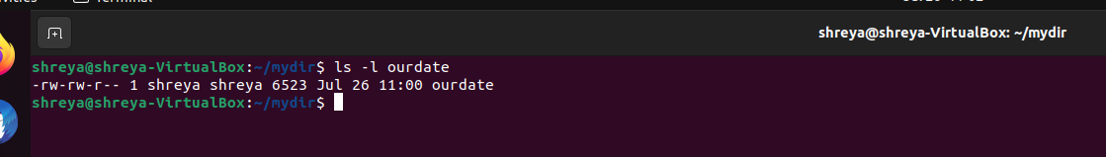

1. Display the name of the current directory starting from the root.

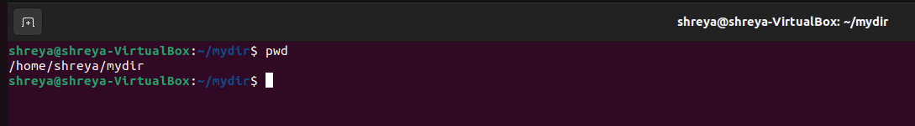

1. Move the files in the directory mydir back to the HOME directory.

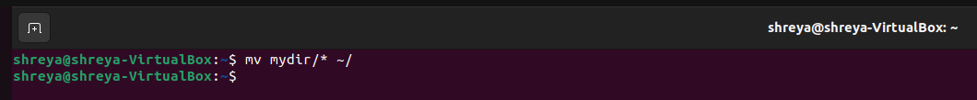

1. List all the files in your HOME directory.

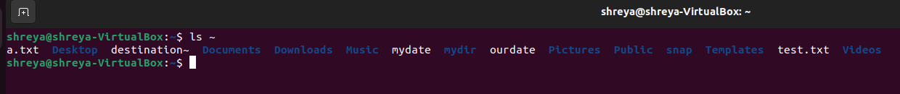

1. Display the first 5 lines of mydate.



1. Display the last 8 lines of mydate.

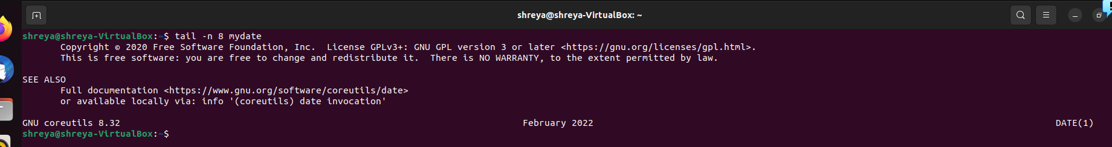

1. Remove the directory mydir.

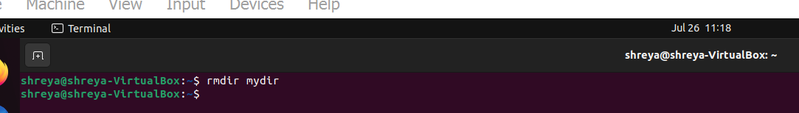

1. Redirect the output of the long listing of files to a file named list.

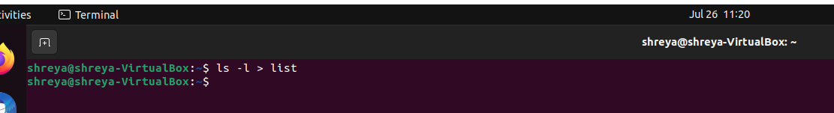

1. Select any 5 capitals of states in India and enter them in a file named capitals1. Choose 5 more capitals and enter them in a file named capitals2. Choose 5 more capitals and enter them in a file named capitals3. Concatenate all 3 files and redirect the output to a file named capitals.

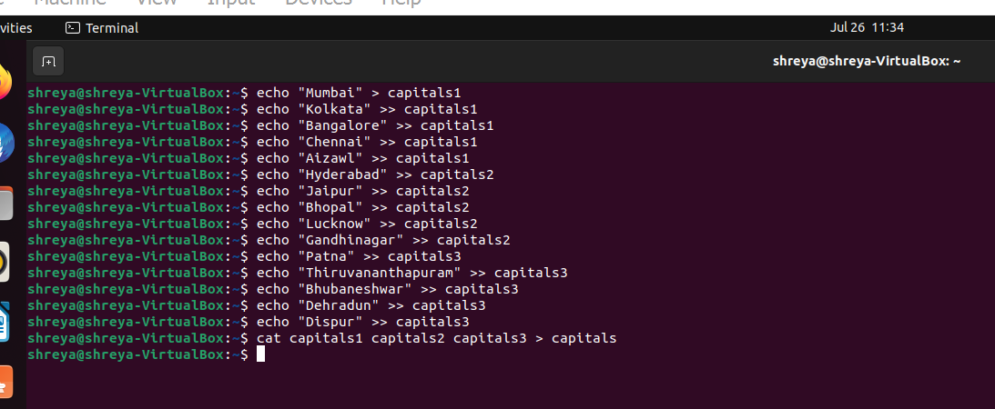

1. Concatenate the file capitals2 at the end of file capitals.

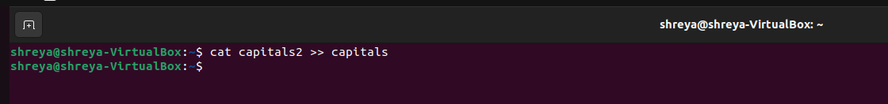

1. Redirect the file capitals as an input to the command “wc –l”.

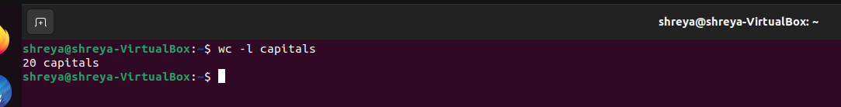

1. Give read and write permissions to all users for the file capitals.

