**OS Lab Assignment 3**

**TY-AI-A**

Name: Shreya Das

Division: A

Batch: Batch 1

Roll Number: 29

PRN: 12111305

Problems to be solved:

1. Write a shell program to print given number in reverse order.

Code:

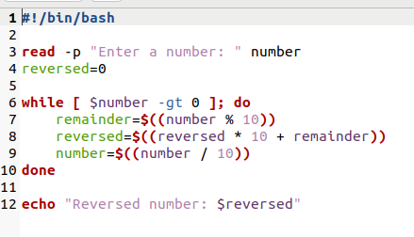

Output:

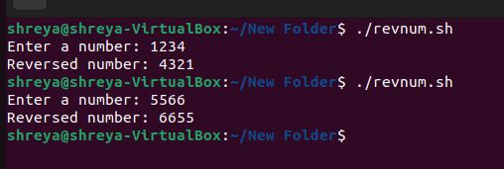

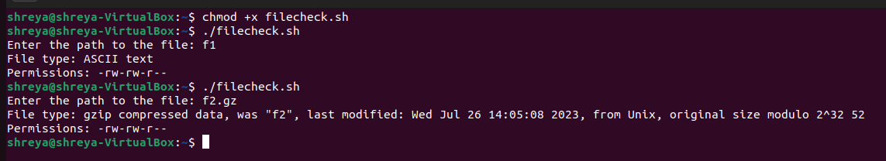

1. Write a shell program to perform arithmetic operations using case.

Code:

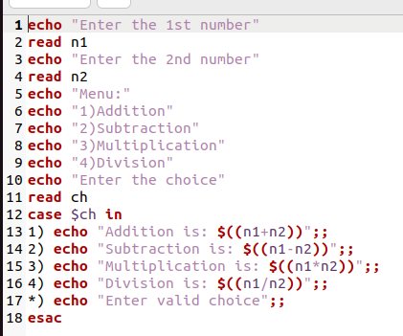

Output:

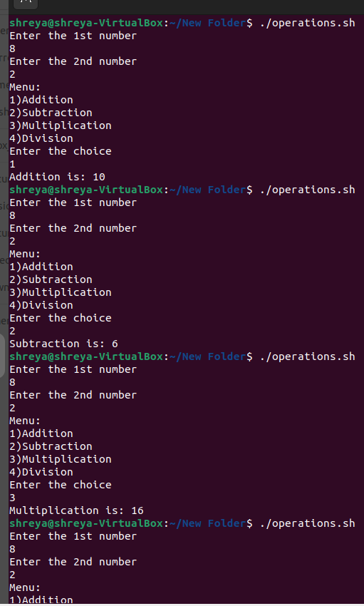

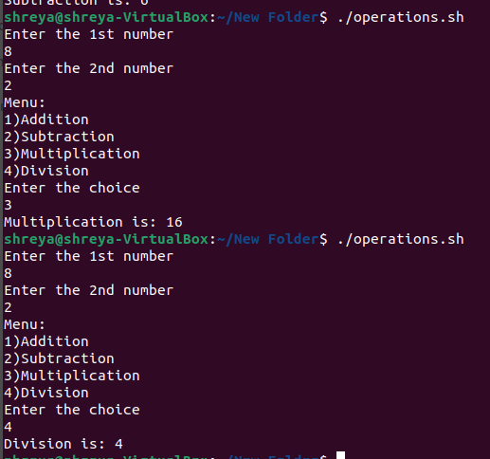

1. Write a shell script to check file type and permissions of a given input by user.

Code:

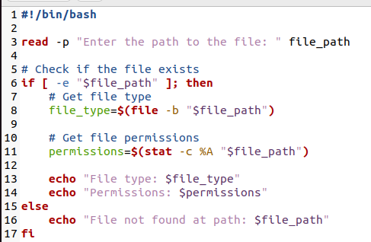

Output:

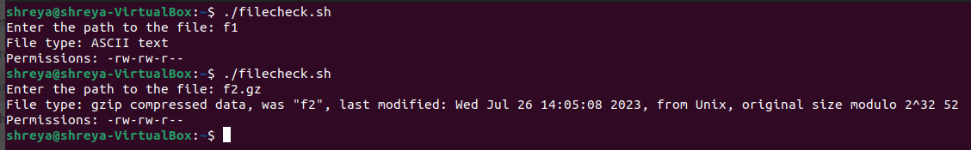

1. Write a shell script to Find factorial of a given number using function.

Code:

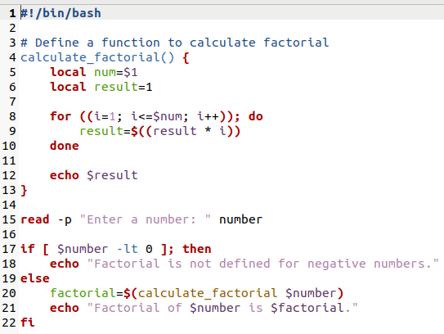

Output:

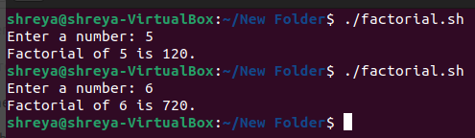

1. Write a shell script to reverse a string.

Code:

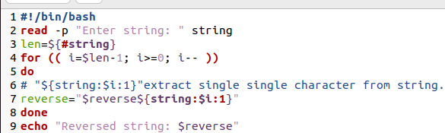

Output:

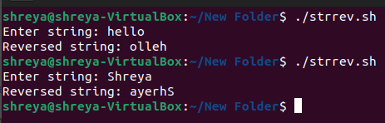

1. White a shell script to print fibonacci series.

Code:

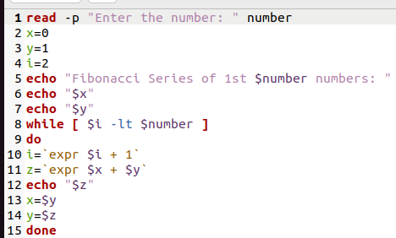

Output:

