**OS Lab Assignment 4**

**TY-AI-A**

Name: Shreya Das

Division: A

Batch: Batch 1

Roll Number: 29

PRN: 12111305

Problems to be solved:

Write a program demonstrating the use of different system calls.

1. process related system all: fork, wait.

Code:

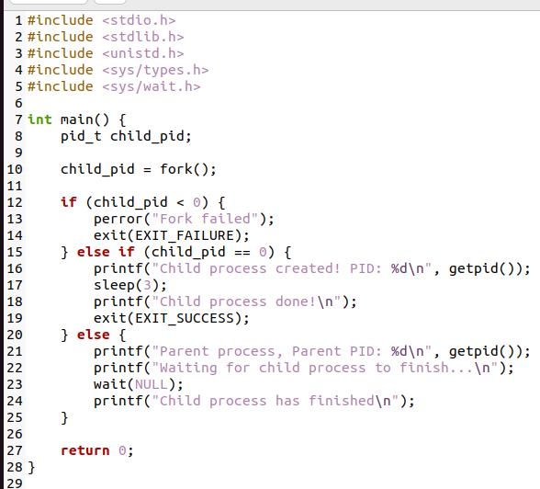

Output:

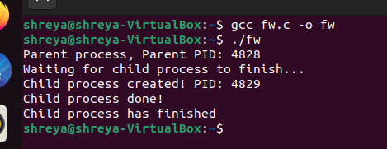

1. file related: open, read, write, close.

Code:

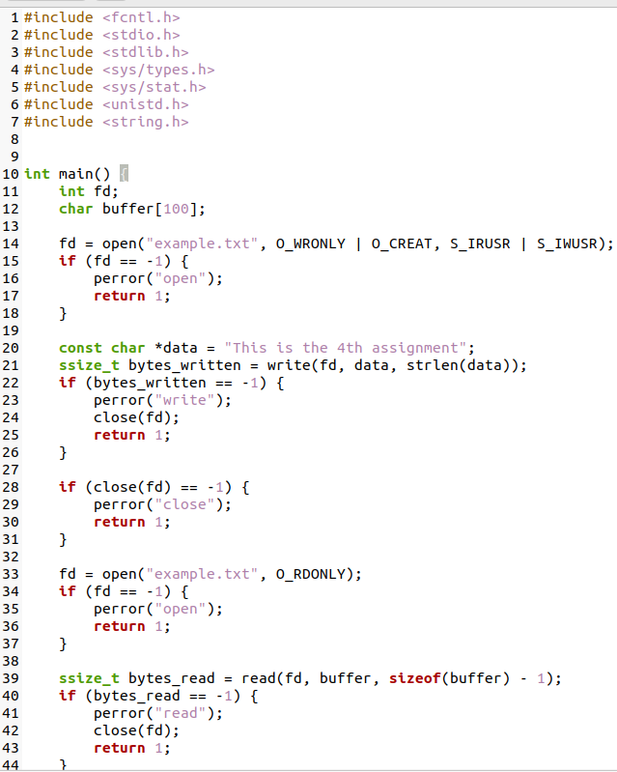

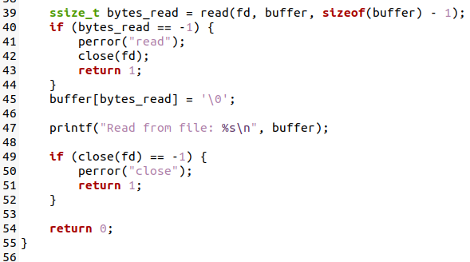

Output:

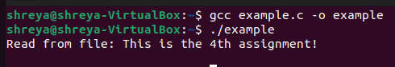

1. Protection: chmod

Code:

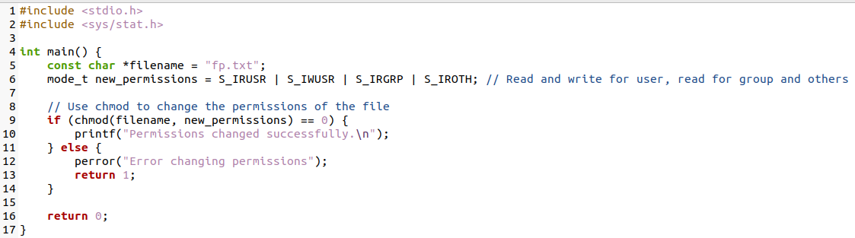

Output:

