**OS Lab Assignment 5**

**TY-AI-A**

Name: Shreya Das

Division: A

Batch: Batch 1

Roll Number: 29

PRN: 12111305

Problem to be solved:

Implementation of classical problem Reader Writer using Threads and Mutex

Code:

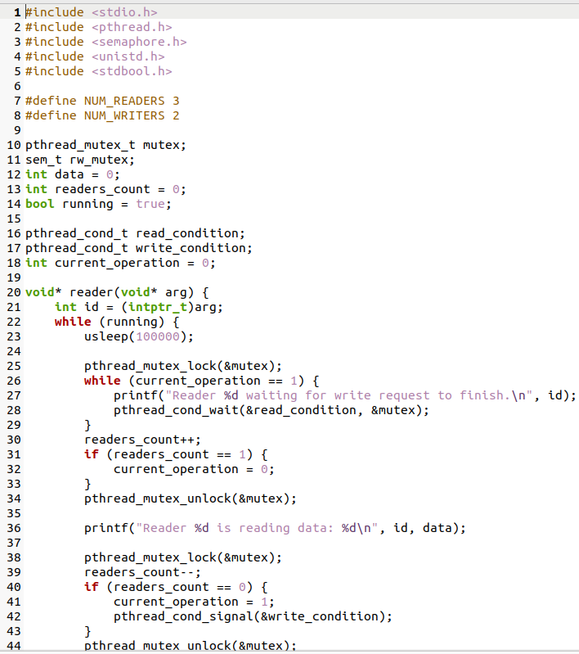

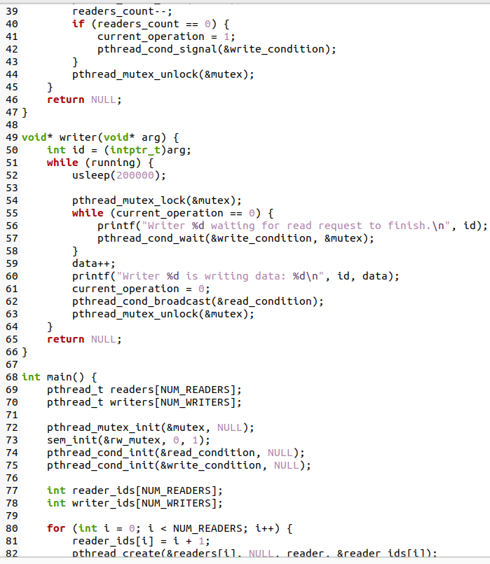

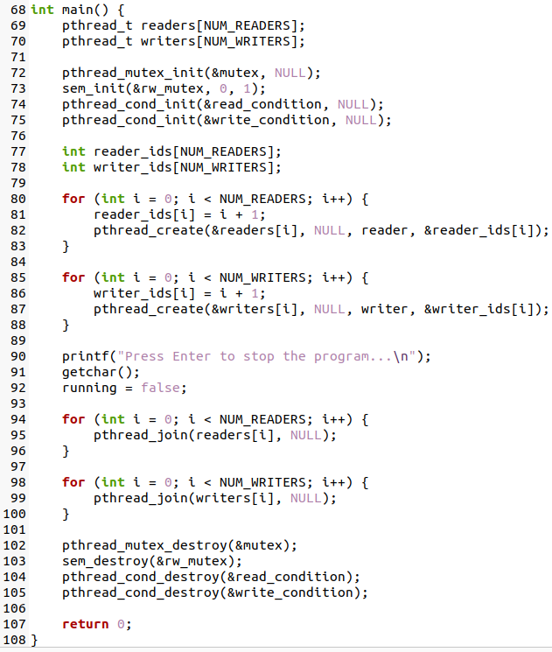

Output:

