**OS Lab Assignment 6**

**TY-AI-A**

Name: Shreya Das

Division: A

Batch: Batch 1

Roll Number: 29

PRN: 12111305

Problem to be solved:

Implementation of Classical problems Producer Consumer using Threads and Semaphore

Code:

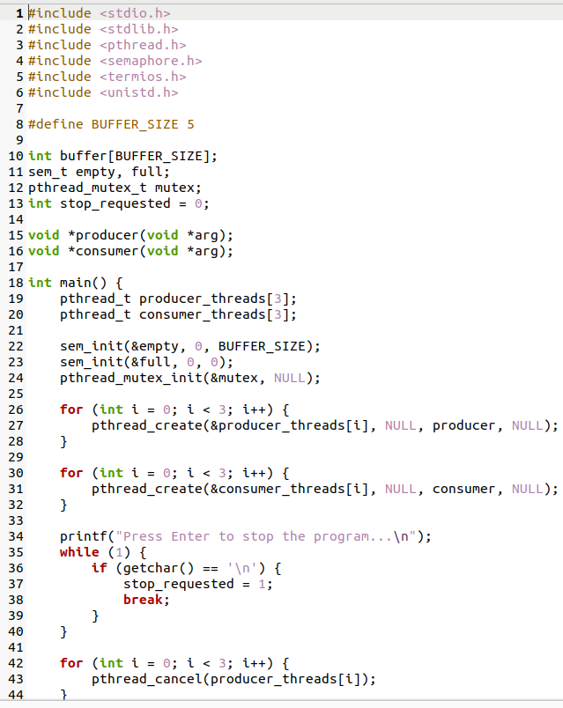

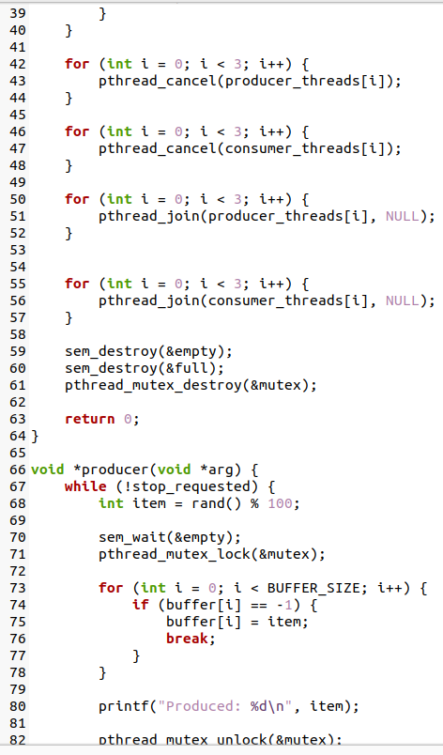

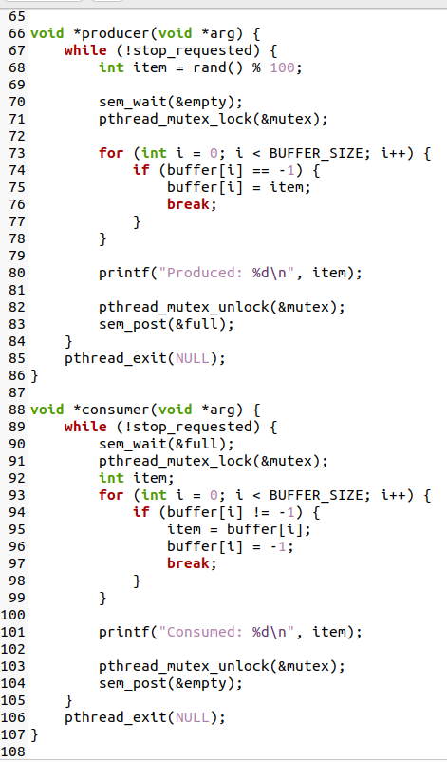

Output:

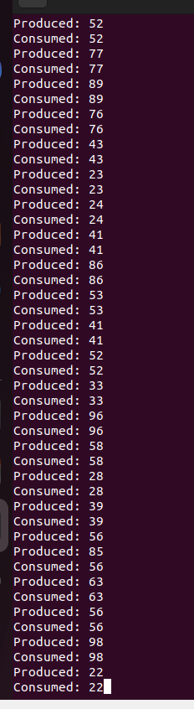

* Song1
* Song2
* Song3
* Song4
* Song5