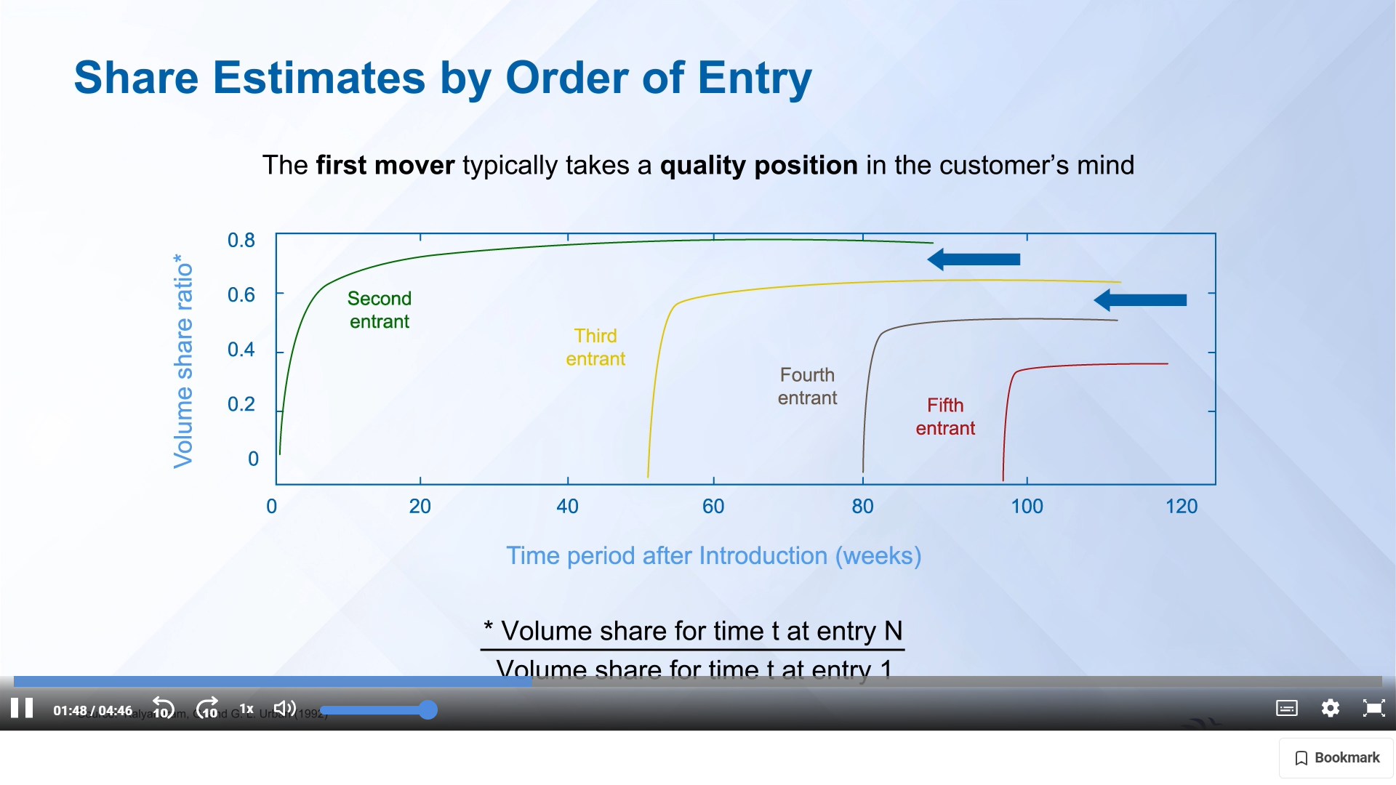

100% = 500 million

60% to first 3 movers = 500 \* (60/100) = 300 million

X to first mover = 153.06 million (approximately 50% of 300 million)

0.6 \* X to second mover = 91.84 million (approximately 30% of 300 million)

0.6 \* 0.6 \* X = 0.36 \* X to third mover = 55.10 million (approximately 20% of 300 million)

X + (0.6 \* X) + (0.36 \* X) = 300 million

Cost of being second = X to first mover - 0.6 \* X to second mover

= approximately 50% of 300 million - approximately 30% of 300 million

= approximately 20% of 300 million

= approximately 60 million

= precisely 153.06 – 91.84

= 61.22 million units

Contribution margin per DVD player = 15$

Cost of being second = approximately 60 million \* $15

= approximately $900 million

= precisely 61.22 million \* $15

= $918.3 million

Cost of being second

(per day) = $900 million / 365 days

= $2.5 million per day

= precisely $918.3 million / 365 days

= $2.52 million per day