# Analysis of a Conjoint Report

## About the experiment

This report is based on an Example Experiment: Which mobile plan will you sign up for? The experiment asked participants to choose among different mobile plans available in the market based on their unique attributes.

The objective of the experiment was to understand which mobile plans are most appealing to consumers, and what underlying attributes influence their preferences the most.

### Attributes and Levels:

Price: 30$ per month – 70$ per month

Mobile Data: 500MB - Unlimited

International Call Limit: 0 Minutes – 300 Minutes

SMS Limit: 300 Messages – Unlimited

### Current Market Situation:

|  |  |  |  |  |
| --- | --- | --- | --- | --- |
| **Product Name** | **Price** | **Mobile Data** | **International Call Limit** | **SMS Limit** |
| Jio 349 True 5G Unlimited | 35 | Unlimited | 0 Min | 300 SMS |
| Jio 198 True 5G Unlimited | 26 | 10GB | 0 Min | 300 SMS |
| Airtel 509 Voice‑SMS-Data | 51 | Unlimited | 90 Min | Unlimited |
| Airtel 279 Entertainment | 26 | 10GB | 0 Min | 300 SMS |
| Vodafone 539 Hero Unlimited | 54 | Unlimited | 90 Min | Unlimited |
| Vodafone 398 Nonstop Hero | 40 | Unlimited | 0 Min | Unlimited |

### New products:

|  |  |  |  |  |
| --- | --- | --- | --- | --- |
| **Product Name** | **Price** | **Mobile Data** | **International Call Limit** | **SMS Limit** |
| NPD1 | 27 | 10GB | 90 Min | 300 SMS |
| NPD2 | 45 | Unlimited | 90 Min | Unlimited |

## Insights from the Conjoint report

1. As per the analysis, Mobile Data is the most important attribute, and International Call Limit is the least important attribute.

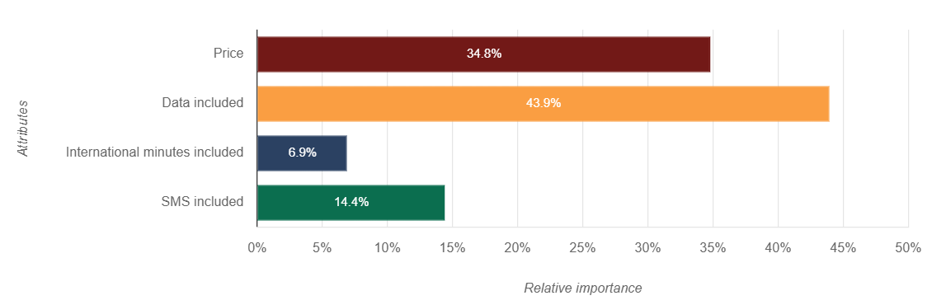

1. Customers are ready to pay a higher price for more Mobile Data provided. 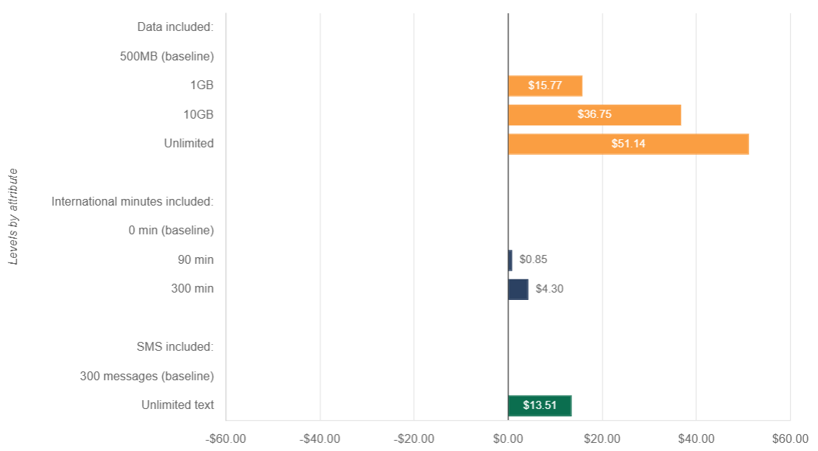
2. In the current market, the Vodafone 398 Nonstop Hero plan has the highest market share (47.4%) as it is the plan that provides Unlimited Mobile Data at a minimum price.

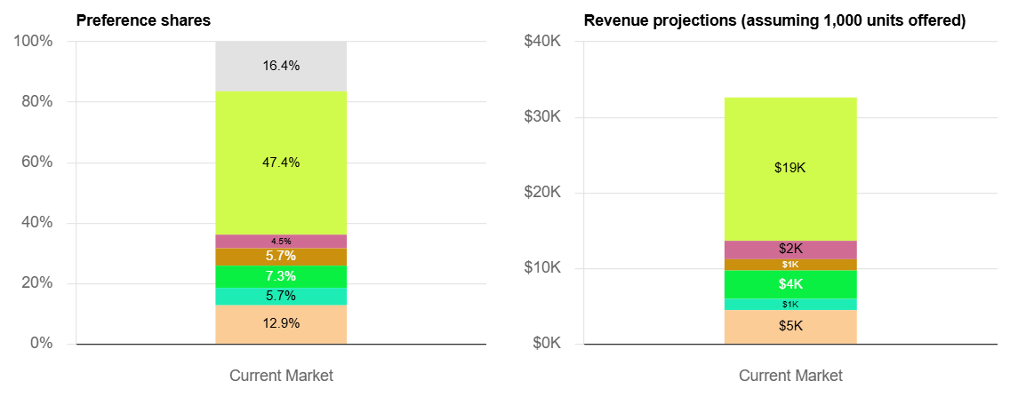

## Discussion points

1. In the current market, the new product NPD1 will be able to grab a small amount of market share from the best plan available in the market. So the optimal combination of Price, Mobile data, and International Call Limit has its market segment.

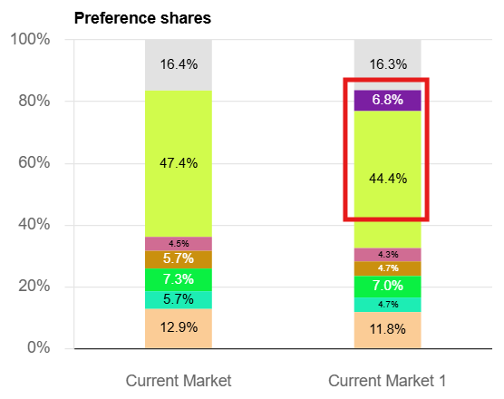

1. New product NPD2 will be more successful in the market as it is providing a better combination of Price, Mobile data, and International Call Limit.

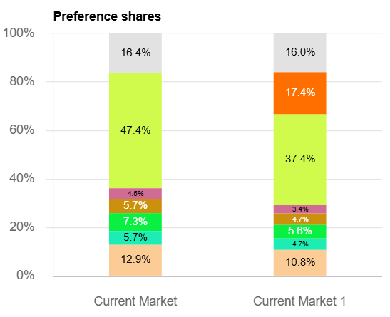

1. There are clearly 2 segments, 1. Limited requirements of Mobile Data but wants to keep the price minimum, 2. Unlimited requirements for Mobile Data are ready to pay a higher price.

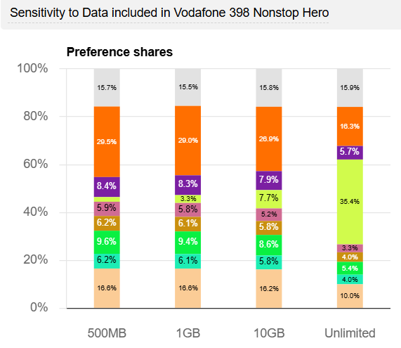

1. Unlimited Mobile Data with Limited International calls combination is preferred over a wide range of prices. Whereas the only Unlimited Mobile Data preference drops below a certain price limit.

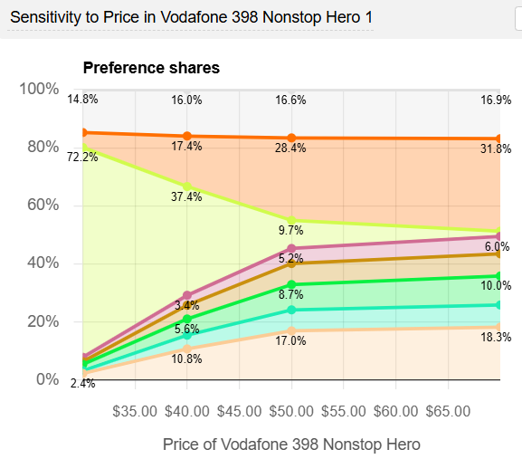

1. Mobile Data is the most important attribute. The possibility of providing maximum data at the cheapest price could be the key to increasing revenue.